Pass for level 26: 5czgV9L3Xx8JPOyRbXh6lQbmIOWvPT6Z

First I tried to log in to ssh -I bandit26sshkey bandit26@localhost but unfortunately I throw out.

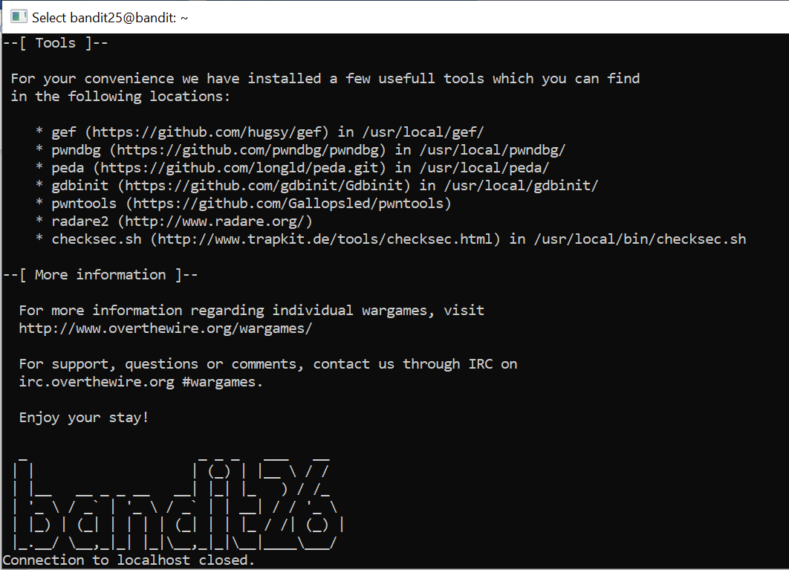Then I looked at /etc/passwd | grep bandit26 for more explanation of what has been executed and I surprised to find out that in user bandit26 we only show some text in more format and quit.

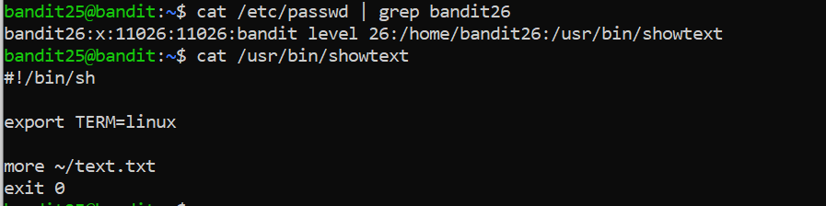

I discovered a bug in "more" linux function – I can resize the screen and execute shell commands like this:

1. press 'v' to open vim format

2. press: ":r /etc/bandit_pass/bandit26"

It will open the /etc/bandit_pass/bandit26 and show the expected password

Then I set the /bin/bash with: ":set shell=/bin/bash"

And execute ":shell" to connect to shell.

