Pass for level 29: bbc96594b4e001778eee9975372716b2

In the readme.md I saw:

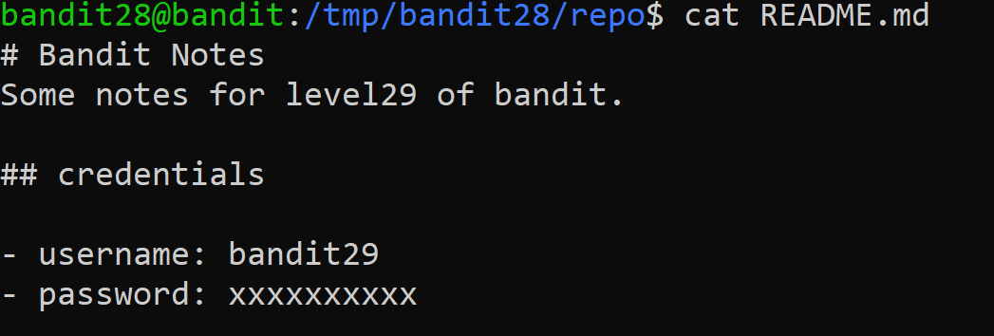

Then I realized that maybe someone hide the password and commit it then I go to log and see:

