Pass for level 3: sJIJNW6ucpu6HPZ1ZAchaDtwd7oGrD14

Step 1: ctr+shift+c enter the source code and see:

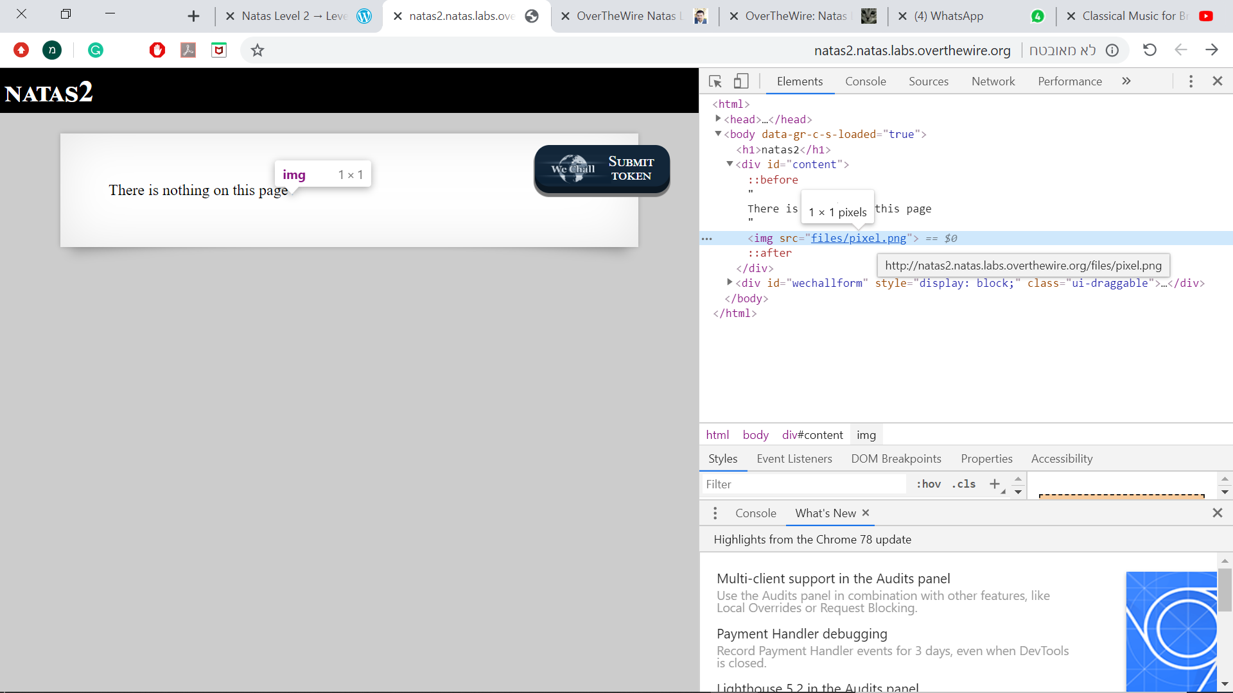

Enter the url :

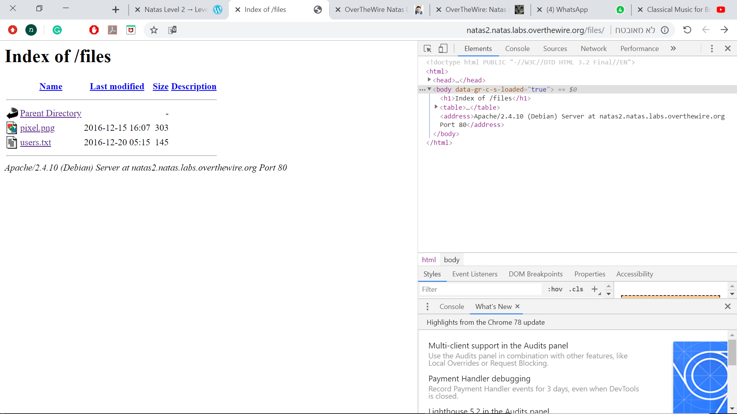

Opening users.txt

