We wrote a program on Julia, a high-level, high-performance dynamic programming language for technical computing, to help us determine properties

of the settlement by calculating gravity, area per person, daily calorie intake, etc.

It can be downloaded from <https://github.com/gale31/Space-Settlement-Calculator>.

We need to install Julia to be able to work with the program. It can be downloaded from <http://julialang.org/downloads/>.

After that, we can open the program in Julia by typing “include(“demo.jl”)” after specifying the appropriate directory, as shown below.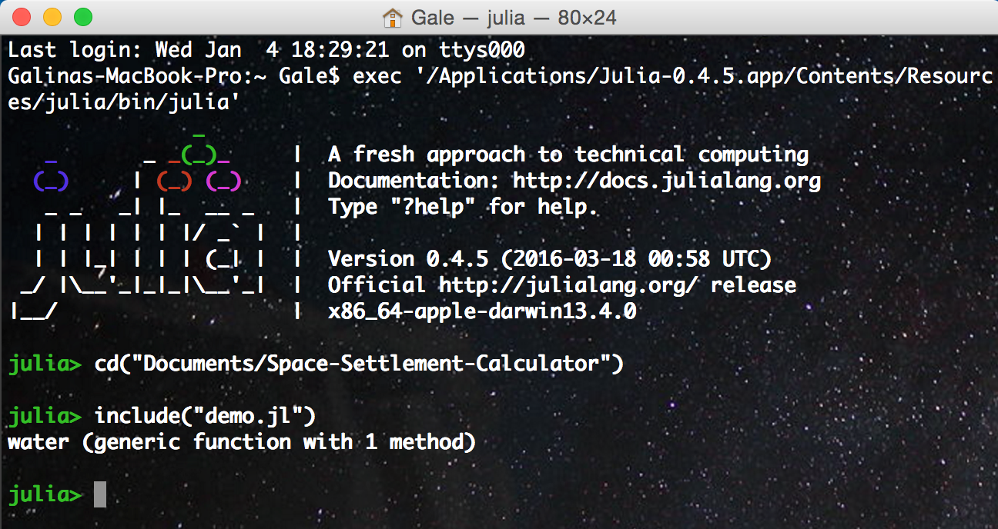

Now we can use the following functions (parameters in <>):

**gravity(<radius>, <angular velocity>)** — Given the radius from the center of rotation in meters and the angular velocity (or spin rate) in rotations/minute, the centripetal acceleration is calculated.

**sphere(<radius>)** — Given the radius of a sphere, its volume and surface area are calculated.

**areaPerPersonSurfaceSphere(<radius>, <population>)** — Given the radius of a sphere and the population living on its surface, area per person is calculated.

**torus(<bigRadius>, <smallRadius>)** — Given the big and small radius of a torus, its volume and surface area are calculated.

**areaPerPersonSurfaceTorus(<bigRadius>, <smallRadius>, <population>)** — Given the radius of a torus and the population living on its surface, area per person is calculated.

**cylinder(<radius>, <height>)** — Given the radius and height of a cylinder, its volume and surface area are calculated.

**areaPerPersonSurfaceCylinder(<radius>, <height>, <population>)** — Given the radius, height and the population living on the surface of a cylinder, area per person is calculated.

**areaPerPersonMultilevelCylinder(<radius>, <height>, <population>, <number of floors>)** — Given the radius, height and the population living on a certain number of floors in a cylinder, area per person is calculated.

**calIntake(<gender>, <weight>, <height>, <age>, <energeticFactor>) —** Given a person’s gender (which can be “female" / "male"), weight (in kg), height (in cm), age and energetic factor (which can be “little” / “1to3dweek” / “3to5dweek" / “6to7dweek" / "heavy"), a daily calorie intake is calculated using the Harris–Benedict equation, revised by Mifflin and St Jeor.

**water(<weight>, <energeticFactor>)** — Given a person’s weight (in kg) and energetic factor (which can be “little” / “1to3dweek” / “3to5dweek" / “6to7dweek" / “heavy”), a daily water intake is calculated.