Woody veg appendices
Table of contents

Appendix: ALA records and ANAE
The Recorded wetland types were extracted from the ALA (Atlas of Living Australia). Those records were intersected with ANAE polygons (Figure 1) to determine the ANAE wetland types where there were records. The records that intersect with ANAE wetlands are shown in Figure 2. The number of records for each species in each catchment is shown in Figure 3, which is on the log scale due to the wide range of values. Grey catchments had no records.
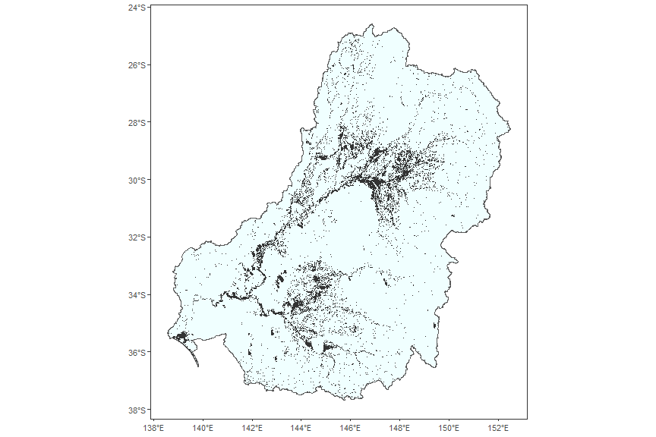
Figure 1: ANAE wetlands across the Murray-Darling Basin

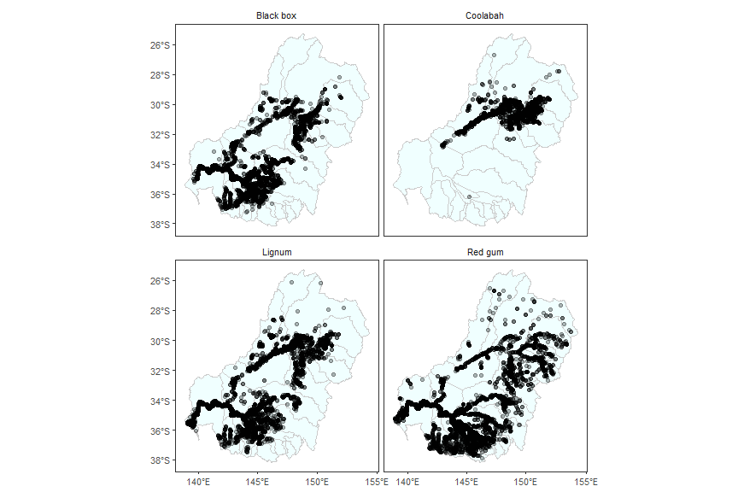
Figure 2: ALA records for each species that intersect with ANAE wetlands. This is the vast majority of ALA records in the Murray-Darling Basin for these species, though there are a small number that fall outside the ANAE polygons.


Figure 3: ALA records for each species that intersect with ANAE wetlands. This is the vast majority of ALA records in the Murray-Darling Basin for these species, though there are a small number that fall outside the ANAE polygons.
The number of ALA records is highly variable across wetland type and varies between species (Table 1, black box Table 2, coolabah Table 3, and lignum Table 4). Strikingly, the Named wetland types are not always the wetland types with the most records, and in some cases are even excluded from the Recorded set because they contain < 0.05% of the total records.
Table 1: Habitat types with red gum records in Atlas of Living Australia, with number of records. ANAE_DESC is the wetland type from the ANAE. Bold rows with green background are the Named records (with the species name in the type). Those in light grey are < 0.5% of the total, and were not included in the set of ANAE wetland types used.
ANAE_DESC | Records
River red gum forest riparian zone or floodplain | 9232
River red gum woodland riparian zone or floodplain | 5063
Black box woodland riparian zone or floodplain | 1694
Temporary river red gum swamp | 1482
Permanent lake | 787
Temporary lowland stream | 754
Temporary swamps | 690
Permanent lowland stream | 553
Lignum shrubland riparian zone or floodplain | 528
Temporary tall emergent marsh | 383
Shrubland riparian zone or floodplain | 344
Coolibah woodland and forest riparian zone or floodplain | 331
Freshwater meadow | 286
Permanent wetland | 285
Temporary lake | 275
Unspecified riparian zone or floodplain | 239
Temporary transitional zone stream | 196
Woodland riparian zone or floodplain | 188
Clay pan | 152
Temporary sedge/grass/forb marsh | 95
Temporary black box swamp | 73
River cooba woodland riparian zone or floodplain | 33
Permanent forb marsh | 32
Temporary woodland swamp | 32
Permanent transitional zone stream | 29
Temporary lignum swamp | 17
Permanent saline wetland | 15
Temporary saline swamp | 14
Temporary shrub swamp | 13
Temporary wetland | 10
Temporary lake with aquatic bed | 10
Sedge/forb/grassland riparian zone or floodplain | 9
Temporary stream | 7
Black box forest riparian zone or floodplain | 6
Temporary saline lake | 6
Temporary low energy upland stream | 5
Permanent tall emergent marsh | 4
Permanent stream | 4
Permanent low energy upland stream | 3
Unspecified river | 2
Salt pan or salt flat | 2
Temporary high energy upland stream | 2
Temporary salt marsh | 2
Temporary coolibah swamp | 2
Permanent high energy upland stream | 2
Temporary saline wetland | 1
Permanent grass marsh | 1
Temporary sedge/grass/forb marsh | 1
Temporary saline lake with aquatic bed | 1

Table 2: Habitat types with black box records in Atlas of Living Australia, with number of records. ANAE_DESC is the wetland type from the ANAE. Bold rows with green background are the Named records (with the species name in the type). Those in light grey are < 0.5% of the total, and were not included in the set of ANAE wetland types used.
ANAE_DESC | Records
Black box woodland riparian zone or floodplain | 7162
River red gum woodland riparian zone or floodplain | 2237
River red gum forest riparian zone or floodplain | 663
Lignum shrubland riparian zone or floodplain | 533
Shrubland riparian zone or floodplain | 491
Coolibah woodland and forest riparian zone or floodplain | 284
Temporary lowland stream | 234
Temporary black box swamp | 167
Temporary swamps | 131
Temporary lake | 106
Freshwater meadow | 92
Temporary tall emergent marsh | 85
Clay pan | 72
Permanent lowland stream | 72
Unspecified riparian zone or floodplain | 58
Woodland riparian zone or floodplain | 51
Permanent lake | 51
Temporary river red gum swamp | 50
Temporary shrub swamp | 36
Temporary woodland swamp | 26
Permanent wetland | 20
Black box forest riparian zone or floodplain | 17
Temporary saline swamp | 16
Temporary saline wetland | 14
Temporary lignum swamp | 13
River cooba woodland riparian zone or floodplain | 11
Temporary sedge/grass/forb marsh | 9
Sedge/forb/grassland riparian zone or floodplain | 9
Temporary lake with aquatic bed | 7
Temporary saline lake | 7
Permanent saline wetland | 4
Permanent saline lake | 4
Temporary transitional zone stream | 2
Temporary coolibah swamp | 2
Temporary wetland | 1
Temporary saline lake with aquatic bed | 1
Permanent low energy upland stream | 1
Permanent stream | 1

Table 3: Habitat types with coolabah records in Atlas of Living Australia, with number of records. ANAE_DESC is the wetland type from the ANAE. Bold rows with green background are the Named records (with the species name in the type). Those in light grey are < 0.5% of the total, and were not included in the set of ANAE wetland types used.
ANAE_DESC | Records
Coolibah woodland and forest riparian zone or floodplain | 2692
Black box woodland riparian zone or floodplain | 296
River red gum forest riparian zone or floodplain | 185
Freshwater meadow | 115
Temporary lowland stream | 106
River cooba woodland riparian zone or floodplain | 60
Lignum shrubland riparian zone or floodplain | 38
Woodland riparian zone or floodplain | 29
Permanent lowland stream | 27
Temporary woodland swamp | 12
Temporary lake | 11
River red gum woodland riparian zone or floodplain | 10
Shrubland riparian zone or floodplain | 9
Permanent lake | 8
Permanent wetland | 8
Temporary sedge/grass/forb marsh | 6
Temporary river red gum swamp | 4
Temporary black box swamp | 3
Temporary stream | 1
Temporary coolibah swamp | 1
Temporary transitional zone stream | 1
Clay pan | 1
Temporary wetland | 1

Table 4: Habitat types with lignum records in Atlas of Living Australia, with number of records. ANAE_DESC is the wetland type from the ANAE. Bold rows with green background are the Named records (with the species name in the type). Those in light grey are < 0.5% of the total, and were not included in the set of ANAE wetland types used.
ANAE_DESC | Records
Black box woodland riparian zone or floodplain | 1777
Coolibah woodland and forest riparian zone or floodplain | 1192
River red gum forest riparian zone or floodplain | 907
Lignum shrubland riparian zone or floodplain | 895
River red gum woodland riparian zone or floodplain | 651
Permanent lake | 360
Temporary lowland stream | 270
Shrubland riparian zone or floodplain | 269
Freshwater meadow | 263
Temporary tall emergent marsh | 195
River cooba woodland riparian zone or floodplain | 140
Temporary sedge/grass/forb marsh | 137
Temporary black box swamp | 128
Temporary lake | 121
Clay pan | 115
Permanent lowland stream | 109
Temporary swamps | 93
Temporary river red gum swamp | 87
Permanent wetland | 83
Unspecified riparian zone or floodplain | 80
Temporary lignum swamp | 61
Temporary shrub swamp | 58
Woodland riparian zone or floodplain | 45
Temporary woodland swamp | 32
Temporary saline swamp | 23
Black box forest riparian zone or floodplain | 20
Permanent grass marsh | 17
Sedge/forb/grassland riparian zone or floodplain | 12
Temporary saline wetland | 10
Temporary lake with aquatic bed | 8
Tide dominated saltmarsh | 6
Temporary sedge/grass/forb marsh | 6
Temporary wetland | 5
Tide dominated forest | 4
Permanent saline wetland | 3
Temporary coolibah swamp | 3
Tide dominated estuary | 3
Permanent stream | 3
Temporary stream | 3
Temporary transitional zone stream | 2
Temporary saline lake with aquatic bed | 2
Permanent forb marsh | 2
Coastal lagoon | 2
Temporary salt marsh | 1
Tide dominated mudflats and sandbar | 1
Temporary saline lake | 1
Permanent saline lake | 1
The area of wetlands in each wetland type group is highly variable across the basin, with some species not having any named wetland types in entire catchments, or even nearly the entire southern basin in the case of Coolabah Figure 4. There are also Recorded habitat types in areas where there are no ALA records ( Figure 2).
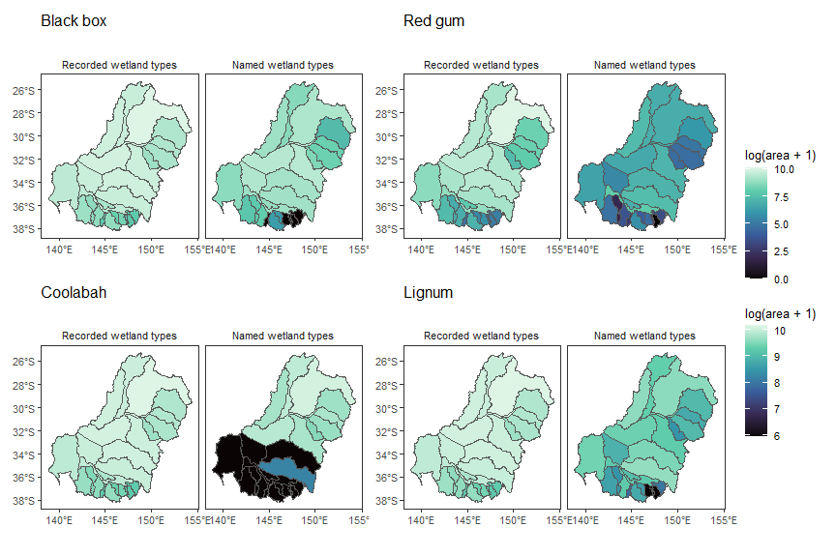
Figure 4: Area of wetlands associated with each species in 25 major catchments across the basin, either by Name or where that species has been Recorded in the ALA. This is simply the area of wetlands, and does not include any inundation information, but instead forms the baseline maximum amount of area that could be achieved within either wetland-type grouping.

Appendix: Other species
The main text presents red gum as an example species, here we show the same figures for the other species, noting important deviations from red gum.
When summed over the basin and averaged over time, (Figure 5, Figure 6, Figure 7).
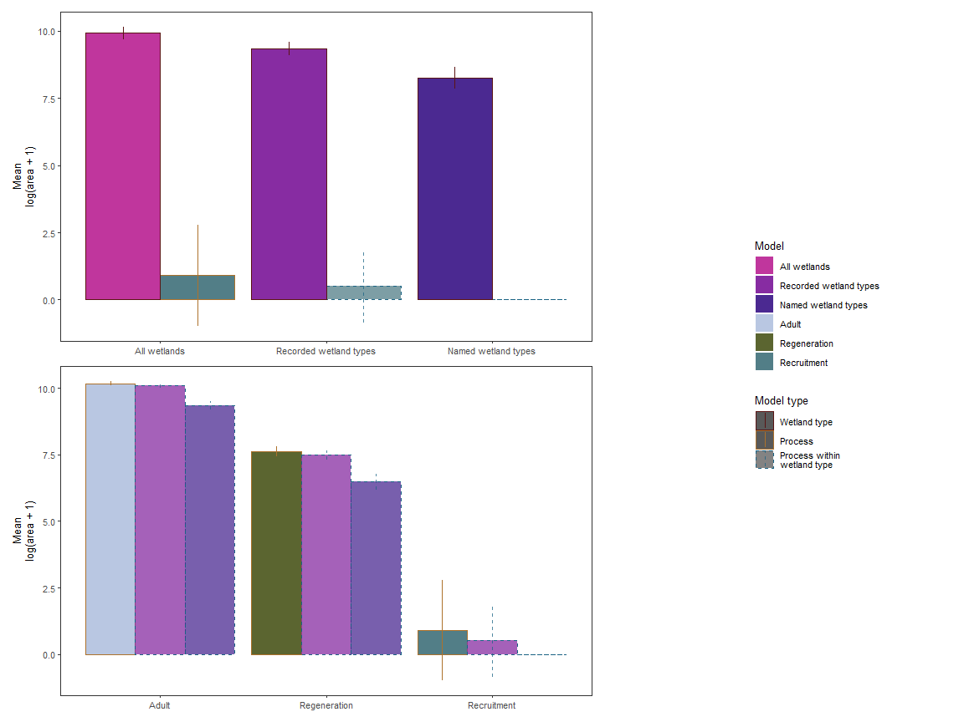
Figure 5: Favourable area for black box as assessed by wetland type, process-based, and interactive models, as is done for red gum in the main text.

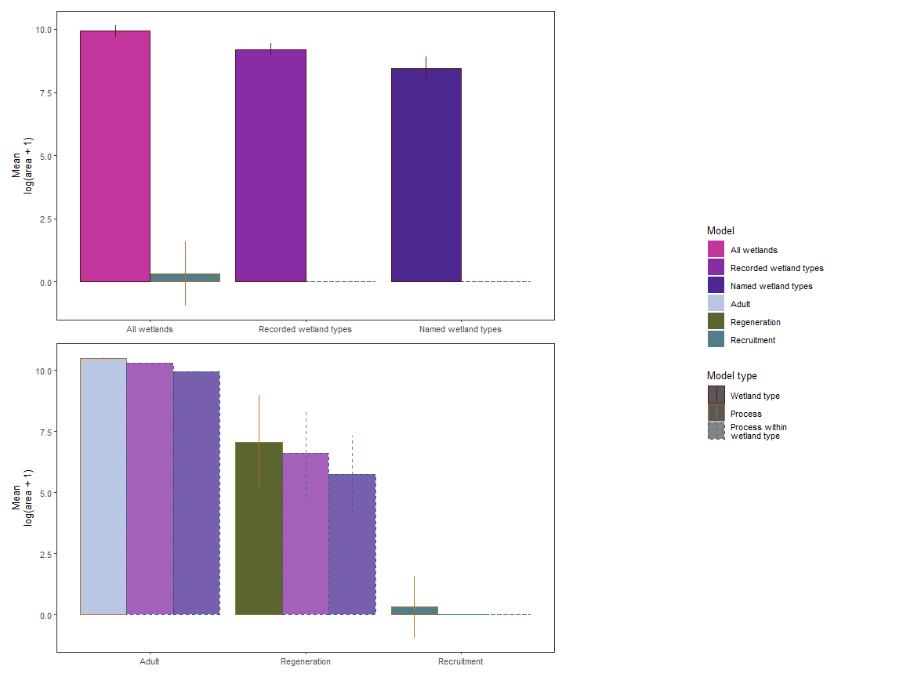
Figure 6: Favourable area for coolabah as assessed by wetland type, process-based, and interactive models, as is done for red gum in the main text.

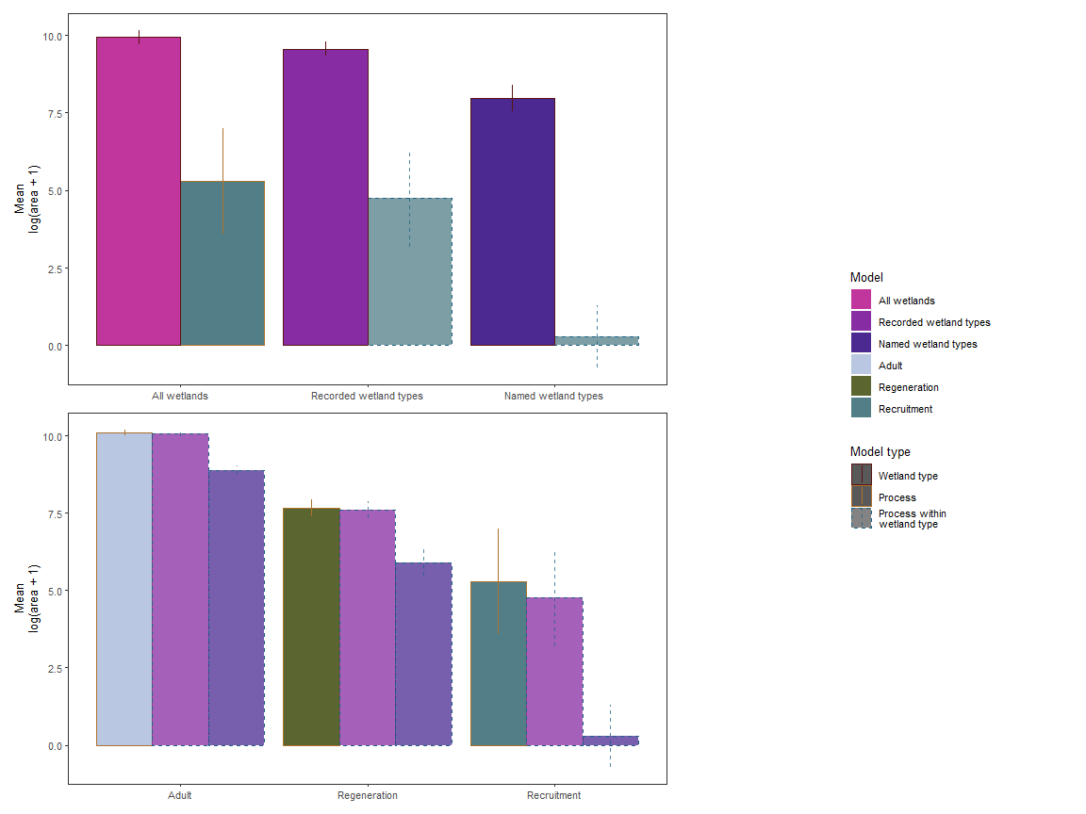
Figure 7: Favourable area for lignum as assessed by wetland type, process-based, and interactive models, as is done for red gum in the main text.
Timeseries of the favourable area at the basin-scale, (Figure 8, Figure 9, Figure 10).
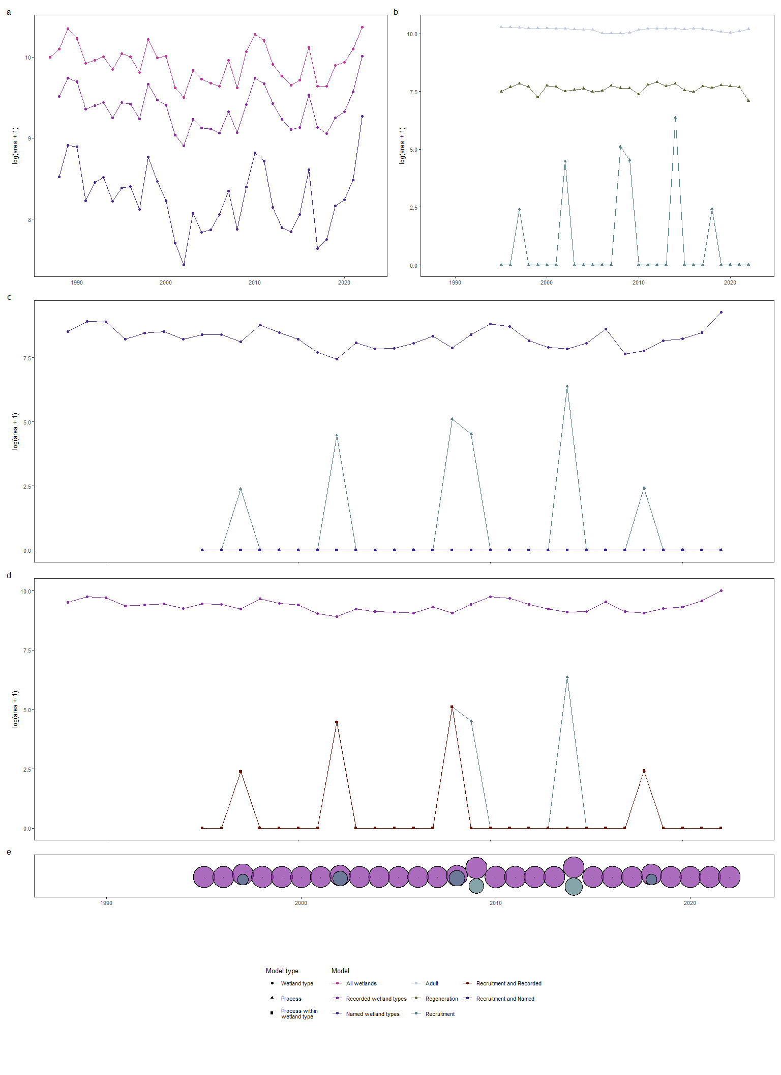
Figure 8: Favourable area for black box as assessed by wetland type, process-based, and interactive models, as is done for red gum in the main text.

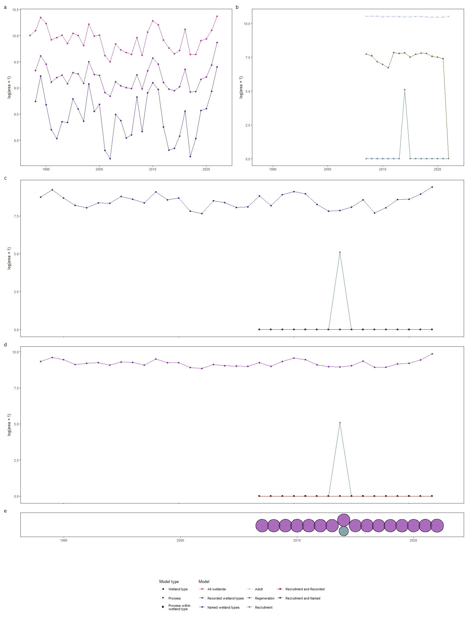
Figure 9: Favourable area for coolabah as assessed by wetland type, process-based, and interactive models, as is done for red gum in the main text.

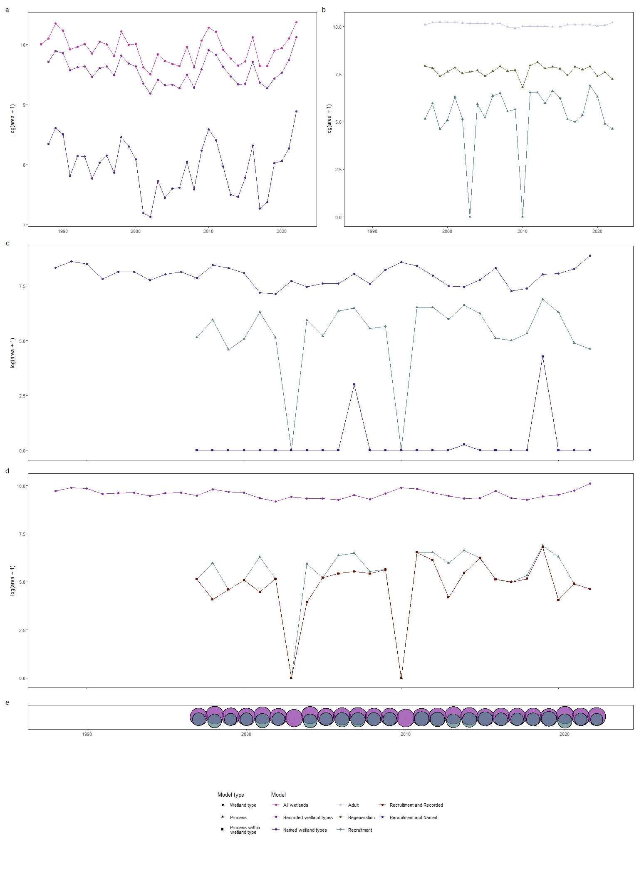
Figure 10: Favourable area for lignum as assessed by wetland type, process-based, and interactive models, as is done for red gum in the main text.
Spatial variation across catchments, (Figure 11, Figure 12, Figure 13).
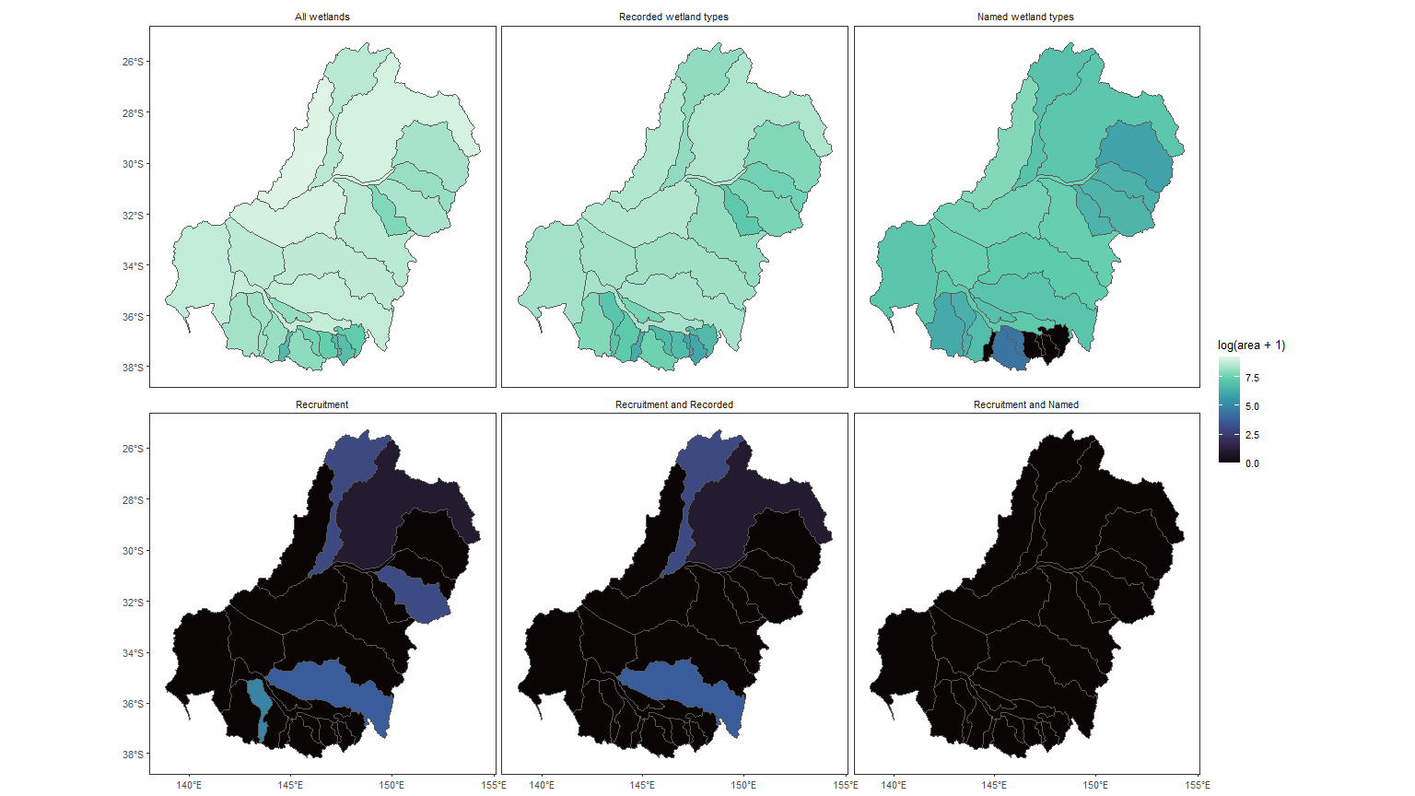
Figure 11: Favourable area for black box as assessed by wetland type, process-based, and interactive models, as is done for red gum in the main text.

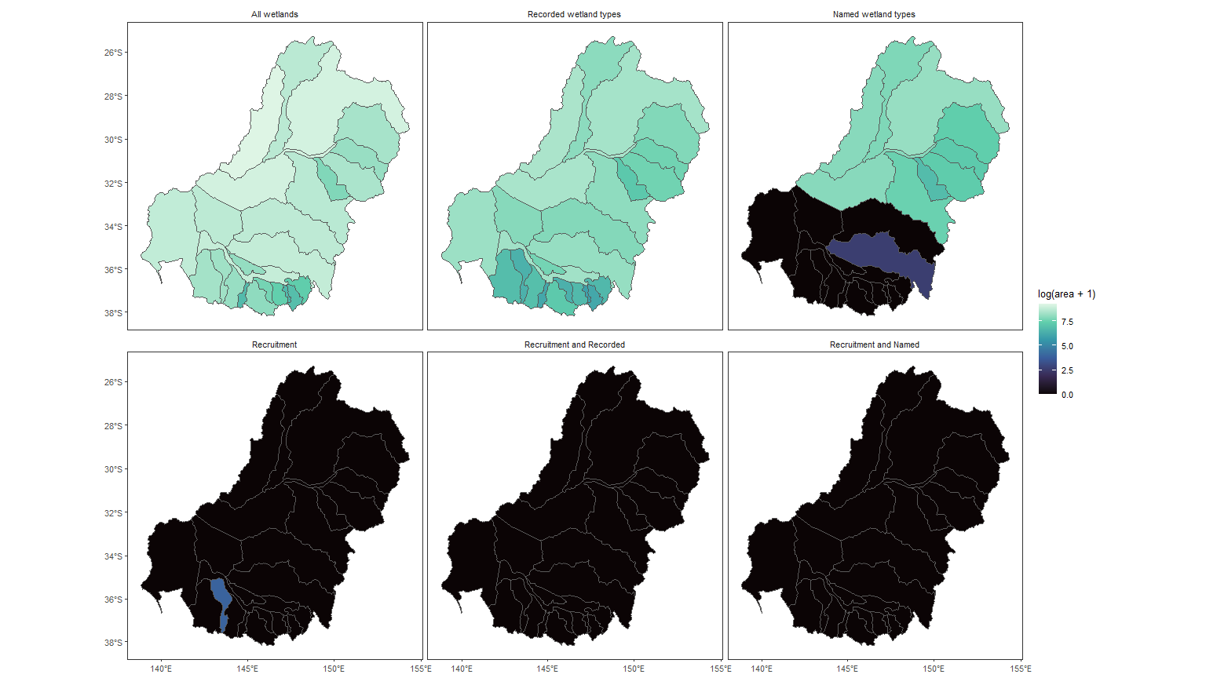
Figure 12: Favourable area for coolabah as assessed by wetland type, process-based, and interactive models, as is done for red gum in the main text.

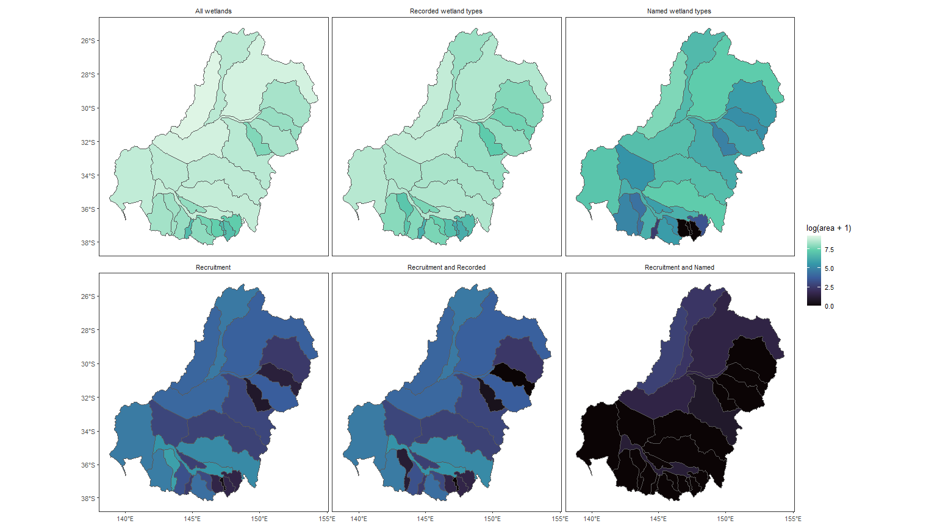
Figure 13: Favourable area for lignum as assessed by wetland type, process-based, and interactive models, as is done for red gum in the main text.

Appendix: Life cycles/identifying limitations
Most would work in a Life cycle-pinch point paper
This creates the individual plots and develops the story. Then some get glued together for the main results.

Basin-scale over time

Habitat alone
Over the whole basin, mean yearly inundation levels of all wetlands are approximately 10¹⁰ m². Unsurprisingly, there is more inundation in the sets of Recorded wetland types than the Named wetland types, though the relative amounts varies between species Figure 14 .
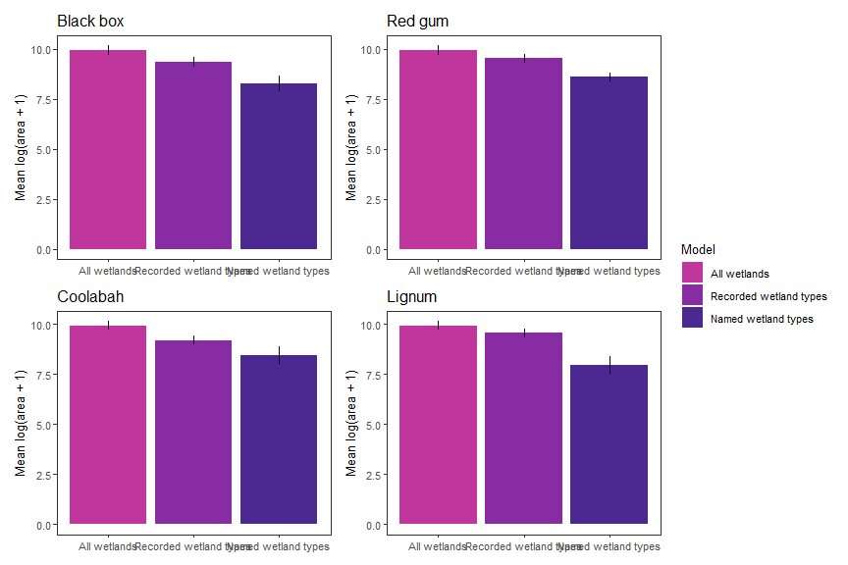
Figure 14: Area of inundation in wetlands associated with each species in the basin, either by Name or where that species has been Recorded in the ALA, averaged over time. Error bars are standard deviation over time, giving a description of the variability, rather than CI.

Process alone
Each species shows the largest area of success in the adult life stage, followed by germination and seedlings Figure 15. To understand the importance of each life stage alone as well as the life cycle itself, we examine each stage alone and sequentialy. When considered indepedently (Adult, Germination, Seedling), every species has high adult favourability and low areas of seedling favourability. Note that the decline in favourability for these three stages is not due to the life cycle, because they are considered independently. The consequences of the life cycle are seen in the Regeneration and Recruitment stages, which require favourable conditions in preceding stages. By comparing these stages to their respective independent stage, we can see that requiring adult favourability decreases the area of germination favourability only slightly, while requiring germination success reduces the already-low seedling favourability by multiple orders of magnitude to the overall Recruitment favourability value Figure 15. For a pinch points paper, we could work this one up, and do two dimensions- through the life cycle, but also across the independent-sequential to get the specific impact of the life cycle itself.
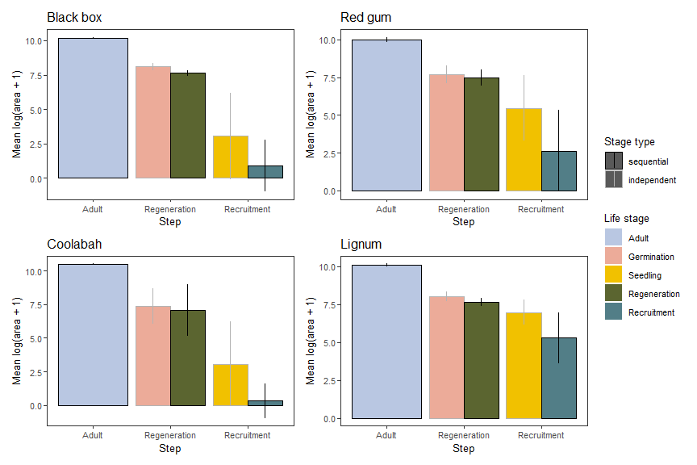
Figure 15: Area of favourability after each stage in the life cycle. We present these for the stages independently and sequentially, with the difference between the two (e.g. between Germinaton and Regeneration) being the consequence of requiring success in preceding stages. Error bars are standard deviation over time, giving a description of the variability, rather than CI.

Interactive
The simplest way to consider the interactive models is to think of them sequentially; i.e. if we have a series of life cycle stages, then we can ask about a habitat requirement as the next step in the life cycle Figure 16 . This paralells the treatment in (Holt et al. in review) and represents a process-centric approach that limits the processes to a habitat covariate at the final step. Note here that the two wetland restrictions are not nested, and so each follows from the Recruitment life stage. For a paper on how life cycles and habitats determine pinch points, this one would be really good, and we could easily work it up into a relativized version too.
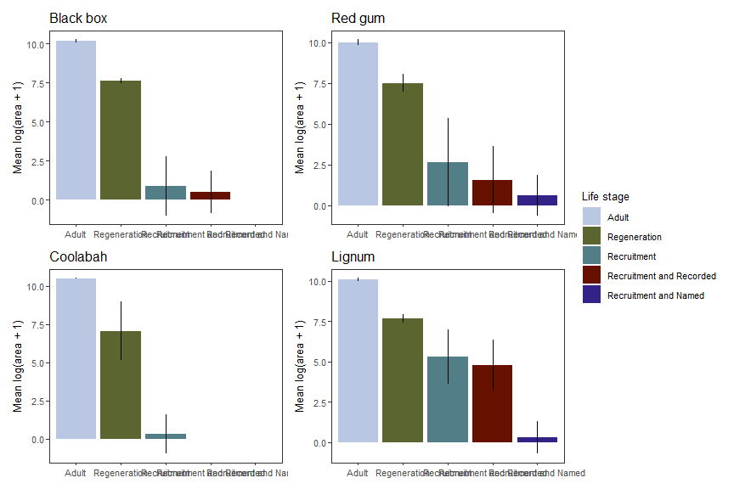
Figure 16: Area of favourability after each stage in the life cycle, followed by wetland type restrictions. Error bars are standard deviation over time, giving a description of the variability, rather than CI.
To examine the impact of wetland type requirements on each life stage, rather than only as a final step, we compare the favourable area for each life stage (as in Figure 15) alone and restricted by wetland requirements. This identifies the life stages that are most sensitive to wetland requirements (and so are the stages with the most favourable area outside designated wetland types) Figure 17. A subset of this plot with only the sequential life stages, and recolored to accentuate the wetland types, is used in the main bar plot in the text.
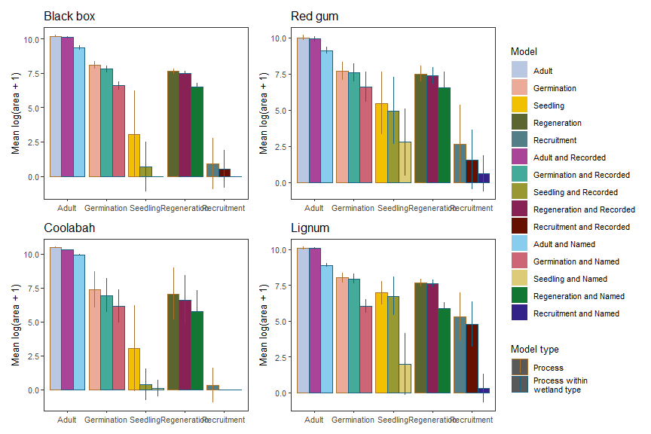
Figure 17: Area of favourability of each stage in the life cycle, both independent and sequential, and the reduction in each stage from wetland requirements. Error bars are standard deviation over time, giving a description of the variability, rather than CI.
A similar approach for the wetland type restrictions identifies how requiring processes to occur within them reduces the area of favourability. A subset of this plot, recolored to accentuate the model type, is used in the main bar plot in the text.
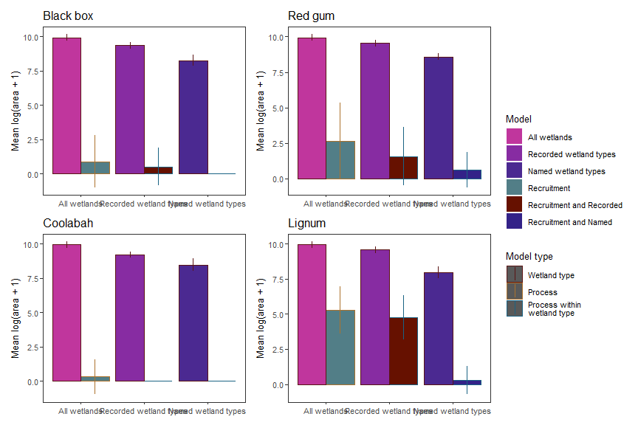
Figure 18: Area of favourability of each wetland type group and the reduction in favourable area when successful recruitment is required within that group. Error bars are standard deviation over time, giving a description of the variability, rather than CI.

Basin-scale timeseries

Habitat alone
A habitat-only model suggests that area is favourable if it is inundated in either Recorded wetland types or Named wetland types. Both are a subset of the total wetland inundation in the MDB, with Recorded types being a larger set and so having a larger amount of inundation Figure 19 .
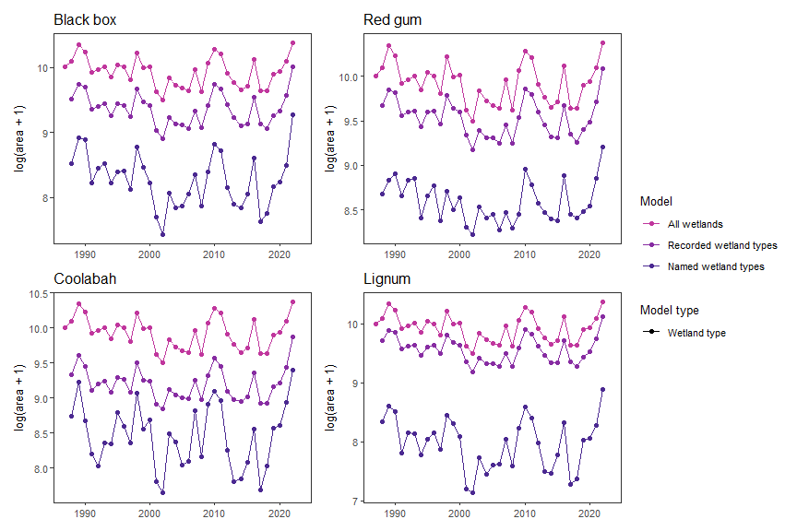
Figure 19: Area of inundation in wetlands associated with each species in the basin, either by Name or where that species has been Recorded in the ALA.

Process alone
In a process-based model, the amount of favourable area for each life stage depends on the specific environmental requirements for that stage. Moreover, these stages are sequential, and so even if all requirements for seedling survival are met in a year, there may not be successful recruitment if there was not germination approximately six months prior to the favourable seedling conditions. In Figure 20, we plot both the independent life stages (Adults, plus Germination and Seedling) as well as the sequential stages (Adult-Regeneration-Recruitment). From these plots, we can clearly see that seedling survival is the most limiting life stage for all species. Further, life-history dependence provides limitation beyond the individual stages. The Regeneration line (Adult + Germination) is almost always lower than the independent Germination line, indicating that there are locations favourable to germination but lacking favourable adult conditions to provide seed. Similarly, even though seeling survival is quite low in general, Recruitment is even lower; there are many times when seedlings could survive, but there were not preceding conditions favourable for Regeneration.
The species are quite different in these relationships. Lignum and Red gum are much less limited by seedling survival than Black box or Coolabah, as a consequence of shorter requirements for soil moisture maintenance Figure 20 . Unlike the other species, Coolabah does not show additional limitation of Regeneration beyond Germination, and so all favourable germination conditions occur in areas that are favourable for adults.
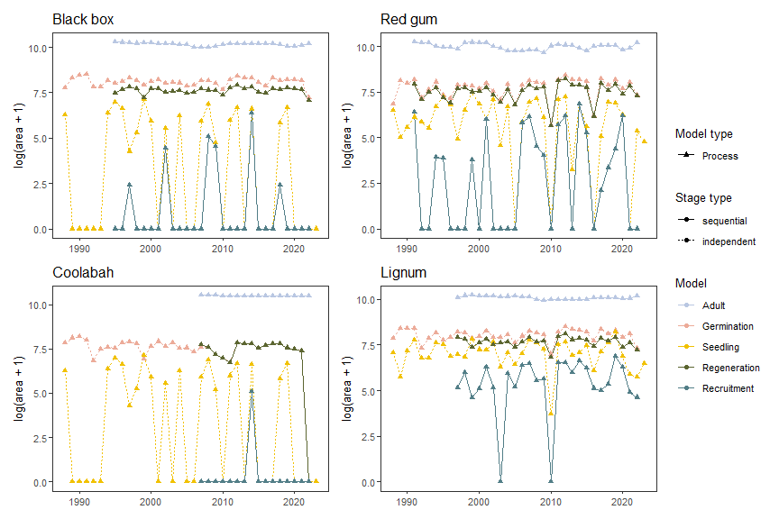
Figure 20: Area favourable for each life stage in a process model, both independently (dashed) and sequentially (solid). Note that Coolabah and Lignum have long lookbacks for adult condition, and so cannot assess adult favourability for a large proprotion of the timeseries.
If we want to go for the life-history pinch-points analyses: Here, we could do a relativization in two dimensions- How does each stage in the sequential reduce things relative to the preceding stage, and how does the joint compare to the individual (e.g. Regeneration vs Germination). The first would give proprotional loss at each step, and the second would say how much the sequencing itself is introducing limitation. The wetland-type filters off the end of this are possible, as shown in the next two figures Figure 21 and Figure 22. Those proportional drops could also be included.

Interactive habitat and process
To look at the interaction between wetland type models and process-based models, we can examine how the joint area differs from the area of their independent outcomes. This is dealt with in detail in the main text.
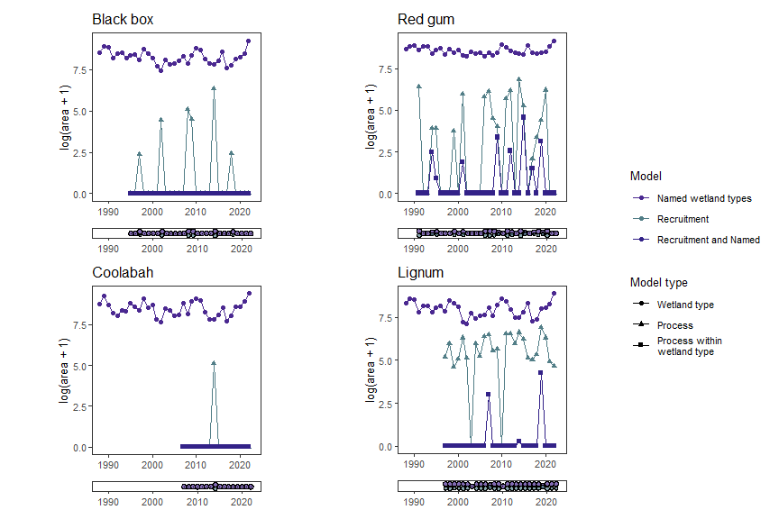
Figure 21: Area favourable for the wetland-type-based model using Named habitat alone, the process model alone (at the final recruitment stage) and jointly. Venn diagrams below each figure show the relationship of overlapping habitat area between the two models, with the area in the overlap being the area in the interactive model.

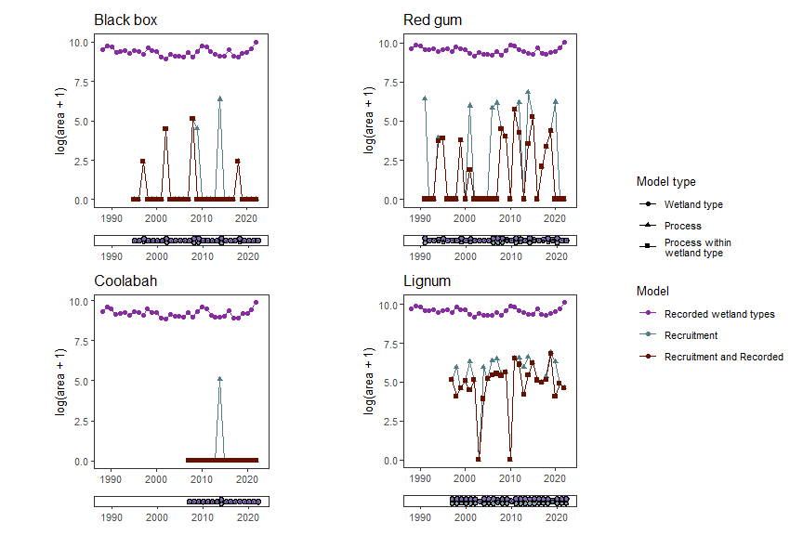
Figure 22: Area favourable for the wetland-type-based model using Recorded habitat alone, the process model alone (at the final recruitment stage) and jointly. Venn diagrams below each figure show the relationship of overlapping habitat area between the two models, with the area in the overlap being the area in the interactive model.

Spatial variation across catchments
In addition to temporal variation, there is striking spatial variation in favourability for these species across the basin, and the different life stages and wetland type requirements are differently limiting across the basin. To examine this spatial variation, we calculate the favourable area within each of 25 large subcatchments in the basin.

Habitat alone
Within the available wetlands of the respective types (total areas shown in Figure 4 , we ask how much area is inundated Figure 23.
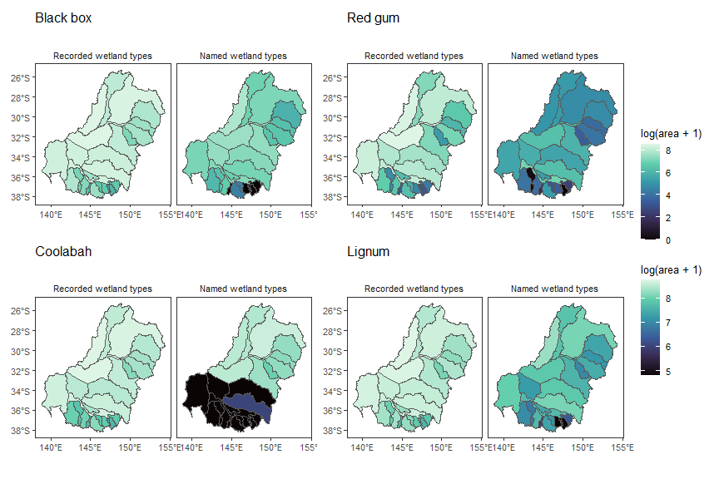
Figure 23: Area of inundation in wetlands associated with each species in 25 major catchments across the basin, either by Name or where that species has been Recorded in the ALA.

Process alone
Both independent (top) and sequential. Going to need to panel this one up differently across species.
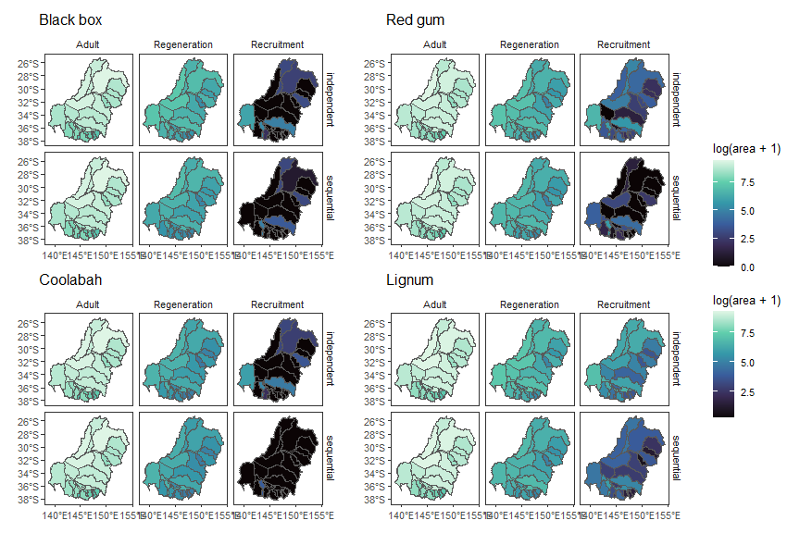
Figure 24: Area of favourability after each stage in the life cycle in 25 major catchments across the basin. We present these for the stages independently (top) and sequentially, as we did in Figure 15. Thus, the top panels are the ‘Adult’ ‘Germination’, and ‘Seedling’ stages as used elsewhere. The difference between the top and bottom (e.g. between Germinaton and Regeneration) being the consequence of requiring success in preceding stages.

Interactive
To examine how a habitat filter further limits the favourable area after all biological processes have occurred, we show those filters as a final step in the sequence Figure 25. This is an ideal point for a sequence of relativised figures too.
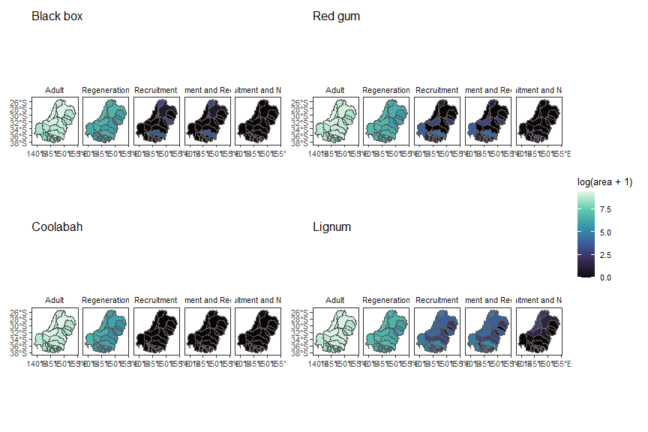
Figure 25: Area of favourability after each stage in the life cycle in 25 major catchments across the basin, followed by a final step of filtering by wetland type. The final two panels are the different specifications of wetland type, and so both are limits beyond the ‘Recruitment’ stage. clearly need to play with fig dims here.
Similarly, we can examine how the area of favourability changes within each wetland type as we move from the total area of those wetland types (top) to requiring inundation (middle) to requiring successful recruitment to occur within them Figure 26. The middle panels here are the ‘Recorded wetland types’ and ‘Named wetland types’ in the text, where we always assume inundation is required. The combination of Figure 25 and Figure 26, without the preceding life stages or the total wetland areas, forms the map figure in the text.
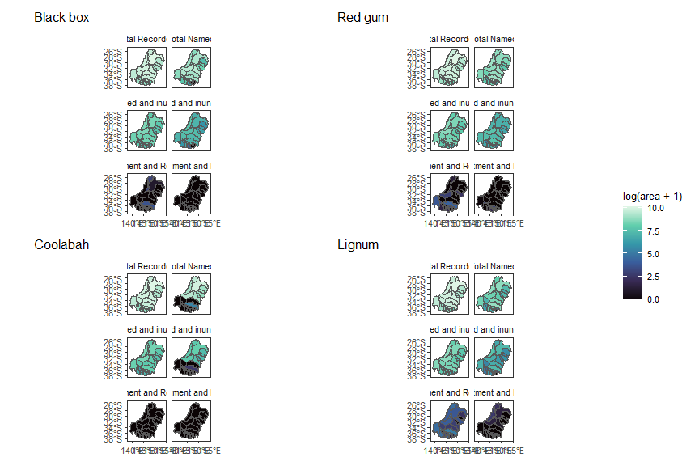
Figure 26: Area of favourability in each of 25 major catchments due to inundation of wetland types (top) and when recruitment conditions are also favourable within those types (bottom). clearly need to play with fig dims here.

Still to do for in-depth and pinch points

Relativised change (especially if we go for pinch points)

spatio-temporal (catchment-paneled timeseries)

Selected catchment-scale bars

