How about a title?

Contents
Heading 1 1
Heading 2 1
Heading 3 1
Other bits 1
Figures 1
Tables 1

Heading 1
Text

Heading 2
Text

Heading 3
Text
More text

Other bits

Figures
Let’s also include crossrefs to Figure 1? Are they needed?
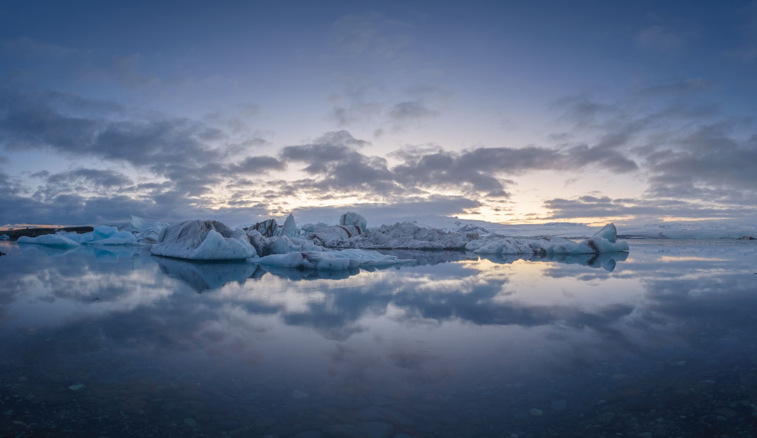
Figure 1. This is a figure

Tables
Not sure this is needed either? Does its format control kable styles?
Table Error! Use the Home tab to apply 0 to the text that you want to appear here..1. This is a table
Header | Row | Stuff | Here
Data | 1 | 3 | H
Data | J | 8 | P

Then some more text.

