How about a title?

Contents

Heading 1 1

Heading 2 1

Heading 3 1

Other bits 1

Figures 1

Tables 1

# Heading 1

Text

## Heading 2

Text

### Heading 3

Text

More text

# Other bits

## Figures

Let’s also include crossrefs to Figure 1? Are they needed?

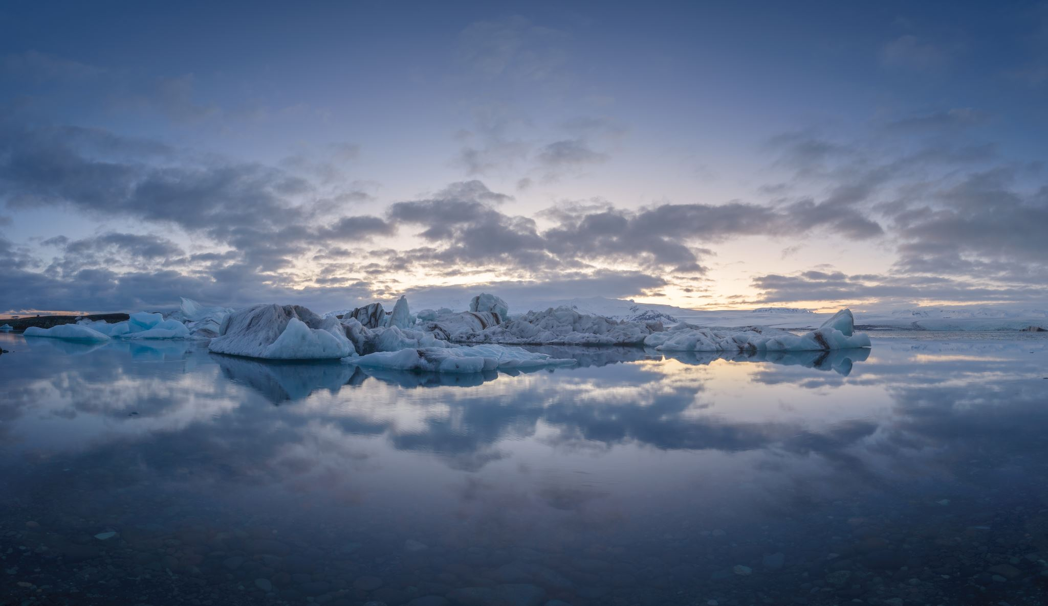

Figure . This is a figure

## Tables

Not sure this is needed either? Does its format control kable styles?

Table Error! Use the Home tab to apply 0 to the text that you want to appear here... This is a table

|  |  |  |  |
| --- | --- | --- | --- |
| **Header** | **Row** | **Stuff** | **Here** |
| Data | 1 | 3 | H |
| Data | J | 8 | P |

Then some more text.