Comparer

Data

Palettes
will need to change some palettes
shapes: triangles = stochastic; circles = historic data
violins: always stochastic data
Shading (alpha): used for climate, licvolfactor, and marks - lighter = less water (i think climate is currently the wrong way around)
Colour: is always the response variable (e.g. and individual EWR or target or economic benefit).

MAP
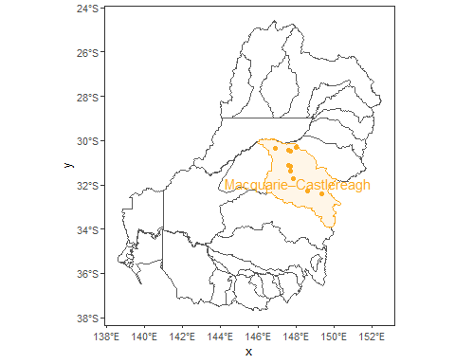

1) Vulnerability plot
quadrant lines = the means for stochastic sequences under the historic climate.

1A) Vulnerability - no climate change
(top left)
no fill

1B) Vulnerability - no climate change - with ewater adaptation (HEW licvol)
(top right)
fill: light = licvol factor 0.5; dark = licvol factor 1.5; linked in order by the lines
There are no economic data for licvol (other than historic/no change licvol)

1C) Vulnerability - no climate change - with ewater management (marks)
(bottom left)
fill: light = Mk4; dark = Mk5; linked in order by the lines (Mk4, Mk4a, Mk5a, MK5)
Marks are irrelevant for Economic results

1D) Vulnerability - With climate change (no adaptation or management)
(bottom right)
fill: light = “Just wet”; dark = “hot and dry”; linked in order by the lines (“Just Wet”, “Hot and Wet”,“Historical climate”,“Just Hot”,“Just Dry”,“Hot and Dry”)
NEED to reverse order of the factor, but only for these figs. not sure how right now.

Figure 1 - Vulnerability - Stochastic data
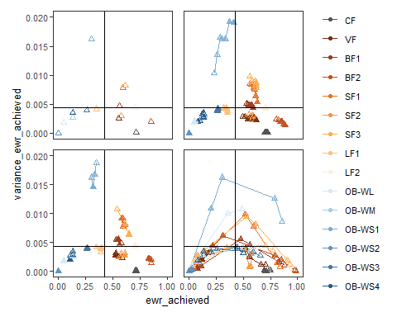
[1] "Fig 1. Vulnerabiliy in EWRs - Stochastic"
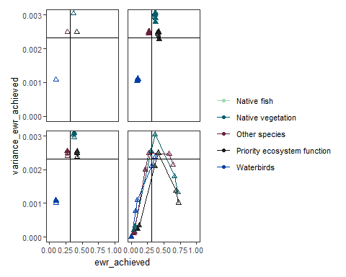
[1] "Fig 1. Vulnerabiliy in target groups - Stochastic"
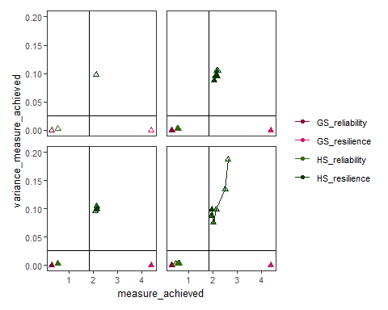
[1] "Fig 1. Vulnerabiliy in water allocation - Stochastic"
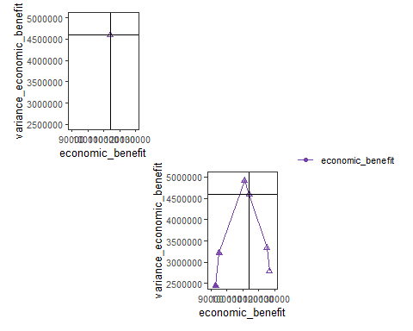
[1] "Fig 1. Vulnerabiliy in economic benefits - Stochastic"

Figure 1 - Vulnerability - Historic data
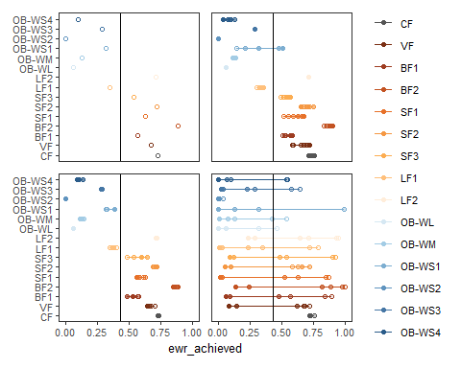
[1] "Fig 1. Vulnerabiliy in EWRs - Historic"
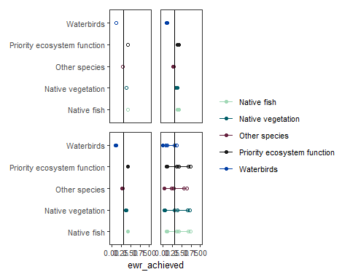
[1] "Fig 1. Vulnerabiliy in target groups - Historic"
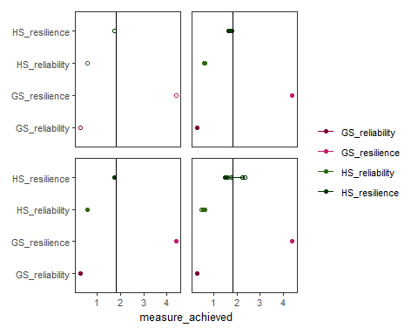
[1] "Fig 1. Vulnerabiliy in water allocation - Historic"
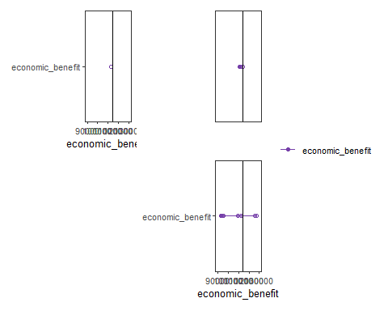
[1] "Fig 1. Vulnerabiliy in economic benefits - Historic"

2) Temporal variability
stochastic error band with historic data - no climate change We dont have time series for Water allocation data (or at least Deakin don’t)
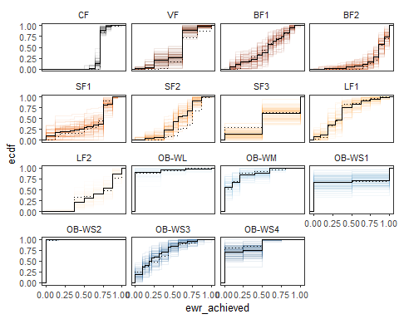
[1] "Fig 2. Temporal variability in EWRs"
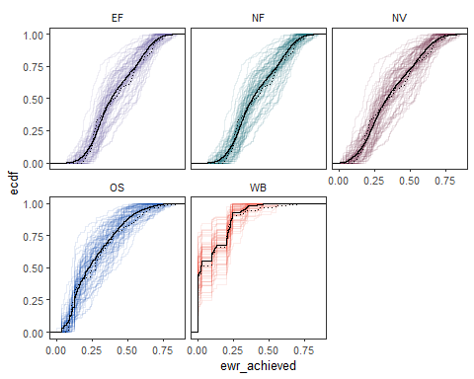
[1] "Fig 2. Temporal variability in target groups"
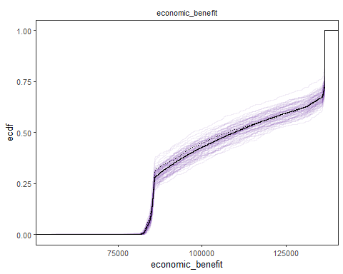
[1] "Fig 2. Temporal variability in economic benefits"

NULL DATA
Null models = all non-events evenly dispersed in the time series or all at one end

3) Spells plots - no climate change
i dont think we can calculate interevent periods for economic or water allocation data
not sure what is going on with the CFs
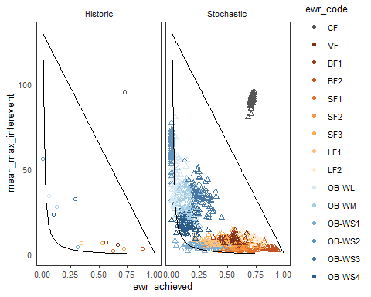
[1] "Fig 3. Spells plot for EWRs"
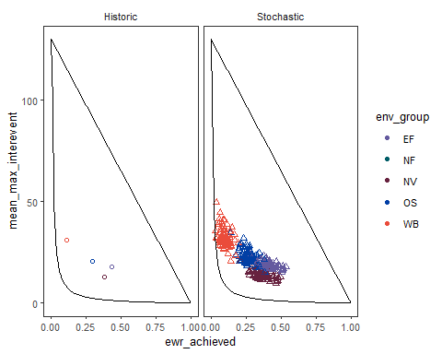
[1] "Fig 3. Spells plot for target groups"

Figs 4 - 7
Violins = stochastic variability
Circle points = historic data (with ewater adaptation and management for figs 6 and 7)
Normal and relative versions
have left triangle points on for only climate variability

4) Climate variability
historic CFs are now in the cloud of stochastic points; but small fresh 2 is at the very top.
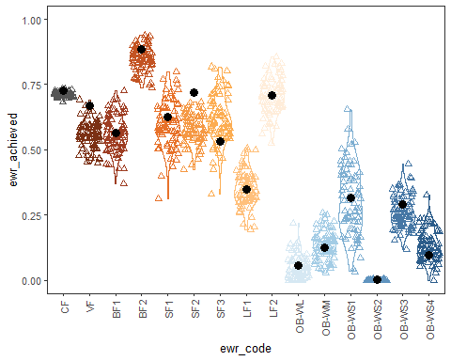
[1] "Fig 4. Climate variability on EWRs"
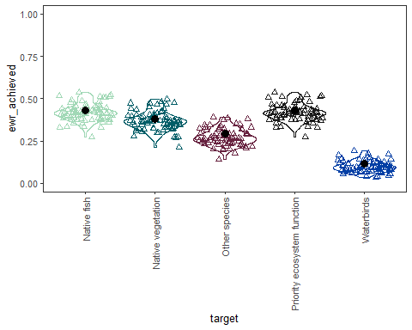
[1] "Fig 4. Climate variability on target groups"
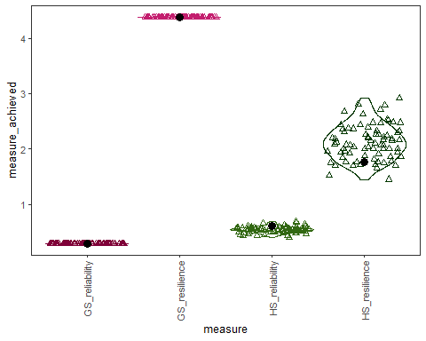
[1] "Fig 4. Climate variability on water allocation"
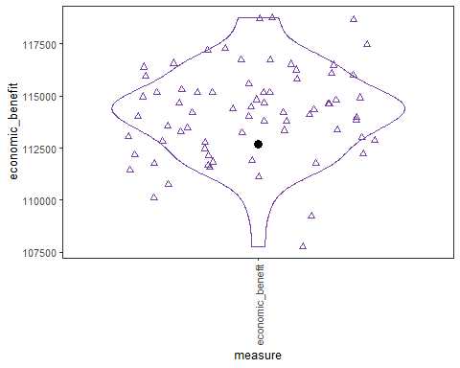
[1] "Fig 4. Climate variability on economic benefits"
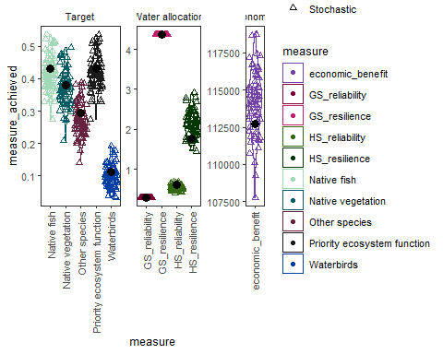
[1] "Fig 4. Climate variability on target groups, water allocation and economic benefits"

4) RELATIVE Climate variability
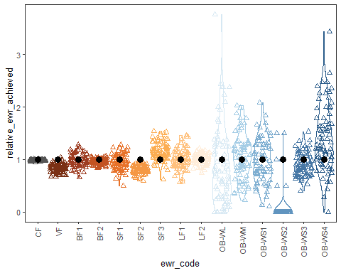
[1] "Fig 4. Climate variability on EWRs relative to historical climate"
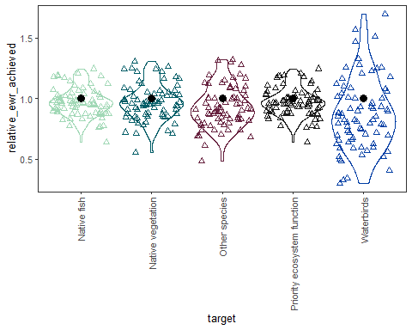
[1] "Fig 4. Climate variability on target groups relative to historical climate"
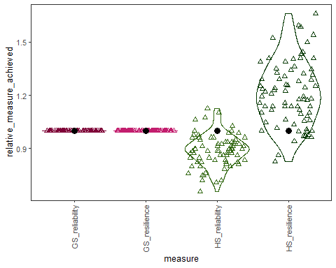
[1] "Fig 4. Climate variability on water allocation relative to historical climate"
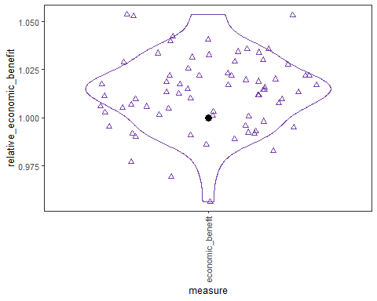
[1] "Fig 4. Climate variability on economic benefits relative to historical climate"
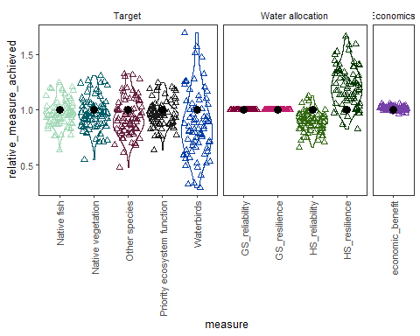
[1] "Fig 4. Climate variability on target groups, water allocation and economic benefits relative to historical climate"

5) Climate change
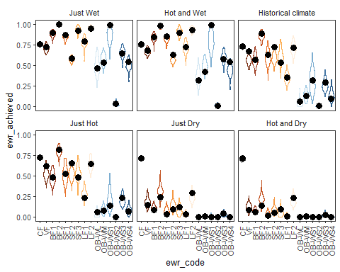
[1] "Fig 5. Climate change on EWRs"
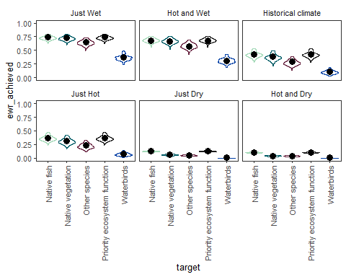
[1] "Fig 5. Climate change on target groups"
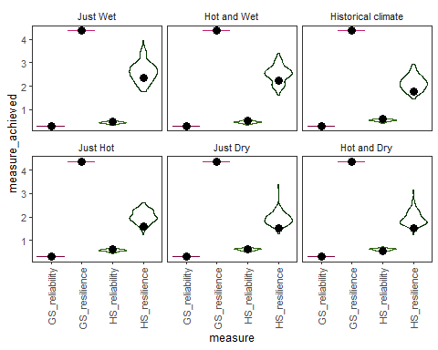
[1] "Fig 5. Climate change on water allocation"
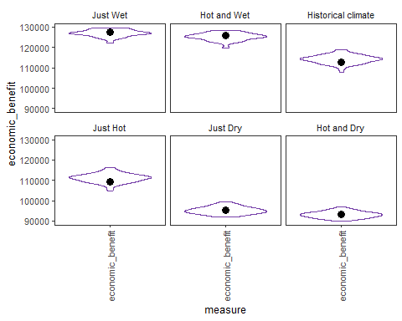
[1] "Fig 5. Climate change on economic benefits"

5) RELATIVE Climate change
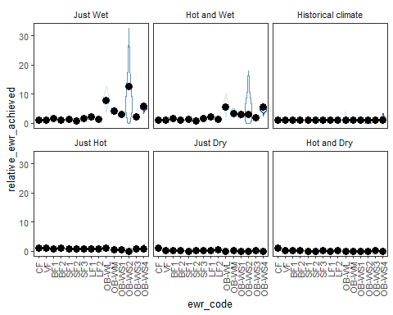
[1] "Fig 5. Climate change on EWRs relative to historical climate"
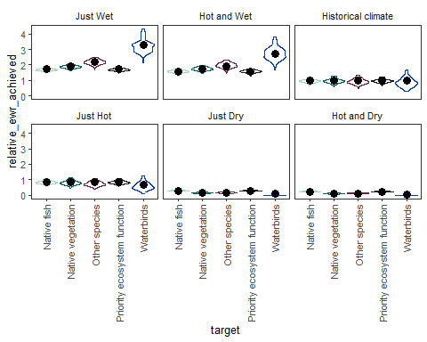
[1] "Fig 5. Climate change on target groups relative to historical climate"
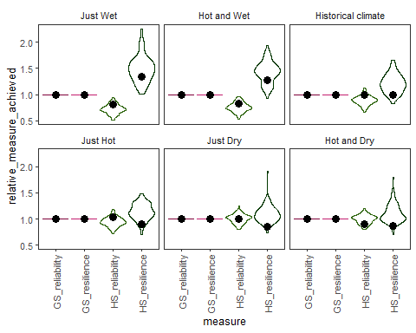
[1] "Fig 5. Climate change on water allocation relative to historical climate"
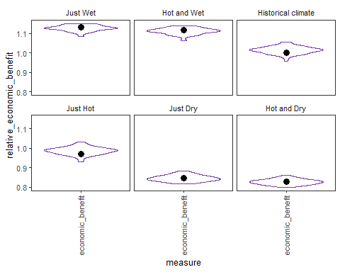
[1] "Fig 5. Climate change on economic benefits relative to historical climate"

6) ewater adaptation (licvol)
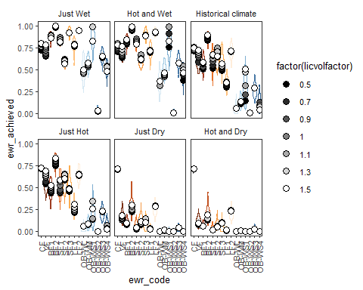
[1] "Fig 6. Climate change and ewater adaptation on EWRs"
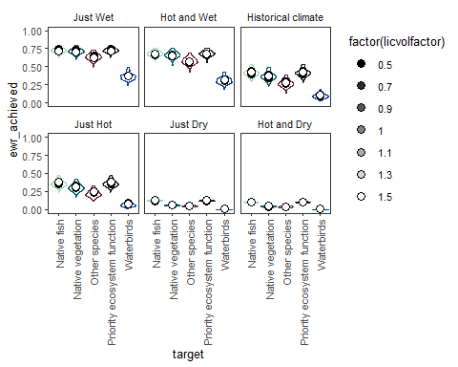
[1] "Fig 6. Climate change and ewater adaptation on target groups"
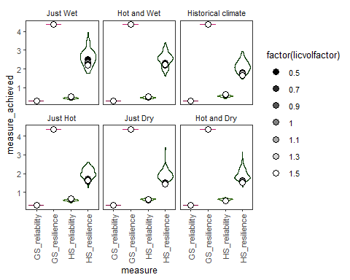
[1] "Fig 6. Climate change and ewater adaptation on water allocation"
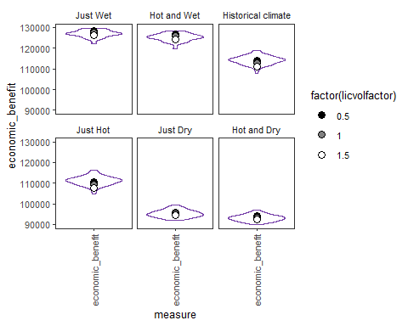
[1] "Fig 6. Climate change and ewater adaptation on economic benefits"

6) RELATIVE ewater adaptation
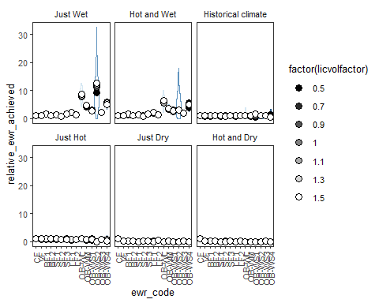
[1] "Fig 6. Climate change and ewater adaptation on EWRs relative to historical climate"
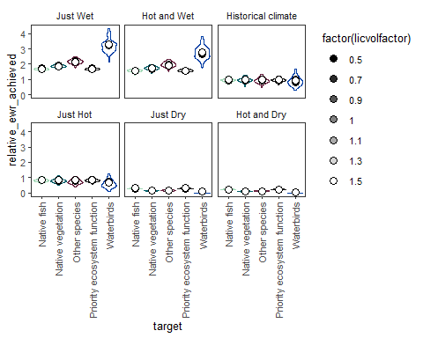
[1] "Fig 6. Climate change and ewater adaptation on target groups relative to historical climate"
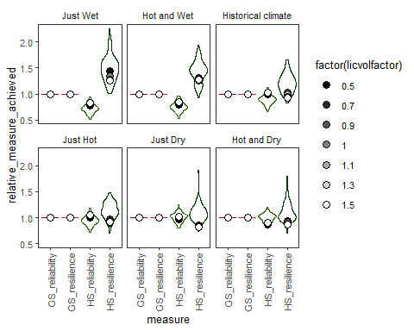
[1] "Fig 6. Climate change and ewater adaptation on water allocation relative to historical climate"
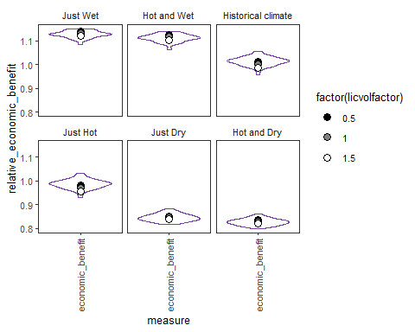
[1] "Fig 6. Climate change and ewater adaptation on economic benefits relative to historical climate"

7) eWater management (Mks)
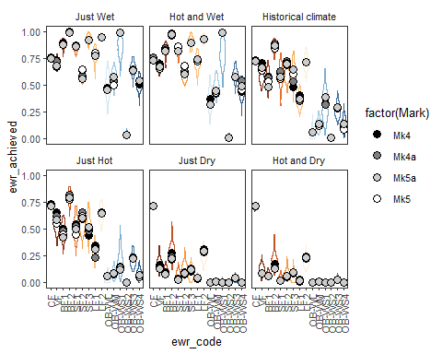
[1] "Fig 7. Climate change and ewater management on EWRs"
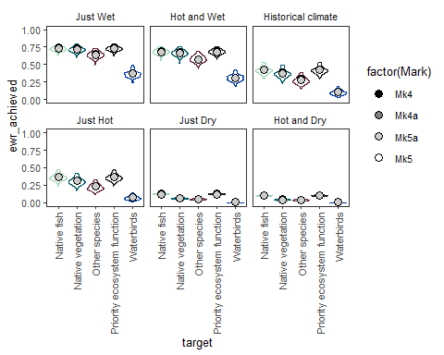
[1] "Fig 7. Climate change and ewater management on target groups"
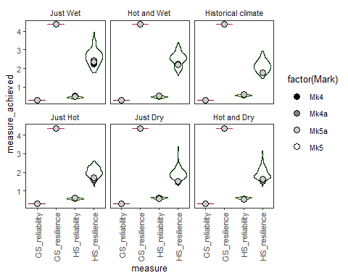
[1] "Fig 7. Climate change and ewater management on water allocation"

7) RELATIVE eWater management
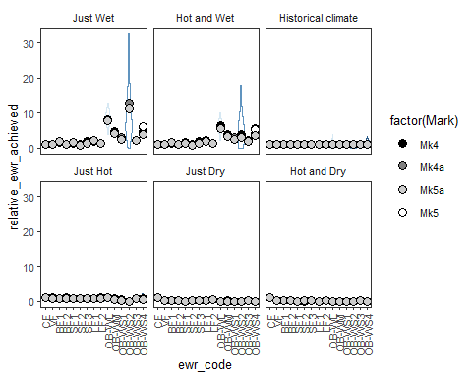
[1] "Fig 7. Climate change and ewater management on EWRs relative to historical climate"
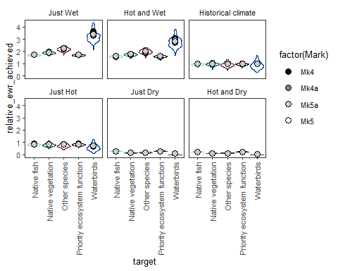
[1] "Fig 7. Climate change and ewater management on target groups relative to historical climate"
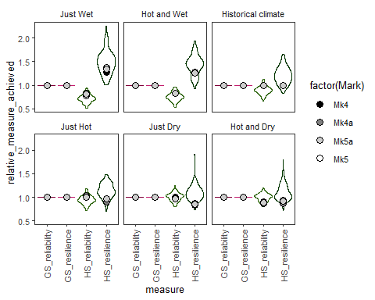
[1] "Fig 7. Climate change and ewater management on water allocation relative to historical climate"

Paneled figures

Figure 4 - Climate variability
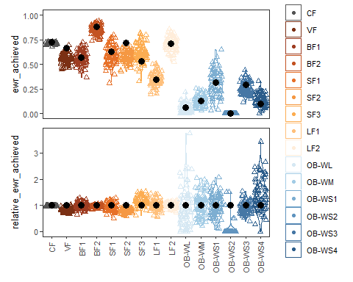
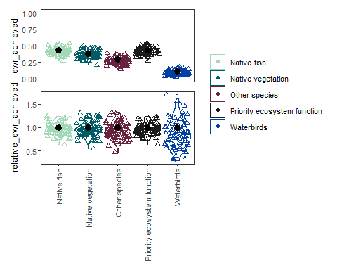
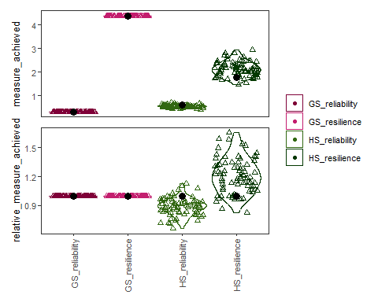
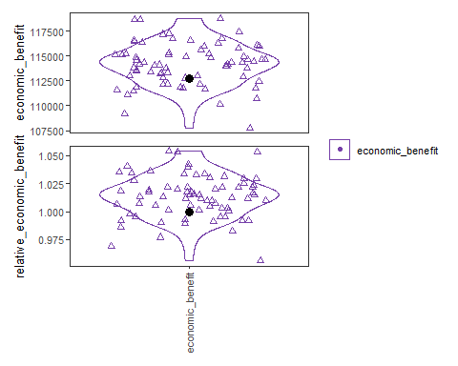
##Figure 5 - Climates
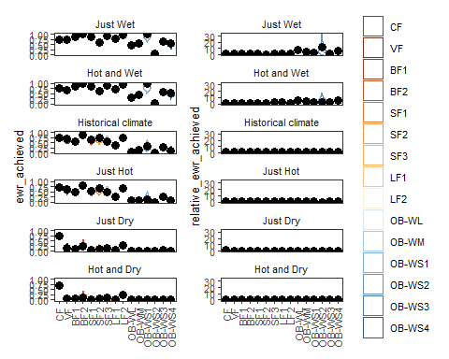
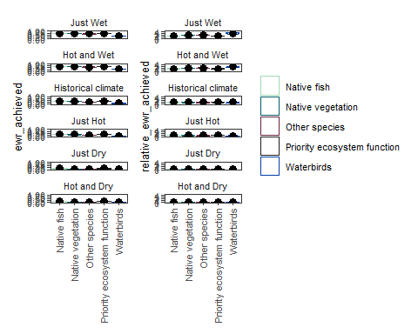
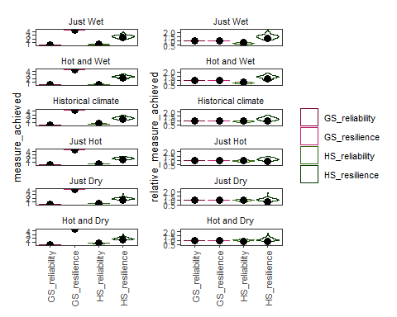
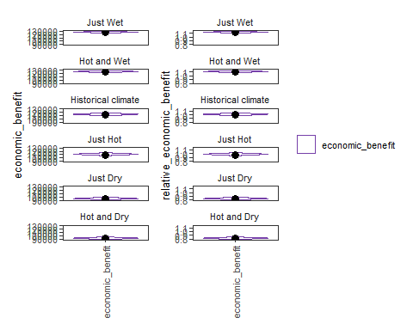
##Figure 6 - ewater adaptation (licvol)
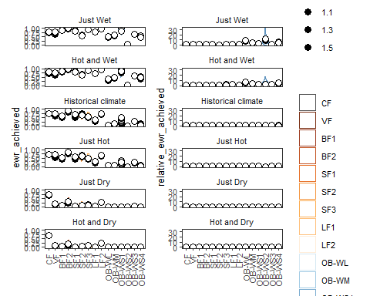
##Figure 7 - eWater management (Mks)

8) Targeted EWR management

