# Pokémon: RPG

# the Pokémon pen and paper rpg

# Game

Pokémon

# Character Generation System:

* Each player much choose a starting trainer class as their initial start class.
  + Available classes to choose from as a starter class are:
    - Bug –Catcher: This trainer may catch Bug type Pokémon.
    - Fisher: This trainer may catch Water type Pokémon.
    - Hiker: This trainer can catch Rock Type Pokémon.
    - All trainers can catch normal-type Pokémon.
  + In addition to their starter classes, each trainer can put attribute points into the following attributes:
    - Strength: The strength stat inspires your Pokémon and increases the likelihood of success of physical attacks, removing a value of 1 from the opponents roll to avoid your attack for every 3 points in this attribute. It is also taken into account when attempting to steal other trainers’ Pokémon (brute force) or perform other feats of strength such as climbing and moving heavy objects.
    - Intelligence: This stat improves the likelihood of success of special attacks performed by the trainers Pokémon, removing a value of 1 from the opponents roll to avoid your attack for every 3 points in this attribute. It is also taken into account when buying and selling for discounts and outsmarting other people or Pokémon or convincing them to do what the player wants them to do.
    - Agility: This stat improves the likelihood of a successful dodge performed by your Pokémon, adding a value of 1 to your roll to avoid your enemy’s attack for every 3 points in this attribute. It is also taken into account when trying to move stealthily or stealing objects or Pokémon (stealth).
  + Trainers start out with 6 points to spend, and can spend a maximum of 3 in each category to start.
* After having an average Pokémon level of ten, across at least 2 Pokémon, a player is awarded a badge and advances to Trainer Rank 2, in which they may take on a secondary trainer role. The available roles are as follows:
  + - Fire breather: This trainer can catch Fire type Pokémon.
    - Engineer: This trainer can catch Electric type Pokémon.
    - Ninja: This can catch Posion type Pokémon.
    - Channeler: This trainer can catch Ghost type Pokémon.
    - Motorcyclist: This trainer can catch Dark type Pokémon.
    - Miner: This trainer can catch Ground type Pokémon.
    - Breeder: This trainer can catch Grass type Pokémon.
    - Psychics: This trainer can catch Physic Pokémon.
  + Trainers also receive an additional 6 stat points to distribute to their attributes.
* After having an average Pokémon level of twenty, across at least 4 Pokémon, a player is awarded a badge and advances to Trainer Rank 3, in which they may take on a secondary trainer role. The available roles are as follows:
  + - Dragon Tamer: This trainer can catch Dragon type Pokémon.
    - Iron Worker: This trainer can catch Steel type Pokémon.
    - Pilot: This trainer can catch Flying type Pokémon.
    - Black-Belt: This trainer can catch Fighting Pokémon.
    - Skier: This trainer can catch Ice-Type Pokémon

# Confrontation System:

* Confrontations in Pokémon: RPG are handled the same across the various types of battles possible in the game world, with small changes between them. A PokeDex is chosen by the Game Master at the beginning of the game, which determines what type of Pokémon from which generations of the Pokémon game the players can encounter.
* The Pokémon’s specific name or species is irrelevant to combat; only its type is used in battle for determining its outcome. For example, a Pikachu is just as likely to win in a battle as an Electrobuzz, even though one Pokémon may be weaker or stronger in the game and both are Electric types.
* Unlike in the game and card game, Pokemon do not have specific move sets in Pokemon: RPG. Players can be creative with the types of Pokemon they command to win the battle. The Pokemon’s stats are relative to it’s level and it’s trainers stats, Pokemon have 3 stats: Attack, Special Attack and Defense. They’re stats are assigned to it upon meeting it in the wild by a D6 roll. 1-2 favors Attack, 3-4 favors special attack, and 5-6 favors defense. This means that 2/3rds rounded down to the nearest whole number of the total attribute points are distrusted to the favored stat, and then the remaining stats are split as evenly as possible amongst the other two stats. If it is not possible to completely evenly distribute the remaining stats the game master decides which of the two the point goes in. The trainer raises these stats as they see fit if they catch and level the Pokémon.
  + Attribute Allocation Table Example:
    - Level 1: 3 Points
    - Level 2: 5 Points
    - Level 3: 7 Points
    - …
    - Level 30: 61 Points
  + The initial level, one, starts with 3 points, and two points are added on after that with each level. The same rule applies for Pokémon that level up under a trainers command.
    - Examples of possible attacks/encounters:
      * Trainer to Electric Type: Paralyze the enemy with an electric attack!
        + GM: Roll a D6 to see if you successfully paralyze the enemy, based upon your Pokémon’s special attack stat.
        + PKMN: Spc. Atk. Of 44! Rolls 3 on D6. Paralyze successful!
      * GM: The battle takes place in a flooded basement…
      * PKMN: Jump up and use an electric attack on the ground to electrocute all Pokémon standing in the water.
      * GM: Roll two D6, one to see if you jump high enough to remain airborn for the attack based upon trainers strength (with a strength of 9, a 1 to 3 is required), and another to see if you attack successfully, based upon Pokemon’s Special Attack.
      * Trainer: Strength of 9, rolls a 1 with a D6. PKMN jumps!
      * PKMN: Special attack of 22, rolls a 5 with a D6. Attack unsuccessful!
  + Types of Battles:
    - Wild Encounters: An encounter between a trainer and a wild Pokémon. The Game Master rolls a D6 to determine the type of the Pokémon you encounter, and then chooses the Pokémon from the PokeDex based upon the area you are in. The GM controls the wild Pokemon’s abilities and assigns it a level appropriate for the area of the game that the player is in with a D6 roll, corresponding with a level table relevant to each area. Players can catch these Pokemon with a Pokemon and a three consectutive D6 rolls, the success rate of which are based upon the Trainer’s Pokemon’s level and the wild Pokemon’s level. Disabling the wild pokemon with a paralyze, sleep or other similar move guarantees a catch.
      * Pokemon catching success rate calculation:
        + Take whichever Pokemons level is higher and subtract it by the opposite Pokemon’s level. The value left is the margin of failure for a catch, and is taken from a D6 at the GM’s decision. If the wild pokemon is a higher level than the trainer’s, the minimum catch possibility is 1 out of 6.
        + Example:

Level 5 Trainer PKMN vs Level 2 Wild PKMN.

GM: Level difference is 3, you must roll a 1, 3, or a 6 to catch.

Level 17 Trainer PKMN vs Level 12 Wild PKMN.

GM: Level difference is 5, you must roll a 1, 2, 3, 5, or 6 to catch.

Level 14 Trainer PKMN vs Level 16 Wild PKM.

GM: Level difference is -2. You must roll a 3 to catch.

* + - NPC Trainer: These battles are exactly like wild pokemon battles, but there can be multiple pokemon called in consecutive order in the battle, and none of them can be caught.
      * The number of Pokemon the NPC trainer has is determined by a D6 roll. Rolling a 1 results in 1 Pokemon, and rolling a 6 results in 6 Pokemon.
      * The GM rolls to determine stats and levels just like a Wild Pokemon battle.
      * The trainers type is determined with a D6 roll or D10 roll based upon the level bracket. Level bracket is determined by the trainers rank, and average Pokémon level.
      * In the 1-10 bracket a D6 roll determines type as follows:
        + 1: Bug
        + 2: Water
        + 3: Rock
        + 4-6 Normal
    - Other Players:
      * These battles operate just like trainer battles except that both sides teams are already determined by the combatting players. The GM oversees the battle and decides what rolls are needed to complete attacks or other moves.
* Weaknesses:
  + Pokemon Weaknesses are a very prominent part of the games strategy. Pokemon RPG takes the original games Weaknesses and strengths when battling different kinds of pokem on directly from the game. The table below demonstrates.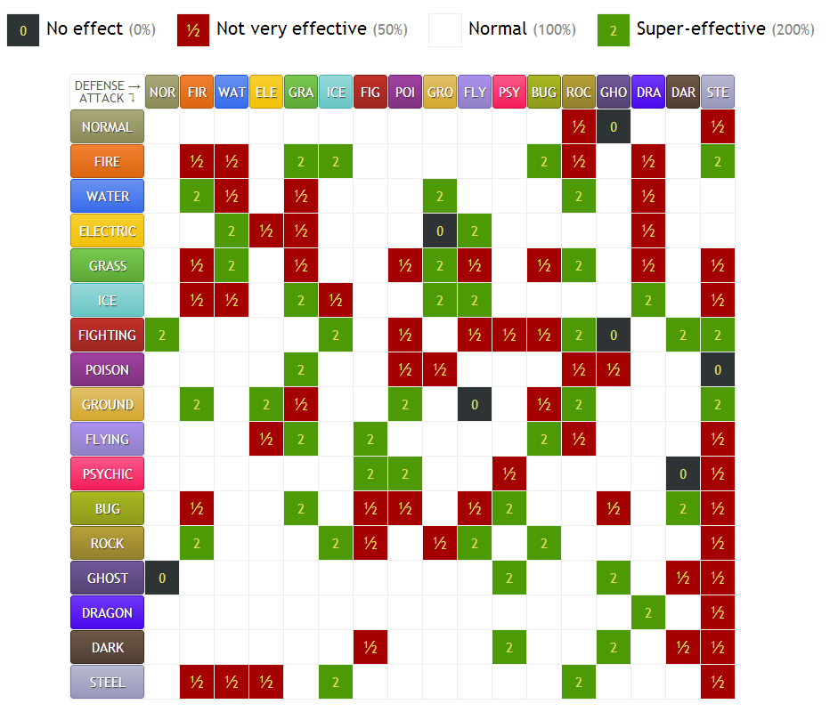

# Story/Setting:

* Pokemon: RPG takes place in the region determined by selecting the PokeDex at the beginning of the game. The Game Master will create a problem for the adventuring trainers to tackle (in under an hour!) involving either Team Plasma, Team Rocket or a Legendary Pokemon with a bad attitude. Trainers will be sent out into the wild at the beginning of the game with a special “starter ball” that has a 100% chance to catch any Pokémon up to level 5. They can only catch Pokémon that pertain to the type of trainer they chose during character creation, or a normal type. If they encounter a type of Pokémon they cannot catch, they must run from battle. Until the player feels they are strong enough to take on the enemy the game master has made for them, they train and catch pokemon to expand the type of pokemon they can train.

# GM Rules:

* The GM is responsible for over-seeing all battles and controlling wild pokemon and NPC trainers, as well as the games final encounter if it is not a player. The final encounter takes on the same rules as a trainer battle, but the GM can determine what kind of Pokemon the final battle trainer has. GM combat rules for battling are covered in the combat section.
* When players perform direct attacks on a pokemon (IE. Use a fire attack on the enemy pokemon!) the attacking player doesn’t have to perform any rolls. The enemy can attempt to avoid the attack by whatever means they have, such as a physical dodge, or the use of their special type to move themselves (IE. Psychic teleport or a Water type self-propelled blast away).
  + The GM will decide what the player needs to roll based upon the trainers stats and pokemons stats. A pokemons maximum stat on any given stat is 60, so a D6 is used to determine a successful special attack or dodge that isn’t a direct attack.
  + A D6 is also used to determine success on other miscellaneous moves based upon the trainers stats as well. Such as having a pokemon jump out of the way to avoid an attack, the trainers strength is used to determine success based upon the 3 to 1 attribute point to dice roll value ratio. The GM decides what numbers are valid for a successful roll based upon the dice roll value determined by the attribute points.