

**RPG Analog Game**

**Characters:** 1-2 Assassin players, 3-5 Templar players

**Goal:** The outnumbered assassin has team up to eliminate all the Templars while using obstacles and stealth to win before the Templar players tracks and eliminates the assassins.

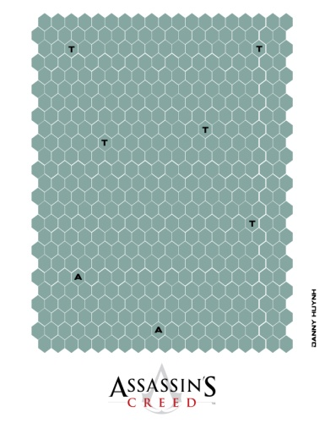**Materials:**

* Map
* 2 Assassin token (1 for each Assassin player)
* 5 Templar token (1 for each Templar player)
* 4-7 players
* 1 six-sided die
* 56 damage Counters (8 for each player)

**Game Setup:** Players pick their character tokens and place it on a

tile with the correct letter.

* A for Assassin Token Start
* T for Templar Token Start

**Players Stats:**

* Health: 8 Damage Counters
* Attack: Players attacking values are from the amount of damage done from an equip weapon.

**Player Movements:**

For movement phase, the turn player rolls a 6 sided die and he/ she can move up to that amount.

*Assassin player have +2 movements on rolls.

**Weapons:**

* Smoke bomb: One turn Stealth. One per assassin.
* Sword: 4 Atk, 1 tile range
* Crossbow: 3 atk, 2 tile range
* Hidden blade: 1 atk, 1 tile range one hit kill with stealth

*Assassin could use all of the weapons mentioned above but Templars could only use a sword or a bow.

**Game Mechanic:**

* Stealth: At the beginning of the assassin player’s turn, if his/her token is more than 5 tiles away from all the Templar players, it has stealth for one turn.
* Assassination: If an assassin player has stealth, he/she can perform an assassination during that turn. The assassin player has to be on an adjacent tile to perform an assassination. When an assassination is declare, the assassin player equips a hidden blade and rolls a die. If the result is greater than 2 the enemy player is eliminated. If the result is 1 or 2 then the assassin receives damage equal to the amount of the enemy’s weapon and the assassin’s turn is over.
* Counter: The assassin player is able to initiate a counter once every battle when an enemy declares an attack. Both players will roll a 6 sided die and if the roll is 5 or 6 the enemy player’s strike is canceled and the assassin player gets to deal a free hit.

*Counters cannot be initiated if the assassin player is equipped with a crossbow.

**Battle Engaged:**

* When a battle is engaged, the attacking player will deal damage equal to the attack of the equipped weapon. In return if the defending player is within their weapon range, they could also deliver a blow. Damage counters are then removed for every damage a player receives. If the attacking player attacks an Assassin, the assassin has a chance to counter and cancel the block if they are within range.

**Sequence of game play:**

* Turn starts
* Stealth Phase
* Weapon Selection
* Movement
* Battle
* Turn ends