Megaman X: Warzone

Description

Megaman X: Warzone is a 4-6 player game requiring a game master and two 7” x 10” grids. Each player chooses either an X-Suit or a Zero-Suit and a starting extra weapon. The game master creates a level for the players to travel through made out of rooms, each room being a 7x10 grid sized area. At the end of the level, the players fight a boss and upon winning receive a new gun. Characters are reuseable in multiple campaigns and continue to extend their maximum life, get new upgrades, and find more weapons.

Requirements

- 4 players
- 1 game master
- Predesigned level involving at least 5 rooms and a boss
- Two 7” x 10” grids (Optionally predrawn rooms on grids)
- Blank paper for character creation
- 10 markers
- One coin

Character Creation

- The player chooses between two suits
- X-Suit which has linear ranged capabilities and deals 10 damage
- Zero-Suit which has melee capabilities and 15 damage
- After choosing a suit, the player chooses between one of three additional starting weapons
- The X-suit can have
- Tornado gun, shoots [air] tornadoes 3 blocks high, 20 damage
- Crocket gun, which shoots crocodile shaped [fire] rockets which explode on impact dealing an area of effect, 20 damage
- Shock gun, which fires electricity that travels along the ground, walls, or ceiling, 20 damage
2. The Zero-Suit can have
- Fire whip, whips out 3 blocks ahead, 30 damage
- Pressure hammer [water], which launches enemies back two spaces, 40 damage
- Ice spear, chucks a spear which breaks on contact and travels 5 horizontal spaces, 40 damage
- X-Suits start with 100 health, Zero-Suits start with 150 health
- All special weapons have a base of 10 ammo.

Enemies

- Enemies are hand crafted by the game master to fit each level appropriately
- The average enemy's health is 50 per player
- Enemies can function as traps, can shoot, and can suicide charge
- An average hit from an enemy deals 40 damage
- All enemies must be killed before moving to the next room
- Killing an enemy has a 50% chance of dropping health or weapon refills
- A drop has a 50% chance of being either a health or weapon refill
- Health and weapon refills have a 50% chance of being large or small

Bosses

- Bosses deal much more damage than regular enemies and have special attacks
- Each boss must have a major element which they are weak against
- Bosses are best made with “phases” of attacks
- The average boss has 150 health per player
- While boss attacks may vary greatly, the average damage is 40 per hit
- Defeating a boss rewards a weapon to the players

Environment

- The bottom of the grid is considered the “ground,” the players move across it
- The edges of the grid is considered “walls” and the players may jump off of it
- Walls and platforms may be marked by the game master for more play area
- The game master may declare trapped areas and empty floor spaces which the players must avoid or die instantly
- There may be items placed around the room which can help the player. Such items may restore health or special weapon ammo, or may even increase maximum health or ammo capacity, or even give permanent upgrades such as allowing special weapons to be charged

Player Interaction

- Each turn, the game master flips a coin to see who goes first, the enemies or the players
- The amount of actions allowed per turn is determined by action points
- Players and bosses get 10 action points, while regular enemies only get 5 action points
- Moving one square is 1 action point
- Dashing 3 squares is 2 action points and may only be done once per turn
- Releasing an attack is 1 action point, attacks can only travel horizontally and die on impact unless otherwise defined.
- Charging up an attack takes 2 action points, special weapons can not be charged unless otherwise defined. Regular attacks pierce enemies when they would otherwise not.
- An attack may be charged twice, each charge double the player's next attack's damage
- Jumping takes 2 action points and reaches 2 blocks high, they can shoot once before falling
- Wall jumping takes 1 action point and allows the player to raise their elevation higher through continuous jumping without returning to the ground
- When an attack is made, the player or game master must toss a coin from at least one foot away horizontally and vertically from the grid. If the coin touches the enemy/player, the attack is successful and they take damage. The coin does not have to land on the enemy/player, it only needs to touch it at some point

Sample Level

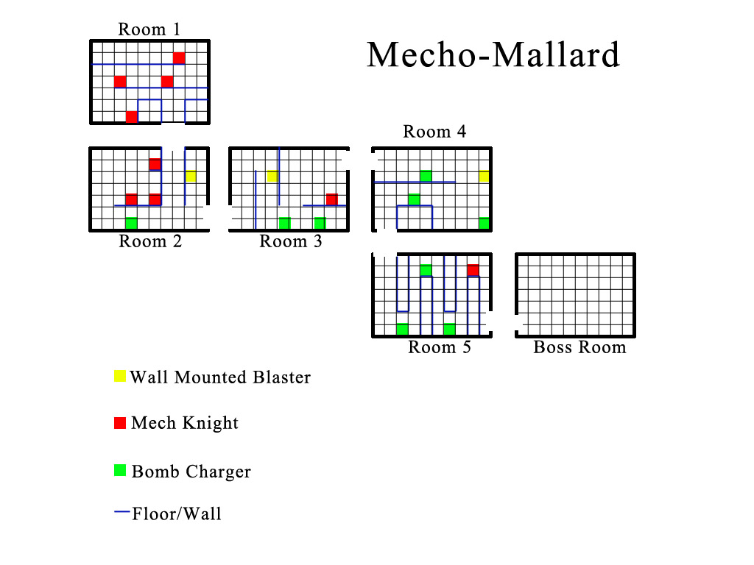
Wall Mounted Blaster

- Fires three shots at once, each deals 20 damage. One horizontal, two diagonal
- Can not move
- 20 health per player

Mech Knight

- Fires horizontal bullets, each deals 20 damage.
- Can move horizontally, can not jump or leave platforms
- 40 health per player

Bomb Charger

- Blows up on collision. Deals 60 damage
- Moves horizontally, will fall off ledges
- 40 health per player

Mecho Mallard

- 200 health per player
- Phase 1 50%+ health:
  - Fires missiles on the ground, hits all players on the ground. Deals 20 damage
  - Fires missiles at the walls, hits all players on the walls. Deals 20 damage
  - Jumps and hangs on ceiling
- Phase 2 49%- health:
  - Fires missiles that hit left or right half of the room. Deals 30 damage
  - Turns into a missile and flies from one side of the room to the other. Deals 50 damage on collision.
  - Fires missiles on the ground, hits all players on the ground. Deals 20 damage

