SharePoint TFS Integration Platform Adapters

Contents

Version Information 2

Overture 4

Prerequisites 4

Overview of Adapters 4

Composition 5

VC 5

Supported actions against SharePoint 5

Not supported actions against SharePoint 5

Supported actions from SharePoint 6

Not supported actions from SharePoint 6

WIT 6

Supported actions against SharePoint 6

Not supported actions against SharePoint 7

Supported actions from SharePoint 7

Not supported actions from SharePoint 7

Deployment 7

Common Configuration 8

Example Configuration 9

WIT Specific 9

Field Map 9

Example Configuration 9

VC Specific 10

Known Issues 10

Example Configuration 10

Appendix 12

Complete WIT Configuration Example 12

Complete VC Configuration Example 13

# Version Information

Version 0.1

* Author: Robert MacLean
* Date: 11 March 2010
* Notes:
  + First draft

Version 0.2

* Author: Robert MacLean
* Date: 14 March 2010
* Notes:
  + Incorporated feedback from Willy-Peter Schaub.

Version 0.3

* Author: Robert MacLean
* Date: 15 March 2010
* Notes:
  + Added list of supported and unsupported actions.

Version 0.4

* Author: Robert MacLean
* Date: 16 March 2010
* Notes:
  + Incorporated feedback from Zayd Kara.

Version 0.5

* Author: Robert MacLean
* Date: 19 March 2010
* Notes:
  + Incorporated feedback from Willy-Peter Schaub.

Version 0.6

* Author: Robert MacLean
* Date: 20 March 2010
* Notes:
  + Updated to latest code changes.

Version 0.7

* Author: Robert MacLean
* Date: 20 April 2010
* Notes:
  + Updated to latest code changes.
  + Removed Outstanding Features section.
  + Added known issues to version control section.
  + Document cleanup.

# Overture

The goal of the SharePoint TFS Integration Platform adapters is to provide a simple way to keep a SharePoint environment in sync with another environment using the TFS Integration Platform. This document tries to give you a head start into the usage and some of the implementation details of the adapters which will give you an idea of what are possible with them. There are two adapters one handling work items (WIT) and the other handling version control (VC).

## Prerequisites

This document is aimed at people who are implementing the TFS Integration Platform with the SharePoint adapters and as such makes the assumption that you, the reader, have read the TFS Integration Platform documentation and are familiar with the basic concepts and terminology used.

## Overview of Adapters

These adapters work against both Windows SharePoint Services (WSS) and Microsoft Office SharePoint Server (MOSS). Both the VC and WIT adapter do basically the same thing, they enable data to be read from SharePoint and data to be written to SharePoint.

In other integration solutions we do not refer to source or target systems, which refer to a system which is used for just reading or writing. In TFSIP we talk about left and right systems as reading and writing can occur during a single run and the SharePoint adapters can handle both in a single run.



Figure : TFS Integration Platform as the middle ground between two systems.

It is important to note that these adapters are still under development and so some features are not yet complete to enable full synchronisation, however in their current state they do support the fundamentals for synchronisation such as adding, updating and reading from or to SharePoint.

# Composition

Both adapters use the same basic building blocks, in that they use the SharePoint web service model to read and write to SharePoint. This enables both the adapters to work from any machine on the network, or in other words the TFS Integration Platform does not need to run on the SharePoint server. The WIT adapter uses just the Lists web service while the VC adapter uses the Lists and Copy web services.

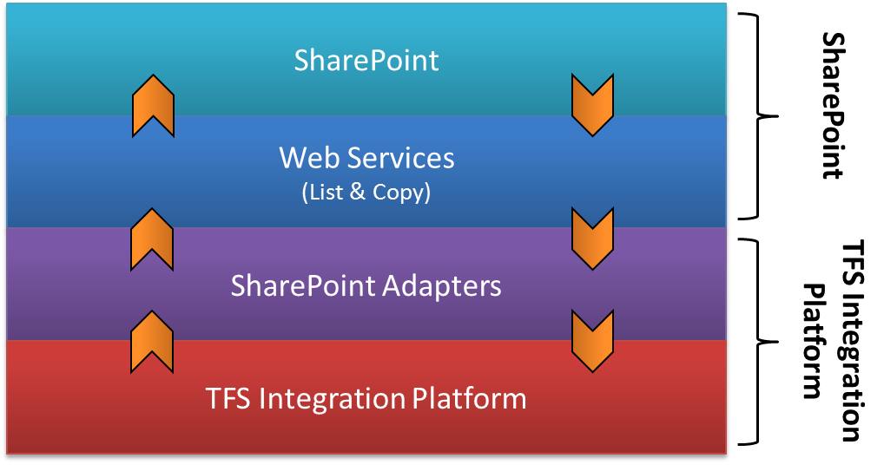

Figure : The layers of communication between SharePoint, the Platform and the adapters.

## VC

The version control adapter allows for version controlled files and folders to be read and written to SharePoint.

### Supported actions against SharePoint

The adapter supports the following actions which can be performed against SharePoint (i.e. SharePoint as a target).

* Add new file to SharePoint
* Update file in SharePoint.
* Delete file in SharePoint.

### Not supported actions against SharePoint

The following actions are not support and are currently not planned to be implemented in a future release.

* Branching.
* Labelling.
* Undelete.
* Renaming.

Branching and labelling are not supported as SharePoint has no concept close enough to them which can be used in all scenarios and would make sense for a public distributable. However in specific scenarios folders or alternative SharePoint lists, but this is rather left for the user implementing this to decide if they was to implement and how to implement so it works in their environment.

Undelete is not supported as working with the SharePoint recycle bin requires additional privileges and we cannot guarantee the file will still exist even in the recycle bin.

### Supported actions from SharePoint

The following actions from SharePoint, i.e. SharePoint as the source, are supported:

* Add new file to target system.
* Update file in target system.

### Not supported actions from SharePoint

The following actions are not supported from SharePoint to a target system:

* Delete file in target system.
* Branching.
* Labelling.
* Undelete.
* Renaming.

There is no efficient want to detect a file deletion or undeletion from the SharePoint web services. Branching and labelling do not have a similar concept in SharePoint, so it would be up to the user to implement these specifically for their environment if it would be needed.

## WIT

The WIT adapter allows for SharePoint lists, regardless of type of list, to be synchronised. The current implementation of adapter only handles inserts and updates of tasks within SharePoint, deletions and adding of attachments are planned for a later release.

### Supported actions against SharePoint

The adapter supports the following actions which can be performed against SharePoint (i.e. SharePoint as a target).

* Add new work item to SharePoint.
* Update work item in SharePoint.
* Delete work item in SharePoint.

### Not supported actions against SharePoint

The following actions are not support and are currently not planned to be implemented in a future release.

* Undelete.

### Supported actions from SharePoint

The following actions from SharePoint, i.e. SharePoint as the source, are supported:

* Add new work item to target system.
* Update work item in target system.

### Not supported actions from SharePoint

The following actions are not supported from SharePoint to a target system:

* Delete work item in target system.

There is no efficient want to detect a work item deletion from the SharePoint web services.

# Deployment

Deployment of the adapters is simple; first copy the assemblies to the plugin folder for the TFS Integration Platform and second edit the configuration.

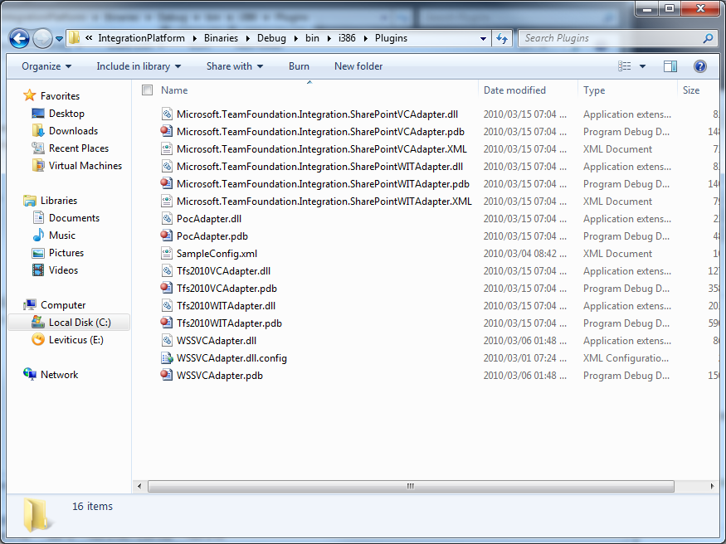

Figure : The adapters in the plugins folder.

## Common Configuration

Both adapters share some basic configuration parameters, in particular for the migration source configuration. The line number referred to in the list before relates to the line number in the example.

* InternalUniqueId

Type: GUID

Value: Anything as long as it is unique

Line: 1

* Friendly Name

Type: String

Value: Anything

Line: 1

* ServerIdentifier

Type: String

Value: Anything

Line: 1

* ServerUrl

Type: String

Value: The URL to the web application within SharePoint.

Line: 1

* SourceIdentifier

Type: String

Value: The name of the list or document library you want to synchronise with.

Line: 1

* ProviderReferenceName

Type: GUID

Value: The identifier for the adapter. For WIT that is 585fc30c-f8fb-4d5c-80de-796f0b3553ef and for VC that is 7f3f91b2-758a-4b3c-bba8-ce34ae1d48ee.

Line: 1

* CustomSettings
  + username

Type: String

Value: The username used to login to SharePoint.

Line: 3

* + Password

Type: String

Value: The password used to login to SharePoint.

Line 4:

### Example Configuration

1. <**MigrationSource** **InternalUniqueId**="00000000-0000-0000-3000-000000000001" **FriendlyName**="WSS WIT" **ServerIdentifier**="SharePoint" **ServerUrl**="http://localhost:40414" **SourceIdentifier**="Tasks" **ProviderReferenceName**="585fc30c-f8fb-4d5c-80de-796f0b3553ef">
2. <**CustomSettings**>
3. <**CustomSetting** **SettingKey**="username" **SettingValue**="administrator" />
4. <**CustomSetting** **SettingKey**="password" **SettingValue**="P@ssw0rd" />
5. </**CustomSettings**>
6. </**MigrationSource**>

## WIT Specific

The work item adapter has no specific configuration. It does require the above common settings and as with any work item adapter a valid field map is required.

### Field Map

The names for the SharePoint fields are based off of the internal names with the *ows_* prefix removed, *_* removed and *x0020* removed.

|  |  |
| --- | --- |
| SharePoint Name | Field Map Name |
| ows_GUID | GUID |
| ows_Title | Title |
| ows__CopySource | CopySource |
| ows_Last_x0020_Modified | LastModified |

### Example Configuration

1. <**Session** **SessionUniqueId**="00000000-0000-8000-0000-000000000001" **FriendlyName**="WIT session" **LeftMigrationSourceUniqueId**="00000000-0000-0000-3000-000000000001" **RightMigrationSourceUniqueId**="00000000-0000-0000-1000-000000000001" **SessionType**="WorkItemTracking">
2. <**CustomSettings**>
3. <**SettingXml**>
4. <**WITSessionCustomSetting**>
5. <**WorkItemTypes**>
6. <**WorkItemType** **LeftWorkItemTypeName**="SharePointItem" **RightWorkItemTypeName**="Task" **fieldMap**="SharePointFieldMap" />
7. </**WorkItemTypes**>
8. <**FieldMaps**>
9. <**FieldMap** **name**="SharePointFieldMap">
10. <**MappedFields**>
11. <**MappedField** **LeftName**="Title" **RightName**="System.Title" **MapFromSide**="Left"/>
12. <**MappedField** **LeftName**="Description" **RightName**="System.Description" **MapFromSide**="Left"/>
13. <**MappedField** **LeftName**="Title" **RightName**="System.Title" **MapFromSide**="Right"/>
14. </**MappedFields**>
15. </**FieldMap**>
16. </**FieldMaps**>
17. </**WITSessionCustomSetting**>
18. </**SettingXml**>
19. </**CustomSettings**>
20. <**Filters**>
21. <**FilterPair**>
22. <**FilterItem** **MigrationSourceUniqueId**="00000000-0000-0000-3000-000000000001" **FilterString**="" />
23. <**FilterItem** **MigrationSourceUniqueId**="00000000-0000-0000-1000-000000000001" **FilterString**="" />
24. </**FilterPair**>
25. </**Filters**>
26. </**Session**>

## VC Specific

The version control adapter requires the common configuration as indicated above as well as the filter pairs to be correctly setup up. The SharePoint instance of the filter pair should point to the URI of the document library root within SharePoint. See line 7 in the example configuration below and note that the URL does have a trailing slash, which is required.

### sharepoint-write.log

The VC adapter maintains a log file in the same folder as the process which started it named, sharepoint-write.log. This file maintains information on files which have been written to SharePoint from other sources and is vital for the successful running of the version control adapter.

If you need to do an *over the wall* sync, in other words a sync which is done once to disk and then moved and loaded from disk, for example if you have two disconnected systems, then this file must move with the rest of the data.

If you need to restart the sync forgetting all previous work, then this file must be deleted so that the adapter can start fresh. If you are restarting a sync to just continue an existing process then this file should not be removed.

### Known Issues

#### Child Folder Creation

When working with the SharePoint version control adapter and the TFS version control adapter a folder with the same name as the library will be created in the library in SharePoint. For example if your library is called *Shared Documents* you will have a folder named *Shared Documents* (as in the image below).

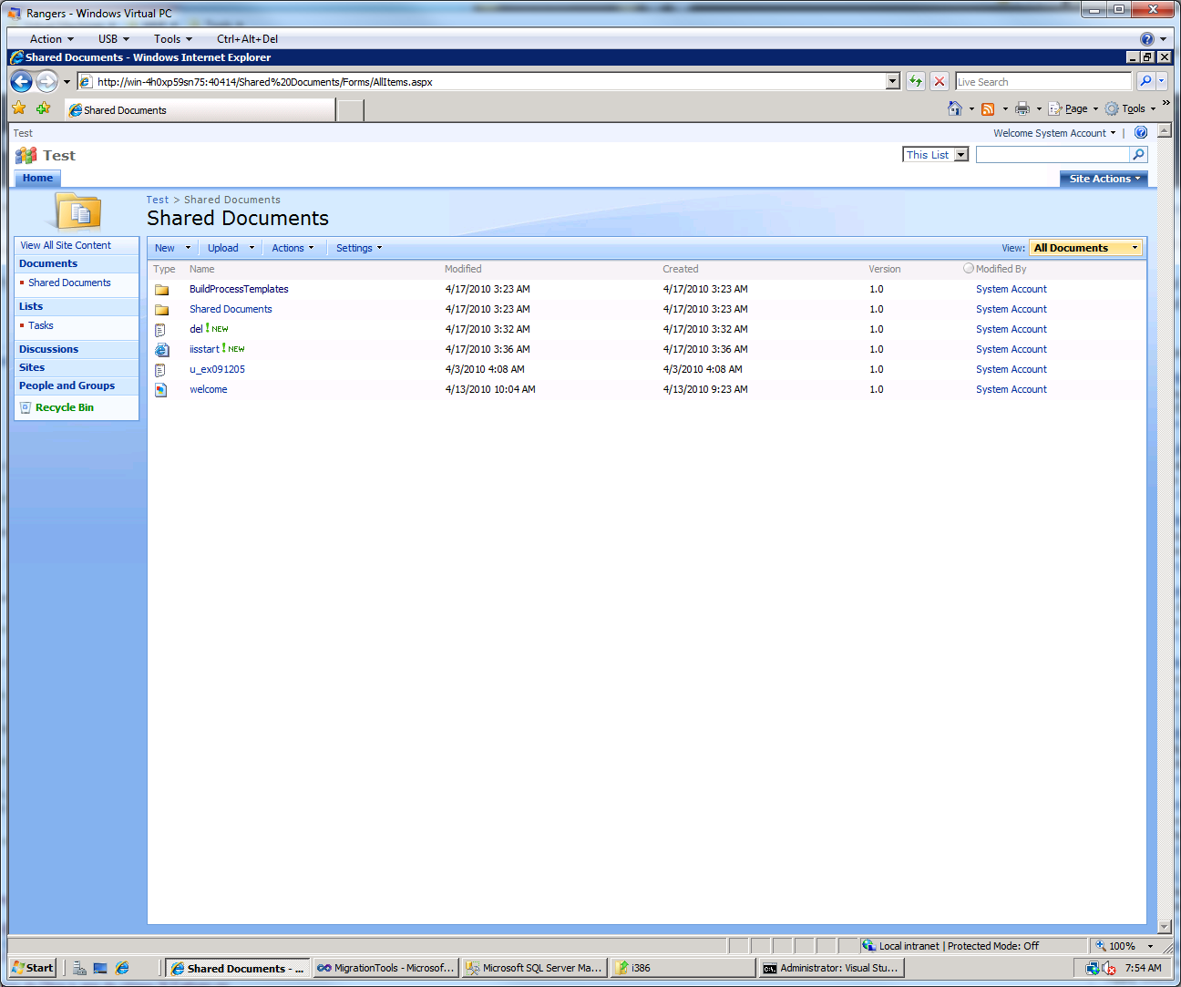

Figure : Shared Documents example

This is caused by a known issue in the TFS adapter which sends the root path through first. The SharePoint adapter has no way to know that it is not a valid folder and so creates it. This has no impact on any other process, nor will it be sync’d back to TFS.

#### Fail to translate VC server path

You may find that the process fails with the first file with the error message *Fail to translate VC server path.* This is caused between a mismatch between the filter string and the URL which SharePoint is providing, in particular the hostname portion.

It is best to make sure the same hostname is used universally in the configuration and this is also a hostname which is configured in the SharePoint Central Administration.

### Example Configuration

1. <**Session** **SessionUniqueId**="00000000-0000-2000-0000-000000000001" **FriendlyName**="Version Control Session" **LeftMigrationSourceUniqueId**="00000000-0000-0000-4000-000000000001" **RightMigrationSourceUniqueId**="00000000-0000-0000-2000-000000000001" **SessionType**="VersionControl">
2. <**CustomSettings**>
3. <**SettingXml**/>
4. </**CustomSettings**>
5. <**Filters**>
6. <**FilterPair**>
7. <**FilterItem** **MigrationSourceUniqueId**="00000000-0000-0000-4000-000000000001" **FilterString**="http://win-4h0xp59sn75:40414/Shared%20Documents/" />
8. <**FilterItem** **MigrationSourceUniqueId**="00000000-0000-0000-2000-000000000001" **FilterString**="$/POC" />
9. </**FilterPair**>
10. </**Filters**>
11. </**Session**>

# Appendix

## Complete WIT Configuration Example

1. <?**xml** **version**="1.0" **encoding**="utf-16"?>
2. <**Configuration** **UniqueId**="00000000-1234-0000-0000-000000000150" **FriendlyName**="SharePoint Adapter Test Config">
3. <**Providers**>
4. <**Provider** **FriendlyName**="TFS WIT Migration Provider" **ReferenceName**="04201d39-6e47-416f-98b2-07f0013f8455" />
5. <**Provider** **FriendlyName**="SharePoint WIT Migration Provider" **ReferenceName**="585fc30c-f8fb-4d5c-80de-796f0b3553ef" />
6. </**Providers**>
7. <**SessionGroup** **FriendlyName**="Session Group 0x0001" **SessionGroupGUID**="00000000-0000-0000-0000-000001000001">
8. <**WorkFlowType** **Frequency**="ContinuousManual" **DirectionOfFlow**="Bidirectional" **SyncContext**="Unidirectional" />
9. <**MigrationSources**>
10. <**MigrationSource** **InternalUniqueId**="00000000-0000-0000-1000-000000000001" **FriendlyName**="TFS 2010 WIT" **ServerIdentifier**="localhost tfs server" **ServerUrl**="http://localhost:8080/tfs/defaultcollection" **SourceIdentifier**="POC" **ProviderReferenceName**="04201d39-6e47-416f-98b2-07f0013f8455">
11. <**CustomSettings** />
12. </**MigrationSource**>
13. <**MigrationSource** **InternalUniqueId**="00000000-0000-0000-3000-000000000001" **FriendlyName**="SharePoint WIT" **ServerIdentifier**="SharePoint" **ServerUrl**="http://localhost:40414" **SourceIdentifier**="Tasks" **ProviderReferenceName**="585fc30c-f8fb-4d5c-80de-796f0b3553ef">
14. <**CustomSettings**>
15. <**CustomSetting** **SettingKey**="username" **SettingValue**="administrator" />
16. <**CustomSetting** **SettingKey**="password" **SettingValue**="P@ssw0rd" />
17. </**CustomSettings**>
18. </**MigrationSource**>
19. </**MigrationSources**>
20. <**Sessions**>
21. <**Session** **SessionUniqueId**="00000000-0000-8000-0000-000000000001" **FriendlyName**="WIT session" **LeftMigrationSourceUniqueId**="00000000-0000-0000-3000-000000000001" **RightMigrationSourceUniqueId**="00000000-0000-0000-1000-000000000001" **SessionType**="WorkItemTracking">
22. <**CustomSettings**>
23. <**SettingXml**>
24. <**WITSessionCustomSetting**>
25. <**WorkItemTypes**>
26. <**WorkItemType** **LeftWorkItemTypeName**="SharePointItem" **RightWorkItemTypeName**="Task" **fieldMap**="SharePointFieldMap" />
27. </**WorkItemTypes**>
28. <**FieldMaps**>
29. <**FieldMap** **name**="SharePointFieldMap">
30. <**MappedFields**>
31. <**MappedField** **LeftName**="Title" **RightName**="System.Title" **MapFromSide**="Left"/>
32. <**MappedField** **LeftName**="Description" **RightName**="System.Description" **MapFromSide**="Left"/>
33. <**MappedField** **LeftName**="Title" **RightName**="System.Title" **MapFromSide**="Right"/>
34. </**MappedFields**>
35. </**FieldMap**>
36. </**FieldMaps**>
37. </**WITSessionCustomSetting**>
38. </**SettingXml**>
39. </**CustomSettings**>
40. <**Filters**>
41. <**FilterPair**>
42. <**FilterItem** **MigrationSourceUniqueId**="00000000-0000-0000-3000-000000000001" **FilterString**="" />
43. <**FilterItem** **MigrationSourceUniqueId**="00000000-0000-0000-1000-000000000001" **FilterString**="" />
44. </**FilterPair**>
45. </**Filters**>
46. </**Session**>
47. </**Sessions**>
48. </**SessionGroup**>
49. </**Configuration**>

## Complete VC Configuration Example

1. <?**xml** **version**="1.0" **encoding**="utf-16"?>
2. <**Configuration** **UniqueId**="00000000-1234-0000-0000-000000000150" **FriendlyName**="WSS Adapter Test Config">
3. <**Providers**>
4. <**Provider** **FriendlyName**="TFS 2010 VC Migration Provider" **ReferenceName**="febc091f-82a2-449e-aed8-133e5896c47a" />
5. <**Provider** **FriendlyName**="SharePoint VC Migration Provider" **ReferenceName**="7f3f91b2-758a-4b3c-bba8-ce34ae1d48ee" />
6. </**Providers**>
7. <**SessionGroup** **FriendlyName**="Session Group 0x0001" **SessionGroupGUID**="00000000-0000-0000-0000-000001000001">
8. <**WorkFlowType** **Frequency**="ContinuousManual" **DirectionOfFlow**="Bidirectional" **SyncContext**="Unidirectional" />
9. <**MigrationSources**>
10. <**MigrationSource** **InternalUniqueId**="00000000-0000-0000-2000-000000000001" **FriendlyName**="TFS 2010 VC" **ServerIdentifier**="localhost tfs server" **ServerUrl**="http://localhost:8080/tfs/defaultcollection" **SourceIdentifier**="POC" **ProviderReferenceName**="febc091f-82a2-449e-aed8-133e5896c47a">
11. <**CustomSettings**/>
12. </**MigrationSource**>
13. <**MigrationSource** **InternalUniqueId**="00000000-0000-0000-4000-000000000001" **FriendlyName**="SharePoint VC" **ServerIdentifier**="SharePoint" **ServerUrl**="http://localhost:40414" **SourceIdentifier**="Shared Documents" **ProviderReferenceName**="7f3f91b2-758a-4b3c-bba8-ce34ae1d48ee">
14. <**CustomSettings**>
15. <**CustomSetting** **SettingKey**="username" **SettingValue**="administrator" />
16. <**CustomSetting** **SettingKey**="password" **SettingValue**="P@ssw0rd" />
17. </**CustomSettings**>
18. </**MigrationSource**>
19. </**MigrationSources**>
20. <**Sessions**>
21. <**Session** **SessionUniqueId**="00000000-0000-2000-0000-000000000001" **FriendlyName**="Version Control Session" **LeftMigrationSourceUniqueId**="00000000-0000-0000-4000-000000000001" **RightMigrationSourceUniqueId**="00000000-0000-0000-2000-000000000001" **SessionType**="VersionControl">
22. <**CustomSettings**>
23. <**SettingXml**/>
24. </**CustomSettings**>
25. <**Filters**>
26. <**FilterPair**>
27. <**FilterItem** **MigrationSourceUniqueId**="00000000-0000-0000-4000-000000000001" **FilterString**="http://win-4h0xp59sn75:40414/Shared%20Documents/" />
28. <**FilterItem** **MigrationSourceUniqueId**="00000000-0000-0000-2000-000000000001" **FilterString**="$/POC" />
29. </**FilterPair**>
30. </**Filters**>
31. </**Session**>
32. </**Sessions**>
33. </**SessionGroup**>
34. </**Configuration**>