Personal project: with the help of this tutorial - https://realpython.com/python-sockets/

writing a local server on my computer with a DB. The server runs on my local computer and listens on a port.
the server has 2 endpoints:
1. endpoint that saves data - I can write a task to insert to the db
2. endpoint that returns data - I can ask for the server to return to me all the tasks that are in the db.

In order to communicate around a network we use sockets and sockets API , they provide an inter-process communication (IPC). The network can be a logical , local network to the computer or one that’s physically connected to to an external network with its on connections to other networks.
Socket:
A network socket is a software structure within a network node of a computer network that serves as an endpoint for sending and receiving data across the network. The structure and properties of a socket are defined by an application programming interface (API) for the networking architecture. Sockets are created only during the lifetime of a process of an application running in the node.

Python’s socket module provides an interface to the Berkeley sockets API.
The primary socket API functions and methods in this module are:socket(),bind(),listen(),accept(),connect(),send(),recv(), etc. Python provides a convenient and consistent API that maps directly to these system calls, their C counterparts. As part of its standard library, Python also has classes that make using these low-level socket functions easier.

When we create a socket object , we use socket.socket() and need to specify the socket type as socket.SOCK_STREM , when we do that , the default protocol that’s used is the transmission control protocol (TCP) . TCP is the default because it has a few good qualities: is reliable - packets are dropped in the network are detected and re-transmitted by the sender. has in-order data delivery - data is read by your app in the order it was written by the sender.
(in contrast to UDP protocol which is not reliable and data isnt transmitted by its original order.

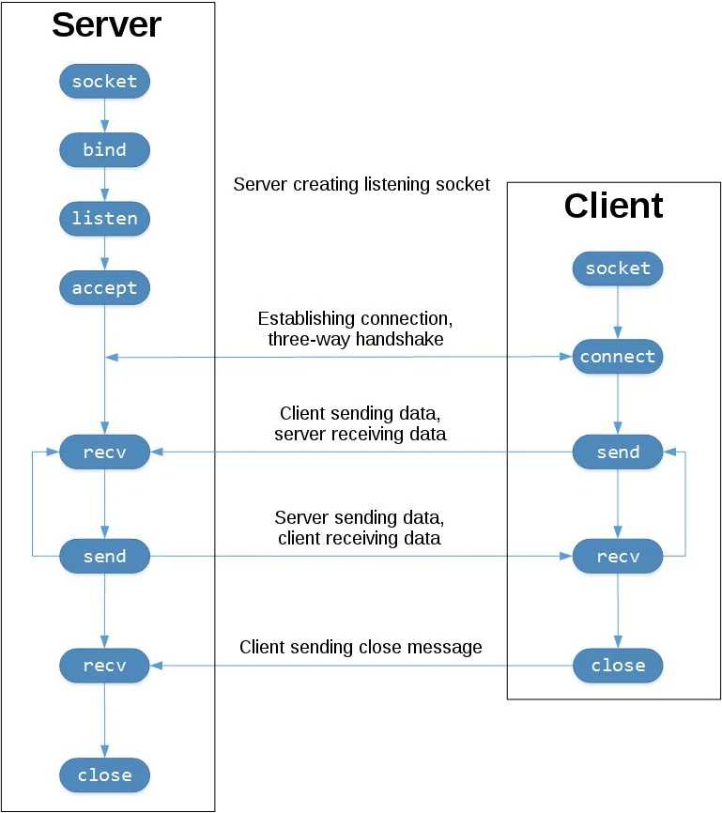

the API calls the server makes to setup a “listening” socket: socket(), bind(), listen() , accept().
A listening socket does just what it sounds like. It listens for connections from clients. When a client connects, the server calls accept() to accept, or complete, the connection. The client calls connect() to establish a connection to the server and initiate the three-way handshake. The handshake step is important since it ensures that each side of the connection is reachable in the network, in other words that the client can reach the server and vice-versa. It may be that only one host, client or server, can reach the other. In the middle is the round-trip section, where data is exchanged between the client and server using calls to send() and recv(). At the bottom, the client and server close() their respective sockets.
Server:
1. create a socket object with socket.socket(socket.AF_INET, socket.SOCK_STREAM) – AF_INET is the Internet address family for IPV4, SOCKET_STREM is the socket type for TCP.
2. socketobj.bind() - associates the socket with a specific network interface and port number (the values of bind depends on the address family.
3. socketobj.listen() - enables a server to accept connections, it has a backlog parameter that specify the number of unaccepted connections that the system will allow before refusing the connection. If your server receives a lot of connection request simultaneously, increasing the backlog value may help setting the max length of the queue for pending requests.
4. socketobj.accept() - blocks and waits for an incoming connection. When client connects it returns a new socket object representing the connection and a tuple holding the address of the client. The tuple will contain (host, port) for IPV4 connections, now we have a new socket object from accept , its the socket we’ll use to communicate with the client.
Its distinct from the listening socket that the server is using to accept new connections.
After getting the client socket object from accept() an infinite loop is used to loop over the blocking calls to returned_connection.recv() , this reads whatever data the client sends and echos it back using returned_connection.sendall(). If its returns an empty bytes object , b’ ’ , then the client closed the connection and the loop terminates.

Client :
it creates a socket object, connects to the server and calls socket.sendall() to send its messages. Lastly it calls socket.recv(1024) to read servers replay and than prints it. The bufsize argument of 1024 used above is the maximum amount of data to be received at once. It doesn’t mean that recv() will return 1024 bytes.

How to run this:
Open a terminal or command prompt, navigate to the directory that contains your scripts, and run the server: $ ./echo-server.py
(Your terminal will appear to hang. That’s because the server is blocked (suspended) in a call: conn, addr = s.accept())

It’s waiting for a client connection. Now open another terminal window or command prompt and run the client:
$ ./echo-client.py
Received b'Hello, world'

In the server window, you should see:
$ ./echo-server.py
Connected by ('127.0.0.1', 64623)
In the output above, the server printed the addr tuple returned from s.accept(). This is the client’s IP address and TCP port number. The port number, 64623, will most likely be different when you run it on your machine.

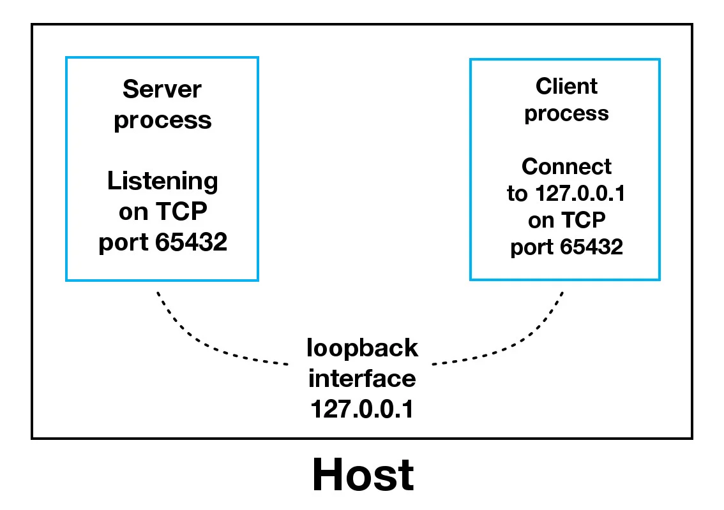

When using the loopback interface (IPv4 address 127.0.0.1 or IPv6 address ::1), data never leaves the host or touches the external network. In the diagram above, the loopback interface is contained inside the host. This represents the internal nature of the loopback interface and that connections and data that transit it are local to the host. This is why you’ll also hear the loopback interface and IP address 127.0.0.1 or ::1 referred to as “localhost.” Applications use the loopback interface to communicate with other processes running on the host and for security and isolation from the external network. Since it’s internal and accessible only from within the host, it’s not exposed. You can see this in action if you have an application server that uses its own private database. If it’s not a database used by other servers, it’s probably configured to listen for connections on the loopback interface only. If this is the case, other hosts on the network can’t connect to it. When you use an IP address other than 127.0.0.1 or ::1 in your applications, it’s probably bound to an Ethernet interface that’s connected to an external network. This is your gateway to other hosts outside of your “localhost” kingdom:

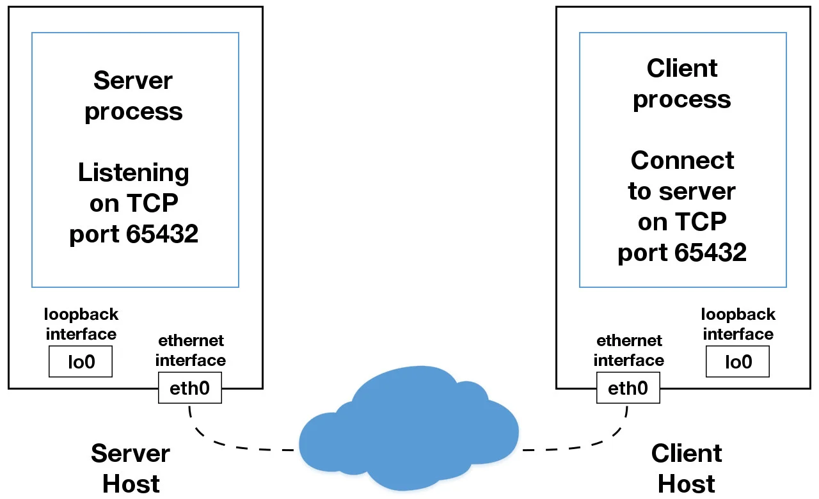

Adding the DB:
We are using MySQL Connector Python to connect MySQL.
Arguments required to connect MySQL from Python.
You need to know the following detail of the MySQL server to perform the connection from Python.
1. Username – i.e., the username that you use to work with MySQL Server. The default username for the MySQL database is a root
2. Password – Password is given by the user at the time of installing the MySQL database. If you are using root then you won’t need the password.
3. Host Name – is the server name or Ip address on which MySQL is running. if you are running on localhost, then you can use localhost, or it’s IP, i.e. 127.0.0.0
4. Database Name – Database name to which you want to connect. Here we are using Database named ‘Electronics‘ because we have already created this for our example.

First we need to run mySQL on new shell:
https://support.rackspace.com/how-to/install-mysql-server-on-the-ubuntu-operating-system/

$ sudo systemctl start mysql

Steps to connect MySQL database in Python using MySQL Connector Python:
1. installing mySQL connector python using pip.
2. Use the mysql.connector.connect() method of MySQL Connector Python with required parameters to connect MySQL.
3. Use the connection object returned by a connect() method to create a cursor object to perform Database Operations.
4. The cursor.execute() to execute SQL queries from Python.
5. Close the Cursor object using a cursor.close() and MySQL database connection using connection.close() after your work completes.
6. Catch Exception if any that may occur during this process.
