Project 2

House price predicting
A Realtor from Boston learned that some of their real estate sales staff underpriced certain properties leading to losses.
So, they would want to estimate the house prices as an independent process as a part of sales preparation steps. This would make help them know whether the agents are making a good judgment.
You have been hired to build a model to predict the house prices given certain key facts about the property itself.
To help you with your analysis, the Boston Realtor has prepared a dataset containing the average sales prices of properties in each district along with key facts such as crime rate in the neighborhood, how close the property is to the industrial park, whether close to a river or not, and nitrogen oxide level in the air, etc.
The variables are given below:
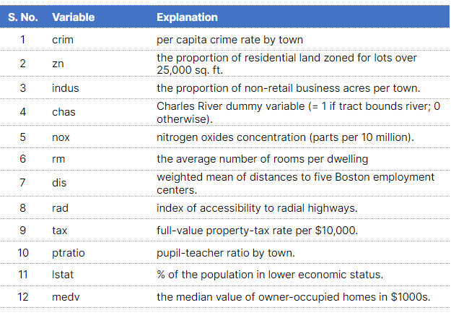Click here to download the House Price Dataset.

Expectations:
- Build a multiple linear regression model with the highest possible R-square value as well as make sure that all of the coefficients are significant.
- Find which variables are most important in explaining the median house prices.

Note:
In order to find the variable importance, the coefficients should be compared against each other. However, the values of each column must be of the same scale in order to do so. Therefore, the data must be scaled or normalized in order to compare the coefficients.
The formula for min-max scaling is given below:
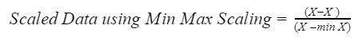
Scale the data and use it to build a model. Then compare the model coefficients.

