Project 1

Nutritional Fact Analysis of Coffee Shop Menu
A popular coffee shop has several beverages such as smoothies, coffee, tea, and iced beverages on its menu.
Beverages are sold in one of the four sizes such as short, tall, grande, and venti. The choice of milk such as whole milk, low fat (2%) milk, no fat milk, and soy milk are available for the beverages with dairy content.
The management of the coffee shop realized that its customers are becoming increasingly health-conscious and therefore, they decided to mark the low-calorie beverages and the healthier options with a special symbol so that the customers can identify them easily.
For instance, one of the popular hypotheses in the management board is that they would want to mark the beverages that use low-fat milk as ‘healthy’ or ‘heart-healthy’ because they presume that it would have fewer calories and lower total fat than the whole milk alternatives.
Similarly, they would want to know beverages are high in protein, high in fat, etc. So that special marketing effort can be planned around them.
For this analysis, the nutritional facts such as calories, total fat, trans fat, saturated fat, sugars, cholesterol, and protein are recorded for more than 30 Beverages on the menu. The facts are organized considering different choices of size and milk.
The variables used in the dataset are as follows:
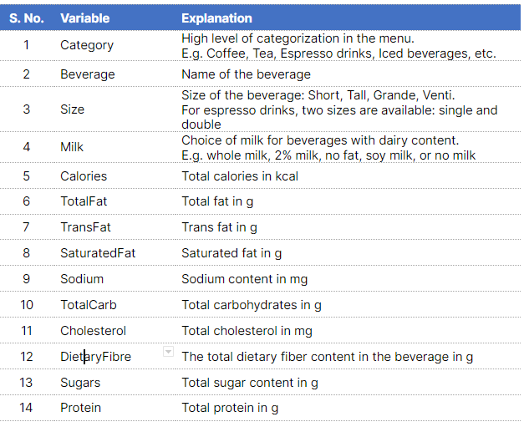
Click here to download the Coffee Shop Menu Dataset.

Expectations
You are a management consultant hired to analyze the nutritional fact of the coffee shop menu items.
There are 3 types of analysis you are expected to deliver.
Exploratory Data Analysis
Generate as many insights as possible on which beverage category, beverage, milk types are high and low on calories, fat, protein, carbs, sugar, and dietary fiber, etc.
Hypothesis testing
One of the popular beliefs among the management is that low-fat milk would the best in terms of calories as well as total fat therefore any beverage that uses low-fat milk should be marked as healthy or heart-healthy.
Conduct ANOVA or t-test to test this hypothesis.
Linear Regression
Also, the management wants to know if the calories can be predicted using a simple model so that they can easily calculate the calories going forward when they add a new item to the menu.
Conduct a linear regression analysis and build a multiple linear model that is simple enough so that it can be easily used to predict the calories.

