Containerizing: The process of taking an application and configuring it to run as a container.

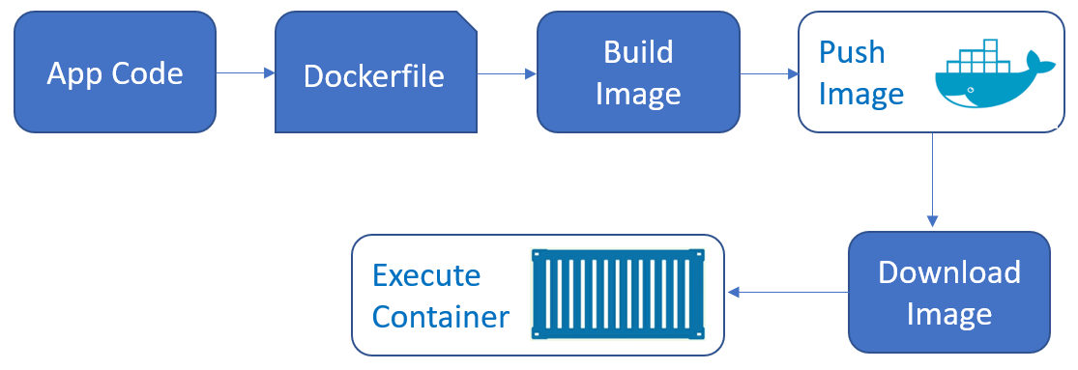

Docker File -> Docker Client’s Build -> Docker Image