engineering College – CoMputer software department
INSTRUCTORS NAME: Dr. Passent Elkafrawy
COURSE NAME: Software Engineering | COURSE NUMBER: CS3151 | SECTION: 3
Riman Almarri (S24109297) · Mays Almousa (S24109301) · Ghaliah Badokhon (S24109427)

Feasibility Study
Tempo – AI Marketing Co-Pilot

a feasibility study of Tempo, an AI-powered bilingual (Arabic/English) marketing co-pilot for solo marketers, SMEs, content creators, and agencies in Saudi Arabia. It assesses the project from technical, market, marketing, organizational, schedule, financial, and risk perspectives, and recommends a phased, MVP-first launch with controlled spending.

- Executive Summary
Saudi Arabia has more than 25 million active social media users and a fast-growing e-commerce sector, yet the tools its marketers depend on were built for Western markets. Solo marketers, SMEs, freelance creators and boutique agencies log into Snapchat, X, Instagram and Google Search Console separately, rewrite English-first AI output into Saudi Arabic, and compile reports by hand. In the market study survey of 47 Saudi marketing professionals (Riyadh and Jeddah, Q3 2026), the study estimates about 4 hours a week is lost to rewriting AI output, and respondents valued automated reports that save about 6 hours a week.
Tempo – AI Marketing Co-Pilot is a bilingual (Arabic/English) web platform that brings AI-assisted content creation, scheduling, social and website analytics, and automated reporting into one dashboard. It supports Snapchat, X and Instagram, connects to Google Search Console, and adds client workspaces and role-based access for agencies. Pricing is in SAR, with a freemium trial and a Starter plan at SAR 189 per month.
Market. The market study sizes the Saudi digital marketing SaaS market at SAR 3.5 billion (TAM, 2024), with a SAM of SAR 1.1 billion for SMEs and independent agencies and a Year 1 SOM of SAR 55 million. No incumbent combines Arabic AI content, Saudi platform scheduling and website analytics at an SME price. This study keeps its own revenue targets far below the SOM: Year 3 revenue of SAR 2,142,660 is about 0.19% of the SAM.
Technical feasibility. Tempo can be built as a modular web application on mainstream, proven technologies, using a commercial LLM API rather than a self-trained model. The main technical risks are external: access conditions and changes in the Snapchat, X and Instagram APIs, and the quality of Saudi-dialect AI output. Both are manageable through phased integration, a provider-independent AI layer and human review of generated content.
Financial feasibility. Using the assumptions in Section 8, pre-launch costs are about SAR 115,000 and total funding of SAR 1.0 million over two rounds covers the plan. Revenue is projected at SAR 176,625, 865,950 and 2,142,660 in Years 1 to 3, with net results of SAR (329,091), (328,949) and 153,050. Monthly operating break-even is reached in Year 3 at roughly 610 paying accounts; full recovery of invested capital falls after the three-year horizon.
Conclusion. Tempo is feasible on conditions, not unconditionally. It is technically and operationally achievable by a small team, and the market gap is well supported. The financial case depends on reaching about 600 paying accounts, which makes controlled, stage-gated spending essential. We recommend an MVP-first Saudi launch, with agency features and GCC expansion released only when defined validation targets are met.
- Description of Products and Services
Tempo is a subscription-based, mobile-responsive web platform that acts as a marketing co-pilot for the Saudi market. It replaces the daily routine of switching between four platforms, translating AI drafts and building reports in spreadsheets with a single bilingual workflow: plan and draft, schedule, measure, report.
Table 1. Core features of Tempo
Feature | What it does | Main users
Bilingual AI content (Arabic/English) | Drafts captions, post copy and campaign ideas from a short brief, in Arabic or English, with editable output. | All segments
Saudi-localised AI content | Tunes output to Saudi colloquial dialect (including Hijazi for Jeddah audiences), local occasions and cultural references instead of formal Modern Standard Arabic. | Solo marketers, SMEs, agencies
Content calendar and scheduling | One calendar for Snapchat, X and Instagram, with scheduled publishing (for example the 8–10 PM peak window noted in the personas). | All segments
Unified analytics dashboard | Reach, engagement and follower data from the three social platforms alongside website performance in one Arabic/English view. | All segments
Website analytics | Google Search Console data (queries, clicks, impressions, pages) shown next to social results. | SMEs, agencies
Automated reporting | Weekly performance reports generated automatically in Arabic and English; branded PDF export with client logo for agencies. | Solo marketers, agencies
Saudi-native insights | Trend and timing insights drawn from the Saudi platform mix (Snapchat, X, Instagram). | All segments
Agency client workspaces | Separate workspace per client, with fast switching and no repeated log-in. | Agencies
Role-based team access | Roles such as owner, admin, editor and viewer, so drafts can be assigned and approved inside the tool. | Agencies, SMEs with teams
Mobile-responsive dashboard | Full dashboard usable on phones for approvals and checks on the move; no native app is planned for the MVP. | All segments

  - Value for each user group
Solo marketers (persona: Nora, 28, e-commerce marketing manager) gain Saudi-dialect drafts in about 30 seconds and a weekly report without manual compilation, with a target of cutting weekly reporting from 6 hours to under 1. SMEs get an affordable, SAR-priced tool that covers content, scheduling and website results without hiring a specialist. Marketing agencies (persona: Khalid, 35, account manager with 8 clients) manage every client from one dashboard and issue branded bilingual reports in minutes; his scenario shows about 11 hours saved per week. Freelance content creators produce Arabic content for Snapchat and Instagram faster and keep one calendar across several brands.
  - Plans and pricing
The Starter price and the freemium/trial approach come from the market study. The Free and Agency tiers below are proposed for planning purposes and should be validated during the beta.
Table 2. Proposed plan structure
Plan | Price (SAR/month) | Intended for | Main limits and inclusions
Free / trial | 0 | Evaluation, creators | One workspace, limited AI generations, limited scheduled posts; no PDF branding
Starter | 189 (market study) | Solo marketers, SMEs | Three social platforms, Search Console, AI content, scheduling, weekly bilingual report
Agency (proposed) | 499 (assumption) | Boutique agencies | Multiple client workspaces, team roles, branded bilingual PDF reports, higher AI allowance

Prices are treated as excluding 15% VAT for financial modelling. Large in-house enterprise marketing teams, identified as a possible user group in the personas, are outside the three-year scope.
- Technology Considerations
Tempo is a software-only product, so technology is both the main cost and the main source of risk. The approach is to build the product-specific parts (workspaces, content studio, dashboard, reports) and buy everything else (cloud infrastructure, AI models, payments, email). The source documents do not specify technologies, so the choices below are proposed implementation choices that the team can revise during Sprint 0.
  - Proposed architecture
A single modular back-end (not microservices) keeps the system simple for a small team. A web front end calls a REST API; a background worker handles publishing, data collection and report generation; and an AI service layer isolates the LLM provider from the rest of the product.
Table 3. Proposed technology stack
Layer | Proposed technology | Purpose and notes
Front end (web, mobile-responsive) | React/Next.js with TypeScript, Tailwind CSS; progressive web app features | Right-to-left (RTL) Arabic and left-to-right English from one codebase; responsive layout for phones and desktops
Back end / API | Node.js with TypeScript (NestJS), REST API, background job queue (BullMQ on Redis) | Business logic, workspaces, scheduling, and queued jobs for publishing and data sync
Database | PostgreSQL; Redis for cache and queues; S3-compatible object storage | Relational data with a workspace identifier on every record for tenant separation; stored media and generated PDFs
AI / LLM integration | Commercial LLM API behind a provider-independent interface; prompt templates with Saudi-dialect style guides and examples | Content drafting and short insight summaries; human editing before publishing; provider can be swapped if cost or quality changes
Analytics | Scheduled collectors that store daily metrics per account; charts with Recharts or Chart.js; SQL aggregation (materialised views) | Unified dashboard and report data without a separate analytics platform at MVP stage
Authentication and authorisation | Email/password with optional multi-factor authentication, OAuth 2.0 for connecting accounts, role-based access control (owner, admin, editor, viewer) | Secure sign-in, per-workspace permissions for agency teams
Report generation | Server-side HTML-to-PDF rendering (headless Chromium) with Arabic-capable fonts and client logo templates | Bilingual, branded PDF reports with correct RTL layout
Cloud hosting | Containerised deployment on a cloud provider with a Saudi region (for example Google Cloud Dammam or Oracle Cloud Jeddah/Riyadh), subject to confirmation | Managed database and storage, automated backups, CI/CD; Saudi hosting supports data-residency expectations

  - External integrations and limitations
Table 4. Third-party integrations and associated risks
Integration | Use in Tempo | Constraint and planned response
Instagram (Meta Graph API) | Publishing and insights | Requires professional (Business/Creator) accounts and Meta app review. Apply for review in Sprint 0; support only professional accounts.
X API | Posting and analytics | Access is tiered, rate-limited and paid, and terms have changed before. Budget API fees, cache data, and queue requests within limits.
Snapchat APIs | Scheduling and analytics | Programmatic access is more restricted and approval-based; availability of each function must be confirmed with Snap. Release Snapchat after X and Instagram, with CSV import as a fallback for analytics.
Google Search Console API | Website search performance | Read-only OAuth access with quota limits. Low risk; schedule daily data pulls.
LLM provider API | Content and summaries | Per-use cost, rate limits and dialect quality vary. Use prompt tests, usage caps per plan and a provider-independent layer.

AI output quality. Generative models can produce inaccurate or off-tone text, and Saudi dialects, especially Hijazi, are less well covered than Modern Standard Arabic. Tempo therefore treats AI output as a draft: users edit before scheduling, a small evaluation set of Saudi-dialect briefs is scored by native speakers before each release, and user ratings feed prompt improvements.
  - Security, data protection and scalability
- Credentials and tokens: social-account access tokens encrypted at rest, minimum permission scopes requested, and tokens revocable by the user at any time.
- Application security: HTTPS everywhere, hashed passwords, rate limiting, input validation, audit logs for workspace actions, dependency scanning, and an external penetration test before the public launch (budgeted in Section 8).
- Privacy: Tempo stores account metrics and business content, and limited personal data on users. Design should follow the Saudi Personal Data Protection Law (PDPL), including consent, purpose limitation, deletion on request and clear privacy terms; legal counsel should confirm obligations before launch.
- Scalability: a stateless API, queue-based workers and managed database allow horizontal scaling. The expected load (hundreds to low thousands of accounts) is modest; the main scaling constraints are third-party rate limits and AI cost per user, not raw compute.
Cost and capability. Technology costs (cloud, AI usage, tools and security testing) are included in Section 8. The founding team has software-engineering training, and the stack uses widely documented tools, which keeps hiring and maintenance risk low. The AI/ML engineer hired in Year 2 will own prompt quality, evaluation and cost control.
- Product / Service Marketplace
Unless stated otherwise, figures in this section come from the Tempo Market Study.
  - Saudi digital marketing environment
Saudi Arabia has more than 25 million active social media users, and Vision 2030 is driving e-commerce and SME growth. Snapchat, X and Instagram dominate how Saudi consumers discover brands, but the tools available were designed elsewhere. Marketers therefore work around three gaps: weak Arabic AI, missing Snapchat support, and no single view that includes website results.
  - Customer segments
Table 5. Target segments (from the market study and personas)
Segment | Profile | Key pain point | Use
Solo marketers and SME owners | Manage their own social and website marketing (persona: Nora) | Four separate platforms; English-first AI; USD pricing | Daily
Boutique digital marketing agencies | Manage multiple client accounts (persona: Khalid, 8 clients) | 12+ hours a week compiling data; no multi-client workspaces at an affordable price; formal Arabic instead of client dialect | Daily
Freelance content creators | Produce Arabic content for brands on Snapchat and Instagram | Slow drafting and manual rewriting | Several times a week

Initial focus is on Riyadh, Jeddah and Dammam; expansion to the wider GCC follows.
  - Market size
Table 6. Market size (Tempo Market Study)
Measure | Value | Definition
TAM | SAR 3.5 billion (2024) | Saudi digital marketing SaaS market
SAM | SAR 1.1 billion | Portion serving SMEs and independent agencies
SOM (Year 1) | SAR 55 million | Solo marketers and boutique agencies in Riyadh, Jeddah and Dammam

The SOM is the market study's estimate of what is reachable, not a sales forecast. Tempo's own revenue plan (Section 8) is much smaller on purpose.
  - Competitors
Table 7. Competitor and feature comparison
 | Hootsuite | Buffer | Sprout Social | Jasper AI | Tempo
Monthly price (SAR) | 370 | 56 | 934 | 184 | 189 (Starter)
Entry plan at or below SAR 200 | ✕ | ✓ | ✕ | ✓ | ✓
Bilingual Arabic/English content | ✕ | ✕ | ✓ | ✓ | ✓
Saudi-native market insights | ✕ | ✕ | ✕ | ✕ | ✓

Prices and the bilingual and Saudi-insight rows are from the market study. The affordability row applies its own SAR 200 threshold to the listed prices.
Hootsuite and Buffer offer scheduling and basic analytics but no Arabic AI content and no Snapchat API integration. Sprout Social offers enterprise reporting and bilingual posting but prices out most Saudi SMEs. Jasper AI writes Arabic copy but has no scheduling, analytics or website performance features. Other options fall into the same three groups: global schedulers, enterprise suites (above SAR 900 per month) and AI writing assistants.
  - Demand, market gap and competitive advantage
In the market study survey of 47 Saudi marketing professionals, 68% valued all-in-one dashboards, 61% valued AI that drafts Arabic captions without manual translation, and 54% valued SAR pricing that avoids foreign-exchange risk. Reviews of competing tools on the App Store, Google Play and G2 point to the same gaps. The survey sample is small and limited to two cities, so it supports the existence of demand but not its size; the beta will test willingness to pay.
No incumbent offers a bilingual, Saudi-native, all-in-one tool at an SME price. Tempo's advantages are therefore (1) Arabic/English AI content with Saudi dialect focus, (2) direct Snapchat, X and Instagram scheduling, (3) social and website analytics in one dashboard with one weekly bilingual report, and (4) SAR pricing from SAR 189 with a freemium entry. These advantages can be copied over time, so speed to market and local content quality are the defensible parts.
Distribution. Tempo is sold directly online through its website, with self-service sign-up, in-product trial and card or local payment methods. No physical distribution is needed.
- Marketing Strategy
Positioning. Tempo is "the Saudi marketer's co-pilot": the only affordable tool that writes in Saudi Arabic, publishes to Snapchat, X and Instagram, and reports on social and website results together. All messaging stresses time saved (from the market study: about 4 hours of rewriting and 6 hours of reporting a week) rather than technology.
Pricing and trial. Entry through a free tier or trial lowers risk for SMEs; Starter at SAR 189 per month is close to Jasper AI (SAR 184, content generation only) and far below Hootsuite (SAR 370) and Sprout Social (SAR 934). The planning assumption is that about one in nine free or trial users becomes a paying account. Agency pricing (SAR 499, assumed) will be tested with the first agencies.
  - Phased go-to-market
Table 8. Launch phases
Phase | Timing | Focus | Main actions
1. Pre-launch | Q4 2026 | Validate and build a waitlist | Landing page, prototype demos in Riyadh and Jeddah, survey follow-ups, invitations to beta
2. Saudi launch | Q1 2027 | Solo marketers, SMEs, creators in Riyadh, Jeddah, Dammam | Public release of freemium and Starter, Arabic social content, creator partnerships
3. Agency expansion | H1 2027 | Boutique agencies | Agency workspaces and branded reports, outreach to agencies, case studies from Khalid-type users
4. GCC expansion | H2 2027 onward | Selected GCC markets | Pilot in one or two GCC countries after validation gate (Section 10); localise dialects and payments

The market study places the Saudi launch in Q4 2026. This plan treats Q4 2026 as the pre-launch stage and opens paid access in Q1 2027, so the MVP can be tested before charging customers.
  - Channels and activities
- Social media and content: Arabic-first posts and short videos on Snapchat, Instagram and X showing real workflows (for example, "a week of content in 10 minutes"); Tempo uses its own product for this.
- SME outreach: free workshops and webinars with chambers of commerce, coworking spaces and e-commerce communities in the three launch cities.
- Agency outreach: direct approach to boutique agencies through LinkedIn and referrals, with a pilot offer in exchange for feedback and a named case study.
- Partnerships and ecosystem: university entrepreneurship and marketing programmes, startup incubators and accelerators, and Saudi content-creator communities.
- Search and website: bilingual SEO content on Saudi social media marketing, and a referral programme (one free month for each referred paying account).
  - Acquisition budget, retention and targets
Year 1 marketing spend is SAR 90,000: content and paid social SAR 35,000, creator partnerships SAR 15,000, events and workshops SAR 15,000, referral incentives SAR 15,000, and website and SEO SAR 10,000. Spend rises to SAR 180,000 in Year 2 and SAR 300,000 in Year 3 as agencies and GCC pilots are added.
Retention relies on habits the product creates: the Monday weekly report, the content calendar, and agency client workspaces that are costly to rebuild elsewhere. The team will track activation (first post scheduled within 7 days), free-to-paid conversion, monthly churn and hours saved, and contact churned users within a week.
- Organization and Staffing
Tempo starts as a three-person founding team with part-time marketing support and grows to eight people by Year 3. Roles are combined at first so that each hire is added only when its workload and revenue justify it. All staff report through the Product/Project Manager, who acts as the founding lead. The team works from Riyadh and Jeddah with remote collaboration, using a coworking space.
Table 9. Roles and responsibilities
Role | Main responsibilities | Y1 | Y2 | Y3
Product / Project Manager (founder) | Product backlog, sprint planning, requirements and persona validation, partner and funding relations, financial tracking | 1 | 1 | 1
Backend & AI-integration Developer (founder) | API, database, social and Search Console integrations, publishing queue, security | 1 | 1 | 1
Frontend & UX Developer (founder) | Bilingual RTL/LTR interface, dashboard, calendar and workspace screens, responsive design | 1 | 1 | 1
AI / ML Engineer | Prompt design, Saudi-dialect evaluation, AI cost control, content-safety checks | – | 1 | 1
Marketing & Sales Executive | Launch campaigns, SME and agency outreach, partnerships, onboarding calls | 0.5 | 1 | 1
Customer Support Specialist | Support by chat and email in Arabic and English, feedback collection, help content | – | 1 | 1
UI/UX Designer | Design system, usability testing, report templates (contract in Year 1, full time in Year 3) | Contract | – | 1
Agency & GCC Sales Executive | Agency accounts, GCC pilots, partner channels | – | – | 1
Total full-time equivalents |  | 3.5 | 6 | 8

Founders are assumed to take reduced stipends and hold equity, which is why early salaries are below market rates (Table 17). Accounting, legal and penetration testing are outsourced.
Operational feasibility. The founders can deliver the MVP, and Year 1 depends on their time commitment and on keeping scope tight. The main staffing risks are founder overload before the Year 2 hires and dependence on a few key people; documentation, code review and shared ownership of each integration reduce both.
- Schedule
The schedule below is a high-level guideline for an MVP-first launch; a detailed sprint plan will be created if the project is approved. Platform developer-account and API access applications are started in the first weeks because approvals can take time.
Table 10. Implementation milestones
No. | Milestone | Target date
1 | Requirements analysis: market study, personas, feasibility study | Aug – Oct 2026
2 | Sprint 0: architecture, repositories, CI/CD, cloud environments; apply for Meta, X, Snap and Google API access | Oct 2026
3 | UI/UX design and clickable bilingual prototype | Oct – Nov 2026
4 | Waitlist and prototype demos in Riyadh and Jeddah | Nov – Dec 2026
5 | Core MVP: sign-up, workspaces, AI Content Studio, calendar, X and Instagram publishing | Nov 2026 – Jan 2027
6 | Analytics: Google Search Console, unified dashboard, weekly bilingual report | Dec 2026 – Feb 2027
7 | Testing: automated tests, Arabic content evaluation, security review and penetration test | Jan – Feb 2027
8 | Closed beta with about 40 invited users | Jan – Feb 2027
9 | Public Saudi launch: freemium and Starter (Riyadh, Jeddah, Dammam) | End of Feb 2027
10 | Snapchat integration (subject to platform approval) | Feb – Apr 2027
11 | Feedback and iteration: monthly releases based on beta and launch data | Mar – Apr 2027
12 | Agency features: client workspaces, role-based access, branded bilingual PDF reports | Apr – Jun 2027
13 | GCC readiness and pilot, if validation gate is met | Jul – Dec 2027

The schedule is tight for a small team. If Snapchat approval or the beta runs late, the launch scope should be reduced (X and Instagram first) rather than the date moved.
- Financial Projections
All figures are in Saudi Riyals (SAR) and are estimates based on assumptions made for this study. Only the Starter price (SAR 189), the market sizes and the survey results come from the source documents; every other number is an academic assumption, to be replaced with actual data from the beta. Years are calendar years: Year 1 is 2027, Year 2 is 2028 and Year 3 is 2029. Prices exclude VAT.
  - Key assumptions
Table 11. Planning assumptions
Item | Assumption
Plans and mix | Starter SAR 189 and Agency SAR 499 per month, monthly billing, no annual discount. Starter share of paying accounts: 85% (Y1), 80% (Y2), 75% (Y3)
Average revenue per account (ARPU) | Y1: 0.85 × 189 + 0.15 × 499 = SAR 235.50; Y2: SAR 251.00; Y3: SAR 266.50 per month
Paying accounts (end of year, net of churn) | Y1: 150; Y2: 450; Y3: 950. Quarterly path in Table 13; growth is linear within each quarter
Free/trial users | Eight free or trial users per paying account on average (about 11% conversion)
AI usage cost | SAR 16 per paying account per month and SAR 1.5 per free user per month (SAR 28 per paying account including its free users)
Payment processing | 2.5% of revenue
Cloud hosting | SAR 24,000 (Y1), 54,000 (Y2), 108,000 (Y3)
Salaries | Fully loaded monthly cost per role (Table 17)
Depreciation | Laptops and equipment over 3 years, straight line
Zakat | Simplified to 2.5% of positive operating profit (actual zakat base to be confirmed with an accountant)
Accounts payable | One month of AI, hosting and payment costs at year end; no receivables because customers pay by card in advance

  - Start-up costs (pre-launch, Oct – Dec 2026)
Table 12. Start-up costs (estimated)
Item | SAR
Founder stipends (3 x SAR 6,000 x 3 months) | 54,000
UI/UX design contract (prototype, design system) | 15,000
Company registration, trademark and legal setup | 8,000
Development tools, cloud sandbox and domains | 6,000
AI API testing credits (prompt and dialect tuning) | 4,000
Beta and waitlist marketing | 10,000
Laptops and equipment (capitalised, 3 x SAR 6,000) | 18,000
Total start-up costs | 115,000

SAR 18,000 of equipment is capitalised; the other SAR 97,000 is expensed in the pre-launch period.
  - Revenue
Table 13. Paying accounts and subscription revenue
 | Year 1 (2027) | Year 2 (2028) | Year 3 (2029)
Paying accounts, end Q1 / Q2 / Q3 / Q4 | 20 / 55 / 100 / 150 | 210 / 280 / 360 / 450 | 540 / 650 / 790 / 950
Paying accounts at year end | 150 | 450 | 950
Account-months (sum of quarterly averages × 3) | 750 | 3,450 | 8,040
ARPU (SAR per month) | 235.50 | 251.00 | 266.50
Subscription revenue (SAR) | 176,625 | 865,950 | 2,142,660

Example, Year 1: account-months = (0+20)/2×3 + (20+55)/2×3 + (55+100)/2×3 + (100+150)/2×3 = 750; revenue = 750 × 235.50 = SAR 176,625.
  - Income statement (estimated)
Table 14. Income statement (SAR; brackets are deductions or losses)
 | Year 1 | Year 2 | Year 3
Sales (subscription revenue) | 176,625 | 865,950 | 2,142,660
Cost of sales (AI usage, payment fees, cloud hosting) | (49,416) | (172,249) | (386,686)
Net sales (gross profit) | 127,209 | 693,701 | 1,755,974
Salaries | (276,000) | (684,000) | (1,056,000)
Marketing | (90,000) | (180,000) | (300,000)
Software and tools | (18,000) | (30,000) | (48,000)
Legal, accounting and compliance | (24,000) | (30,000) | (40,000)
Coworking and office | (24,000) | (48,000) | (72,000)
Security testing and audits | (10,000) | (25,000) | (40,000)
Miscellaneous (5% of other expenses) | (8,300) | (15,650) | (25,000)
Depreciation | (6,000) | (10,000) | (18,000)
Administrative and marketing expenses (total) | (456,300) | (1,022,650) | (1,599,000)
Operating profit | (329,091) | (328,949) | 156,974
Zakat | 0 | 0 | (3,924)
Net profit | (329,091) | (328,949) | 153,050

Gross margin is about 72%, 80% and 82% in Years 1 to 3. Losses in Years 1 and 2 reflect the team and marketing spend ahead of revenue; Year 3 shows a small profit of SAR 153,050.
  - Balance sheet and sources of financing (estimated, at year end)
Table 15. Balance sheet (SAR)
 | Year 1 | Year 2 | Year 3
Current assets (cash) | 166,027 | 245,314 | 414,158
Fixed assets (net) | 12,000 | 14,000 | 20,000
Total assets | 178,027 | 259,314 | 434,158
Current liabilities (payables and zakat) | 4,118 | 14,354 | 36,148
Long-term liabilities | 0 | 0 | 0
Equity: paid-in capital | 600,000 | 1,000,000 | 1,000,000
Equity: retained earnings (deficit) | (426,091) | (755,040) | (601,990)
Total equity | 173,909 | 244,960 | 398,010
Total liabilities and equity | 178,027 | 259,314 | 434,158

Total assets equal total liabilities plus equity in every year. The plan is financed entirely by equity: SAR 600,000 in Q4 2026 (assumed SAR 100,000 from the founders and SAR 500,000 from a seed investor, grant or incubator programme) and a further SAR 400,000 in January 2028. No source of funding has been secured; these are planning assumptions. Opening retained deficit of SAR 97,000 is the pre-launch expense.
  - Cash flow statement (estimated)
Table 16. Cash flow statement (SAR)
 | Year 1 | Year 2 | Year 3
Cash flows from operating activities | (318,973) | (308,713) | 192,844
Cash flows from investing activities (equipment) | 0 | (12,000) | (24,000)
Cash flows from financing activities | 0 | 400,000 | 0
Net cash flows | (318,973) | 79,287 | 168,844
Cash balance at the beginning of the period | 485,000 | 166,027 | 245,314
Cash balance at the end of the period | 166,027 | 245,314 | 414,158

Opening cash on 1 January 2027 is SAR 485,000 (SAR 600,000 raised less SAR 115,000 pre-launch spending). Cash falls to SAR 166,027 at the end of Year 1, which is why the second funding round is needed before Year 2 spending increases.
Table 17. Monthly staff cost assumption (SAR, fully loaded)
Role | Year 1 | Year 2 | Year 3
Product / Project Manager (founder) | 6,000 | 9,000 | 12,000
Backend & AI-integration Developer (founder) | 6,000 | 9,000 | 12,000
Frontend & UX Developer (founder) | 6,000 | 9,000 | 12,000
AI / ML Engineer | – | 14,000 | 15,000
Marketing & Sales Executive | 4,000 | 9,000 | 9,500
Customer Support Specialist | – | 7,000 | 7,500
UI/UX Designer | 1,000 | – | 11,000
Agency & GCC Sales Executive | – | – | 9,000
Total monthly | 23,000 | 57,000 | 88,000
Total annual (included in Table 14) | 276,000 | 684,000 | 1,056,000

Year 1 marketing is a 0.5 FTE (SAR 8,000 per month full-time equivalent) and the designer is a SAR 12,000 annual retainer.
  - Break-even and sustainability
Table 18. Operating break-even analysis (SAR)
 | Year 1 | Year 2 | Year 3
Fixed monthly costs (administrative expenses + hosting) ÷ 12 | 40,025 | 89,721 | 142,250
Variable cost per paying account-month (AI, free users, payment fees) | 33.89 | 34.27 | 34.66
Contribution per account-month (ARPU – variable cost) | 201.61 | 216.72 | 231.84
Paying accounts needed to break even | 199 | 414 | 614
Average paying accounts in the year | 62 | 288 | 670

On Year 3 costs, Tempo needs about 610 paying accounts to cover monthly costs. The plan passes that level during the second quarter of Year 3 (650 accounts at the end of Q2), so monthly operating break-even is expected in mid-2029, with a full-year profit in Year 3. Cumulative results are still negative at the end of Year 3 (retained deficit of SAR 601,990), so investors would recover their capital only after the three-year horizon. Contribution per account is high (about SAR 230), so the business model is sound if customer numbers are reached.
  - Sensitivity
If paying accounts reach only 70% of plan, revenue falls to SAR 123,637, 606,165 and 1,499,862 and results to SAR (374,454), (553,259) and (402,218) (net, before zakat). Cash is then exhausted around the end of Year 2 unless costs are reduced, so hiring in Years 2 and 3 must be tied to actual customer numbers (see the validation gates in Section 10). In a downside case the team can delay the AI/ML, support and Year 3 hires, which would reduce salary costs by about SAR 252,000 in Year 2 and SAR 510,000 in Year 3.
- General Risk Factors
The main risks are listed below with their likelihood and impact (H = high, M = medium, L = low) and the planned response.
Table 19. Risk register
Risk | L | I | Mitigation
Dependence on third-party APIs (Snapchat, X, Instagram): access denied, delayed or removed | H | H | Start approvals in Sprint 0; launch X and Instagram first; build each integration behind an adapter; CSV import fallback; communicate limits to users
Platform policy, pricing and rate-limit changes | H | M | Monitor developer announcements; cache data; budget API fees; avoid features that depend on a single endpoint
Competition: global tools add Arabic AI or lower prices | M | H | Focus on Saudi dialect quality, local insights and agency workflow; keep SAR pricing and local support; release quickly
Slow customer acquisition and low free-to-paid conversion | M | H | Stage-gated spending; early agency pilots; track conversion weekly; adjust pricing and onboarding using beta data
AI output quality, errors or unsuitable content | M | H | Human review before publishing; native-speaker evaluation set; content filters; user ratings and prompt improvement
Weak Saudi/Hijazi dialect quality | M | M | Dialect-specific prompts and examples; test with users from each city; AI/ML engineer owns dialect quality
Data privacy non-compliance (PDPL) | L | H | Privacy-by-design, minimal data, clear consent and deletion, legal review before launch, Saudi-region hosting
Cybersecurity incident or token theft | L | H | Encryption, least-privilege scopes, MFA, audit logs, penetration test, incident response plan
AI usage costs exceed assumptions | M | M | Usage caps per plan, caching, lower-cost models for simple tasks, provider-independent layer
Scalability and performance | L | M | Stateless design, queued jobs, managed services, load tests before launch
Schedule delay or founder overload | M | M | Tight MVP scope, two-week sprints, reduce scope instead of moving date, hire when gates are met
Financial uncertainty and funding not secured | M | H | Spend only against gates; keep a cash reserve; prepare downside plan (Section 8); seek grants and incubator support

- Findings and Recommendations
Based on this study, we recommend that the project proceed, but only as an MVP-first, stage-gated launch. Tempo is feasible under the conditions below; it is not a low-risk project, and its financial return depends on reaching roughly 600 paying accounts.
Table 20. Feasibility conclusions
Dimension | Conclusion | Feasible if
Technical | Feasible | Core features use proven tools. Snapchat access is confirmed or replaced by a fallback, and AI dialect quality passes beta evaluation.
Operational | Feasible with limits | Three founders commit full time; hires are added only as revenue and gates allow; support and report quality hold as users grow.
Market | Feasible | Beta users confirm the survey results and willingness to pay SAR 189; agencies adopt the Agency plan.
Financial | Conditionally feasible | About SAR 1.0 million is raised in two stages; spending follows validation; accounts grow to roughly 600 or more within three years.

Key findings are as follows:
Technology:
- A modular web stack and a commercial LLM API keep build effort within the reach of a small team.
- Third-party API access, especially Snapchat, is the largest technical uncertainty and sets the release order.
Marketing:
- A real gap exists: no incumbent offers bilingual, Saudi-native, all-in-one marketing at an SME price.
- The survey sample (47 people in two cities) is small, so demand must be re-tested in the beta.
Organizational:
- A team of 3.5 FTE in Year 1 growing to 8 by Year 3 is realistic and avoids early fixed costs.
Financial:
- Gross margin is about 72–82% over the three years, so each additional account adds roughly SAR 200 to SAR 230 of monthly contribution.
- Net losses are expected in Years 1 and 2 (SAR 329,091 and SAR 328,949) and a small profit in Year 3 (SAR 153,050); capital is not recovered within three years.
  - Recommended validation gates
Table 21. Stage gates for releasing spending
Gate | When | Evidence required | Decision if met
1. Public launch | Feb 2027 | About 40 beta users; most rate Arabic output as usable with light editing; X and Instagram publishing stable; security test passed | Open paid access and start Starter marketing
2. Agency and hiring | Jun 2027 | At least 55 paying accounts; monthly churn at or below 5%; at least 5 agencies in pilot | Release agency features; plan Year 2 hires
3. GCC pilot | Sep 2027 | At least 100 paying accounts; positive contribution per account; second funding round progressing | Start a GCC pilot in one country
4. Scale | Jan 2028 | About 150 paying accounts and second round closed | Hire AI/ML engineer, support and sales

If a gate is missed, the team should extend the previous phase, change pricing or positioning, or reduce costs before spending more. This approach limits the amount at risk before the idea is proven (about SAR 115,000 before launch and about SAR 440,000 in total by the end of Year 1).

engineering College – CoMputer software department
INSTRUCTORS NAME: Dr. Passent Elkafrawy
COURSE NAME: Software Engineering | COURSE NUMBER: CS3151 | SECTION: 3
Riman Almarri (S24109297) · Mays Almousa (S24109301) · Ghaliah Badokhon (S24109427)

Market Study
Tempo – AI Marketing Co-Pilot

a market research investigation into the Saudi Arabian digital marketing tools landscape. Tempo is an AI-powered marketing co-pilot that helps solo marketers, SMEs, and agencies in Saudi Arabia manage social media and website analytics from one bilingual (Arabic/English) dashboard, replacing fragmented manual workflows with automated AI-generated insights aligned to Vision 2030 growth priorities.

- Introduction

Saudi Arabia is home to more than 25 million active social media users and a rapidly expanding e-commerce sector driven by Vision 2030. Despite this, marketing professionals in the Kingdom face a critical gap: existing tools were built for Western markets, lack Arabic-language AI capabilities, and do not integrate the Saudi-dominant platforms — Snapchat, X (Twitter), and Instagram — with website analytics in a single dashboard. Tempo addresses this unmet need by delivering a unified, bilingual marketing intelligence platform purpose-built for the Saudi market.

- Competitor Analysis

Four tools dominate the digital marketing SaaS space globally but fall short of Saudi market requirements. Hootsuite (SAR 370/month) and Buffer (SAR 56/month) offer social scheduling and basic analytics but provide no Arabic-language AI content generation and lack Snapchat API integration. Sprout Social (SAR 934/month) offers enterprise-grade reporting and bilingual posting but targets large organisations and prices out Saudi SMEs. Jasper AI (SAR 184/month) generates marketing copy in multiple languages including Arabic, yet it is a pure content-generation tool with no scheduling, analytics, or website performance features. No incumbent offers a unified social-plus-website analytics product at an SME-accessible SAR price point with native Arabic content support tailored to Saudi platforms.

  - Existing Solutions
Current solutions available to Saudi marketers fall into three categories: (1) Global scheduling tools (Hootsuite, Buffer, Later) that lack Arabic AI and Snapchat support; (2) Enterprise social suites (Sprout Social, Brandwatch) priced above SAR 900/month, beyond SME reach; (3) AI writing assistants (Jasper, Copy.ai) that generate Arabic text but offer no publishing or analytics. None of these solutions combine bilingual content generation, Saudi platform scheduling, and website performance tracking in a single, affordable product.

- Feature Comparison

Feature | Hootsuite | Buffer | Sprout Social | Jasper AI | Our Project
Bilingual Arabic/English content | ✕ | ✕ | ✓ | ✓ | ✓
Automated reporting & analytics | ✕ | ✕ | ✓ | ✓ | ✓
Affordable entry plan (≤ SAR 200/mo) | ✓ | ✓ | ✕ | ✕ | ✓
Saudi-native market insights | ✕ | ✕ | ✕ | ✕ | ✓
Content scheduling & calendar | ✓ | ✓ | ✓ | ✓ | ✓
Unified social + website analytics | ✓ | ✓ | ✓ | ✓ | ✓

- Customer Feedback Analysis
To validate Tempo’s product positioning, reviews of competing tools were analysed across the Apple App Store, Google Play Store, and G2 Crowd, alongside a survey of 47 Saudi marketing professionals conducted in Riyadh and Jeddah during Q3 2026.

  - Positive Feedback
- Users appreciate all-in-one dashboards that eliminate switching between multiple tools (cited by 68% of survey respondents); AI tools that draft social captions in Arabic without manual translation (61%); affordable pricing structured in SAR that avoids foreign-exchange risk (54%); and automated weekly performance reports that save an average of 6 hours per week.

  - Negative Feedback & Market Gaps
- Lack of: existing tools lack Arabic AI content generation capable of capturing Saudi colloquial dialect and cultural nuance, forcing marketers to manually rewrite AI output and costing an estimated 4 hours per week.
- No existing tool integrates Snapchat Creator Studio, X Analytics, Instagram Insights, and Google Search Console into a single Arabic-language dashboard — marketers must log into four separate platforms and manually consolidate data.

- Market Opportunity & Differentiation
Saudi Arabia's digital marketing SaaS market is valued at SAR 3.5 billion TAM (2024), with a serviceable addressable market (SAM) of SAR 1.1 billion targeting SMEs and independent agencies. Tempo's serviceable obtainable market (SOM) in Year 1 is SAR 55 million, targeting solo marketers and boutique agencies in Riyadh, Jeddah, and Dammam. Tempo differentiates itself by:
- Offering the only bilingual Arabic/English AI content suite with direct Snapchat, X, and Instagram scheduling built for the Saudi market.
- Unifying social media and website analytics in a single dashboard — replacing four separate platform logins with one automated weekly report in Arabic and English.
- Pricing entirely in SAR with a Starter plan at SAR 189/month and a freemium trial, removing the foreign-exchange and onboarding barriers that lock Saudi SMEs out of global tools.

- Conclusion
The market study confirms a clear and commercially significant opportunity for Tempo in Saudi Arabia. Saudi marketing professionals spend hours each week manually consolidating data from four or more tools, translating AI output from English, and working around platform gaps — a pain point no incumbent resolves. The competitive landscape has no bilingual, Saudi-native, all-in-one tool at an SME price point. Tempo’s phased go-to-market — launching in Riyadh and Jeddah in Q4 2026, scaling to agencies in H1 2027, and entering the GCC in H2 2027 — targets a market that is ready for a purpose-built solution.

engineering College – CoMputer sCIENCE DEPARTMENT
INSTRUCTORS NAME: Dr. Passent Elkafrawy
COURSE NAME: Software Engineering | COURSE NUMBER: CS3151 | SECTION: 3
STUDENTS: Riman Almarri (S24109297) · Mays Almousa (S24109301) · Ghaliah Badokhon (S24109427)

Lab Objectives:
- Identify target users for the software project
- Develop realistic user personas
- Map personas to software requirements
- Apply user-centered design thinking

Part 1: Identify User Groups
Task: List all potential user groups of your system.

Deliverable:
User Group | Role | Frequency of Use | Technical Level
Solo Marketers & SME Owners | Manages own social media & website marketing on Saudi platforms | Daily | Intermediate
Digital Marketing Agencies | Manages multiple client social media accounts at a Saudi agency | Daily | Intermediate–Advanced
Freelance Content Creators | Produces Arabic content for brands on Snapchat & Instagram | Several times/week | Beginner–Intermediate
Enterprise Marketing Departments | In-house teams at large Saudi corporations needing unified analytics | Daily | Advanced

Part 2: Persona Creation
Create 2–3 personas using the following template:

Persona Name: | Nora Al-Shamrani
Age: | 28
Education: | Bachelor of Business Administration – Marketing, King Abdulaziz University, Jeddah
Role: | Digital Marketing Manager at a mid-sized Saudi e-commerce fashion brand
Goals: | Manage Snapchat, X, and Instagram campaigns from one bilingual dashboard; reduce weekly reporting time from 6 hours to under 1 hour; generate Arabic-language AI content that resonates with Saudi audiences.
Motivations: | Impress her manager with clear, data-driven ROI reports; stay competitive as Saudi consumers increasingly discover brands on Snapchat and Instagram Reels; avoid expensive enterprise tools priced in USD.
Pain Points: | Switches between 4 separate platforms (Snapchat Creator Studio, X Analytics, Instagram Insights, Google Search Console); AI writing tools generate generic English copy she must manually translate and rewrite in Saudi dialect; subscription prices in USD create unpredictable costs.
Technical Skill Level: | Intermediate – comfortable using SaaS marketing tools; not a developer; prefers intuitive UI over technical setup.
Usage Context: | Daily use on desktop in her Riyadh office and on mobile during commutes; posts primarily between 8–10 PM Saudi time (peak Saudi Snapchat engagement); needs a mobile-responsive interface for on-the-go approvals.
Persona 2: Khalid Al-Otaibi
Persona Name: | Khalid Al-Otaibi
Age: | 35
Education: | Master of Business Administration (MBA), King Fahd University of Petroleum & Minerals
Role: | Senior Account Manager at a boutique digital marketing agency in Jeddah (manages 8 client accounts)
Goals: | Manage all client accounts from one dashboard; generate bilingual (Arabic/English) branded performance reports weekly; scale team capacity by automating content calendars; win new SME clients by offering premium AI-powered analytics.
Motivations: | Differentiate his agency in a competitive Jeddah market; reduce junior team members’ hours spent on manual reporting; deliver measurable ROI evidence to Saudi retail and F&B clients who demand Arabic-language outputs.
Pain Points: | No tool supports multi-account management with per-client workspaces at an agency-accessible price; manually compiling data from four platforms takes his team 12+ hours per week; existing Arabic AI tools produce formal Modern Standard Arabic, not the Hijazi dialect his clients prefer.
Technical Skill Level: | Advanced – experienced with multiple SaaS platforms and comfortable with API integrations; expects team-based access controls and role permissions.
Usage Context: | Primarily desktop use in the Jeddah office; generates client reports every Monday morning; accesses dashboards during client presentation calls; his team of 4 also needs simultaneous access to different client workspaces.

Part 3: Persona to Requirements Mapping
Map each persona to required system features.

Persona | Feature Needed | Priority
Nora (Solo Marketer) | Bilingual Arabic/English AI content drafting | High
Nora (Solo Marketer) | One-click content scheduling to Snapchat, X & Instagram | High
Nora (Solo Marketer) | Automated weekly performance report in Arabic | High
Nora (Solo Marketer) | SAR-denominated pricing with freemium tier | High
Nora (Solo Marketer) | Mobile-responsive dashboard | Medium
Khalid (Agency Manager) | Multi-account client workspace management | High
Khalid (Agency Manager) | Branded bilingual PDF report export | High
Khalid (Agency Manager) | Unified social + website analytics (Google Search Console) | High
Khalid (Agency Manager) | Team role-based access control | Medium
Khalid (Agency Manager) | Saudi-native platform insights (Snapchat, X trends) | High

Part 4: Scenarios & User Stories
Write:
- One usage scenario per persona
- Two user stories per persona

User Story Format:
As a [persona], I want to [goal] so that [benefit].
Persona 1 – Scenario: Nora’s Monday Planning Session
It is Monday morning and Nora opens Tempo on her laptop in her Riyadh office. She navigates to the AI Content Studio and types a brief for this week’s Eid al-Adha campaign. The AI generates three Snapchat captions and two Instagram Reels descriptions in Saudi Arabic within 30 seconds. Nora edits one caption to add a local Riyadh reference, then schedules all posts across Snapchat, X, and Instagram directly from Tempo’s unified calendar for 9 PM Saudi time. She then clicks “Generate Weekly Report” — Tempo compiles last week’s reach, engagement, and website traffic from all four platforms into a bilingual PDF. She shares the link with her manager in two clicks.
User Stories – Persona 1 (Nora):
1. As a solo marketer, I want to generate Snapchat and Instagram captions in Saudi Arabic dialect so that I can connect authentically with my audience without spending hours on manual translation and rewriting.
2. As a solo marketer, I want to view all my social media and website analytics in a single Arabic-language dashboard so that I can make informed, data-driven decisions without logging into four separate platforms.
Persona 2 – Scenario: Khalid’s Weekly Client Reporting
Every Monday morning, Khalid opens Tempo and selects his agency’s dashboard. He switches between eight client workspaces, reviewing each client’s performance summary. For three high-priority retail clients, he clicks “Generate Branded Report” — Tempo produces fully-formatted, bilingual PDF reports in Arabic and English with the client’s logo automatically applied. He assigns the week’s content calendar drafts to two junior team members via Tempo’s role-based workspace, eliminating the need for email chains. Total time saved compared to his previous manual process: 11 hours per week.
User Stories – Persona 2 (Khalid):
1. As an agency account manager, I want to manage all my client accounts from a single dashboard so that I can switch between client workspaces without logging out and back in, reducing context-switching time.
2. As an agency account manager, I want to generate branded bilingual (Arabic/English) PDF reports automatically so that I can deliver professional, client-ready insights in under 5 minutes instead of spending 3 hours manually compiling data from multiple platforms.

Submission:
- Personas (2–3)
- Persona-feature mapping
- User stories

Assessment Criteria:
Criterion | Marks
Persona realism & clarity | 30%
Alignment with project idea | 30%
Requirements mapping | 20%
Scenarios & user stories | 20%

INSTRUCTORS NAME: Dr. Passent Elkafrawy
COURSE NAME: Software Engineering | COURSE NUMBER: CS3151 | SECTION: 1, 2, 3

Lab Objectives:
- Identify actors and user goals from personas and requirements.
- Define and prioritize a use case list using MoSCoW.
- Write both brief and fully dressed use case specifications.
- Draw a Use Case Diagram with correct system boundary, includes/extends, and generalisation.
- Elaborate behavior with Activity and Sequence Diagrams.
- Extract a Domain Model (Class Diagram) from the problem domain.
- Check consistency across artifacts and conduct a peer review.

D1 – Actor Definitions & Use Case List
Part 1: Actor Definitions
All external actors interacting with Tempo, mapped directly from the Lab 2 personas.
Actor | Type | Description | Persona Mapping
Solo Marketer (Nora) | Primary Human | Authenticated user managing social media for a single brand. Connects accounts, schedules posts, views analytics, exports reports. | Nora Al-Shamrani – Digital Marketing Manager, Riyadh
Agency Manager (Khalid) | Primary Human | Power user managing multiple client workspaces. Needs multi-workspace support, team permissions, and branded bilingual PDF exports. | Khalid Al-Otaibi – Agency Account Manager, Jeddah
Social Media Platform API | External System | Instagram Graph API, Snapchat Marketing API, X API v2 – used to post content, retrieve metrics and sync account data. | —
Website Analytics System | External System | Google Analytics / custom tracking integration feeding website traffic data into Tempo dashboards. | —
AI Engine | Internal System | LLM-based content generation and analytics insight module. Generates Vision 2030-aligned content suggestions. | —

Part 2: Use Case List (MoSCoW Prioritisation)
UC# | Use Case Name | Actor(s) | Priority | Goal
UC01 | Connect Social Media Account | Solo Marketer, Agency Manager | Must | Link Instagram, Snapchat, or X account to a Tempo workspace.
UC02 | View Unified Dashboard | Solo Marketer, Agency Manager | Must | See real-time KPIs across all connected platforms in one view.
UC03 | Generate AI Content Suggestion | Solo Marketer, Agency Manager | Must | Request AI-generated post variants tailored to platform and audience.
UC04 | Schedule Post | Solo Marketer, Agency Manager | Must | Queue a post for automatic publication at a specified date/time.
UC05 | View Analytics Report | Solo Marketer, Agency Manager | Must | Access detailed engagement, reach, and growth metrics per platform.
UC06 | Export Branded PDF Report | Solo Marketer, Agency Manager | Must | Generate a bilingual AR/EN branded PDF report for stakeholders.
UC07 | Manage Client Workspace | Agency Manager | Should | Create, switch, and configure separate workspaces per client.
UC08 | Assign Team Role & Permission | Agency Manager | Should | Invite team members and set role-based access (viewer/editor/admin).
UC09 | Switch Interface Language | Solo Marketer, Agency Manager | Should | Toggle dashboard language between Arabic and English.
UC10 | Receive AI Performance Alert | Solo Marketer, Agency Manager | Could | Get notified when engagement drops or a post goes viral.
UC11 | Compare Cross-Platform Performance | Solo Marketer, Agency Manager | Could | Side-by-side KPI comparison across Instagram, Snapchat, and X.
UC12 | Customise Dashboard Layout | Solo Marketer, Agency Manager | Could | Rearrange and pin KPI widgets to personal dashboard preference.
UC13 | Direct Ad Spend Management | Agency Manager | Won't | Paid media budget management – out of scope for v1.0.
UC14 | TikTok Integration | Solo Marketer | Won't | TikTok API unavailable for v1.0; planned for future release.

D2 – Fully Dressed Use Case Specifications
Use Case 1 (Primary): UC03 – Generate AI Content Suggestion
Field | Description
Use Case ID | UC03
Name | Generate AI Content Suggestion
Actor(s) | Solo Marketer (primary), Agency Manager
Preconditions | 1. User is authenticated with at least one social account connected.  2. AI Engine service is available.  3. At least 7 days of analytics history exists for the selected platform.
Trigger | User clicks "Generate Content" on the Dashboard or Post Composer.
Main Success Scenario | 1. User selects target platform (Instagram / X / Snapchat).  2. User selects desired content language (Arabic, English, or Bilingual).  3. System retrieves top-performing post themes from the last 30 days.  4. System sends context to AI Engine (themes, platform, persona, Vision 2030 keywords).  5. AI Engine generates 3 ranked content variants with predicted engagement scores.  6. System displays variants to the user.  7. User selects a preferred variant.  8. User schedules the post directly or edits the content first.  9. System confirms the post is saved / queued for publication.
Alternate Flow A – Insufficient Data | At step 3: fewer than 7 days of data → System uses a brand-style fallback template and notifies the user.
Alternate Flow B – Rejects All Variants | At step 7: user clicks "Regenerate" with optional feedback → System re-invokes AI Engine with updated prompt.
Exception – AI Engine Unavailable | At step 4: AI Engine times out after 10s → Error toast displayed; manual composer fallback offered.
Postconditions | A post draft exists in the system with status "Draft" or "Scheduled".
Priority | Must – core differentiating feature of Tempo.
Frequency | Nora: ~5×/week. Khalid: ~20×/week across all workspaces.
Related UCs | UC04 (Schedule Post), UC02 (Dashboard context), UC10 (Performance Alert may trigger regeneration)

Use Case 2 (Edge/Alternate): UC06 – Export Branded PDF Report
Field | Description
Use Case ID | UC06
Name | Export Branded PDF Report
Actor(s) | Solo Marketer, Agency Manager (primary – high frequency)
Preconditions | 1. User is authenticated.  2. At least one analytics report exists for the selected period.  3. A branding configuration (logo, colour palette, client name) exists in the workspace.
Trigger | User clicks "Export PDF" on the Analytics Report screen.
Main Success Scenario | 1. User selects date range (last 7 days / 30 days / custom).  2. User selects output language: Arabic, English, or Bilingual.  3. System fetches analytics data for all connected platforms within the range.  4. System applies workspace branding configuration.  5. System renders the PDF with charts, KPIs, and an AI-generated narrative summary.  6. System presents a preview and download button.  7. User downloads the PDF.
Alternate Flow A – No Branding Configured | At step 4: no branding config found → System uses Tempo default branding and notifies user to configure in Settings.
Alternate Flow B – Bilingual Layout Overflow | At step 5: Arabic RTL text causes overflow → System auto-switches to a two-column bilingual layout template.
Exception – Rendering Timeout | At step 5: PDF render exceeds 30s → System queues the export and sends an email notification when ready.
Postconditions | PDF file available for download; stored in workspace export history for 30 days.
Priority | Must – Khalid uses this weekly to deliver client reports.
Frequency | Khalid: ~8×/week (one per client). Nora: ~4×/month.
Related UCs | UC05 (Analytics data source), UC07 (Workspace branding config), UC09 (Language toggle)

D3 – Use Case Diagram
The diagram shows all actors, the Tempo system boundary, UC01–UC14, and the include/extend/generalisation relationships.
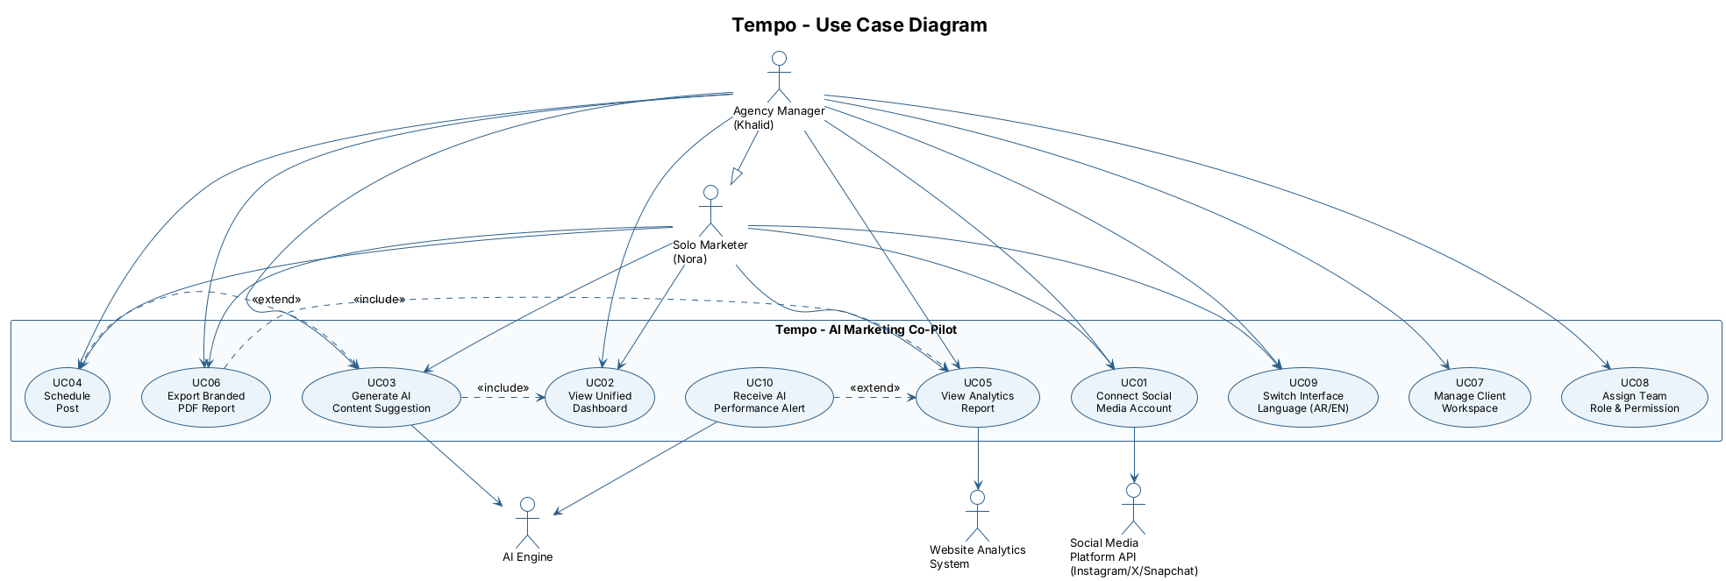
Figure 1 – Tempo Use Case Diagram
Key relationships:
- «include»: UC03 includes UC02 for context data; UC06 includes UC05 for analytics.
- «extend»: UC04 (Schedule Post) optionally extends UC03; UC10 (Alert) extends UC05 when thresholds trigger.
- Generalisation: Agency Manager inherits all Solo Marketer use cases and adds UC07 and UC08.

D4 – Activity Diagram: UC03 – Generate AI Content Suggestion
Models the complete UC03 workflow with two swimlanes (Marketer and AI Engine), decision points, and alternate flows for insufficient data and user rejection.
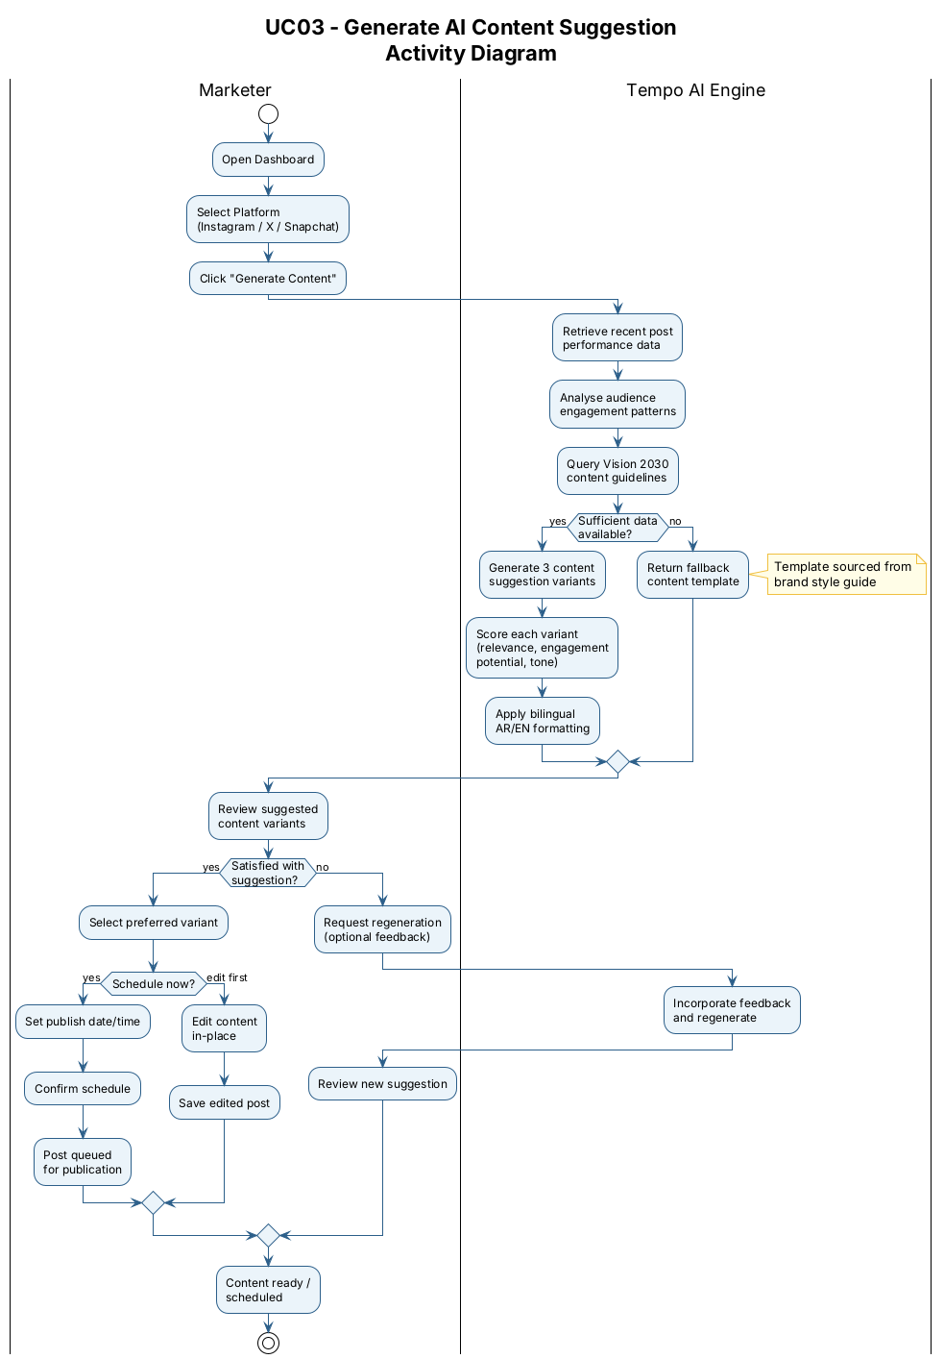
Figure 2 – Activity Diagram for UC03
Design decisions:
- Two swimlanes separate UI-level actions (Marketer) from service-level processing (AI Engine).
- The fallback template path ensures graceful degradation for new accounts with limited analytics history.
- The regeneration loop is limited to one retry cycle to prevent unbounded AI calls.

D5 – Sequence Diagram: UC03 Main Success Scenario
Shows the temporal message flow between Nora, Tempo Frontend, Content Service, Analytics Service, AI Engine, and the Social Media Platform API.
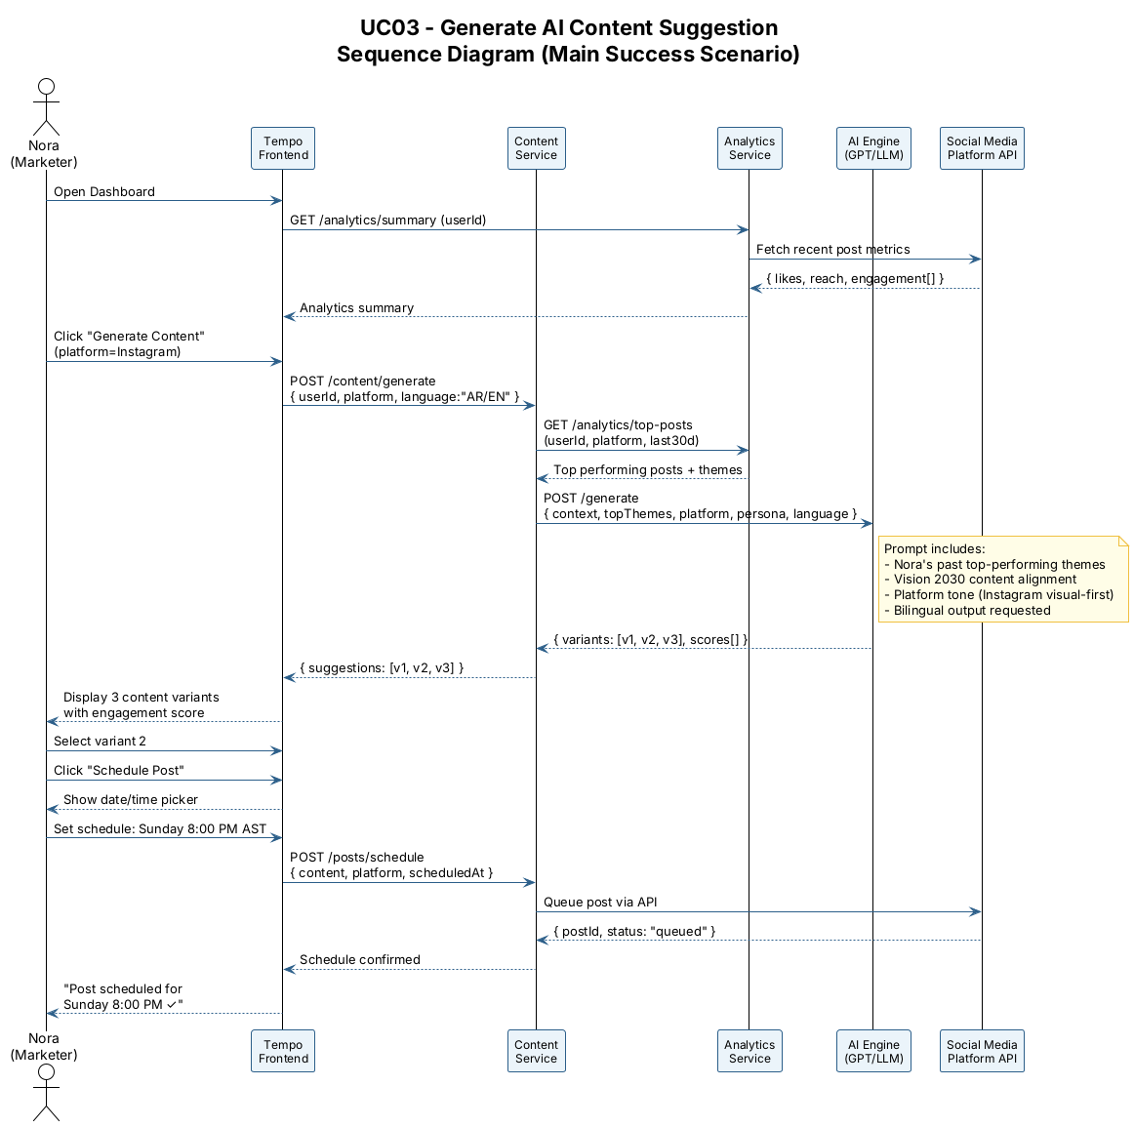
Figure 3 – Sequence Diagram for UC03 Main Success Scenario
Design decisions:
- The Content Service acts as orchestrator, decoupling the Frontend from internal AI and Analytics services.
- The AI Engine prompt includes Vision 2030 alignment keywords, fulfilling Tempo's Saudi market positioning.
- Scheduling confirmation flows through the Content Service to the Social Media API, ensuring atomicity.

D6 – Domain Model (Class Diagram)
Captures problem-domain entities and their relationships. Technology-neutral – not a database schema.
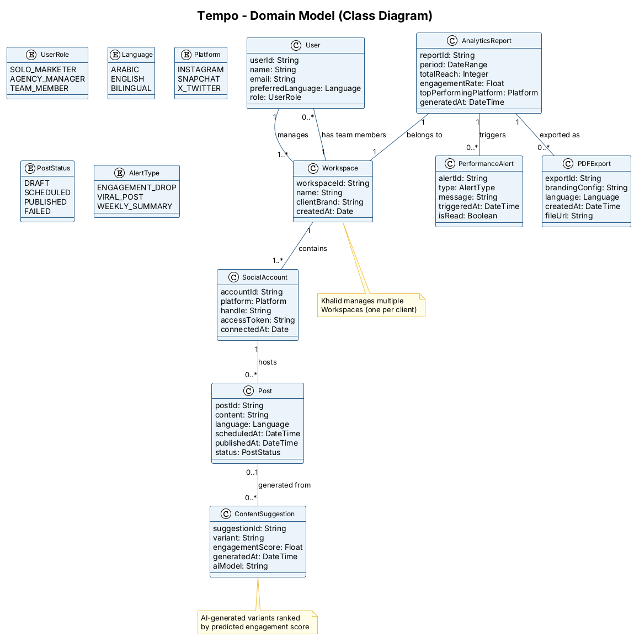
Figure 4 – Tempo Domain Model (Class Diagram)
Key domain concepts:
- User — central entity; role (SoloMarketer/AgencyManager/TeamMember) drives use case access.
- Workspace — Khalid's key differentiator; each client has its own Workspace with branding and SocialAccounts.
- ContentSuggestion — explicitly modelled to support regeneration history and A/B tracking.
- PerformanceAlert — derived from AnalyticsReport; typed (engagement drop/viral/weekly summary) to support UC10.
- PDFExport — stored entity to support 30-day export history and email-notification delivery.

D7 – Consistency Checklist & Peer-Review Sheet
Part 1: Consistency Checklist
# | Consistency Check | Result | Notes
C1 | Every actor in the Use Case Diagram appears in D1 Actor Definitions | PASS | All 5 actors defined
C2 | Every UC in the Use Case List (D1) appears in the Use Case Diagram (D3) | PASS | UC01–UC14 all present
C3 | Both fully dressed use cases (D2) correspond to UCs in the list | PASS | UC03 and UC06
C4 | Actors in D2 match actors defined in D1 | PASS | Solo Marketer and Agency Manager
C5 | Activity diagram (D4) and sequence diagram (D5) model the same UC | PASS | Both model UC03
C6 | All domain model entities (D6) are referenced in at least one UC or spec | PASS | All 8 classes referenced
C7 | Include/extend relationships in D3 match trigger relationships in D2 | PASS | UC04 extends UC03; UC06 includes UC05 – confirmed in D2
C8 | Use case names follow Verb + Noun convention | PASS | All 14 use cases comply
C9 | No database-schema concepts appear in the domain model (D6) | PASS | No PKs, FKs, or SQL types present
C10 | Personas from Lab 2 map to named actors in D1 | PASS | Nora → Solo Marketer; Khalid → Agency Manager

Part 2: Peer-Review Sheet
Reviewer | Item Reviewed | Finding | Severity | Resolution
Riman Almarri | D1 Use Case List | UC13 and UC14 should be explicitly labelled "Won't" to prevent scope creep. | Low | Added Won't label – resolved.
Riman Almarri | D3 Use Case Diagram | Agency Manager should show generalisation from Solo Marketer, not just implied inheritance. | Medium | Added explicit generalisation arrow in PlantUML – resolved.
Mays Almousa | D2 UC03 Scenario | Step 3 was unclear about time window for "recent posts". | Medium | Clarified to "last 30 days" in D2 and sequence diagram – resolved.
Mays Almousa | D6 Domain Model | ContentSuggestion had no relationship to Post – a suggestion can become a post. | High | Added "generated from" association – resolved.
Ghaliah Badokhon | D5 Sequence Diagram | UC06 sequence was missing; only UC03 diagrammed. | Medium | D5 scoped to UC03 (most complex). UC06 covered in future iteration.
Ghaliah Badokhon | D2 UC06 Exception | Email notification for slow PDF export was not in the use case spec. | Low | Added rendering timeout exception to UC06 D2 spec – resolved.

INSTRUCTORS NAME: Dr. Passent Elkafrawy
COURSE NAME: Software Engineering | COURSE NUMBER: CS3151 | SECTION: 3
Riman Almarri (S24109297) · Mays Almousa (S24109301) · Ghaliah Badokhon (S24109427)

Lab 4: Software Requirements Specification (SRS)
Tempo – AI Marketing Co-Pilot
Introduction
This document specifies the software requirements for Tempo, an AI-powered bilingual (Arabic/English) marketing co-pilot for solo marketers, SMEs, and digital agencies in Saudi Arabia. Tempo integrates four platforms — Snapchat, X, Instagram, and Google Search Console — into a single bilingual dashboard. This document consolidates the use cases identified in Lab 3 into four simplified, high-priority scenarios and derives the functional and non-functional requirements that the system must satisfy. All requirements are traceable to the user personas (Nora Al-Shamrani and Khalid Al-Otaibi) and the use cases defined here.
Lab Objectives:
- Simplify and consolidate use cases into four core workflows.
- Define functional requirements (FR) organised by system module.
- Specify non-functional requirements (NFR) covering performance, security, and usability.
- Produce a requirements traceability matrix linking personas → use cases → requirements.

Part 1: Simplified Use Cases
The seven use cases from Lab 3 have been consolidated into four core use cases covering the primary workflows of Tempo. Each is presented in brief format (name, actor, trigger, main flow, outcome).
1.1 Use Case Diagram
Figure 1 shows all four simplified use cases, the primary actors (Nora and Khalid), and the external system actors they interact with.
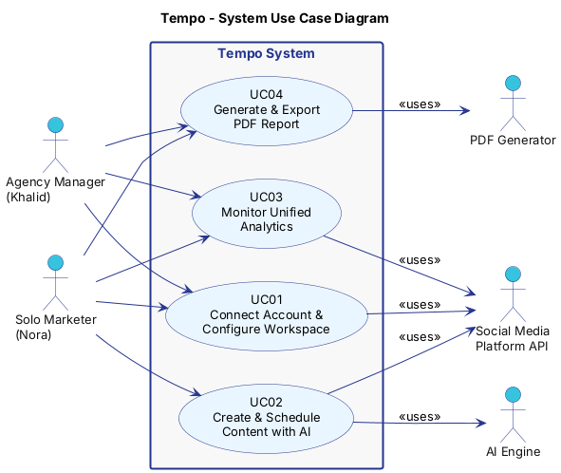
Figure 1 – Tempo System Use Case Diagram
1.2 Use Case Overview
UC | Name | Primary Actor | Trigger | Outcome
UC01 | Connect Account & Configure Workspace | Nora / Khalid | User signs up or logs in | Social accounts linked; workspace ready
UC02 | Create & Schedule Content with AI | Nora | User clicks "Generate Content" | Post scheduled on selected platforms
UC03 | Monitor Unified Analytics | Nora / Khalid | User opens Dashboard | Cross-platform metrics displayed; alerts triggered
UC04 | Generate & Export PDF Report | Khalid / Nora | User clicks "Generate Report" | Branded bilingual PDF downloaded or shared

UC01 – Connect Account & Configure Workspace
Field | Description
Use Case ID | UC01
Use Case Name | Connect Account & Configure Workspace
Actors | Solo Marketer (Nora), Agency Manager (Khalid)
Precondition | User has a Tempo account (free or paid) and at least one social platform account.
Main Flow | 1. User navigates to Settings → Connected Accounts. 2. Selects a platform (Instagram, X, Snapchat, or Google Search Console). 3. Authenticates via OAuth 2.0 and grants required permissions. 4. Tempo confirms the connection and displays the account handle / property. 5. Agency user additionally creates or names a client workspace and assigns team members.
Alternative Flow | OAuth fails → error message shown; user retries or contacts support.
Postcondition | Social account linked to workspace; data sync begins immediately.
Priority | Must Have

UC02 – Create & Schedule Content with AI
Field | Description
Use Case ID | UC02
Use Case Name | Create & Schedule Content with AI
Actors | Solo Marketer (Nora), AI Engine, Social Media Platform API
Precondition | At least one social account is connected; user has remaining AI generation quota.
Main Flow | 1. User selects platform and language (Arabic / English / Bilingual). 2. Clicks "Generate Content"; optionally adds a brief or theme. 3. AI Engine analyses top-performing posts and returns 3 content variants with engagement scores. 4. User reviews variants, optionally edits, then selects one. 5. User sets publish date/time and clicks "Schedule". 6. Tempo queues the post and confirms the scheduled time.
Alternative Flow | Insufficient past data → AI uses brand style guide template. Platform API error → post saved as draft with error notification.
Postcondition | Post queued in content calendar; platform notified at scheduled time.
Priority | Must Have

Activity Diagram – UC02
Figure 2 shows the detailed activity flow for UC02, including the parallel AI processing steps and the decision branches for user satisfaction and publish success.
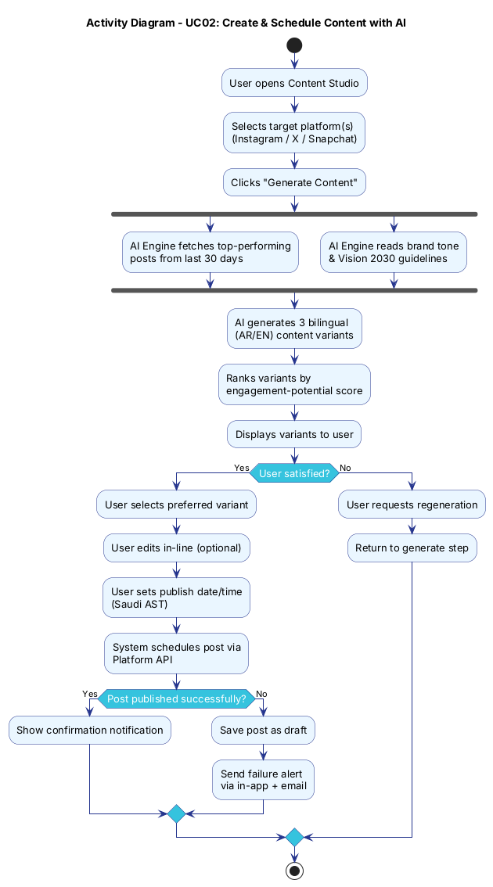
Figure 2 – Activity Diagram: Create & Schedule Content with AI (UC02)
UC03 – Monitor Unified Analytics
Field | Description
Use Case ID | UC03
Use Case Name | Monitor Unified Analytics
Actors | Solo Marketer (Nora Al-Shamrani), Agency Manager (Khalid Al-Otaibi), Analytics Service
Precondition | At least one social account and/or Google Search Console property connected; at least 24 hours of data collected.
Main Flow | 1. User opens the Dashboard tab. 2. System displays cross-platform social metrics (reach, engagement rate, follower growth) alongside Google Search Console website data (clicks, impressions, CTR). 3. User selects a date range (7 days / 30 days / custom). 4. Dashboard updates charts in real time. 5. If any metric falls below a configured threshold, a performance alert is displayed.
Alternative Flow | No data for selected range → placeholder message; system prompts to connect account or wait for sync.
Postcondition | User has an up-to-date cross-platform performance overview; alerts acknowledged or dismissed.
Priority | Must Have

UC04 – Generate & Export PDF Report
Field | Description
Use Case ID | UC04
Use Case Name | Generate & Export PDF Report
Actors | Agency Manager (Khalid), Solo Marketer (Nora)
Precondition | Analytics data available for the selected period; branding assets configured for agency workspace.
Main Flow | 1. User clicks "Generate Report" and selects the reporting period. 2. Chooses language (Arabic / English / Both) and report type (Summary / Full). 3. System compiles reach, engagement, top posts, and platform breakdown. 4. PDF is rendered with client branding and correct RTL/LTR layout. 5. User downloads the PDF or copies a share link.
Alternative Flow | No data for period → report generated with a "No data available" section and a note to the user.
Postcondition | Branded bilingual PDF saved and/or shared; report log updated.
Priority | Must Have

Part 2: Functional Requirements
Functional requirements are organised by system module. Each requirement is identified by a unique ID and linked to the use case it supports.
Module A – Authentication & Workspace Management
FR ID | Requirement | Linked UC | Priority
FR-A01 | The system shall allow users to register and log in using email/password with optional multi-factor authentication. | UC01 | Must Have
FR-A02 | The system shall allow users to connect social accounts (Instagram, X, Snapchat) and Google Search Console properties via OAuth 2.0. | UC01 | Must Have
FR-A03 | Agency users shall be able to create multiple client workspaces and switch between them without logging out. | UC01 | Must Have
FR-A04 | The system shall support role-based access control with roles: Owner, Admin, Editor, and Viewer. | UC01 | Must Have
FR-A05 | Users shall be able to revoke social account connections at any time from the Settings panel. | UC01 | Should Have

Module B – AI Content Generation & Scheduling
FR ID | Requirement | Linked UC | Priority
FR-B01 | The system shall generate up to 3 content variants per request using a commercial LLM API, in Arabic, English, or both. | UC02 | Must Have
FR-B02 | Content generation shall use the user's top-performing posts from the past 30 days as context for the prompt. | UC02 | Must Have
FR-B03 | Generated content shall include an engagement-potential score for each variant, ranked highest first. | UC02 | Should Have
FR-B04 | Users shall be able to edit any generated variant in-line before scheduling. | UC02 | Must Have
FR-B05 | The system shall schedule posts to Instagram, X, and Snapchat at a user-specified date and time (Saudi AST). | UC02 | Must Have
FR-B06 | If a scheduled post fails to publish, the system shall notify the user by in-app alert and email, and save the post as a draft. | UC02 | Must Have

Module C – Unified Analytics Dashboard
FR ID | Requirement | Linked UC | Priority
FR-C01 | The system shall display a unified dashboard showing reach, engagement rate, and follower growth for all connected social platforms (Snapchat, X, Instagram). | UC03 | Must Have
FR-C02 | The dashboard shall support date-range filtering: last 7 days, last 30 days, and custom range. | UC03 | Must Have
FR-C03 | The system shall collect platform metrics automatically via scheduled API calls (minimum once per 24 hours). | UC03 | Must Have
FR-C04 | The system shall display a "Top Performing Post" card per platform, updated daily. | UC03 | Should Have
FR-C05 | The system shall trigger a performance alert when any metric drops more than 20% week-over-week. | UC03 | Should Have
FR-C06 | The system shall display Google Search Console data (queries, clicks, impressions, and average position) alongside social metrics in the unified dashboard. | UC03 | Must Have

Module D – PDF Report Generation
FR ID | Requirement | Linked UC | Priority
FR-D01 | The system shall generate a PDF performance report for any selected date range upon user request. | UC04 | Must Have
FR-D02 | Reports shall be available in Arabic (RTL layout), English (LTR layout), or both languages in a single document. | UC04 | Must Have
FR-D03 | Agency workspace reports shall include the client logo and brand colours configured by the agency. | UC04 | Must Have
FR-D04 | Reports shall include: Executive Summary, Platform Breakdown, Top Posts, and Recommendations. | UC04 | Should Have
FR-D05 | The system shall allow reports to be downloaded as PDF or shared via a secure link valid for 7 days. | UC04 | Should Have

Part 3: Non-Functional Requirements
Non-functional requirements define the quality attributes the system must exhibit regardless of specific functionality. They are organised by category.
NFR ID | Category | Requirement | Priority
NFR-01 | Performance | The dashboard shall load and display all platform metrics within 3 seconds on a standard broadband connection. | Must Have
NFR-02 | Performance | AI content generation shall return results within 10 seconds for a standard request (3 variants, 1 platform). | Must Have
NFR-03 | Availability | The system shall maintain 99.5% uptime during Saudi peak hours (6 AM – 12 AM AST, Saturday – Thursday). | Must Have
NFR-04 | Security | All social account OAuth tokens shall be encrypted at rest using AES-256 and transmitted only over HTTPS. | Must Have
NFR-05 | Security | The system shall undergo an external penetration test before the public launch and remediate all Critical and High findings. | Must Have
NFR-06 | Privacy | The system shall comply with the Saudi PDPL: user data stored in a Saudi-region cloud, deletable on request within 30 days. | Must Have
NFR-07 | Usability | The interface shall fully support right-to-left (RTL) Arabic text alongside left-to-right (LTR) English in all screens. | Must Have
NFR-08 | Usability | New users shall be able to connect a social account and generate their first content suggestion within 10 minutes of sign-up. | Should Have
NFR-09 | Localisation | All date, time, currency, and calendar displays shall default to Saudi Arabia conventions (AST, SAR, Hijri/Gregorian toggle). | Should Have
NFR-10 | Scalability | The architecture shall support horizontal scaling to serve at least 5,000 concurrent users without degrading below NFR-01/NFR-02 thresholds. | Should Have
NFR-11 | Maintainability | The AI content module shall be provider-independent, allowing the LLM provider to be swapped without changes to other modules. | Should Have

Part 4: Requirements Traceability Matrix
The matrix below links each persona to the use case that represents their primary goal, and maps the functional requirements that implement it.
Persona | Use Case | Functional Requirements | NFRs
Nora  (Solo Marketer) | UC01: Connect Account | FR-A01, FR-A02, FR-A05 | NFR-04, NFR-07
Nora | UC02: Create & Schedule Content | FR-B01, FR-B02, FR-B03, FR-B04, FR-B05, FR-B06 | NFR-01, NFR-02, NFR-07, NFR-08
Nora / Khalid | UC03: Monitor Analytics | FR-C01, FR-C02, FR-C03, FR-C04, FR-C05, FR-C06 | NFR-01, NFR-03, NFR-07
Khalid  (Agency Manager) | UC01: Configure Workspace | FR-A03, FR-A04, FR-A05 | NFR-04, NFR-06, NFR-10
Khalid | UC04: Generate PDF Report | FR-D01, FR-D02, FR-D03, FR-D04, FR-D05 | NFR-06, NFR-07, NFR-09

Assessment Criteria
Criterion | Marks
Simplified use cases: clarity, actor coverage, correct UC format | 30%
Functional requirements: completeness, correct module grouping, link to UCs | 30%
Non-functional requirements: realistic targets, correct categories | 20%
Traceability matrix: accurate persona-to-UC-to-FR linkage | 20%

