INSTRUCTORS NAME: Dr. Passent Elkafrawy
COURSE NAME: Software Engineering | COURSE NUMBER: CS3151 | SECTION: 3
Riman Almarri (S24109297) · Mays Almousa (S24109301) · Ghaliah Badokhon (S24109427)

Lab 4: Software Requirements Specification (SRS)
Tempo – AI Marketing Co-Pilot
Introduction
This document specifies the software requirements for Tempo, an AI-powered bilingual (Arabic/English) marketing co-pilot for solo marketers, SMEs, and digital agencies in Saudi Arabia. Tempo integrates four platforms — Snapchat, X, Instagram, and Google Search Console — into a single bilingual dashboard. This document consolidates the use cases identified in Lab 3 into four simplified, high-priority scenarios and derives the functional and non-functional requirements that the system must satisfy. All requirements are traceable to the user personas (Nora Al-Shamrani and Khalid Al-Otaibi) and the use cases defined here.
Lab Objectives:
- Simplify and consolidate use cases into four core workflows.
- Define functional requirements (FR) organised by system module.
- Specify non-functional requirements (NFR) covering performance, security, and usability.
- Produce a requirements traceability matrix linking personas → use cases → requirements.

Part 1: Simplified Use Cases
The seven use cases from Lab 3 have been consolidated into four core use cases covering the primary workflows of Tempo. Each is presented in brief format (name, actor, trigger, main flow, outcome).
1.1 Use Case Diagram
Figure 1 shows all four simplified use cases, the primary actors (Nora and Khalid), and the external system actors they interact with.
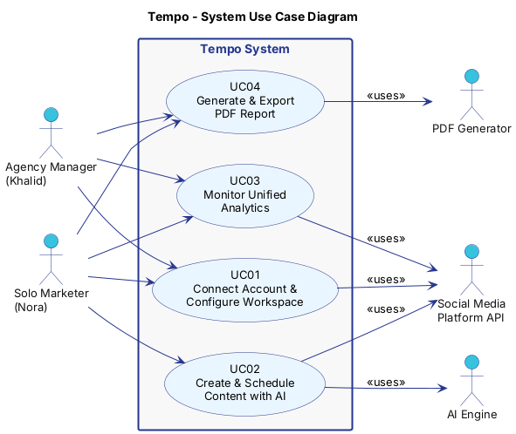
Figure 1 – Tempo System Use Case Diagram
1.2 Use Case Overview
UC | Name | Primary Actor | Trigger | Outcome
UC01 | Connect Account & Configure Workspace | Nora / Khalid | User signs up or logs in | Social accounts linked; workspace ready
UC02 | Create & Schedule Content with AI | Nora | User clicks "Generate Content" | Post scheduled on selected platforms
UC03 | Monitor Unified Analytics | Nora / Khalid | User opens Dashboard | Cross-platform metrics displayed; alerts triggered
UC04 | Generate & Export PDF Report | Khalid / Nora | User clicks "Generate Report" | Branded bilingual PDF downloaded or shared

UC01 – Connect Account & Configure Workspace
Field | Description
Use Case ID | UC01
Use Case Name | Connect Account & Configure Workspace
Actors | Solo Marketer (Nora), Agency Manager (Khalid)
Precondition | User has a Tempo account (free or paid) and at least one social platform account.
Main Flow | 1. User navigates to Settings → Connected Accounts. 2. Selects a platform (Instagram, X, Snapchat, or Google Search Console). 3. Authenticates via OAuth 2.0 and grants required permissions. 4. Tempo confirms the connection and displays the account handle / property. 5. Agency user additionally creates or names a client workspace and assigns team members.
Alternative Flow | OAuth fails → error message shown; user retries or contacts support.
Postcondition | Social account linked to workspace; data sync begins immediately.
Priority | Must Have

UC02 – Create & Schedule Content with AI
Field | Description
Use Case ID | UC02
Use Case Name | Create & Schedule Content with AI
Actors | Solo Marketer (Nora), AI Engine, Social Media Platform API
Precondition | At least one social account is connected; user has remaining AI generation quota.
Main Flow | 1. User selects platform and language (Arabic / English / Bilingual). 2. Clicks "Generate Content"; optionally adds a brief or theme. 3. AI Engine analyses top-performing posts and returns 3 content variants with engagement scores. 4. User reviews variants, optionally edits, then selects one. 5. User sets publish date/time and clicks "Schedule". 6. Tempo queues the post and confirms the scheduled time.
Alternative Flow | Insufficient past data → AI uses brand style guide template. Platform API error → post saved as draft with error notification.
Postcondition | Post queued in content calendar; platform notified at scheduled time.
Priority | Must Have

Activity Diagram – UC02
Figure 2 shows the detailed activity flow for UC02, including the parallel AI processing steps and the decision branches for user satisfaction and publish success.
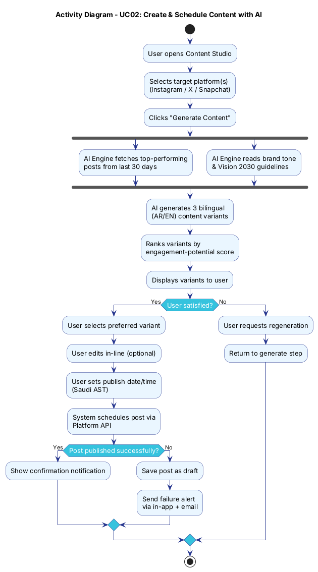
Figure 2 – Activity Diagram: Create & Schedule Content with AI (UC02)
UC03 – Monitor Unified Analytics
Field | Description
Use Case ID | UC03
Use Case Name | Monitor Unified Analytics
Actors | Solo Marketer (Nora Al-Shamrani), Agency Manager (Khalid Al-Otaibi), Analytics Service
Precondition | At least one social account and/or Google Search Console property connected; at least 24 hours of data collected.
Main Flow | 1. User opens the Dashboard tab. 2. System displays cross-platform social metrics (reach, engagement rate, follower growth) alongside Google Search Console website data (clicks, impressions, CTR). 3. User selects a date range (7 days / 30 days / custom). 4. Dashboard updates charts in real time. 5. If any metric falls below a configured threshold, a performance alert is displayed.
Alternative Flow | No data for selected range → placeholder message; system prompts to connect account or wait for sync.
Postcondition | User has an up-to-date cross-platform performance overview; alerts acknowledged or dismissed.
Priority | Must Have

UC04 – Generate & Export PDF Report
Field | Description
Use Case ID | UC04
Use Case Name | Generate & Export PDF Report
Actors | Agency Manager (Khalid), Solo Marketer (Nora)
Precondition | Analytics data available for the selected period; branding assets configured for agency workspace.
Main Flow | 1. User clicks "Generate Report" and selects the reporting period. 2. Chooses language (Arabic / English / Both) and report type (Summary / Full). 3. System compiles reach, engagement, top posts, and platform breakdown. 4. PDF is rendered with client branding and correct RTL/LTR layout. 5. User downloads the PDF or copies a share link.
Alternative Flow | No data for period → report generated with a "No data available" section and a note to the user.
Postcondition | Branded bilingual PDF saved and/or shared; report log updated.
Priority | Must Have

Part 2: Functional Requirements
Functional requirements are organised by system module. Each requirement is identified by a unique ID and linked to the use case it supports.
Module A – Authentication & Workspace Management
FR ID | Requirement | Linked UC | Priority
FR-A01 | The system shall allow users to register and log in using email/password with optional multi-factor authentication. | UC01 | Must Have
FR-A02 | The system shall allow users to connect social accounts (Instagram, X, Snapchat) and Google Search Console properties via OAuth 2.0. | UC01 | Must Have
FR-A03 | Agency users shall be able to create multiple client workspaces and switch between them without logging out. | UC01 | Must Have
FR-A04 | The system shall support role-based access control with roles: Owner, Admin, Editor, and Viewer. | UC01 | Must Have
FR-A05 | Users shall be able to revoke social account connections at any time from the Settings panel. | UC01 | Should Have

Module B – AI Content Generation & Scheduling
FR ID | Requirement | Linked UC | Priority
FR-B01 | The system shall generate up to 3 content variants per request using a commercial LLM API, in Arabic, English, or both. | UC02 | Must Have
FR-B02 | Content generation shall use the user's top-performing posts from the past 30 days as context for the prompt. | UC02 | Must Have
FR-B03 | Generated content shall include an engagement-potential score for each variant, ranked highest first. | UC02 | Should Have
FR-B04 | Users shall be able to edit any generated variant in-line before scheduling. | UC02 | Must Have
FR-B05 | The system shall schedule posts to Instagram, X, and Snapchat at a user-specified date and time (Saudi AST). | UC02 | Must Have
FR-B06 | If a scheduled post fails to publish, the system shall notify the user by in-app alert and email, and save the post as a draft. | UC02 | Must Have

Module C – Unified Analytics Dashboard
FR ID | Requirement | Linked UC | Priority
FR-C01 | The system shall display a unified dashboard showing reach, engagement rate, and follower growth for all connected social platforms (Snapchat, X, Instagram). | UC03 | Must Have
FR-C02 | The dashboard shall support date-range filtering: last 7 days, last 30 days, and custom range. | UC03 | Must Have
FR-C03 | The system shall collect platform metrics automatically via scheduled API calls (minimum once per 24 hours). | UC03 | Must Have
FR-C04 | The system shall display a "Top Performing Post" card per platform, updated daily. | UC03 | Should Have
FR-C05 | The system shall trigger a performance alert when any metric drops more than 20% week-over-week. | UC03 | Should Have
FR-C06 | The system shall display Google Search Console data (queries, clicks, impressions, and average position) alongside social metrics in the unified dashboard. | UC03 | Must Have

Module D – PDF Report Generation
FR ID | Requirement | Linked UC | Priority
FR-D01 | The system shall generate a PDF performance report for any selected date range upon user request. | UC04 | Must Have
FR-D02 | Reports shall be available in Arabic (RTL layout), English (LTR layout), or both languages in a single document. | UC04 | Must Have
FR-D03 | Agency workspace reports shall include the client logo and brand colours configured by the agency. | UC04 | Must Have
FR-D04 | Reports shall include: Executive Summary, Platform Breakdown, Top Posts, and Recommendations. | UC04 | Should Have
FR-D05 | The system shall allow reports to be downloaded as PDF or shared via a secure link valid for 7 days. | UC04 | Should Have

Part 3: Non-Functional Requirements
Non-functional requirements define the quality attributes the system must exhibit regardless of specific functionality. They are organised by category.
NFR ID | Category | Requirement | Priority
NFR-01 | Performance | The dashboard shall load and display all platform metrics within 3 seconds on a standard broadband connection. | Must Have
NFR-02 | Performance | AI content generation shall return results within 10 seconds for a standard request (3 variants, 1 platform). | Must Have
NFR-03 | Availability | The system shall maintain 99.5% uptime during Saudi peak hours (6 AM – 12 AM AST, Saturday – Thursday). | Must Have
NFR-04 | Security | All social account OAuth tokens shall be encrypted at rest using AES-256 and transmitted only over HTTPS. | Must Have
NFR-05 | Security | The system shall undergo an external penetration test before the public launch and remediate all Critical and High findings. | Must Have
NFR-06 | Privacy | The system shall comply with the Saudi PDPL: user data stored in a Saudi-region cloud, deletable on request within 30 days. | Must Have
NFR-07 | Usability | The interface shall fully support right-to-left (RTL) Arabic text alongside left-to-right (LTR) English in all screens. | Must Have
NFR-08 | Usability | New users shall be able to connect a social account and generate their first content suggestion within 10 minutes of sign-up. | Should Have
NFR-09 | Localisation | All date, time, currency, and calendar displays shall default to Saudi Arabia conventions (AST, SAR, Hijri/Gregorian toggle). | Should Have
NFR-10 | Scalability | The architecture shall support horizontal scaling to serve at least 5,000 concurrent users without degrading below NFR-01/NFR-02 thresholds. | Should Have
NFR-11 | Maintainability | The AI content module shall be provider-independent, allowing the LLM provider to be swapped without changes to other modules. | Should Have

Part 4: Requirements Traceability Matrix
The matrix below links each persona to the use case that represents their primary goal, and maps the functional requirements that implement it.
Persona | Use Case | Functional Requirements | NFRs
Nora  (Solo Marketer) | UC01: Connect Account | FR-A01, FR-A02, FR-A05 | NFR-04, NFR-07
Nora | UC02: Create & Schedule Content | FR-B01, FR-B02, FR-B03, FR-B04, FR-B05, FR-B06 | NFR-01, NFR-02, NFR-07, NFR-08
Nora / Khalid | UC03: Monitor Analytics | FR-C01, FR-C02, FR-C03, FR-C04, FR-C05, FR-C06 | NFR-01, NFR-03, NFR-07
Khalid  (Agency Manager) | UC01: Configure Workspace | FR-A03, FR-A04, FR-A05 | NFR-04, NFR-06, NFR-10
Khalid | UC04: Generate PDF Report | FR-D01, FR-D02, FR-D03, FR-D04, FR-D05 | NFR-06, NFR-07, NFR-09

Assessment Criteria
Criterion | Marks
Simplified use cases: clarity, actor coverage, correct UC format | 30%
Functional requirements: completeness, correct module grouping, link to UCs | 30%
Non-functional requirements: realistic targets, correct categories | 20%
Traceability matrix: accurate persona-to-UC-to-FR linkage | 20%

