*Name: Asadullah Hill Galib*

*Netid: galibasa*

**CSE 803 Computer Vision: Homework 6**

**1. Camera Calibration**

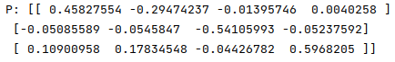

**2 Estimation of the Fundamental Matrix**

**F (normalized):**

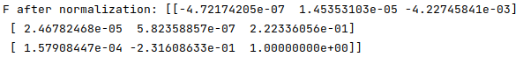

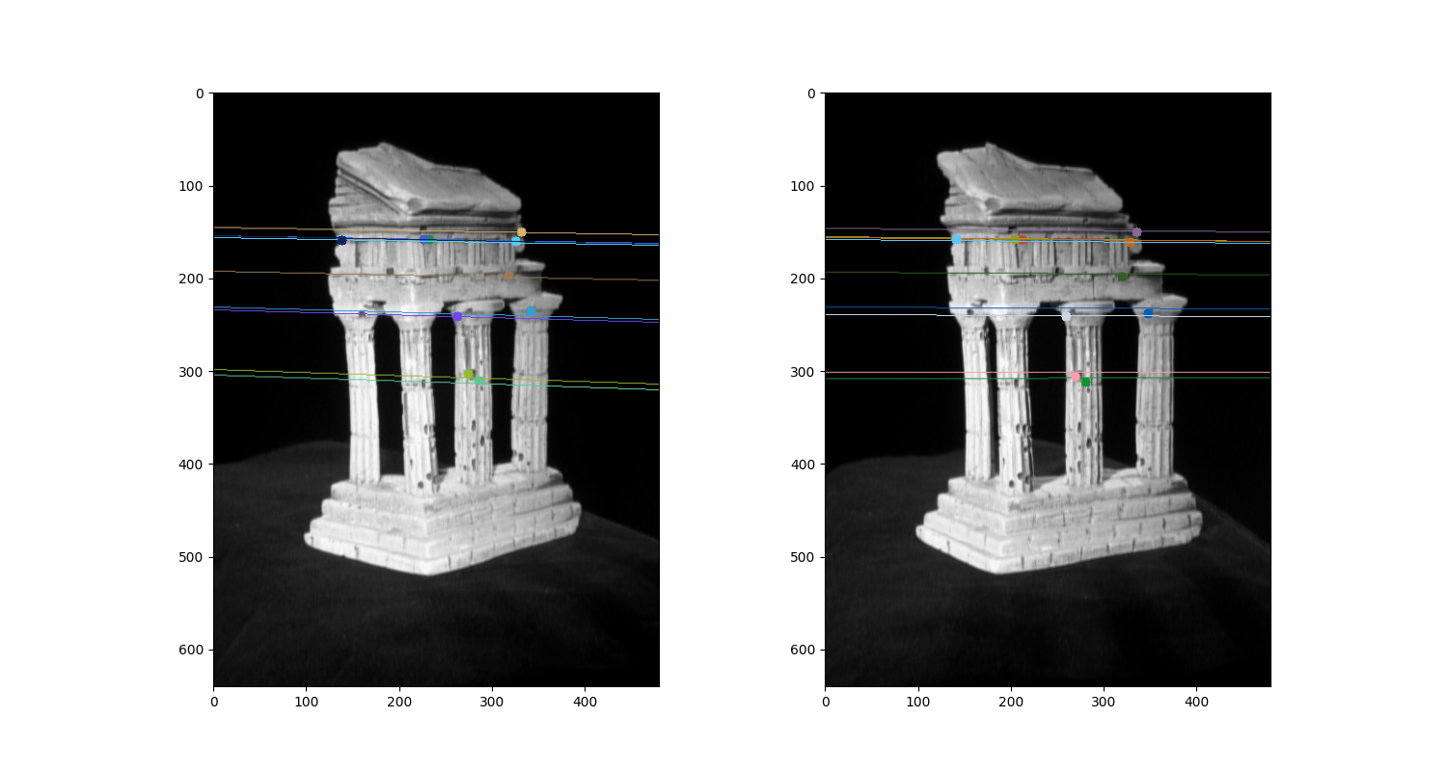

**3 Triangulation**

**Essential matrix E:**

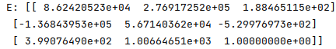

**Camera projection matrix P1 and P2:**

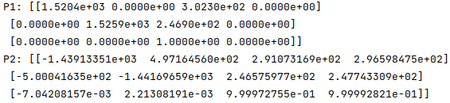

**Visualization of point cloud:**

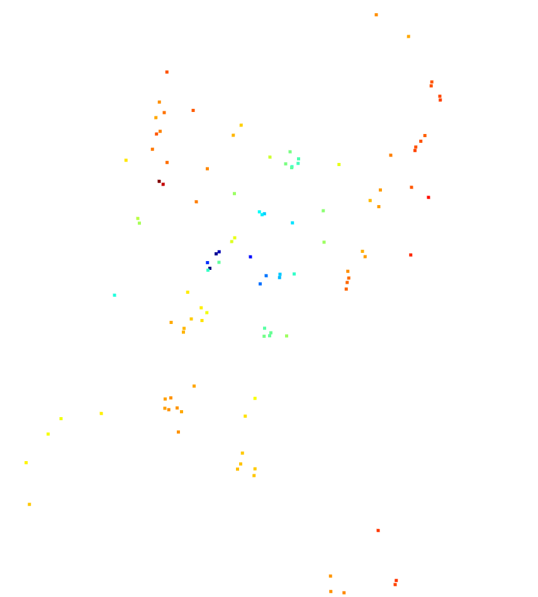

Figure 1: Visualization of the point cloud

NB: I have just included all the portions which are mentioned to included or reported. The details codes are attached in the zip file.