CSE 891: Written Homework 4

Asadullah Hill Galib (galibasa)

**Q1. Reversible Architectures:**

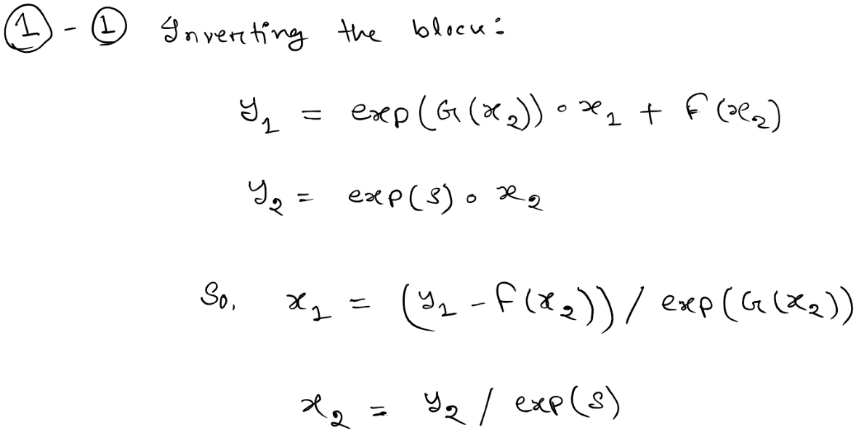

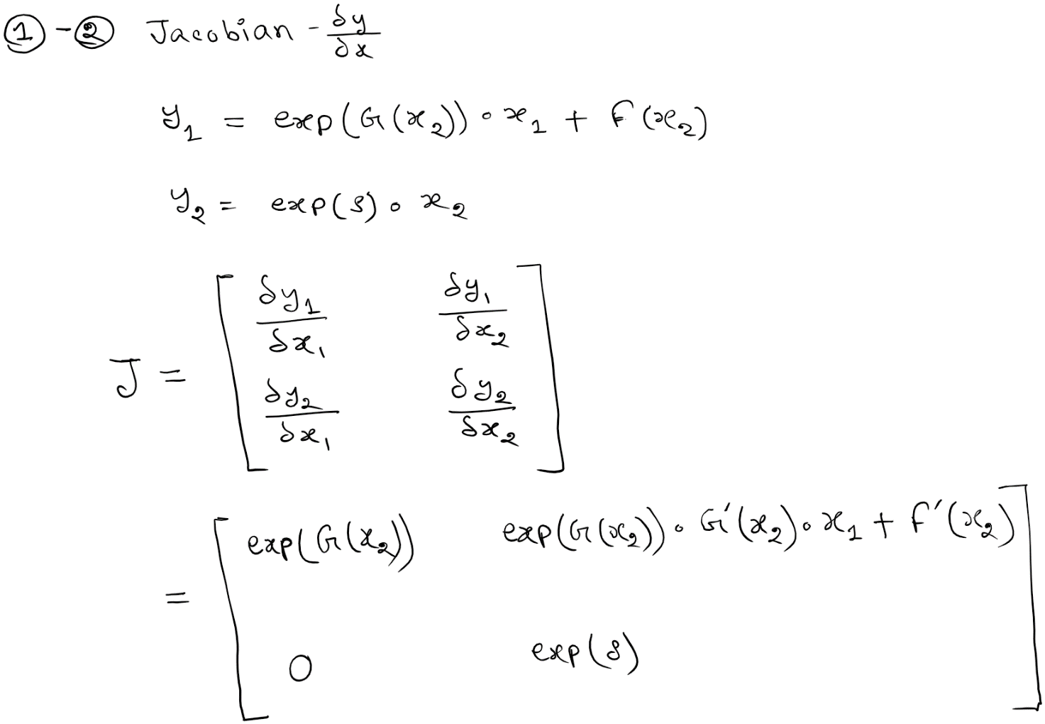

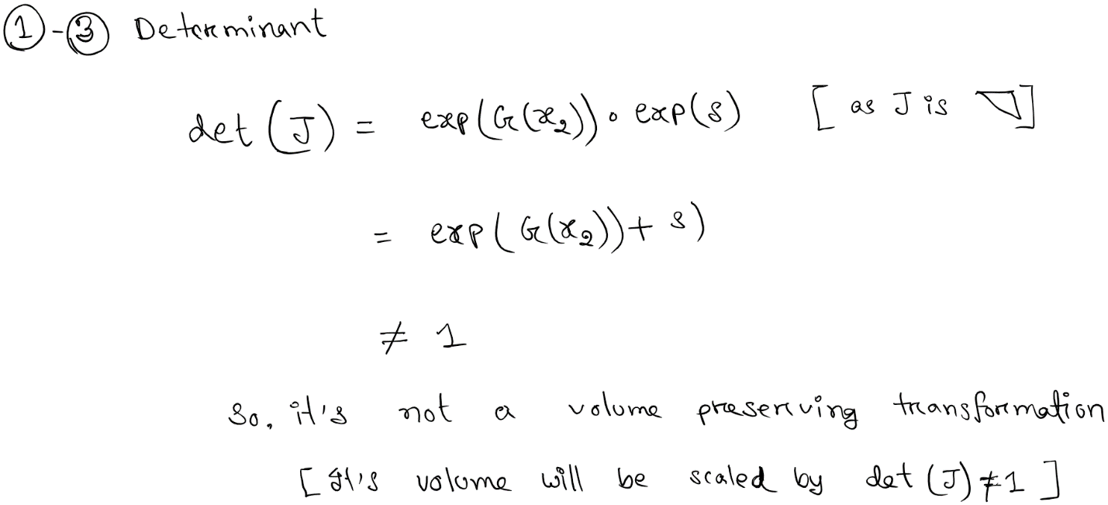

**Q2 : See next page**

**Q2. Variational Free Energy:**

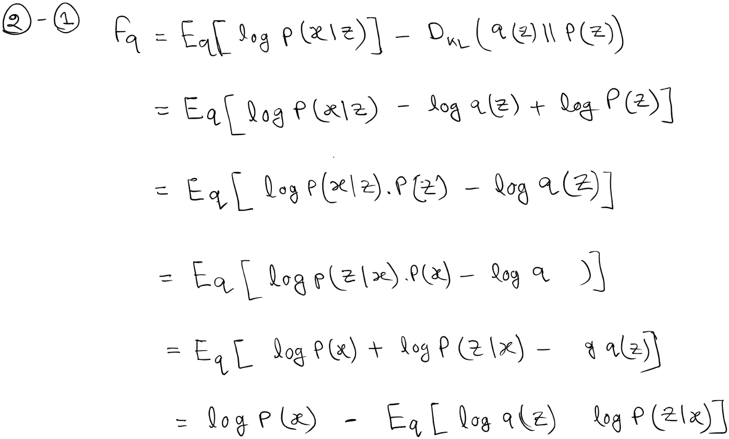



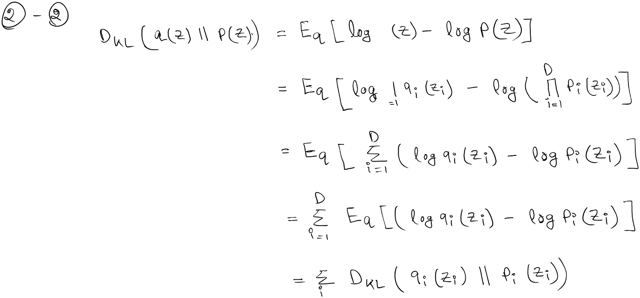

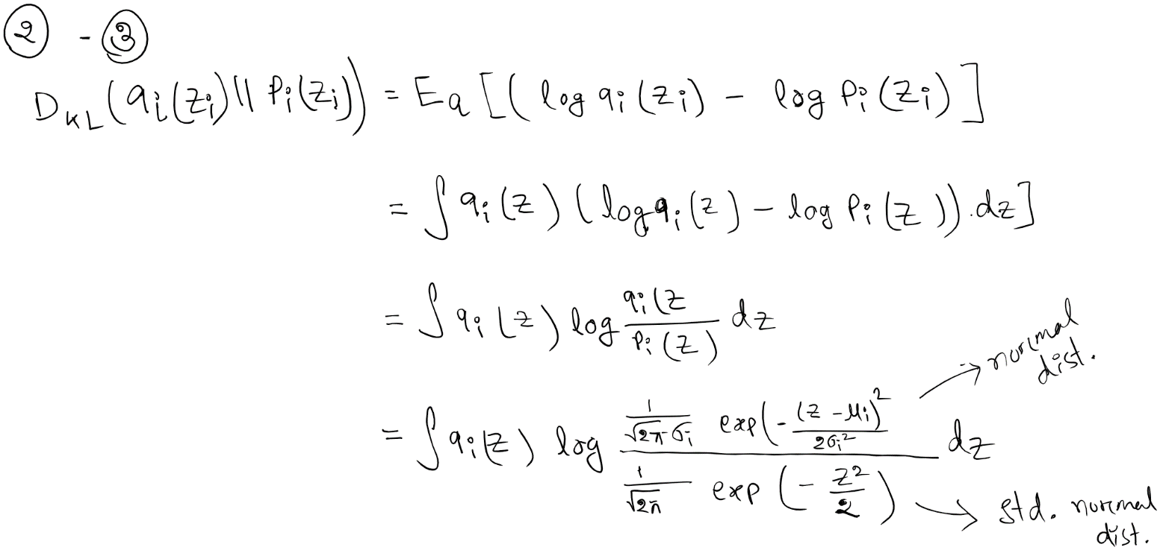

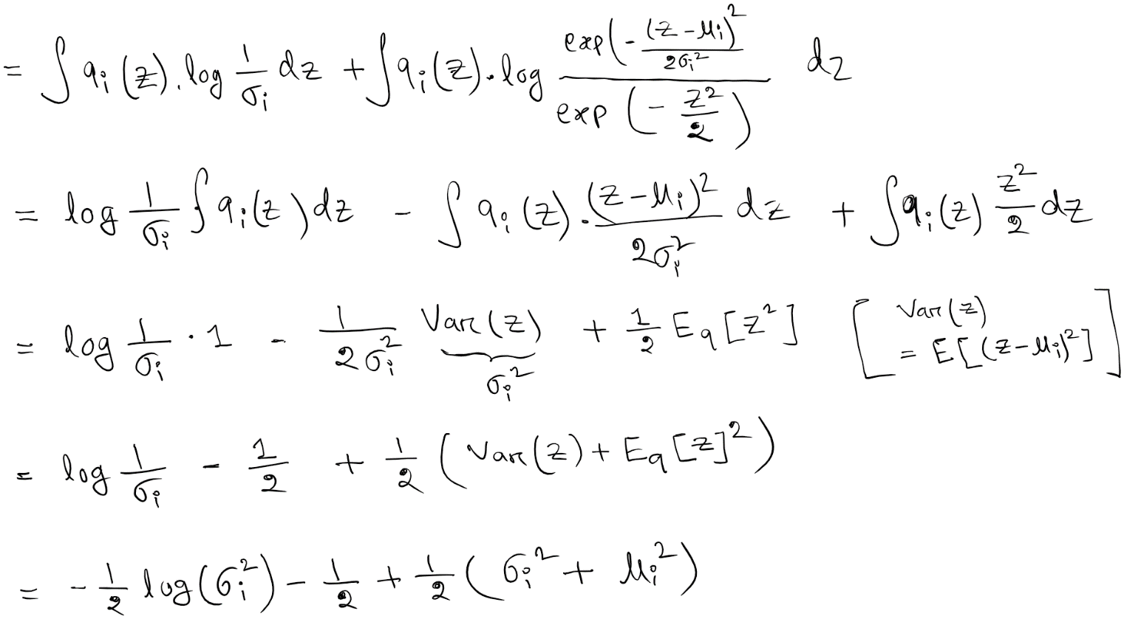

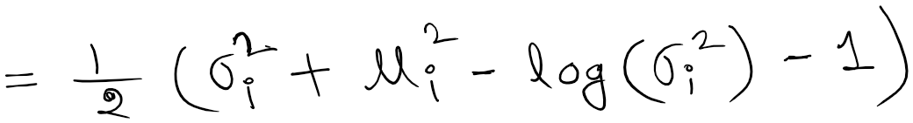

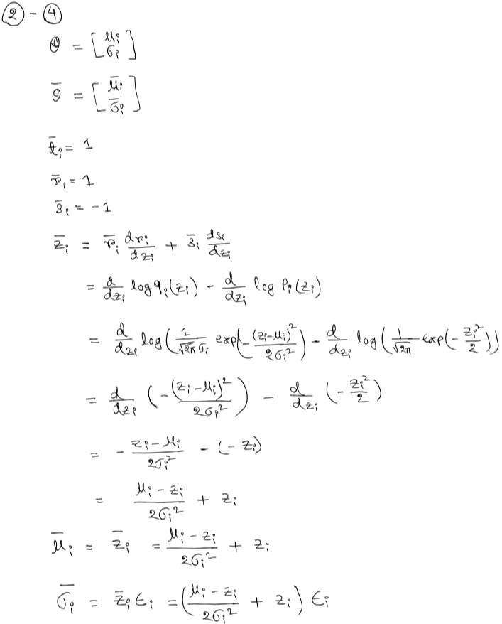

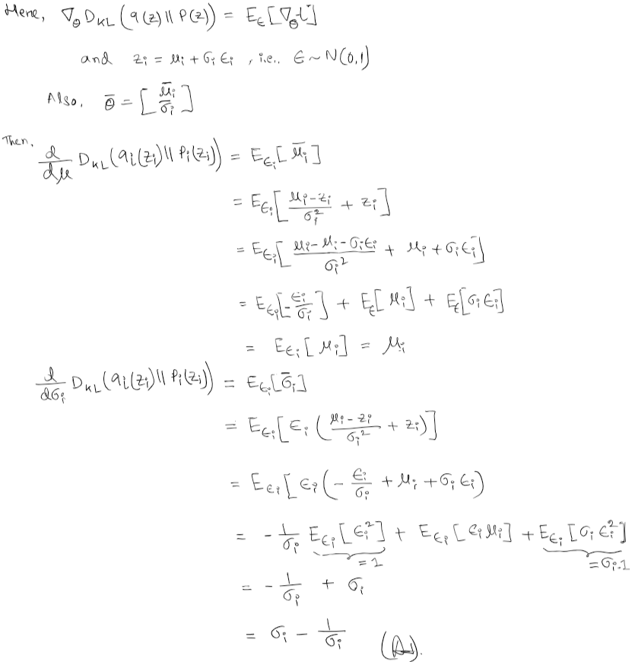

Q3: Feedback:

1. What aspects of the written and programming homeworks did you enjoy for this course?

=> I enjoyed the troublesome but interesting derivations and explanations questions in the written part, like LSTM gradients, VAE derivation, skip connections before or after batch norm, backpropagation derivation, etc. In programming part, I enjoyed implementing backpropagation, and the visualization stuff (attention, semantic segmentation, word analogy, etc.). These things seem troublesome but really help in understanding the concepts. Honestly, I started learning deep learning from January 2021, worked with recurrent models, but I did not understand the underlying things (like the derivatives in LSTM, etc.) until this course.

2. What aspects of the written and programming homeworks did you hate for this course?  
With the written part, I do not have any bad experiences. But I hate the computationally time-consuming programming works (like, semantic segmentation). I do not have any flexible GPU access, so I suffered a lot while training this kind of high computational stuff. I tried to run the code on Google Colab to take advantage of the GPUs, but I failed to run the provided code and data into google colab file system.

3. Suggestions for what you would like to modify in the homeworks.

I would suggest to provide the template codes in the ipynb format as well. Then, we can deal with those in online platforms (for GPU access) like, Google Colab or Kaggle.

4. Suggestions for course content/lecture slides and topics.

May be I missed these concepts, but I would suggest to add/give some idea on the following concepts: Restricted Boltzmann Machines, GrowNet, TabNet, etc.