Logbook

 |

A Personal task management web application

Submitted to

**Emon Kumar Dey**

**Assistant Professor**

**Saeed Siddik**

**Lecturer**

**Institute of Information Technology  
University of Dhaka**

Submitted by

**Team Pirates**

**Jahidul Islam (BSSE 0702)**  
**Asadullah Hill Galib (BSSE 0712)**

Supervised by

**Emon Kumar Dey**

**Assistant Professor**

**Institute of Information Technology  
University of Dhaka**

**Session: 2014-2015  
Institute of Information Technology  
University of Dhaka**



**Institute of Information Technology  
University of Dhaka**22-04-2017

Table of Contents

Chapter 1: Project Definition 1

1.1 About the Project 1

1.2 Scope of Our Project 1

Chapter 2: Implementation Overview 2

2.1 Problem Description 2

2.2 Technology Used in implementation 2

2.1.1 Client-side Technology 2

2.1.2 Server-side Technology 4

2.1.3 Implementation Tools 6

Chapter 3: Source Code Description 8

3.1 Non-User 8

3.1.1 Sign Up 8

3.1.2 Log In 10

3.2 User 11

3.2.1 Home 11

3.2.2 Adding Note Page 11

3.2.3 View Note Page 11

3.2.4 Adding Task Page 12

4.2.5 Adding Reminder Page 12

4.2.6 Contact Page 12

4.2.7 About Us Page 13

4.2.8 Change Password Page 13

Chapter 4: User Manual 15

4.1 Non-User 15

4.1.1 Intro Page 15

4.1.2 Sign Up Page 16

4.1.3 Log In Page 17

4.2 User 18

4.2.1 Home Page 18

4.2.2 Adding Note Page 18

4.2.3 View Note Page 20

4.2.4 Adding Task Page 21

4.2.5 Adding Reminder Page 22

4.2.6 Contact Page 23

4.2.7 About Us Page 24

4.2.8 Change Password Page 25

Chapter 5: Conclusion 26

5.1 Achievements 26

5.2 Obstacles 26

5.3 Future Plan 26

# Chapter 1: Project Definition

In Software Project Lab –II we are going present a worthwhile and easy-to-use web application – “Logbook”. This project will aim to build a personal task management tool, which can ease our life.

## About the Project

Basically, Project managers are aware of the difficulty in keeping track of various tasks, resources, timeline in maintaining daily life easily. Our proposed personal task manager is such kind of tool which will be serviceable and easy-to-use. It will have some light features to keep track of daily activities:

* Authentication the access
* Add note
* Add attachments (files or images)
* Archive note
* Add Tags
* Search using tags
* Reminder
* Synchronize with Calendar and clock
* Synchronize with mail

## Scope of Our Project

Scope of our project is-

* Mobility of the web application can’t be properly handled
* There will be no retrieval of data if database gets lost or deleted or damaged
* Email Verification is out of scope of this project

# Chapter 2: Implementation Overview

This chapter aims to describe the implementation process of “Logbook”. Here the technologies that have been used to develop this system and the testing that have been done during this system development will be described in brief.

## Problem Description

There is are two interfaces- admin interface and user interface.

Users have to authenticate to the system to perform tasks. They can add, remove, update notes, lists, tasks, to-do-list, reminder. They can update their information in the account. There is a common introduction page for all the users. From there they can sign up and log in. A non-user can register to be a user. There is a search-bar to search specific note by using heading or tag words.

## Technology Used in implementation

Development technologies are growing very rapidly with the increase of requirements. The technologies that have been used to develop this system is the most recent technologies and also very much appropriate to it.

### Client-side Technology

* **Hyper Text Markup Language (HTML)**

Hyper Text Markup Language (HTML) is the main markup language for web pages. HTML elements are the basic building-blocks of a webpage. We have used the latest HTML5 for developing this system.

* **Cascading Style Sheets (CSS)**

Cascading Style Sheets (CSS) is a style sheet language used for describing the presentation of a document written in a markup language. Although most often used to set the visual style of web pages and user interfaces written in HTML. We have used css3 for developing this system. CSS3 is the latest standard for CSS. It is completely backwards-compatible with earlier versions of CSS.

* **JavaScript(JS)**

JavaScript is a high-level, dynamic and interpreted run-time language. Alongside HTML and CSS, JavaScript is one of the three core technologies of World Wide Web content production. The majority of websites employ it and all modern Web browsers support it without the need for plug-ins. It has an API for working with text, arrays, dates and regular expressions, but does not include any I/O, such as networking, storage, or graphics facilities, relying for these upon the host environment in which it is embedded.

* **W3-CSS**

W3.CSS is a modern CSS framework with built-in responsiveness.

* Smaller and faster than other CSS frameworks.
* Easier to learn, and easier to use than other CSS frameworks.
* Uses standard CSS only (No jQuery or JavaScript library).
* Speeds up and simplifies web development.
* Supports modern responsive design (mobile first) by default.
* Provides CSS equality for all browsers. Chrome, Firefox, IE, Safari, and more.
* Provides CSS equality for all devices. PC, laptop, tablet, and mobile

* **Bootstrap (front-end framework)**

Bootstrap is a free and open-source collection of tools for creating websites and web applications.

* Bootstrap is a free front-end framework for faster and easier web development
* Bootstrap includes HTML and CSS based design templates for typography, forms, buttons, tables, navigation, modals, image carousels and many other, as well as optional JavaScript plugins
* Bootstrap also gives you the ability to easily create responsive designs

### Server-side Technology

For back-end coding, we used various languages and libraries-

* **PHP**

PHP (recursive acronym for PHP: Hypertext Preprocessor) is a widely-used open source general-purpose scripting language that is especially suited for web development and can be embedded into HTML.

* PHP is a recursive acronym for "PHP: Hypertext Preprocessor".
* PHP is a server side scripting language that is embedded in HTML. It is used to manage dynamic content, databases, session tracking, even build entire e-commerce sites.
* It is integrated with a number of popular databases, including MySQL, PostgreSQL, Oracle, Sybase, Informix, and Microsoft SQL Server.
* PHP is pleasingly zippy in its execution, especially when compiled as an Apache module on the Unix side. The MySQL server, once started, executes even very complex queries with huge result sets in record-setting time.
* PHP supports a large number of major protocols such as POP3, IMAP, and LDAP. PHP4 added support for Java and distributed object architectures (COM and CORBA), making n-tier development a possibility for the first time.
* PHP is forgiving: PHP language tries to be as forgiving as possible.
* PHP Syntax is C-Like.
* **MYSQL**

MySQL is a fast, easy-to-use RDBMS being used for many small and big businesses. MySQL is developed, marketed, and supported by MySQL AB, which is a Swedish company. MySQL is becoming so popular because of many good reasons:

* MySQL is released under an open-source license. So you have nothing to pay to use it.
* MySQL is a very powerful program in its own right. It handles a large subset of the functionality of the most expensive and powerful database packages.
* MySQL uses a standard form of the well-known SQL data language.
* MySQL works on many operating systems and with many languages including PHP, PERL, C, C++, JAVA, etc.
* MySQL works very quickly and works well even with large data sets.
* MySQL is very friendly to PHP, the most appreciated language for web development.
* MySQL supports large databases, up to 50 million rows or more in a table. The default file size limit for a table is 4GB, but you can increase this (if your operating system can handle it) to a theoretical limit of 8 million terabytes (TB).
* MySQL is customizable. The open-source GPL license allows programmers to modify the MySQL software to fit their own specific environments.

### Implementation Tools

As types of software are increasing day by day, new implementation tools are also needed for their implementation. Nowadays, there are many implementation tools. Developers have to choose right tools for each part of their application. If they can utilize tools perfectly, their labor can be reduced.

* **Apache HTTP Server**

The Apache HTTP Server, colloquially called Apache is the world's most used web server software. Released under the Apache License, Apache is free and open-source software. Apache supports a variety of features, many implemented as compiled modules which extend the core functionality. These can range from server-side programming language support to authentication schemes.

* **XAMPP Control Panel v3.2.2**

XAMPP stands for Cross-Platform (X), Apache (A), MariaDB (M), PHP (P) and Perl (P). XAMPP is a free and open source cross-platform web server solution stack package developed by Apache Friends, consisting mainly of the Apache HTTP Server, MariaDB database, and interpreters for scripts written in the PHP and Perl programming languages. Major features as available in XAMPP:

* It is a simple, lightweight Apache distribution that makes it extremely easy for developers to create a local web server for testing and deployment purposes.
* Everything needed to set up a web server – server application (Apache), database (MariaDB), and scripting language (PHP) – is included in an extractable file.
* XAMPP is cross-platform, it works equally well on Linux, Mac and Windows.
* Since most actual web server deployments use the same components as XAMPP, it makes transitioning from a local test server to a live server extremely easy as well.

# Chapter 3: Source Code Description

We can divide user manual into two section, Non-User and User

## Non-User

There are two major part of this side. They are- sign up, log in.

### 3.1.1 Sign Up

* Checking if username already exists

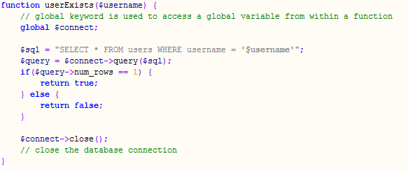

* Matching two password

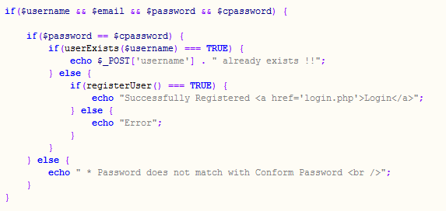

* Register user and insert info. into database.

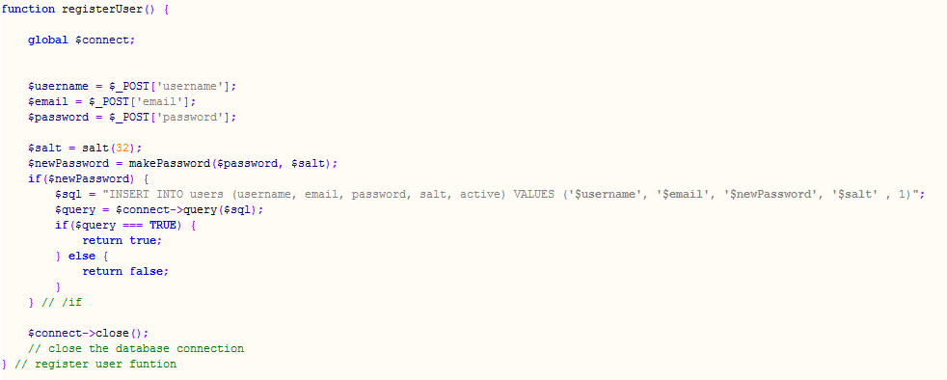

### 3.1.2 Log In

* First checking whether the username exists or not? Code snippet for this section is same as sign up section’s username exists part.
* Then Fetching the row according to username from database and match the password. Of course the the encrypted password is used here, for security issue.

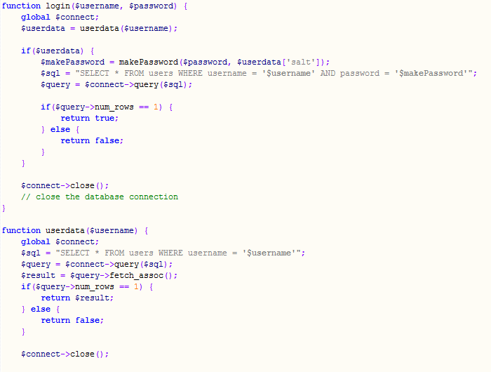

* Then proceed to home page or show password mismatch massage.

## User

User can perform multiple task after get logged in.

### 3.2.1 Home

After user get authenticated, she will get access to the home page.

### 3.2.2 Adding Note Page

After selecting add note option, user can write note in text format, add tag, heading and also can attach file/image. And finally she can save changes.

### 3.2.3 View Note Page

After selecting the view note option, user can view previously saved note in text format. She also have a option to edit the note again.

### 3.2.4 Adding Task Page

After selecting add task option, user can set a task and also set its description, progress status, deadline. And finally she can save changes.

### 4.2.5 Adding Reminder Page

After selecting add reminder option, user can set reminder on a particular event. And finally she can save changes.

### 4.2.6 Contact Page

After navigating contact option, user can contact with the server end authority. By this she can complain about anything or give recommendation.

### 4.2.7 About Us Page

After navigating about us page, user can know about the publisher of this application.

### 4.2.8 Change Password Page

After user select change password, she can update her account password with a new one for security.

And User can logged out using log out button.

# Chapter 4: User Manual

We can divide user manual into two section, Non-User and User

## Non-User

There are three major part of this side. They are- intro page, sign up page, log in page.

### 4.1.1 Intro Page

Both the member and non-member users get this intropage when they first enter to this website.

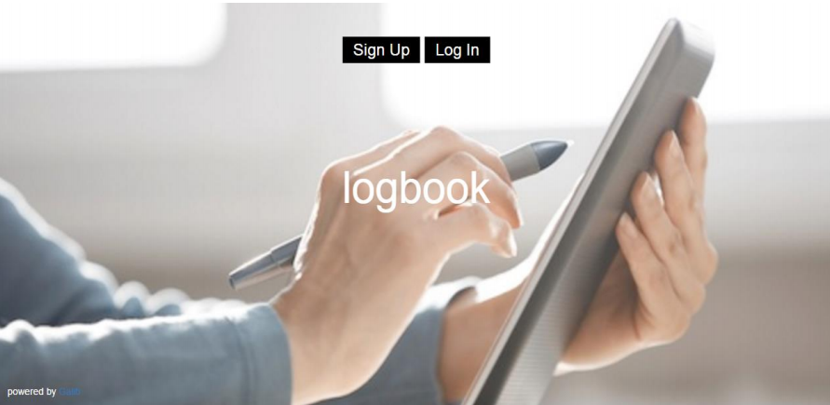

### 4.1.2 Sign Up Page

By clicking sign up button user can get access to sign up page, where she can provide info and get signed up.

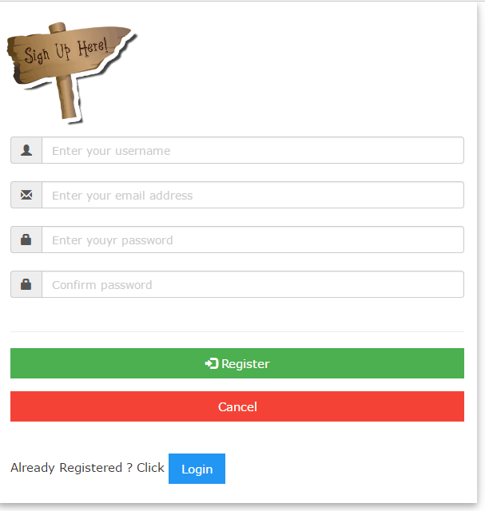

### 4.1.3 Log In Page

By clicking log in button user can get access to sign up page, where she can provide info and get Logged in.

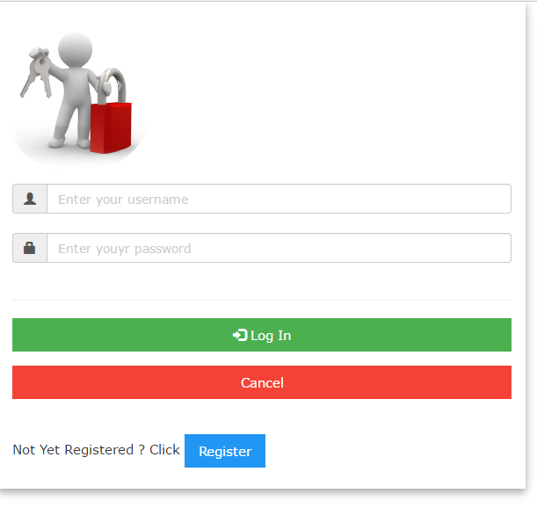

## User

User can perform multiple task after get logged in.

### 4.2.1 Home Page

After user get authenticated, she will get access to the home page.

### 4.2.2 Adding Note Page

After selecting add note option, user can write note in text format, add tag, heading and also can attach file/image. And finally she can save changes.

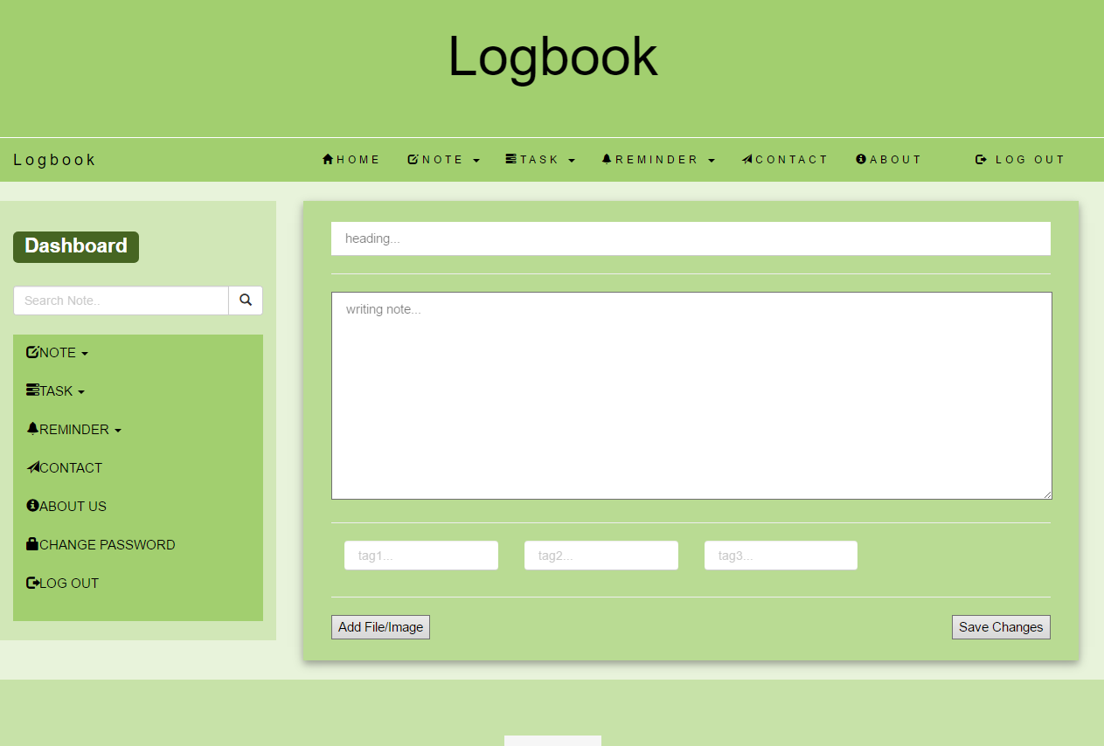

### 4.2.3 View Note Page

After selecting the view note option, user can view previously saved note in text format. She also have a option to edit the note again.

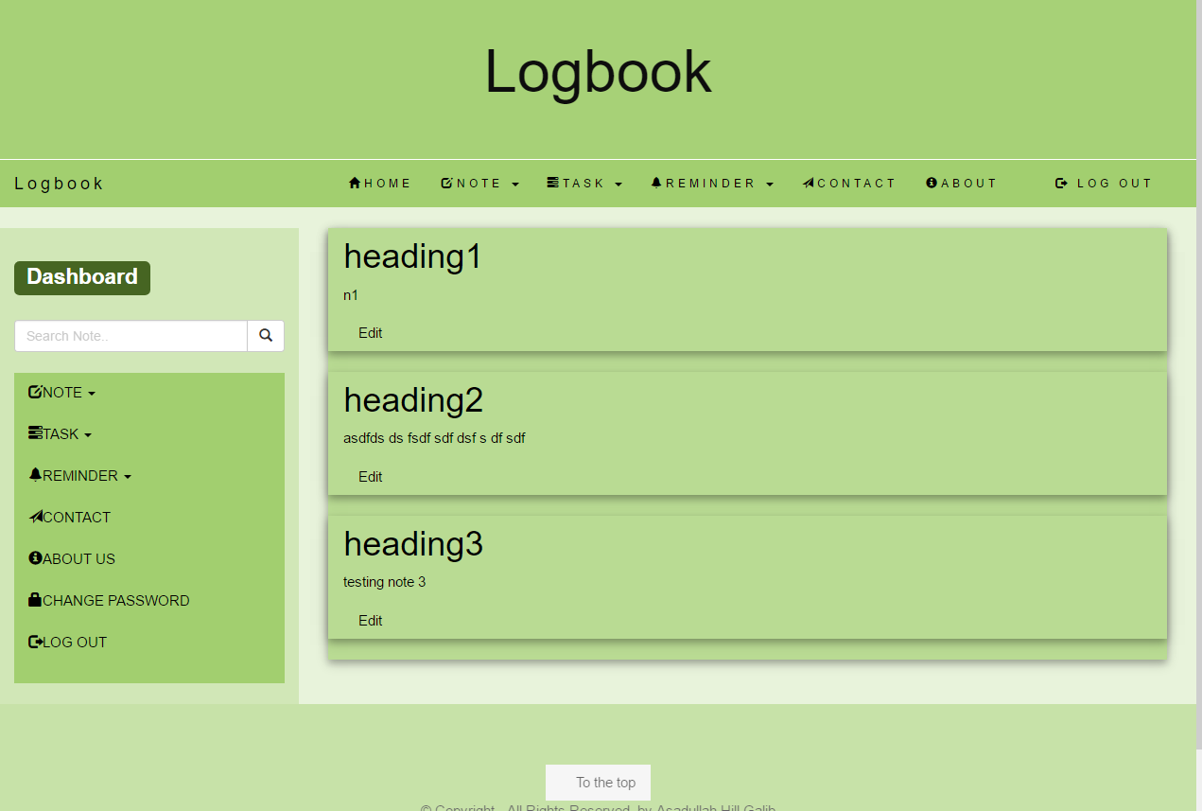

### 4.2.4 Adding Task Page

After selecting add task option, user can set a task and also set its description, progress status, deadline. And finally she can save changes.

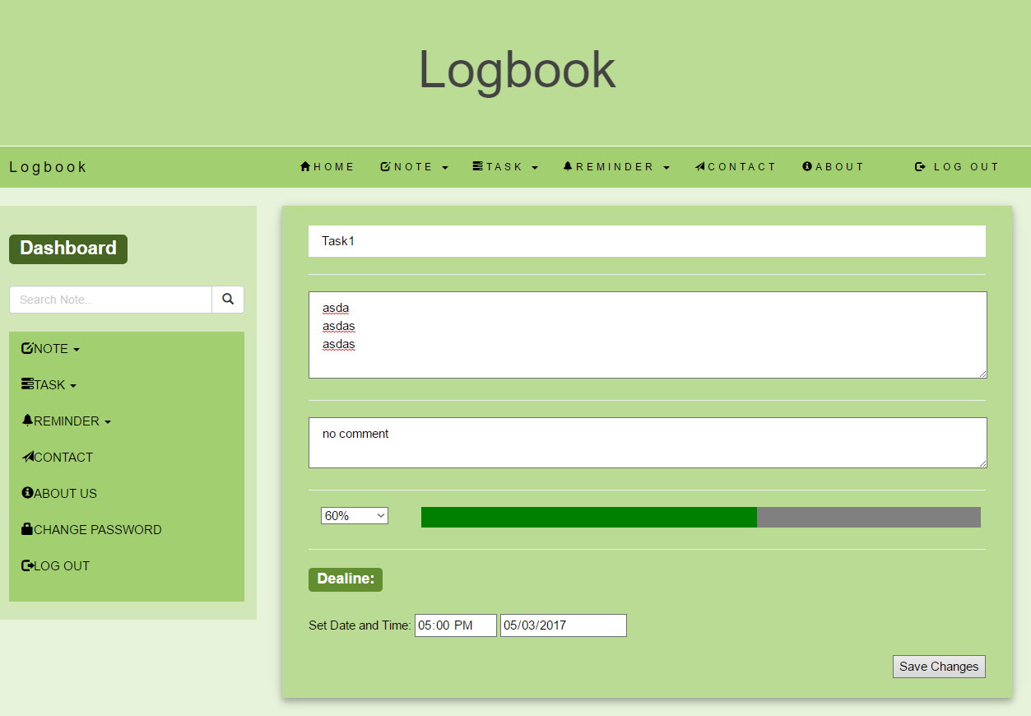

### 4.2.5 Adding Reminder Page

After selecting add reminder option, user can set reminder on a particular event. And finally she can save changes.

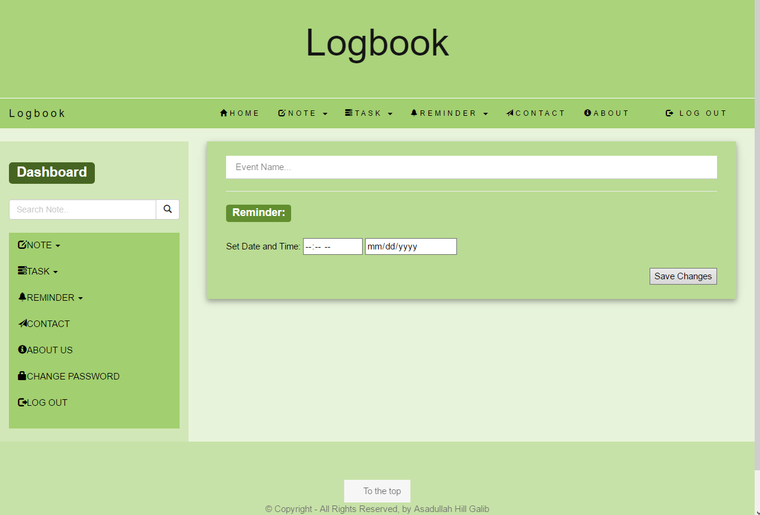

### 4.2.6 Contact Page

After navigating contact option, user can contact with the server end authority. By this she can complain about anything or give recommendation.

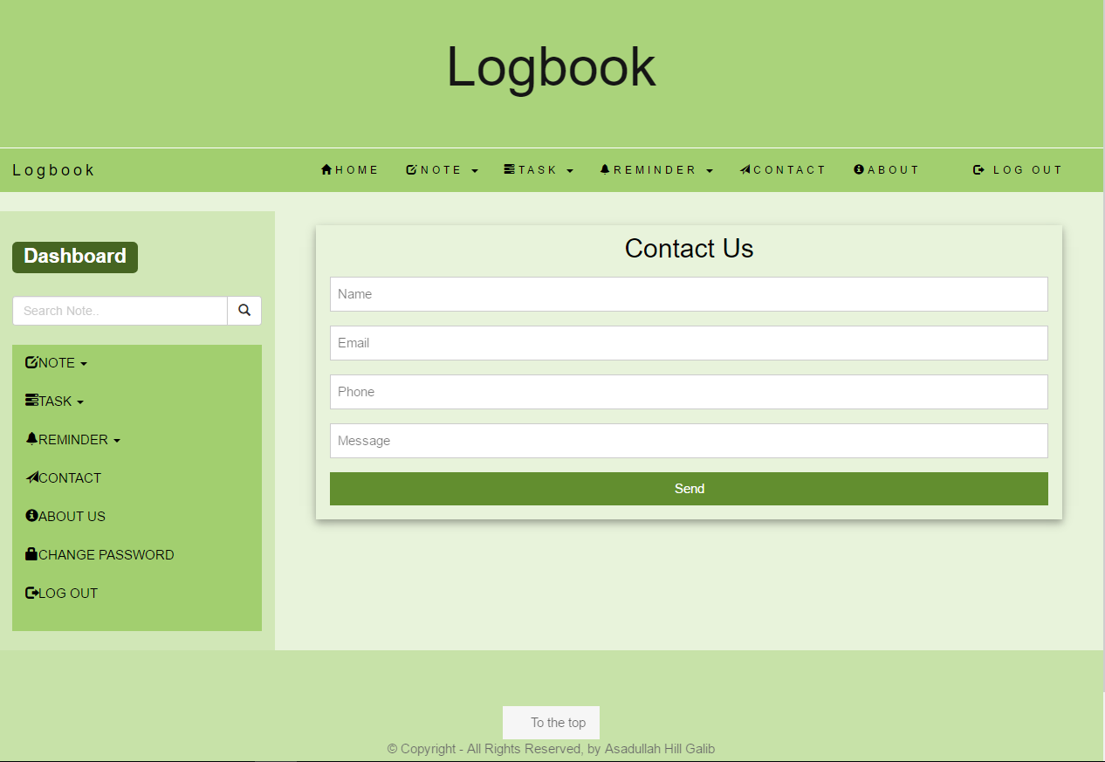

### 4.2.7 About Us Page

After navigating about us page, user can know about the publisher of this application.

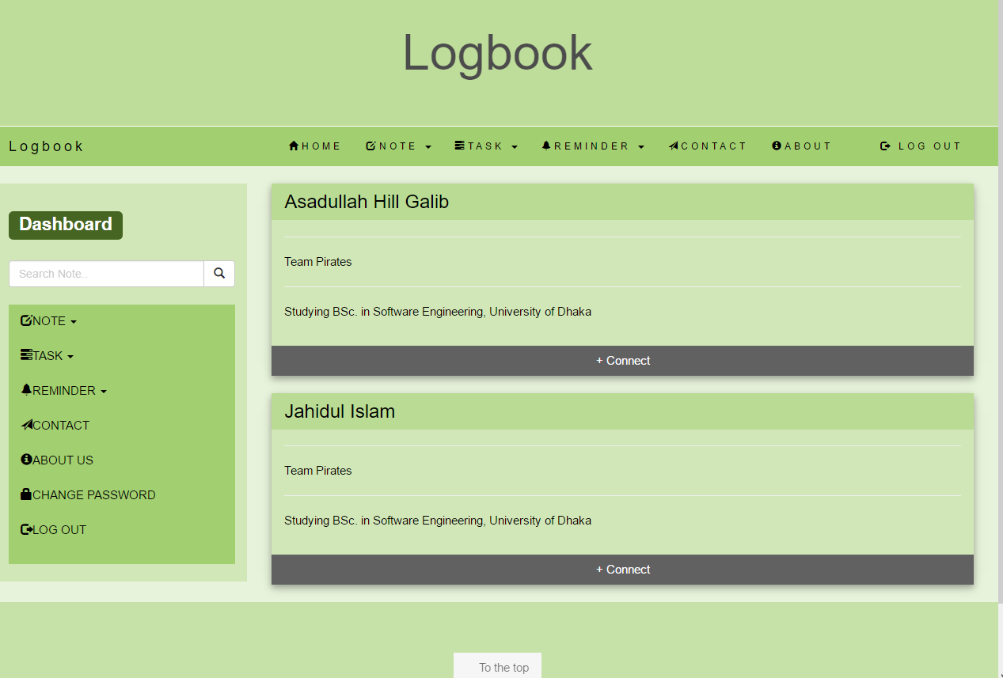

### 4.2.8 Change Password Page

After user select change password, she can update her account password with a new one for security.

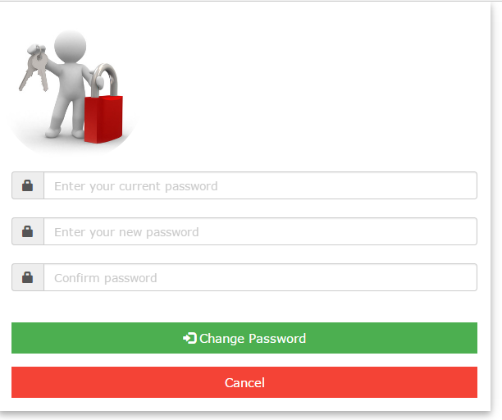

And User can logged out using log out button.

# Chapter 5: Conclusion

Project managers are aware of the difficulty in keeping track of various tasks, resources, timeline in maintaining daily life easily. Our personal task manager is such kind of tool which will be serviceable and easy-to-use. Developing this application was a great experience for us.

## Achievements

This project helped us to achieve a lot of experiences-

* Building first web application
* Creating a real usable software product
* Learning and implementing primititive web technology

## Obstacles

* In spite of using framework, we use raw code. For which we often faces obstacles to handle code.
* To learn and implement web technology simultaneously

## Future Plan

* Updating this application as far as possible
* Creating a android app of this application