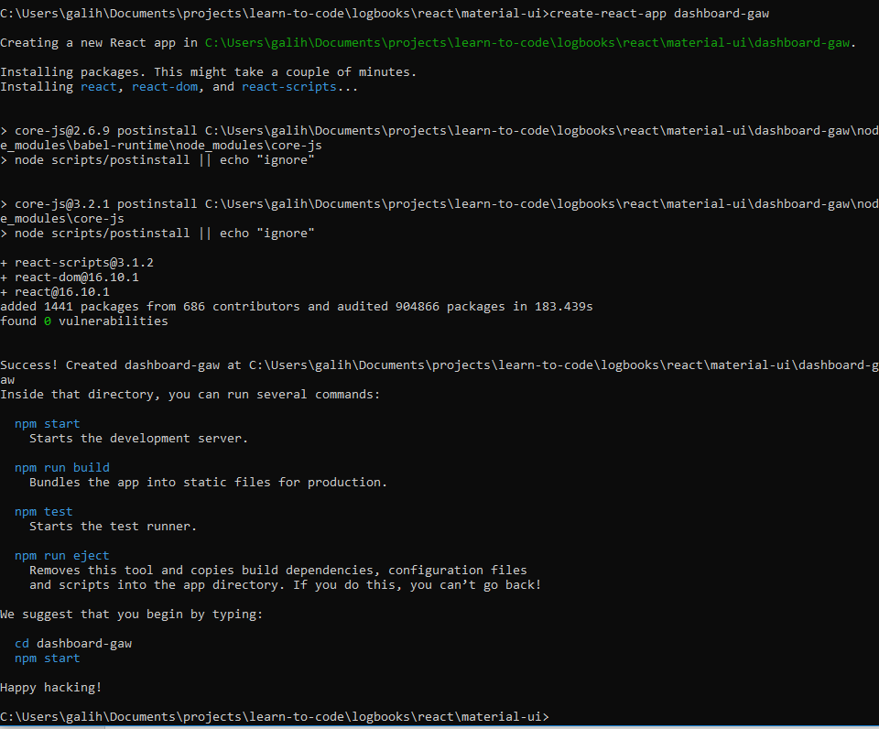

hapus logo.svg

Bersihkan App.js

Copy: public, src, jsconfig.json, package.json. Lalu npm install, enter

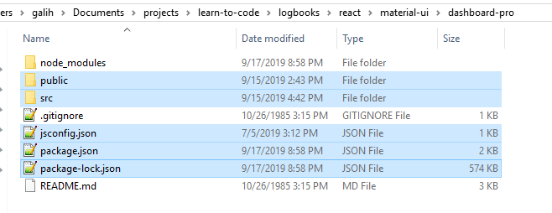

npm install –save redux

npm install –save react-redux

npm install –save axios

