Cek versi NPM & Node JS

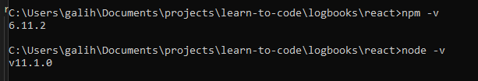

Install create-react-app globally



Bikin project basic

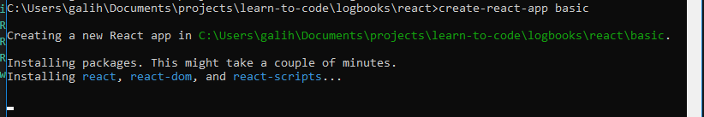

Start development

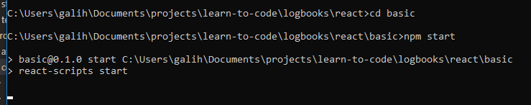

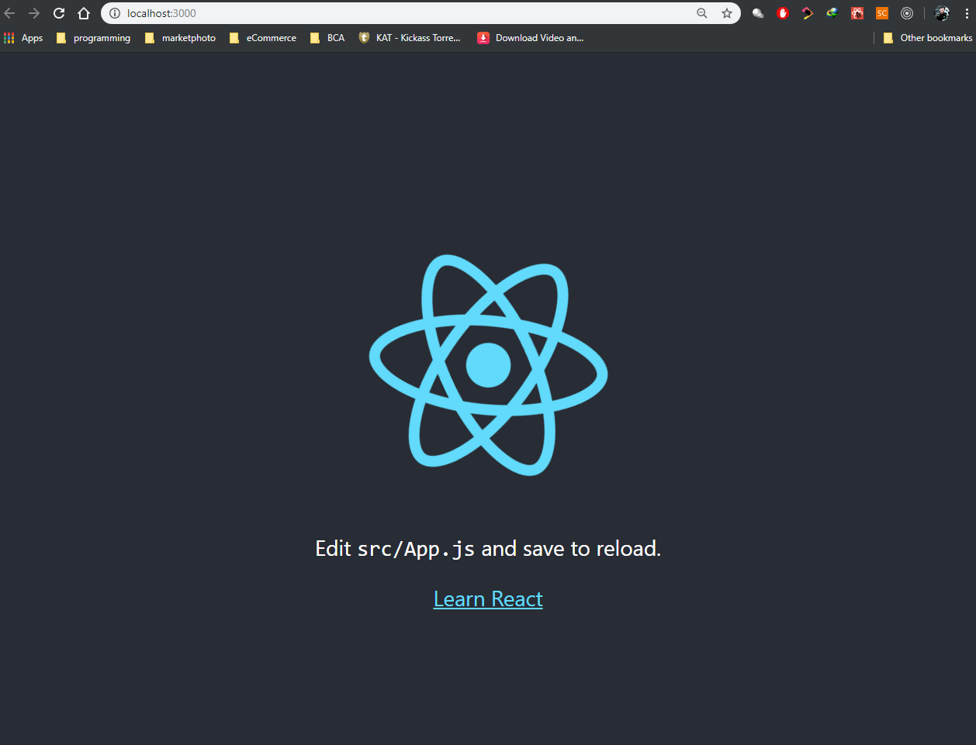

===============================================================================================

**Creating a functional component**

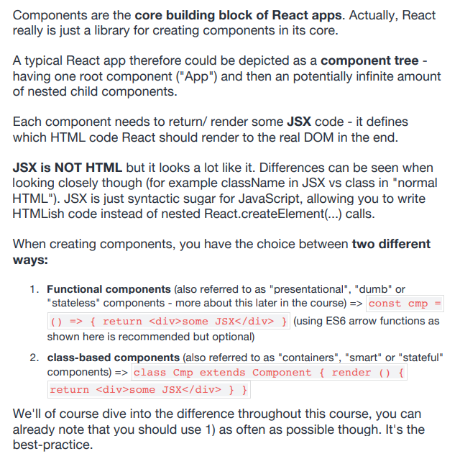

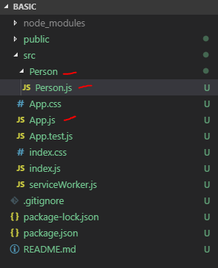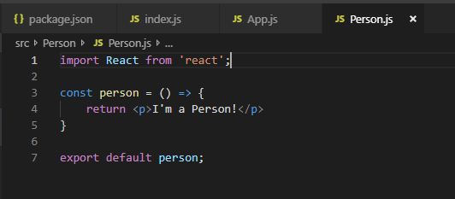

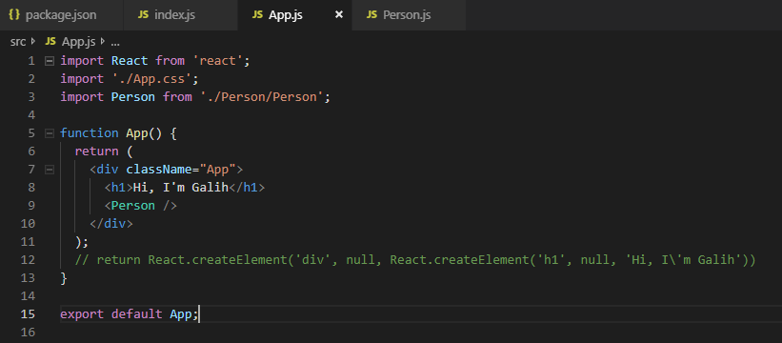

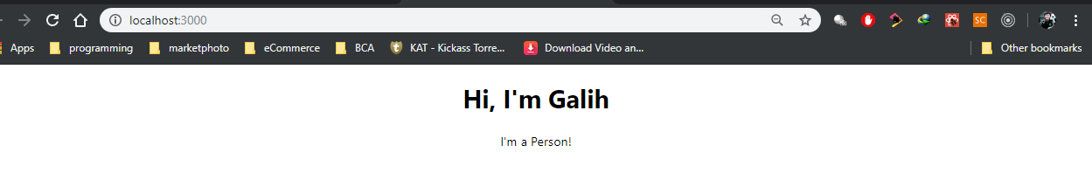

* Working with Components & Re-Using them
* Outputing Dynamic Content
* Working with Props
* Understanding the Children Property

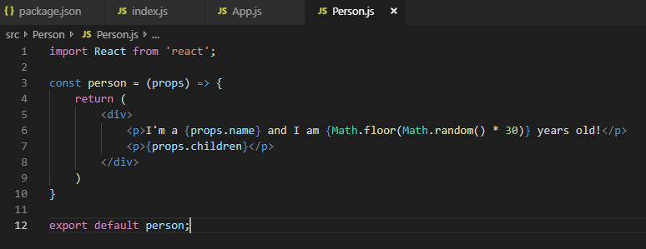

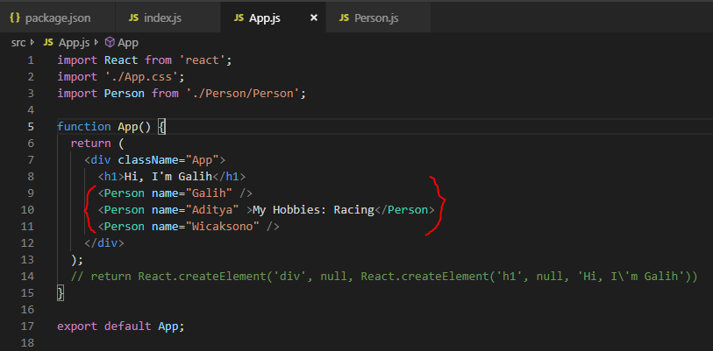

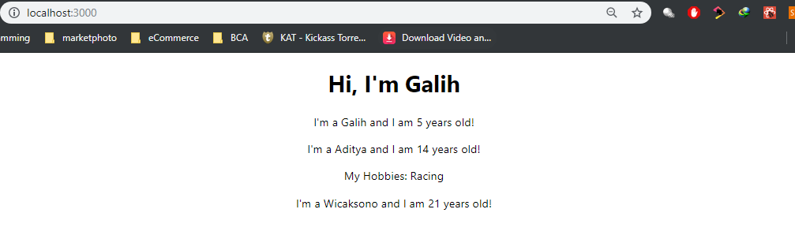

===============================================================================================

**Props & State**

ubah functional component 🡪 class based component

Before

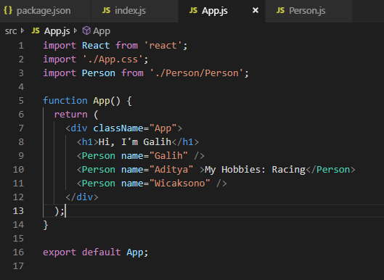

After

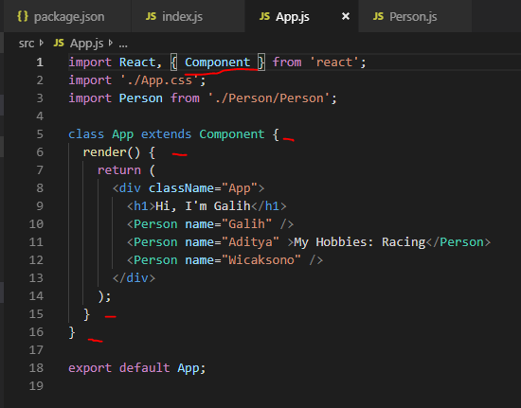

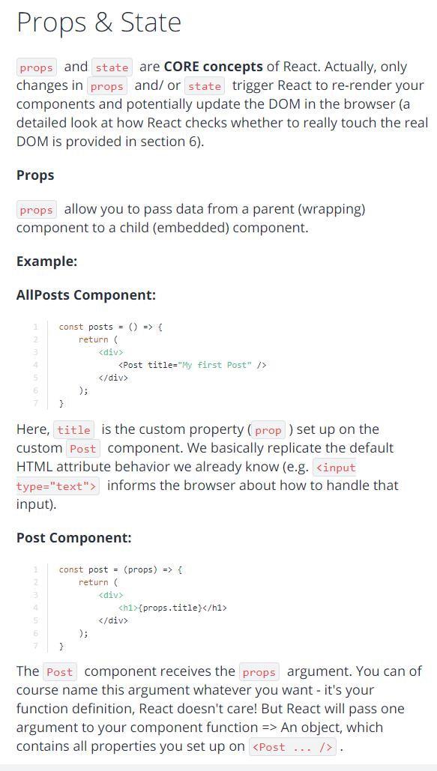

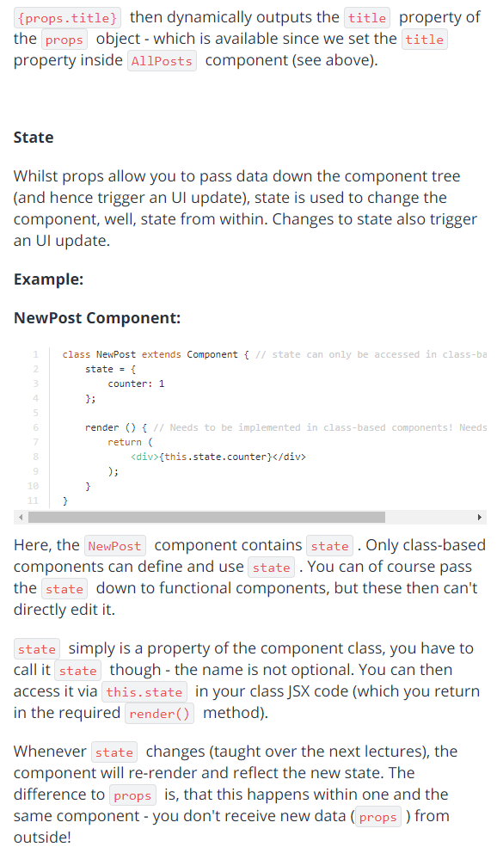

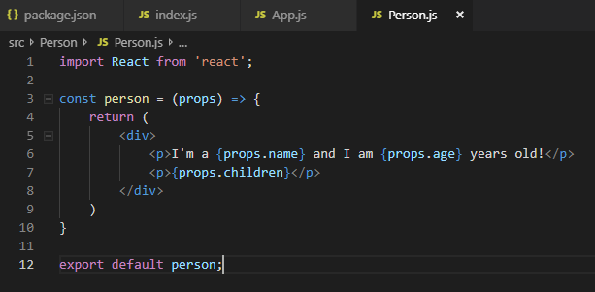

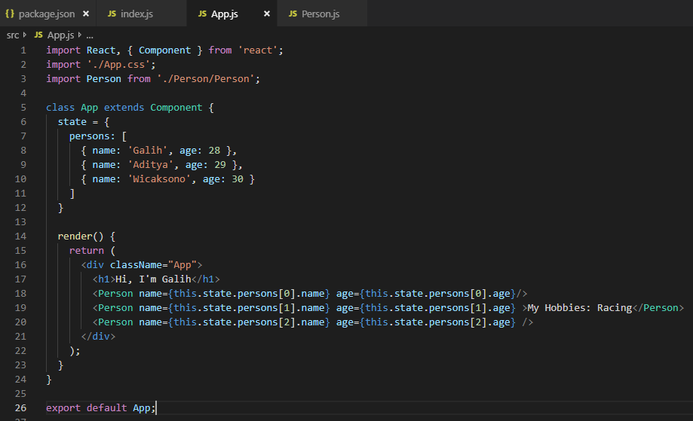

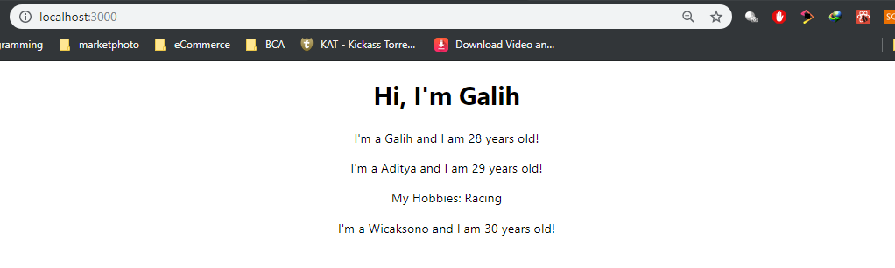

Manipulating the State --------------------------------------------------------------------------------------------------------------------------

DON’T DO THIS

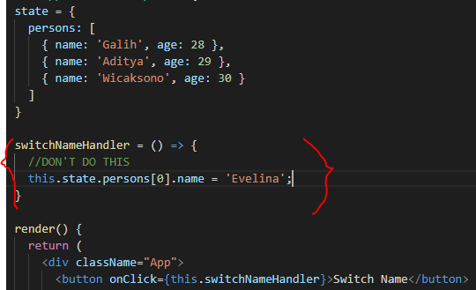

Use this instead

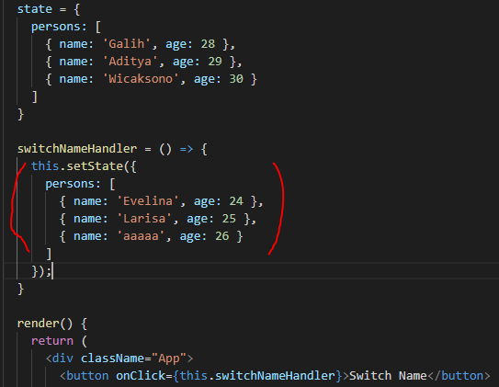

UseState() Hook for State Manipulation------------------------------------------------------------------------------------------------------

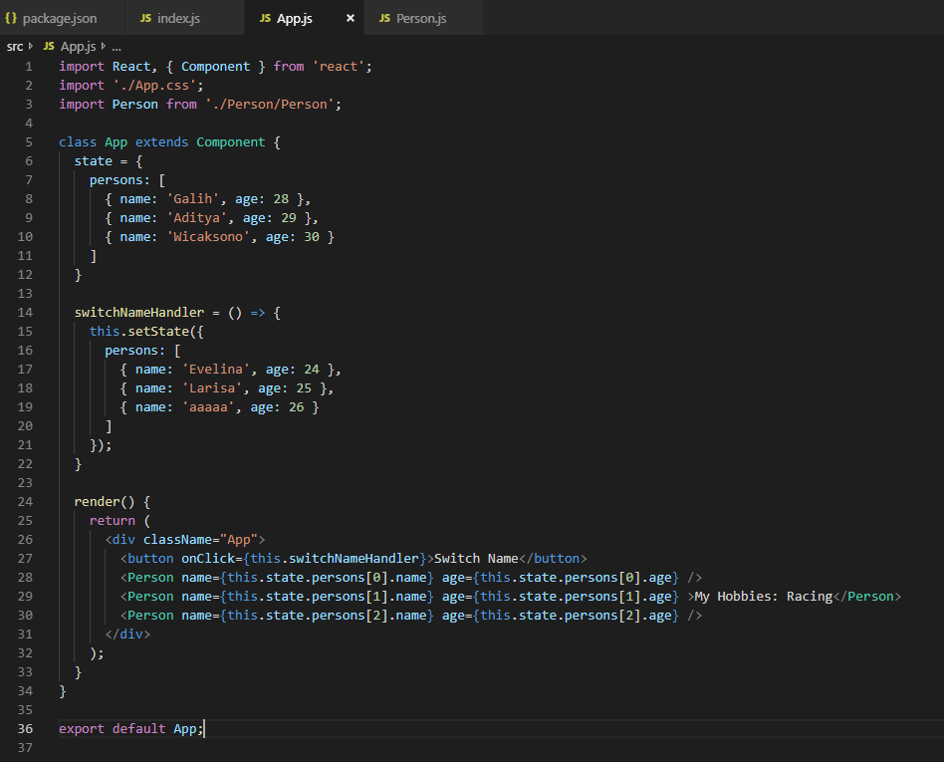

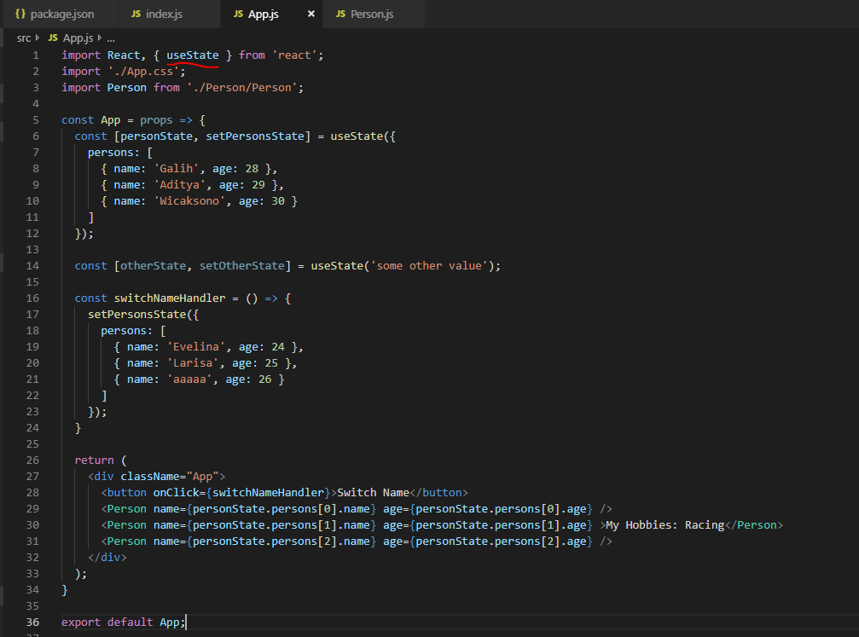

Passing Method References Between Components ---------------------------------------------------------------------------------------

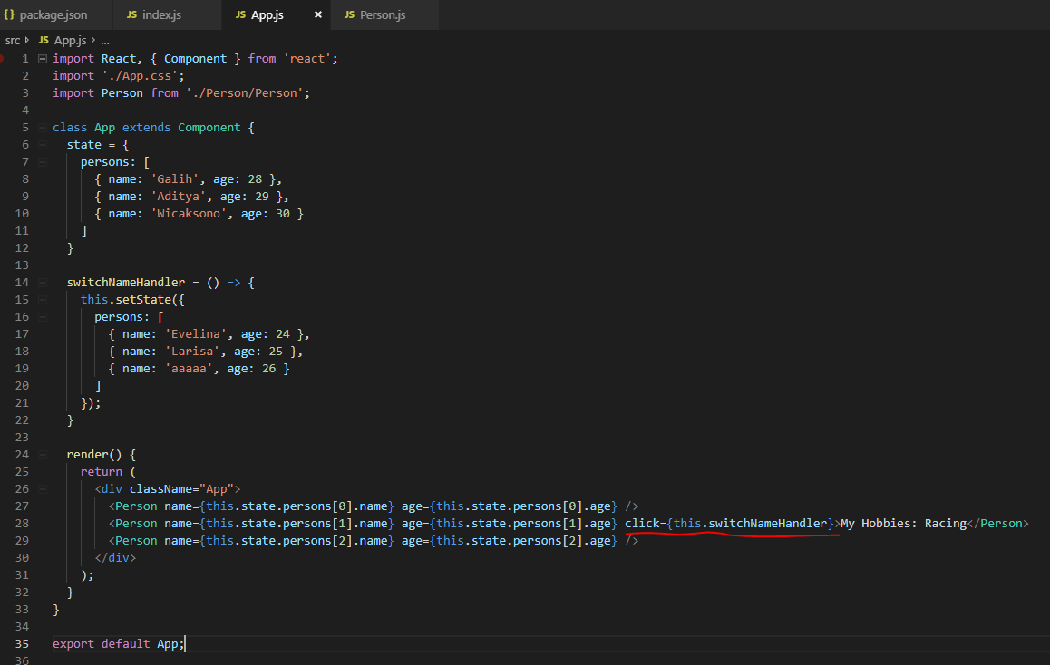

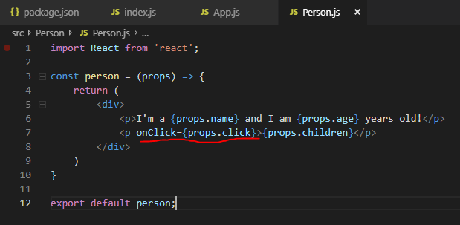

* **Bagaimana jika method yang di-passing mempunyai parameter?**

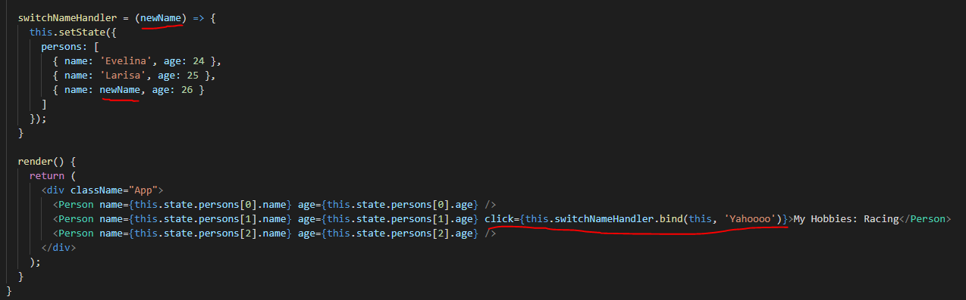

Atau pake arrow function (tapi lebih prefer cara di atas)

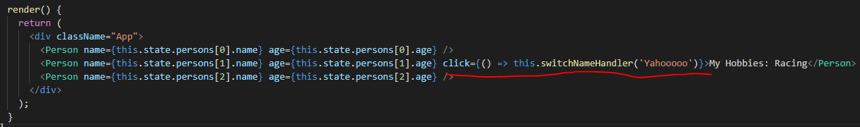

Two Way Binding -----------------------------------------------------------------------------------------------------------------------------------

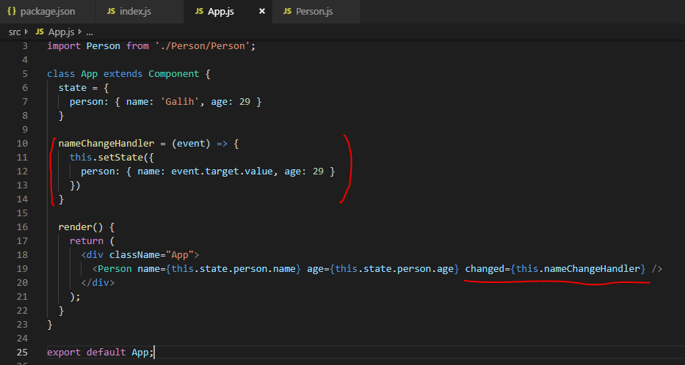

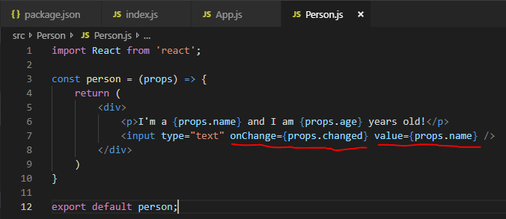

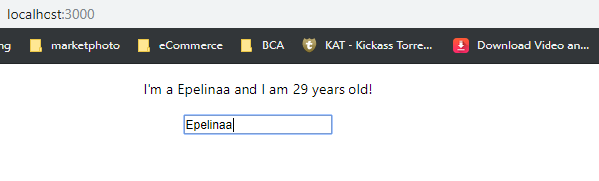

Adding Styling with Stylesheets -----------------------------------------------------------------------------------------------------------------

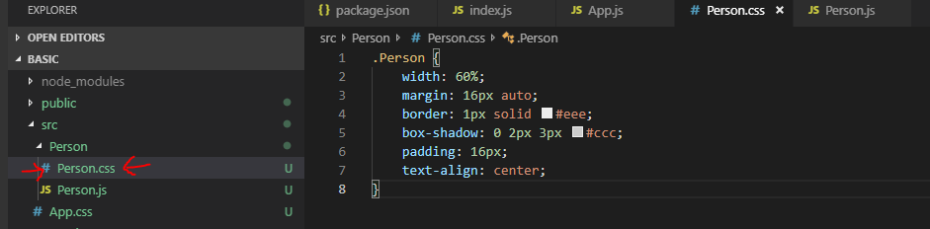

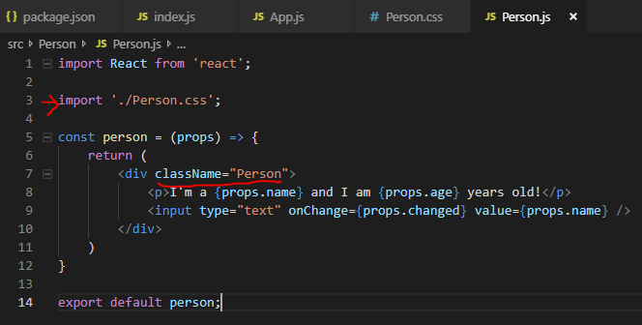

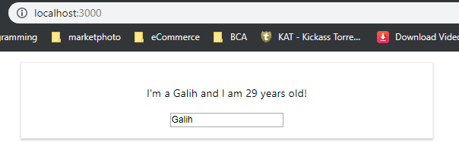

Rendering Content Conditionally -----------------------------------------------------------------------------------------------------------

* condition? true : false 🡪 Ternary expression 🡪 jika JSX/dalam return()
* if (condition){ true } 🡪 jika dalam render tapi diluar return

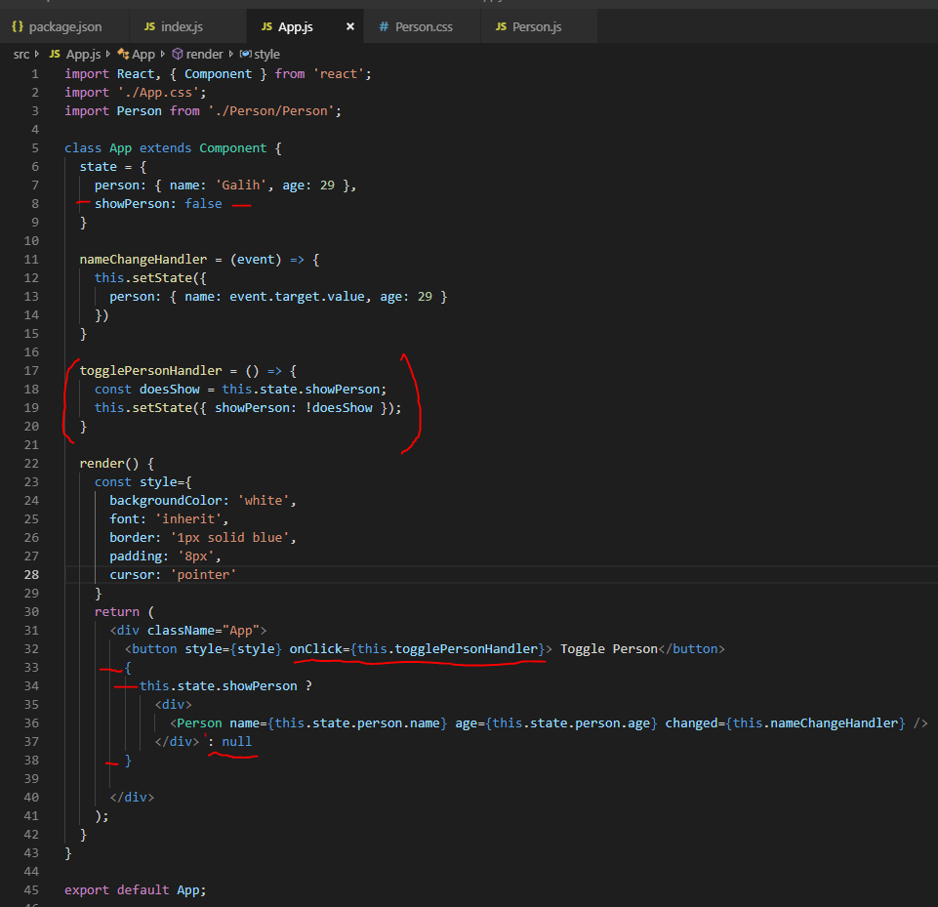

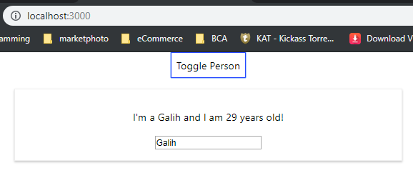

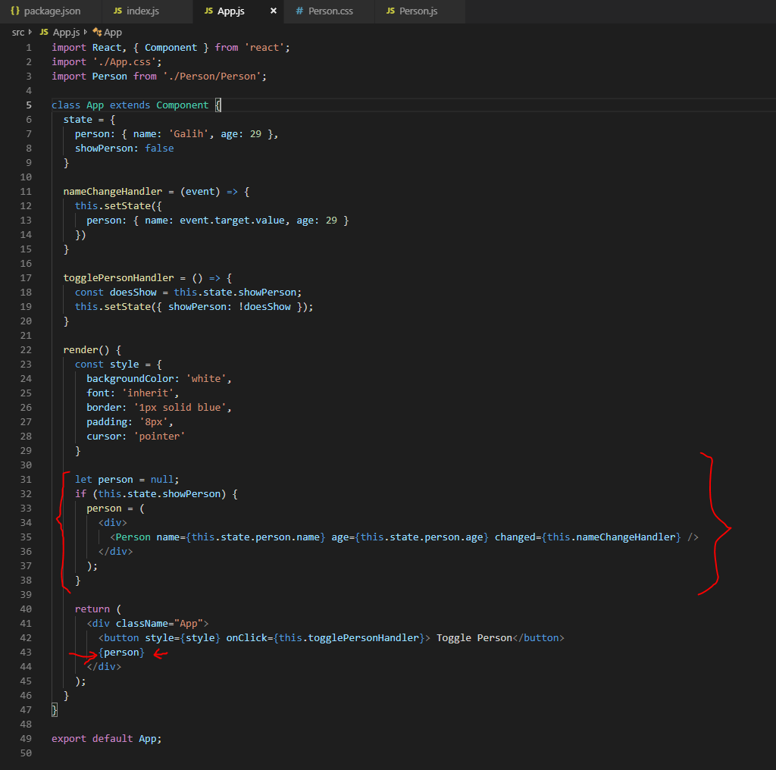

List & State -------------------------------------------------------------------------------------------------------------------------------------------

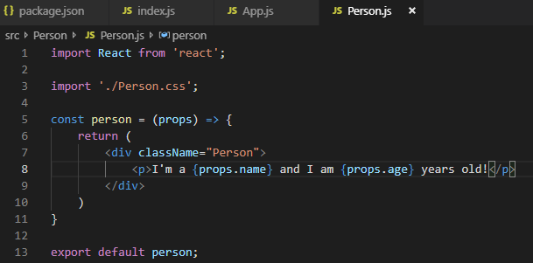

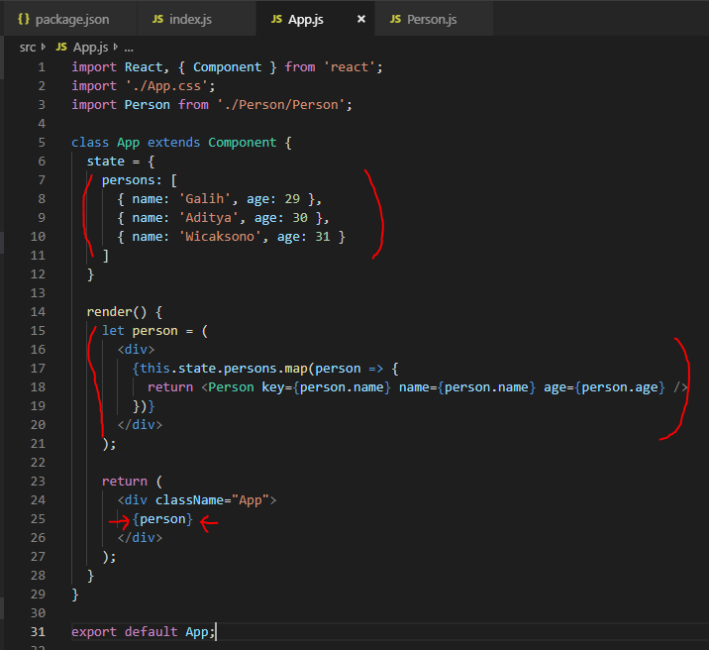

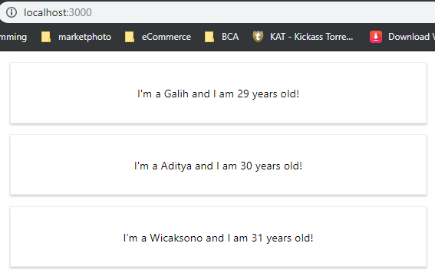

Hapus Person bila di-klik

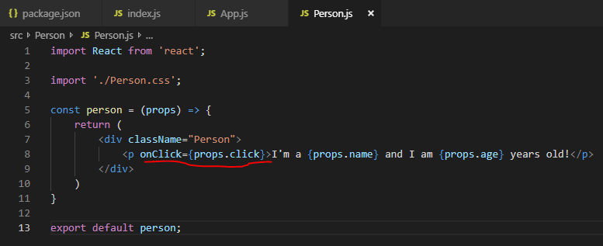

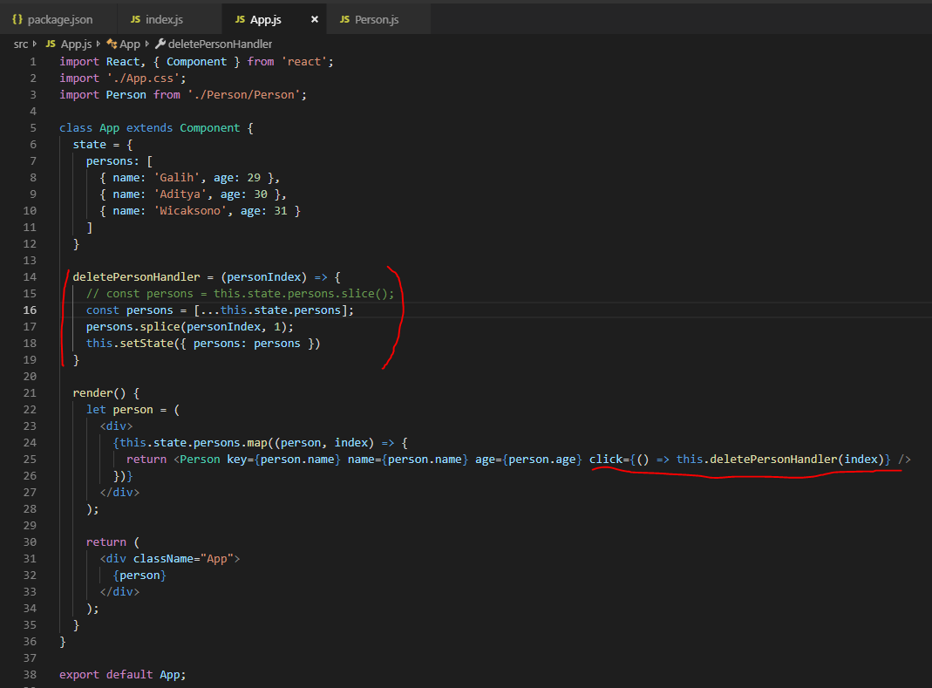

Flexible Lists -----------------------------------------------------------------------------------------------------------------------------------------

