# PEMROGRAMAN WEB



**Untuk Memenuhi Project UTS**

**Mata Kuliah Pemrograman Web 1**

**Dosen Pengampu : Sharfina Handayani, M.Kom.**

**Disusun Oleh:**

**Nama : M.Galih Fikran Syah**

**NIM : 19090074**

**Kelas : 3B**

**PRODI DIV TEKNIK INFORMATIKA**

**POLITEKNIK HARAPAN BERSAMA**

**TEGAL**

**2020**

**KATA PENGANTAR**

Puji syukur penulis panjatkan kehadirat Tuhan Yang Maha Esa yang telah berkenan memberi petunjuk dan kesabaran kepada penulis sehingga makalah **"Pemrograman Web"** ini dapat diselesaikan dengan baik. Makalah ini disusun dan dibuat berdasarkan materi-materi yang ada yang bertujuan agar dapat menambah pengetahuan dan wawasan mahasiswa dalam belajar serta agar mahasiswa juga dapat memahami nilai-nilai dasar yang dikembangkan dalam berpikir dan bertindak. Mudah-mudahan dengan mempelajari makalah ini, para mahasiswa akan mampu menghadapi masalah-masalah atau kesulitan-kesulitan yang timbul dalam belajar Dan dengan harapan semoga mahasiswa mampu berinovasi dan berkreasi dengan potensi yang dimiliki. Kami menyadari bahwa dalam pembuatan Makalah Teknologi Informasi ini masih ada kekurangan sehingga penulis berharap saran dan kritik dari pembaca sekalian agar penulis dapat meningkatkan dan memperbaiki penyajian makalah yang lebih baik dari sebelumnya. Akhir kata penulis ucapkan terima kasih.

Tegal, 12 November 2020

**PENJELASAN**

Website merupakan platform yang didalamnya berisi banyak informasi, website menghubungkan banyak sekali mesin computer sehingga dapat bertukar data dan informasi. Salah satu yang dapat kita manfaatkan dari website ialah e-commerce. Tidak dapat dipungkiri semakin canggihnya teknologi mendorong manusia pada peradaban era modern, sekarang aktivitas jual beli dilakukan secara daring tanpa harus bertatap muka.

Fa-Shop merupakan salah satu website e-commerce yang menyediakan berbagai keperluan fashion bagi pria maupun wanita. Selain fitur online shop Fa-Shop juga menyediakan fitur blog untuk para user yang tertarik pada dunia fashion.

Dari segi teknis website ini terdiri dari beberapa bagian berdasarkan tata letaknya, antara lain : header, banner, sidebar, main, aside, dan footer. Masing-masing elemen mempunyai fungsinya sendiri.

**HEADER**

Header berisi icon fa-shop, menu navigasi antara lain shop, pages, blog, contact, cart serta login.

<header id="header">

        <div class="head-left">

            <h2 onclick=document.location.href='index.html' id="sitename"><i class="fas fa-shopping-cart"></i>&nbsp;Fa-SHop</h2>

            <ul>

                <li><a id="shopMenu">Shop&nbsp;&nbsp;<i class="fas fa-caret-down"></i></a></li>

                <li><a href="about.html">Pages&nbsp;&nbsp;<i class="fas fa-caret-down"></i></a></li>

                <li><a href="blog.html">Blog</a></li>

                <li><a href="contact.html">Contact</a></li>

            </ul>

        </div>

        <div class="head-right" id="head-right">

            <ul id="link-right">

                <li onclick="document.location.href='checkout.html'"><a href="#"><i class="fas fa-shopping-cart"></i><span> Cart</span></a></li>

                <li id="login-toggle"><a href="#"><i class="fas fa-user"></i><span> login</span></a></li>

            </ul>

            <div class="menu" id="menu"><i class="fas fa-bars"></i></div>

        </div>

    </header>

**STYLE HEADER**

/*header*/

header{

    width: 100%;

    height: 100px;

    background-color: #fff;

    font-family: cremona;

    position: relative;

    box-shadow: 0 .2px 6px #ddd;

    position: fixed;

    z-index: 999;

}

.head-left h2{

    display: inline-block;

    line-height: 100px;

    cursor: pointer;

    width: 150px;

    padding-left: 100px;

    padding-right: 30px;

}

.head-left ul{

    height: 50px;

    display: inline-block;

}

.head-left ul li{

    display: inline-block;

    height: 50px;

    line-height: 50px;

    padding: 0 10px;

    cursor: pointer;

}

.head-left ul li a{

    text-decoration: none;

    color: #707070;

}

.head-left ul li a:hover{

    color: #343434;

}

.head-right{

    position: absolute;

    right: 100px;

    top: 0;

    height: 100%;

}

.head-right a{

    text-decoration: none;

    color: #707070;

}

.head-right ul li:first-child{

    border-left: 1px solid #ddd;

}

.head-right ul li{

    display: inline-block;

    padding: 0 20px;

    height: 100px;

    border-right: 1px solid #ddd;

}

.head-right ul{

    line-height: 100px;

}

.head-right ul li:first-child{

    position: relative;

    left: 5px;

}

.head-right ul li:hover{

    color: #343434;

    cursor: pointer;

    background-color: #fffded;

}

.head-right ul li span{

    visibility: hidden;

    font-size: 0px;

}

@keyframes fadeInText{

    from{

        font-size: 0px;

        visibility: hidden;

    }

    to{

        font-size: 16px;

        visibility: visible;

    }

}

@keyframes fadeOutText{

    from{

        font-size: 16px;

        visibility: visible;

    }

    to{

        font-size: 0px;

        visibility: hidden;

    }

}

#menu{

    line-height: 100px;

    font-style: italic;

    display: none;

}

#menu .fas{

    padding: 3px;

    cursor: pointer;

}

/*end-header*/

**BANNER**

Banner adalah elemen yang menampilkan informasi utama mengenai website antara lain yaitu slogan, welcome text dan main button.

<div id="banner">

        <div>

            <div class="wrapper">

                <div>

                    <center><h1 style="margin-bottom: 10px;">SHOP TILL YOU DIE</h1></center>

                    <p>Currently FA-SHOP is the best online shopping site in the world after Shopee and Tokopedia.

                         Let's support us by continuing enjoy our service and sending comments and suggestions.</p>

                    <div>

                        <div id="mainButton1"><a href="blog.html" style="color: #ddd; text-decoration: none;">VIEW BLOG</a></div>

                        <div id="mainButton2"><a href="#list-product" style="color: #ddd; text-decoration: none;">VIEW COLLECTIONS</a></div>

                    </div>

                </div>

            </div>

        </div>

    </div>

**STYLE BANNER**

#banner{

    height: 100%;

    background-color: #201335;

    background-image: url('../img/banner.jpg');

    background-size: cover;

    background-position: center;

}

#banner > div h1{

    font-family: "Constantia";

    font-size: 40px;

    line-height: 50px;

}

#banner > div{

    height: 100%;

    padding: 0 20%;

    padding-top: 100px;

    background-color: rgba(0,0,0,.7);

}

#categories-img{

    display: flex;

}

.wrapper{

    height: 80%;

    display: flex;

    justify-content: center;

    align-items: center;

    line-height: 25px;

}

.wrapper > div{

    text-align: center;

    color: rgb(225,225,255);

}

.wrapper > div > div{

    display: flex;

    justify-content: center;

}

#mainButton1, #mainButton2{

    border: 1px solid #4f4789;

    width: auto;

    padding: 10px;

    display: inline-block;

    text-align: center;

    margin: 10px;

}

#mainButton2{

    background-color: #4f4789;

}

#mainButton1{

    border: 1px solid #fff;

}

**INTERFACE HEADER & BANNER**

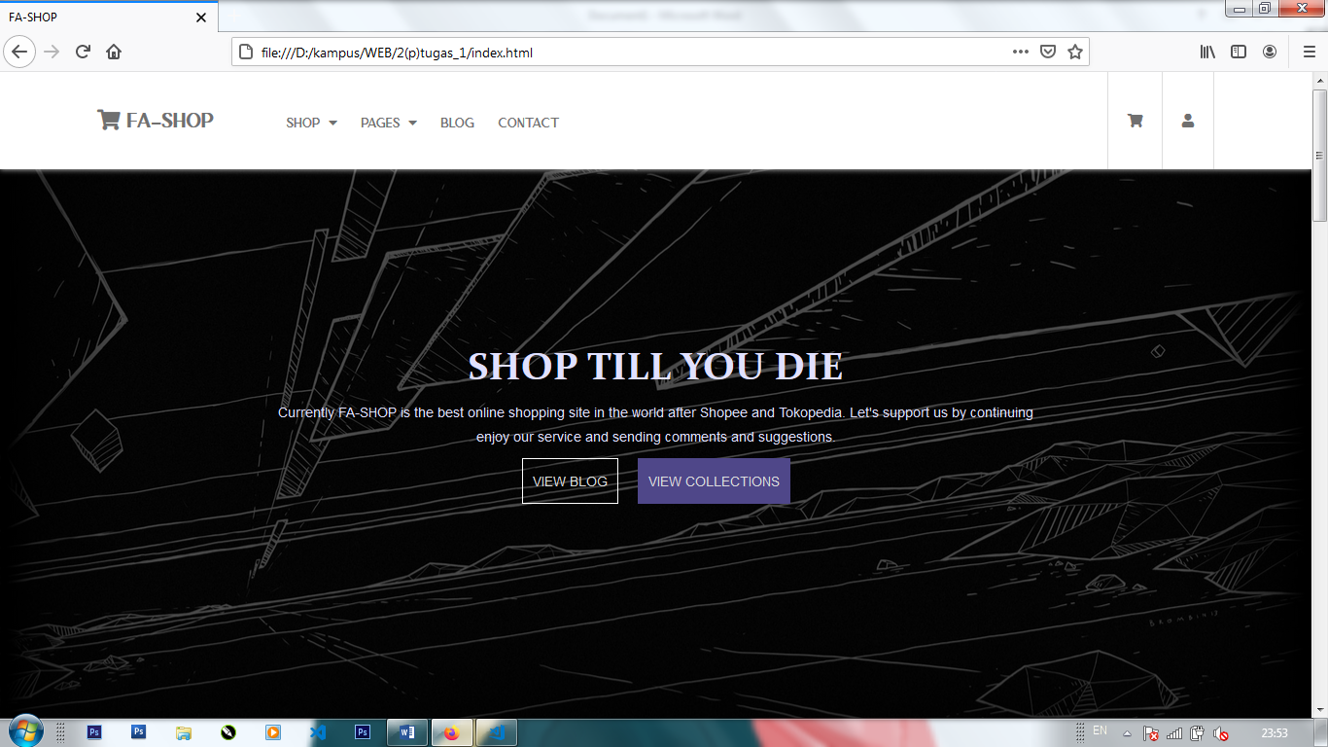

**SIDEBAR**

Sidebar bisa berisi menu navigasi atau informasi-informasi lain mengenai website dan juga dapat berisi link alternative.

<div class="sidebar" id="sidebar">

        <div id="sidebar-head">

            <h2 onclick=document.location.href='index.html' id="sitename"><i class="fas fa-shopping-cart"></i>&nbsp;Fa-SHop</h2>

            <span id="close-sidebar"><i class="fas fa-times"></i></span>

        </div>

        <div id="sidebar-body">

            <ul>

                <li><a href="index.html">Home</a></li>

                <li><a href="blog.html">Blog</a></li>

                <li><a href="contact.html">Contact</a></li>

                <li><a href="#" id="login-toggle">Login</a></li>

            </ul>

        </div>

    </div>

**STYLE SIDEBAR**

.sidebar{

    position: fixed;

    z-index: 999;

    box-shadow: 3px 2px 10px #000;

    top: 0;

    bottom: 0;

    background-color: #fff;

    width: 250px;

    left: 0;

    display: none;

}

#sidebar-head{

    padding: 15px 20px;

    margin-bottom: 20px;

}

#sidebar-body ul li{

    margin: 10px 20px;

    padding: 3px 0;

    list-style-type: none;

    border-bottom: 1px solid #ddd;

    cursor: pointer;

    padding: 10px 0;

}

#sidebar-body ul li a{

    color: #707070;

    text-decoration: none;

}

#sidebar-head h2{

    display: inline-block;

    font-family: 'cremona';

}

#close-sidebar{

    cursor: pointer;

    font-size: 15px;

    float: right;

    display: inline-block;

    padding: 1px 5px;

    background-color: rgba(0,0,0,.7);

    color: #fff;

}

**INTERFACE SIDEBAR**

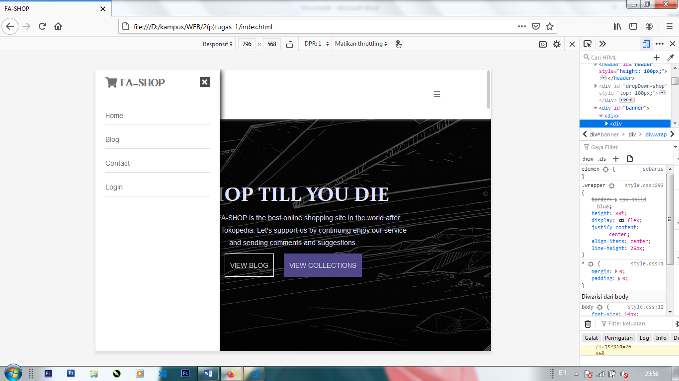

**FOOTER**

Footer adalah bagian paling akhir pada website, biasanya berisi informasi website, nama ,contact, about, link alternative dan lain-lain.

<footer class="footer-distributed">

        <div class="footer-left">

            <h3>Fa-SHOP</h3>

            <p class="footer-links">

                <a href="<?=base_url('home')?>">SHOP</a>

                ·

                <a href="<?=base_url('home/faq')?>">BLOG</a>

                ·

                <a href="<?=base_url('home/disclaimer')?>">CONTACT</a>

                ·

                <a href="#" id="login-toggle-alt">LOGIN</a>

            </p>

            <p class="footer-company-name flow-text">Copyright &copy; 2020 | fa-shop.com</p>

        </div>

        <div class="footer-center">

            <div>

                <i class="fas fa-fw fa-map-marker"></i>

                <p>Tegal, Jawa Tengah, Indonesia</p>

            </div>

            <div>

                <i class="fas fa-phone"></i>

                <p>+6289-8667-6180</p>

            </div>

            <div>

                <i class="fas fa-envelope"></i>

                <p><a href="mailto:galih11120@gmail.com">Send Email</a></p>

            </div>

        </div>

        <div class="footer-right">

            <p class="footer-company-about">

                <span>About Us</span>

                    Currently FA-SHOP is the best online shopping site in the world after Shopee and Tokopedia.

                    Let's support us by continuing enjoy our service and sending comments and suggestions.

            </p>

            <div class="footer-icons">

                <a href="#"><img src="assets/icon/facebook-f-brands.svg" style="width: 10px;filter: invert(1);"></a>

                <a href="#"><img src="assets/icon/instagram-brands.svg" style="width: 15px;filter: invert(1);"></a>

                <a href="#"><img src="assets/icon/twitter-brands.svg" style="width: 15px;filter: invert(1);"></i></a>

                <a href="#"><img src="assets/icon/tiktok-brands.svg" style="width: 15px;filter: invert(1);"></i></a>

            </div>

        </div>

    </footer>

**STYLE FOOTER**

.footer-distributed{

background-color: #292c2f;

box-shadow: 0 1px 1px 0 rgba(0, 0, 0, 0.12);

box-sizing: border-box;

width: 100%;

text-align: left;

padding: 55px 50px;

}

.footer-distributed .footer-left,

.footer-distributed .footer-center,

.footer-distributed .footer-right{

display: inline-block;

vertical-align: top;

}

/* Footer left */

.footer-distributed .footer-left{

width: 40%;

}

/* The company logo */

.footer-distributed h3{

color: #fff;

font: normal 3vw 'cremona', cursive;

margin: 0;

}

.footer-distributed h3 span{

color: #5383d3;

}

/* Footer links */

.footer-distributed .footer-links{

color: #ffffff;

margin: 20px 0 12px;

padding: 0;

}

.footer-distributed .footer-links a{

display:inline-block;

line-height: 1.8;

text-decoration: none;

color: inherit;

}

.footer-distributed .footer-company-name{

color: #8f9296;

font-size: 14px;

font-weight: normal;

margin: 0;

}

/* Footer Center */

.footer-distributed .footer-center{

width: 35%;

}

.footer-distributed .footer-center i{

color: #ffffff;

font-size: 15px;

border-radius: 50%;

text-align: center;

line-height: 42px;

margin: 10px 15px;

vertical-align: middle;

}

.footer-distributed .footer-center i.fa-envelope{

font-size: 17px;

line-height: 38px;

}

.footer-distributed .footer-center p{

display: inline-block;

color: #ffffff;

vertical-align: middle;

margin:0;

}

.footer-distributed .footer-center p span{

display:block;

font-weight: normal;

font-size:14px;

line-height:2;

}

.footer-distributed .footer-center p a{

color: #5383d3;

text-decoration: none;;

}

/* Footer Right */

.footer-distributed .footer-right{

width: 20%;

}

.footer-distributed .footer-company-about{

line-height: 20px;

color: #92999f;

font-size: 13px;

font-weight: normal;

margin: 0;

}

.footer-distributed .footer-company-about span{

display: block;

color: #ffffff;

font-size: 14px;

font-weight: bold;

margin-bottom: 20px;

}

.footer-distributed .footer-icons{

margin-top: 25px;

}

.footer-distributed .footer-icons a{

display: inline-block;

width: 35px;

height: 35px;

cursor: pointer;

background-color: #33383b;

border-radius: 2px;

font-size: 20px;

color: #ffffff;

text-align: center;

line-height: 35px;

margin-right: 3px;

margin-bottom: 5px;

}

@media (max-width: 880px) {

.footer-distributed{

font: bold 14px sans-serif;

}

.footer-distributed .footer-left,

.footer-distributed .footer-center,

.footer-distributed .footer-right{

display: block;

width: 100%;

margin-bottom: 40px;

text-align: center;

}

.footer-distributed .footer-center i{

margin-left: 0;

}

}

**INTERFACE FOOTER**

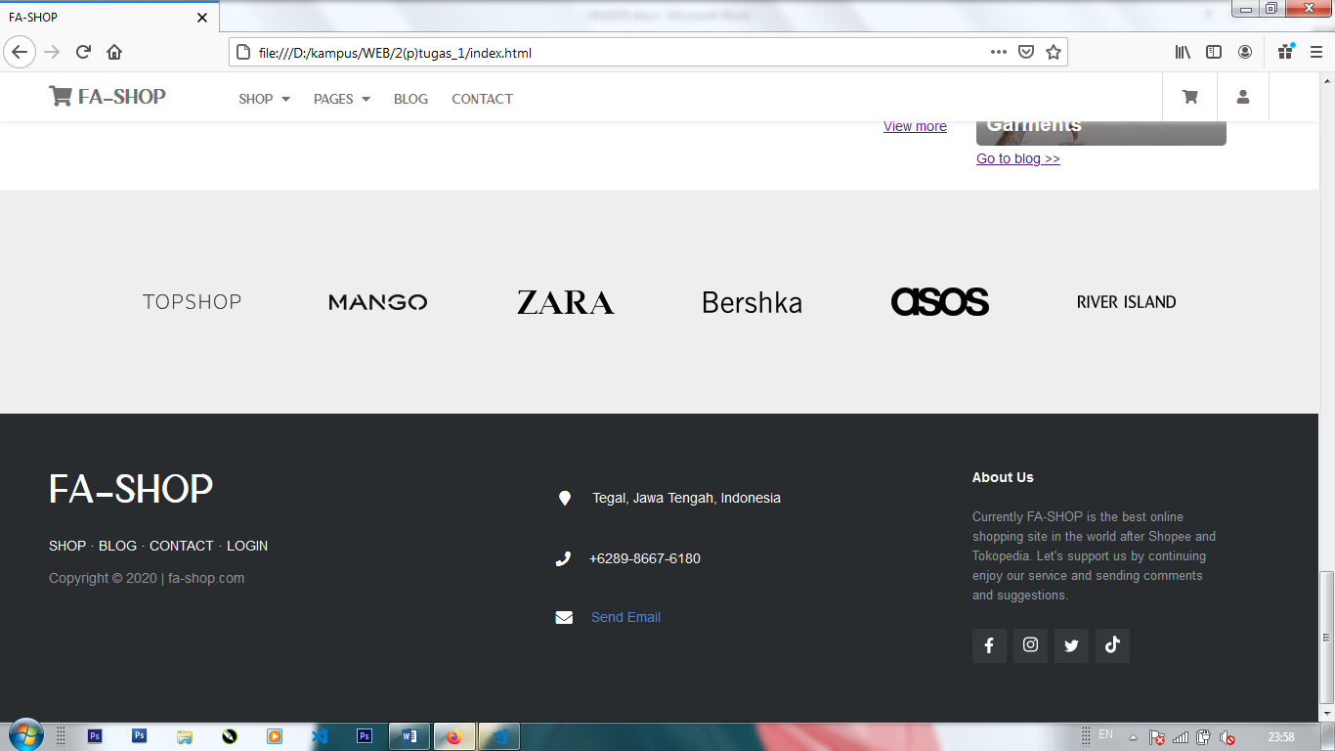

**LIST PRODUCTS**

Menampilkan produk-produk yang dijual pada website

<section>

                <div class="product">

                    <img src="assets/img/products/product-1.png">

                    <div class="desc">

                        <span class="brand-name">ZARA</span>

                        <h4><u><a href="detail-product.html">Seven Peaks Mens Jacket & Handsome Men</a></u></h4>

                        <span class="price"><i>Rp.170.000,00</i></span>

                        <div class="button-buy">ADD TO CART</div>

                    </div>

                </div>

                <div class="product">

                    <img src="assets/img/products/product-2.png">

                    <div class="desc">

                        <span class="brand-name">RIVER ISLAND</span>

                        <h4><u><a href="detail-product.html">Thatcher Oxford Shirt With The Smilling Father</a></u></h4>

                        <span class="price"><i>Rp.249.900,00</i></span>

                        <div class="button-buy">ADD TO CART</div>

                    </div>

                </div>

                <div class="product">

                    <img src="assets/img/products/product-3.png">

                    <div class="desc">

                        <span class="brand-name">MANGO</span>

                        <h4><u><a href="detail-product.html">Double Breasted Coat In Navy Wool & Cashmere Blend by</a></u></h4>

                        <span class="price"><i>Rp.165.000,00</i></span>

                        <div class="button-buy">ADD TO CART</div>

                    </div>

                </div>

                <div class="product">

                    <img src="assets/img/products/product-4.jpg">

                    <div class="desc">

                        <span class="brand-name">MANGO</span>

                        <h4><u><a href="detail-product.html">Women's Notched Lapel Double Breasted Long Trench</a></u></h4>

                        <span class="price"><i>Rp.369.900,00</i></span>

                        <div class="button-buy">ADD TO CART</div>

                    </div>

                </div>

**</section>**

**STYLE LIST PRODUCTS**

section{

    display: flex;

    flex-direction: row;

}

section .product{

    padding: 10px;

    width: 25%;

    flex: 1;

}

.brand-name{

    color: #707070;

    font-weight: bold;

}

section .product img{

    width: 100%;

    border: 2px solid #fff;

}

span.price{

    display: block;

    margin-bottom: 20px;

}

.product div.button-buy{

    height: 40px;

    background-color: #4f4789;

    margin: auto;

    color: #fff;

    line-height: 40px;

    text-align: center;

    margin-top: 10px;

    cursor: pointer;

}

**INTERFACE LIST PRODUCTS**

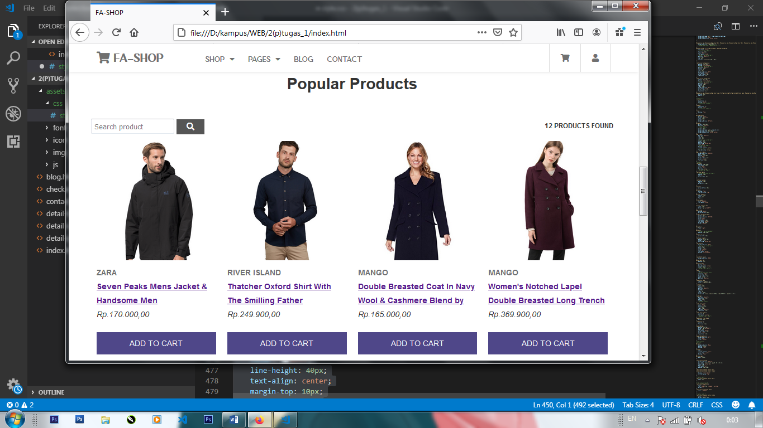

**CONTACT PAGE**

Menampilkan informasi kontak website

<div class="container" id="detail-contact">

    <main>

        <div class="gmap">

            <div class="mapouter"><div class="gmap_canvas"><iframe width="1060" height="500" id="gmap_canvas" src="https://maps.google.com/maps?q=pangkah&t=&z=15&ie=UTF8&iwloc=&output=embed" frameborder="0" scrolling="no" marginheight="0" marginwidth="0"></iframe><a href="https://putlocker-is.org">the a team putlockers</a></div><style>.mapouter{position:relative;text-align:right;height:500px;width:860px;}.gmap_canvas {overflow:hidden;background:none!important;height:500px;width:860px;}</style></div>

        </div>

    </main>

    <aside>

        <h1>How to Find Us</h1>

        <p>Anda bisa menemukan kami jika anda naik sepeda motor lewat jalan 1 ke utara terus sampai kantor pos besar Tegal, lalu belok kiri ..kemudian ada pertigaan belok kiri lagi.. kemudian ada pertigaan lagi belok kanan boleh belok kiri boleh, kalau belok kanan ke barat terus nanti pesen gojek ke alamat kami begitu juga kalau belok kiri..</p>

        <span><b>ADDRESS</b> Tegal OKEOKEOKE</span>

        <span><b>PHONE</b> +68 986 676 180</span>

        <span>galih11120@gmail.com</span>

    </aside>

</div>

**STYLE CONTACT**

#contact{

            padding: 110px 80px 0 80px;

        }

        aside span{

            display: block;

        }

        .gmap{

            width: 100%;

            overflow: hidden;

        }

**INTERFACE CONTACT PAGE**

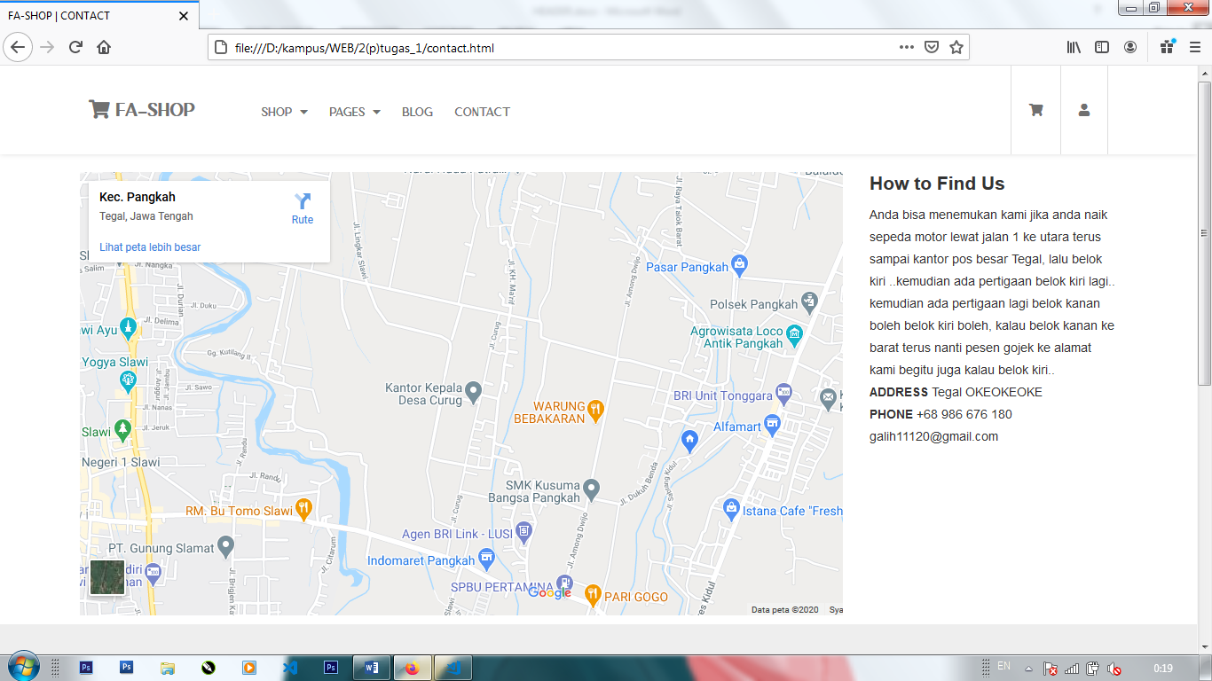

**CHECKOUT PAGE**

Menampilkan detail pemesanan, harga dan transaksi pembayaran

<div id="checkout">

        <div class="form-left">

            <h2>Billing Address</h2>

            <form>

                <ul>

                    <li>

                        <label for="fname">First name*</label>

                        <input type="text" name="fname" id="fname">

                    </li>

                    <li>

                        <label for="lname">Last name*</label>

                        <input type="text" name="lname" id="lname">

                    </li>

                    <li>

                        <label for="company">Company name (optional)</label>

                        <input type="text" name="company" id="company">

                    </li>

                    <li>

                        <label for="address">Address*</label>

                        <input type="text" name="address" id="address">

                    </li>

                    <li>

                        <label for="phone">Phone no*</label>

                        <input type="text" name="phone" id="phone">

                    </li>

                    <li>

                        <label for="email">Email address*</label>

                        <input type="text" name="email" id="email">

                    </li>

                </ul>

            </form>

        </div>

        <div class="form-right">

            <h2>Your order</h2>

            <table cellpadding="10" cellspacing="0" border="0">

                <tr>

                    <td>PRODUCT</td>

                    <td align="right">TOTAL</td>

                </tr>

                <tr>

                    <td>JASND NIPPON</td>

                    <td align="right">$89.00</td>

                </tr>

                <tr>

                    <td>SUBTOTAL</td>

                    <td align="right">$89.00</td>

                </tr>

                <tr>

                    <td>TOTAL</td>

                    <td align="right">$89.00</td>

                </tr>

            </table>

            <h3>Payment method</h3>

            <ul>

                <li><input type="radio" name="payment">PAYPAL</li>

                <li><input type="radio" name="payment">DANA</li>

                <li><input type="radio" name="payment">CASH ON DELIEVERY</li>

                <li><input type="radio" name="payment">CREDIT CARD</li>

            </ul>

            <div class="btnorder">ORDER NOW</div>

            <div id="viewMore"></div>

        </div>

    </div>

**STYLE CHECKOUT**

#checkout{

            padding: 120px 100px 20px 100px;

            display: flex;

        }

        #checkout h2, h3{

            margin: 20px 0;

        }

        #checkout .form-left label{

            font-size: 15px;

        }

        #checkout .form-left input{

            display: block;

            padding: 10px 10px;

            transition: .04s;

            margin: 10px 0;

            font-size: 15px;

            box-sizing: border-box;

            width: 100%;

        }

        #checkout .form-left li{

            list-style: none;

        }

        #checkout .form-left li:first-child{

            display: inline-block;

            width: 49%;

        }

        #checkout .form-left li:nth-child(2){

            display: inline-block;

            /*margin-left: 20px;*/

            width: 50%;

        }

        #checkout .form-left input:focus{

            border: 2px solid lightblue;

        }

        #checkout .form-left{

            flex: 2;

            /*border: 1px solid red;*/

            padding: 0 20px;

        }

        #checkout .form-right{

            flex: 1;

            box-shadow: 0px 0px 3px 0px #ddd;

            padding: 0 20px;

        }

        #checkout .form-right table{

            width: 100%;

        }

        #checkout .form-right table td{

            height: 50px;

            border-bottom: 1px solid #707070;

        }

        #checkout .form-right input{

            margin-right: 10px;

        }

        #checkout .form-right ul li{

            list-style: none;

            margin-top: 20px;

            font-size: 15px;

            font-weight: bold;

        }

        .btnorder{

            padding: 0 10px;

            height: 40px;

            cursor: pointer;

            text-align: center;

            line-height: 40px;

            font-weight: bold;

            color: #ddd;

            background-color: #4f4789;

            font-size: 15px;

            margin: 20px 0;

            float: right;

        }

**INTERFACE CHECKOUT PAGE**

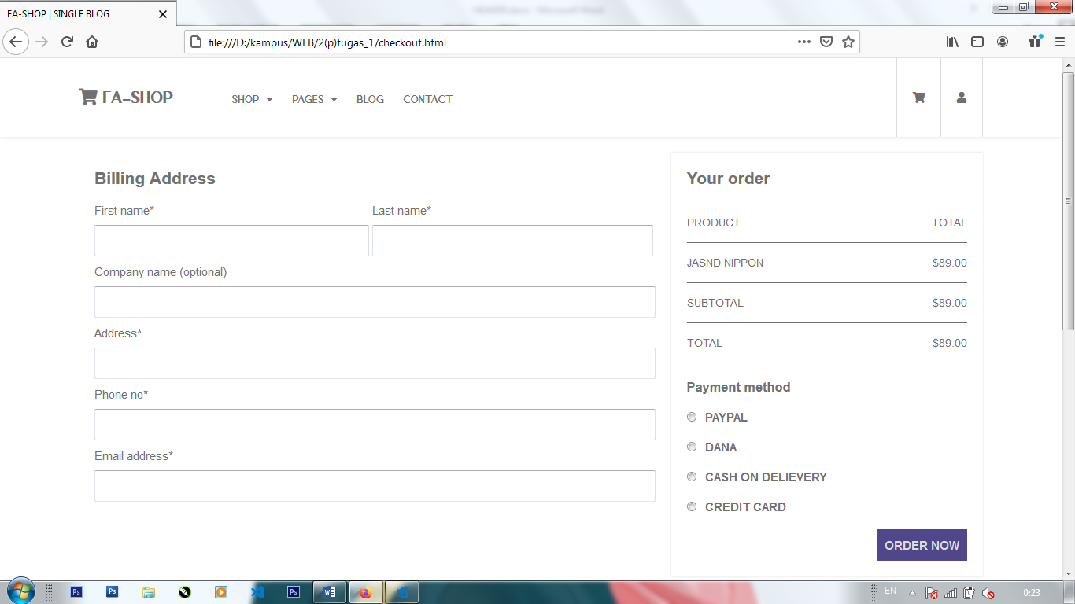

**Javascript**

Toggle sidebar

var menu = document.getElementById("menu");

var sidebar = document.getElementById("sidebar");

var closeSidebar = document.getElementById("close-sidebar");

document.querySelector('#menu .fas').addEventListener('click', function(){

    sidebar.classList.toggle('visible');

});

document.onclick = function(e){

    if(e.target == sidebar){

        sidebar.classList.add('visible');

    }else if(e.target !== document.querySelector('#menu .fas')){

        sidebar.classList.remove('visible');

    }

}

closeSidebar.addEventListener('click', function(e){

    sidebar.classList.remove('visible');

});

View more button toggle

var viewMore = document.getElementById("viewMore");

var section = document.querySelector("section#sectionHide");

viewMore.addEventListener('click', function(e){

    if(section.classList.contains("flex")){

        this.innerHTML = "View more";

    }else{

        this.innerHTML = "View less";

    }

    e.preventDefault();

    section.classList.toggle('flex');

});

Login button toggle

var loginToggle = document.getElementById("login-toggle");

var loginToggleAlt = document.getElementById("login-toggle-alt");

var containerModal = document.getElementById("containerModal");

var closeModalButton = document.getElementById("closeModalButton");

closeModalButton.addEventListener('click', function(){

    containerModal.style.display = 'none';

});

loginToggleAlt.addEventListener('click', function(e){

    e.preventDefault();

    containerModal.style.display = 'block';

});

loginToggle.addEventListener('click', function(e){

    e.preventDefault();

    containerModal.style.display = 'block';

    sidebar.classList.add('hidden');

});

Onmouseenter animation

var linkRight = document.getElementById("link-right");

linkRight.children[0].onmouseenter = function() {

    linkRight.children[0].children[0].children[1].style.animationName = 'fadeInText';

    linkRight.children[0].children[0].children[1].style.animationTimingFunction = 'ease-out';

    linkRight.children[0].children[0].children[1].style.animationDuration = '.2s';

    linkRight.children[0].children[0].children[1].style.animationFillMode = 'forwards';

}

linkRight.children[1].onmouseenter = function() {

    linkRight.children[1].children[0].children[1].style.animationName = 'fadeInText';

    linkRight.children[1].children[0].children[1].style.animationTimingFunction = 'ease-out';

    linkRight.children[1].children[0].children[1].style.animationDuration = '.3s';

    linkRight.children[1].children[0].children[1].style.animationFillMode = 'forwards';

}

linkRight.children[0].onmouseleave = function() {

    linkRight.children[0].children[0].children[1].style.animationName = 'fadeOutText';

    linkRight.children[0].children[0].children[1].style.animationTimingFunction = 'ease-out';

    linkRight.children[0].children[0].children[1].style.animationDuration = '.2s';

    linkRight.children[0].children[0].children[1].style.animationFillMode = 'forwards';

}

linkRight.children[1].onmouseleave = function() {

    linkRight.children[1].children[0].children[1].style.animationName = 'fadeOutText';

    linkRight.children[1].children[0].children[1].style.animationTimingFunction = 'ease-out';

    linkRight.children[1].children[0].children[1].style.animationDuration = '.3s';

    linkRight.children[1].children[0].children[1].style.animationFillMode = 'forwards';

}

Scroll event resize header height

var header = document.getElementById("header");

var headRight = document.getElementById("head-right");

var sitename = document.getElementById("sitename");

var linkRight = document.getElementById("link-right");

var dropDownShop = document.getElementById("dropDown-shop");

window.onscroll = function() {scrollFunction()};

function scrollFunction() {

if (window.scrollY > 50) {

header.style.height = "50px";

headRight.style.height = "50px";

menu.style.height = "50px";

menu.style.lineHeight = "50px";

sitename.style.paddingLeft = "50px";

sitename.style.lineHeight = "50px";

linkRight.style.lineHeight = "50px";

linkRight.style.height = "50px";

headRight.style.right = "50px";

dropDownShop.style.top = "50px";

linkRight.children[0].style.height = "50px";

linkRight.children[1].style.height = "50px";

} else {

  var h = 100 - window.scrollY;

if(h <= 50){

    header.style.height = "50px";

    headRight.style.height = "50px";

    menu.style.height = "50px";

    menu.style.lineHeight = "50px";

    sitename.style.paddingLeft = "50px";

    sitename.style.lineHeight = "50px";

    linkRight.style.lineHeight = "50px";

    linkRight.style.height = "50px";

    headRight.style.right = "50px";

    dropDownShop.style.top = "50px";

    linkRight.children[0].style.height = "50px";

    linkRight.children[1].style.height = "50px";

}else{

    // alert('ok')

    header.style.height = h + "px";

    headRight.style.height = h + "px";

    menu.style.height = h + "px";

    menu.style.lineHeight = h + "px";

    sitename.style.paddingLeft = h+"px";

    sitename.style.lineHeight = h+"px";

    linkRight.style.lineHeight = h + "px";

    linkRight.style.height = h + "px";

    headRight.style.right = h+"px";

    dropDownShop.style.top = h+"px";

    linkRight.children[0].style.height = h+"px";

    linkRight.children[1].style.height = h+"px";

}

}

}

Dropdown menu

var shopMenu = document.getElementById("shopMenu");

let enter = false;

dropDownShop.onmouseover = function() {

    enter = true;

    shopOff(enter);

};

dropDownShop.onmouseout = function() {

    enter = false;

    shopOff(enter);

};

shopMenu.onmouseover = function() {shopOn()};

shopMenu.onmouseout = function() {shopOff()};

function shopOn(){

    dropDownShop.style.display = "flex";

    dropDownShop.style.animationName = 'fadeIn';

    dropDownShop.style.animationTimingFunction = 'ease-out';

    dropDownShop.style.animationDuration = '.2s';

}

function shopOff(){

    setTimeout(function(){

        if(enter){

            dropDownShop.style.display = "flex";

        }else{

            dropDownShop.style.animationName = 'fadeOut';

            dropDownShop.style.animationTimingFunction = 'ease-out';

            dropDownShop.style.animationDuration = '.2s';

            dropDownShop.style.animationFillMode = 'forwards';

        }

    },500);

}

Count animation

document.querySelector('#categoriesImg1').onmouseenter = function() {

    animateCount("count-items-1", 0, 34, 700);

}

document.querySelector('#categoriesImg2').onmouseenter = function() {

    animateCount("count-items-2", 0, 40, 700);

}

document.querySelector('#categoriesImg3').onmouseenter = function() {

    animateCount("count-items-3", 0, 24, 700);

}

function animateCount(id, start, end, duration){

    if(start === end) return;

    var range = end - start;

    var current = start;

    var increment = end > start ? 1 : -1;

    var stepTime = Math.abs(Math.floor(duration / range));

    var obj = document.getElementById(id);

    var timer = setInterval(function(){

        current += increment;

        obj.innerHTML = current;

        if(current == end){

            clearInterval(timer);

        }

    }, stepTime)

}