Adaptive Quiz & Exam Engine
Java Mini Project – Modules 1, 2 & 3
Based on Computational Thinking, Control Flow, Methods and 1D Arrays

1. Abstract
The Adaptive Quiz & Exam Engine is a console-based Java application that conducts a quiz and changes the difficulty of the next question based on the student's previous answer. A correct answer increases the difficulty, while an incorrect answer decreases it or keeps it at the minimum level. The project demonstrates problem solving using algorithms, Java program structure, primitive data types, variables, constants, operators, Scanner input, conditional statements, loops, switch, methods and one-dimensional arrays.

2. Problem Statement
Traditional quizzes normally present questions in a fixed order and difficulty. This project aims to create a simple Java-based quiz engine where the question difficulty can adapt to the student's performance during the quiz.
- Accept the number of questions to attempt.
- Display questions and multiple-choice options.
- Read the student's answer using Scanner.
- Check the answer and update the score.
- Adapt the difficulty level after each response.
- Display the final score and performance summary.

3. Main Features
- Console-based Java application.
- Three difficulty levels: Easy, Medium and Hard.
- Automatic difficulty adjustment after each answer.
- Score calculation.
- Question storage using 1D arrays.
- Methods are used to divide the program into smaller tasks.
- Uses only concepts covered in Modules 1–3.

4. Concepts Used from the Syllabus
Module | Concepts Used
Module 1 | Problem solving, algorithm, Java program structure, variables, constants, literals, operators, type casting, expressions, Scanner and formatted output.
Module 2 | if, if-else, if-else-if, switch, break, for loop, while loop, continue and nested control flow.
Module 3 | Methods, method calls, parameters/return values, 1D arrays.

5. Algorithm
1. Start the program.
2. Create arrays containing questions, options, correct answers and difficulty levels.
3. Read the number of questions from the user.
4. Start with difficulty level 1 (Easy).
5. Select a question matching the current difficulty.
6. Display the question and its four options.
7. Read the user's answer using Scanner.
8. If the answer is correct, increase the score and increase difficulty if possible.
9. If the answer is incorrect, decrease difficulty if possible.
10. Repeat until the required number of questions is completed.
11. Display the final score and performance.
12. Stop.

6. Flowchart Description
Start → Initialize arrays and variables → Read number of questions → Set difficulty to Easy → Select question → Display question/options → Read answer → Check answer → Correct? Yes: increase score and difficulty → No: reduce difficulty → More questions? Yes: repeat → No: display final result → Stop.

7. Advantages
- Personalized: question difficulty changes according to performance.
- Simple console interface that is easy to understand and implement.
- Provides immediate feedback after each answer.
- Uses core Java concepts without requiring advanced libraries.
- Can be extended with more questions and subjects.
- Useful for demonstrating algorithms, control flow, methods and arrays.

8. Implementation Details
The implementation below intentionally uses only basic Java features from the specified syllabus. Questions, options, answers and difficulty levels are stored in one-dimensional arrays. Methods are used for displaying questions, checking answers and updating difficulty. The program uses Scanner for typed console input and if/else, for, while and switch where appropriate.

9. Java Code – Complete Mini Project
import java.util.Scanner;
public class AdaptiveQuizEngine {
public static void main(String[] args) {
Scanner scanner = new Scanner(System.in); // [MODULE 1: Console I/O Scanner]
// [MODULE 3: 1D Arrays - Questions, Options, and Correct Answer Keys]
String[] questions = {
"Q1: What is the size of an int data type in Java?",
"Q2: Which operator is used for bitwise AND in Java?",
"Q3: What is the default value of an uninitialized local variable?"
};
String[] optionsQ1 = { "1. 2 Bytes", "2. 4 Bytes", "3. 8 Bytes", "4. Depends on OS" };
String[] optionsQ2 = { "1. &&", "2. &", "3. |", "4. ^" };
String[] optionsQ3 = { "1. 0", "2. null", "3. Garbage value", "4. No default value (Compile Error)" };
int[] correctAnswers = { 2, 2, 4 }; // [MODULE 3: 1D Array of Correct Option Keys]
int totalQuestions = questions.length;
int score = 0; // [MODULE 1: Primitive Variables]
// [MODULE 3: Method Calling]
printHeader("JAVA FOUNDATIONS ADAPTIVE QUIZ ENGINE");
// [MODULE 2: Iteration - For Loop through Questions]
for (int i = 0; i < totalQuestions; i++) {
System.out.printf("%n[Question %d of %d]%n", (i + 1), totalQuestions); // [MODULE 1: Formatted Output]
// Select corresponding 1D options array
String[] currentOpts = (i == 0) ? optionsQ1 : (i == 1) ? optionsQ2 : optionsQ3;
// [MODULE 3: Method Calling]
displayQuestion(questions[i], currentOpts);
System.out.print("Enter your answer (1-4): ");
// [MODULE 3: Method Calling & MODULE 2: Input Validation Control Loop]
int userChoice = readValidInput(scanner);
// [MODULE 3: Method Calling & MODULE 1: Relational Operator Evaluation]
boolean isCorrect = evaluateAnswer(userChoice, correctAnswers[i]);
// [MODULE 2: Selection Control Flow - if-else]
if (isCorrect) {
System.out.println("Result: Correct!");
score++; // [MODULE 1: Unary Increment Operator]
} else {
System.out.printf("Result: Incorrect! Correct answer was option %d.%n", correctAnswers[i]);
}
}
// [MODULE 3: Method Calling for Final Performance Calculation]
displayPerformanceSummary(score, totalQuestions);
scanner.close(); // Clean resource release
}
// [MODULE 3: Creating Methods - Display Question & Options]
public static void displayQuestion(String question, String[] opts) {
System.out.println(question);
for (String option : opts) { // [MODULE 2: For-each Loop]
System.out.println(" " + option);
}
}
// [MODULE 3: Creating Methods & MODULE 2: While Loop with Input Validation]
public static int readValidInput(Scanner scanner) {
int input = -1;
while (true) {
if (scanner.hasNextInt()) { // [MODULE 2: Conditional Check]
input = scanner.nextInt();
if (input >= 1 && input <= 4) { // [MODULE 1: Logical AND Operator]
break; // [MODULE 2: Break Statement]
}
} else {
scanner.next(); // Clear invalid token
}
System.out.print("Invalid choice. Please enter a number between 1 and 4: ");
}
return input;
}
// [MODULE 3: Creating Methods & MODULE 1: Relational Operator Evaluation]
public static boolean evaluateAnswer(int userChoice, int correctAnswer) {
return userChoice == correctAnswer; // Returns boolean calculation
}
// [MODULE 3: Creating Methods & MODULE 1: Formatted Console Output]
public static void printHeader(String title) {
System.out.println("==================================================");
System.out.printf(" %s%n", title); // [MODULE 1: Formatted String Printing]
System.out.println("==================================================");
}
// [MODULE 3: Creating Methods, MODULE 1: Explicit Typecasting, MODULE 2:
// If-Else-If Ladder]
public static void displayPerformanceSummary(int score, int total) {
// [MODULE 1: Explicit Double Typecasting & Expression Evaluation]
double percentage = ((double) score / total) * 100.0;
System.out.println("\n--------------------------------------------------");
System.out.println(" EXAM RESULTS ");
System.out.println("--------------------------------------------------");
System.out.printf("Total Questions : %d%n", total);
System.out.printf("Correct Answers : %d%n", score);
System.out.printf("Final Score : %.2f%%%n", percentage); // [MODULE 1: Formatted Float Output]
// [MODULE 2: Nested Conditional Ladder for Grade Determination]
System.out.print("Grade Status : ");
if (percentage >= 85.0) {
System.out.println("EXCELLENT (Grade A)");
} else if (percentage >= 60.0) {
System.out.println("GOOD (Grade B)");
} else if (percentage >= 40.0) {
System.out.println("PASS (Grade C)");
} else {
System.out.println("NEEDS IMPROVEMENT (Fail)");
}
System.out.println("--------------------------------------------------");
}
}

10. Sample Output
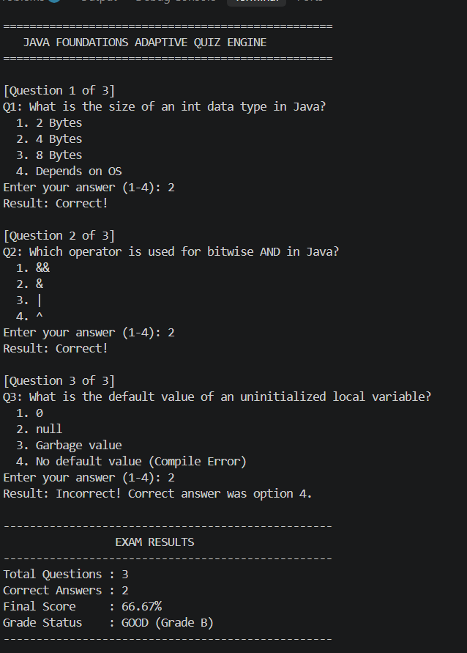

11. Explanation of Important Code Parts
- static final int EASY = 1; – creates constants for the three difficulty levels.
- String[] questions – a 1D array that stores quiz questions.
- String[] options – a 1D array that stores answer choices.
- int[] answers – stores the correct option number for each question.
- int[] difficulty – stores the difficulty level of each question.
- Scanner sc – reads typed input from the keyboard.
- if/else – checks answers and changes difficulty.
- for loop – controls how many questions are asked.
- while loop – validates the number of questions and searches for an unused question.
- Methods – displayQuestion(), checkAnswer(), updateDifficulty(), findQuestion() and showResult() divide the program into manageable tasks.
- boolean[] used – prevents the same question from being selected twice.

12. Why This Project Fits Modules 1–3
Module 1 is demonstrated through the Java class structure, variables, constants, literals, primitive data types, operators, expressions, Scanner input and formatted console output. Module 2 is demonstrated through if/else conditions, a ternary expression, while loops, for loops and continue. Module 3 is demonstrated through user-defined methods, method calls and one-dimensional arrays. Therefore, the project can be implemented and explained using the specified syllabus without depending on advanced Java frameworks.

13. Limitations
- The current version is console-based.
- Questions are stored directly in the Java source code.
- The question bank is small.
- There is no database or user login.
- Adaptation is based only on the previous answer.

14. Future Work
- Add a larger question bank for different subjects.
- Store questions in files or a database.
- Add student login and score history.
- Add a graphical user interface using Java Swing or JavaFX.
- Use more advanced adaptive rules based on several previous answers.
- Add a timer for each question.
- Generate detailed performance reports.
- Add random question selection and random option order.

15. Conclusion
The Adaptive Quiz & Exam Engine is a simple Java project that applies computational thinking to a practical educational problem. It demonstrates how an algorithm can be converted into a Java program using variables, operators, Scanner input, conditional statements, loops, methods and one-dimensional arrays. The adaptive mechanism makes the quiz responsive to the student's performance while keeping the implementation suitable for Modules 1–3.

16. Presentation Summary
- Problem: Fixed-difficulty quizzes do not adapt to student performance.
- Solution: Adjust question difficulty according to the previous response.
- Technology: Java console application.
- Core concepts: Algorithms, Scanner, operators, if/else, switch, loops, methods and 1D arrays.
- Output: Score, feedback and adaptive difficulty.
- Future: GUI, database, timer, analytics and larger question bank.

