|  |  |  |
| --- | --- | --- |
| X | **THE GALILEO OBSERVER The Official Newsletter of the  Galileo Alumni Association**  ***Clarity . . . Honesty . . . Integrity*** | C:\Users\cca\Desktop\lion.jpg |
|  | | |

**Vol. X, No. 4 \_\_\_\_\_\_\_\_\_\_\_\_\_\_\_\_\_\_\_ \_\_\_\_\_\_\_\_\_\_\_October 2012**

**ANNUAL SPORTS HALL OF FAME WILL HONOR**

**13 ATHLETES AND COACHES**

**The annual Galileo Sports Hall of Fame will honor 13 former outstanding athletes and coaches at a dinner on Friday, October 26th at the San Francisco Italian Athletic Club. This year’s crop of honorees covers 8 sports and 5 decades. The SHOF selection committee members are Sisvan Der Harootunian, Vince Gomez, Joe Martino and Cherise Johnson. GAA President Charlene Mori acts as liaison and is in charge of dinner arrangements. “The committee has worked hard and long to come up with a group of honorees we feel are second to none. The dinner ceremony will have some unique features not previously seen,” Der Harootunian says.**

**Besides receiving engraved medallions and certificates, the honorees will have their names displayed in the showcase at Galileo Academy. Cocktails start at 5:30 PM, dinner and ceremony follow at 7:30 PM.**

**This year’s honorees are: JOE ANGEL (’65) – football, baseball, basketball; PAUL AVEDANO (’77) – football; SHEIRE COLEMAN (’96) – softball, basketball, track & field; MIKE DUNNE (’63) – baseball, basketball; MACEO HOUSTON (’91) – football, baseball, basketball; MARK HUYNH (’90) – football (player & coach), basketball, tennis; JASON LEE (’90) – basketball, track & field, coach; KEVIN MOONEY (’71) – basketball, baseball; STEVE MORESI (’64) – baseball, soccer; HUDARI MURRAY (’90) – football, basketball; DINO NATALI ((’52) – basketball, football, baseball, track & field; SAM PEOPLES (’89) – football, baseball, basketball; MARGARET CREER-SOLON (’99) – softball, volleyball, basketball, track & field.**

**\* \* \* \* \* \***

**NOTED CARDIOLOGIST TO BE HONORED AT EVENT**

*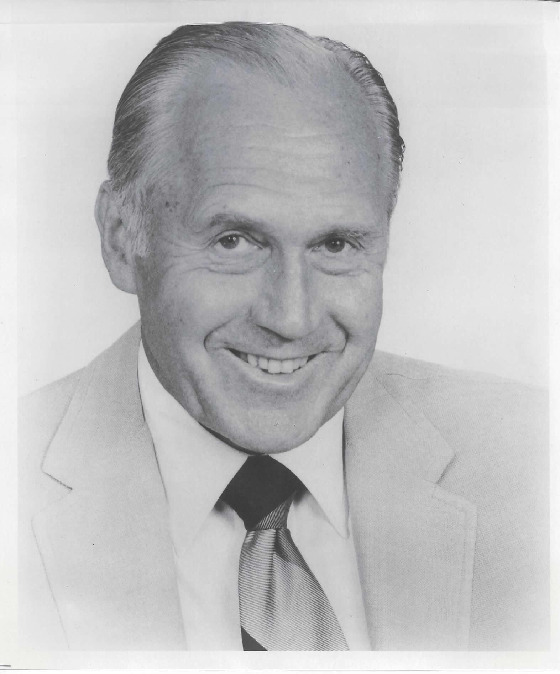*

**Galileo alumnus Dr. Robert W. “Bobby” Brown will receive the school’s Hall of Merit award on Friday, October 26th at the Italian Athletic Club. The presentation will be part of the annual Sports Hall of Fame awards ceremony. Dr. Brown becomes the first person to receive both the Sports Hall of Fame award (1989) and the Hall of Merit award. Dr. Brown played third base for the New York Yankees with Yogi Berra and fellow San Franciscans Joe DiMaggio, Jerry Coleman and Charley Silvera. He became a distinguished cardiologist, practicing in Fort Worth, Texas, served 10 years as American League President, and championed the cause of banning chewing tobacco for major league players.**

**Parking Garages located near the Italian Athletic Club, make sure you check on their hours.**

VALLEJO STREET GARAGE (Stockton & Powell)

***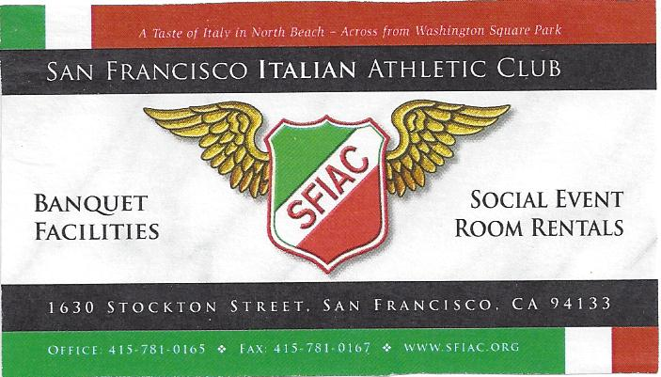***766 Vallejo St  
San Francisco, CA 94131  
Neighborhood: North Beach/Telegraph Hill

(415) 989-4490

|  |  |  |  |
| --- | --- | --- | --- |
|  |  |  |  |

FILBERT STREET GARAGE (Mason & Columbus)

721 Filbert Street  
San Francisco, CA 94133  
Neighborhood: North Beach/Telegraph Hill

(415) 983-0800

NORTH BEACH PARKING GARAGE (Stockton & Powell)

735 Vallejo St  
San Francisco, CA 94110  
Neighborhood: North Beach/Telegraph Hill

(415) 399-9564

***MISUNDERSTANDING***

**IMPORTANT MESSAGE FROM THE GAA PRESIDENT**

**I have heard from several alumni that they receive the Lions Pride every**

**Saturday morning via email, thinking the GAA publishes this newsletter. I would like to correct this immediately. The Lions Pride published by Phil Kaiser is in no way related to the Galileo Alumni Association’s *Observer* newsletter or approved by the Board of Directors. It is also not**

**endorsed by the Galileo Academy. We do not feel that Phil Kaiser's Lions**

**Pride represents the best interests of GAA. We do not communicate with Mr. Kaiser or in any way support his negative writings. Our newsletter *The Observer* is published 4 times a year in January, April, July and October. I hope this clears the air for many of you.**

|  |  |
| --- | --- |
| **Through The Telescope. . .**  **Sisvan Der Harootunian** | X |

**A Holiday Message**

***In a couple of months we’ll be reaching the end of one year and celebrating the start of another. In these somewhat troubling times of uncertainty, violence and distrust, let us remember that we are all human beings sharing this planet. Let us look to the future with a positive attitude, knowing that there will always be doomsday advocates attempting to stray us from our goal. However, we see a bright sun in a blue sky, and we share the joy of having friends and family around us. Let us rejoice in our blessings, downplay our shortcomings, and move forward so that when we are gone, our children and their children will have a better place in which to live. Let us live long and peaceful lives like the California redwoods, wash away our worries like the Pacific Ocean, and soar through the skies like the American eagle. May you have peace and all good things now and always.***

**\* \* \* \* \* \* \***

**Correction: In the July issue we stated that Vince Gomez was traveling to Shanghai in November to conduct a symphony orchestra. Although Vince has conducted symphony orchestras in the past, he will be conducting a group of students in China.**

**“Your mind is like a computer.**

**It stores memory and plays it back when you least expect it.”**

****

**PLEASE SUPPORT YOUR ALMA MATER**

***Tony Compagno’s Ramblings***

*On June 23 of this year, I took a ride out to the Irish Cultural Center across from the San Francisco Zoo. The occasion: a reunion of the Galileo classes of '61 and '62. And a success it was, by my standards. The venue itself was a good choice, the upstairs room big and conducive to the warm mingling and re-discovery of dear old friends and acquaintances from a shared period in a past that seems to be receding more quickly the older we get. The food was good, the photos, Gal newspapers and yearbooks laid out on tables a nice touch, and the baseball caps and coffee cups precious gifts to take home as reminders of a wonderful evening. Lift those caps and cups to the reunion team who worked so hard at staging the event.*

*Below is something that is loosely based on a Gal reunion I attended some years ago. The piece is included in a book called SEASONING and serves to convey my feelings about reunions in general, and the mixed ingredients that go into such a Nostalgia Stew. This is dedicated to old-timers everywhere.*

I couldn't understand why I was feeling such anxiety in the weeks before the event.

The gathering, scheduled for the Hyatt Hotel at Fisherman's Wharf loomed larger and more significant than I could have anticipated.

My high school reunion, San Francisco's Galileo High School, on the borderline separating North Beach from the Marina. A school attended by the famous and infamojus, such as Joltin' Joe DiMaggio and O. J. Simpson. A school from which I had graduated more than 35 years earlier.

We drove into The City at twilight on an exquisitely beautiful October evening. The sidewalks along the Embarcadero were dense with people looking for a good crab cocktail or a breathtaking view of the bay or a nightspot that offered oldies but goodies and the promise of love.

Here I was, grandson of a Sicilian fisherman, back in North Beach around Columbus Day, at a juncture in history when the paisano from Genoa, who so courageously had sailed the ocean blue and stumbled on a new world, was being accused of treachery and genocide by upstart revisionists.

It was unsettling, this awareness of the drastic social changes that had led with nearly imperceptible inevitability to this year, this day, this moment I drove my Toyota Camry up to the entrance of the Hyatt.

But tonight I had no plans to wrap myself in issues of the day. I was going back in time, back to 1961, when social problems existed beyond my small domain and the drapes of my naivete, and Columbus was clearly heroic and unimpeachable, a Genovese to be cheered, not jeered.

Inside, high school kids trapped in bodies betraying the various signs of advancing age stood with drinks and squinted as tactfully as possible at identification tags.

I had bought new pants for the occasion, and new, shiny, black loafers with tassels that would have made Tempest Storm (a legendary disrober of that time) envious. My lovely wife at my side, I stood in the lobby of the Hyatt, fighting off panic. Would nobody recognize me? Would no one remember me? Would I prove invisible? Was this a long-lost Rod Serling script? I nervously fingered the photo name tag handed me when we came in.

One fellow came up to me, grimaced, awkwardly titled his head to study the picture on my lapel, my 1961 image, and stuck out his hand with summoned sincerity and said, "Tony...you haven't changed a bit." Well, maybe I still look somewhat the same but for the expected gray hairs and the assorted wrinkles. It's amazing, though: if my outer changes corresponded with my inner changes since those innocent days spent in North Beach, my visage would resemble that of one of the extraterrestrials in the bar scene from STAR WARS.

Alas, old friends began flagging me down, recognizing me -- oh, there IS a God in Heaven -- from across the room. Soon we were all talking animatedly about the old days, recounting the magic moments of which Perry Como -- who?" -- sings, while my wife tried to look interested, or at least to remain awake.

I was in my glory. Some remembered me when I was all promise and gave indications of doing spectacular things one day. That's all they would see; they didn't really want to destroy that by asking me much about the present, which could contaminate that precious past we shared, which we resurrected with such joy and single-mindedness.

There was sadness, too, that night, information dropped here and there about accidents, various forms of demise, ugly divorces, and untimely deaths. But mostly it was laughter and warm feelings and happy reminiscences, made even sweeter by the appearance of a favorite science teacher, Jurassic by now but jovial, who was known to rhapsodize on the subject of the consciousness of plants, although he had his doubts about the consciousness of high school students.

The music played in the background over all this: the hormonal spasms of rock'n'roll, and the pubescent whining about unrequited love. How silly they sounded, these ditties, but how important they were in feeding and chronicling my feelings at that stage of our development.

I looked for my wife, Kathy, whose eyes by now were providing the roadmap to guide us back to the freeway entrance not so easy to find since the '89 Quake in The City, and I knew it was time to say goodbye to my old friends, my old life, yesterday.

After hugs and vigorous handshakes and kisses all around, we left that place which had briefly been sealed tight against the madness and pain and increasing strangeness of the world outside.

A reunion, indeed. Promise fulfilled or not, for a spell that October night, I had been reunited with a young man I used to know...

***Editor’s Note: This piece originally appeared in* SEASONING, *a book by Tony Compagno. It is used with permission of the author.***

**Spring Fling July 14, 2012**

**We would like to thank the following for their generous donations to the 2012 Annual Spring Fling Auction:**

**Aim Fitness Mark Emmons – Bay Area Golf Academy**

**Alioto’s #8 Marriott Hotel Fisherman’s Wharf**

**Amici’s Mr. & Mrs. Wm. Buchanan**

**Barbara LaRocca Pat’s Café**

**Beach Blanket Babylon Perry’s**

**Cordy Surdyka Pompei’s**

**Elisabetta Favero Show Up Fitness**

**Flora Springs Winery & Vineyards Sisvan Der Harootunian**

**Gigi’s Sotto Mare Synergy Fitness Studio**

**Holiday Inn Fisherman’s Wharf Stinking Rose**

**Joe Scafidi Tommy Toy’s**

**Lance Hughston Tony Compagno**

**Lenore LaRocca U.S. Restaurant**

**La Toscana Restorante Vince Gomez**

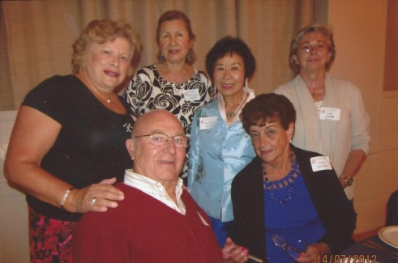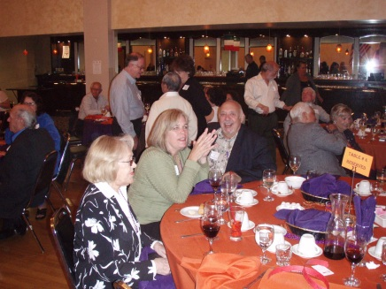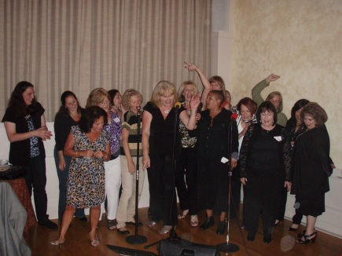

**Columbus Day Parade (Italian Heritage) October 7, 2012**

**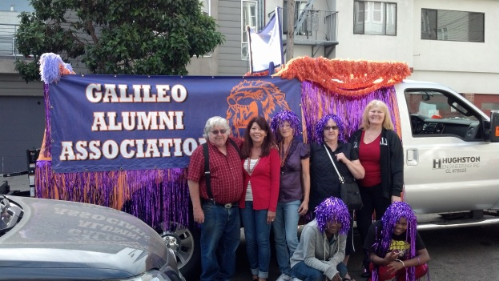 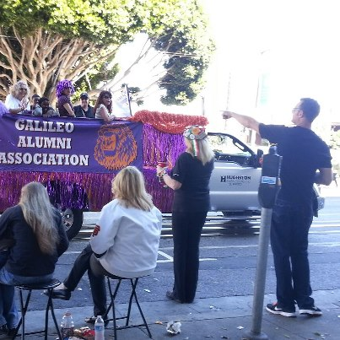**

**The Crew Float gets better every year!**

***GALILEO 68TH SONG & YELL CONTEST***

***OCTOBER 5, 2012***

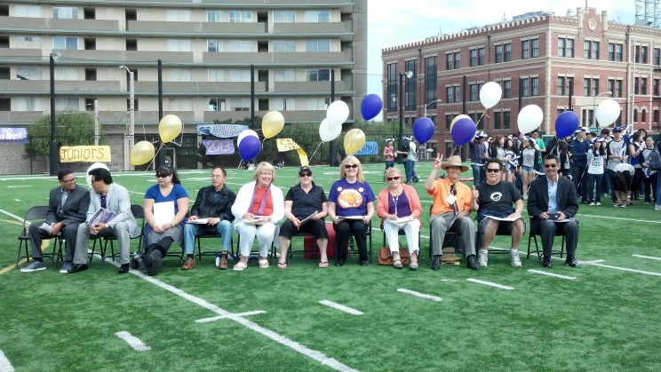 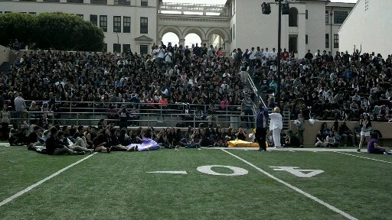

JUDGES

***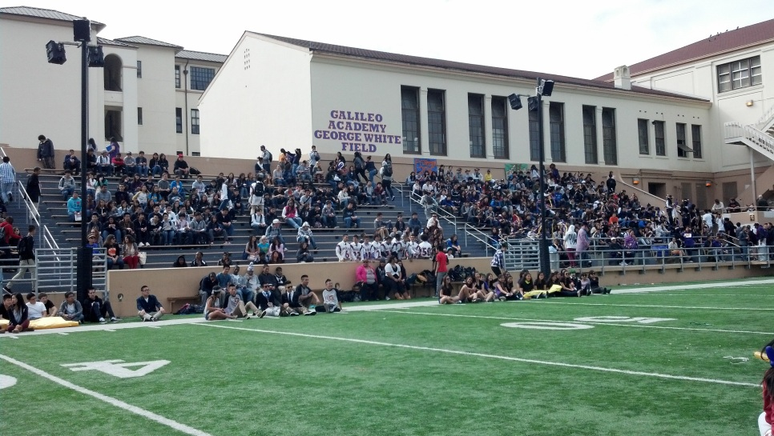***

***Additional Pictures will be posted on our website***

www. <http://galileoweb.org/alumni/>

***Announcements***

**October 20th – Homecoming Dance** Hyatt Fisherman’s Wharf. Semi-formal. 7 – 11 pm. First 200 get free neon necklaces. Free ice cream desserts, dj dancing in the ballroom, karaoke in side lounge room. Contact Eugene Wing for more information [ishiwing@sbcglobal.net](mailto:ishiwing@sbcglobal.net)

**October 13th – 1972 Reunion All you Galileo Class of ’72 Alumni, the date has been set for our big 40th reunion, it will be Saturday October 13, 2012 and we are excited that it will be held at the Hyatt at Fisherman’s Wharf at 555 North Point St, San Francisco and the entertainment will be provided by special hometown favorite band “Jest Jammin”, so mark your calendars and stay tuned, we will be announcing more details and information within the next few months.**

[**http://www.galileoclass72.org/1.html**](http://www.galileoclass72.org/1.html)[**https://www.facebook.com/groups/166308560107344/**](https://www.facebook.com/groups/166308560107344/)

**October 13, 2012 - 1982 Reunion** **Galileo 30th Reunion class of 1982. Saturday October 13, 2012 at the Nikko Hotel in San Francisco.** [**galileo\_classof82@yahoo.com**](mailto:galileo_classof82@yahoo.com)

****

**October 13, 2012 – Amici Vechi, SF Italian Athletic Club, starts at 11AM, luncheon at 12:30 pm. Charley Faruggia, Don Dibasilio, Mel Chiarenza.**

**1963 Reunion 50th reunion coming up in 2013, Contact: Sheldon Wong for info** [**gtrzot@comcast.net**](mailto:gtrzot@comcast.net)

**1952 Reunion 60th Reunion tentatively booked at the Basque Cultural Center for a Luncheon on October 20, 2012. Contact Marion Napoletano Gizzi at 925-250-2797 or email** [**GEMINI0406@aol.com**](mailto:GEMINI0406@aol.com)

**\_\_\_\_\_\_\_\_\_\_\_\_\_\_\_\_\_\_\_\_\_\_\_\_\_\_\_\_\_\_\_\_\_\_\_\_\_\_\_\_\_\_\_\_\_\_\_\_\_\_\_\_\_\_\_\_\_\_\_\_\_\_**

***Reporters Wanted:***

***The Observer is seeking persons who are willing to gather and report news of interest to Galileo alumni. Writing skills are not necessary, just the ability to communicate and write legibly. We are accepting any bits of information about alumni, such as what they are doing now, marriages, births and deaths. If you have a photo of an event, a luncheon or small gathering, send it in. Send all submissions to the Galileo Observer (***[***galileoobserver@aol.lcom***](mailto:galileoobserver@aol.lcom)***) or the Editor, Galileo Observer, c/o*** [***www.galileoweb.org***](http://www.galileoweb.org)***.***

**Galileo scored big in the Target on line competition – placed 10th in the nation and 1st in San Francisco in the Target**

**Voting campaign.**

**\_\_\_\_\_\_\_\_\_\_\_\_\_\_\_\_\_\_\_\_\_\_\_\_\_\_\_\_\_\_\_\_\_\_\_\_\_\_\_\_\_**

**RENT THIS SPACE**

1 YEAR (4 ISSUES) $75.00

Send your business card with your check to:

Galileo Alumni Association

Advertising Dept.

1150 Francisco Street, S.F., CA 94109

**ATTENTION POTENTIAL ADVERTISERS**

***This newsletter is now accepting advertisements for future issues. If you have a business or service you want to advertise, The Galileo Observer is the ideal***

***place to place your ad. It will appear for 4 issues during the year – in January, April, July and October and will reach Galileo alumni, family, friends and students. Rates are reasonable -- $75 for 4 issues (business card size ad).***

***In addition to promoting your product or service, you will be helping the Galileo Alumni Association carry out its mission of helping the Galileo Academy of Science and Technology.***

***Please contact*** [***GalileoObserver@aol.com***](mailto:GalileoObserver@aol.com) ***or*** [***JScafidiMV@aol.com***](mailto:JScafidiMV@aol.com)***.***

***Sweetheart Stories***

Two people who are now together are Dee Ann (Falwell) Morgan (class of ’53) and Paul Lamphere (class of ’51).

When Dee Ann was a sophomore she went with Paul’s best friend Ben Dito. Dee’s best friend, Carla Fischer, went with Paul. They double dated throughout that year. After graduation, Paul and Dee remained friends and once in a while, Paul would invite Dee to “double date” with him and his future wife. Then as it usually happens, each became involved with other things and would not see each other again for 56 years! They reunited through a luncheon on September 20th, 2010, almost a year after the untimely death of his lovely wife of so many years.

Dee and Paul have been together ever since. There is something special about sharing memories of those carefree times when the future ahead of you was unknown, but open, and seeing what each of us became, Paul an attorney and Dee a teacher, principal and Assistant Superintendent.

***Please send us your stories on alumni who met at Galileo and are still together, or who have spent a lifetime together. Email to:*** [***galileoobserver@aol.com***](mailto:galileoobserver@aol.com) ***or mail to: GAA, 1150 Francisco Street, S.F., CA 94109***

***Tales from Opera***

***by Giovanna DiTano***

**I**

***I graduated from Galileo High School on June 13, 1951. All through my school years I sang at many rallies, shows, and musicals such as “HMS Pinafore.” My mother, Norma DiTano, was my voice teacher, and I was trained to sing operas and classical music. That said, the first opera I saw was “Rigoletto.” My mother brought me to the San Francisco War Memorial Opera House in September of 1937. I was already singing professionally at the tender age of three, many times at Fugazi Hall in North Beach, where “Beach Blanket Babylon” has been showing for a long time. In the opera “Rigoletto”, the soprano sings her famous aria, “Caro Nome”. When Lily Pons was in the middle of her aria, I ran down the center aisle in the orchestra, yelling at the top of my voice, “She’s singing my song!” My mother’s only explanation for my outburst was that, at my tender age of three, I was terribly jealous of Miss Pons.***

**II**

***I sang thirteen seasons with the San Francisco Opera Chorus. Many funny situations occurred while on stage. During a performance of “Carmen”, one of the ladies in the chorus lost her long petticoat. All the male members of the chorus gathered around her to form a shield so Maestro Kurt Herbert Adler would not see her, as she stepped out of her skirt, picked it up quickly and exited off the stage.***

**III**

***The first time I sang in “Carmen” I came out on stage on the wrong musical cue. I was the only member of the chorus on stage in the second act, with all the principals singing in front of me. Maestro Adler saw me and came back stage to make a big joke of it. Alas, the joke was on me!***

**IV**

***I had the honor of singing with Luciano Pavarotti in Verdi’s “The Masked Ball”. In the last act he is killed, and the director said to various members of the chorus standing near Pavarotti to catch him as he fell backwards so as not to injure himself. We were 8 people, and I was the only woman in the group. At the time Luciano weighed a good 300 pounds. He had a magnificent voice so we didn’t look at the person. He is sorely missed today in the operatic world.***

**Editor’s Note: Giovanna DiTano, the professional name of Jowanna Woeber (her name at Galileo), is a voice teacher and is happy to teach anyone interested in learning how to sing for pleasure or to keep their voice in good shape. She teaches in San Francisco in the Richmond District. For information, call 415-751-9811 or 650-755-5420.**

**\_\_\_\_\_\_\_\_\_\_\_\_\_\_\_\_\_\_\_\_\_\_\_\_\_\_\_\_\_\_\_\_\_\_\_\_\_\_\_\_\_\_\_\_\_\_\_\_\_\_\_\_\_\_\_\_\_\_\_\_\_\_\_\_\_\_\_\_\_\_\_\_\_\_\_\_\_\_\_\_\_\_\_\_\_\_\_\_\_\_\_\_\_\_\_\_\_\_\_\_\_\_\_\_\_\_\_\_\_\_\_\_\_\_\_\_\_\_\_\_**

****Between the Lions****

**by Bettie Grinnell**

**Fall 2012**

Greetings, Mighty Lions! Here’s what’s happening at Galileo these days.

**Early Start:**

School began early this year for Galileo and all the other schools in the San Francisco Unified School District. Classes started for all schools on Monday, August 20, 2012. The first semester will end on December 21, 2012, and school will end for the year on May 31, 2012. We have the second largest student body in the San Francisco School District, second only to Lowell.

**Academics:**

Galileo's API (Academic Performance Index) has reached an all time high of 791, beating both Lincoln and Washington! Test scores have risen significantly for our English Language Learners and our Latino population.   Although this is not the only way that we measure our program quality, it's an important sign that our hard work is paying off for students.

**Galileo Drive 4 UR School Event:**

Galileo Academy was been selected as the beneficiary of the Fall 2012 Drive 4 UR School Program by the Serramonte Ford Dealership.  Galileo alumnus Norman Cho from the class of 1972 negotiated with Serramonte Ford to make this event possible. This program, in these challenging budget times, will help raise money to support Galileo’s extracurricular activities such as homecoming, dances, assembly programs, prom, graduation and a new electronic sign.  Serramonte Ford brought vehicles to Galileo on Saturday, September 22, 2012 between 9:00AM and 4:00PM.  The Ford Motor Company will donate $20 to the Galileo Associated Student Body for every person who test drove one of the vehicles, up to a maximum of $6,000.  Both the Galileo PTSA and the Galileo Alumni Association supported this fundraising event by encouraging parents and alums to participate.  In addition, there was a home non-league football game that day and the Senior class sponsored a car wash in the parking lot by the football field. The Junior Class had a BBQ.

The event brought out 70 parents and faculty to test-drive the cars, netting $1400 for the ASB. The Junior Class raised $600.00 with their hot dog and hamburger barbecue sales. The Girls Tennis Team made $260 from their sale of homemade cookies. The Sophomore Class earned $200 with their sales of Krispy Kreme donuts and Starbucks coffee. The Freshman Class catered Chinese goods and made $100. The Senior Class and the Football Program shared the gate receipts and each made $100.00. Everyone had a great time!

**FALL SPORTS**

**Football:**

Pre-season football is underway for the Galileo Lions. The varsity is 1-1-1 (tied Mills 14-14 to open the season, beat Gonzales 47-8, then lost to De Anza 13-9).

Frosh/ Soph pre-season stands at 1-2 (lost the first 2 games because of injuries, then won last against De Anza, 24-12).

Leading players have been:

Varsity-Ronzel Fox had 5 touchdowns in the win against Gonzales. He also leads the team in tackles and interceptions on defense.

Frosh/Soph is led by running back Rodney Morgan, a sophomore. He accounted for all of the touchdowns in the win at De Anza; 3 on offense and 1 on defense with an interception returned for a touchdown.

The final preseason games was against Kennedy, and the league play season opened Friday, October 5, with the Lions losing to Mission, 39-20.

**Homecoming:**

Galileo’s 2012 Homecoming was held on Friday, October 5th.  The festivities began with our 68th Song and Yell Contest. The Mighty Lions faced the Mission Bears on our field at 3:00pm. The Homecoming dance will be held on Friday, October 20, 2012 at the Hyatt Hotel Fisherman’s Wharf, 7-11 PM.

**Other Fall Sports:**

**Girls Volleyball:**

The Girls’ Volleyball team went 2-4 against tough teams and looks forward to league play starting Sept. 21 and making the play-offs. We are young and the future is promising, with some talented players. Coach Don Papa hopes to lead the Lady Lions to many victories.

**Boys’ Soccer:**

The Galileo Boys Soccer Team has a new coach this season, Marieke Blazeski. Under her leadership the team has shown great improvement this year. The team has only played 3 games to date; they have 1 win, 1 loss and 1 tie. The top scorers representing the Galileo Lions are Jesus Jimenez with 3 goals, Francisco Duran with 2 goals and Jorge Cruz with 2 goals. All team members, their coach and the team manager, Alejandra Hidalgo, have their sights set on reaching the playoffs and the championship. The team has come together perfectly by supporting each other and never looking down. Here’s to the Galileo Boys Soccer Team. Go Lions!

**Cheerleading:**

We had cheerleading try-outs the second week of school and had a huge turn out. We now have 20 Galileo students on the varsity team and 4 students on the apprentice team. We have practice three days a week-- Tuesdays, Thursdays, and Fridays--where the cheerleaders are working on their cheers, stunts, and half-time dances. The girls have shown a lot of enthusiasm, dedication, and of course a lot of Galileo spirit.

**Girls Tennis:**

The Galileo girls tennis team is off to a great start with a one game win, in a 6 - 1 loss against Lowell, our first opponent, and a 4-3 victory against Lincoln, at Lincoln on Wed, 9/18/12. With the assistance of Coach Lin Ishihara (Mrs. Wing), who has an extensive tennis background, the team has bonded with a core group of returning players including seniors Pauline Ruan, Brittany Wong and Judy Xie, who have mentored and helped our many new players including juniors Janice Ma, Annie Lai, and sophomore Johanna Nordstrom. Upcoming new freshmen who show great potential if they stick with the game include Joanne Louie, Lena Kim, and Suzy Kong. During our discussion after the Lincoln match with the girls, I asked the question, "Just think how good we would be if we had six new tennis courts to practice on?" Our girls are doing great. Considering we only have three courts at Alice Marble, only four times a week from 3:30-5:00, our girls have a great enthusiasm for the game, and the drive to work hard and get better every day.

**Girls Golf:**

In a season that should include a run for the playoffs, the Galileo Girls Varsity Golf Team is struggling. A team loaded with seniors, many of them four year varsity starters, the team has run into difficult times as senior commitments have caused Galileo to forfeit one match and jeopardized the remainder of the season. With a record of 1 and 2 (one forfeit), the girls have rallied and hope to make a push for the playoffs. The team is led by senior captain Demetra Sematova, who hopes to represent Galileo at the San Francisco All-City Finals at season’s end.

**Dragon Boat Team:**

The Galileo Celestial Dragons (dragon boat team) are at the beginning of their season with the school year just starting, and the team practices year round. The team is looking for new members. The first meet (Youth Race at Lake Merced) will be in April. 2013. At a special event, on September 16th, the team placed first in the High School B Division Championships at Treasure Island.

In addition to competing, the team also gets involved in many other activities such as volunteer activities, and fund raising to pay for trips to Vancouver, Canada, Long Beach, and even Macau. The team concentrates on physical fitness, teamwork, friendships, leadership and more. The team has one land practice each week and one water practice each week on Saturdays at Lake Merced. I’ve been there a number of times to watch from the shore. Very exciting! Stop by when you are in the area on a Saturday afternoon.

**The Telescope:**

Severe budget cuts almost affected The Telescope and Galileo faced a year without a yearbook. The first solution was to have Yearbook Club to produce the 2013 Telescope. Fortunately one of our teachers, Ashley Sequoia, stepped forward and said she would add this responsibility to her already busy daily schedule. Senior Portraits have been taken as well as the school photos for the 9th, 10th and 11th graders. Here is what today’s yearbook costs:

- $65 now through Oct 31st 2012

- $75 Nov. 1st through March 31st 2013

- $85 March 1st through end of the year

- The school is ordering a limited number of books so buy early or you could be left without a yearbook (we sold out last year!).

We also have yearbooks from past years. If you would like to ask about a yearbook from a particular year, please call me or email me and I will check it out for you. Phone: 415-749-3430, ext. 3225, or email: grinnellb1@galileoweb.org..

**The Pendulum:**

This year the Galileo Pendulum features its biggest staff ever, with 34 students. Although the majority of the class is new to the staff, there are a few key staff members who are back from last year, and will play vital roles in making sure the newspaper gets published on time. One of the benefits of having such a large staff this year is that it allows for more coverage of school events and more thorough coverage of the things happening at Galileo. Another benefit is that the staff can be spread out to work not only on publishing the newspaper, but also putting things on the web. You can check out articles and blurbs by the students at [www.gpub.org](http://www.gpub.org). The site is updated weekly. Of course, the Pendulum continues to look for financial support in order to keep publishing the newspaper, and always appreciate the constant support that the Alumni Association gives.

**Technology at Galileo**

Galileo continues to stay on the cutting edge of technology. We have embraced and extended the district's School Loop service to include student photos so teachers can easily identify students as they keep parents updated on grades and attendance. We also continue to lead the district in providing email addresses and online document collaboration to our student body through the [galileoweb.org](http://galileoweb.org) partnership with Google. The school's web site was recently updated to use the latest version of WordPress, which integrates with our school-wide Google calendars. Visit us virtually today and see what's going on at Gal! <http://galileoweb.org>

We have been able to greatly reduce the use of paper as we can post most in-house documents on our website and no longer have to make copies of everything for everybody. Go Green, Galileo!

**Let me know what you’d like to hear/read about at Galileo. Bettie on the Beat will be happy to answer your questions and handle your requests.**

**\_\_\_\_\_\_\_\_\_\_\_\_\_\_\_\_\_\_\_\_\_\_\_\_\_\_\_\_\_\_\_\_\_\_\_\_\_\_\_\_\_\_\_\_\_\_\_\_\_\_\_\_\_\_\_\_\_\_\_\_\_\_\_\_\_\_\_\_\_\_\_\_\_\_\_\_\_\_**

**Obituaries**

**Frank Alioto** Born on December 5, 1929 to Nunzio and Grace Alioto. After attending Galileo High School, Frank served in the Navy. Frank and Anthony took over the family business and soon after opened their first venture, N. Alioto's Pacific Fair Restaurant, with a full service crab stand, a cafeteria and a fine dining room "The Captain's Cabin." <http://www.legacy.com/obituaries/sfgate/obituary.aspx?n=FRANK-ALIOTO&pid=160304971#fbLoggedOut>

**Catherine Baccari** Passed away on August 7, 2012 from cancer. She was born on January 3, 1930 in Pont Canavese, Italy in the region of Piedmont. She and her family emigrated to New York in 1939 and two years later moved to San Francisco. She is survived by her husband of 62 years Alessandro Baccari Jr, sons Gregory and Stephen. <http://www.legacy.com/obituaries/sfgate/obituary.aspx?n=catherine-baccari&pid=159037331&fhid=2318#fbLoggedOut>

**B. John Bugatto** Ben was born and raised in North Beach and attended Galileo High School. Beloved husband of Maria Bugatto for over 50 years. <http://www.legacy.com/obituaries/sfgate/obituary.aspx?n=b-john-bugatto&pid=158536897#fbLoggedOut>

**Ed DeMartini**  April 9, 1934 - July 8, 2012 Ed passed away peacefully in San Luis Obispo, Ca. He was our true renaissance man- a teacher, athlete, award-winning film maker, traveler, artist, sculptor, painter, winemaker, chef, car buff, carpenter, and more. He led a storied life- a truly kind, genuine and interesting man- never to be forgotten. <http://www.legacy.com/obituaries/sfgate/obituary.aspx?n=edward-demartini&pid=158795459#fbLoggedOut>

**Norman Lee** Born and raised in San Francisco Chinatown,Norman Lee passed away peacefully on September 6, 2012 at the age of 61. Norman graduated from Galileo High School. http://www.legacy.com/obituaries/sfgate/obituary-print.aspx?n=norman-lee&pid=159986276 [http://www.legacy.com/obituaries/sfgate/obituary-print.aspx?n=norman-lee&pid=159986276](http://www.legacy.com/obituaries/sfgate/obituary-print.aspx?n=norman-lee&pid=159986276" \t "_blank)

**Jerome Solari** **(GAA benefactor)** June 15, 1929 - July 26, 2012 High School. Jerome is survived by his wife Nancy, his sons Peter and Andrew, daughters-in-law LuAnn and Sarah, seven grandchildren and one great-grandchild. He is also survived by his sister-in-law Betty Solari and numerous nieces and nephews <http://www.legacy.com/obituaries/sfgate/obituary.aspx?n=jerome-solari&pid=158963749#fbLoggedOut>

***– Memorial Gift –***

***Make donations expressing your sympathy to family and friends who have lost a loved one. A memorial card will be sent to the family in your name. Donations are tax deductible to the extent allowed by the law. Tax ID 30-0066848***

***Donations should be mailed to:***

***Galileo Alumni Association***

***1150 Francisco Street***

***San Francisco CA 94109***

< 2 Results for **Harvey Tepfer**http://o.aolcdn.com/cdn.webmail.aol.com/36478/images/common/space.gif**Images blocked for your protection:** Show images | Always show for this sender | Never block images **CALENDER OF UPCOMING EVENTS**

**Here is a Gift to the Galileo Alumni Memorial Fund**

**From \_\_\_\_\_\_\_\_\_\_\_\_\_\_\_\_\_\_\_\_\_\_\_\_\_\_\_\_\_\_\_\_\_\_\_\_\_\_\_\_\_\_\_ Class \_\_\_\_\_\_**

**Address \_\_\_\_\_\_\_\_\_\_\_\_\_\_\_\_\_\_\_\_\_\_\_\_\_\_\_\_\_\_\_\_\_\_\_\_\_\_\_\_\_\_\_\_\_\_\_\_\_\_\_**

**City \_\_\_\_\_\_\_\_\_\_\_\_\_\_\_\_\_\_\_\_\_\_\_\_\_\_\_\_\_\_\_\_\_State\_\_\_\_\_ Zip\_\_\_\_\_\_\_\_\_\_**

**In memory of \_\_\_\_\_\_\_\_\_\_\_\_\_\_\_\_\_\_\_\_\_\_\_\_\_\_\_\_\_\_\_\_ Amount \_\_\_\_\_\_\_\_**

**Send memorial card to:**

**Name \_\_\_\_\_\_\_\_\_\_\_\_\_\_\_\_\_\_\_\_\_\_\_\_\_\_\_\_\_\_\_\_\_\_\_\_\_\_\_\_\_\_\_\_\_\_\_\_\_\_\_\_\_**

**Address\_\_\_\_\_\_\_\_\_\_\_\_\_\_\_\_\_\_\_\_\_\_\_\_\_\_\_\_\_\_\_\_\_\_\_\_\_\_\_\_\_\_\_\_\_\_\_\_\_\_\_\_**

**City\_\_\_\_\_\_\_\_\_\_\_\_\_\_\_\_\_\_\_\_\_\_\_\_\_\_\_\_\_\_\_\_\_\_\_\_\_ State \_\_\_\_\_ Zip \_\_\_\_\_**

**GAA Board Meeting – Room 210, Galileo Academy, 6:00 PM, Wed., November 14, 2012**

**Class of 1972 40th Reunion, Hyatt at Fisherman’s Wharf, Saturday, October 13, 2012**

**Class of 1982, 30th Reunion, Nikko Hotel, Saturday, October 13, 2012**

**Amichi Vechi, SF Italian Athletic Club, 11 AM, Saturday, October 13, 2012**

**Class of June 1952 60th Reunion, Saturday, October 20, 2012**

**Sports Hall of Fame & Hall of Merit Awards October 26, 2012**

**Class of 1963, 50th Reunion coming up in 2013**

**When checking for upcoming events between issues of the *Observer*, please visit the web site** <http://galileoweb.org/alumni/> **for the most up-to-date listings.**

**\*\*\*\*\*\*\*\*\*\*\*\*\*\*\*\*\*\*\*\*\*\*\*\*\*\*\*\***

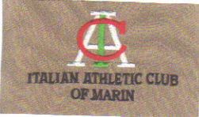

**Established 1968**

**P.O. Box 36, Larkspur, CA 94977**

**THE ALUMNI BOARD NEEDS YOU!**

**If you would like to work with current Directors to further the mission and goals of the GAA please contact Charlene Mori at 415-297-4280. We are searching for new Board Members, assistance with the newsletter “Observer” and someone to help maintain & build our web site. You can also email -** [**http://galileoalumni.org/messagePres2.html**](http://galileoalumni.org/messagePres2.html)

***HELP US MAKE GALILEO THE BEST ALUMNI IN SAN FRANCISCO!!***

**RENT THIS SPACE**

1 YEAR (4 ISSUES) $75.00

Send your business card with your check to:

Galileo Alumni Association

Advertising Dept.

1150 Francisco Street, S.F., CA 94109

**RENT THIS SPACE**

1 YEAR (4 ISSUES) $75.00

Send your business card with your check to:

Galileo Alumni Association

Advertising Dept.

1150 Francisco Street, S.F., CA 94109

1/4 page = $150 (4 issues) 1/2 page = $300 (4 issues)

Please cut on line and mail

**GALILEO ALUMNI ASSOCIATION FUNDRAISING**

* PLEASE HELP TO KEEP THE PENDULUM GOING EACH MONTH, IT IS NO LONGER FUNDED BY THE SCHOOL
* DONATION TO THE ELECTRONIC SIGN/MARQUEE TO PUT ON THE CORNER OF VAN NESS & BAY

**YES, I want to donate $ \_\_\_\_\_\_\_\_\_\_ towards:**

**The Pendulum** **Science Dept.**  **Other**\_\_\_\_\_\_\_\_\_\_\_\_\_\_\_

**Is it ok to mention your name as a donor? Yes \_\_\_\_No \_\_\_\_**

Name: \_\_\_\_\_\_\_\_\_\_\_\_\_\_\_\_\_\_\_\_\_\_\_\_\_\_\_\_\_\_\_\_\_\_\_\_\_\_\_\_\_\_\_\_ Email \_\_\_\_\_\_\_\_\_\_\_\_\_\_\_\_\_\_\_\_\_\_\_\_\_\_\_\_\_\_\_\_\_\_

Address: \_\_\_\_\_\_\_\_\_\_\_\_\_\_\_\_\_\_\_\_\_\_\_\_\_\_\_\_\_\_\_\_\_\_\_\_\_\_\_\_\_\_City\_\_\_\_\_\_\_\_\_\_\_\_\_\_\_State\_\_\_\_Zip\_\_\_\_\_\_\_\_\_

**Mail to: Galileo Alumni Association**

**1150 Francisco Street**

**San Francisco CA 94109**

**YOU CAN ALSO DONATE ON LINE AT:**  <http://galileoweb.org/alumni/>

**The OBSERVER Is For All**

**Galileo alumni, family, friends, students, faculty . . . anybody and everybody, the *Observer* is for you. If you haven't already done so, send in the email addresses of anyone who would like to receive a FREE emailed newsletter to** [**http://galileoalumni.org/contact.html**](http://galileoalumni.org/contact.html)**. We'd like to reach as wide a range of readers as possible.**

**PLEASE SEND US YOUR IDEAS, GOSSIP,**

**UPDATES ETC.**

**The Galileo Observer invites your articles, letters, memories, inquiries and suggestions. All submissions are subject to editing. Deadlines for submissions are January 1st, April 1st, July 1st and October 1st.**

**Send emails (preferable) to** [**galileoobserver@aol.com**](mailto:galileoobserver@aol.com)

**Send letters to Galileo Observer, c/o Galileo Alumni Association, 1150 Francisco Street, San Francisco, CA 94109. All letters are subject to editing.**

**BACK ISSUES OF THE GALILEO OBSERVER CAN BE VIEWED AT**

[**http://galileoweb.org/alumni/newsletter/**](http://galileoweb.org/alumni/newsletter/)**.**

**For all EDITORIALLY-RELATED comments or suggestions, please address your emails to** [**galileoobserver@aol.com**](mailto:galileoobserver@aol.com)**.**

**For all TECHNICAL problems (non-receipt of newsletter, etc.), contact the webmaster through** [**http://galileoweb.org/alumni/contact/**](http://galileoweb.org/alumni/contact/)**.**

**Editor**

**Sisvan Der Harootunian**

**Managing Editor**

**Charlene Fachner Mori**

**Columnists**

**Tony Compagno**

**Sisvan Der Harootunian**

**Bettie Grinnell**

**Advertising**

**Joe Scafidi**

**Printing/Mail Distribution**

**Toni Alessandra**

**The Galileo Observer is published quarterly in January, April, July and October by the Galileo Alumni Association, 1150 Francisco Street, San Francisco, CA 94109. Views expressed are strictly those of the Association and in no way reflect those of the Galileo Academy of Science and Technology, its students or faculty. Sisvan Der Harootunian, Editor; Vaughn Spurlin, Production Manager/Website Director. Copyright 2012, Galileo Alumni Association.**

***Last updated October l 2012. © 2002-2012 Galileo Academy of Science and Technology Alumni Association of San Francisco. Tax ID 30-0066848. No part of this publication may be reprinted or reproduced in any form without permission of The Galileo Observer and/or The Galileo Alumni Association***

GAA BOARD OF DIRECTORS, OFFICERS, & COMMITTEE CHAIRS ARE LISTED AT [**http://galileoweb.org/alumni/contact/**](http://galileoweb.org/alumni/contact/)