|  |  |  |
| --- | --- | --- |
| X | **THE GALILEO OBSERVER The Official Newsletter of the  Galileo Alumni Association**  ***Clarity . . . Honesty . . . Integrity*** | C:\Users\cca\Desktop\lion.jpg |
| ***“Serving the Galileo Alumni Community”*** | | |

**Vol. XI, No. 1 10th Anniversary Issue ___________February 2013**

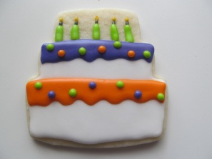

**Happy Birthday, Obie!**

**This month marks the tenth year that The Observer has been published. It’s been a long ride, and the newsletter has developed much as a youngster grows, evidenced by the evolution of our present masthead and the length of the issues. We’ve added color and photos and columns. Like all things that get better with age, we plan to make even more changes, hopefully all for the better, in the next few issues.**

**To paraphrase the President whose birthday we celebrate this month,**

**The Observer is “of the alumni, by the alumni and for the alumni.”**

**So, Happy Birthday, Obie, and may you have many more!**

**C:\Users\cca\Desktop\k9184389.jpg**

**THE GALILEO OBSERVER  
A Monthly Newsletter of the Galileo Alumni Association**

**VOL. I, NO. 1 February, 2003**

WELCOME to the first issue of the monthly newsletter of the Galileo Alumni Association. It is an honor for me to serve as the Editor of this publication. Each month we will bring you timely news about what’s happening at Galileo Academy of Science and Technology, stories and whereabouts of Galileo alumni, and upcoming events.

The newsletter will be emailed to a list of alumni and will also be available by mail and on the Galileo website, [www.galileoalumni.org](http://www.galileoalumni.org/). As the newsletter expands and reaches more alumni, it will serve as a binding factor to renew friendships, share high school memories, and help our school achieve its present day goals.

We welcome your comments and suggestions. Please send them to Editor, The Galileo Observer, c/o Galileo Academy of Science and Technology, 1150 Francisco Street, San Francisco, CA 94109. In our next issue, we will also have an email address for you to contact us. Sisvan Der Harootunian, Editor, Class of 1951

**Sports Hall of Fame Honors 13 Athletes**

**Dr. Bobby Brown Inducted into Hall of Merit**

**On October 26, 2012, Galileo honored its outstanding former athletes at a dinner ceremony at the San Francisco Italian Athletic Club. Over 250 people attended the event, including family and friends of the 13 inductees. There were cocktails, a multi-course sit-down dinner, music by Vince Gomez and Dale Nesbitt, a video presentation, and a raffle. Those honored with induction into the prestigious Hall and recipients of the Hall of Fame medallion were Joe Angel, currently the voice of the Baltimore Orioles, Paul Avedano, former high school football All-American, Sheire Coleman, former American youth ambassador to Israel, Mike Dunne, former coach at St. Vincent de Paul grammar school, Maceo Houston, member of the 1994 CCSF football national championship team, Mark Huynh, current Galileo football coach, Jason Lee, basketball coach at various SF high schools for 20 years, Kevin Mooney, former Sacramento State basketball star, Steve Moresi, most valuable player on the 1964 Galileo baseball team, Hudari Murray, founder of the Golden State Giants minor league football team, Dino Natali, entertainer, actor and 4 sport athlete, Sam Peoples, 1988 AAA football player of the year, and Margaret Creer-Solon, first team All-City in softball and volleyball.**

**Also honored as the second member of the Hall of Merit was Dr. Robert W. “Bobby” Brown, cardiologist, who flew in from Fort Worth, Texas for the ceremony. He thus became the first member of both the Hall of Merit and Sports Hall of Fame. He reminisced about his time at Galileo with anecdotes to the delight of the audience (read Tony Compagno’s poignant column about the event). Brown played professional baseball with Joe DiMaggio and Charley Silvera for the New York Yankees, later becoming President of the American League. Silvera attended the dinner to honor his old friend and teammate. Dr. Brown is a well-known cardiologist in Fort Worth and initiated the movement to ban chewing tobacco in the major leagues. A highlight of his trip to San Francisco was accompanying Hall of Fame committee member Joe Martino on a visit to Galileo where they were taken on a tour of the school by Bettie Grinnell, Assistant to the Principal (read Bettie’s story in her column, Between the Lions, below). Committee Chairman Sisvan Der Harootunian presented Dr. Brown with a Certificate of Merit signed by San Francisco Mayor Ed Lee. The evening concluded with the singing of Sweet Bobby Brown (after Sweet Georgia Brown) by Bill Dito, Vince Gomez and Cherise Johnson, with special lyrics by Dito.**

***Click on the following link to see photos of the above event:*** <http://s1273.beta.photobucket.com/user/galileoalumni/library/#/user/galileoalumni/library/Galileo%20HOFM%20AWARDS%202012?&_suid=136069977023805891907747865726>

Photos can also be viewed on the Galileo website. <http://galileoweb.org/alumni/>

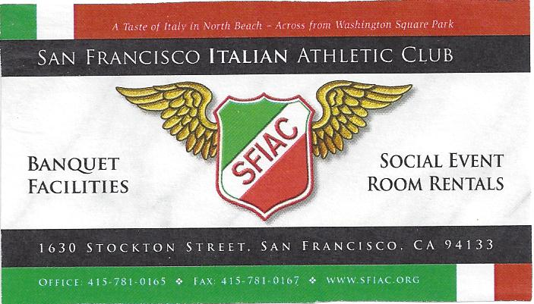

|  |  |  |  |
| --- | --- | --- | --- |
|  |  |  |  |

**P**

Behind the Scenes of the Sports Hall of Fame Dinner

Putting on a dinner with 250+ guests is no easy task. GAA President Charlene Mori is used to these challenges, and she and her team (Toni Alessandra, Barbara LaRocca and Lance Hughston) worked their tails off getting the IAC’s tables set, arranging the seating order, decorating, and coordinating with Lisa Michelis and Paul Alioto of the Club. They were responsible for seeing that Mike Dunne’s table had enough chairs for his large group.

One of Dr. Bobby Brown’s guests and former classmates called me over to request that her dinner entrée and other dishes have no garlic in them. She was an Italian GALumna at that! The kitchen graciously accommodated her.

When Dr. Brown arrived in town a few days before the ceremony, committee member Joe Martino met him at the airport, drove him to his favorite hotel, and then the two of them visited Galileo at Brown’s request. They were greeted by Bettie Grinnell, and she relates what happened after that (read her account in her column below).

Three hours before the dinner, I still did not have Dr. Brown’s Certificate of Merit signed and issued by the Mayor of San Francisco, Ed Lee. I hustled down to City Hall, and the staff had it ready. I thankedthem, and, envelope in hand, made the dinner on time.

The evening was enhanced by the presence of the families and friends of the sports honorees. Sam Peoples introduced me to his brother Brice, who, he said, was a better football player than he. So we’ll be considering him for this year’s awards. Paul Avedano’s family was so appreciative of his being honored with an award.

The committee hadn’t counted on the size of the IAC’s drop-down video screen. When Kevin Mooney, wellover 6 feet tall, got up to accept his medallion, he had to lean over.

Our photographer, Mike Mustacchi, a Sports Hall of Famer himself, took over 400 photos of the event! He was a very busy man. His photos can be seen at<http://photobucket.com/galileoalumni> and also on the Galileo website.

The dessert the IAC served was my personal choice, and I asked the waitress to provide a box to take it home as I didn’t have time to eat it there. When I got home, the box felt very light. I opened it to find I had forgotten to put the dessert in.

Nominations Open for 2013. We need nominations for the 2013 Hall of Fame class. Please send your nominations to GAA, Galileo Sports Hall of Fame, 1150 Francisco St., SF CA 94109. A nomination form can be found on the Galileo website, <http://galileoweb.org/alumni/>.

NEEDED: PERSONS INTERESTED IN JOINING THE SPORTS HALL OF FAME AND HALL OF MERIT COMMITTEES. PLEASE CONTACT S. DER HAROOTUNIAN AT [GALILEOOBSERVER@AOL.COM](mailto:GALILEOOBSERVER@AOL.COM)

|  |  |
| --- | --- |
| **Through The Telescope. . .**  **Sisvan Der Harootunian** | X |

**My cousin who lived in San Francisco in the late 30s used to say that San Francisco was so chic that women wore dresses and hats, and men wore neckties and hats to go downtown. When Jimmy Carter was President he wore open neck shirts and sweaters when the occasion allowed it. I never saw a photograph of Richard Nixon without a tie. He wore a suit and tie when writing his memoirs in his San Clemente home. Singer Perry Como gave up suits and ties for the more casual look of sweaters on his television program. I prefer casual clothes to formal or dressy garments. I attended a 50th wedding anniversary celebration at the Round Hill Country Club wearing a suit and tie. Entering the room, I saw every male guest including the groom of honor wearing open neck shirts!**

**Caesar’s Restaurant, the site of many Galileo-related functions, has closed. Rumor has it they will re-open at some other location.**

**GALumni in the news: Congratulations to London Breed (Class of 1992) who won the District 5 race for Supervisor. I met London on the corner of Cole and Parnassus where she was campaigning just before the election and told her I predicted she would win.**

**Just married: Jowanna Woeber (AKA Giovanna diTano), Class of 1951, to pianist Bill Novales. They**

**plan to resume singing and playing at Westlake Joe’s in the future.**

**Congratulations to Bettie Grinnell, Assistant to the Principal, for 40 years of service to Galileo.**

**Dylan Nelson, Class of 2010, has enrolled at Cal. Major league baseball is not far off. Brother Kyle made honorable mention as quarterback for Galileo.**

**OBSERVation: MUNI has replaced the “Go 49ers!” electronic signs on its buses with “Go Giants!” in plenty of time for the baseball season. One day last week I was the only rider on the #49 cable car on California Street. The car was decorated with scarlet red and metallic gold throughout the NFL playoffs.**

**Hostess Cupcakes are no more. A good alternative are Pinguinos by Bimbo from Mexico. They are just as good.**

**“*If you cannot do great things, do small things in a great way.”***

**Until next time . . .**

**\* * * * * * \***

***Tony Compagno’s Ramblings***

**When I walked up to the dais and introduced my unfamiliar mug to inductee Dino Natali, class of '52, I immediately explained that my sister Angie had been a classmate and neighborhood friend of his in the old days. The actor/entertainer warmly shook my outstretched Lion's paw and asked if she and her husband Tommy Venezia were in the room. His hopeful look turned sad when I said that we'd lost Angie a couple of years ago. He squeezed my hand and asked if I would say hello to Tommy, leaving me with an Italian phrase: "Siamo tutti famiglia..." We are all family. And that stayed with me as I sat with my oldest and dearest friends from the golden era that formed and blessed us. I'm going to throw some names out at you. You all have your own lists like this, of course, and aren't we fortunate. My group was there primarily to honor inductee Mike Dunne, class of '63, a good athlete but more importantly a good man for whom a bunch of us showed up that beautiful October evening on Stockton Street in magical North Beach: The Flanagan brothers, Bill and Ken. Jim Guerrero, Mike Bellanca, Dave Barni, Frank Rossi, Al Vernarecci, George DeLuca, Tommy Sugrue, Cosmo Violante, Bronco Duzdevich, Paul Giambra, just to name a few. But, in walking around, I found and said hello to Lions who'd prowled the corridors of Galileo High long before I had. I spoke briefly with Pete Pompei and Sisvan Der Harootunian; I also insisted on shaking the hand of Dr. Bobby Brown, recipient of the Hall of Merit Award. Dr. Brown, who'd attended Gal back in the early '40s, hit a home run with his comments, telling the rapt audience about his dad moving the family to San Francisco and specifically the Marina District. "My father stood with a real estate agent on a street overlooking the Marina, and my dad directed the agent's attention to a field below with two ball diamonds and instructed the agent that the Browns needed a home no more than two blocks from that field." That field, of course, was Funston Playground, where the young Bobby Brown learned the skills that took him to Yankee Stadium alongside Joe DiMaggio and Yogi Berra. Years later the Yankee third baseman would become a cardiologist and also serve a stint as President of the American League. We could sense the warmth in Dr. Brown's voice as he reminisced about the old days, the formative days, playing under Ras Johnson with the coach's "hands-off" coaching style, and his old teammates, a couple of whom were in attendance, and Funston Playground so many years and world-changing events before it became Moscone Field. You could hear a pin drop, and there was a lump in more than one throat, when the Doc said that it was great to come home again. And the word "home" conjured so many thoughts and images for me; the word "home" was meaningful on various levels. All you Lions, especially those of you raised in or near the vicinity of venerable Galileo High School, know what I'm talking about. Home is a place, and it's a time, and it's a special sense of one's beginnings; okay, I'll go there: it's where the heart is: there, I said it. You're right, Dino. "Tutti famiglia." Yeah, we're all family. Everyone on the dais and in the audience that night: African-American, Colombian, Italian, Irish, Vietnamese, Chinese, Filipino - you name it. We were all purple and orange that night, and this isn't the mere rambling of a life-long liberal Democrat in an election year. It's the truth so many still resist. Thank you, Alumni Association, for a memorable evening.**

**Mez Sez**

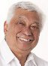

**Vince Gomez (’52)**

**When I graduated from Galileo High School in June of 1952, I had no idea that some 60 years later I would be guest conducting a high school string orchestra in Shanghai, China. As I said to some of my classmates at our 60th class reunion on October 20, 2012, we must be having fun since the years have literally flown by. This latest guest conducting assignment was from November 11 to November 18, 2012 at the Concordia International School in Shanghai, China. The hardest part of the trip was the 14 hours direct flight from San Francisco to Shanghai. (Also Shanghai time is 16 hours ahead of SF time). Once I was settled into my room at the Diamond Court Hotel, my week at the school was like any other work week in the States. The first three days of the week were spent assisting Sara Preus, orchestra director at the school with her various string classes from 5th to 12th grade levels. I also had the opportunity to assist the band and**

**choir directors as well. During this part of the week I had a couple of fortuitous meetings. One was with a lady who was introduced to me by Chris Bishop, the Activities Director of Concordia. She had just directed a Global Leadership Summit Event at the school. After a brief conversation I found out that she had graduated from Galileo High School in 1984. Her name is Clarissa Hsu. The other chance meeting was with Mark Inouye, principal trumpet of the San Francisco Symphony. The group was on their Asia tour that included two concerts in Shanghai. Sisvan Der Harootunian, Observer Editor, had told me of their tour, and I was able to have Ms. Preus arrange the opportunity to hear the Symphony in rehearsal. I was able to speak with Inouye on his break during the rehearsal and found out that he too was a GIANTS season ticket holder. We first met when I was performing at The Washington Square Bar & Grill in North Beach where he sat in with Dick Fregulia and me about 10 years ago. What a small world! On Thursday of this week in Shanghai the 81 students and 6 teachers who were to form the Asia Pacific Activities Conference Orchestra of 2012 met for their first rehearsal with me. The six International Schools came from Kobe, Japan, Manila, Philippines, Guangzhou, Beijing and two from Shanghai. We rehearsed Thursday, Friday and Saturday and concluded our work with a concert on Saturday night for parents, teachers, students and friends in the Rittmann Center for the Arts of the Concordia School. The works they performed included pieces by Handel, Elgar, Bernstein, Vaughn Williams, and Tchaikovsky, among others. A student composition by a 17 year old student, Sam Wu, from the Shanghai American School-Puxi was**

**also performed. The concert and week with the students was a great success, and the students received a standing ovation at the end of the concert. The very next day I was back at the airport and back to SF. The great thing was that it only took 10 hours (with the help of tail winds). I arrived in San Francisco at 8 am on the 18th after leaving Shanghai at 2 PM of the same day. It was an exciting and rewarding week for your FAITHFUL LION.**

***Announcements***

**1963 Reunion 50th reunion coming up in 2013, Contact: Sheldon Wong for info** [**gtrzot@comcast.net**](mailto:gtrzot@comcast.net)

**“End of The 70’s” Class Reunion will be held Saturday, June 29, 2013 – contact Nolan McCoy at: macdon1959@yahoo.com or LaQuita Scales at:** [**la2uita@aol.com**](mailto:la2uita@aol.com)

**GAA Election Results: Toni Alessandra was re-elected to the Board of Directors in November. She was the only member up for re-election.**

**Because of rising costs in postal rates, GAA will no longer mail the Observer to members who do not make a yearly donation or to non-members. The newsletter will gladly be emailed to any and all who request it.**

**Please see our new tab on our website “MERCHANDISE” we now have Shirts and Mugs.**

[**http://galileoweb.org/alumni/merchandise-2/?preview=true&preview_id=1288&preview_nonce=e1e4b5f788**](http://galileoweb.org/alumni/merchandise-2/?preview=true&preview_id=1288&preview_nonce=e1e4b5f788)

**ATTENTION POTENTIAL ADVERTISERS**

***This newsletter is now accepting advertisements for future issues. If you have a business or service you want to advertise, The Galileo Observer is the ideal***

***place to place your ad. It will appear for 4 issues during the year – in January, April, July and October and will reach Galileo alumni, family, friends and students. Rates In addition to promoting your product or service, you will be helping the Galileo Alumni Association carry out its mission of helping the Galileo Academy of Science and Technology.***

***Please contact*** [***GalileoObserver@aol.com***](mailto:GalileoObserver@aol.com) ***or*** [***JScafidiMV@aol.com***](mailto:JScafidiMV@aol.com)***.***

***are reasonable –***

**RENT THIS SPACE**

1 YEAR (4 ISSUES) $75.00

Send your business card with your check to:

Galileo Alumni Association

Advertising Dept.

1150 Francisco Street, S.F., CA 94109

***$75 for 4 issues (business card size ad).***

**Oldest GALumnus? Nicholas Quirarte, 96, Class of 1933, may be the oldest living Galileo alumnus. Currently residing in Acapulco, Mexico, with his daughter Susie, he is scheduled to return to his home in Paradise, California, in April of this year. So writes his daughter.** “My father served in WWII and some of his friends are with Easy Company. You may know them as the Band of Brothers. He was presented with the National Americanism award in 2008 back in Overland Park, Kansas. I believe his story is still posted on the internet. My father will be happy to hear he is the oldest alumnus. I was raised, went to school (St. Peters) and worked in San Francisco. I am familiar with North Beach as my father lived in North Beach as a young man with his mother and grandmother.”

*Ed. Note: Friends may call Nicholas and Susie at 530-520-1119 and will be charged as a call to Paradise, CA.*

***MISUNDERSTANDING***

**IMPORTANT MESSAGE FROM THE GAA PRESIDENT**

**I have heard from several alumni that they receive the Lions Pride every**

**Saturday morning via email, thinking the GAA publishes this newsletter. I would like to correct this immediately. The Lions Pride published by Phil Kaiser is in no way related to the Galileo Alumni Association’s *Observer* newsletter or approved by the Board of Directors. It is also not endorsed by the Galileo Academy. We do not feel that Phil Kaiser's Lions Pride represents the best interests of the GAA. We do not communicate with Mr. Kaiser or in any way support his criticism or negative writings. Our newsletter *The Observer* is published 4 times a year in January, April, July and October. I hope this clears the air for many of you.**

**\* * * * * * \***

***Reporters Wanted:***

***The Observer is seeking persons who are willing to gather and report news of interest to Galileo alumni. Writing skills are not necessary, just the ability to communicate and write legibly. We are accepting any bits of information about alumni, such as what they are doing now, marriages, births and deaths. If you have a photo of an event, a luncheon or small gathering, send it in. Send all submissions to the Galileo Observer (***[***galileoobserver@aol.lcom***](mailto:galileoobserver@aol.lcom)***) or the Editor, Galileo Observer, c/o*** [***www.galileoweb.org***](http://www.galileoweb.org)***.***

**\* * * * * * \***

***Visit our Facebook page at:*** [***https://www.facebook.com/pages/Galileo-Alumni-Association-San-Francisco/278283128875474***](https://www.facebook.com/pages/Galileo-Alumni-Association-San-Francisco/278283128875474)

****Between the Lions****

**by Bettie Grinnell**

**Winter 2012/13**

Greetings Mighty Lions! Here’s what happening at Galileo these days.

**HOTEL VERTIGO (a novel) by Dutch author Kees ‘T Hart**

Galileo High School is featured in this exciting novel set in 1957 in San Francisco. Mr. Kees ‘T Hart came to Galileo 3 years ago to visit the campus and learn about the students and faculty in the 1950’s. I spent several hours with him and his wife and then he would email me with questions. The Galileo Hymn is printed in the book, in English, while the rest of the book is printed in Dutch. The central character in the story is a young high school student named Vincent, who comes to San Francisco as a foreign exchange student for a year and enrolls in Galileo High School. He lives with a family who are very interested in Alfred Hitchcock during the time the movie “Vertigo” was being filmed. It is the time of the beat poets, and the family with whom he gets connected is involved with the influential support group Synanon.  'T Hart paints a picture of San Francisco of this era, the setting for the film” Vertigo” by Hitchcock. Vincent ends up spending more time working on the second crew for the film than he does in high school. He drifts away from San Francisco and lives his life. He returns to San Francisco twenty years later and comes back to visit his old haunts, including Galileo High School.

Mr. ‘T Hart and his wife came to San Francisco to be honored at the Dutch Consulate for his novel in December 2012. They came to Galileo to see me the next day and present me with a copy of the novel. They showed me the Galileo Hymn, and the acknowledgement they included to me for my help in showing them around Galileo. I gave the book to one of our teachers who speaks and reads Dutch and she shared the story with me. It was an honor to participate in a small way in his book that includes Galileo High School!

**FAREWELL GLORIA DONOHOE**

Veteran School Secretary Gloria Donohoe passed away on October 14, 2012. Gloria was the Secretary in the Main Office from the mid 1980’s to the mid 1990’s, serving under Principal John Quinn. In all, Gloria worked for the San Francisco Unified School District for more than 20 years. Gloria was with her family vacationing in Lake Tahoe when she suffered a stroke and never recovered. Many will remember her smiling face in the Main Office.

**SPECIAL ALUMNI NOSTALGIA**

On Friday, October 26, 2012, several gentlemen came into the Main Office, asking for “Bettie.” Joe Martino, Class of 1950, introduced himself first. Then he introduced Dr. Bobby Brown, Class of 1942. Of course I already knew about Bobby Brown. The guys wanted to see the auditorium, so I took them onto the stage and turned everything on in the auditorium. They had great fun looking out into the auditorium and remembering addressing the students and all the fun they both had during their time as ASB Presidents. I thoroughly enjoyed hearing their reminisces of their days as students at Galileo High School. Bobby told me that he had looked forward to returning to Galileo, his high school, for 70 years. We left the auditorium and walked in some of Galileo’s hallways. Dr. Brown told me all about playing major-league baseball and attending medical school. And we talked about such high school topics as “who smoked,” “who was allowed to date,” and “who wasn’t allowed to date.” Before Joe and Bobby left, we gave Bobby a 1941 yearbook. He was most anxious to see the list of teachers and he remembered them all. We hope it is not another 70 years before Joe and Bobby return to their alma mater.

**JROTC**

After being the 2 time defending champions, Galileo’s JROTC was disappointed after not placing at the annual JROTC Fall Competition at Balboa High School on November 17, 2012. They participated in 4 events: Color Guard, Guidon, Squad Drill and Drum Corps. They placed 3rd in the Drum Corps competition. Practice space is currently a big problem for JROTC. The artificial turf on the Athletic Field is not a good place for the team to practice and after school tutoring classes complain about the noise in the courtyard. The other challenge the teams faced is that many of the members are new to JROTC. Motivation is high and the JROTC members have high hopes for the next competition.

**WINTER SPORTS UPDATE**

**Varsity Girls Basketball**

Currently we are 15-3; 3-1 in league; we are battling Lowell (the favorite) to play in the City championship; we have 15 girls and the top 8 are juniors who will return next year; we hope to make the championship game at Kezar in early March! Don Papa is the coach.

**Frosh/Soph Girls Basketball**

The Frosh/Soph Galileo Lady Lions are trying to be “the best in the West.” The 2012-2013 team is young and inexperienced, but they have a heart and a bright future ahead of them. If they continue to develop they will be a team to reckon with, as they are very fast and aggressive. In the past few weeks they have developed into a cohesive team. Thanks, in part, to the efforts and experiences of Coach Greg Esby and Coach Steve Hardee, the team record is 3-1. The coaches expect big things from Point Guard Fiona Fong, freshman, and shooting guard Tiffany Lee, freshman, and Marisa Louie a sophomore. Go Lions!

**Varsity Boys Basketball**

Speed and experience describes this years Galileo Boys Varsity Basketball team, as they push through the regular season, with an eye on making a deep run in the playoffs. Led by 5 seniors, Brion Gregorson, Chris Lee, Kenny Lum, Nick Toy & Ken Rivera, who have all been playing on the Varsity team since they were sophomores, the team is hoping their experience from previous years will give them the edge on their competition. Although experienced, the team does lack height, but is hoping to combat that weakness with overall team speed. The Lions plan to get up and down the court in order to negate the advantages taller opponents might have. The Lions are currently sitting in a tie for second place with a 3-1 record. However, tough games against Lincoln, Washington, & Mission await the team.

**Frosh/Soph Boys Basketball**

https://mail.google.com/mail/u/0/images/cleardot.gifAfter returning to the playoffs in the previous season for the first time in 7 years, the 2012-13 Galileo Frosh-Soph Boys’ Basketball Team looks to build on that success.  This year’s team features 16 talented and skilled student-athletes.   The team is a mix of 6 sophomores and 10 freshmen and features 4 returning players from last year’s playoff team.  This group of sophomores has been counted on to provide leadership to the new players and experience during competition.  The team finished the preseason with a record of 1 win and 8 losses.  Despite the rough start, the team played better toward the end of the preseason, competing in close games that included a two 4 point losses, a 3 point loss, and a 2 point loss.  The improved play gave the team momentum headed into the regular season where they appear to have turned the corner, currently holding a 3-1 record.  Their schedule is still filled with several tough games against several traditional powerhouse schools such as Lincoln, Washington and Mission.  Through continued hard work, the team continues to improve and is gearing toward the stretch run, which they hope will include another playoff berth.

**Wrestling**

The Galileo Lions wrestling team has started their season well. The team is currently 2-1 in the league, with wins over Mission High School and John O'Connell. Unfortunately team captains Max Friedman and Justin Wong are currently out due to injuries, but captain Swain Wong is having a great year and is currently undefeated in league. Juniors Jeremy Chen and Yan Hakobyan are really picking up the slack in the captains’ absences, both scoring wins in the last two matches. Freshman stands outs Alessandro Szabo and Lavelle Johnson, are both having very impressive seasons with both wrestlers having a 2-1 record at the varsity level. The Lions are looking like strong contenders to win the league this year. Coach Allen Loretz is a former Galileo wrestler.

**40 YEARS OF FUN AT GALILEO**

Yours truly started at Galileo High School on November 16, 1972, when Jim Kearney was the principal. Word got out and on November 16, 2012, a group of administrators, counselors, teachers, secretaries and others surprised me with a wonderful serenade and some lovely gifts. It was overwhelming! The day before I was honored for the same service at the weekly meeting of the Rotary Club of Fisherman’s Wharf and presented with flowers and applause. Galileo is a member of the Rotary Club of Fisherman’s Wharf and members help with the Galileo Service Interact Club. I can truly say it is a joy to come to Galileo every day and I look forward to many more days to come.

**Let me know what you’d like to hear/read about at Galileo. Bettie on the Beat will be happy to answer your questions and handle your requests.**  [**grinnellb@galileoweb.org**](mailto:grinnellb@galileoweb.org)

**\* * * * * * \***

**Obituaries**

**Edmund Bacigalupi.** <http://www.legacy.com/obituaries/sfgate/obituary.aspx?n=edmund-bacigalupi&pid=161948590>

**Richard Battaglia.** <http://www.legacy.com/obituaries/sfgate/obituary.aspx?n=richard-battaglia&pid=161285944&fhid=14232>

**Mackenzie Joy Boka-Timmerberg, age 15.** <http://obit.duggans-serra.com/obitdisplay.html?id=990087>

**Ray Bower, member of Sports Hall of Fame.**

**Eleanor Theresa (Servidio) Carter, Class of 1937**

**Ray DalPoggetto, member of Sports Hall of Fame.** <http://www.legacy.com/obituaries/sfgate/obituary.aspx?n=ray-dalpoggetto&pid=162619784>

**Bronco Dudjevich, member of Sports Hall of Fame.** <http://www.legacy.com/obituaries/sfgate/obituary.aspx?n=bronco-duzdevich-dennis&pid=162545824&fhid=2299>

**Raymond Fornaciari, Class of 1940, member of Sports Hall of Fame.**  <http://www.legacy.com/obituaries/sfgate/obituary.aspx?n=raymond-fornaciari&pid=162866429>

**Frances Gatto Gori, Class of 1940.** : <http://www.legacy.com/obituaries/sfgate/obituary.aspx?n=frances-gori&pid=162715410>

**Norman Lee.** <http://www.legacy.com/obituaries/sfgate/obituary.aspx?pid=159986276#fbLoggedOut>

**Fay Woo Pingree.** <http://www.legacy.com/obituaries/sfgate/obituary.aspx?pid=161212041#fbLoggedOut>

**Josephine Chiarenza Ternullo**. <http://www.legacy.com/obituaries/sfgate/obituary.aspx?n=josephine-chiarenza-ternullo&pid=162272508&fhid=2299>

**Fred Tooker, member of Sports Hall of Fame.** <http://www.legacy.com/obituaries/sfgate/obituary.aspx?n=frederic-tooker&pid=161348310>

**Elizebeth Peiser.** [**http://www.legacy.com/obituaries/sfgate/obituary.aspx?pid=162879668#fbLoggedOut**](http://www.legacy.com/obituaries/sfgate/obituary.aspx?pid=162879668#fbLoggedOut)

**Mitchell (Mickey) Vasilatos Davies.** [**http://www.halstedngray.com/obituary/Mitchell-Mickey-Vasilatos-Davies/San-Francisco/1169982**](http://www.halstedngray.com/obituary/Mitchell-Mickey-Vasilatos-Davies/San-Francisco/1169982)

**Anthony “Tony” Schiariti .** [**http://www.halstedngray.com/obituary/Anthony-Tony-Schiariti/San-Francisco/1163270**](http://www.halstedngray.com/obituary/Anthony-Tony-Schiariti/San-Francisco/1163270)

**Walter Simon Newman.** [**http://www.halstedngray.com/obituary/Walter-Simon-Newman/San-Francisco/1141676**](http://www.halstedngray.com/obituary/Walter-Simon-Newman/San-Francisco/1141676)

**Linda Machi.** [**http://www.halstedngray.com/obituary/Linda-Machi/San-Francisco/1166404**](http://www.halstedngray.com/obituary/Linda-Machi/San-Francisco/1166404)

**Here is a Gift to the Galileo Alumni Memorial Fund**

**From ___________________________________________ Class ______**

**Address ___________________________________________________**

**City _________________________________State_____ Zip__________**

**In memory of ________________________________ Amount ________**

**Send memorial card to:**

**Name _____________________________________________________**

**Address____________________________________________________**

**City_____________________________________ State _____ Zip _____**

***– Memorial Gift –***

***Make donations expressing your sympathy to family and friends who have lost a loved one. A memorial card will be sent to the family in your name. Donations are tax deductible to the extent allowed by the law. Tax ID 30-0066848***

***Donations should be mailed to:***

***Galileo Alumni Association***

***1150 Francisco Street***

***San Francisco CA 94109***

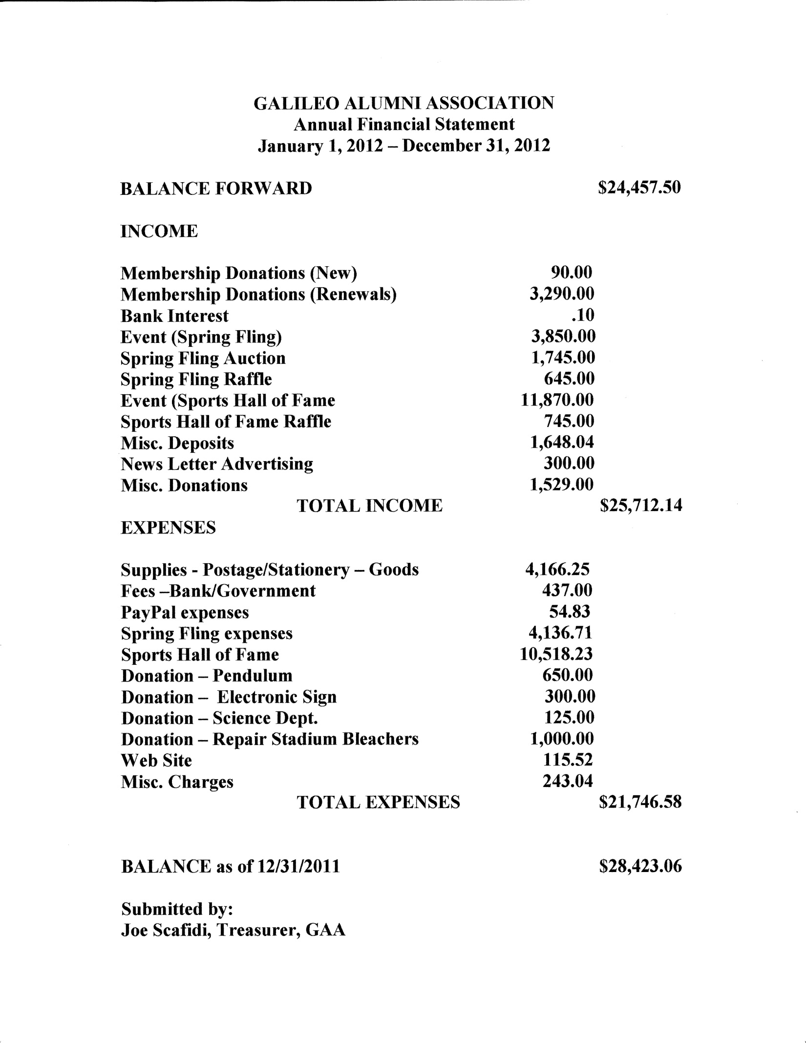

< 2 Results for **Harvey Tepfer**http://o.aolcdn.com/cdn.webmail.aol.com/36478/images/common/space.gif**Images blocked for your protection:** Show images | Always show for this sender | Never block images **CALENDER OF UPCOMING EVENTS**

**GAA Board Meeting – Room 210, Galileo Academy, 6:00 PM, Wed., February 13, 2013**

**Class of 1963, 50th Reunion coming up in 2013**

**When checking for upcoming events between issues of the *Observer*, please visit the web site** <http://galileoweb.org/alumni/> **for the most up-to-date listings.**

**\*\*\*\*\*\*\*\*\*\*\*\*\*\*\*\*\*\*\*\*\*\*\*\*\*\*\*\***

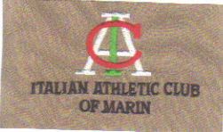

**Established 1968**

**P.O. Box 36, Larkspur, CA 94977**

**THE ALUMNI BOARD NEEDS YOU!**

**If you would like to work with current Directors to further the mission and goals of the GAA please contact Charlene Mori at 415-297-4280. We are searching for new Board Members, assistance with the newsletter “Observer” and someone to help maintain & build our web site. You can also email -** [**http://galileoalumni.org/messagePres2.html**](http://galileoalumni.org/messagePres2.html)

***HELP US MAKE GALILEO THE BEST ALUMNI IN SAN FRANCISCO!!***

**RENT THIS SPACE**

1 YEAR (4 ISSUES) $75.00

Send your business card with your check to:

Galileo Alumni Association

Advertising Dept.

1150 Francisco Street, S.F., CA 94109

**RENT THIS SPACE**

1 YEAR (4 ISSUES) $75.00

Send your business card with your check to:

Galileo Alumni Association

Advertising Dept.

1150 Francisco Street, S.F., CA 94109

1/4 page = $150 (4 issues) 1/2 page = $300 (4 issues)

**GALILEO ALUMNI ASSOCIATION FUNDRAISING**

* PLEASE HELP TO KEEP THE PENDULUM GOING EACH MONTH, IT IS NO LONGER FUNDED BY THE SCHOOL
* DONATION TO THE ELECTRONIC SIGN/MARQUEE TO PUT ON THE CORNER OF VAN NESS & BAY

**YES, I want to donate $ __________ towards:**

**The Pendulum** **Science Dept.**  **ROTC**_______________

**Sports**  **Other**_____________________________________________________

**Is it ok to mention your name as a donor? Yes ____No ____**

Name: ____________________________________________ Email __________________________________

Address: __________________________________________City_______________State____Zip_________

**Mail to: Galileo Alumni Association**

**1150 Francisco Street**

**San Francisco CA 94109**

**YOU CAN ALSO DONATE ON LINE AT:**  <http://galileoweb.org/alumni/>



**The OBSERVER Is For All**

**Galileo alumni, family, friends, students, faculty . . . anybody and everybody, the *Observer* is for you. If you haven't already done so, send in the email addresses of anyone who would like to receive a FREE emailed newsletter to** [**http://galileoalumni.org/contact.html**](http://galileoalumni.org/contact.html)**. We'd like to reach as wide a range of readers as possible.**

**PLEASE SEND US YOUR IDEAS, GOSSIP,**

**UPDATES ETC.**

**The Galileo Observer invites your articles, letters, memories, inquiries and suggestions. All submissions are subject to editing. Deadlines for submissions are January 1st, April 1st, July 1st and October 1st.**

**Send emails (preferable) to** [**galileoobserver@aol.com**](mailto:galileoobserver@aol.com)

**Send letters to Galileo Observer, c/o Galileo Alumni Association, 1150 Francisco Street, San Francisco, CA 94109. All letters are subject to editing.**

**Editor**

**Sisvan Der Harootunian**

**Managing Editor**

**Charlene Fachner Mori**

**Columnists**

**Tony Compagno**

**Sisvan Der Harootunian**

**Bettie Grinnell**

**Vince Gomez**

**Advertising**

**Joe Scafidi**

**Printing/Mail Distribution**

**Toni Alessandra**

**BACK ISSUES OF THE GALILEO OBSERVER CAN BE VIEWED AT**

[**http://galileoweb.org/alumni/newsletter/**](http://galileoweb.org/alumni/newsletter/)**.**

**For all EDITORIALLY-RELATED comments or suggestions, please address your emails to** [**galileoobserver@aol.com**](mailto:galileoobserver@aol.com)**.**

**For all TECHNICAL problems (non-receipt of newsletter, etc.), contact the webmaster through** [**http://galileoweb.org/alumni/contact/**](http://galileoweb.org/alumni/contact/)**.**

**The Galileo Observer is published quarterly in January, April, July and October by the Galileo Alumni Association, 1150 Francisco Street, San Francisco, CA 94109. Views expressed are strictly those of the Association and in no way reflect those of the Galileo Academy of Science and Technology, its students or faculty. Sisvan Der Harootunian, Editor; Vaughn Spurlin, Production Manager/Website Director. Copyright 2012, Galileo Alumni Association.**

***Last updated February 12, 2013. © 2002-2013 Galileo Academy of Science and Technology Alumni Association of San Francisco. Tax ID 30-0066848. No part of this publication may be reprinted or reproduced in any form without permission of The Galileo Observer and/or The Galileo Alumni Association***

GAA BOARD OF DIRECTORS, OFFICERS, & COMMITTEE CHAIRS ARE LISTED AT <http://galileoweb.org/alumni/about/contact/>

**GALILEO SPORTS HALL OF FAME**

**NOMINATION FORM**

**CRITERIA**

1. Nominee must have attended Galileo High School/Galileo Academy of Science and Technology in good standing at least 5 years prior to being nominated.
2. Nominee must have been an outstanding athlete. Examples: Member of a championship team, selected All City, hold a high school record, recipient of a specific individual or team award, considered by peers as worthy of being a member of the Galileo Sports Hall of Fame.

(Consideration will be given for recognized athletic activities and/or accomplishments after graduation.)

1. Nominee may be an individual (faculty, coach, student) whose valued contributions to a specific sport or athletics in general at Galileo are worthy of consideration for this award.

4. Galileo alumni, faculty members, coaches, or family members of a nominee, may nominate a candidate. All nominations will be reviewed and facts about qualified nominees will be verified by the Galileo Alumni Association Sports Hall of Fame Committee.

5. Posthumous awards are given, so nominee may be deceased. If selected, he/she must be represented by a family member or recognized close friend.

I would like to nominate the following person for the Galileo Academy Sports Hall of Fame:

Name of Nominee:

Class of: Phone: Email: ___________________

Spring/Fall/Year

Address:

Street City State/Zip Code

Nominator's Name:

Address

Street City State/Zip Code

Class of: Phone: Email:____________________

Spring/Fall/Year

Signature: Date:

Mail to: Galileo Alumni Association

Sports Hall of Fame Committee

1150 Francisco Street

San Francisco, CA 94109

Or email to: [GALILEOOBSERVER@AOL.COM](mailto:GALILEOOBSERVER@AOL.COM)

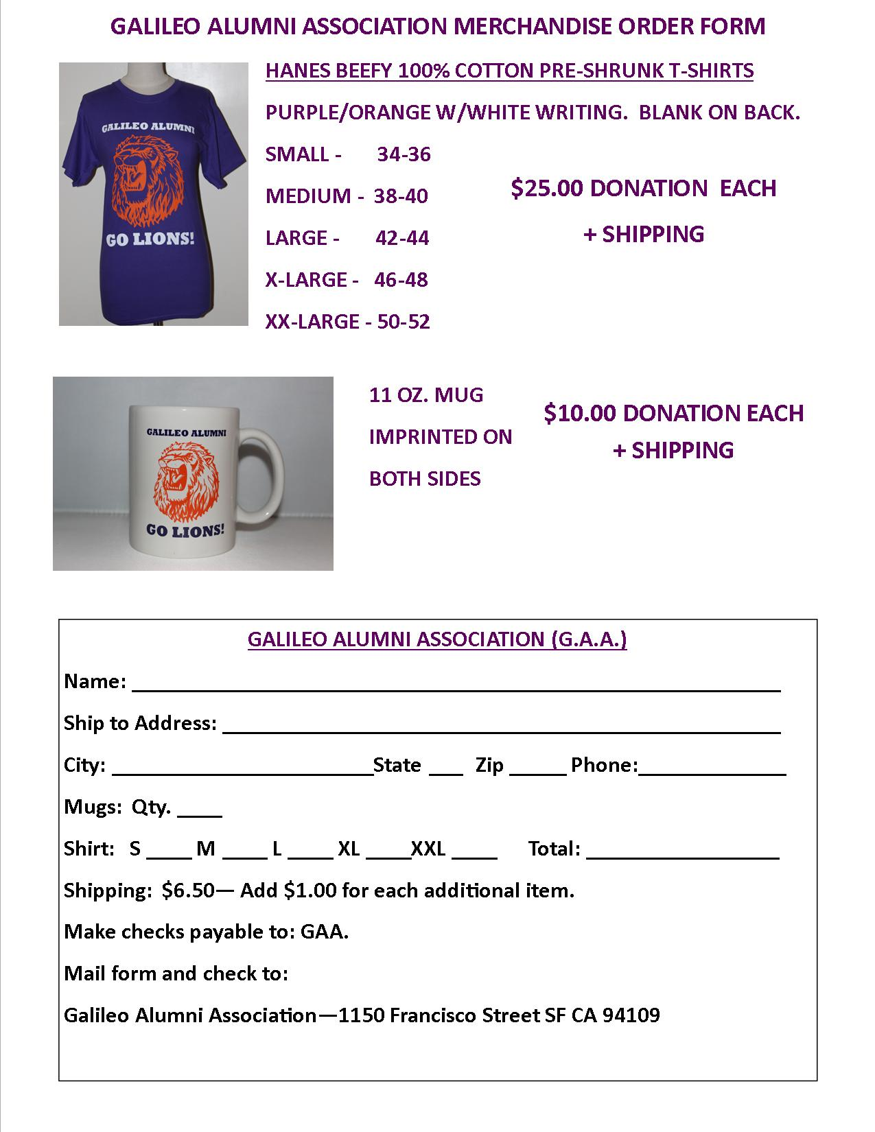

**GALILEO ALUMNI ASSOCIATION MEMBERSHIP APPLICATION**



**GALILEO ACADEMY OF SCIENCE AND** BENEFITS OF MEMBERSHIP **PLEASE CONSIDER DONATING**

**TECHNOLOGY ALUMNI ASSOCIATION** * Alumni activities and events **WE NEED YOUR SUPPORT.**

**OF SAN FRANCISCO CA.**  * Membership Card **JOIN THE G.A.A. SUPPORT YOUR**

The Mission of this Association shall be to * Assistance to all reunion committees **ALMA MATER!**

Organize Alumni into a cohesive unit to benefit * Quarterly newsletter “The Observer” Please visit the Galileo Alumni

all members of the high school Community: * Notice of Association Updates Association web site for further

Alumni, Students, Faculty, Staff and Friends. * Helping the current students of information at:

Galileo Achieve their goals. And much <http://galileoweb.org/alumni/>

more as the membership grows.

**BOARD OF DIRECTORS** **DIRECTORS** **STANDING COMMITTEE CHAIRPERSONS**

President: Charlene Fachner Mori (1965) Sisvan Der Harootunian (1951) **COMMUNICATIONS (NEWSLETTER):**

Vice President: Augie Venezia (1953) Barbara Fachner LaRocca (1969) Sisvan Der Harootunian (1951)

Secretary: Position Open Cordy Surdyka (1953) **MEMBERSHIP:** Toni Alessandra (1964)

Treasurer: Joe Scafidi (1950) Vince Gomez (1952) **PUBLIC RELATIONS:**

Toni Alessandra (1964) Barbara Fachner LaRocca (1969)

Lance Hughston (1966) **WEBMASTER:** Vaughn Spurlin (1960)

**IF YOU HAVE ALREADY DONATED THIS YEAR, PLEASE DISREGARD THIS NOTICE AND THANK YOU**

- - - - - - - - - - - - - - - - - - - - - - - - - - - - - - - - - - - - - - - - - - - - - - - - - - - - - - - - - - - - - - - - - - - - - - - - - - - - - - - - - - - - - - - - - - - - - - - - - - - - - - - - -

**WE NOW ACCEPT PAYMENT ON LINE WITH PAYPAL**

PLEASE DETACH AND MAIL OR PAY ON LINE AT: <http://galileoweb.org/alumni/>

DATE: ______________________________ NEW MEMBER ______________ RENEWAL _____________

NAME: __________________________________________________ MAIDEN NAME ______________________________________

ADDRESS ________________________________________________ CITY/COUNTRY __________________STATE____ ZIP________

GRADUATION YEAR ______ EMAIL _____________________________________________________ PHONE _____________________

MAKE CHECKS PAYABLE TO THE GALILEO ALUMNI ASSOCIATION. INTERESTED IN HELPING OR BEING ON A COMMITTEE YES ___ NO___ DONATION ENCLOSED $ ___________ ALL DONATIONS ARE TAX DEDUCTIBLE TO THE EXTENT ALLOWED BY THE LAW. TAX ID 30-0066848 YOU CAN ALSO DONATE ON LINE AT <http://galileoweb.org/alumni/>

**Mail application to:** Donation of $25.00 - $25,000.00 graciously accepted Your information is strictly

**Galileo Alumni Association** and is tax deductible confidential and will ONLY be used

**1150 Francisco Street**  All donations are used solely for the benefit of Galileo for assisting Galileo functions/reunions. **San Francisco Ca 94109** Academy.

**If you have any news from your class for the GAA newsletter, please send to** [**GalileoObserver@aol.com**](mailto:GalileoObserver@aol.com)

**TOGETHER WE CAN MAKE GALILEO ACADEMY OF SCIENCE & TECHNOLOGY THE BEST ALUMNI IN SAN FRANCISCO!**

**GO LIONS!!! Observer Jan.**