## GALILEO ACADEMY OF SCIENCE & TECHNOLOGY ALUMNI ASSOCIATION

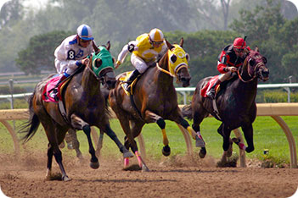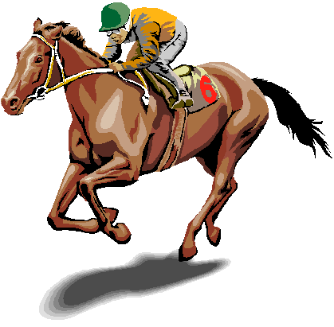**DAY AT THE RACES 2014**

**GOLDEN GATE FIELDS – TURF CLUB**

**Golden Gate Fields Sunday June 8, 2014 $40.00 Includes:**

**1100 Eastshore Highway Gates Open - 11:00 a.m. Parking**

**Berkeley, Ca 94710 Lunch 11:30 – 2:30 p.m. Buffet Lunch**

**(510) 559-7300 Post Time – 1:15 p.m. Official Program**

**Turf Club dress code is “Smart Casual”. Bring your binoculars but no jeans, shorts or tennies.**

**(Men, please wear collared shirts). No host cocktails. SORRY NO REFUNDS.**

**One of the races will be named for the Galileo Alumni Association. A raffle will be held for 6 lucky attendees to visit the “Winners Circle” to take a picture with the winning jockey.**

**Please make check payable to Galileo Alumni Association.**

**Mail to: Charlene Mori, 808 Greenwich Street, San Francisco, Ca. 94133.**

**Questions? Call Barbara LaRocca at 415- 846-9863 or Charlene Mori 415-297-4280**

**RESERVATION FORM “DAY AT THE RACES 2014”**

**Please fill out return with your check, pay by Credit Card or by Pay Pal. DEADLINE: May 15, 2014**

**Credit Card Number _________________________________________ Exp.____ Visa ___ MC___ Pay by Pay Pal at** [**http://galileoalumni.org/membership/DonateAnyAmount.html**](http://galileoalumni.org/membership/DonateAnyAmount.html) **even though it says Donate, you can use it for event payments also. If you have any problems on Pay Pal call Charlene at 415-297-4280.**

**Name or Name on Credit Card _____________________________________________________**

**Address _______________________________________________________________________**

**City/State/Zip__________________________________________________________________**

**Phone number __________________________ Email__________________________________**

**Names of Guest ________________________________________________________________**

INV