|  |  |  |
| --- | --- | --- |
| X | **THE GALILEO OBSERVER The Official Newsletter of the  Galileo Alumni Association**  ***Clarity . . . Honesty . . . Integrity*** | C:\Users\cca\Desktop\lion.jpg |
| **“Serving the Galileo Alumni Community”** | | |

**Vol. XII, No. 3 ____________________ ­­­­­____ July 2014**

***…Today’s Students are Tomorrow’s Alumni…***

**Sports Hall of Fame Dinner Date CHANGED**

**Due to a scheduling conflict, the Sports Hall of Fame Dinner has been moved up to Friday, October 17, 2014, at the San Francisco Italian Athletic Club. No-host cocktails are at 5:30 PM with the dinner at 7:00 PM. This year’s event promises to be a sellout so reserve early. Eleven former Galileo players and a coach will be honored. The following will be honored:**

**Curt Decker** (’55-’65) Coach Baseball & Soccer. **Dexter Doss** (’91) Baseball, Basketball, Football, Track. **Danielle Fong** (’07) Basketball, Softball. **Gus Geraldi** (’62) Baseball. **Keith Hazell** (‘78) Basketball, Track. **Reggie Leipsic** (’58) Baseball, Basketball, Football. **Nolan McCoy** (’78) Baseball, Basketball, Football, Soccer, Track, Wrestling, ROTC rifle team. **Gon Yee Ng** (’97) Tennis, **Michelle Ng** (‘97) Tennis, **Richard Thompson** (’64) Baseball, Track. **Kenny Walls** (’98) Basketball, Football. **Lenny Walls** (’97) Basketball, Football.

**Send in your check and reservation form today. See attached form.**

**HALL OF MERIT COMMITTEE BEING FORMED**

**A group of GAA alumni and faculty met twice in recent weeks to formulate a committee to select Hall of Merit candidates. Criteria were established and a nomination form created. It can be found on the Galileo web site.**

**The Hall of Merit is distinguished by those individuals who have made a contribution to their community, locally or globally, after attending Galileo.**

**It is non-sports related and already has two members: John Goldman, philanthropist, and Dr. Bobby Brown, physician. Brown is also a member of the Sports Hall of Fame, the first honoree to be a member of both Halls.**

**A Hall of Merit dinner and awards ceremony is tentatively planned for Spring, 2015, time and location to be announced. Meanwhile, a permanent committee and chairperson will be selected soon. Anyone interested in joining the committee, please contact** [**GalileoObserver@aol.com**](mailto:GalileoObserver@aol.com)**. Look for more details in the October Observer. See attached form.**

|  |  |
| --- | --- |
| **Through The Telescope. . .**  **Sisvan Der Harootunian** | X |

**In 12 years of writing this column, I have seldom been faced with writer’s block. I always have more to write than the space permits. I also make notes between issues and by the time the next deadline arrives, I’ve written most, if not all, of the column. But this time I had a problem: I couldn’t come up with any topic that was fresh and of possible interest to alumni. Should I say I’m on vacation, see you in October? What would my fellow columnists think? Was I a cop-out? So the other day, while in the shower, I decided to write about not being able to write. The shower is a very creative time for me. In my youth I used to sing in the shower. If I did so today, I’d scare myself silly. But when I was singing in the shower, I would belt out a Mario Lanza aria as best I could (*Che Gelida Manina* and *Be My Love* were my favorites). Sinatra, Presley and the Beatles were other favorites. Today, I’m still creative in the shower, but my memory is short-lived. Frequently, by the time I finish my shower and am drying off, I forget the details of my thoughts and often have to rush to a pad and pencil to write down what I remember. I wish Apple would invent a waterproof iPad that can be installed on the wall of the shower so I could instantly record my thoughts.**

**So please excuse this rather short column; I’ll be back in October with more to say. In the meantime, let’s say I didn’t have writer’s block, but rather *WRITER’S PAUSE.***

**\*\*\*\*\*\*\*\*\*\*\*\*\*\*\*\*\*\*\*\*\*\*\*\*\*\*\***

**Jim Fong, New President of PTSA, Announces Plans**

**Jim Fong will be the new President of the PTSA next year, and he has announced his exciting new projects for Galileo. Besides fund-raising and increasing membership, Fong, who graduated from Galileo in 1967, wants to start The Galileo Project. “Within the school, there is not much that describes Galileo, the scientist, who some think is the scientist of the millennium because of his “modern scientific research” methods . . .” The project is two-fold: the first part is designed to tell more about Galileo, the scientist, in order to inspire students, teachers, administrators, parents and anyone walking through the halls of the school; the second part is to show the work of the students inspired by Galileo. Galileo said “I have loved the stars too fondly to be fearful of the night,” and Fong wants to sell “Stars” with donor names on them as the basis for raising funds for the school. These “Stars” will be mounted on the ceiling of the hall to the auditorium. A star chart will enable donors to see where their stars are located.**

**Fong is an architect by profession and was involved in the conversion of the old San Francisco main library into the Asian Art Museum. He worked with the world-renown architect, Gae Aulenti, from Milan, Italy, on the project. On Sundays, John Lum conducts an architectural tour of the museum, and Fong invites alumni to join him while he presents the highlights of the design process.**

**Other projects Fong has worked on include the B.A.R.T.-SFO project, Moscone 3, the Paramount Apartments, the CCSF Chinatown-North Beach campus, and the Shanghai Golden Bridge Mansions (a competition-winning 30 story apartment building).**

**DAY AT THE RACES**

A group of Galileo Alumni, Family & Friends attended a Day at the Races on June 8, 2014 at Golden Gate Fields. Fun was had for all. We will be doing this again soon.

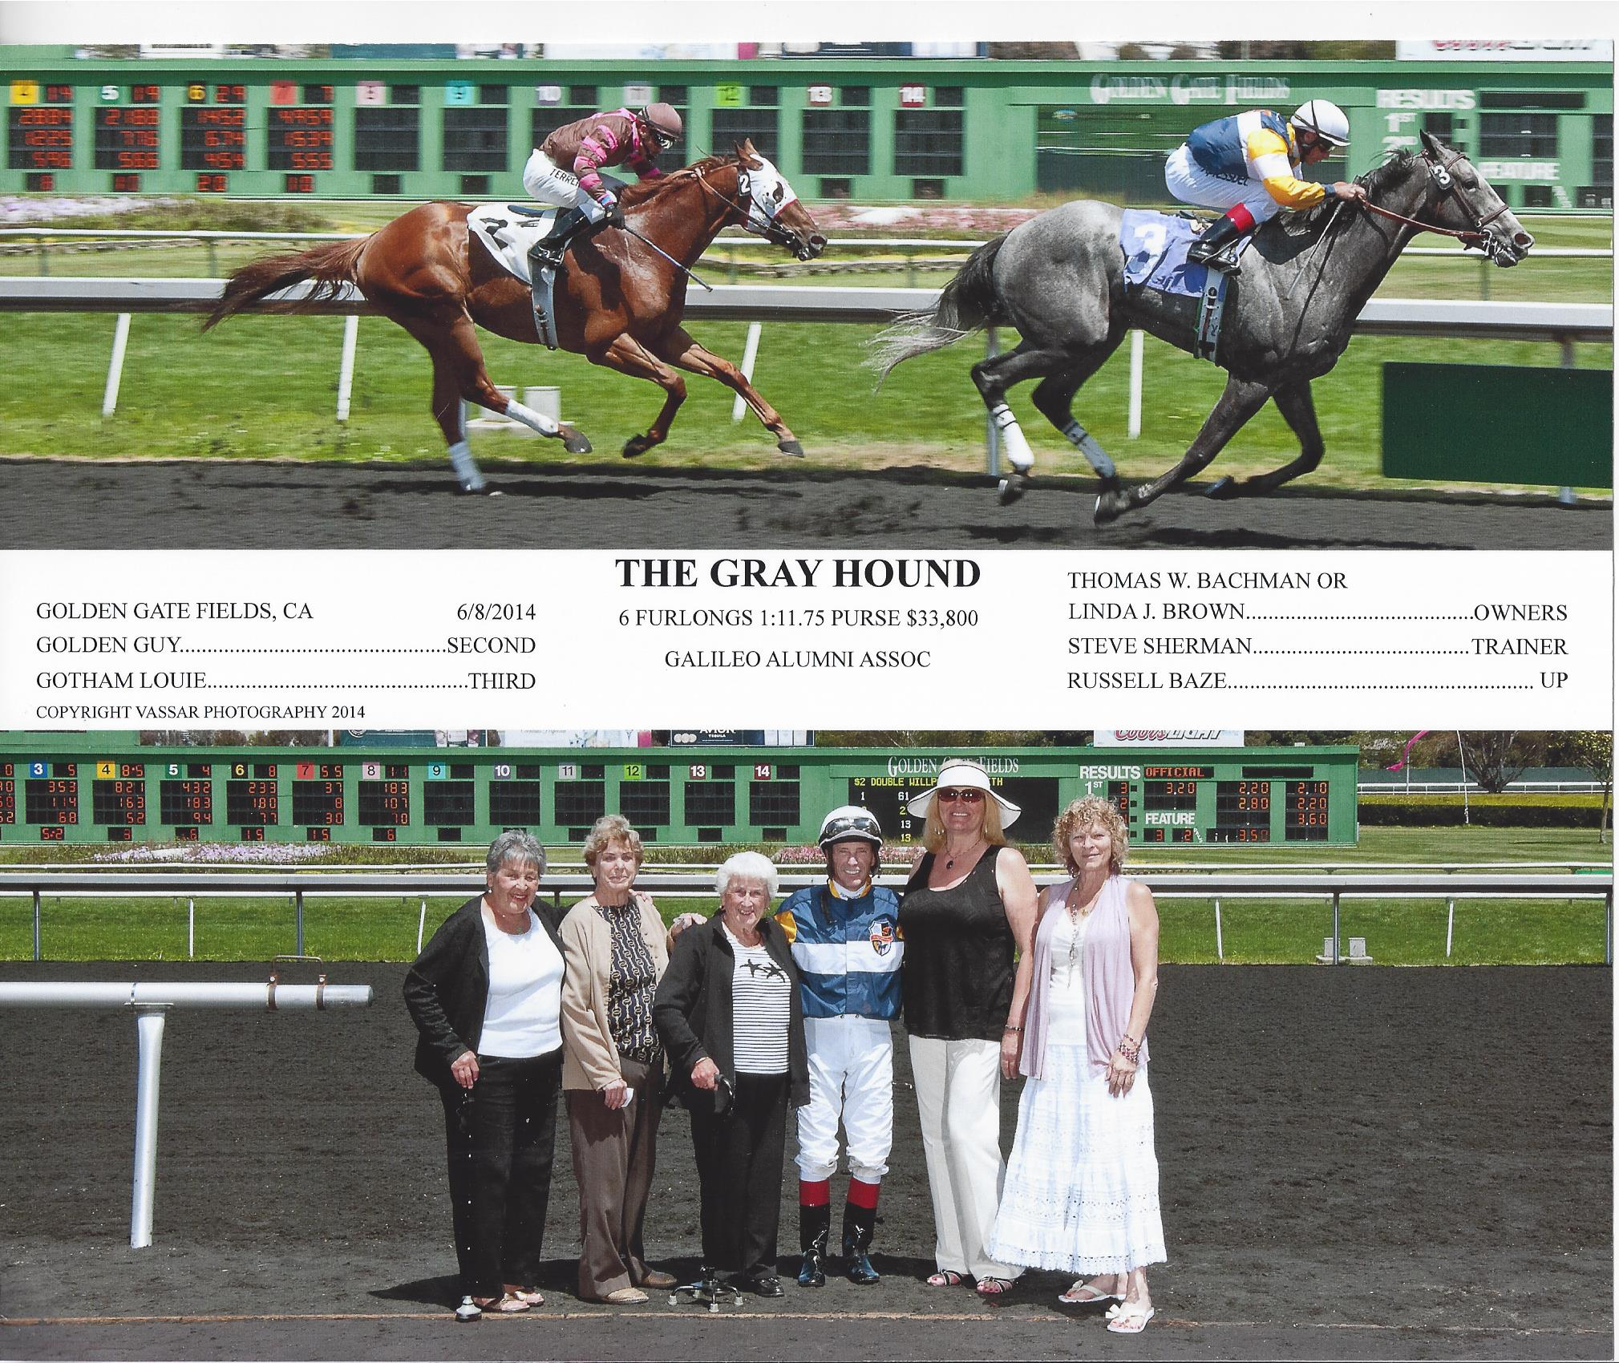

***GREAT SHOT IN THE WINNER’S CIRCLE***

***LaVerne LaRocca, Marie DeMartini, Marie Gandolfo, Russell Baze, Charlene Mori, Barbara LaRocca***

***See additional pictures at:*** [***http://galileoweb.org/alumni/events/archive-of-past-events/***](http://galileoweb.org/alumni/events/archive-of-past-events/)

****Between the Lions****

**By Bettie Grinnell**

Greetings Mighty Lions! Here’s what happening at Galileo these days.

**GALILEO CLASS OF 2014 GRADUATION**

The Graduation Ceremony for Galileo’s Class of 2014 was held on Wednesday, May 28th at the Bill Graham Civic Auditorium. Over 500 members of the Class of 2014 walked in the ceremony. Supervisor Norman Yee (former San Francisco Board of Ed Member and Galileo Alumnus (Class of 1967) was the keynote speaker. Galileo shared the hall for the day with Lincoln and Lowell High Schools. Each school paid $13,000 for their use of the auditorium.

**GALILEO SPORTS HALL OF FAME SHOW CASES UPDATE**

Work continues on showcases outside the Main Office. Paul Giambra and his crew have completed the first of the two Hall of Fame showcases. The names are now arranged in alphabetical order by the year of induction. This first case begins with 1975, the year of the first Galileo Sports Hall of Fame, and continues through 2005. Paul promised the second showcase will be ready soon and there will be lots of room for future inductees. Visitors continue to enjoy seeing their friends, relatives and themselves as they interact in front of the showcase.

**SUMMER SCHOOL 2014**

Summer School started on June 11 and will conclude on July 16, 2014. As in the past we are the Graduation High School for the school district. Graduation will be held in our auditorium on Wednesday, July 16, 2014 at 11:00am. We all applaud those students who complete their high school requirements at Galileo’s summer school and wish them well as they go onto what is next for them after high school.

**GALILEO STUDENTS PERFORM AT SFUDS LITERARY ARTS FESTIVAL**

Five Galileo students won awards at the SFUSD Literary Arts Festival, a nine-day event held this year from March 15 – March 23, 2014. Students participated under the direction of English and Drama teacher Myrna Maroun. They competed against Lowell, Lincoln, Washington, School of the Arts and various other middle schools and high schools in the district. The winners were announced at the awards ceremony on Sunday, March 23. 2014 at the Koret Auditorium in the San Francisco Main Library. Students write stories, short stories and poems and then read their work in the competition.

Two Galileo students were selected to read their works at the awards ceremony. Kevin Lee read a true story he authored, entitled “Ceaselessly Falling,” a love story between two longtime friends. Unfortunately the girl announces to the boy that she is moving away, deeply saddening the boy. Later on the boy comes to a realization that he is in love with her and tries to find her.

Derek Lau read his story, “A Change of Heart,” which is about two brothers who play basketball. The older brother is good at basketball while the younger one is still practicing to be good as his brother. One day, his older brother is unable to play a basketball game due to heart problems and was sent to the hospital for a needed heart transplant. Both stories are very moving.

**A CUTE STORY**

May 21, 2014 was a beautiful spring day and just before 10:00am I walked up to the mailbox at the corner of Polk & Francisco Streets (this is something I do almost daily to mail letters and look out at the San Francisco Bay). As I was walking back to the main entrance I noticed a family with two young boys in front of me. One of the boys was doing a very animated bouncing movement as he traveled excitedly down the sidewalk, and he was saying over and over again, “Galileo, Galileo, Galileo.” That caught my attention and I caught up with his parents. They told me they were from the East Coast, here on vacation, and that both of their grandfathers graduated from Galileo in 1937. They did not know that until they were engaged. They told me that they had seen a 1937 yearbook with both of their grandfather’s signatures. And, the best part of the story is that they gave the middle name of “Galileo” to their first-born son. That’s how he knew the name of our high school! They took lots of pictures with the boys in front of the school. I went inside and told everyone about the young “Galileo” I had just met!

**A SAD TURN FOR A VERY SWEET LADY**

How many of you remember Galileo Counselor Mrs. Bonnie Reid? Mrs. Reid was hired by the San Francisco Unified School District in 1956. Through looking at the old yearbooks, it seems she came to Galileo in 1965. Bonnie was a caring counselor at Galileo for many years and when she retired she continued to return to Galileo as a substitute. She worked almost every day as a substitute, at Galileo, Lincoln and Washington. Always a picture of health, she swam for 40 minutes 5 days a week, did the “Jumble” in the newspaper, and lived happily with her husband of many years, Wallace (Wally) Reid. In the middle of the Spring semester, I got voice mail from Wally saying that Bonnie would not be able to substitute for a while. I learned from another former Galileo Counselor, Miss Vivienne Miller, that Bonnie had suffered a massive stroke and was not able to speak or walk.

In mid-July I got a call from Wally. He wondered if former students who had Mrs. Reid as a counselor would like to know about what had happened in her life and if they would like to contact her. We had a very moving conversation and I told him I would add his news in “Between the Lions.” They have moved to Southern California where a family they were close with now lives. The Reids have no children of their own. If Mrs. Reid was your counselor or helped you, please send her a card. This is her address: Mrs. Bonnie Reid, Care Center, The Canterbury, 5801 Crestridge Road, Rancho Palos Verdes, CA 90275. I know both Bonnie and her husband will be touched in a wonderful way to hear from her former counselees.

**SPRING SPORTS REVIEW**

**Fencing**

Galileo hosted the All State Fencing Competition again his year. This year’s fencing team had many new members, consequently they did not do as well as the previous year, but they will be more experienced and stronger next year. They did finish 5th in San Francisco AAA.

**Softball**

The Galileo Softball Team members this year were all underclassmen. They missed the playoffs by one game. First base player Junior Jamie Gumru reports, “In the beginning of the season we were not as focused or dedicated, but as a team we are beginning to communicate more with each other and improve on our weaknesses.” They look to the season next year as a very strong team.

**Boys’ Golf**

The Boys’ Golf Team made it to the playoffs this year and lost to Lowell. Junior Nick Foster reports, “We should have won a few more games than we actually did, but overall I think it was a pretty good season. I think my advice for next year’s golf players is to practice more, possibly over the summer.

**Girls Golf**

Junior Jamie Gumaru reports, “We were one game from playoffs. Joining Golf is fun ad from playing golf I’ve worked and learned from others.”

**Badminton**

The badminton team is now co-ed. Sixty students tried out for the 20 spots on the team. They ended the season in 5th place overall. Senior Vicky Zhou reports, “I think next year’s players should practice more, try their best and come on time to tournaments. I think this year Galileo’s badminton team did well this season because many players have tried hard in order to win.”

**Baseball**

Galileo’s Varsity Baseball Team had an exciting season up to their loss in the semi-finals. They had hoped to make it to the championship game at A T & T Park. Unfortunately senior pitcher, Kyle Nelson, injured his pitching arm towards the end of the season. A freshman player and a sophomore player stepped up and the team came close to winning in the semi-finals, but in the end fell short. One consolation is that Galileo beat the final Champions, Lowell in 2 out of the 3 games they played against each other during the season. Senior Joshua Lu, Center Field reports: “We had a very good season we went through many struggles as a team but we continued to work hard and improve our game.” league 5-7, playoffs 1-1, practice games 5-3 league 5-7, playoffs 1-1, practice games 5-3

**Boys’ Volleyball**

Galileo Boys’ Volleyball Team members were young, with ¾ of them being underclassmen. Sophomore setter Calvin Huang reports, “We’re doing good this year and we are fighting for the playoffs.”

**Girls’ Soccer**

Galileo’s Girls’ Soccer Team made it to the semi-finals where they lost to O’Connell. Senior Dina Moncada reports, “Just have fun and most importantly play the sport because we genuinely love it. I’d have to say the experience so far has been a blessing. Being able to make it to the playoffs, and do something that I really love couldn’t have been a better gift granted to me as a senior.”

**Swimming**

Galileo’s Swim Team was large this year with 35 members. The two top swimmers on the team both took 3rd place in the All City Meet. Josh Lu, a senior took 3rd place in Freestyle and Jordon Lim, a freshman, took 3rd place in the Medley. Senior Idy Ly reports, “I think overall we had a pretty good season considering how many new people we had on the team. Even though we may not be the fastest team in the district, our team has a lot of chemistry that makes

**Ramblings**

**By Tony Compagno**

This quarter's *RAMBLINGS* will really live up to its name as I go from subject to subject.  But offer an old Lion a little slack here as I chew on matters that engage me at the moment.

Nicknames.  An old chum e-mailed me a piece on baseball nicknames, many of which I've heard before, but many new to me.  I love nicknames and have used them fairly often in my humble attempts at fiction-writing.  The article got me to thinking about nicknames in ALL sports and beyond.  Is there one of us who does not remember with fondness and a special poignancy people who went by a particular nickname?  How many big guys are called "Tiny" and red-heads "Carrot Top" and little guys "Peanut"?  And with affection, with love for our differences which bind as they separate us, making life a smorgasbord.  Sure, there are the purposely cruel tags designed to hurt and alienate, but let's set those aside for the moment.

In baseball, the greatest players ever, in my estimation, were DiMaggio, Mays and Ruth.  The Yankee Clipper, The Say Hey Kid and The Sultan of Swat.  Sportswriters have for years come up with such names for modern-day "gladiators" and "warriors" to help elevate athletics and athletes to the status of myth or folklore.  The nicknames spice up reminiscences in saloons or among old men on park benches.  "I was there when Hammerin' Hank (Aaron) hit his 500th."  "The Splendid Splinter (Ted Williams) had a better eye than DiMag, even."  "Brooks (The Human Vacuum Cleaner) Robinson was my idol back in Baltimore."  "What did you think of Penitentiary Face  (Jeffery) Leonard back in the Candlestick days?"

And so it goes, through old timers such as Schoolboy Roe, Leo the Lip Durocher, Bucketfoot Al Simmons, Charlie Hustle, Piano Legs Hickman, Oil Can Boyd, right through to our Kung Fu Panda at ATT Park.  And in there somewhere is, of course, Galileo's own Walt (No Neck) Williams.  The whole thing's a rapturous litany, a catalog that stokes the ultimately unquenchable fires of my imagination.

                                                                                      *****

This newsletter goes out to ALL alumni of Galileo High School.  Because I graduated in 1961, much of what I write about may not engage Lions from subsequent generations.  I shoot for universality as much and as often as I can, but I'm a little out of the loop sometimes and surely betray an annoying "disconnect" from the lives of younger alumni out there.  My wife complains about my reluctance - she may be thinking "incompetence" - when it comes to embracing new technology.  I prefer phone calls to texting, and black-and-white films in movie-houses to color films on DVD at home.  I'm a damned dinosaur who can't get it through his thick and scaled head that he's extinct, or nearly.

However, I do like to think that I'm forward-looking and progressive in the sense that I value the idea of learning and discovering new things all the time.  I read as much or more than ever.  I listen to KCSM's jazz offerings from the College of San Mateo.  My one indulgence in the way of Reality TV is "American Idol" because I'm a sucker for "amateur contests" and the hope of witnessing the embryonic stage of musical stardom and celebrity.  Generally speaking, I try to keep my mind full and my bowels empty as much as possible.  I think it was Leo Buscaglia, The Love Doctor from PBS fame of a few years ago, who's responsible for that last idea.

In these last few years, I've finally gotten 'round to reading the main Dickens classics.  I've discovered writers such as Pat Conroy, Dalton Trumbo and John Irving.  I've discovered singers Chet Baker, Andy Bey and Diana Krall.  I can bring new understanding to Yeats and to Gibran's "The Prophet".   I learned that Chaplin could move one to tears as in "City Lights", or to indignation as in "Monsieur Verdoux".  I'm still hungry to learn, to feel, to fill myself up with what pleases and satisfies me.  My little world: it's neither better nor worse than anyone's, but it's mine.  Own yours, and move steadily forward.  "Avanti!" the Italians say, which I repeat often, much to the chagrin and weariness of my friends and associates.

                                                                                       *****

                                  A thank you to alumnus Jimmy Guerrero, who had suggested and organized a small get-together of old Lions on the first of May this year at the Presidio Café.  All present were Galileo grads except for one, Judge James Ellis of San Mateo, who attended Marina Junior High with us before he graduated mid-year (at the end of 1955, or start of '56) and went on to Lowell High to join the varsity basketball team there alongside the great Tom Meschery, who became a San Francisco Warrior back in the day.

Present at the lunch were Bill and Ken Flanagan, Washington Johnson, Bob Leipsic, Mike Bellanca, Louie Muzio, and me, with Guerrero presiding.  A day of sweet reminiscing.

**\*\*\*\*\*\*\*\*\*\*\*\*\*\*\*\*\*\*\*\*\*\*\*\*\*\*\***

**Mark Huynh Receives Teacher of the Year Award**

**Mark Huynh won the prestigious Asian Heritage Street Celebration Teacher of the Year Award for the San Francisco Bay Area. He was honored at the Asian Art Museum on May 17th. Several Galileo students attended, displaying a school banner and cheering. Mark graduated from Galileo as the senior class president and winning back-to-back varsity football championships. He received a B.A. in art from San Francisco State University, and in 2000 returned to teach the subject at Galileo and coached the football team to a recent championship. Mark was inducted into the Galileo Sports Hall of Fame in 2012.**

**He currently serves as the Pendulum and Telescope advisor and has organized student government leaders in volunteering for the Chinese New Year Parade. In conjunction with Jim Fong’s “Star Project,” Mark is working on having a mural painted showing some of Galileo’s famous alumni. The hallway outside the auditorium will eventually be a tribute to the history of Galileo Academy.**

**\*\*\*\*\*\*\*\*\*\*\*\*\*\*\*\*\*\*\*\*\*\*\*\*\*\*\***

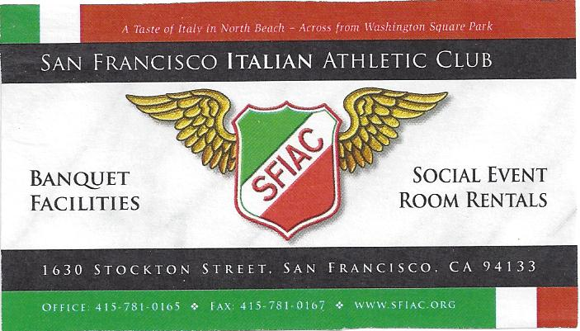

***NEW LOOK FOR THE GALILEO ALUMNI HALL OF FAME DISPLAY***

Paul Giambra took the lead along with Lance Hughston to update the Sports Hall of Fame display located in the hallway at Galileo in front of the Office. Looking mighty spiffy. Work was done at the Hughston Engineering Inc. work site. Should all be completed soon. Stop by and take a look!

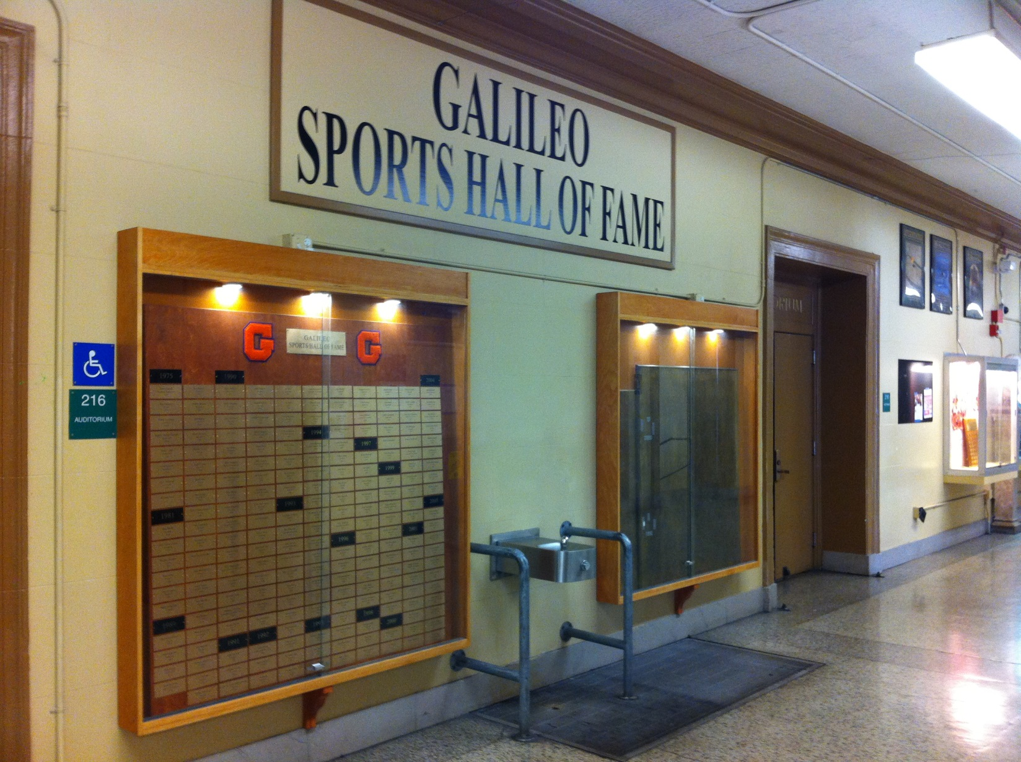

**RENT THIS SPACE**

1 YEAR (4 ISSUES) $75.00

Send your business card with your check to:

Galileo Alumni Association

Advertising Dept.

1150 Francisco Street, S.F., CA 94109

**ATTENTION POTENTIAL ADVERTISERS**

***This newsletter is now accepting advertisements for future issues. If you have a business or service you want to advertise, The Galileo Observer is the ideal***

***place to place your ad. It will appear for 4 issues during the year – in January, April, July and October and will reach Galileo alumni, family, friends and students. Rates are reasonable -- $75 for 4 issues (business card size ad).***

***In addition to promoting your product or service, you will be helping the Galileo Alumni Association carry out its mission of helping the Galileo Academy of Science and Technology.***

***Please contact*** [***GalileoObserver@aol.com***](mailto:GalileoObserver@aol.com) ***or*** [***JScafidiMV@aol.com***](mailto:JScafidiMV@aol.com)

**RENT THIS SPACE**

1 YEAR (4 ISSUES) $75.00

Send your business card with your check to:

Galileo Alumni Association

Advertising Dept.

1150 Francisco Street, S.F., CA 94109

**RENT THIS SPACE**

1 YEAR (4 ISSUES) $75.00

Send your business card with your check to:

Galileo Alumni Association

Advertising Dept.

1150 Francisco Street, S.F., CA 94109

***__________________________________________***

**THE ALUMNI BOARD NEEDS YOU!**

**If you would like to work with current Directors to further the mission and goals of the GAA please contact Charlene Mori at 415-441-6445. We are searching for new Board Members, assistance with the newsletter “Observer” and someone to help maintain & build our web site. You can also email -** [**http://galileoweb.org/alumni/about/contact/**](http://galileoweb.org/alumni/about/contact/)

**\* * * * * \***



***\* * * * * \****

***HELP US MAKE GALILEO THE BEST ALUMNI IN SAN FRANCISCO!!***

**Obituaries**

**TO VIEW LINKS – PLACE MOUSE OVER LINK AND RIGHT CLICK THEN SELECT “OPEN HYPERLINK”**

Elmo Arthur Armanini 1917 – 2014 <http://www.legacy.com/obituaries/marinij/obituary.aspx?n=elmo-arthur-armanini&pid=171711509>

Baptiste Cava 1917 – 7/26/2014 <http://www.legacy.com/obituaries/mercurynews/obituary.aspx?n=Baptiste-Cava&pid=171895689>

Annabelle Chow 4/24/14 <http://www.legacy.com/obituaries/sfgate/obituary.aspx?n=annabelle-chow&pid=170860416>

Anthony “Tony” Cresci 7/30/2014 <http://www.legacy.com/obituaries/sfgate/obituary.aspx?n=anthony-cresci&pid=171948143&fhid=2170>

Joseph Crivello 1945 – 7/13/2014 <http://www.legacy.com/obituaries/mercurynews/obituary.aspx?n=joseph-crivello&pid=171762879&fhid=2102>

George “Big G” DeLuca 5/29/14 <http://www.legacy.com/obituaries/sfgate/obituary.aspx?n=george-deluca&pid=171188063>

Victor Destin 1922 – 2014 <http://www.legacy.com/obituaries/mercurynews/obituary.aspx?n=victor-destin&pid=171102697&fhid=6744>

Dawn Doherty 7/24/14 <http://www.legacy.com/obituaries/sfgate/obituary.aspx?n=Dawn-Doherty&pid=171869690>

Frank Farr May 2014 82 years old <http://www.legacy.com/obituaries/sfgate/obituary.aspx?n=frank-farr&pid=170870150&fhid=2515>

Bernice Toschi Fix 1928-5/20/14 <http://www.legacy.com/obituaries/contracostatimes/obituary.aspx?n=bernice-toschi-fix&pid=171278757&fhid=2298>

Sister Joseph Mary Galli RSM 6/8/2014 Age 89 <http://www.legacy.com/obituaries/sfgate/obituary.aspx?n=joseph-mary-galli&pid=171343478&fhid=2515>

Clara Lucia Giovannoli 1922 – 2014 <http://obits.dignitymemorial.com/dignity-memorial/obituary.aspx?n=Clara-Giovannoli&lc=7064&pid=170610366&mid=5927786>

Judy A. Malone 3/26/36 – 6/3/14 <http://www.legacy.com/obituaries/fresnobee/obituary.aspx?n=judy-a-malone&pid=171379136>

Jackie McInerney 6/19/30 – 6/15/14 Member of the “CHICKS” <http://www.legacy.com/obituaries/sfgate/obituary.aspx?n=jackie-mcinerney&pid=171388366>

Anthony Parki 6/5/2014 <http://www.legacy.com/obituaries/marinij/obituary.aspx?n=anthony-pardi&pid=171286595>

Paul Pieri 2/28/31 – 2/13/14 <http://www.legacy.com/obituaries/sfgate/obituary.aspx?n=paul-pieri&pid=169687336&fhid=2353>

Felix Virgil Pioli 7/22/24 – 7/16/14 <http://www.legacy.com/obituaries/marinij/obituary.aspx?n=felix-virgil-pioli&pid=171780909&fhid=24159>

Ann Puccinelli 4/22/24 – 5/16/14 <http://www.legacy.com/obituaries/sfgate/obituary.aspx?n=ann-puccinelli&pid=171042162>

Nicolas D. Quirarte 1910 – 5/27/14 <http://www.legacy.com/obituaries/chicoer/obituary.aspx?n=nicolas-d-quirarte&pid=171260717>

Fedora Barbera Taormina 1913 – 6/11/14 <http://www.legacy.com/obituaries/marinij/obituary.aspx?n=fedora-barbera-taormina&pid=171362892&fhid=3069>

Eleanor Wieder 1/22/24 – 5/10/14 <http://www.legacy.com/obituaries/sfgate/obituary.aspx?n=eleanor-wieder&pid=171048040>

**DONATIONS IN MEMORY**



June Bury in memory of Robert Bury

Estelle Landi in memory of Carmen Morello

**Here is a Gift to the Galileo Alumni Memorial Fund**

**From ___________________________________________ Class ______**

**Address ___________________________________________________**

**City _________________________________State_____ Zip__________**

**In memory of ________________________________ Amount ________**

**Send memorial card to:**

**Name _____________________________________________________**

**Address____________________________________________________**

**City_____________________________________ State _____ Zip _____**

***– Memorial Gift –***

***Make donations expressing your sympathy to family and friends who have lost a loved one. A memorial card will be sent to the family in your name. Donations are tax deductible to the extent allowed by the law. Tax ID 30-0066848***

***Donations should be mailed to:***

***Galileo Alumni Association***

***1150 Francisco Street***

***San Francisco CA 94109***

**ATTENTION POTENTIAL ADVERTISERS**

***This newsletter is now accepting advertisements for future issues. If you have a business or service you want to advertise, The Galileo Observer is the ideal place to place your ad. It will appear for 4 issues during the year – in January, April, July and October and will reach Galileo alumni, family, friends and students. Rates are reasonable -- $75 for 4 issues (business card size ad).***

***In addition to promoting your product or service, you will be helping the Galileo Alumni Association carry out its mission of helping the Galileo Academy of Science and Technology.***

***Please contact*** [***GalileoObserver@aol.com***](mailto:GalileoObserver@aol.com) ***or*** [***JScafidiMV@aol.com***](mailto:JScafidiMV@aol.com)

**\*\*\*\*\*\*\*\*\*\*\*\*\***

***Reporters Wanted:***

***The Observer is seeking persons who are willing to gather and report news of interest to Galileo alumni. Writing skills are not necessary, just the ability to communicate and write legibly. We are accepting any bits of information about alumni, such as what they are doing now, marriages, births and deaths. If you have a photo of an event, a luncheon or small gathering, send it in. Send all submissions to the Galileo Observer (***[***galileoobserver@aol.lcom***](mailto:galileoobserver@aol.lcom)***) or the Editor, Galileo Observer, c/o*** [***www.galileoweb.org***](http://www.galileoweb.org)***.***

***Visit our Facebook page at:*** [***https://www.facebook.com/pages/Galileo-Alumni-Association-San-Francisco/278283128875474***](https://www.facebook.com/pages/Galileo-Alumni-Association-San-Francisco/278283128875474)

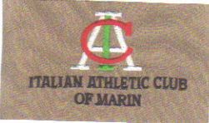

**Established 1968**

**P.O. Box 36, Larkspur, CA 94977**

***Upcoming Events***

**August 9th 2014 - 50th reunion class of 1964. Pass the word, see who’s going and all the details at** [**https://sites.google.com/site/llenore46/**](https://sites.google.com/site/llenore46/)

**\* * * * * \***

**GAA Board Meeting – Room 210, Galileo Academy, 6:00 PM, held the 2nd Wednesday of the month except for June/July/August. Our next meeting is September 10, 2014. Please join us.**

**\* * * * * \***

**October 17, 2014 - *Sports Hall of Fame Induction Dinner**

**San Francisco Italian Athletic Club**

**\* * * * * \***

**Hall of Merit Induction Dinner – Spring, 2015 (Time and place TBA)**

**When checking for upcoming events between issues of the *Observer*, please visit the web site** <http://galileoweb.org/alumni/>

**____________________________________________________________**

**THE GAA IS LOOKING FOR……………………..**

* **A NEW SECRETARY**
* **NEW BOARD MEMBERS**
* **ALUMNI TO HELP ON COMMITTEES**
* **SWEETHEART STORIES**
* **WHERE ARE YOU NOW?**
* **REUNIONS FOR 2014 and 2015**
* **PICTURES OF OLD SCHOOL GAL**
* **GOSSIP/NEWS/STORIES**

**Mail to: GAA, 1150 Francisco Street, SF Ca 94109**

**Or email** [**galileoobserver@aol.com**](mailto:galileoobserver@aol.com)

**The OBSERVER Is For All**

**Galileo alumni, family, friends, students, faculty . . . anybody and everybody, the *Observer* is for you. If you haven't already done so, send in the email addresses of anyone who would like to receive a FREE emailed newsletter to** [**http://galileoweb.org/alumni/about/contact/**](http://galileoweb.org/alumni/about/contact/)**. We'd like to reach as wide a range of readers as possible.**

**PLEASE SEND US YOUR IDEAS, GOSSIP, UPDATES ETC.**

**The Galileo Observer invites your articles, letters, memories, inquiries and suggestions. All submissions are subject to editing. Deadlines for submissions are January 1st, April 1st, July 1st and October 1st.**

**Send emails (preferable) to** [**galileoobserver@aol.com**](mailto:galileoobserver@aol.com)

**Send letters to Galileo Observer, c/o Galileo Alumni Association, 1150 Francisco Street, San Francisco, CA 94109. All letters are subject to editing.**

**BACK ISSUES OF THE GALILEO OBSERVER CAN BE VIEWED AT**

[**http://galileoweb.org/alumni/newsletter/**](http://galileoweb.org/alumni/newsletter/)**.**

**For all EDITORIALLY-RELATED comments or suggestions, please address your emails to** [**galileoobserver@aol.com**](mailto:galileoobserver@aol.com)**.**

**For all TECHNICAL problems (non-receipt of newsletter, etc.), contact the webmaster through** [**http://galileoweb.org/alumni/contact/**](http://galileoweb.org/alumni/contact/)**.**

**Editor**

**Sisvan Der Harootunian**

**Managing Editor**

**Charlene Fachner Mori**

**Columnists**

**Tony Compagno**

**Sisvan Der Harootunian**

**Bettie Grinnell**

**Advertising**

**Joe Scafidi**

**Printing/Mail Distribution**

**Charlene Fachner Mori**

**The Galileo Observer is published quarterly in January, April, July and October by the Galileo Alumni Association, 1150 Francisco Street, San Francisco, CA 94109. Views expressed are strictly those of the Association and in no way reflect those of the Galileo Academy of Science and Technology, its students or faculty. Sisvan Der Harootunian, Editor; Vaughn Spurlin, Production Manager/Website Director. Copyright 2013, Galileo Alumni Association.**

***Last updated July 2014. © 2002-2014 Galileo Academy of Science and Technology Alumni Association of San Francisco. Tax ID 30-0066848. No part of this publication may be reprinted or reproduced in any form without permission of The Galileo Observer and/or The Galileo Alumni Association***

GAA BOARD OF DIRECTORS, OFFICERS, & COMMITTEE CHAIRS ARE LISTED AT <http://galileoweb.org/alumni/about/contact/>

**ANNUAL DONATIONS**

**January 1, 2013 – December 31, 2013**

**$1,000.00**

Haidee Stade

**$300.00 - $999.99**

Robert W. (Bobby) Brown

Joe/Pola Martino

**$100.00 - $299.99**

Helen Amoroso

Henry Black

Joe/Jane Borg

Irwin Gibbs

Carmela Lombardi Hoffman

Edgar Stone

Ronald Yee

**$26.00 – $99.99**

Paul Cassidy

Sisvan Der Harootunian

Charlene Fachner Mori

Yola Panelli Ferralis

Frank Lem

Frank Norick

Helen Oroso

Joe Scafidi

J. Milton Seropan

Loyd Sherwood

Cordy Surdyka

Gloria Tornay

Augie Venezia

**$1.00 - $25.00**

Toni Alessandra

John Alioto

Angelo Balistreri

Joe Bencharsky

Doreen Bertani

Andrew Cafasso

Angela Canepa

Reuben Cannon

Danny Chan

Rosalie Cirby

Irma Ferro

Vincent Gomez

Al Gragnani

Dorothy Hawkes

Lance Hughston

Alvin Joe

Barbara LaRocca

Steve W. Larson

Gretchen Lipow

Dave Lippi

Leon Manalo

London Morrow

Joel M. Napp

Mary Peruzzo

Frank Quadrelli

Joel Redmon

Seb Saia

Laverne Schultz

Barbara & Lorin Scola

Jean Giovannoni Shelley

Vaughn Spurlin

Bevelry Delosa Thomey

Robert Vaccarezza

Guido Venezia

Donald Vidal

Lynette Wong

Victoria Wong

Jim Yee

**ANNUAL DONATIONS**

**January 1, 2014 – December 31, 2014**

**$1,000.00**

**$300.00 - $999.99**

**$100.00 - $299.99**

Helen Amoroso

Wayne Beasley

Robert W. “Bobby” Brown

Frank Brucia

Bob Bury (In Memory)

Minnie Campos

Gene DeMartini

Angela Little

Mario Lombardi

Dipak Patel

George Paxson

Joel Redmon

J Milton Seropan

Eric Soderstron

Robert Vaccarezza

Ron Yee

**$26.00 – $99.99**

John Alioto

Bill Alkire

Margaret Badano

Angelo Balistreri

Andrew Cafasso

Anna Chew

Jimmy Chu

Rosalie Cirby

Alexander A. Cortez

Diane Cowart

Beverly Domeniconi

Charlene Fachner Mori

Yola Ferralis

Joseph Garbarino

Sally Garbarino

Irwin Gibbs

Sisvan Der Harootunian

Lenore Heffeman

Carmela Hoffmann

Dawson Lee

Frank Lem

Anthony Lyau

Joyce Massucco

Frank Norick

Joe Scafidi

Lorin & Barbara Scola

Jacqueline Sram

Edgar Stone

Danny Strazzullo

Cordy Surdyka

Gloria Tornay

**CONTINUED - ANNUAL DONATIONS**

**January 1, 2014 – December 31, 2014**

**$1.00 - $25.00**

Toni Alessandra

Nina Alioto

Steven Aronson

Doreen Bertani

Henry Black

Paul Cassidy

Mel Chiarenza

Frances Christani

Ralph Cicurel

Eugene DiBasilio

Debbie Dittman

Irma Ferro

Lance R. Hughston

Marie Eisen

Ron Ertola

Irma Ferro

Joan Gaskell

Salvatore Gianino

Hugo Giovannini

Vince Gomez

Kathy Guerrero

Carla Harris

Lance Hughston

Alvin Joe

Harriet Kunze

Estelle Landi

Barbara La Rocca

**$1.00 - $25.00 continued**

Eugene Leung

Dave Lippi

Carmen Morello

Joel Napp

David Negherbon

Pete Pompei

Laurie Prescott

Frank Quandrelli

Sharon Reich

Ronald & Anstel Ricossa

Vincent Rigoni

Seb Saia

Thomas Savnik

LaVerne Schultz

Jean Shelley

Vaughn Spurlin

Beverly Thomey

Rudy Torigiani

Chuck Torres

Lynette Wong

Sherman Wong

Victoria Wong

Shig Yabu

Jim Yee

John Zuffo

**GALILEO ALUMNI ASSOCIATION FUNDRAISING**

* **BECAUSE OF CUT BACKS AND THE ECONOMY, GALILEO NO LONGER RECEIVES FUNDS FOR MOST OF THEIR ACTIVITIES AND FUNCTIONS. THEY DEPEND ON FUND RAISERS AND DONATIONS. I’M SURE YOU REMEMBER DOING CAR WASHES, BAKE SALES WHATEVER YOU COULD TO RAISE MONEY FOR YOUR SENIOR ACTIVITIES. STUDENTS NOW HAVE TO WORK EVEN HARDER TO RAISE THESE FUNDS. DON’T FORGET YOUR ALMA MATER. GO LIONS!!!**

**YES, I want to donate $ __________ towards:**

**Grant Awards Sports**  **Seniors (events/graduation)**

**Other ____________________________________________**

**Is it ok to mention your name as a donor? Yes ____No ____**

Name: ____________________________________________ Email __________________________________

Address: __________________________________________City_______________State____Zip_________

**Mail to: Galileo Alumni Association**

**1150 Francisco Street**

**San Francisco CA 94109**

**YOU CAN ALSO DONATE ON LINE AT:**  <http://galileoweb.org/alumni/>

**RENT THIS SPACE**

1 YEAR (4 ISSUES) $75.00

Send your business card with your check to:

Galileo Alumni Association

Advertising Dept.

1150 Francisco Street, S.F., CA 94109

**GALILEO ALUMNI ASSOCIATION MEMBERSHIP APPLICATION**



**GALILEO ACADEMY OF SCIENCE AND** BENEFITS OF MEMBERSHIP **PLEASE CONSIDER DONATING**

**TECHNOLOGY ALUMNI ASSOCIATION** * Alumni activities and events **WE NEED YOUR SUPPORT.**

**OF SAN FRANCISCO CA.**  * Membership Card **JOIN THE G.A.A. SUPPORT YOUR**

The Mission of this Association shall be to * Assistance to all reunion committees **ALMA MATER!**

Organize Alumni into a cohesive unit to benefit * Quarterly newsletter “The Observer” Please visit the Galileo Alumni

all members of the high school Community: * Notice of Association Updates Association web site for further

Alumni, Students, Faculty, Staff and Friends. * Helping the current students of information at:

Galileo Achieve their goals. And much <http://galileoweb.org/alumni/>

more as the membership grows.

**BOARD OF DIRECTORS** **DIRECTORS** **STANDING COMMITTEE CHAIRPERSONS**

President: Charlene Fachner Mori (1965) Sisvan Der Harootunian (1951) **COMMUNICATIONS (NEWSLETTER):**

Vice President: Cordy Surdyka (1953) Barbara Fachner LaRocca (1969) Sisvan Der Harootunian (1951)

Secretary: Position Open Vince Gomez (1952) **MEMBERSHIP:** Toni Alessandra (1964)

Treasurer: Joe Scafidi (1950) Toni Alessandra (1964) **PUBLIC RELATIONS:**

Lance Hughston (1966) Barbara Fachner LaRocca (1969)

**WEBMASTER:** Vaughn Spurlin (1960)

**IF YOU HAVE ALREADY DONATED THIS YEAR, PLEASE DISREGARD THIS NOTICE AND THANK YOU**

- - - - - - - - - - - - - - - - - - - - - - - - - - - - - - - - - - - - - - - - - - - - - - - - - - - - - - - - - - - - - - - - - - - - - - - - - - - - - - - - - - - - - - - - - - - - - - - - - - - - - - - - -

**WE NOW ACCEPT PAYMENT ON LINE WITH PAYPAL**

PLEASE DETACH AND MAIL OR PAY ON LINE AT: <http://galileoweb.org/alumni/>

DATE: ______________________________ NEW MEMBER ______________ RENEWAL _____________

NAME: __________________________________________________ MAIDEN NAME ______________________________________

ADDRESS ________________________________________________ CITY/COUNTRY __________________STATE____ ZIP________

GRADUATION YEAR ______ EMAIL _____________________________________________________ PHONE _____________________

MAKE CHECKS PAYABLE TO THE GALILEO ALUMNI ASSOCIATION. INTERESTED IN HELPING OR BEING ON A COMMITTEE YES ___ NO___ DONATION ENCLOSED $ ___________ ALL DONATIONS ARE TAX DEDUCTIBLE TO THE EXTENT ALLOWED BY THE LAW. TAX ID 30-0066848 YOU CAN ALSO DONATE ON LINE AT <http://galileoweb.org/alumni/>

**Mail application to:** Donation of $25.00 - $25,000.00 graciously accepted Your information is strictly

**Galileo Alumni Association** and is tax deductible confidential and will ONLY be used

**1150 Francisco Street**  All donations are used solely for the benefit of Galileo for assisting Galileo functions/reunions. **San Francisco Ca 94109** Academy.

**If you have any news from your class for the GAA newsletter, please send to** [**GalileoObserver@aol.com**](mailto:GalileoObserver@aol.com)

**TOGETHER WE CAN MAKE GALILEO ACADEMY OF SCIENCE & TECHNOLOGY THE BEST ALUMNI IN SAN FRANCISCO!**

**GO LIONS!!! Obsv.7/14**



**Sports Hall of Fame 2014 Inductees**

**PLEASE MAKE SURE YOU WEAR YOUR BLOCK “G” SWEATERS/JACKETS & HOF MEDALLIONS OR ANY OTHER GALILEO MEMORABILIA**

Support the Galileo Alumni Association and staff for an evening of fun. The Galileo Sports Hall of Fame Induction Dinner will be held on Saturday, OCTOBER 17, 2014 at the Italian Athletic Club in San Francisco. So save the date and send your reservation form in ASAP as it will surely be a sell out. **Tickets will not be sold at the door.**

Dinner includes: Salad, Antipasti, Pasta, Cross Rib Roast or ½ Roasted Rosemary Chicken (veggies/roasted potatoes) Dessert and Wine. For vegetarians Eggplant Parmigiana will be available. (Napoleon of Eggplant, Fontina Cheese, Basil, Tomatoes).

**PLEASE RETURN NO LATER THAN OCTOBER 13, 2014**

Please detach form and mail

**Make check payable to:** **Galileo Alumni Association**. Complete this form and **mail to:**

**GAA c/o C. Mori 808 Greenwich Street, San Francisco, CA. 94133**

You can also pay on-line at <http://galileoweb.org/alumni/> click on the donate button.

OCTOBER 17, 2014

No host Cocktails at 5:30 – Dinner 7:00

Italian Athletic Club

1630 Stockton Street

San Francisco CA 94133

Name: __________________________________ Email _____________________________Phone__________________

Number of Tickets: _____ x $65.00 per ticket = Total $_____________ Roast Beef _____ Chicken_____ Eggplant _____

Print name of guest Print name of guest

____________________________________________ ________________________________________________

____________________________________________ _________________________________________________

**____________________________________________ _________________________________________________**

**All tickets will be held at the door.** If you have any questions, please contact Charlene Moriat 415-297-4280 or email [galileoalumni@yahoo.com](mailto:sportshalloffame@galileoalumni.org) Visit the GAA Web Page at: <http://galileoweb.org/alumni/>

Sorry, I cannot make it but please accept my donation for $______________________________________________

Description: MC900088528[1]Description: MC900088528[1]

**HALL OF MERIT**

**NOMINATION FORM**

**CRITERIA**

1. Nominee must have attended Galileo High School/Galileo Academy of Science and Technology in good standing prior to being nominated.
2. Nominee may be an individual (student, staff or faculty member).
3. Nominee must have made a significant contribution, after graduation or attendance, to his/her

community, city, state, country, or globally. (Examples: science, technology, government, business, education, the arts, philanthropy).

1. Anyone, including Galileo alumni, faculty, staff, family or friends of a nominee may nominate a candidate. All nominations will be reviewed and facts about qualified nominees will be verified by the Galileo Alumni Association Hall of Merit Committee.
2. Posthumous awards may be given, so nominee may be deceased. If selected, he/she must be represented by a family member or recognized close friend.

I would like to nominate the following person for the Galileo Academy Hall of Merit:

Name of Nominee:

Field of Accomplishment: _________________________________________________

Class of: Phone: Email: ___________________

Spring/Fall/Year

Address:

Street City State/Zip Code

Nominator's Name:

Address

Street City State/Zip Code

Class of: Phone: Email:____________________

Spring/Fall/Year

Signature: Date:

Mail to: Galileo Alumni Association

Hall of Merit Committee

1150 Francisco Street

San Francisco, CA 94109

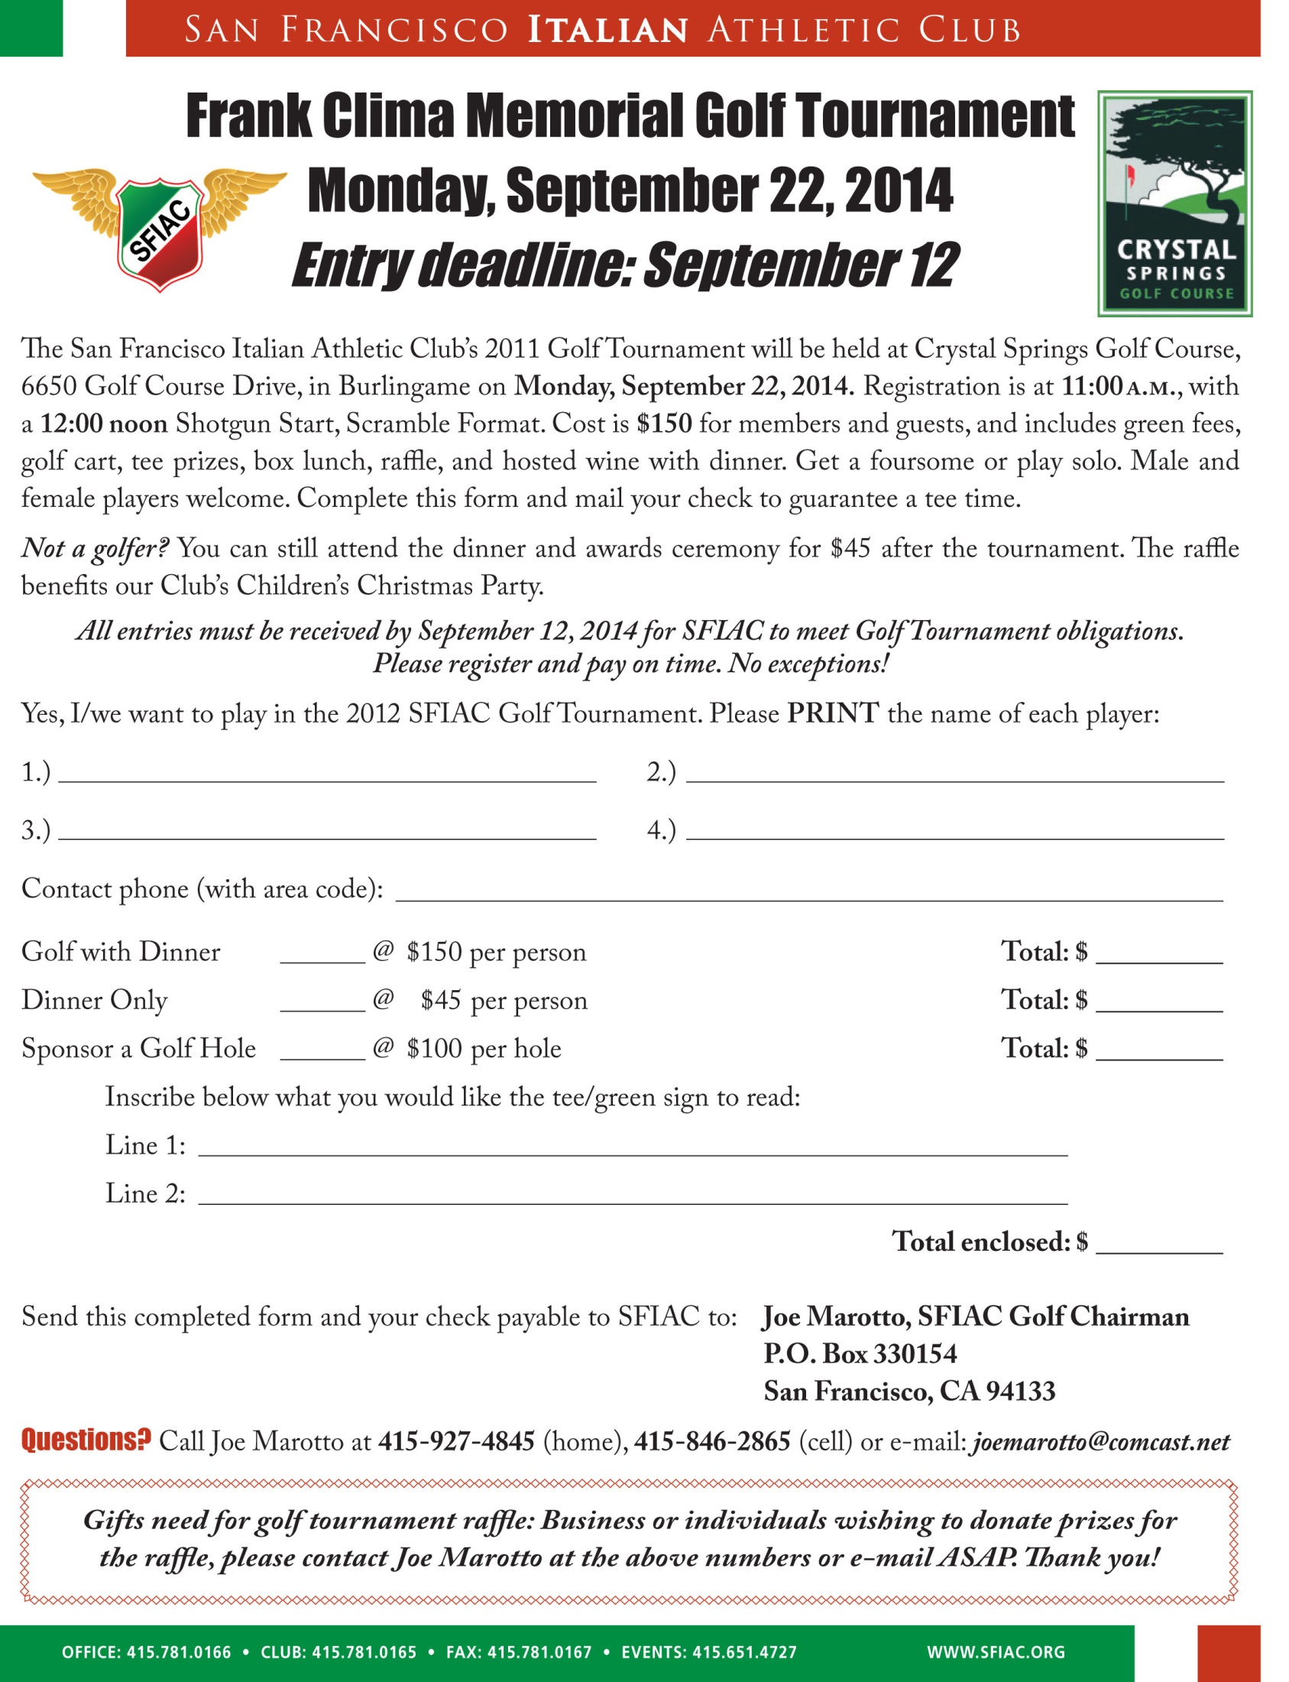

**GALILEO ALUMNI ASSOCIATION MERCHANDISE ORDER FORM**



**HANES BEEFY 100% COTTON PRE-SHRUNK T-SHIRTS**

**PURPLE/ORANGE W/WHITE WRITING. BLANK ON BACK.**

**SMALL -**34**-36**

**MEDIUM -**38**-40 $20.00 DONATION EACH**

**LARGE -**42**-44 + SHIPPING**

**X-LARGE -**46**-48**

**XX-LARGE -**50**-52**



**BASEBALL CAPS ORANGE CAP**

**$20.00 DONATION EACH + SHIPPING**

**PURPLE LETTERING**

**ONE SIZE FITS ALL**

**VELCRO ADJUSTMENT STRAP ON BACK**

**11 OZ. MUG**

**IMPRINTED ON $5.00 DONATION EACH**

**BOTH SIDES + SHIPPING**

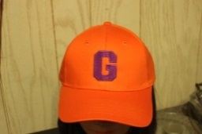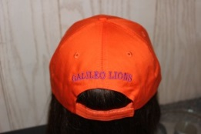

**GALILEO ALUMNI ASSOCIATION (G.A.A.)**

**Name: _________________________________________________________**

**Ship to Address: _________________________________________________**

**City: _______________________State** ___ **Zip _____ Phone:_____________**

**Mugs: Qty. ____**

**Shirt: S ____ M ____ L ____ XL ____XXL ____ Total: _________________**

**Cap/Hat Qty: _____**

**Shipping: $6.50—Add $1.00 for each additional item.**

**Make checks payable to: G.A.A.**

**Mail form and check to:**

**Galileo Alumni Association—1150 Francisco Street SF CA 94109** [**http://galileoweb.org/alumni/**](http://galileoweb.org/alumni/)