|  |  |  |
| --- | --- | --- |
| X | **THE GALILEO OBSERVER The Official Newsletter of the  Galileo Alumni Association**  ***Clarity . . . Honesty . . . Integrity*** | C:\Users\cca\Desktop\lion.jpg |
| **“Serving the Galileo Alumni Community”** | | |

**Vol. XII, No. 4 ____________________ ­­­­­__October 2014**

***…Today’s Students are Tomorrow’s Alumni…***

**Sports Hall of Fame Will Honor 12**

**The Galileo Sports Hall of Fame committee will induct eleven former athletes and one former coach at the annual dinner on Friday, October 17, at the S. F. Italian Athletic Club. Festivities start at 5:30 PM with no-host cocktails followed by dinner and the ceremony at 7:00 PM. This year’s honorees are:**

**Curt Decker** (’55-’65) Coach Baseball & Soccer. **Dexter Doss** (’91) Baseball, Basketball, Football, Track. **Danielle Fong** (’07) Basketball, Softball. **Gus Geraldi** (’62) Baseball. **Keith Hazell** (‘78) Basketball, Track. **Reggie Leipsic** (’58) Baseball, Basketball, Football. **Nolan McCoy** (’78) Baseball, Basketball, Football, Soccer, Track, Wrestling, ROTC rifle team. **Gon Yee Ng** (’97) Tennis, **Michelle Ng** (‘97) Tennis, **Richard Thompson** (’64) Baseball, Track. **Kenny Walls** (’98) Basketball, Football. **Lenny Walls** (’97) Basketball, Football.

**Send in your check and reservation form today. See attached form. Deadline is October 13th.**

**COLUMBUS DAY PARADE/BAZAAR/BLUE ANGELS 2014**

**Join us this year for the 2014 Columbus/Italian Heritage Day Festivities on Saturday/Sunday October 11th & 12th in North Beach. Look for us in the Parade, the Galileo Alumni Association Float and the ROTC marching band.**

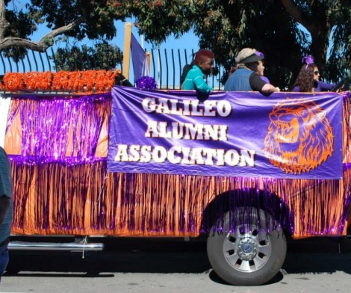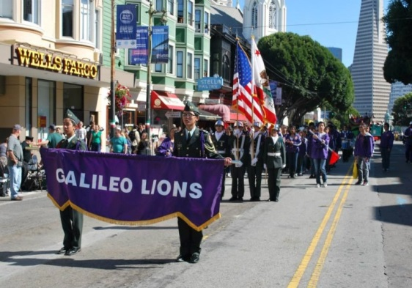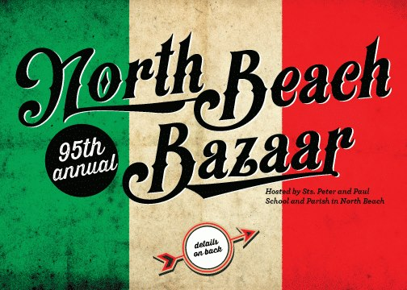

|  |  |
| --- | --- |
| **Through The Telescope. . .**  **Sisvan Der Harootunian** | X |

**The recent luncheon at the Basque Cultural Center in SSF arranged by Mel Chiarenza (’52) and others for those Galumni turning 80 was an enjoyable affair with friends meeting old friends.**

**PTSA President Jim Fong’s project for the Galileo hallway, “Reach for the Stars,” is moving along. Jim is an award-winning architect.**

**OBSERVations: Janet Sullivan Neilsen (’51) at Opera in the Park. She goes every year.**

**At this same event, it was disheartening to see how many people did not doff their hats during the playing of the National Anthem. Dozens of men, young and old, kept their hats on during the playing. Maybe they didn’t want to get sunburned.**

**Citibank advertises on the sides of Muni trains. And the bank’s doors are lined up perfectly with the train’s doors.**

**In arguably the best car chase in movies, Steve McQueen as Bullitt (1968) drives right past Galileo on Francisco Street headed for the Golden Gate Bridge. It’s a 7 minute chase and well worth seeing again if just for the scenes of our beautiful city.**

**George Clooney’s wedding in Venice last week was a class act.**

**Bringing Down The House: The year was 1964. I was sitting in the 12th row of the Winter Garden Theatre in New York City, anticipating the start of the show, “Funny Girl” and its young new star Barbra Streisand. When she sang “I’m The Greatest Star” in the first act, the audience stopped the show with a thunderous standing ovation. A star was born . . .**

**The price of an orchestra ticket was $8.80! For more information, visit** [**http://barbra-archives.com/live/60s/funny_girl_broadway_16.html**](http://barbra-archives.com/live/60s/funny_girl_broadway_16.html)**.**

**While watching Man vs. Food on TV, I recalled the time when my late friend Ben Dito (’51) challenged me to eat 4 Zimburgers in 1 hour at Zim’s on Lombard St. (in the space now occupied by Amici’s). If I succeeded he would pay for all 4. I ate the first 3 in 15 minutes, and it took me 45 minutes to eat the 4th one, but I did it and Ben paid.**

**Smoke Gets in Your Eyes: Smokey Robinson & Smoky the Bear have a name in common. Now they have been joined by the smoke from the recent forest fire in the Sierras. On a short trip to Reno a few weeks ago, there was smoke inside and outside the hotel, and it even was indicated on my iPhone screen. The smoke in the air smelled just like BBQ sauced ribs.**

**My iPhone is now more valuable to me than my wallet. It contains so much information that, if lost, I’d be without over 150 phone numbers, photos, music downloads, internet access, email, etc. Why can’t Apple consolidate all our credit cards and other plastic cards (they might be already doing this)? Call it a SmartWallet instead of a SmartPhone.**

**The late Robin Williams called San Francisco “Heaven.” Just two issues ago (April, 2014) I wrote in this column how I met Robin Williams 10 years ago. It may be a coincidence or an unconscious thought, but if you watch Robin’s movie, “World’s Greatest Dad,” released in 2009, you might find a prophecy of the manner of his death. It is a good film, but is also very sad considering what happened.**

**Will gondolas be next? Hardly. But the SF water taxi service currently operating between Ghirardelli Square (Hyde St. Pier) and AT&T Park (Pier 40) with a stop at the Ferry Bldg. (Pier 1-1/2) is due to expand to Pier 52 (Mission Bay at the proposed Warriors arena). What a good idea! Not only for baseball and basketball fans, but for locals and tourists to traverse the Embarcadero and enjoy the waterfront of SF. It is intended to relieve congestion on the E as is the extension of CalTrain to Chinatown.**

**What I yearn for (a potpourri of dreams) . . . baseball games at Seals Stadium . . . the musicals of Richard Rodgers . . . the novels of Ernest Hemingway . . . roasted chestnuts on Manhattan street corners . . . hot tamales on Mexico City street corners . . . 10 cent movie matinees at the Ahambra on Polk Street . . . a deep dish pizza at Zachary’s in the East Bay . . . chiles en nogada in Mexico . . . New Mexico sunsets . . . my mother’s pakhlava . . . chocolate dipped rocky road ice cream cones at Swensen’s original store at Union and Hyde . . . 19 cent/gallon gasoline (circa 1951) . . . Maria Callas singing anything . . . the International Expostion on T. I. (circa 1939) . . . ice cold gazpacho in Spain . . . a dinner at Charles . . . the white sand beaches of South Africa and the wild animals in Kruger National Park . . . just being in Paris.**

**Wish I’d Said That: Sealy has a patriotic double entendre slogan: “We Support The Backbone of America.”**

**Cashiers sometimes put the ball point pens customer use to sign their checks in a bowl filled with roasted coffee beans. “Why do you that?” I asked. Cashier: “So the pens don’t go to sleep.” ☺**

**Until next time . . . stay interested.**

**\*\*\*\*\*\*\*\*\*\*\*\*\*\*\*\*\*\*\*\*\*\*\*\*\*\*\***

*Tales from the Opera*

*By Giovanna DiTano*

Ed. Note: It’s opera season, and our resident soprano, Giovanna DiTano (Jowanna Woeber ‘51) is back with three tales from the opera world.

1. *During a performance of “Les Troyens” by Berlioz in the 1966 opera season, tenor Jon Vickers was singing and a big moth flew out of the curtain above the stage and right into his mouth. Luckily he had just finished a phrase of music. He turned around, spit the moth out of his mouth and continued singing without missing one beat of music.*
2. *During the first act of “Carmen” by Bizet in the 1964 season, a female chorister’s petticoat dropped to the floor. All the male choristers gathered around her in a circle to cover her. She stepped out of her petticoat and made her way off stage right, put the petticoat on and came back on stage.*
3. *The first opera I did with the Spring Opera in 1963 was “Faust.” Those os us who could dance were put on a table, center stage. I was paired with an Italian tenor who danced very badly but had a lot of strength and energy, and he almost pushed me off the table.*

*******************

Licia Albanese, a lyrico-spinto soprano who sang here during the 1940s and 1950s, died on August 15, 2014, in New York at the age of 105. She was the only soprano to have lived that long.

**\*\*\*\*\*\*\*\*\*\*\*\*\*\*\*\*\*\*\*\*\*\*\*\*\*\*\***

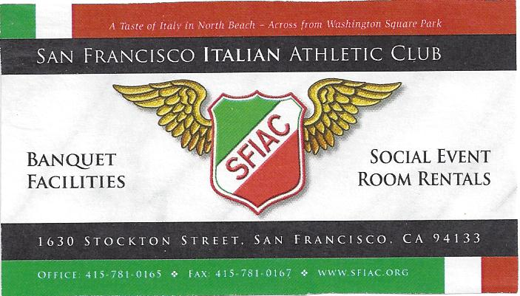

****Between the Lions****

**by Bettie Grinnell**

Greetings Mighty Lions! Here’s what happening at Galileo these days.

**FALL SEMESTER BEGINS**

Classes began this semester on Monday, August 18, 2014, with an enrollment of approximately 2,000 students. The semester will end just before Winter Break on Friday, December 19, 2014. Our enrollment includes 144 Newcomer students, meaning students who are new to the United States. A special ruling allows these students to be eligible for enrollment for 4 years from the entrance date, even if they are over 18 years of age during those 4 years.

**FRESHMEN ORIENTATION**

Freshmen Orientation, sponsored by Galileo and the awesome Galileo PTSA, was a wonderful way to introduce Galileo to our incoming 9th grade students and their parents. It was held on Friday, August 15th from 8:30am – 1:30pm. Students were given a tour of the school, an opportunity to purchase PE uniforms, information about lunch applications, school lockers and much more. There were also special presentations for the parents. The PTSA and the JROTC worked together to provide lunch for everyone, which included BBQ’d hot dogs, chilidogs, chips and drinks. The PTSA provided the food and a new large gas BBQ grill. JROTC students, under the guidance of Sgt. Hardee manned the grill and cooked hot dogs for the students, parents and staff. Over 800 hot dogs were served! Yours truly was on the COSTCO shopping trip for the food—the hot dog buns alone filled an entire cart! Everyone enjoyed the event as we welcomed the new Freshman Class to Galileo!

**NEWSWEEK MAGAZINE NAMES GALILEO IN THE TOP US HIGH SCHOOLS**

“Beating the Odds – Top Schools for Low-Income Students”—That is the headline on the Newsweek Magazine website announcing America’s Top High Schools for 2014. There are 2 categories for 500 top high schools and Galileo scored 196 out of 500 in the “Top Schools for Low Income Students” category. This year Newsweek sought to recognize schools that beat the odds, performing better than statistically expected for their level of poverty. Newsweek ranked schools on how well they prepare their students for college, taking the socio-economic background into account. This is the Newsweek’s way of recognizing schools that narrow the achievement gap. Galileo is the only high school in the San Francisco Unified School District to make the list. Go Lions!

**CIRCLE THE SCHOOLS PROGRAM FOR SFUSD AND GALILEO**

San Francisco Mayor Ed Lee and Superintendent of Schools Richard Carranza joined with leaders from the Citizens Initiative for Technology and Innovation to announce plans to pair a technology company with each of the city’s 116 schools. Each company will make a one-year commitment to the schools they adopt. The companies meet with the schools to learn the needs and then provide part of the needs by volunteering at a minimum of three school events a year. The companies also must donate $5,000 to cover expenses in implementing the program, plus anything else the companies choose to donate.

Galileo is paired with a company called **Achievers**, a startup company that helps other companies reward and encourage employee successes. We have had one meeting with representatives from the San Francisco Ed Fund, the liaison between the schools and the tech companies. Plans are in the works for this partnership.

**AN EXCITING NEW PARTNERSHIP FOR GALILEO WITH GOOGLE**

San Francisco Supervisor London Breed (Galileo Graduate Class of 1992) had a 2-hour meeting at Google Headquarters in Mountain View in September. She toured the Google Headquarters and asked the company to adopt “her high school,” Galileo. Google accepted and our principal, Marcus Blacksher, along with Assistant Principal Lisa Warnke and Assistant Principal Stephen Emmi, had a conference call session with a representative from Google in late September to begin to plan the partnership and learn how Google can help Galileo. More information will follow in the next issue. Galileo looks forward to this partnership.

**GALILEO PRINCIPAL APPEARS ON CHANNEL 2 (KTVU) MORNING NEWS**

Galileo Principal Marcus Blacksher was interviewed on September 24, 2014, by Channel 2 Reporter Tara Moriarty about the School Board decision to allow students who complete all 3 middle school grades at the new Willie Brown Academy in the Bayview to attend the high school of their choice (except Lowell and SOTA). Ms. Moriarty asked Marcus how he felt about this and would he welcome these students to Galileo? Marcus told her that he grew up in the Bayview and said he would welcome any of the students who completed 3 years at the new Willie Brown Academy, and as he pointed up to “Galileo” on the building, he said, “To Galileo, the best high school in San Francisco!”

After the interview Marcus and I had a conversation with Tara Moriarty. She told us she chose to come to Galileo to do this story as “her favorite uncle, Uncle Jack taught for many years at Galileo.” I asked her what her uncle’s last name was and she smiled as she said, “McCaffrey.  
We had a fun conversation about Jack McCaffrey and his years at Galileo. For those of you who don’t know, Jack passed away a few years ago. I think he was with us that morning! Then we asked Tara when the story would air, and she said, “in 10 minutes.” We were surprised, but she told us what to do for the live streaming, and sure enough we turned our computers into TV sets and enjoyed the show! It’s always fun being at Galileo!

**ESPN SPORTS 30 – 30 COMES TO GALILEO**

On October 3, 2014 a researcher from ESPN Sports 30 – 30 came to Galileo seeking information about O.J. Simpson and his years at Galileo. They are producing a documentary about O.J. that will be aired a year from now and are not only reporting all of his legal troubles, but also focusing on his years as an athlete. Our collection of the “Telescope” from past years provided a wealth of information. These books provided pictures of O.J.’s years as a player at Galileo and of the naming of our Athletic Field in his honor in 1970, when he was already in the NFL. As most everyone knows, the field was renamed for Coach George White when we opened the new astro-turf surface in the late 2000’s.

**70th ANNUAL SONG & YELL CONTEST**

The 2014 Song & Yell Contest was held on Friday, October 3, 2014. Judges for the event were all Galileo alumni. Sisvan Der Harootunian (class of 1951), Diane Nishio-Go (Class of 1974), Janice Hom (Class of 1974), Steve Bokura (Class of 1984), Leeva Chung (Class of 1984), and Dominic Tsang (Class of 2009) enjoyed being the judges this year. Other Galileo alumni seen in the audience were GAA President Charlene Fachner Mori (Class of 1965 ) and Barbara Fachner LaRocca, (Class of 1969 ), and numerous alumni from the class of 1984. As always this was a very spirited event with the competition among the 4 classes. Everyone enjoyed the cheers, the singing, the skits and the presentation of the Homecoming Court. The Seniors came out on top again and a great time was had by everyone. The air temperature at the height of the competition reached 90°, but that didn’t stop the Lions’ enthusiasm.

**HOMECOMING**

Galileo faced the Lowell Cardinals during the Homecoming Football Game. The mighty Lions suffered in the first half of the game with our top offensive player being injured and unable to play in the rest of the game. The score at the end of the first half was 32-0. According to Coach Mark Huynh, the Lions came back and played well in the second half, but in the end Lowell was the victor with a final score of 40-6.

On Thursday, October 2, 2014, the Frosh/Soph Football Team defeated Lowell with a final score of 40-0. The future of Galileo football looks bright. Go Lions!

After the game Galileo students enjoyed the Homecoming Dance in the Galileo cafeteria.

**GALILEO TEACHER HONORED BY SAN FRANCISCO 49’ERS**

Two members of the staff of the San Francisco 49ers along with two of the team’s cheerleaders came to the 70th Annual Song and Yell this year to present their “Teacher of the Year” award to Henry Curtin, a Galileo math teacher. Before the Song & Yell, the 49er cheerleaders met with Galileo’s cheerleaders and were then on the field for the presentation waving their gold pompoms with spirited enthusiasm. At the Song & Yell, Henry Curtin was presented with his award and given a gift card, two tickets to that weekend’s home game and a VIP tour of the new Levi’s Stadium. Galileo was presented with a $1,000 check from the 49ers organization. Go Niners! Go Lions!

**FALL SPORTS**

**FOOTBALL**

After losing their first two contests at home, the varsity and frosh/soph teams won their respective games at De Anza (El Sobrante) for a first-victory celebration. The frosh/soph team won their nail biter by blocking a field goal attempt as time expired to preserve a 22-20 victory. The varsity team followed with a 12-6 win by shutting out De Anza in the second half. Senior free safety/receiver, Rodney Morgan led the way with 2 interceptions and a 65-yard touchdown catch. Sophomore running back, Kenneth Grady scored twice for the frosh/ soph Lions but freshman linebacker, Johan Lacayo's interception and score was the play of the game.

Galileo also played in Oakland before starting league play against Lowell on October 3rd.

**BOYS’ VARSITY SOCCER**

Galileo’s Boys’ Varsity Soccer team is undefeated to date this season. Their record now stands at 5 wins (Burton 9-1), (Balboa 3-1), Mission (201), and Kip (12-1); 3 ties (Lowell 1-1), Lincoln (2-2), and O’Connell (0-0 in the toughest game of the season), (Washington 2-0 on October 2, 2014). 0 losses. The goal for the team this year is to make the finals. Right now the team is in 2nd place behind Mission by one point.

**GIRLS’ GOLF**

The senior laden girls' golf team continues to make improvements in league play. With the majority of the team consisting of first year golfers each player continues to show signs of improvement in their golf game. The girls realize that learning a new sport is extremely difficult but through hard work and dedication that the team can continue to compete and have fun doing it. Again Coach Sklarz continues to recruit athletes from his physical education classes to participate and hopes to find interested 9th and 10th grade girls to join next year!

**GIRLS’ TENNIS**

The Girls Tennis Team consists of 12 girls, some who are experienced players and others who new beginners eager to become top players. They lost against Washington High School 4-3. Scores for other matches were Lincoln (0-7) and Wallenberg (6-1). The team practices every day at the Alice Marble tennis courts under the guidance of Coach Papa. Right now, there are only seniors, juniors and sophomores on the team. All the girls are looking for some freshmen girls that are interested in the sport.

**GIRLS’ VOLLEYBALL**

The team’s biggest win to date was against Lincoln, which went to 5 sets. Their record so far this year is 1 win (Lincoln), 3 losses (Washington, Balboa and Lowell). It is still early in the season and there are still two more rounds against each of the 4 other teams. The top 4 of the 5 teams will go to the playoffs the first week in November. The team is comprised of mostly seniors this year.

https://mail.google.com/mail/u/0/images/cleardot.gif**JROTC**

JROTC began their school year at a special corporate event at Galileo put on by Williams Sonoma in the Galileo Courtyard and Auditorium. The Color Guard and the Drum Corps performed, along with the Galileo Cheerleaders, for the attendees in the courtyard and then again in the auditorium. All the Williams Sonoma folks enjoyed our student performers and showered them with enthusiastic applause. Williams Sonoma has promised monetary donations to our JROTC, Cheerleaders, our Visual and Performing Arts Department and to the school.

On Saturday, September 20th, 70 JROTC cadets along with Sgt. Hardee participated in the Beach Clean-Up at Ocean Beach from 9:00am – 12:00noon.

On Thursday, September 25th, the JROTC Color Guard had the honor of presenting the colors at the Annual Hero Breakfast, hosted by the American Red Cross and honoring San Francisco’s heroes. The event this year was held at the Sir Francis Drake Hotel. The students had breakfast with the San Francisco honorees after their presentation of the colors.

**Let me know what you’d like to hear/read about at Galileo. Bettie on the Beat will be happy to answer your questions and handle your requests.**

**\*\*\*\*\*\*\*\*\*\*\*\*\*\*\*\*\*\*\*\*\*\*\*\*\*\*\***

**Then & Now**

Student Body Officers.Telescope yearbook Sp1950 seated Pola Massoni-VP. L to R John Zuffo-custodian, Laverne LaRocca-Treasurer, Joe Martino-President and Carmela Lombardi-Secretary. 

Summer 2014 Seated.. Pola Massoni Martino ,   
L to R John Zuffo, Laverne LaRocca Schultz, Joe Martino, Carmela Lombardi Hoffman.   
 Together again....sixty four years later!

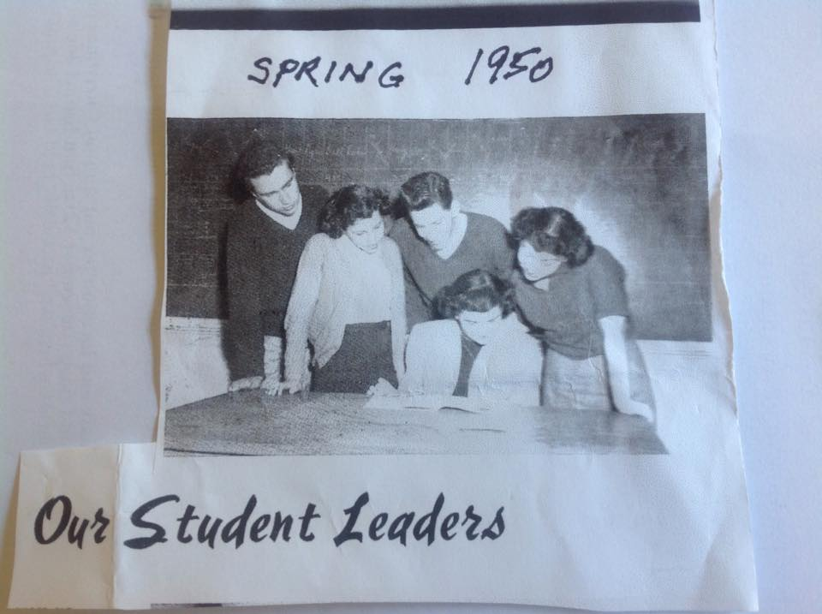 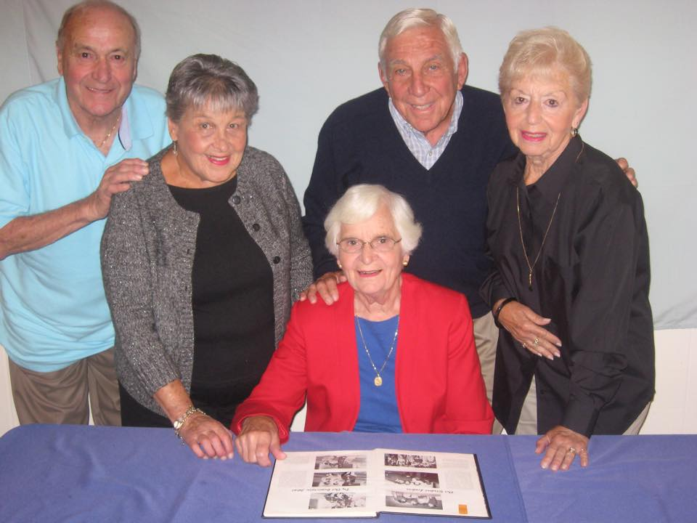

**Ramblings**

**By Tony Compagno**

October Reminiscence:

*Although I told myself that I was some distance beyond getting excited over the imminent costume party, I was clearly anxious for Saturday night to come so that I could slip into my outfit.*

*I was to be a sheik-like character, to complement, in a rather un-chic way, my wife Kathy, whose belly-dancing costume, borrowed from her best friend, was worth about 250 bucks.*

*Maybe I was excited because I hadn't dressed up for Halloween since Kathy and I had thrown a small party some seven or eight years earlier.  She'd been Vampira and I a little old, baggy-trousered lecher, which was a real stretch for me since I have always been conscious of the length of my cuff and have always looked - longingly, but looked only - at everything in a skirt.*

*Or maybe I was excited because I expected to become, for one night at least, someone awesome, more commanding, more dynamic than I am from day to ordinary day.  With a blouse-like shirt made in Taiwan, and a plastic scimitar from the local toy store, I was ready to take my woman, my subject, who knew better than to be anything but shy and submissive with her sheik and master, and for one glorious evening I could strut about in absolute power beyond challenge.  Move over, Mr. Mitty.*

*We arrived at the house a little late.  Some might have assumed that we were trying to make the grand entrance.  They didn't know how long it took for this sheik to adjust his headband so that it wouldn't completely cut off the circulation of blood to his brain.  Or how long it took his prima belly-ballerina to adjust her baubles, bangles and beads.  Or how long it took this domestic dummy to locate the popcorn-popper, the corn, the oil, and the salt for the baby-sitter while Salome painted her nails.  Or how long it took Kathy to negotiate getting into and out of the car so as not to crush, crease, crinkle, wrinkle, smash, puncture, bend, fold, or mutilate a square inch of her precious and borrowed costume.  (Why couldn't she have listened to me and bought that Princess Leia costume with life-like mask, the package dramatically reduced to a buck and a quarter?)*

*The hostess greeted us at the door.  She immediately mistook me for a visiting professor of comparative terrorism from Ayatollah U.  The costumed guests stood or sat talking in interesting combinations.  A very tall nurse with hairy legs talked with a cone-head, perhaps about corrective surgery.  An armed guerilla was offering Heidi some punch.  A gorilla, disarmingly dressed in a shirt and tie, was intimidating a cotton-tailed bunny.  An extremely sinister-looking red devil was conversing with a pregnant bride-in-white.  I half-expected to see Salvadore Dali peeking through a window, doing preliminary sketches for yet another painting.*

*When my wife and I walked through the weird but wonderful crowd, I assessed (with the best steely gaze I could muster) the eyeball action of the male guests.  I've seen that look many times...that distracted, astonished, stupidly longing, licentious look.  You'd think they'd never seen baubles and beads before.  I reached for my scimitar, but realized instantly that it couldn't cut through margarine, let alone lop off heads and other parts of perverts and scoundrels.*

*As the evening went on, though I tried to hold and believe the Valentino sneer I wore which complemented the cold, cock-sure demeanor, my fallible, vulnerable, real self slowly slipped from under its mask.*

*I should have just bought the marked-down Othello get-up from Kmart, and just played the brooding, jealous Moor of Venice to the hilt...of my plastic scimitar.*

*(Hope this provided a smile or two, Lions young and old.  Happy Halloween to you.)*

*\*\*\*\*\**

*Just some notes on three of the 2014 Galileo Sports Hall of Fame inductees.*

*Curt Decker.  I picture Curt in his Galileo baseball uniform on game day.  He was a powerfully built man with good, sound baseball knowledge and a sense of fairness in dealing with his charges.  He had an infectious smile and could joke with the best of 'em, but was no push-over, making difficult decisions with confidence, always balancing the competitive spirit with an interest in character-building for his youthful squad members.*

*I personally applaud Curt's inclusion in the Gal Hall of Fame.  I would conjecture that his soccer gang would, too, and that Curt is pleased with the fairly recent soccer "explosion" in this country.*

*Reggie Leipsic:  When I was a kid playing at Funston Field, Reggie was already looking like one of the heroes from Marvel Comics.  He could throw a football a mile, run like a deer, tear the cover off a baseball, and move to the basket like a bull.  His little brother, Bob, wasn't bad, either; he's in the Gal Hall of Fame, too.*

*Gus Geraldi:  Nice guys don't always finish last.  Quiet, mild-mannered Gus, now a respected restaurant-owner at The Wharf, was a superior infielder; we turned a few nifty double-plays together on Diamond #1 at Funston in the old days...but Gus continued to get better, while I....well...*

**\*\*\*\*\*\*\*\*\*\*\*\*\*\*\*\*\*\*\*\*\*\*\*\*\*\*\***

**LETTERS**

Frank Brucia (1935) writes: I saw a parking space on Francisco St. last Friday and decided to visit the school in which I had not since 1935. I talked to a faculty person teaching English in the room on the main floor in which I studied two years of Latin. I still remember the entry that previous students wrote in the first page of the text book: "LATIN IS A DEAD LANGUAGE, IT DIED ACROSS THE SEA, IT KILLED OFF ALL THE ROMANS AND NOW IT'S KILLING ME". My last instructor was Mr. Cummings whose personality as I remember reflected the dead language.*:) happy

I also was pleased that opposite the main office was a reprint of one of my graduation class pages from the Telescope including Peter Haas and others.  I still have a copy of the "Telescope" for that year if you would like to make any other reprints.

I am the retired dentist(1992) that with my wife enjoyed the alum dinner dance two years ago. Charlene Mori was very gracious to us….. Frank '35.

P. S. I have lost so many of my friends.... the price of longevity (97years.), all in S.F except for WW2.

**Outstanding and informative GAA Newsletter.  Take particular pride in a job/publication well done.  As Coach George Poppin would always say,  “Remember the Human Element, “  and you have.  Best wishes for continued success   Gpaxson.......  and “Like a Fine Wine, the Class of ‘59 gets better with time”.**

**___________________________________________________________________________________________**

**70th SONG & YELL 2014**

Had a wonderful time at the Song & Yell Contest and Football game on Oct 3rd. See Bettie’s review above in “Between the Lions.” Make sure you make the next Song & Yell or any of the Football games Galileo has. It’s great sitting back up there in the stands. Brings back fun memories. Charlene Fachner Mori ‘65

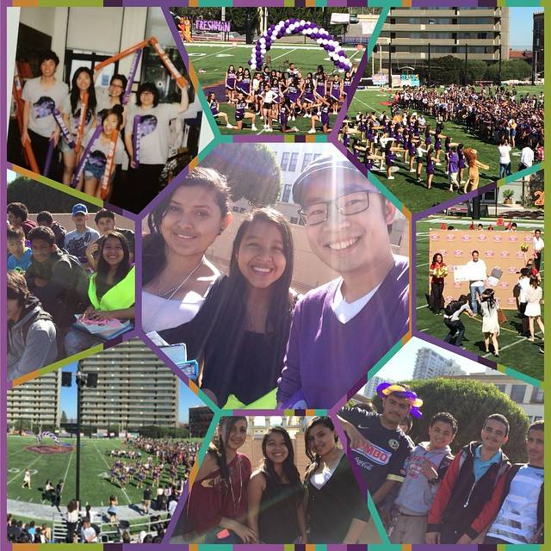 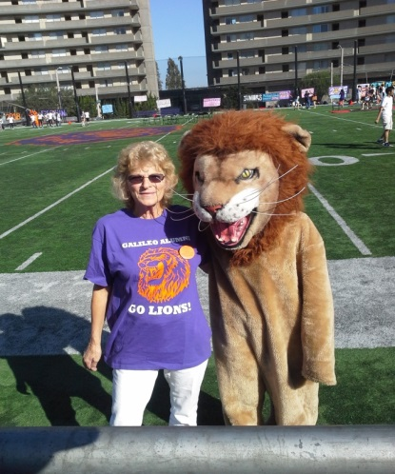

**RENT THIS SPACE**

1 YEAR (4 ISSUES) $75.00

Send your business card with your check to:

Galileo Alumni Association

Advertising Dept.

1150 Francisco Street, S.F., CA 94109

**RENT THIS SPACE**

1 YEAR (4 ISSUES) $75.00

Send your business card with your check to:

Galileo Alumni Association

Advertising Dept.

1150 Francisco Street, S.F., CA 94109

***__________________________________________***

**THE ALUMNI BOARD NEEDS YOU!**

**If you would like to work with current Directors to further the mission and goals of the GAA please contact Charlene Mori at 415-441-6445. We are searching for new Board Members, assistance with the newsletter “Observer” and someone to help maintain & build our web site. You can also email -** [**http://galileoweb.org/alumni/about/contact/**](http://galileoweb.org/alumni/about/contact/)

**\* * * * * \***



***___________________________________________________________________***

**Make sure you buy your Galileo Alumni hats/shirts/mugs. See attached form or go to our website.** [**http://galileoweb.org/alumni/merchandise/**](http://galileoweb.org/alumni/merchandise/)

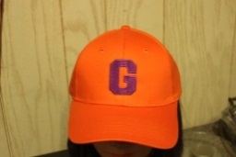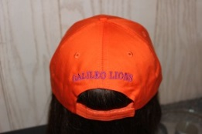

***HELP US MAKE GALILEO THE BEST ALUMNI IN SAN FRANCISCO!!***

**Obituaries**

Teresa Balestrieri May 29, 1920 – Sept 10, 2014 <http://www.legacy.com/obituaries/sfgate/obituary.aspx?n=Teresa-Balestrieri&pid=172445936>

Jose Buenavista March 10, 1952 – Sept. 2, 2014 Vice Principal <http://www.legacy.com/obituaries/sfgate/obituary.aspx?n=Jose-Buenavista&pid=172378300>

Kenneth Lee May 25, 1935 – Sept. 17, 2014 <http://obits.dignitymemorial.com/dignity-memorial/obituary.aspx?n=Kenneth-Lee&lc=4620&pid=172552486&mid=6126147>

Harriet Lloyd May 9, 1917 – Sept 12, 2014 <http://www.legacy.com/obituaries/sfgate/obituary.aspx?n=Harriet-Lloyd&pid=172490506>

Alphonse Rodriguez Sept 14, 2014 90 years old <http://www.legacy.com/obituaries/sfgate/obituary.aspx?n=Alphonse-Rodriguez&pid=172591289>

Lucille Theis Sept. 2014 90 years old <http://www.legacy.com/obituaries/sfgate/obituary.aspx?n=Alphonse-Rodriguez&pid=172591289>

Joseph Vallarino March 18, 1924 – Sept. 10, 2014 90 years old <http://www.legacy.com/obituaries/sfgate/obituary.aspx?n=Joseph-Vallarino&pid=172478142>

**Here is a Gift to the Galileo Alumni Memorial Fund**

**From ___________________________________________ Class ______**

**Address ___________________________________________________**

**City _________________________________State_____ Zip__________**

**In memory of ________________________________ Amount ________**

**Send memorial card to:**

**Name _____________________________________________________**

**Address____________________________________________________**

**City_____________________________________ State _____ Zip _____**

***– Memorial Gift –***

***Make donations expressing your sympathy to family and friends who have lost a loved one. A memorial card will be sent to the family in your name. Donations are tax deductible to the extent allowed by the law. Tax ID 30-0066848***

***Donations should be mailed to:***

***Galileo Alumni Association***

***1150 Francisco Street***

***San Francisco CA 94109***

**DONATIONS IN MEMORY**

June Bury in memory of the “Robert Bury Family”

Estelle Landi in memory of “Carmen Morello”

Jane Borg in memory of “Joe Borg”

**ATTENTION POTENTIAL ADVERTISERS**

***This newsletter is now accepting advertisements for future issues. If you have a business or service you want to advertise, The Galileo Observer is the ideal place to place your ad. It will appear for 4 issues during the year – in January, April, July and October and will reach Galileo alumni, family, friends and students. Rates are reasonable -- $75 for 4 issues (business card size ad).***

***In addition to promoting your product or service, you will be helping the Galileo Alumni Association carry out its mission of helping the Galileo Academy of Science and Technology.***

***Please contact*** [***GalileoObserver@aol.com***](mailto:GalileoObserver@aol.com) ***or*** [***JScafidiMV@aol.com***](mailto:JScafidiMV@aol.com)

**\*\*\*\*\*\*\*\*\*\*\*\*\***

***Reporters Wanted:***

***The Observer is seeking persons who are willing to gather and report news of interest to Galileo alumni. Writing skills are not necessary, just the ability to communicate and write legibly. We are accepting any bits of information about alumni, such as what they are doing now, marriages, births and deaths. If you have a photo of an event, a luncheon or small gathering, send it in. Send all submissions to the Galileo Observer (***[***galileoobserver@aol.lcom***](mailto:galileoobserver@aol.lcom)***) or the Editor, Galileo Observer, c/o*** [***www.galileoweb.org***](http://www.galileoweb.org)***.***

***Visit our Facebook page at:*** [***https://www.facebook.com/pages/Galileo-Alumni-Association-San-Francisco/278283128875474***](https://www.facebook.com/pages/Galileo-Alumni-Association-San-Francisco/278283128875474)

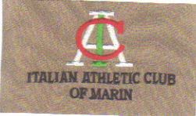

**Established 1968**

**P.O. Box 36, Larkspur, CA 94977**

***Upcoming Events***

**GAA Board Meeting – Room 210, Galileo Academy, 6:00 PM, held the 2nd Wednesday of the month except for June/July/August. Our next meeting is October 8, 2014. Please join us.**

**\* * * * * \***

**October 17, 2014 - *Sports Hall of Fame Induction Dinner**

**San Francisco Italian Athletic Club – Deadline October 13,2014**

**\* * * * * \***

**Hall of Merit Induction Dinner – Spring, 2015 (Time and place TBA)**

**\* * * * * \***

**We will be doing another “Day at the Races” (Date/Time TBA)**

**When checking for upcoming events between issues of the *Observer*, please visit the web site** <http://galileoweb.org/alumni/>

**____________________________________________________________**

**THE GAA IS LOOKING FOR……………………..**

* **A NEW SECRETARY**
* **NEW BOARD MEMBERS**
* **ALUMNI TO HELP ON COMMITTEES**
* **SWEETHEART STORIES**
* **WHERE ARE YOU NOW?**
* **REUNIONS FOR 2014 and 2015**
* **PICTURES OF OLD SCHOOL GAL**
* **GOSSIP/NEWS/STORIES**

**Mail to: GAA, 1150 Francisco Street, SF Ca 94109**

**Or email** [**galileoobserver@aol.com**](mailto:galileoobserver@aol.com)

**The OBSERVER Is For All**

**Galileo alumni, family, friends, students, faculty . . . anybody and everybody, the *Observer* is for you. If you haven't already done so, send in the email addresses of anyone who would like to receive a FREE emailed newsletter to** [**http://galileoweb.org/alumni/about/contact/**](http://galileoweb.org/alumni/about/contact/)**. We'd like to reach as wide a range of readers as possible.**

**PLEASE SEND US YOUR IDEAS, GOSSIP, UPDATES ETC.**

**The Galileo Observer invites your articles, letters, memories, inquiries and suggestions. All submissions are subject to editing. Deadlines for submissions are January 1st, April 1st, July 1st and October 1st.**

**Send emails (preferable) to** [**galileoobserver@aol.com**](mailto:galileoobserver@aol.com)

**Send letters to Galileo Observer, c/o Galileo Alumni Association, 1150 Francisco Street, San Francisco, CA 94109. All letters are subject to editing.**

**BACK ISSUES OF THE GALILEO OBSERVER CAN BE VIEWED AT**

[**http://galileoweb.org/alumni/newsletter/**](http://galileoweb.org/alumni/newsletter/)**.**

**For all EDITORIALLY-RELATED comments or suggestions, please address your emails to** [**galileoobserver@aol.com**](mailto:galileoobserver@aol.com)**.**

**For all TECHNICAL problems (non-receipt of newsletter, etc.), contact the webmaster through** [**http://galileoweb.org/alumni/contact/**](http://galileoweb.org/alumni/contact/)**.**

**Editor**

**Sisvan Der Harootunian**

**Managing Editor**

**Charlene Fachner Mori**

**Columnists**

**Tony Compagno**

**Sisvan Der Harootunian**

**Bettie Grinnell**

**Advertising**

**Joe Scafidi**

**Printing/Mail Distribution**

**Charlene Fachner Mori**

**The Galileo Observer is published quarterly in January, April, July and October by the Galileo Alumni Association, 1150 Francisco Street, San Francisco, CA 94109. Views expressed are strictly those of the Association and in no way reflect those of the Galileo Academy of Science and Technology, its students or faculty. Sisvan Der Harootunian, Editor; Vaughn Spurlin, Production Manager/Website Director. Copyright 2014, Galileo Alumni Association.**

***Last updated October 2014. © 2002-2014 Galileo Academy of Science and Technology Alumni Association of San Francisco. Tax ID 30-0066848. No part of this publication may be reprinted or reproduced in any form without permission of The Galileo Observer and/or The Galileo Alumni Association***

GAA BOARD OF DIRECTORS, OFFICERS, & COMMITTEE CHAIRS ARE LISTED AT <http://galileoweb.org/alumni/about/contact/>

**ANNUAL DONATIONS**

**January 1, 2013 – December 31, 2013**

**$1,000.00**

Haidee Stade

**$300.00 - $999.99**

Robert W. (Bobby) Brown

Joe/Pola Martino

**$100.00 - $299.99**

Helen Amoroso

Henry Black

Joe/Jane Borg

Irwin Gibbs

Carmela Lombardi Hoffman

Edgar Stone

Ronald Yee

**$26.00 – $99.99**

Paul Cassidy

Sisvan Der Harootunian

Charlene Fachner Mori

Yola Panelli Ferralis

Frank Lem

Frank Norick

Helen Oroso

Joe Scafidi

J. Milton Seropan

Loyd Sherwood

Cordy Surdyka

Gloria Tornay

Augie Venezia

**$1.00 - $25.00**

Toni Alessandra

John Alioto

Angelo Balistreri

Joe Bencharsky

Doreen Bertani

Andrew Cafasso

Angela Canepa

Reuben Cannon

Danny Chan

Irma Ferro

Vincent Gomez

Al Gragnani

Dorothy Hawkes

Lance Hughston

Alvin Joe

Barbara LaRocca

Steve W. Larson

Gretchen Lipow

Dave Lippi

Leon Manalo

London Morrow

Joel M. Napp

Mary Peruzzo

Frank Quadrelli

Joel Redmon

Seb Saia

Laverne Schultz

Barbara & Lorin Scola

Jean Giovannoni Shelley

Vaughn Spurlin

Bevelry Delosa Thomey

Robert Vaccarezza

Guido Venezia

Donald Vidal

Lynette Wong

Victoria Wong

Jim Yee

**ANNUAL DONATIONS**

**January 1, 2014 – December 31, 2014**

**$1,000.00**

**$300.00 - $999.99**

**$100.00 - $299.99**

Helen Amoroso

Wayne Beasley

Robert W. “Bobby” Brown

Frank Brucia

Bob Bury

Minnie Campos

Gene DeMartini

Carmela Hoffman

Angela Little

Mario Lombardi

Dipak Patel

George Paxson

Joel Redmon

J Milton Seropan

Eric Soderstron

Robert Vaccarezza

Ron Yee

**$26.00 – $99.99**

John Alioto

Bill Alkire

Margaret Badano

Angelo Balistreri

Ed Belasco

Andrew Cafasso

Anna Chew

Rosalie Cirby

Alexander A. Cortez

Diane Cowart

Beverly Domeniconi

Yola Ferralis

Joseph & Sally Garbarino

Marilyn Gay

Irwin Gibbs

Sisvan Der Harootunian

Lenore Heffeman

Carmela Hoffmann

Monica Kirkland

Cathy Kornblith

Frank Lem

Angela Little

Anthony Lyau

Joyce Massucco

Charlene Fachner Mori

Frank Norick

Craig Paulsen

Joe Scafidi

Lorin & Barbara Scola

Jacqueline Sram

Edgar Stone

Danny Strazzullo

Cordy Surdyka

Gloria Tornay

**CONTINUED - ANNUAL DONATIONS**

**January 1, 2014 – December 31, 2014**

**$1.00 - $25.00**

Toni Alessandra

Nina Alioto

Steven Aronson

Doreen Bertani

Henry Black

Paul Cassidy

Mel Chiarenzo

Ralph Cicurel

Barbara Cope-Colaman

Eugene DiBasilio

Debbie Dittman

Marie Eisen

Ron Ertola

Irma Ferro

Christine Frances

Joan Gaskell

Salvatore Gianino

Hugo Giovannini

Vince Gomez

Kathy Guerrero

Carla Harris

Lance R. Hughston

Alvin Joe

Harriet Kunze

Estelle Landi

Barbara LaRocca

Dawson Lee

Eugene Leung

Dave Lippi

Leon Manalo

Carmen Morello

Joel Napp

David Negherbon

Joe Ortisi

Mary Peruzzo

Lorraine Peters

Pete Pompei

Laurie Prescott

Kendall Price

Frank Quandrelli

Sharon Reich

Ronald & Anstel Ricossa

Vincent Rigoni

Donald Sabatini

Seb Saia

Thomas Savnik

LaVerne Schultz

Jean Shelley

Vaughn Spurlin

Beverly Thomey

Rudy Torigiani

Chuck Torres

Elizabeth Trujillo

Guido Venezia

Lynette Wong

Sherman Wong

Victoria Wong

Shig Yabu

Jim Yee

John Zuffo



What? Don’t know what to do with all that extra money you have. Donate to the Galileo Alumni Association. All donations go directly to the school. The Science department is strapped for money. Just buying rubber disposable gloves costs a lot. The printing supplies to print the Pendulum cost so much money now. TAX ID 30-0066848

SUPPORT YOUR ALMA MATER! WE NEED YOUR HELP.**GALILEO ALUMNI ASSOCIATION FUNDRAISING**

* **BECAUSE OF CUT BACKS AND THE ECONOMY, GALILEO NO LONGER RECEIVES FUNDS FOR MOST OF THEIR ACTIVITIES AND FUNCTIONS. THEY DEPEND ON FUND RAISERS AND DONATIONS. I’M SURE YOU REMEMBER DOING CAR WASHES, BAKE SALES WHATEVER YOU COULD TO RAISE MONEY FOR YOUR SENIOR ACTIVITIES. STUDENTS NOW HAVE TO WORK EVEN HARDER TO RAISE THESE FUNDS. DON’T FORGET YOUR ALMA MATER. GO LIONS!!!**

**YES, I want to donate $ __________ towards:**

**Grant Awards Sports**  **Seniors (events/graduation)**

**Science Dept. Other ______________________________________**

**Is it OK to mention your name as a donor? Yes ____No ____**

Name: ____________________________________________ Email __________________________________

Address: __________________________________________City_______________State____Zip_________

**Mail to: Galileo Alumni Association**

**1150 Francisco Street**

**San Francisco CA 94109**

**YOU CAN ALSO DONATE ON LINE AT:**  <http://galileoweb.org/alumni/>

**RENT THIS SPACE**

1 YEAR (4 ISSUES) $75.00

Send your business card with your check to:

Galileo Alumni Association

Advertising Dept.

1150 Francisco Street, S.F., CA 94109

**GALILEO ALUMNI ASSOCIATION MEMBERSHIP APPLICATION**



**GALILEO ACADEMY OF SCIENCE AND** BENEFITS OF MEMBERSHIP **PLEASE CONSIDER DONATING**

**TECHNOLOGY ALUMNI ASSOCIATION** * Alumni activities and events **WE NEED YOUR SUPPORT.**

**OF SAN FRANCISCO CA.**  * Membership Card **JOIN THE G.A.A. SUPPORT YOUR**

The Mission of this Association shall be to * Assistance to all reunion committees **ALMA MATER!**

Organize Alumni into a cohesive unit to benefit * Quarterly newsletter “The Observer” Please visit the Galileo Alumni

all members of the high school Community: * Notice of Association Updates Association web site for further

Alumni, Students, Faculty, Staff and Friends. * Helping the current students of information at:

Galileo Achieve their goals. And much <http://galileoweb.org/alumni/>

more as the membership grows.

**BOARD OF DIRECTORS** **DIRECTORS** **STANDING COMMITTEE CHAIRPERSONS**

President: Charlene Fachner Mori (1965) Sisvan Der Harootunian (1951) **COMMUNICATIONS (NEWSLETTER):**

Vice President: Cordy Surdyka (1953) Barbara Fachner LaRocca (1969) Sisvan Der Harootunian (1951)

Secretary: Position Open Vince Gomez (1952) **MEMBERSHIP:** Toni Alessandra (1964)

Treasurer: Joe Scafidi (1950) Toni Alessandra (1964) **PUBLIC RELATIONS:**

Lance Hughston (1966) Barbara Fachner LaRocca (1969)

**WEBMASTER:** Vaughn Spurlin (1960)

**IF YOU HAVE ALREADY DONATED THIS YEAR, PLEASE DISREGARD THIS NOTICE AND THANK YOU**

- - - - - - - - - - - - - - - - - - - - - - - - - - - - - - - - - - - - - - - - - - - - - - - - - - - - - - - - - - - - - - - - - - - - - - - - - - - - - - - - - - - - - - - - - - - - - - - - - - - - - - - - -

**WE NOW ACCEPT PAYMENT ON LINE WITH PAYPAL**

PLEASE DETACH AND MAIL OR PAY ON LINE AT: <http://galileoweb.org/alumni/>

DATE: ______________________________ NEW MEMBER ______________ RENEWAL _____________

NAME: __________________________________________________ MAIDEN NAME ______________________________________

ADDRESS ________________________________________________ CITY/COUNTRY __________________STATE____ ZIP________

GRADUATION YEAR ______ EMAIL _____________________________________________________ PHONE _____________________

MAKE CHECKS PAYABLE TO THE GALILEO ALUMNI ASSOCIATION. INTERESTED IN HELPING OR BEING ON A COMMITTEE YES ___ NO___ DONATION ENCLOSED $ ___________ ALL DONATIONS ARE TAX DEDUCTIBLE TO THE EXTENT ALLOWED BY THE LAW. TAX ID 30-0066848 YOU CAN ALSO DONATE ON LINE AT <http://galileoweb.org/alumni/>

**Mail application to:** Donation of $25.00 - $25,000.00 graciously accepted Your information is strictly

**Galileo Alumni Association** and is tax deductible confidential and will ONLY be used

**1150 Francisco Street**  All donations are used solely for the benefit of Galileo for assisting Galileo functions/reunions. **San Francisco Ca 94109** Academy.

**If you have any news from your class for the GAA newsletter, please send to** [**GalileoObserver@aol.com**](mailto:GalileoObserver@aol.com)

**TOGETHER WE CAN MAKE GALILEO ACADEMY OF SCIENCE & TECHNOLOGY THE BEST ALUMNI IN SAN FRANCISCO!**

**GO LIONS!!! Obsv.7/14**

**Sports Hall of Fame 2014 Inductees**

**Curt Decker** (’55-’65) Coach Baseball & Soccer. **Dexter Doss** (’91) Baseball, Basketball, Football, Track. **Danielle Fong** (’07) Basketball, Softball. **Gus Geraldi** (’62) Baseball. **Keith Hazell** (‘78) Basketball, Track. **Reggie Leipsic** (’58) Baseball, Basketball, Football. **Nolan McCoy** (’78) Baseball, Basketball, Football, Soccer, Track, Wrestling, ROTC rifle team. **Gon Yee Ng** (’97) Tennis, **Michelle Ng** (‘97) Tennis, **Richard Thompson** (’64) Baseball, Track. **Kenny Walls** (’98) Basketball, Football. **Lenny Walls** (’97) Basketball, Football.

**PLEASE MAKE SURE YOU WEAR YOUR BLOCK “G” SWEATERS/JACKETS & HOF MEDALLIONS OR ANY OTHER GALILEO MEMORABILIA**

Support the Galileo Alumni Association and staff for an evening of fun. The Galileo Sports Hall of Fame Induction Dinner will be held on Friday October 17, 2014 at the Italian Athletic Club in San Francisco. So save the date and send your reservation form in ASAP as it will surely be a sell out. **Tickets will not be sold at the door.**

Dinner includes: Salad, Antipasti, Pasta, Cross Rib Roast or ½ Roasted Rosemary Chicken (veggies/roasted potatoes) Dessert and Wine. For vegetarians Eggplant Parmigiana will be available. (Napoleon of Eggplant, Fontina Cheese, Basil, Tomatoes).

**PLEASE RETURN NO LATER THAN OCTOBER 13, 2014**

Please detach form and mail

**Make check payable to:** **Galileo Alumni Association**. Complete this form and **mail to:**

**GAA c/o C. Mori 808 Greenwich Street, San Francisco, CA. 94133**

You can also pay on-line w/pay pal or credit card at <http://galileoweb.org/alumni/> click on the donate button.

October 17, 2014

No host Cocktails at 5:30 – Dinner 7:00

Italian Athletic Club

1630 Stockton Street

San Francisco CA 94133

Name: __________________________________ Email _____________________________Phone__________________

Number of Tickets: _____ x $65.00 per ticket = Total $_____________ Roast Beef _____ Chicken_____ Eggplant _____

Print name of guest Print name of guest

____________________________________________ ________________________________________________

____________________________________________ _________________________________________________

**____________________________________________ _________________________________________________**

**All tickets will be held at the door.** If you have any questions, please contact Charlene Moriat 415-297-4280 or email [galileoalumni@yahoo.com](mailto:sportshalloffame@galileoalumni.org) Visit the GAA Web Page at: <http://galileoweb.org/alumni/>

Sorry, I cannot make it but please accept my donation for $______________________________________________

Description: MC900088528[1]Description: MC900088528[1]

**GALILEO ACADEMY**

**HALL OF MERIT**

**NOMINATION FORM**

**CRITERIA**

1. Nominee must have attended Galileo High School/Galileo Academy of Science and Technology in good standing prior to being nominated.
2. Nominee may be an individual (student, staff or faculty member).
3. Nominee must have made a significant contribution, after graduation or attendance, to his/her

community, city, state, country, or globally. (Examples: science, technology, government, business, education, the arts, philanthropy).

1. Anyone, including Galileo alumni, faculty, staff, family or friends of a nominee may nominate a candidate. All nominations will be reviewed and facts about qualified nominees will be verified by the Galileo Alumni Association Hall of Merit Committee.
2. Posthumous awards may be given, so nominee may be deceased. If selected, he/she must be represented by a family member or recognized close friend.

I would like to nominate the following person for the Galileo Academy Hall of Merit:

Name of Nominee:

Field of Accomplishment: _________________________________________________

Class of: Phone: Email: ___________________

Spring/Fall/Year

Address:

Street City State/Zip Code

Nominator's Name:

Address

Street City State/Zip Code

Class of: Phone: Email:____________________

Spring/Fall/Year

Signature: Date:

Mail to: Galileo Alumni Association

Hall of Merit Committee

1150 Francisco Street

San Francisco, CA 94109

**GALILEO ALUMNI ASSOCIATION MERCHANDISE ORDER FORM**



**HANES BEEFY 100% COTTON PRE-SHRUNK T-SHIRTS**

**PURPLE/ORANGE W/WHITE WRITING. BLANK ON BACK.**

**SMALL -**34**-36**

**MEDIUM -**38**-40 $20.00 DONATION EACH**

**LARGE -**42**-44 + SHIPPING**

**X-LARGE -**46**-48**

**XX-LARGE -**50**-52**



**BASEBALL CAPS ORANGE CAP**

**$20.00 DONATION EACH + SHIPPING**

**PURPLE LETTERING**

**ONE SIZE FITS ALL**

**VELCRO ADJUSTMENT STRAP ON BACK**

**11 OZ. MUG**

**IMPRINTED ON $5.00 DONATION EACH**

**BOTH SIDES + SHIPPING**



**GALILEO ALUMNI ASSOCIATION (G.A.A.)**

**Name: _________________________________________________________**

**Ship to Address: _________________________________________________**

**City: _______________________State** ___ **Zip _____ Phone:_____________**

**Mugs: Qty. ____**

**Shirt: S ____ M ____ L ____ XL ____XXL ____ Total: _________________**

**Cap/Hat Qty: _____**

**Shipping: $6.50—Add $1.00 for each additional item.**

**Make checks payable to: G.A.A.**

**Mail form and check to:**

**Galileo Alumni Association—1150 Francisco Street SF CA 94109** [**http://galileoweb.org/alumni/**](http://galileoweb.org/alumni/)