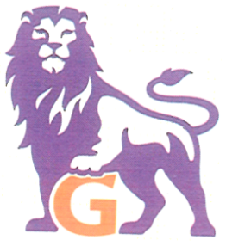
Galileo High School
Class of 1970 Reunion

Dear Classmates and Friends:

The Class of 1970 Reunion Committee will hold its 40th year reunion:

DATE: Saturday, October 30, 2010 PLACE: Green Hills Country Club
5 PM to 10 PM 500 Ludeman Lane, Millbrae, CA 94030

Attire: Dressy Casual or Dressy. NO JEANS Optional: 1970’s Block G sweaters

Cost: $75.00 per person if postmarked by July 31, 2010 or $85.00 per person if postmarked after July 31, 2010

Menu: Buffet-style dinner includes Cheese & crackers, Salads, Carved meats, Pasta, Fruits, Desserts, Coffee and Tea.

Drink tickets will be sold at the door. $3 per ticket. (minimum of 2 tickets for alcoholic drinks). CASH ONLY. Dietary restrictions upon request.

Dance to the music of Jest Jammin’

Questions? Email them to galileoreunion2010@yahoo.com or contact
Nancy J.Yee, DDS – callmenjy@yahoo.com; Gail Chong Megdadi – gailchong1970@yahoo.com (925-837-9198);
Galen Dea – galendea@yahoo.com; Lemoyne Wong – wonglady1970@yahoo.com

Copies of the yearbook will be on sale for $10 at the reunion. To reserve your copy, contact Galen Dea at galendea@yahoo.com or call 510-205-9660

Please detach form

Complete this form and mail to: Galileo Class of 1970 Reunion
c/o Gail Chong Megdadi
P. O. Box 1233, Danville, CA 94526

Make check payable to: Gail Chong Megdadi

A table of 10 can be reserved by making a one-time payment for 10 people.

Name: ________________________ Email: ______________________ Phone: _________________

Print name(s) of guest(s)
________________________________________________________________________

_________________________________________________________________________

