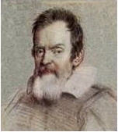 | THE GALILEO OBSERVER  The Official Newsletter of the  Galileo Alumni Association | 

"To make GAA great... communicate and participate"

VOL. VI, No. 2 _____________________ April, 2008

Communicate and Participate
(an editorial)

These are the words that appear on our masthead. They mean that to fully benefit from and enjoy your membership in GAA, you must communicate (network, call, write, get together) with other alumni and participate (join the Board or a committee, attend meetings and events and contribute if you can).

The future of GAA depends on you, the present GAA members and new alumni. We must all join together to make GAA great. Otherwise, the organization will just be a list of members and nothing else. The purpose of GAA is to help Galileo, its students and faculty, to achieve their educational goals and to maintain the high standards that have made it an institution of learning that merits your support. Galileo’s academic and athletic achievements have been many. Let’s be proud of them and let’s show our pride by communicating and participating. Go Lions!

* * *
Commentary

The Galileo Observatory: Relic or Asset?

What’s with the Galileo Observatory? It has been unused for God knows how many years. When I was at Galileo in the early 1950s, Mr. Campbell, our science teacher, would occasionally take us up there to view the heavenly bodies. I do not know the present condition of the telescope, but it seems to me it is an asset not being put to good use. Why doesn’t the science department open it up to students, alumni, and even the general public, possibly charging the latter an entrance fee, thereby bringing in a little extra income to the school? As far as I know, the observatory is the only one in San Francisco. What a glorious occasion it would be if Galileo announced the opening of its observatory! Come on, Lions, let’s do something about it.
_______________________________________________________________________

THANK YOU

Thanks to alumni who made donations to GAA recently. Your continued support is appreciated and helps support activities at Galileo Academy. Since GAA is a California public charity, exempt under section 501(c)(3) of the Internal Revenue Code, your donation is fully tax deductible. The success of GAA depends on your interest and involvement.
______________________________________________________________________

COMMEMORATIVE TILE GRAND OPENING
By Dennis Eleen ‘60
There is nothing as beautiful as The City on a sunny day, especially North Beach and the Marina. Such was the case on Saturday, March 8, 2008. It was sunny, clear, and a nice mid-60's San Francisco day.

The setting was perfect for The Galileo Commemorative Tile Grand Opening and Ribbon Cutting. Many alumni from the 1920's to the 2000's searched for their tiles on the courtyard perimeter while music from all eras played in the background. Graduating seniors manned tables, selling food and drinks to raise funds for graduation.
To open the ceremony, the traditional Chinese Lion Dance, symbolizing the exorcism of evil and summoning of good luck and fortune, was performed by The West Portal Lion Dance Team. Emceed by Bruce Eng, the ribbon cutting was performed by Galileo principal Vickie Pesek along with past principals and Board of Education member Norman Yee. Bruce Eng singled out The GAA to publicly acknowledge and thank the Association for its recent grants to various school groups. After the official opening, we were entertained by young performers with a variety of ethnic and contemporary dance.
Response to the tile drive was a success as all 168 available tiles were sold. Their popularity initiated Tile Drive II with an additional 128 spaces available to be purchased. Everyone in attendance had several things in common - we were all San Franciscans, we were all alumni, and we all attained a bit of immortality with our Galileo tiles.

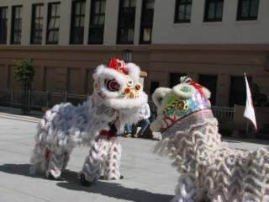
Lion Dancers

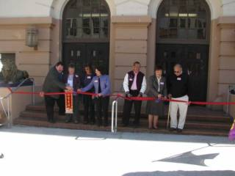
Ribbon Cutting

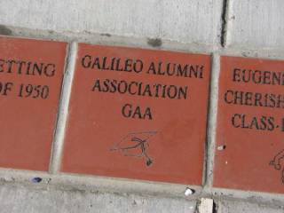
GAA Tile

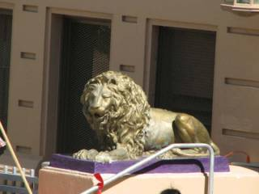
Galileo Lion

Click on any of the links below to view more photos of the tile ceremony:
Additional Photo of the Tile Ceremony, courtesy of Dennis Eleen ‘60
- Courtyard
Photos of the Tile Ceremony, courtesy of Fred Setting ‘50
- Fan dancers
- Student entertainment
- Bettie Grinnell
- John Bologna '50 & Nancy Lambert, AP
*******************************************
Last Chance To Order A Tile For The
Galileo Courtyard

April 20th is the deadline for ordering your customized tile for the Galileo courtyard. These tiles will become a permanent part of the
Go to www.galileoweb.org/ptsa for an order form. Be a part of Galileo history and tradition – order your tile today.

For additional photos of the tile installations, go to http://www.kodakgallery.com/ShareLandingSignin.jsp?Uc=k4nkxka.2zitej8u&Uy=pye1ze. Thanks to Bruce Eng, PTSA, for taking these pictures.

_______________________________________________________________________

SAN FRANCISCO ALUMNI COUNCIL

By Augie Venezia ‘53

A meeting of the San Francisco Alumni Council was held at George Washington High School on March 28, 2008. Representatives from Lincoln, Balboa, Galileo, and Washington alumni associations attended. Agenda items included a discussion of operating documents, communications, fundraisers, and school relations. Recruitment of new directors, reflecting diversity, was a concern for all the schools.

~~~~~~~~~~~~~~~~~~~~~~~

Ed. Note: If you are interested in joining the GAA Board of Directors, plan to attend the next meeting or contact a current member: http://galileoalumni.org/committee.html. All alumni are welcome!

________________________________________________________________________

LOOKING FOR …

NEW COMMITTEE MEMBERS

Several members of the Galileo Sports Hall of Fame Committee recently announced their retirements. So now we’re looking for alumni who would like to join the committee – those of you who are enthusiastic about acknowledging Galileo's past athletes and supporting the current Athletic Department. Responsibilities include attending regular meetings at Galileo, recruiting and evaluating qualified nominees, interacting with school personnel, and arranging a dinner to honor new inductees.

If you’re interested in joining the committee, go to http://galileoalumni.org/messagePres2.html. Then complete and submit the form. Please put “Sports Hall of Fame” in the message subject line.

GAA thanks Ron Ertola ’49, Mario Lombardi ’50, Pete Pompei ’51, and Bernard Valdez ‘49, for their dedication and service. During the past five years, they volunteered time, effort, and energy to honor athletes and raise funds for Galileo Academy.

Ed. Note: To view photos from past induction dinners, visit:
http://galileoalumni.org/event-sportsHallDin-2007.html,
http://galileoalumni.org/event-sportsHallDin-2006-May.html,
http://galileoalumni.org/event-sportsHallDin-2004-May.html.

~~~~~~~~~~~~~~~~~~~~~~~~~~~~~~~~~~~~

Through The Telescope. . . | 

SPRING has sprung, but, as John Denver used to sing, “Some days are diamonds, some days are stones”. We’ve had warm, sunny days mingled with cool, very breezy days. And while we’re in a musical vein, “Though April showers may come your way, they bring the flowers that bloom in May” (Al Jolson). And June will soon be “bustin’ out all over” (Oscar Hammerstein). What a prelude to “Summertime” (George Gershwin).

On April 15, Nina Clima and a group of Galileo friends attended the Giants game at AT&T Park to watch Gino Cimoli throw out the first ball. Cimoli played baseball and basketball at Galileo in the forties and was drafted by the then Brooklyn Dodgers. He played for the Pittsburgh Pirates in the famous World Series when they beat the New York Yankees in the seventh game on Bill Mazeroski’s bottom of the ninth home run. He is a member of the Galileo Sports Hall of Fame.

My favorite photo of Joe DiMaggio at the North Beach restaurant of the same name is the one of him sitting on a chair at the beach dressed in a full suit. In the men’s room you’ll see a photo of Joe with Gina Lollobrigida and another with lovelies attending a suit-clad Joe (with spats!) in a barber’s chair. Outside the men’s room there is a photo signed by Babe Ruth. Some of the most beautiful photos are of Marilyn Monroe, all in black and white.

Joe was a sartorially elegant gentleman. In the early and middle parts of the last century, men wore suits and hats, and women wore dresses and hats, especially when they went downtown. When I was in Joe DiMaggio’s restaurant recently, I saw one man with a suit and tie. How times have changed!

More sibling alumni: Frank, Nini and Manuel Tornay, Vince and Ann Tringali, Pete and Marie Moreci, Joe and Seb Saia, Al and George Karahadian.

Where are: Frank Orden, Elaine Cristiani, Joan Preble, Jean Little, Harold Sinclair, Scott Amour, Bob Gemingnani, Shelly Post, Rosemary D’Amico, Steve Sacco, Italo Baioni, Mafalda Maughelli, Paul Marchetti, Glenda Higgins, Bobbi McElroy, Irene Chicos, Larry Geraldi, Leo Giragosian, Hugh Gee.

Amichi Vecchi: Charlie Farruggia’s twice-a-year get together of old friends at Caesar’s Restaurant, is scheduled for Saturday, April 26th, at noon. There are guys who attend this luncheon that you won’t see at other events. Maybe some of the above people will show up.

I’m looking forward to attending Spring Valley Elementary School’s 155th anniversary next month along with many other Galileo alumni. At the 150th anniversary dinner, Galileo had the largest group. Tom Johnson danced with Josephine Belasco. Sadly, both are no longer with us.

The Olympic Torch, in a master stroke of re-direction (or was it deception?), was carried down Van Ness Avenue right past Galileo Academy as the whole world watched. Four years ago Galileo alum Ray Piccinini was one of the torch carriers.

I remember seeing two Presidents of the United States ride down Van Ness Avenue – Franklin Delano Roosevelt while I stood between Union and Greenwich, and Dwight D. Eisenhower at Pacific Avenue. I was standing on the traffic island in front of the United Artists Theater on Market Street waiting for the streetcar when a limo stopped in front of me at the stop light. Inside was President Harry Truman. There was no fanfare, no large police presence, just a man from Missouri visiting the City by the Bay.

Have you been to the AMC Kabuki Theater lately? When you buy your ticket you also select your seat on a computer screen. It won’t be long before other theaters adopt this policy. There is, of course, a slightly higher ticket price.

OBSERVation: With all the crazies walking around the streets of the City talking to themselves, some screaming and shouting, it’s hard to tell if some of them aren’t regular citizens talking on their cell phones and listening through ear pieces.

Pet Peeve: I’m getting annoyed by hearing orchestras warming up before concerts. It’s not music, it’s noise. I think I’ll start arriving just in time for the opening chord.

Moose’s, the popular North Beach restaurant, will close at the end of this month, after sixteen years.

Food challenge: Take a ripe avocado, cut it in half lengthwise and fill it with what? Help me out by sending in your suggestions. Tiny shrimp would be nice.

The commemorative tiles in the Galileo courtyard look great. You still have time to buy a tile (see article in this issue).

I’ve only seen one prizefight in person. In the mid sixties in Honolulu I saw the great Sugar Ray Robinson, already past his prime, fight an up-and-coming fighter named Harrington. Sugar Ray, a true boxer, moved around the ring with all the grace and agility he was famous for, but he was outmatched by the much younger man. Harrington won a 12 round decision.

Remember Pat Valentino, the local heavyweight who once went seven rounds with champ Ezzard Charles at the Cow Palace? After he retired from the ring, Pat worked as the maitre d’ at Scoma’s on the Wharf. Scoma’s never took reservations, but Pat would seat you very quickly. His paws were enormous, like bear claws. He appeared in the Clint Eastwood film, Escape from Alcatraz.

Question: What is the origin of “navel oranges”? Answer: Sailors used to eat them aboard ship. (Joke)

Serious thought: Life is a play. It’s not its length, but its performance that counts. ------ Chinese fortune cookie.

____________________________________________

Announcements

GALILEO HIGH SCHOOL REUNION
CLASSES OF 1965 THROUGH 1969
"THE WAY YOU LOOK TONIGHT"
Date: Saturday, October 18, 2008
Time: 5 p.m. to 12 a.m.
Place: Empress of China Restaurant
838 Grant Avenue (Between Washington & Clay Streets)
San Francisco, CA 94108
Menu: Chinese Banquet Dinner
Music: Groovin' to the sounds of Jest Jammin'
Cost: $75 per person (postmarked by June 30, 2008)
$85 per person (postmarked after June 30, 2008)
Make Check Payable To: Galileo 60's Reunion
Send Payment to: Ellie Wong, P.O. Box 434, San Francisco, CA 94104
For more information: Call Ellie Wong at (415) 601-5888 or Harvey Louie at (415) 982-4778

BAYVIEW REUNION

This year's Bayview Reunion will be held on Saturday April 26, 2008. Registration forms are available . If you are not on the mailing list, call Henry Sanchez at 1(415) 585-1721.

******************
FIFTH ANNUAL SAN FRANCISCO NATIVE JAMBOREE
Date: Friday, October 3, 2008 - 6:30 – 11:30 PM
Place: Sir Francis Drake Hotel, 450 Powell Street, S.F.
The San Francisco Native Jamboree is a fabulous party bringing together native San Franciscans who share the common bond of being born or raised in the most beautiful city in the world! The event’s theme is “San Francisco- the movie star, highlighting the many wonderful films that have used San Francisco as their backdrop over the years.
See the flyer for more information: http://galileoalumni.org/event-info/2008%20SF%20Native%20Jamboree.doc

THE STREETS OF SAN FRANCISCO
A group of San Francisco Natives will visit the Society of California Pioneers Museum for a docent led tour of the “Streets of San Francisco” exhibit on Saturday, May 3, 1:00 pm. The Society of California Pioneers is located at 300 4th St, San Francisco. www.californiapioneers.org

Do you know who Geary was? How about O'Farrell? Why is downtown laid out that way? Learn these answers as well as more fascinating information about the people and stories behind our streets. The exhibition incorporates paintings, prints, drawings, photographs, books, maps, sculpture, shop signs, and artifacts recalling those who made a contribution to the life and lore of the City. Visitors will also be able to view selected clips of car chase scenes-- San Francisco's cinematic calling card-- filmed on the City's steeply- graded streets.

A $5 donation to the Society of California Pioneers will be requested at the door. If you plan to attend the tour or have questions email jokeefe@yahoo.com or leave a message at 415-732-7520 X 49. This tour has been organized by volunteers who put on the annual San Francisco Native Jamboree which will be held in the fall at The Sir Francis Drake Hotel, 450 Powell Street, San Francisco, CA 94102 on Friday, October 3, 2008 from 6:30 pm to 11:30 pm. For more information, visit the Website at www.sfnativejamboree.com or email: info@sfnativejamboree.com.

________________________

Spring Valley Elementary School
To Celebrate 155th Anniversary

Be part of history! Come celebrate Spring Valley’s 155th Anniversary with former classmates and teachers. The day’s events will include sharing your story for our Memory Book, enjoying good food and great company, while honoring Lonnie K. Chin for 40+ years of contributions to education.

Date: Sunday, May 18, 2008 - 11:00 AM – 3:00 PM

Cost: $50 per person

Location: University of California San Francisco
Mission Bay Conference Center
1675 Owens Street (cross street – 16th Street)
San Francisco, CA 94158

RSVP by: April 25, 2008

Send check to Spring Valley School Social Committee, 1451 Jackson Street, San Francisco, CA 94109.

Note: Donations are welcome! Please bring memorabilia. If you have a story to share, please bring it to the luncheon or email it to springvalleysf@yahoo.com.
*******************************************************************************
Coming in the Fall . . .
There will be a exciting fundraising event in the Fall.
Watch for details in the July Observer!
GAA AWARDS LUNCHEON
By Dennis Eleen ‘60
Ghosts from the distant past arose when members of the Galileo Alumni Association met with faculty and students in the school library on February 21, 2008, to present monetary awards to various student groups.
The luncheon was provided by GAA. There was a choice of lasagna, tortellini, meat and cheese ravioli, along with a green salad.
Since we were on the school schedule, proceedings took place as we ate. Principal Vickie Pesek opened with a short greeting, after which Augie Venezia ‘53, GAA Vice President, addressed the students and faculty.
Next, Treasurer Joe Scafidi ‘50 gave out awards of $1,500 to the Dragon Boat Team, $1,600 to The Pendulum, and $1,550 to JROTC. The amounts were higher than quoted in the last Observer thanks to additional donations from alumni.
All recipients were gracious and appreciative. Members of the JROTC came to the alumni table to thank us personally for the contribution.
The highlight and major surprise of the event was when Dick Bechelli ’51, alumnus and Sports Hall of Fame member, awarded the Athletic Department a check for $9,390. Ethan Winterling, Director, gratefully accepted the gift which was $5,000 more than expected, thanks to a generous donation from an anonymous alumnus.
The meeting came to a close as the bell rung. Students and teachers had to return to class, and the alumni had to leave the ghosts in the library.
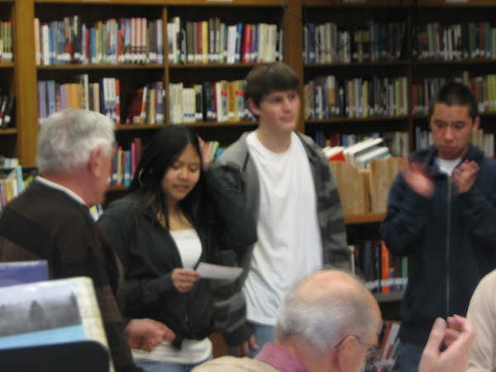
Students from The Pendulum receive their check.

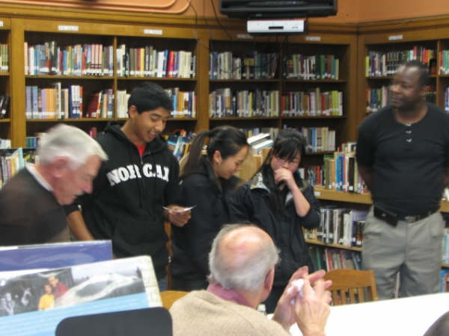
Joe Scafidi ‘50 presents check to student from JROTC.

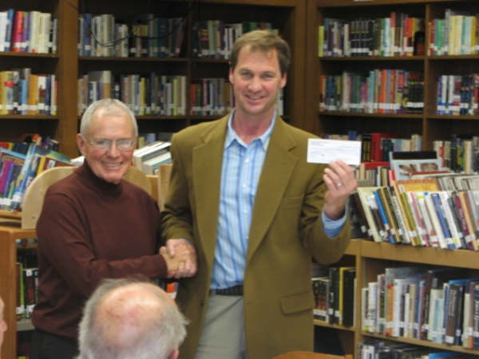
Dick Bechelli ‘51 and Ethan Winterling, Director, display results of the successful “challenge” to raise funds for Galileo’s Athletic Department.
**************************************
THANK YOU
February 29, 2008

Mr. Jim Dresser, President
Mr. Dick Bechelli
Galileo Alumni Association
1150 Francisco Street
San Francisco, CA 94109

Dear Jim and Dick:

On behalf of the Galileo Academy Athletic Program, the student athletes, and coaches of Galileo Academy thank you and the Galileo Alumni Association for your continued support and amazing, generous donation to our athletic program in the amount of $9,390.00. Your generous donation will help in the need for new uniforms and equipment, supplement travel expenses for our team tournaments, and in general improve the quality of our athletic program.

It is our continuing goal for many students to participate in a wide variety of sports throughout the school year. We also continue to emphasize the proper ideals of sportsmanship, ethical conduct, and fair play. We encourage leadership and good judgment by all Galileo student athletes; and recognize that the purpose of athletics is to promote the physical, mental, moral, social and emotional well being within our program.

Again, thank you for your continued support and commitment to Galileo sports and athletics.

Very truly yours,

Ethan C. Winterling
Athletic Director
___________________________________________________________

A Message from Linda Lau, PTSA President

Dear SF Public School Families & Supporters,

On behalf of Galileo PTSA and a concerned public school parent, I'd like to share the impact of the Governor's proposed budget cuts with you and ask for your support to take action below. Please share this info with friends and families!

Thanks,
Linda Lau, Galileo PTSA President
--------------------------------------------
Governor Schwarzenegger proposed $4.8 BILLION cut to public schools in 2008-09. The California PTA is asking for EVERYONE's help to speak up and give a LOUD message to Governor Schwarzenegger and the Legislature to: FLUNK THE BUDGET!

What does $4.8 Billion cut mean in California:
--Shutting down every school across the state for nearly one month.
--Laying off more than 107,000 teachers.
--Increasing class sizes statewide by as much as 35%.
--Reducing per-student spending by $786 per student when we already fund schools at $1900 BELOW the national average.
--Laying off more than 137,000 bus drivers, janitors, food service workers, maintenance workers and other education support professionals.
--Cutting more than $24,000 per classroom.
--Eliminating all music, art and career technical education programs statewide, with room to cut even more.

Please call or email the senators and assembly reps below to express the key points below. Together we CAN make a difference! Make the contacts NOW if you don't want the Governor's budget to pass! Provide your name, that you're a constituent living in SF, and that you're urging the senator/assembly rep to Flunk the Governor's Budget.

Read more info & advocacy tips from CA PTA's website: http://pta1stdistrict.org/webpage.asp?mid=101

California Senate and Assembly Reps to contact:
Senator Carole Migden
Capitol Office | San Francisco District Office
State Capitol, Room 5114 | 455 Golden Gate Ave
Sacramento, CA 95814 | Suite 14800
(916) 651-4003 | San Francisco, CA 94102
 | (415) 557-1300
email link: http://legplcms01.lc.ca.gov/PublicLCMS/ContactPopup.aspx?district=SD03
Senator Leland Yee
Capitol Office | San Francisco Office
State Capitol, Room 4048 | 455 Golden Gate Avenue,
Sacramento, CA 95814 | Suite 14200
(916) 651-4008 | San Francisco, CA 94102
 | (415) 557-7857
email link: http://legplcms01.lc.ca.gov/PublicLCMS/ContactPopup.aspx?district=SD08
Assemblywoman Fiona Ma:
Capitol Office | District Office
State Capitol | 455 Golden Gate Ave., Suite 14600
P.O. Box 942849 | San Francisco, CA 94102
Sacramento, CA 94249-0012 | (415) 557-2312
(916) 319-2012
email link: http://legplcms01.lc.ca.gov/PublicLCMS/ContactPopup.aspx?district=AD12
Assemblyman Mark Leno:
Capitol Office | District Office
State Capitol | 455 Golden Gate Ave.
P.O. Box 942849 | Suite 14300
Sacramento, CA 94249-0013 | San Francisco, CA94102
(916) 319-2013 | (415) 557-3013

Restaurant Review

A Roman Beauty

On buildings all over Rome there are the initials SPQR (meaning the Senate and the people of Rome). The two people (Terry Lindgren and Nate Appleman) who own the highly successful and popular restaurant A16 in the Marina recently opened their second location and named it SPQR. On Fillmore Street between Pine and Bush, it is in the center of the Pacific Heights/Fillmore trendy district. Its concept is what attracted me: no reservations, walk-ins only and small plates and large plates that change daily. The restaurant opens for dinner at 5:30 PM. I walked in at 5:45 on a Friday night to find the one remaining seat at the bar. The restaurant was filled to capacity. People line up outside, waiting for the door to open. Conversation is easily initiated among the excited diners and drinkers. Wines are served in your choice of taste, glass, half bottles or bottles. Whereas A16 serves Southern Italian wines, SPQR concentrates on Northern Italy.

Small plates are $7 each or 3 for $18 and 5 for $28 when ordered together. One can easily make a meal of 3 small plates. There are pastas ($12 - $14) and entrees (all at $19). I chose a delicious marinated beets and ricotta dish, fried Brussels sprouts with garlic, capers, lemon and parsley, and sweetbreads with celery, garlic, lemon and oregano. The Brussels sprouts are one of the most popular dishes while the sweetbreads, four delicately breaded pieces, were just the right amount. I finished the meal with a rice pudding with pistachios, dates and lemon ($7), the best I’ve had anywhere. I’ve been back to this restaurant several times, and it never fails to please.

Chef Appleman oversees SPQR as well as A16, and his creative master touches are evident in both restaurants. When the house is full (when isn’t it?), the table seating can be a little too close, but there are two sections to the bar, one of which is directly in front of the open kitchen. This is a wonderful place to visit for a bite or a full dinner before going to a movie in the area or afterwards, provided you can get a table or seat. Don’t miss it; it’s already a bright spot in the A16 portfolio. By the way, SPQR is also open for lunch Monday through Friday and brunch on weekends.

SPQR, 1911 Fillmore Street, San Francisco. Tel. 415-771-7779. 4 stars out of 5.

Note: While you’re in the Fillmore, you might want to wander down to 1300 Fillmore, the new restaurant and lounge near Yoshi’s. It has great atmosphere, like a true nightclub. Check out the DVD located in the mirror behind the bar. It has constantly changing images of the great jazz figures who made the old Fillmore famous, people like Duke Ellington, Louis Armstrong, Billie Holliday, Charlie Parker, Eartha Kitt, Dizzie Gillespie, Vernon Alley, and places such as Onorato’s, New Jack’s Lounge, Jimbo’s Bop City, Wesley Johnson’s Club Flamingo, and Gallen Kamp’s. It’s a visually fascinating history of The Fillmore from 1941 to 1968.

_________________________________________

LETTERS
Hello, my name is Ofelia Salazar and I graduated in 1998 and was curious as to whom I can contact for information of a 10 year reunion. I hope it didn't pass already, but any information if it did or didn't I would appreciate. Thanks. Please send any information to salazarofelia@comcast.net.
Ed.Note: If you are planning such a reunion, please contact Ofelia, and let us know so we can post it on http://galileoalumni.org/home.html.
*******************
Good to meet you the other day at school [Galileo Tile Ceremony]. I didn't realize that the 1972 website had a link to your alumni website. I'll take a better look at it soon. The last time I went into there was to view the pics of the class reunion picnic a couple of years ago.

I think the best way to get the word out is for someone to email the Tile Drive flyer directly to the alumni email addresses. People are generally not going to open up a website, whether it be the PTSA or alumni website, and go searching for a flyer or a link. If Bruce Eng had not attached the flyer and sent it to me directly at my email address, I wouldn't have purchased one.

The persons whom I know from our class that are in charge of the group reunions are Gloria Louie and Frank Jang. Thanks for the link. ---Leslie Chan

Ed. Note: Leslie and I had an interesting discussion about how to better communicate among the various web sites and reunion committees in order to increase awareness of Galileo alumni events.

~~~~~~~~~~~~~~~~~~~~~~~~~~~~~~~~~~~~~~~~~~~~~~~~~
Editor’s Note
The Observer is issued four times a year during the months of January, April, July and October, and has no specific publication date.
**********************************************
CALENDAR OF UPCOMING EVENTS
GAA Board Meeting, June 5, 2008, 6:30 PM, Galileo Academy
Bayview Reunion, April 26, 2008
Amichi Vecchi, April 26, 2008, Caesar’s Restaurant
Streets of San Francisco Museum Tour, May 3, 2008
Spring Valley School 155th Anniversary, May 18, 2008, UCSF Mission Bay Conference Center
Exciting Fundraiser, Fall 2008
S. F. Native Jamboree, October 3, 2008
40th Reunion Classes 1965 through 1969, October 18, 2008
When checking for upcoming events between issues of the Observer, please visit the web site http://galileoalumni.org/home.html which has the most up-to-date listing.
_________________________________________________________
Observer Staff

Editor
Sisvan Der Harootunian

Assistant Editor (Mail Edition)
Jan Baumel

Contributors
Dennis Eleen
Bruce Eng
Linda Lau
Fred Setting
Augie Venezia

Production/Circulation (Email)
Vaughn Spurlin
_____________________________________________________

WRITERS/REPORTERS WANTED!
For articles and stories on alumni, events, whereabouts of graduates for this newsletter. No mastery of English required, just your willingness to communicate and participate. Contact the Editor.
* * *
If you would like to promote your Galileo event on the GAA website
http://www.galileoalumni.org/, please send information to
galileoobserver@aol.com and/or webmaster@galileoalumni.org.
* * * * *
The OBSERVER Is For All
Galileo alumni, family, friends, students, faculty . . . anybody and everybody, the Observer is for you. If you haven't already done so, send in the email addresses of anyone you know who would like to receive a FREE emailed newsletter once every four months. We'd like to reach as wide a range of readers as possible. Send the email addresses to webmaster@galileoalumni.org.

BACK ISSUES OF THE GALILEO OBSERVER CAN BE VIEWED AT http://galileoalumni.org/news/newsletters.html
For all EDITORIALLY-RELATED comments or suggestions, please address your emails to galileoobserver@aol.com.
For all TECHNICAL problems (non-receipt of newsletter, etc.), address your emails to webmaster@galileoalumni.org.
* * * *
The Galileo Observer invites your articles, letters, memories, inquiries and suggestions. All submissions are subject to editing. Deadlines for submissions are January 1, April 1, July 1 and October 1. Send them by email (preferable) to galileoobserver@aol.com, or by postal mail to: Galileo Observer, c/o Galileo Alumni Association, 1150 Francisco Street, San Francisco, CA 94109.

GAA BOARD OF DIRECTORS & OFFICERS ARE LISTED AT http://galileoalumni.org/committee.html

The Galileo Observer is issued quarterly during the months of January, April, July and October by the Galileo Alumni Association, 1150 Francisco Street, San Francisco, CA 94109. Views expressed are strictly those of the Association and in no way reflect those of the Galileo Academy of Science and Technology, its students or faculty. James Dresser, President; Sisvan Der Harootunian, Editor; Vaughn Spurlin, Production Manager/Website Director. Copyright 2008, Galileo Alumni Association.
Last updated April 2008
© 2002-2008 Galileo Academy of Science and Technology Alumni Association of San Francisco. No part of this publication can be reprinted or reproduced in any form without the permission of The Galileo Observer and/or The Galileo Alumni Association.

