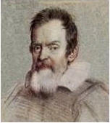 | THE GALILEO OBSERVER  The Official Newsletter of the  Galileo Alumni Association | 

“Communicate and Participate”

Vol. VIII, No. 2 __________________ _____________________ April 2010

Editor’s Note: This month we introduce two articles by Galileo Pendulum staff writers. Molly Smith writes
about the state competition on the Constitution, and Annie Kwok discusses the environmental
project taken on by the statistics class. Vince Gomez (’52) continues his quarterly column, Mez Sez, with
memories of his San Francisco school days, friends, and musical career.
________________________________________________________________________________________

We’re having a
Spring Fling
. . . . .and you’re invited!



GO LIONS!

GALILEO ALUMNI ASSOCIATION FAMILY & FRIENDS “SPRING FLING”

On April 17, 2010 the Galileo Alumni Association will be holding a “SPRING FLING” social event for the Alumni, their Family and Friends at the Italian Athletic Club, 1630 Stockton St. San Francisco. Please join us for an evening of socializing, no host cocktails, dinner, silent auction, raffle and dancing. Tickets are $40.00 each. Cocktails start at 6:00 p.m. and dinner at 7:30 p.m.

Seating is open so first come first serve.

Dinner includes: Salad, Antipasto, Rosemary Roasted Half Chicken, Pasta, Dessert and wine. For vegetarians Eggplant Parmigiana will be available. (Napoleon of Eggplant, Fontina Cheese, Basil, Tomatoes).

Order your tickets early as they will go fast. Tickets will not be sold at the door.

PLEASE RETURN NO LATER THAN APRIL 10, 2010

Please detach form and mail

Complete this form and mail to address below. Make check payable to Galileo Alumni Association.
Galileo Alumni Association, Attn: Spring Fling, 1150 Francisco Street, San Francisco, Ca. 94109

APRIL 17, 2010
No host Cocktails at 6:00 – Dinner 7:30
Italian Athletic Club
1630 Stockton Street
San Francisco Ca 94133

Name: __________________________________ Email ______________________Phone______________

Number of Tickets: ______ x $40.00 per ticket = Total _______

Print name of guest Print name of guest

____________________________________ ______________________________________

____________________________________ ______________________________________

All tickets will be held at the door.

If you have any questions, please contact Charlene Fachner Mori at 415.297.4280 or email at galileoalumni@yahoo.com.

________________________________________________________________________________

Salesian Honors Two Galileo Alumni

On April 10th, the Salesian Boys’ & Girls’ Club will honor Joe Martino (’50) as their Man of the Year.
The dinner dance will be held at the Westin St. Francis Hotel. Joe has been very active in the Club, having served as President of the Board of Directors. He previously was awarded the Father Trinchieri Medal in 2002 for his contributions to the Club.

Gene Di Basilio (’50) will be honored as the Old Timer of the Year and receive the Father Trinchieri Medal on May 3rd at the Club’s Annual Founders’ Night in the Sts. Peter & Paul Church auditorium.

______________________________________________________________________________________________
Through The Telescope. . .  Sisvan Der Harootunian | 

With all the talk about global warming, I wish we’d have some local warming. Oh, well, spring is here and summer’s on the way.

Hey, Pola and Joe Martino! You’ve got company! Ronald Ricossa (’46) and Anstell Daini (Fall ’47) write that they have been together for 57 years! They bet there are more couples to keep Pola and Joe company. Are there?

Question: Where did the Caesar Salad originate? (answer at the end of this column)

The latest buzz phrase, “body of work,” is not referring to an author’s or an artist’s total production, but to the entire season of an NCAA basketball team.

Does anybody know if Brian Boitano, Olympic gold medal skater and recent Bay Area Hall of Fame inductee, is related to Jerry Boitano (Galileo 1951)?

George Poppin was a good friend of the Observer. He always enjoyed reading about Galileo and the alumni, many of whom he coached in football. When he died last month at the age of 91, he was remembered and missed by many loyal friends, students and players, even by those who never met him.

Fortune in Chinese cookie: “A man can fail many times, but he isn’t a failure until he gives up.”

Answer to question above: the Caesar Salad was originated on July 4, 1924 by Italian-born Mexican Chef Cesare Cardini at the Hotel Caesar in Tijuana, Mexico.

Until next time, the observatory is closed.

____________________________________________________________________________________

Mez Sez

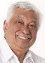
Vince Gomez (’52)

On Groundhog Day, February 2,1935, I made my vocal debut in the nursery at San Francisco General Hospital. Little
did I know that 75 years later I would be guest conducting at the 47th annual Orchestra Festival held in Billings, Montana. It was a long way from San Francisco on life's road. This concert reminded me of my own development in the schools I attended in the San Francisco Unified School District -- Washington Irving, Francisco Junior High. and Galileo High School. My Filipino immigrant parents, Vicente Gomez and Catalina Entero, started my private violin lessons at age 5. All my teachers at these schools encouraged my music endeavors. Mr. Haig Kafafian at Francisco and Mr. Kenneth Ball at Galileo were the music directors of the first orchestras I played in. Mr. Ball was instrumental in my gaining a violin scholarship to the then College of Pacific (now University of Pacific) in Stockton, California.
On March 12, 2010 I was inducted into the California Music Educators Association Hall of Fame at the annual
conference held in Sacramento. These two memorable events brought back many thoughts and memories from my school days in San Francisco. I recalled three classmates who went to school with me at all three schools and graduated in 1952 from Galileo. They were Irma Briano, Rita Chin, and Caroline Pieretti. I did not see them again until our 50th class reunion in 2002. We must have been having fun since those years just flew by. Several of my fellow 1952 Galileo graduates were also classmates at Francisco. They were Lawrence Bravo Jr., Sal Giannino, Norm Marcelli, Juan Rico, Marian Napolitano, Andrea Puglisi, Shirley Sichon, and Mercedes Refre, among others. The years at Galileo brought together students from Marina and other Junior Highs. Student musicians Jack La Rocca, Vince La Rocca, Fred Rocco, Ron Malvesti, Sandra Bicknase, and singers Joanna Woeber, Irene Laytman, and Mel Chiarenza were fellow musical Lions. Members of the Galileo athletic teams of that time included fellow Sports Hall of Famers Jim Dresser, Sisvan Der Harootunian, Ron Sligar, Pete Pompei, Don Bragg, Ed De Martini, Frank Pavich, Fred Setting, Tom King, Carla Fischer, and Joanne Millen to name a few. Monica Parenti and Dee Ann Falwell were two schoolmates that went into the teaching profession after college work at San Jose State.
My two years as a music teacher at Benjamin Franklin Jr. High (Fillmore District) in the 60's brought me together
with faculty members John Orofino and Leon Cathey, who eventually taught at Galileo with Fred Setting in the 70's and 80's. Fellow 1952 graduate, Ed DeMartini was also on the Franklin faculty. Another interesting note is that Robert Mohler, who was the Galileo school librarian at that time, was my 5th grade teacher's (Edna Mohler) son. Those of us who were born and raised in San Francisco during that time period have truly become a rare breed. We remember with fondness our classmates, teachers, family and the San Francisco landmarks like Playland at the Beach, the City of Paris store, Roos Brothers, the Fox Theater, Seals Stadium, Kezar Stadium, and the Commerce High School football field which is now Davies Symphony Hall. This reflection on our schooldays in San Francisco made me aware of what a beautiful area we have lived in. I send all who read this the best of health for the rest of 2010, and KEEP HAVING BIRTHDAYS!
Ed. Note: On April 3rd, Vince Gomez received the Lifetime Achievement Award from the San Francisco Filipino American Jazz Festival at the San Francisco Public Library during Jazz Appreciation Month. He played bass with other jazz musicians who were also honored at the event.
_______________________________________________________________________________________________

Announcements
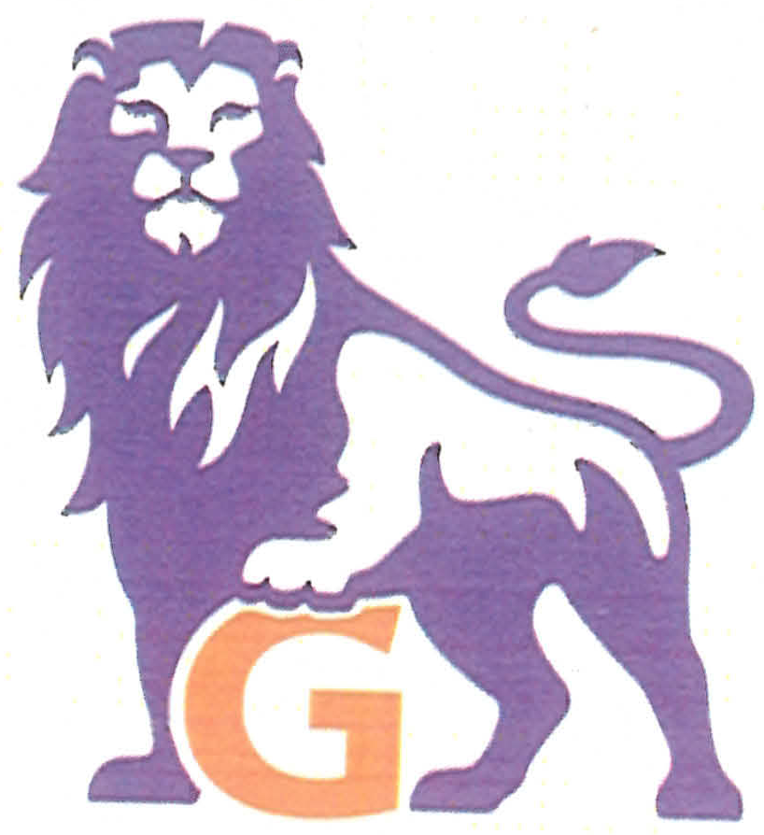
Galileo High School
Class of 1970 Reunion

Dear Classmates and Friends:

The Class of 1970 Reunion Committee will hold its 40th year reunion:

DATE: Saturday, October 30, 2010 PLACE: Green Hills Country Club
5 PM to 10 PM 500 Ludeman Lane, Millbrae, CA 94030

Attire: Dressy Casual or Dressy. NO JEANS Optional: 1970’s Block G sweaters

Cost: $75.00 per person if postmarked by July 31, 2010 or $85.00 per person if postmarked after July 31, 2010

Menu: Buffet-style dinner includes Cheese & crackers, Salads, Carved meats, Pasta, Fruits, Desserts, Coffee and Tea.

Drink tickets will be sold at the door. $3 per ticket. (minimum of 2 tickets for alcoholic drinks). CASH ONLY. Dietary restrictions upon request.

Dance to the music of Jest Jammin’

Questions? Email them to galileoreunion2010@yahoo.com or contact
Nancy J.Yee, DDS – callmenjy@yahoo.com; Gail Chong Megdadi – gailchong1970@yahoo.com (925-837-9198);
Galen Dea – galendea@yahoo.com; Lemoyne Wong – wonglady1970@yahoo.com

Copies of the yearbook will be on sale for $10 at the reunion. To reserve your copy, contact Galen Dea at galendea@yahoo.com or call 510-205-9660
Please detach form

Complete this form and mail to: Galileo Class of 1970 Reunion
c/o Gail Chong Megdadi
P. O. Box 1233, Danville, CA 94526

Make check payable to: Gail Chong Megdadi

A table of 10 can be reserved by making a one-time payment for 10 people.

Name: ______________________________ Email: __________________________ Phone: _________________

Print name(s) of guest(s)________________________________________________________________________

____________________________________________________________________________________________

* * * * *
The 66th Homecoming Song & Yell Contest is scheduled to be held on Friday, October 8, 2010, at George White Field. The football game will be Galileo vs. Balboa.

* * * * *

Galileo Makes it to Semi-Finals of “We The People” For The First Time
By Molly Smith, staff writer

After competing for over 10 years in “We The People: The Citizen and the Constitution,” a California competition among high school students regarding principles of the constitution, Galileo made it to the semi-finals in Sacramento for the first time. Despite not getting a top score at the competition, Ms. Rosemarie Langley’s American Democracy 12th grade class was able to spend two nights at the Hilton Hotel along with students from eleven other schools around the state.
The first phase of the competition was held at City Hall in December against Foothill High from Pleasanton and Leadership High from San Francisco. The classes were divided into six groups, each of which prepared a short speech answering various questions and presented them before a panel of judges ranging from teachers to law professors. They were then given follow up questions and later critiqued and scored by the panel.
Galileo was invited to Sacramento as a “wild card,” a school that came in second place but beat out other first place schools from other districts, along with all of the first place schools from around California. Galileo has been invited to Sacramento before, but was never able to attend because of the timing or lack of funds.
This year, the money came from the Social Studies department, paying for the hotel, the bus, and the substitutes while the teachers (Ms. Vicky Ung, Ms. Loan Ly, and Mr. Stanley Debella) were absent.
Students were provided with many activities apart from the competition itself, such as a dance and access to a pool, gym and Jacuzzi. During the group dinners, two student speakers from each school gave a speech, read a poem, or sang a song thanking their teacher. Galileo’s student speakers were Rory Fewer and Molly Smith.
In the first round of the competition, the students headed to their hearing rooms where they sat for six hours as judges came in and listened to each unit’s presentation, followed by eight minutes of follow up questions and some critiques. The teams were scored individually, then put up for round two following the same procedure.
Amador High won the competition, moving on to the State Capitol the following day and eventually moving on to Washington D.C. to represent California in the finals. An additional recognition award was given to six different schools for one of their group’s performance. From Galileo, Zsa Zsa Zseng, Brian Pang, Nicholas Lew, Andy Lo, Peggy Li, and Ivan Lu won the award.
Although Galileo’s students were as dedicated as the rest, it was not an unexpected loss because of their lack of preparation. Many of the other schools involved worked all year, and some even the summer before, being trained by debate and speech coaches and forming clubs or teams instead of the entire class going. However, because of this, Galileo also seemed to draw more attention and to stand out from the crowd. “People were coming up to me saying we gave off a good vibe and they wanted to see what we were all about,” said Ms. Langely.
Ms. Langley hopes the tradition will continue next year, but teachers are hesitant because it takes a lot of preparation time and can take away from regular lessons. “It’s a more interesting and challenging way to learn than from just a textbook. Students get a better idea of politics and what it takes to be a good citizen,” she said.
“We The People” is considered one of the most prestigious academic competitions for high schools. It promotes civic competence and responsibility and raises awareness in students of their rights and the foundations of American democracy. It is set up to simulate a congressional hearing so students can gain a more hands on experience.
Ed. Note: Dee Ann Falwell Morgan (’52) is Region Coordinator of the program. Additional information can be found at www.cawtp.com.

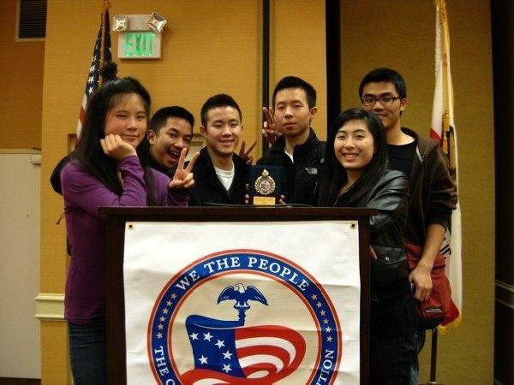

Statistics Students Take on Environmental Project
By Annie Kwok, Staff Writer
This year, AP Statistics teacher Mr. Page is using a new and creative method for his statistics class to learn about data. Statistics students are taking on an environmental project that not only allows them to get involved in their community, but also to experience it through statistics. When the projects are completed, they will have a chance of having them presented at the Eco Fest this spring, which is a yearly environmental summit and green block party held in San Francisco.
This is the first year that Mr. Page has decided to have his students work on an environmental related project. “While many aspects of statistics are easy to understand and learn from a text or regular teaching methods, the complexities and issues with producing data need to be experienced first hand by actually doing a project,” he explains.
Usually, Mr. Page has students working on a group project after the AP exam in May, but he wanted students to work on something more meaningful and new. “The projects didn't really contribute to anything beyond a grade in my class. It seemed like a waste to have so many bright students working on projects, but not having anything to really show for it in the end,” he explains. “While there are lots of potential issues for student projects, most don't have the current and future impact on students like environmental issues. The student's generation will have to live the effects on the environment that my generation and previous generations have created.”
From this project, Mr. Page hopes students not only gain knowledge in statistics, but also in the environment. “I really hope they get an understanding of how challenging it is to do statistics right, and to look critically at numbers and claims that they see and read in the newspaper and other sources. I also hope this provides them a positive experience and gives them a better appreciation and understanding of their environment.”

For the project, students are designing and conducting studies, surveys, and experiments in order to discover more about environmental issues while using statistics. The topics that students have chosen to work on concern water, energy and food. Richard Liu chose the topic fresh water drinking supply safety because he is interested in learning about water. “I hope to learn what is in the water we are drinking so we can be careful of what we put in our bodies,” he explains.
Students have found almost 500 resources regarding these topics that will help them throughout their experiment and designing questions. The next step for students is to develop a statistical study or experiment to answer their questions.
Mr. Page met the ESLI (Environmental Service Learning Initiative) organization that was enthusiastic about working in conjunction with the statistics class and lent a hand in following through with the project. ESLI works to teach environmental education in San Francisco high school classes. Ms. Eiei Khin, from ESLI has been coming in weekly to work with students. “My experience with collaborating with teachers and students at Galileo, in general, has yielded valuable harvests. The statistics class, specifically, is exciting because of the highly capable students and a passionate teacher leading them,” she says.
Some students find learning how to use statistics through this project makes class more exciting. "Not only does this project teach us how we can use statistics in our daily life, but it also makes class more interesting because this project is very meaningful," says Anna Cai, a student currently working on the project.
However, some students fear that with this project, they will not have enough preparation for the AP exam in May. "I would prefer to spend our time focusing on learning and preparing for the AP exam, and maybe work on the project after the exam,” a student explains. Mr. Page feels confident that students will be able to accomplish both the project and preparing for the AP Exam. “To some students outside class work and working on a project like this are far more valuable than lectures and homework,” he says.
* * *
Obituary
George Poppin
(1918 – 2010)
The beloved former Galileo football coach (late 50’s and early 60’s) passed away on March 1st. Those who knew him or played for him remember him well. He will be missed by all. For the complete obituary, go to http://www.legacy.com/obituaries/sfgate/obituary.aspx?n=george-poppin&pid=140240933

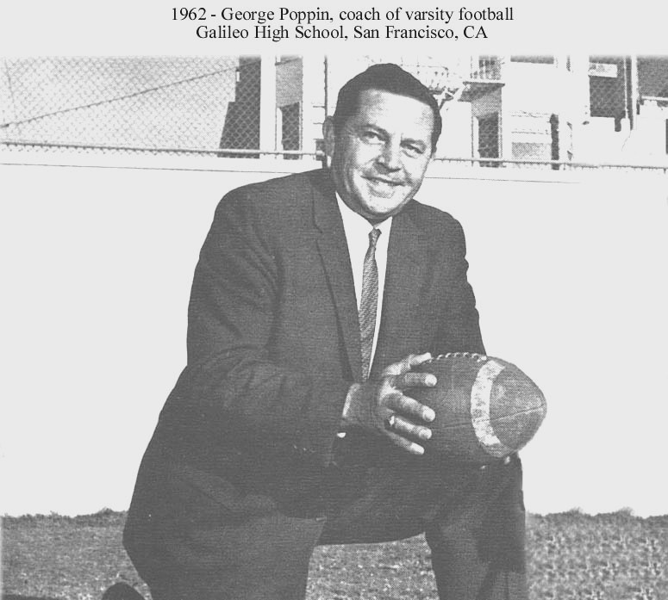

LETTERS
Great job “new staff”…..thanks so much…Informative, nostalgic, and just plain good reading….Bill Flanagan ’56.
___________________________________________________________________________________
CALENDAR OF UPCOMING EVENTS
GAA Board Meeting - Room 210, Galileo Academy, 6:30 PM, Thursday, April 8, 2010
Family & Friends Spring Fling, Italian Athletic Club, San Francisco, 6:00 PM, Saturday, April 17, 2010
66th Homecoming Song & Yell Contest, George White Field, Friday, October 8, 2010
Class of 1970 40th Reunion, Green Hills Country Club, Millbrae, Saturday, October 30, 2010
****************************
When checking for upcoming events between issues of the Observer, please visit the web site http://galileoalumni.org/home.html for the most up-to-date listings.
_____________________________________________________

Contributors
Vince Gomez
Annie Kwok
Molly Smith
The OBSERVER Is For All
Galileo alumni, family, friends, students, faculty . . . anybody and everybody, the Observer is for you. If you haven't already done so, send in the email addresses of anyone who would like to receive a FREE emailed newsletter to http://galileoalumni.org/contact.html. We'd like to reach as wide a range of readers as possible.

BACK ISSUES OF THE GALILEO OBSERVER CAN BE VIEWED AT
http://galileoweb.org/alumni/newsletter/.
For all EDITORIALLY-RELATED comments or suggestions, please address your emails to galileoobserver@aol.com.
For all TECHNICAL problems (non-receipt of newsletter, etc.), address your emails to http://galileoalumni.org/contact.html.
* * * *
The Galileo Observer invites your articles, letters, memories, inquiries and suggestions. All submissions are subject to editing. Deadlines for submissions are January 1, April 1, July 1 and October 1. Send them by email (preferable) to galileoobserver@aol.com, or by postal mail to: Galileo Observer, c/o Galileo Alumni Association, 1150 Francisco Street, San Francisco, CA 94109.

GAA BOARD OF DIRECTORS, OFFICERS, & COMMITTEE CHAIRS ARE LISTED AT http://galileoweb.org/alumni/contact/
The Galileo Observer is published quarterly in January, April, July and October by the Galileo Alumni Association, 1150 Francisco Street, San Francisco, CA 94109. Views expressed are strictly those of the Association and in no way reflect those of the Galileo Academy of Science and Technology, its students or faculty. Dennis Eleen, President; Sisvan Der Harootunian, Editor; Vaughn Spurlin, Production Manager/Website Director. Copyright 2010, Galileo Alumni Association.

Last updated April 2010 © 2002-2010 Galileo Academy of Science and Technology Alumni Association of San Francisco. No part of this publication may be reprinted or reproduced in any form without permission of The Galileo Observer and/or The Galileo Alumni Association.

