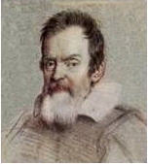 | THE GALILEO OBSERVER  The Official Newsletter of the  Galileo Alumni Association | 

“Communicate and Participate”

Vol. VIII, No. 3 __________________ ______________________________________ July 2010

A Letter from the Editor

The Board of Directors of the Galileo Alumni Association is comprised of a group of dedicated alumni who meet several times during the year, usually once a month, to plan, discuss and implement ways to help our school and encourage alumni to participate in events and activities. This group, of which I am proud to be a member, volunteers its time and efforts to carry out the mission of GAA, “to engage the alumni as a unified group to the benefit of all members of the high school community which include the alumni, students, faculty, staff, and friends.” One board member travels over 200 miles roundtrip to attend meetings and events, another over 100 miles. The Board has received the endorsement and cooperation of the faculty and staff of Galileo and members of the PTSA. Increasingly more of these individuals have shown interest in helping GAA to achieve its goals. Our membership has recently increased greatly (see article in this newsletter).

To our members and alumni: Look to your GAA for leadership, honesty and integrity in carrying out its mission. If at any time you have a comment or suggestion, please let us know directly at GalileoObserver@aol.com or send to Galileo Observer, c/o Galileo Alumni Association, 1150 Francisco Street, San Francisco, CA 94109. At the end of each newsletter is a statement inviting you to do so. We publish all letters to the editor.

May you all enjoy a happy summer.

Sisvan Der Harootunian
_________ _____________________________________
Picnic by the Bay
Get the suntan lotion out and gather up the kids. The GAA is holding a picnic for all alumni, family and friends on Saturday, August 14th at McNear’s Beach in San Rafael. There will be games, a cash raffle, relay races, volleyball, horseshoes and more. There is also a fishing pier (no license needed on the pier). Food is included in the fee. Hope to see you there! See details below. . .

GAA FRIENDS & FAMILY PICNIC BY THE BAY
MCNEAR’S BEACH SATURDAY AUGUST 14, 2010 201 CANTERA WAY, SAN RAFAEL CA 94901
RAFFLE BEACHSIDE # 7 – 10:00 am to 6:00 pm GAMES
SATURDAY AUGUST 14, 2010 THE GALILEO ALUMNI ASSOCIATION WILL BE HAVING A FAMILY & FRIENDS “PICNIC BY THE BAY”. FOOD & FUN. BRING THE FAMILY, CHILDREN AND FRIENDS. THERE WILL BE GAMES, CASH RAFFLE, FOOD (HAMBURGERS/HOTDOGS/CHICKEN, SALADS, ETC.) AND DRINK PROVIDED (NO ALCOHOL PROVIDED) BYOB. PLEASE FEEL FREE TO BRING A SIDE DISH TO SHARE. WE WILL HAVE GAMES, RELAY RACES, VOLLEYBALL, AND HORSESHOES ETC. FOR CHILDREN AND ADULTS.
PLEASE PACK YOUR CAR WITH RIDERS TO SHARE THE PARKING FEE WHICH IS $10.00 PER CAR. SWIMMING IS $5.00. BRING YOUR FISHING POLE, NO FISHING LICENSE NEEDED ON THE PIER.
PLEASE RETURN/PAY NO LATER THAN FRIDAY AUGUST 6, 2010
PAY ON LINE AT http://galileoweb.org/alumni/ OR DETACH FORM AND MAIL NO LATER THAN AUGUST 6, 2010.
MAKE CHECKS PAYABLE TO GALILEO ALUMNI ASSOCIATION. MAIL TO: GALILEO ALUMNI ASSOCIATION, ATTN: “PICNIC BY THE BAY”, 808 GREENWICH STREET, SAN FRANCISCO CA. 94133.
SATURDAY AUGUST 14, 2010 10:00 A.M. – 6:00 P.M.
MCNEAR’S BEACH BEACHSIDE #7
201 CANTERA WAY, SAN RAFAEL, CA. 94901
NAME: _______________________________EMAIL:______________________PHONE:________________
PLEASE PRINT CLEARLY IF YOU WOULD LIKE TO VOLUNTEER PLEASE GIVE CHARLENE A CALL
NUMBER OF TICKETS___ADULT X $15.00 NUMBER OF TICKETS ____CHILDREN 8—15 X $10.00 7 & UNDER FREE TOTAL AMOUNT ENCLOSED $_________
YOU CAN NOW PAY ON LINE BY CREDIT CARD OR PAYPAL JUST CLICK ON THIS LINK http://galileoweb.org/alumni/
If you have any questions, please contact Charlene Fachner Mori at 415-441-6445 or email galileoalumni@yahoo.com
 GAA Web Page http://galileoweb.org/alumni/ 

* * * * * * *

Welcome, 2010 Graduates!

The Galileo Class of 2010 has the distinction of being the first class to be made GAA members upon graduation.

The 2010 Class consisting of almost 500 seniors received their GAA membership cards along with their diplomas at graduation in Bill Graham Auditorium on June 3rd.

Some of the highlights of the 2010 Class:
- 16th All City Football Turkey Bowl Champions (new CIF record)
- All City Baseball Champions (first since 1978)
- College destinations include: UC Berkeley, UC Davis, UC Irvine, UCLA, UC Merced, UC Riverside, UC Santa Barbara, UC Santa Cruz, UC San Diego, SF State, SJ State, CSU East Bay, CSU Long Beach, Sacramento State, Cal Poly San Luis Obispo, CSU Fullerton, CCSF, Skyline, College of San Mateo, and 20 private schools (e.g., Dartmouth).

Many thanks to those who helped in this GAA membership boosting project: GAA - Toni Alessandra, Charlene Mori, Sisvan Der Harootunian, Dennis Eleen, Vaughn Spurlin; Galileo Administration – Nancy Lambert, Candace Boran, Vicki Pesek, Zoe Duskin; Galileo PTSA – Bruce Eng.

With some advanced planning and coordination, it is anticipated to make GAA membership upon graduation a tradition for all future graduating classes of Galileo.

Ed. Note: Bruce Eng of the PTSA was the driving force behind this plan that stems from his original idea. He contributed this article.
___________________________________________________________
Spring Fling A Huge Success!
On April 17th the Galileo Alumni Association Family & Friends held its first “Spring Fling”. Over 100 alumni, friends and family attended the event at the Italian Athletic Club in San Francisco for a night of fun. The evening started with cocktails, dinner, a raffle and auction. Dancing followed. There was much socializing, laughter, and reminiscing. There was a guest appearance by Mr. Jack McCaffrey, a favorite teacher to most of us. He taught at Galileo from 1959 to 1999. If you couldn’t make this one, we will be having other events in the near future so make sure you check the Galileo web page for updates, http://galileoweb.org/alumni/.
You may view the pictures from the Spring Fling here… http://picasaweb.google.com/113394033156730045567/GAASpringFling?feat=directlink#

Note: Charlene Fachner Mori (’66), event organizer, contributed this report.

**********************************
__________________________________
Through The Telescope. . .  Sisvan Der Harootunian | 

4th of July weekend in the Bay Area. Many events going on. Sunday, saw a spectacular patriotic concert at the Stern Grove Festival with Patricia Racette and the S. F. Opera Orchestra & Chorus in a program that rivaled that of any in Boston or Washington, D.C., minus the fireworks. Monday, in Sausalito, walked around town like a tourist. The Alta Mira, where we used to drink gin fizzes, is now a drug rehab center. My dream Tuscan villa, Ladera, down the hill, is one of my two favorite houses, the other being south of Carmel overlooking the bay. Gene Hiller in Sausalito sells Brioni suits for $6,000 and belts for $325+. I bought my first Brioni jacket for under $100 in the 60s at David Stephen in S. F. At a gallery I admire the work of Rodney Lough Jr., a wilderness photographer who makes high definition photos of familiar scenes and has a gallery in Las Vegas’ new City Center. At Poggio I have a double cappuccino made by Diego Rodriguez, the coffee-savvy bar manager. At noon I meet Paul Lamphere (’51) for lunch at The Spinnaker, and we spend 2 hours at a corner view table going over old times. Paul and I were born on the same day in 1933 (the racehorse Seabiscuit was born the same year). A stroll through downtown Sausalito follows on an overcast, cold typical summer day (what else is new?).

It’s summer (really?), and I’m wondering where I’ll go on my vacation. I’ve yet to go to France, but that takes some planning. Should I go on my first cruise? It’s hurricane season in the Caribbean, and that’s where I’d go, to the island of Antigua, where 40 years ago I tried my hand at the hoop and hook game (the real name escapes me) at English Harbour. Perhaps Santa Fe or New Orleans, two of my favorite spots. Nawlins needs the business, but don’t eat the oysters unless you want to get lubricated. Yes, it’s sad what’s happened down there – first Katrina and now the oil leak. But the Saints managed to win the Super Bowl. Pismo Beach, Hawaii, or any beach would be fun as would Nashville, but I’ve been to all three places. Mendocino beckons, a rugged look-a-like of the Maine coast. The Seychelles would be nice, about as far as you can go from California, a place where Mary Welsh Hemingway, Ernest’s widow, wanted to go but never did. Vancouver is a possibility, with a side trip to Whistler and a train ride on the Rocky Mountaineer. I had better decide soon; otherwise summer will be over. “The world is a great book, of which they who never stir from home read only a page.” (St. Augustine)

Congrats to Karen Field, a teacher at Galileo, for being honored by Mayor Gavin Newsom as Teacher of the Month (see article in this issue).

Earlier this year, Dick Bechelli (’51) was honored by USF as Alumnus of the Year.

Kudos to the Galileo students who manned the phones at the annual KGO Radio Leukemia and Lymphoma Cure-a-Thon on April 10th. And to student Winnie Sin who was selected to participate in Bank of America’s Student Leaders program. When asked why she likes to volunteer, she replied, “I really like helping others, and it’s amazing to see that the smallest thing I can do really makes a difference for them.”

And how about the Mighty Lions’ baseball team winning the City Championship for the first time since 1978! Multi-sports star Dylan Nelson is a sure-fire bet to make the Galileo Sports of Fame in 5 years when he becomes eligible. This young man has real talent.

And speaking of the SHOF, the dinner on October 15 should be the highlight event of the fall, and for the first time Galileo athletes from 7 decades will be honored. One of this year’s recipients of the coveted medallion is Vince Moreci (’78), the son of 40s All-City first baseman, Vince Sr. One family member who sadly will not be present is his mother, Irene, who passed away recently. This may be the first time that a father and son have been inducted into the Hall of Fame. Bernie Valdez, who has a medallion and is a member of the Hall of Fame committee, lives on Medallion Court in the East Bay. How about that!

Vince Gomez (’52) sent me a packet of old published photos of Don Bragg (’50) when he played for the late John Wooden at UCLA. It brought back a lot of good memories. Ben Dito (’51), Don and I used to shadow box on Jackson Street across from Don’s flat. In Mrs. Emma McCormick’s Spanish class, while I studied hard for exams, Don got good grades with less study and innate ability. In Vince’s thoughts about life and friends, he said, “We are in the 7th inning” of the game of life, and I answered, “And I hope the game goes to extra innings”. Read his interesting remarks in his Mez Sez column.

Since the Ricossa-Daini team answered the challenge of Pola and Joe Martino, Joe goes one better. How many married couples, if any, were President and Vice President of the student body during the same term? Joe was Prez and Pola was VP.

Good summer reading: Tony Compagno’s new book, Discovery Day: Ten Stories. “Atlas” dramatizes the chasm between young college boys’ precious intellectualizing and the very basic, human experience of the office scapegoat, an older fellow with whom the undergraduates work part-time at a San Francisco newspaper in the 1960s. “The Last Fire” deals with a retired fireman, a former relief pitcher nicknamed The Douser, and his teacher wife, who handle a terrible crisis quite differently, the former deciding that he does the “dousing.”

In the “Pursuit of Mediocrity” we nominate the Oakland Raiders, TV dinners and Farmer Bros. Coffee.

If the Galileo Wall of Fame ever comes to fruition, I have two nominees: Dr. Harrison Brown and State Senator Milton Marks.

I think soccer players are the most aerobically fit athletes in the world. Any naysayers?

OBSERVations:
- Man on the street whistling the last movement (Ode to Joy) of Beethoven’s 9th Symphony. It reminded me of the talented pianist, Jeannie Hoffman, who on occasion would play this piece at the old Villa Roma on Columbus Avenue.
- On a California Street cable car, the gripman stops the car, pulls out his cell phone and says, “I ordered Number 1,” to which I add, “I’ll take Number 2,” and he comes back inside and tells the 4 riders, “I just ordered for all you guys” amid much laughter.
- The cost of running a stoplight in the city is now $466. When I got my first traffic ticket in 1950 after going through a yellow light at Park Presidio and Lake Street, it cost something like $15.
- FedEx has the same colors as Galileo – purple and orange.
- Item in the SF Examiner: “An insider says Mariah Carey and husband Nick Cannon are pregnant, though the couple has not confirmed the rumor.” Jay Leno, are you listening?

What do I have in common with Bob Hope, Bing Crosby, Walt Disney, Elvis Presley, Woody Allen, Al Pacino and Grace Kelly? We all were/are AAA members.

3 quotations (mine), 1 paraphrase, and a fortune cookie:

- “The only fight worth fighting is the fight for freedom and equality.”
- “A racial remark or an act of infidelity are like a cracked vase. No amount of apology or crazy glue can restore them to their former condition.”
- “People with big egos have little respect for their psyches.”
- “The poison pen writes, and having writ, embarrasses its holder and insults its readers.” (Paraphrase of Omar Khayyam)
- Love is like paint . . . it makes things beautiful when you spread it, but it will dry up if you don’t use it. (fortune cookie)

Until next time, the observatory is closed.
____________________________________________________________________________________

Galileo Wins City Baseball Championship in Dramatic Fashion
By Jeanne Yee

On May 13th at AT&T Park, Galileo won the CIF/SF Section Baseball Championship against Washington by a score of 5 to 4. Galileo had not taken home "the trophy" since 1978. Great job and congratulations to Head Coach Papa and all the "Mighty Lions".

For details and complete story of the thrilling Lion victory, click on the following links:

Galileo's cliff hanger baseball championship win, news/photos/video by:
SF Examiner
http://www.sfexaminer.com/sports/Galileo-takes-title-in-thriller-93745854.html
SF Chronicle
http://www.sfgate.com/cgi-bin/blogs/prepsports/index?
http://www.sfgate.com/cgi-bin/article.cgi?f=/c/a/2010/05/13/SPOE1DEKVU.DTL
youtube (winning run)
http://www.youtube.com/watch?v=fartBmoNvws
http://www.sanfranpreps.com/2010/05/14/baseball-wilsons-walk-off-single-gives-galileo-first-aaa-title-in-32-years/

Ed. Note: Jeanne Yee is Secretary of the Galileo PTSA.
********************************************************************************************************************************************************

Mayor Announces Recipients of Teacher and Principal Awards
During a joint reception in City Hall, Mayor Gavin Newsom announced the four winners of his 2010 Mayor’s Principal of the Year Award and the ten winners of the 2010 Mayor’s Teacher of the Month Award. These awards recognize the outstanding San Francisco public school educators for their dedication, professionalism, and work on behalf of our City’s young people. Recipients of the Mayor’s Award were nominated by the community – parents, youth, educators, administrators, and other community members – for excellence in their classroom, their school, and their City. “I’m very proud of all our principals and teachers.” said Mayor Newsom. “Even during these difficult fiscal times, our principals and teachers prioritize our students and provide an enriching environment in school and in the classroom.” At the awards ceremony, San Francisco Unified School District Superintendent Carlos Garcia called the group the “rock stars of education,” people who managed to “make learning joyful.”
Four principals were honored during the ceremony, one for each division (Child Development Centers, Elementary Schools, Middle School and High School). The 2009-2010 Mayor’s Principal of the Year Award Winners honored included:
Mr. Raul Erazo-Chavez, Bryant Child Development Center
Ms. Sara Shenkan-Rich, Sherman Elementary School
Ms. Judith Giampaoli, Francisco Middle School
Mr. William Kappenhagen, Phillip and Sala Burton Academic High School
Mayor Newsom recognized the work of ten outstanding teachers, each representing one month of the 2009-2010 school year (September- June). The Mayor’s Teacher of the Month Award Winners honored included:
Ms. Trude Yazman, Commodore Sloat Elementary School
Ms. Karen Field, Galileo Academy of Science and Technology High School
Ms. Xiao-Lin Yin-Croft, Ulloa Elementary School
Mr. David Costanza, Balboa High School
Ms. Julie Coghlan, School of the Arts High School
Ms. Karen Leong, Francis Scott Key Elementary School
Mr. Robert Roth, Mission High School
Ms. Debra Netkin, Lawton Alternative Elementary School
Ms. Janet Nedeau, Thurgood Marshall Academic High School
Ms. Tanya de la Jara, Monroe Elementary School
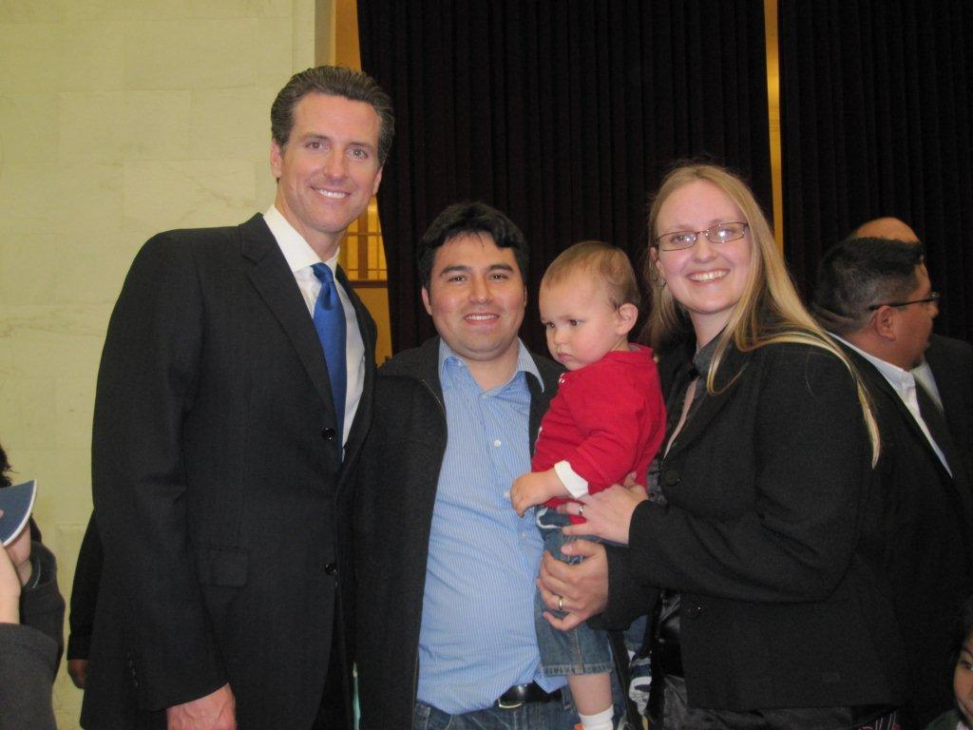
Note: In the photo, from the left are Mayor Newsom, Cesar Landa (Ms. Field’s husband), Benjamin Landa (her son), Karen Field.
*****************************************************************************************************************************

Mez Sez

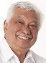
Vince Gomez (’52)

The death of basketball coaching legend, John Wooden, on
June 4, 2010 at the age of 99 reminded me of the night of January
29, 1954. It was when the College of Pacific Tigers basketball team played the UCLA Bruins at the old Westwood Gym. Being the 10th man on the Tigers team, I was on the same basketball court with Wooden and my high school hero from Galileo, Don Bragg, who was an All-American player for Wooden that year. During warm ups before the game, Bragg told me how much I'd grown since high school. I was only 4' 10" when I last saw him in 1951. Even at 5' 7", I said, "You're still taller than I at 6' 4''. By the way, the Bruins won for one of Wooden's early wins before his 10 national championships. I did not get in the game, but what a thrill it was to be on the same court with Bragg and Wooden.
On April 3, 2010, the San Francisco Filipino-American
Jazz Festival sponsored a jazz concert for Jazz Appreciation Month at
the San Francisco Public Library Theatre. This event brought by pure
happenstance an audience that included two of my Galileo friends from
the class of 1952. They were Joe De Guzman and Fred Basconcillo. I had not seen them for 58 years! In our brief conversations I discovered
some interesting information about their lives since our high school
days. De Guzman earned his Doctorate from Columbia University and also was a member of the San Francisco Ballet prior to his advanced degrees and professional work. Basconcillo was a member of the San Francisco Iron Workers Union and eventually became President of the Union. He represented San Francisco at national conventions and conferences for the Iron Workers.
These two men made me proud to be a Galileo graduate and native San Franciscan. As the years go by it feels great to know how our old Galileo Lions were able to make a difference in their professional lives.
On Father’s Day 2010, my wife gave me three books: San Francisco Then by Fred Lyon; Giants, Past & Present; and Death in North Beach, a mystery by Ronald Tierney.

_______________________________________________________________________________________________

Announcements

MARK YOUR CALENDAR!

IT’S TIME FOR DINNER WITH FRIENDS

Hosted by the classes of January, 1953, June 1953, and January, 1954

ALL ALUMNI WELCOME!

Saturday, September 18, 2010
Nick’s—Rockaway Beach—Pacifica
Dinner--$35.00 (Entrée, salad, dessert and wine)
Lodging available within walking distance from Nick’s
Contact: Dave Negherbon—650-873-6263
Invitations with all details will be sent in early August.

**********************************************************************************************

Honoring 7 Decades of Athletes

GALILEO SPORTS HALL OF FAME DINNER

Join other Galileo alumni & staff for an evening of fun

Support Galileo’s Athletic Department

Honor this year’s inductees:
Pete Arnautoff ’69, Steve Bokura ‘84, Albert Bravo ‘51, Rodney Clement ‘87,
Ray Dal Poggetto ‘47, Fernando Escobar ’01, Cherise Johnson ’92, Vince Moreci ’78, Ken Scaruffi ‘47, Otis White ‘04, Eugene Wing (special category)

**************

A special award will be presented posthumously to Frank Clima ‘51 and
Kay Lazzari Michelis ’53 for their commitment & service to Galileo and its alumni.

*****************

Date: Friday, October 15, 2010

Location: Dominic’s at Oyster Point, 360 Oyster Point Blvd., South San Francisco
Plenty of free parking. Directions provided below.

Time: No host cocktails - 6:00 PM
Dinner - 7:30 PM

Entrée: Choice of beef filet scaloppini or chicken parmesan

Price: $50.00 per person includes wine, tax, and tip
All profits go to Galileo athletics

Sports Hall of Fame Members: Please wear your medallions.

Seating is limited, so complete the form below and mail it with your check payable to Galileo Sports Hall of Fame today. If you wish to be seated with friends, please complete one form per group (maximum 10 per table) and list each person’s name and choice of entrée. No tickets will be mailed. Deadline for reservations is October 8, 2010. No tickets will be sold at the door.

Mail check and reservation form to:

Bernard Valdez
Galileo Sports Hall of Fame Committee
31 Medallion Ct.
Pleasant Hill, CA 94523

Galileo Sports Hall of Fame Dinner Reservations

Friday, October 15, 2010

Name Phone or Email Beef or Chicken
____________________________________________________________________________________
____________________________________________________________________________________
______________________________________________________________________________________________________________________________________________________________________________________________________________________________________________________________________________________________________________________________________________________________________________________________________________________________________________________________________________________________________________________________________________________________________________________________________________________________________________________________________________________________________________________________________________________________________________________________________________________________________________________________________________________________________________________________________________________________________________________

Contact information:
Name: ___________________________________________________
Address: __________________________________________________
Phone: ___________________________________________________
Email: ________________________________________

Please indicate whom you’re coming to honor: ________________________________________

Make check payable to Galileo Sports Hall of Fame. Mail this form with your check to:

Bernard Valdez
Galileo Sports Hall of Fame Committee
31 Medallion Ct.
Pleasant Hill, CA 94523

DRIVING DIRECTIONS TO
Dominic’s at Oyster Point
360 Oyster Point Blvd.,
South San Francisco, CA 94080
650-589-1096
http://www.dominicsop.com/
From the North Bay

- Take 101 South to Oyster Point exit
- Follow Oyster Point Blvd. 1.5 - 2 miles to 360 Oyster Point Blvd.

From the South Bay

- Take 101 North to Oyster Point exit
- Turn left at the light onto Dubuque Ave.
- Turn right at the light onto Oyster Point Blvd.
- Follow Oyster Point Blvd. 1.5 – 2 miles to 360 Oyster Point Blvd.

________________________________________________________________________________________________________________________________________________________

Class of 1990 Reunion
August 7th, 2010
six-thirty for cocktails
followed by dinner at seven
Attire: semi-formal
Cost: $50
Jillians
101 4th St.
San Francisco, CA 94102
Web site: galileo1990.org
_____________________________________________________________________
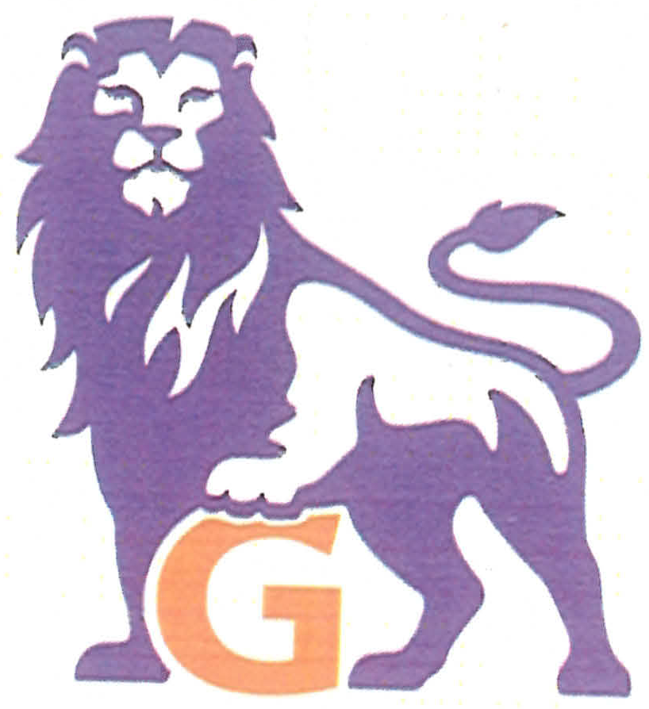
Galileo High School
Class of 1970 Reunion

Dear Classmates and Friends:

The Class of 1970 Reunion Committee will hold its 40th year reunion:

DATE: Saturday, October 30, 2010 PLACE: Green Hills Country Club
5 PM to 10 PM 500 Ludeman Lane, Millbrae, CA 94030

Attire: Dressy Casual or Dressy. NO JEANS Optional: 1970’s Block G sweaters

Cost: $75.00 per person if postmarked by July 31, 2010 or $85.00 per person if postmarked after July 31, 2010

Menu: Buffet-style dinner includes Cheese & crackers, Salads, Carved meats, Pasta, Fruits, Desserts, Coffee and Tea.

Drink tickets will be sold at the door. $3 per ticket. (minimum of 2 tickets for alcoholic drinks). CASH ONLY. Dietary restrictions upon request.

Dance to the music of Jest Jammin’

Questions? Email them to galileoreunion2010@yahoo.com or contact
Nancy J.Yee, DDS – callmenjy@yahoo.com; Gail Chong Megdadi – gailchong1970@yahoo.com (925-837-9198);
Galen Dea – galendea@yahoo.com; Lemoyne Wong – wonglady1970@yahoo.com

Copies of the yearbook will be on sale for $10 at the reunion. To reserve your copy, contact Galen Dea at galendea@yahoo.com or call 510-205-9660
Please detach form

Complete this form and mail to: Galileo Class of 1970 Reunion
c/o Gail Chong Megdadi
P. O. Box 1233, Danville, CA 94526

Make check payable to: Gail Chong Megdadi

A table of 10 can be reserved by making a one-time payment for 10 people.

Name: ______________________________ Email: __________________________ Phone: _________________

Print name(s) of guest(s)________________________________________________________________________

____________________________________________________________________________________________

* * * * *
The 66th Homecoming Song & Yell Contest is scheduled to be held on Friday, October 8, 2010, at George White Field. The football game will be Galileo vs. Balboa.

* * * * *
REFLECTIONS OF A FRIEND
By Marion Napoletano Gizzi (’52)

Webster defines a FRIEND as a person attached to another by feelings of affection or personal regard; one who gives assistance; one who is on good terms with another. This pretty much sums up the relationship that so many of us were fortunate enough to have had with KAY MICHELIS. She was always there to lend a helping hand to any and all who needed it -- a natural caregiver.
She was very involved in the many fundraisers and celebrations in North Beach. For more years than I care to remember she worked on the Columbus Day committee, fulfilling a variety of jobs. Sts. Peter & Paul Church and the Salesian Boys & Girls Club were the recipients of many, many hours of her help. If there was a function going on at the Church, you can be sure you would find Kay there in some capacity.
She also worked diligently with the San Francisco Auxiliary of the Lucille Packard Children’s Hospital at Stanford, wearing many hats. And, of course, she was on the Board of the Galileo Alumni Association since its inception.
Kay was a fun loving person, always ready to do and go. An avid fan of the 49ers, the Warriors, and the Giants, including cheering them on at their spring training camp. And who can forget the sounds of the ringing slots paying their homage to our Lucky Kay.
Kay is sorely missed by her family and many friends. I especially miss my favorite traveling companion and shopping cohort.
People come and go in our lives and some leave an indelible footprint. Those are the ones we seldom forget. Kay left a deep footprint on my life and on many of yours, I am sure. We will always miss you, Kay.
It is not length of life, but depth of life --- Ralph Waldo Emerson
_______________________________________________________________________________________________
Gone But Not Forgotten

Vince Tringali

Galileo alumnus and member of the historic 1951 USF football team and St. Ignatius football coach passed away in April at 81. Tringali played football at Galileo in the late forties and was inducted into the Sports Hall of Fame in 1996. For his obituary go to http://www.legacy.com/obituaries/sfgate/obituary.aspx?m=vince-tringali+pid=141422252.

* * * * * * * * *
Ann Dougherty

A retired Galileo teacher, she developed a leadership program at Galileo that was known around the United States. As my master teacher, she started me on my wonderful teaching career in the physical education department. The women’s physical education program was honored as one of nine schools in the United States for its very diverse program. She set high standards for the many students and colleagues who were lucky enough to know her. She never hesitated to help her many friends when needed. She will be missed. -----Marie Eisen

--------------------------------------------------------

LETTERS
The following letter was sent by Mel Chiarenza (’52) to a list of his contacts with a copy to GAA.
Hello, I thought you might be interested in this newsletter that is about the Galileo Alumni Association ONLY and does not use politics or other high schools or social activities and personal comments to expand interest. I think this newsletter is right on the MARK on its content. If you are not signed up to receive this newsletter and want to subscribe, please feel free to let the editor know and have them add your email address. A good job of remembering yesteryears. Thank you. -----Mel Chiarenza (Class of ’52).
Ed. Note: Thank you, Mel. To subscribe to this newsletter, send your email address to http://galileoalumni.org/contact.html.

Molly (Smith) did a great job on the article on Galileo in the We The People Finals competition (in the April issue). I lost track of time and had planned to write an article for the next Observer, then read this one. She captured the essence of the program well. Thank you, Molly, I enjoyed reading it! ----Dee Falwell Morgan (’52)

The following letter is from Shigeru Yabu, Galileo classmate and basketball teammate. His book will be reviewed in the October issue of the Observer.

I wrote a children's book called “Hello Maggie." This is about a magpie baby bird whose nest we knocked with our sling shots at Shoshone River. We were at Heart Mountain Relocation Center during World War II, but we would sneak out for hiking, swimming, fishing, and shooting our sling shots. Magpie birds are related to the crow, raven, and blue jays, and all of these birds are extremely smart.

I named this bird Maggie even though I was not certain whether it was a male or female. Maggie was up early in the morning, extremely active and excited when anyone would be going to the rest room, mess hall, or in my case, school, play, or the movies. I would always say, “Hello Maggie,” whether I was leaving or returning to the barracks. It was amazing that one day this beautiful black and white feathered bird with a long tail repeated “Hello Maggie” back to me. It did not take long before the word got around all throughout Heart Mountain because this was the only talking magpie among 11,000 internees. This wonderful pet picked up many other words, so now our little book company, Yabitoon, has published “Hello Maggie” and “The Boy of Heart Mountain”.

It has been a long time since we played basketball for Coach Thomas “Fox” DeNike. I now realize how great a coach he was because I see the NBA using the same fast break we used to use. What an honor to have Angelo “Hank” Luisetti and a player from the University of California come and show us how to shoot a basketball. I was playing Senior Olympic basketball and qualified for five National Senior Olympic Tournaments, but now with our book company it has been impossible to do both.

Willie Ito is the illustrator for both books, and his first assignment with Disney was Lady and the Tramp, and he, with other illustrators, worked on the famous scene where two dogs are nibbling on a noodle and ended up kissing. Willie and I were in the Cherry Blossom Festival parade; the problem is that no one knows us any more because those folks our age won't fight the traffic so they stay home.

I am involved with the Heart Mountain Wyoming Foundation board of directors, and we are working on the interpretive learning center, and we have a company, Split Rock, that is creating the design work for this center. We hired Fallon Company’s Steve Okazaki to do the documentary movie which is only one minute long, but he has won an Academy Award for short documentary. He has won many honors with other documentary film productions.

I play basketball each Monday evening except tonight it was cancelled because of Memorial Day. It sounds macho, except I can't run as fast, jumping is impossible, and you might say running is at a quarter speed. I still could shoot except the younger players do not know the word PASS. I do not get out of breath, but at the pace I am going who would get out of breath? I now look at this as exercise and meeting the younger generation. ------Shigeru Yabu (’51)

Note: Send letters to GalileoObserver@aol.com or to Galileo Observer, c/o Galileo Alumni Association, 1150 Francisco Street, San Francisco, CA 94109. All letters are subject to editing.

CALENDAR OF UPCOMING EVENTS
Class of 1990 20th Reunion, Jillian’s, San Francisco, Saturday, August 7, 2010
Picnic by the Bay, McNear’s Beach, San Rafael, Saturday, August 14, 2010
GAA Board Meeting - Room 210, Galileo Academy, 6:30 PM, Thursday, September 9, 2010
Dinner with Friends, Nick’s at Rockaway Beach, Pacifica, Saturday, September 18, 2010
66th Homecoming Song & Yell Contest, George White Field, Friday, October 8, 2010
Sports Hall of Fame Dinner, Dominic’s at Oyster Point, South San Francisco, Friday, October 15, 2010
Class of 1970 40th Reunion, Green Hills Country Club, Millbrae, Saturday, October 30, 2010
****************************
When checking for upcoming events between issues of the Observer, please visit the web site http://galileoalumni.org/home.html for the most up-to-date listings.
_____________________________________________________

Contributors
Marie Eisen
Bruce Eng
Marion Napoletano Gizzi
Vince Gomez
Dee Falwell Morgan
Charlene Fachner Mori
Jeanne Yee

The OBSERVER Is For All
Galileo alumni, family, friends, students, faculty . . . anybody and everybody, the Observer is for you. If you haven't already done so, send in the email addresses of anyone who would like to receive a FREE emailed newsletter to http://galileoalumni.org/contact.html. We'd like to reach as wide a range of readers as possible.

BACK ISSUES OF THE GALILEO OBSERVER CAN BE VIEWED AT
http://galileoweb.org/alumni/newsletter/.
For all EDITORIALLY-RELATED comments or suggestions, please address your emails to galileoobserver@aol.com.
For all TECHNICAL problems (non-receipt of newsletter, etc.), contact the webmaster through http://galileoweb.org/alumni/contact/.
* * * *
The Galileo Observer invites your articles, letters, memories, inquiries and suggestions. All submissions are subject to editing. Deadlines for submissions are January 1, April 1, July 1 and October 1. Send them by email (preferable) to galileoobserver@aol.com, or by postal mail to: Galileo Observer, c/o Galileo Alumni Association, 1150 Francisco Street, San Francisco, CA 94109.

GAA BOARD OF DIRECTORS, OFFICERS, & COMMITTEE CHAIRS ARE LISTED AT http://galileoweb.org/alumni/contact/
The Galileo Observer is published quarterly in January, April, July and October by the Galileo Alumni Association, 1150 Francisco Street, San Francisco, CA 94109. Views expressed are strictly those of the Association and in no way reflect those of the Galileo Academy of Science and Technology, its students or faculty. Dennis Eleen, President; Sisvan Der Harootunian, Editor; Vaughn Spurlin, Production Manager/Website Director. Copyright 2010, Galileo Alumni Association.

Last updated Julyl 2010 © 2002-2010 Galileo Academy of Science and Technology Alumni Association of San Francisco. No part of this publication may be reprinted or reproduced in any form without permission of The Galileo Observer and/or The Galileo Alumni Association.

