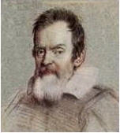 | THE GALILEO OBSERVER  The Official Newsletter of the  Galileo Alumni Association | 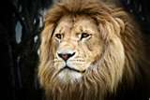

“Communicate and Participate”

Vol. VIII, No. 4 ________________________________________________October 2010

WISHING YOU HAPPY HOLIDAYS

FROM THE GALILEO ALUMNI ASSOCIATION

Thank you for your support in 2010.
To all of those alumni and donors who have invested in our students, school and G.A.A. activities this year: Thank you! Your support provides an added margin of excellence that has a profound impact on the lives and experiences of our students.
Please have a safe and relaxing holiday season, and a healthy and happy 2011.

************************************

From the Editor

For our year-end issue, we are pleased to introduce two new columnists. Tony Compagno (’61) is a published writer
and author of A Remarkable Collection of Angels, Seasoning, and Discovery Day (a book of short stories).
His Ramblings will add much to the Observer – wit, charm and nostalgia. Bettie Grinnell has worked for ten
different principals at Galileo during her long tenure. She is currently Assistant to the Principal and is involved
in many different aspects of the Academy’s educational progress. She was the first non-athlete or coach
to be inducted into the Galileo Sports Hall of Fame in 2008. Her column, Between the Lions, will deal with various
activities inside Galileo.

------------------------------------------------------------------------------------------------------------------------------------------------

Best Ever Sports Hall of Fame Dinner!

Ten athletes from seven decades and one faculty member. These were the outstanding sportspeople honored at the recent gala dinner at Dominic’s Restaurant in South San Francisco. The evening was filled with an exciting buzz as over 200 people, many of them Galileo alumni, including several former honorees filled the room which had a decided country club atmosphere. Cocktails on the terrace along with hors d’oeuvres, including Jim Dresser’s famous jumbo shrimps, preceded the delicious dinner. Attendees chattered away with friends and family of the honorees. Former Galileo Principal Margaret Chu, as vibrant as ever, sported a Galileo jacket worthy of a Block G. Bettie Grinnell proudly related her tenure at Galileo with 10 different Principals. Nina Clima and Lisa Michelis were there to receive a special tribute posthumously for their husband and mother, respectively. The entire Lombardi clan was there – John, Mario and Carmela – with their spouses. Bernie Valdez looked dashing with an attractive new beard. Pete Pompei repeated a story 60 years old, told to him by JD. Vince Gomez lamented the fact there was no room for him to play music prior to the festivities. Marion Napoletano Gizzi, Doris Repetto Ross, John Zuffo, Joyce and Rich Cozzarin, Joe Scafidi, George DeMartini (the Packers fan of the Vince Lombardi years), all the Bravos, John Bologna, Fred Setting with his camcorder, Al Massucco, Ethan Winterling, Rusty Enos, Ron Sligar, Chairman Ron Ertola – they were all there. These and others willed the sold out room. They came to honor Ken Scaruffi (’47), Ray Dal Poggetto (’47), Al Bravo (’51), Peter Arnautoff (’69), Eugene Wing (faculty), Vince Moreci (’78), Steve Bokura (’84), Rodney Clemente (’87), Cherise Johnson (’92), Fernando Escobar (’01), and Otis White (’04). The late Frank Clima (’51), one of the founding members of GAA, and Kay Lazzari Michelis (’53), a tireless organizer and member of GAA, were honored with suitable plaques. The surprise of the evening came when Jim Dresser was called to the podium to receive a special plaque “in appreciation for [his] extraordinary leadership as president of the Galileo Alumni Association and invaluable contribution as a member of the Sports Hall of Fame Committee 2002-2010.”
Overall a great event. Kudos to the SHOF Committee -- Ron Ertola, Bernard Valdez, Mario Lombardi, Pete Pompei and Jim Dresser.

************************************

66TH SONG AND YELL COMPETITION

On Friday October 8, 2010, Galileo Academy of Science and Technology conducted the 66th Annual Song and Yell Competition at George White Field
The morning was opened by a call to order by ASB president, Julie Yu and introductions by Principal Vicki Pesek.
The contest pitted all four classes, Freshmen, Sophomore, Junior and Seniors, against each other in highly spirited and raucous displays of creative entertainment.
This initial event was each class’s rendition of the Galileo Fight Song and The Lions Whisper. That was followed by short skits created by and performed by the students.
The 2010 theme was entertainers and the performers showed everyone their many talents in dance, song and impressionism.
We saw the likes of modern entertainers Lil Wayne, Justin Timberlake, Britney Spears, Justin Bieber and Lady Gaga.
The competition was judged by alumni Victor Lim, Vince Moreci, Steve Bokura, a former Gal teacher Mr. James Brown, former Gal sports nurse, Ms. Toni Brown a former Gal principal, Ms. Margaret Chu and your alumni president.
After much scrutiny, the judges considered all aspects of the competition and the consensus was that the Senior class, once again, prevailed in this year’s Song and Yell and Contest.
Later in the afternoon, The Mighty Lions hosted The Buccaneers of Balboa.
It was hardly a contest with The Lions whipping The Bucs, 56-33.
Gal was sparked by, Player of The Week, Quincy Nelson, as he rushed for 349 yards and scored six touchdowns.
A magnificent day for Quincy and for The Mighty Lions.

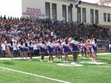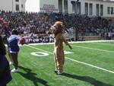

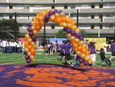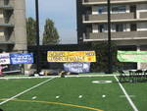

************************************

Through The Telescope. .. 
Sisvan Der Harootunian

Sixty years ago Galileo was named “The High School of Champions” by Boys Life magazine. It’s good to see that it still is.
October 15th’s Sports Hall of Fame Dinner was sold out six weeks before the event, making it one of the most popular annual affairs on the G.A.A. calendar (see article below). Another event that brought out alumni was the Dinner with Friends in September. 60 people attended this 3rd annual event, which was really a reunion of the class of 1953.

Three grandfathers (Jim Dresser (Galileo ’51), Paul Lamphere (Galileo ’51), and Cliff Righetti (Washington ’51) and a bachelor (Sisvan Der Harootunian (Galileo ’51) got together for dinner at MoMo”s on August 5th.

A recent walk in the Marina District with Paul Lamphere revealed changes Paul hadn’t seen in many years since his working days at a pharmacy (now a bank) and Edy’s and his elementary school days at Winfield Scott. Bechelli’s restaurant is still next door to the Presidio Theater. Marina Middle school has a brand new whitewashed look. Mrs. Emma Croce, our Marina science teacher, lived on Avila Street. Joe DiMaggio lived on Beach Street with Marilyn Monroe. Lucca, a great Italian deli, makes delicious sandwiches to go. Drop in at Books Inc. and you might see Bill Dito (’50) working there. Delarossa, a hot new restaurant, is packing them in. It joins other popular eating spots – A16, Risto Bar, Judy’s, Izzy’s, Isa, Parma, Barney’s, E’Angelo, Mezze, Liverpool Lil’s -- in making the Marina a culinary destination.

Mario Lombardi sends in two items: Kendrick Chow (’09) was a member of the winning bridge team in the North American Collegiate Championship. Also competing were Jason Yee (’09) and Lauren Lai, a sophomore at Galileo.

Enrico Cinquini lives in Oakley, a town he helped found. Cinquini is a former Marine who survived some of the bloodiest battles of World War II, a true hero. He is also a Galileo graduate. While in a foxhole in Okinawa, he received by mail his high school diploma.

Back in the day: Did you know that Vince Gee (better known as Vince Gomez (’52), our Observer columnist, did a stint in 1961-62 as master of ceremonies at the Chinese Sky Room on the corner of Grant Avenue and Pine? This was the heyday of nearby Chinatown spots such as the Ricksha Lounge, China Smith’s and Forbidden City.

Eddie Cantor look-a-like: Art Leones (’51) with the “googly eyes.”

OBSERVation: There is no more iconic symbol of San Francisco than the cable cars. On a recent afternoon, I am the only passenger sitting on the inside (to avoid the wind); the rest are all tourists occupying the outside seats, front and back, left and right, plus the running boards. I’ve been there, done that, rode the cable car every day to Marina Junior High and to Galileo.

Food tip: Many foods and beverages are their tastiest at room temperature – red wine, beer, apple pie and ice cream. Ice cream? Yes! Try this: deliberately let ice cream melt and then taste it. You’ll find a taste the frozen product doesn’t have. Breweries serve beer directly from the vats, only slightly cooled, not ice cold. When ice cream is frozen, its flavor is locked up; thawing it releases the sweetness. A decadent chocolate ice

cream when melted turns into a smooth velvety chocolate mousse. Try putting ice cream in a container, and store it in your refrigerator, not the freezer. Then take it out and enjoy its taste – and there’s no brain freeze!

Cell phone mania: Comedian Bob Sarlatte says he went to a movie theater and every kid had a cell phone. One called his friend at the concession counter to tell him what kind of popcorn he wanted.

One for Jay Leno: “The pairing of individual micro-climates with our old-world wine making techniques intensifies the character and nuisance of each varietal.” -- from the label on a bottle of Stacked Stone Cellars 2004 Zinfandel, Paso Robles. Didn’t they mean nuance?

“Don’t let someone with no life ruin yours” – Colin Cowherd, ESPN Radio Sports Talk Show host.

Until next time, the observatory is closed.
____________________________________________________________________________________

Mez Sez


Vince Gomez (’52)

Since my last column, much has happened of interest for our Galileo alumni. In
early August the famous North Beach Washington Square Bar and Grill
closed down for the second time after its renovation in 2008.
Ironically two days after the new owners shut down the establishment,
Ed Moose, the original owner of the Wash Bag and Moose's, passed away.
The late noted reporter and author, Ron Fimrite, was given a memorial
celebration at the site on May 22nd. Many North Beach folks showed up
for that event. Fimrite had written books on the Square and Cal
football teams. Dick Fregulia, jazz pianist and I (on bass) had the
opportunity to perform for the memorial. As a jazz duo Fregulia and I
had worked every Thursday night for12 years (1995 to 2007) at the
Square. The memorial brought back memories of the many Galileo
graduates and North Beach friends I had seen on occasions during that
12 year period. The list includes the following: Will Marchetti,
Jowanna Woeber, Dee Falwell Morgan, Monica Parenti Kirkland, Dolores Veloz, Bev De
Losa, Tom Venezia, Angie Compagno, Barbara Amadeo, Don Di Basilio, Harry
Holsworth, Mel Chiarenza, Ron Sligar, Ed De Martini, Kay Lazzari
MIchelis, Andree Puglisi Nippe, Al Vogan, Bill Dito, John Zuffo,
Sisvan Der Harootunian, Fred Tooker, Jim Dresser, Peggy McCullough
Orofino, John Orofino, and Leon Cathey among others.
Being an avid San Francisco baseball fan since
1945 at Seals Stadium and a season ticket holder with the Giants since
1978, it is always a distinct pleasure to be the ball dude at AT&T at
certain games. This year I worked two games in April and the game with
Cincinnati on August 25th where the Giants came back from a 10 to 1
deficit only to lose 12 to11 in 11 innings. Harry Holsworth, Galileo
classmate, has worked several games with me in the past years at the
new ball park. On July 31, 2010, Nino Cresci, Galileo class of 1947,
died. He was a dear friend who worked 30 years as an usher for the
Giants at Candlestick and At&T Park. During his years at Galileo he
was on the championship soccer team of 1947. RIP, Nino. It is truly
sad that he will miss the 2010 Giants participation in the World Series.

It was fantastic at the park on Wednesday and Thursday during the World Series. Cain looked great and Lincecum settled down after a rough start. Who knew that the Giants would score 20 runs in two World Series

games after all the close games against Atlanta and the Phillies. Once again the whole team contributed to the wins. On to Texas for the weekend. We need to win two of the next 5 possible games to bring home the first MLB championship to SAN FRANCISCO.
During this summer, several events involving
Galileo alumni occurred. On August 5th there was a Picnic on the beach at
Johnson's beach in Russian River. Marion Napoletano Gizzi, Mel
Chiarenza, and Carla Fisher Harris were the organizers. On August 14th
there was another successful beach party/picnic sponsored by the Galileo
Alumni Association. On September18th, a group of Galileo alumni from
the 50's held a get together at Nick's in Pacifica. Dave Negherbon,
Monica Parenti Kirkland, Dee Falwell Morgan organized the bash which
was well attended. I regret that I was unable to attend these events
since I had previous engagements planned . One of these was
attendance at the 75th annual Oregon Shakespeare Festival in Ashland.
We were able to see strong performances of Hamlet and The Merchant of
Venice plus Throne of Blood, a new play based on the 1957 Kurosawa
film version of Macbeth. Another date was August 14th when I was one
of the honorary parade marshals for the 17th annual Pistahan Parade
and Festival at the Yerba Buena Gardens. The Filipino American Arts
Exposition was able to present the best of the Filipino Community in
their largest parade and festival ever for the benefit of the San
Francisco Bay Area. As a child growing up in the Embarcadero district
by the Ferry Building, I witnessed many parades starting on Beale and
Market Streets, and now I was in the parade with Filipino dignitaries.
My parents would have been very proud. At the concluding program at
the Yerba Buena Gardens I met SF Mayor Gavin Newsom and the former
California Interim Lieutenant Governor Mona Pasquil.
On September 4th I was part of a panel
sponsored by the Smithsonian Museum held at the San Francisco Public
Library, discussing the roots of Filipino American Jazz in San
Francisco. It was moderated by Carlos Zialcita, historian/musician.
Others on the panel were Jo Canion, jazz vocalist, Elsie Remo Yupunco and Fred
Basconcillo. Fred was a classmate from our Galileo days and was the
former President of the local Iron Workers Union as well as an event
promoter and personal manager for performing artists. The small group in attendance asked many questions and appreciated the information we were able to share. . On September 19th the late Al Robles (Galileo 1948)
was given a literary salute from poets, writers, editors, and
booksellers at the Intersection 5M, 925 MIssion. This tribute cast
light on his work to preserve the stories of the Filipino elders for
Filipino Youths. His art and poetry were linked to his activism and
concern for people. An important exhibition was held this month
at the SF Public Library. It was called "Singgalot: The Ties That
Bind". The exhibit had a hundred photo murals that portrayed the social
history and development of the Filipino community in the United States.
All these events this summer made me recall my
3 years at Galileo where most of my classmates were students of
Italian, Irish, Chinese, Mexican, English, Armenian and African descent.
Those of us born in San Francisco of Filipino parents were few. Some
had one parent of Filipino background and so were called mestizos. In
looking at my Galileo yearbooks from 1949 to 1952 I was able to
recall my classmates of similar cultural backgrounds. This group
included the following: Leon and Andres Manalo, Frank Orden, Shirley
Sichon, Anita Directo, Fred Directo, Mercedes Refre, John Matulac, Bob
Palapaz, Margery Fernandez, Bonifacio Bitanga, Guilllermo Fonacier,
James Tatton, Joe DeGuzman, Leon Mazon, and Fred Basconcillo.

Fast forward to 2010, and we find many more Americans of Filipino background living in the San Francisco Bay Area. A high school in the American Canyon area near Vallejo has a student body where 70% are of Filipino origin. Bay Area sports and entertainment figures such as San Francisco Giants pitcher Tim Lincecum, Tampa Bay shortstop Jason Bartlett (from Mountain View), Olympic Games gold medal winner Natalie Coughlin, and actor/comedian Rob Schneider all have mothers of Filipino descent. What a difference as time goes by between 1950 and 2010.

October events that occurred were the 3rd annual San
Francisco Filipino American Jazz Festival held on October10th
at Yoshi's SF. Artists included Primo (Villaruz) Kim and Jo
Canion among several others . The Galileo Sports Hall Of Fame
held its induction dinner at Dominic's at
Oyster Point on October 15th. The inductees included Al
Bravo (51) and Renato (Ray) Dal Pogetto (47) among several from the
80's and 90's.
With all these activities and events, it will be
Thanksgiving, Christmas, and New Year’s Eve before we know it. So let
me be the first to wish you a Happy New Year, and remember to KEEP
BREATHING and GO GIANTS!!!!!!

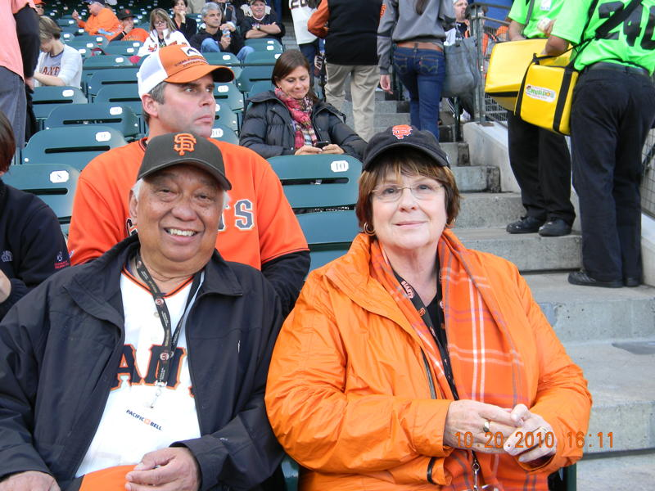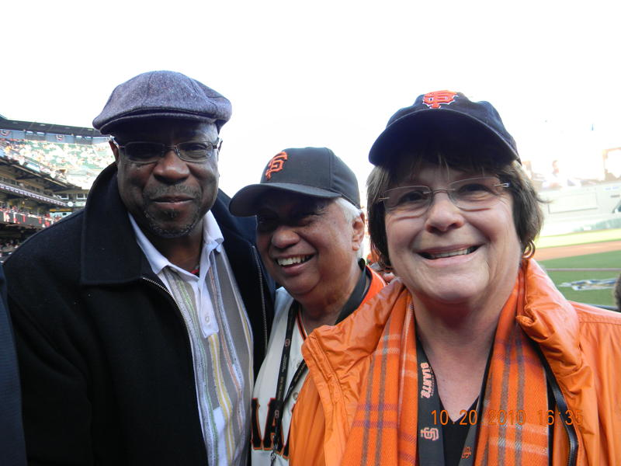

Vince and Carol Gomez with Dusty Baker, former Giants Manager and current Cincinnati Reds Manager.
Photos by Rick Weller
____________________________________________________________________________________________

Tony Compagno’s
Ramblings

(To ramble is to stroll or walk without a special destination in mind, or talk without sequence of ideas. Sometimes this isn't a bad thing, after all, is it?)

I attended Galileo from 1958 to 1961. The younger of my two sisters, Angela (Angie), attended Gal about a decade earlier than I. The names, faces and exploits of many of her friends and classmates are as familiar and precious to me as those of my contemporaries. As a pigeon-toed kid with a tan line starting halfway down my forehead because of the baseball cap some thought was glued to my noggin, I would study Angie's yearbooks as a Biblical scholar might go through the Old Testament with a fine-tooth comb. Young adults I didn't know, and some I've never met to this day, took on legendary proportions, their faces luminous on the slick pages of the Telescope, faces informed by pure promise. I recall randomly names under photos: Don Bragg and Jerry Tamalier, Tom King and Pete Pompei, Manny Tornay and Seb Saia. These were the heroes of the eight- year- old's imagination that couldn't anticipate in any clear way life outside North Beach and the Marina in The City, in that glorious, if flawed, decade, the 50s.

Which brings me to present time: A good friend and fellow Gal alumnus Barry Ercoles told me a story at lunch the other day about a local who was visiting Manhattan when the San Franciscan was asked where he was from. Answer: The City. (Is there another?) Now, only someone from our treasured S.F. would make that pronouncement among residents of one of the most historically rich and vibrant places on the globe. Do we love our home turf, or what? As to Ercoles, or Herc as he's widely known, this venerable Lion is to be commended for his continuing effort in getting old friends (mostly Galileo alumni) together for lunch on a fairly regular basis. Caesar’s Restaurant is currently the favorite place to convene. Santo Alioto, retired East Bay teacher who grew up in North Beach and whose brother John was a star athlete at Gal in the late 40s, has also been passionate about preserving the sense of camaraderie and the love for our shared past in a city in which, by some stroke of good fortune, we were raised.

I picked Santo up at Jones and Greenwich. Herc, who doesn't drive, was to phone when he was ready to be picked up after a visit to Kaiser Hospital out on Geary. When he got there, Herc was peeved because Santo hadn't checked his cell phone and Barry had to wait half an hour. "I can't hear like I used to," said Santo, "and I forget to listen to my messages." Then, in the ride east on Geary to the Cliff House for lunch, Santo remembered every vivid detail of a last minute touchdown executed on Washington High School's football field in 1954, names of the participants included and their second cousins on the maternal side. We're getting older. In our anecdotage. Selective memory.

Speaking of sports, I want to close this maiden installment by mentioning several Lions from the past with whom I've recently re-connected. Santo told me one day at lunch that my old and dear childhood buddy and teammate, Dave Barni, was to be inducted into San Francisco's Prep Hall of Fame. That was no surprise to me, but I felt that the honor was a bit late in coming. I informed another old friend who was a stellar athlete at Gal in the 50s and who had called me one evening a couple of years ago to inform me that he'd read a book
I'd written - (Oh, HE was the one!) - This was Ken Flanagan, class of '59, All-City baseball and basketball, and a good student, besides (went on to the Peace Corps, Santa Clara University and a long teaching career). Off we went to Patio Espanol out on Alemany to honor Davey, a truly terrific and exciting athlete whose Uncle Roy had been a star athlete at Gal, U.S.F. and later with the Chicago Cardinals and Washington Redskins as a pro. It was a joy for me to see Dave again, and his wife Joyce, and to meet their two lovely daughters. Dave paid homage to Kenny at our table after the formal speeches, calling Flanny his mentor. It was a beautiful moment. At dinner, I sat across from Mike Bellanca, a great all-around Lion athlete, class of '61. And teacher/coach Jack McCaffery sat a few chairs away, as did former Gal shortstop, smooth as silk, Gus Geraldi, popular restaurant owner at the Wharf. What a night. I thought I'd died and gone to Heaven. Maybe I had been granted a glimpse of Paradise, in fact.

Have you checked out any of the sports books written by Kris Setting Clark, whose daughter Brittany is in the Galileo Sports Hall of Fame? Dr. Setting has always had a keen interest in pro football, especially the formative years. She has penned several books about former NFL greats, among them Y. A. Tittle and Bob St. Clair. Also available at Amazon.com and other sites is her chronicle of the 1951 U.S.F. Dons football team that turned down a bowl invitation because it was contingent on the S.F. team leaving its black players home. You'll be surprised to learn who those black players were, if you don't already know your local history. Racism is yet alive on the planet, but it was a monstrously ugly behemoth back in '51. By the way, the aforementioned Roy Barni was on that history-making Dons squad. Also Dr. Clark's uncle Fred Setting coached the Galileo baseball team for years. And Kris's dad, John, was a star baseball player at Gal before WWII, and one of the nicest and funniest men I've ever known.

That's enough for now. When my wife and I return from our first trip to Europe, I will lay some more "ramblings" on you...if you've survived these.

************************************

Between the Lions
by Bettie Grinnell

Greetings, Mighty Lions! Here’s what’s happening at Galileo these days.
Early Start:
School began early this year for Galileo and all the other schools in the San Francisco Unified School District. Classes started for all schools on Monday, August 16, 2010. The first semester will end on December 17, 2010, and school will end for the year on May 27, 2011.
Academics:
Galileo's API (Academic Performance Index) has reached an all time high of 778, beating Lincoln! We also have the top overall scores on California's state tests of any of the comprehensive high schools in the city. Although this is not the only way that we measure our program quality, it's an important sign that our hard work is paying off for students.
Football:
The Lions are currently tied for first place with Mission whom they played on Friday, October 29. We look to have a shot at the playoffs and possibly the championship as well even though 2009 AAA running back of the year Quincy Nelson is injured and may be out for the entire season. Fellow senior quarterback Jonathan Luas has been a pleasant surprise, running and throwing for a total of 5 touchdowns. Max Malloy and Young Ene are anchoring the Galileo defense. Top newcomers include speedy running back Robbie Trumbo and center Michal Brzozek. The Lions are smaller this season than last year's championship team but faster. The younger team has a great freshman crop and is ready to have a run at a championship.
Homecoming:
Galileo’s 2010 Homecoming was held on Friday, October 8th. The festivities began with our 66th Song and Yell Contest. The Mighty Lions defeated the Balboa Buccaneers, 54-33. The Homecoming festivities culminated with a dance in the school cafeteria from 7pm-11pm.
Girls Volleyball:
The volleyball team this year started off early and so they are now well prepared. The senior leadership of Stephanie Owyeong, Linda Lim, and Melissa Ancheta are leading the team to a successful season this year. They started the season beating San Rafael in 3 games, losing one. A couple of days later, they played Tamalpais High. They played five games, winning the first two. The freshman phenomenon, Samantha Liu, will make the volleyball program bright in the upcoming years.
Boys’ Soccer:
The Boys’ Soccer team has many young players. The new coach, Nate Holmes, brings enthusiasm and hard work to an inexperienced and youthful team.
Dragon Boat Team:
The Galileo Celestial Dragons had yet another successful season, ending at Long Beach, CA with a 1st place victory in the High School Division A and 1st place in the Mixed Division 1B. The Celestial Dragons kicked off this season on September 25th at Treasure Island. GCD is setting its sights on another triumphant season. The dragon boat team placed 2nd in the high school division B. The event was the 15th annual San Francisco International Dragon Boat Festival at Treasure Island.
The Telescope:
The Telescope for 2011 will be Galileo's first multi-media yearbook. All clubs, sports, departments, etc. will be in the book. There will be fewer pages, but that will be balanced out by more than 3 hours of footage on two DVDs. The DVDs will be packed into the cover of the yearbook. It's all one package. The price is $60 until September 30, 2010, $70 until February 28, 2011, and $80 after March 1, 2011.
The Telescope staff is also selling ads for the back of the book: $300 for a full page, $165 for half a page, $85 for a quarter page, $45 for an eighth page. Since 2005 Media Arts students have videotaped Galileo activities and shown short clips of that footage on G-House TV Broadcasts. This year the Media Arts students will also be creating longer videos to put on the Yearbook DVDs. (For instance, students edit a 3-minute version of Song & Yell for broadcast to the school. They will edit a 10-minute version of Song & Yell that is more inclusive for the Yearbook DVDs.)
The Pendulum:
Our journalism students work hard on The Pendulum, publishing consistently 5-6 issues per school year. This year we're shooting for 7 issues. The last 9 issues, dating back to February 2009 have featured color on the front and back and middle pages. Lately the reporters have been trying to draw more attention to our student population and staff featuring them regularly in articles. Our biggest issue (page wise) was last June with 28 pages. The Pendulum depends on advertising, and the staff and sponsor are always trying to find more ways to get businesses to advertise in our school newspaper.
Technology at Galileo:
Galileo continues to stay on the cutting edge of technology. We have embraced and extended the district's School Loop service to include student photos so teachers can easily identify students as they keep parents updated on grades and attendance. We also continue to lead the district in providing email addresses and online document collaboration to our student body through the galileoweb.org partnership with Google. The school's web site was recently updated to use the latest version of WordPress, which integrates with our school-wide Google calendars. Visit us virtually today and see what's going on at Gal! -- http://galileoweb.org.
We have been able to greatly reduce the use of paper as we can post most in-house documents on our website and no longer have to make copies of everything for everybody. Go Green Galileo!
Let me know what you’d like to hear/read about at Galileo. Bettie on the Beat will be happy to answer your questions and handle your requests.
___________________________________________________

Exclusive to The Observer
The San Bruno Fire – An Eyewitness Account
by Renee Mau Wade
Sept. 22, 2010…..My son, Scott Smith, lived in the smoke path of the recent San Bruno fire. He called me at about 8:20 PM, Texas time, the night of the fire wanting me to know that there was a huge explosion near his house but he was okay.
“I heard a roar, like a loud airplane engine that lasted about ten seconds. I am outside and see the black smoke towering in the air, but I don’t see any fire because the ridge is in the way. I can still hear the roar of a jet engine. It must be an airplane as I haven’t heard any aircraft coming from the airport since the explosion.”
The wailing sounds of sirens filled the phone. It sounded like every emergency vehicle in San Mateo County was on their way.
“It might not be a plane as it might be the airplanes at the airport testing their engines. I am still hearing that sound of the engines. If it were a plane crash the engines wouldn’t be turning so it must be something else. The smoke is getting worse and I have to go back in the house. I will call you later if I find anything out.”
About an hour later, Scott called to tell me the center of the fire was at Sneath Lane and Skyline. I looked at a map to refresh my memory of that area as my Mom used to live close to that intersection. There are lots of trees close by, but 280 is between Scott and the fire. “Don’t’ worry, Mom, the fire won’t cross 280.” I had friends in the East Bay fire in 2000, and they thought they were safe but lost everything,
“Please get your important papers handy, just in case you have to make a quick exit.” That was the only motherly advice I could offer. I live in hurricane country, and that message has been repeated and repeated to us in Texas. It is good advice to anyone to have all your important papers together in one place in order to grab on your way out the door.
For two hours I was glued to CNN and to my computer. Larry King was interviewing and nothing of the fire on either one. Finally “Breaking News” was flashed on the TV. “A fire is raging in San Bruno, CA and has destroyed many homes. “More at 11.” For over two hours there wasn’t much information here in Texas. For a mother in Texas it was more like an eternity.
Meanwhile Scott started getting calls from South America and all over the U.S.
Finally CNN had pictures and information. By 2 AM Texas time, it was 50% controlled, but according to the pictures on TV it looked like it was just embers burning. What a relief that a fire storm fueled by trees had not swept over the ridge, the 280 freeway and down the hill to El Camino Real. I still think it was a miracle.
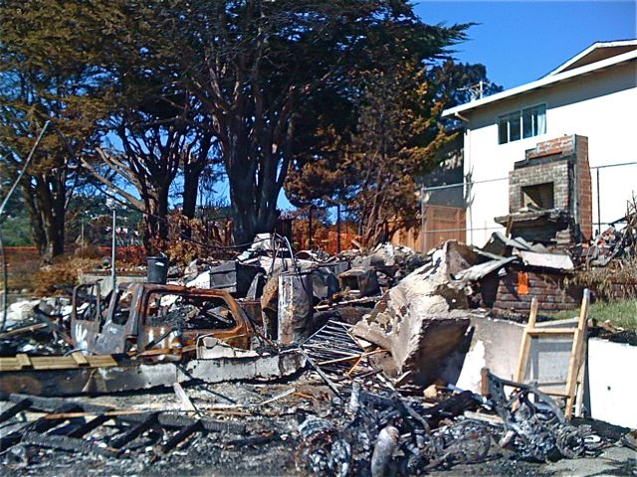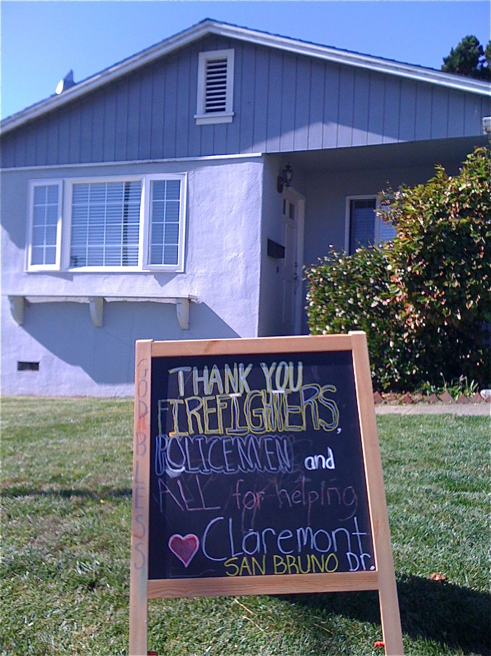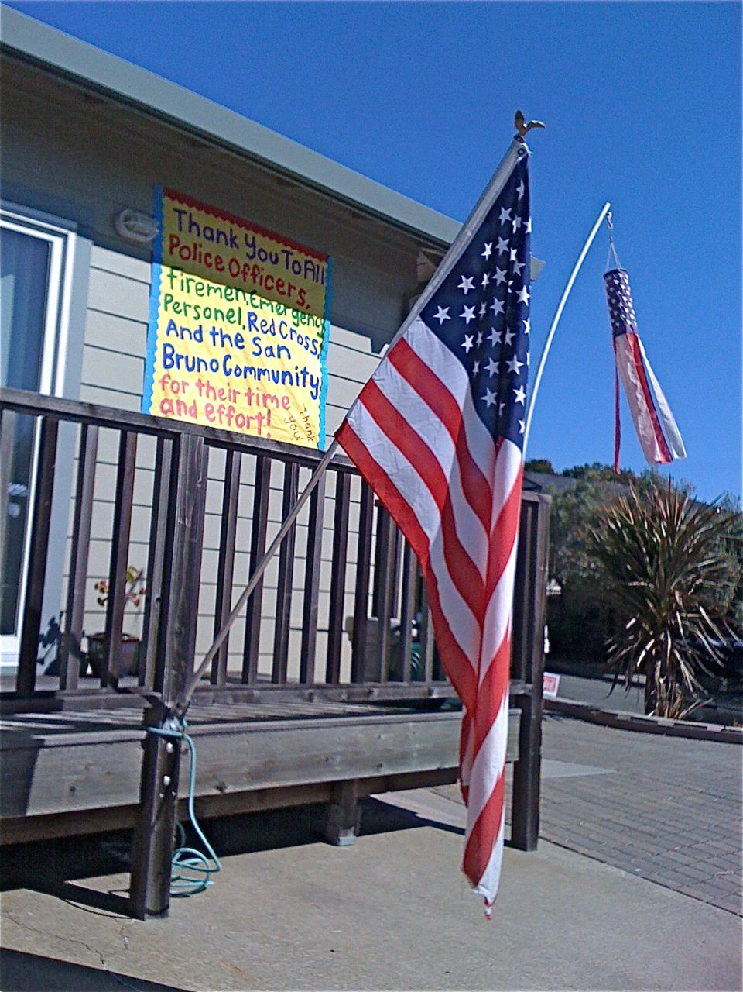
Photos by Callista Shepherd

_______________________________________________________________________

Dragonboat Recap

by Henry Gee

The GCD dragonboat team has just finished the last race of the year,
so this marks the end of the 2009-2010 season. Here's the recap of
what happened throughout this past year.
~Treasure Island (September 26-27, 2009)~
With the departure of the class of 2009, GCD lost a big part of the
team (around 20 paddlers, who made up most of A boat). Due to this
huge loss, our team struggled to compete well against the top youth
teams in the bay area, with our B boat placing 5th in the High School
B division and our A boat placing 4th in the same division. One superb
moment though was that for the first time in the team's history our
hotties (all women) crew managed to place 3rd in the high school
women's final. Although we didn't do as well as the other teams, GCD
still showed high spirit and managed to have fun despite our results
(such as the team's singing of Taylor Swift's "You Belong With Me").
~Youth Race (April 24, 2010)~
Youth Race is considered by many the start of the dragonboat season,
and finally being able to expose our new wave of paddlers to a race,
we were ready to begin.
Due to the enormous amount of new paddlers, we were able to bring 3
boats. Our C boat finished 6th place in D division, our B boat
finished 5th in C division, and our A boat finished 5th in A division.
Once again, although we weren't able to gain any medals, we gained the
knowledge in knowing how hard we needed to work in order to compete to
be the best.
~Vancouver (June 17-22, 2010)~
Going back to the Rio Tinto Alcan dragonboat festival for the 2nd
consecutive year, we had high expectations to do well. On the first
day of racing we managed to win both our heats in dominating fashion,
getting ourselves ranked 2nd out of all the junior teams. The second
day was a lot tougher, and at the end of it all, the better teams did
prevail. GCD ended up placing 4th again, but represented the Bay Area
well as the only youth team there. My personal favorite moment was
lining up before our races and hearing the other teams go "oh
-explicit-, it's that team from San Francisco again, we're going to
lose!" It made me proud to know that our team had left an impression
in Vancouver.

~Fremont Sprints (July 11, 2010)~
Even though our team did not train primarily for this race (when Long
Beach was just a few weeks away), we were still motivated to do our
best. This 250 meter race, as compared to the traditional 500meters,
proved very tough, as many teams focused on the use of strength rather
than technique. Our team faired up pretty well against the
competition, with A boat placing 5th in the Youth/College Cup, and
4th in Mixed Division B, while B boat placed 6th in Mixed Division E.
One remarkable highlight was our meat (all men) crew. In the past, our
meat crew has had horrible timing, much too ugly for anyone to recall.
But during this race, they were much better, although they did not
place, they pulled off a race with perfect, crisp timing, which is
worth way more than a plaque.

~Long Beach (July 29 - August 2, 2010)~
This was truly another spectacular race. From the moment we set foot
upon the race site, to the last stroke we paddled in our final race,
our team had on a game face, an aura of focus. This was one race that
we knew we would do our best in, having been training 17 of the 18
days before the race, but we knew that victory wasn't just handed to a
team. Prior to the trip, there were many troubles from our B boat to
gain more speed, but through togetherness, they worked together and
managed to get 5th place in the Mixed 3B division, and 4th place in
the High School B division (which far exceeds their expected outcome.)
Our A boat did an outstanding job once again by placing 1st in both
the High School A and Mixed 1B division. (The Mixed 1B was the second
highest division in the whole race, which included over 200 adult and
youth teams).
Our coach Brian Suzuki's main emphasis at the race was the idea of
mental focus, which worked out well for us at the end. Throughout the
trip, our A boat had raced DRD (of UC Davis) a total of 4 times.
During the first 3 encounters (which were raced side by side), we
emerged as the losers. But with each race, as our idea of the mental
focus and determination grew stronger, we started to creep up on them.
During the Mixed 1B final, not only did we win, but we were finally
able to defeat DRD.
~Team Recap~ (In the perspective of the team manager)
The year was tough, and our team definitely struggled. Our coach had
many occasions where he questioned if we would ever be able to find
our own identity (because we were so concerned on trying to be last
year's team). At times we showed potential, but it was quickly
diminished by the fact that we just couldn't get it together, we just
weren't able to reach our full potential. It wasn't until the summer
that everything started to click again, and we became more confident
in ourselves. During the Long Beach race coach Brian talked about how
much he's seen our team grow, and I've seen it too. Between Treasure
Island and Long Beach, we grew from a team full of confusion, doubts,
and disputes to a team of determination, a team of mental conquerors,
but most important a family. Coach Brian gave us a motto for the Long
Beach race, and it was a great motivator, but I can proudly say that
the motto can be used to sum up our whole season. "We are united, we
are family, we are GCD"
Ed. Note: Henry Gee is the former GCD Manager 2009-2010

Announcement

Attention! Graduates from years 1977, 78 & 79: Contact Melva Sheard masadaya2@aol.com 1(707) 334-4869 for a potential 25 year reunion

Gone But Not Forgotten

Nino Cresci. Nino “Skipe” Cresci (’47), a native San Franciscan from North Beach, passed away on July 31st, while watching a Giants-Dodgers game. http://www.legacy.com/obituaries/sfgate/obituary-print.aspx?n=nino-cresci&pid=144451395.

*********************************

Grace Licata. Grace Licata (Spring, ‘51) passed away on April 25th.

***********************************************

Joe Cricchio. Joe Cricchio (’51) passed away recently.
________________________________________________________________________________

Note: Send letters to GalileoObserver@aol.com or to Galileo Observer, c/o Galileo Alumni Association, 1150 Francisco Street, San Francisco, CA 94109. All letters are subject to editing

************************************

CALENDAR OF UPCOMING EVENTS
GAA Board Meeting - Room 210, Galileo Academy, 6:30 PM, Thursday, November 18, 2010
REMEMBER TO ATTEND AND VOTE
Here are the names for the November 18, 2010 ballot:
There are six openings. Vote yes or no for each candidate.
Vince Gomez ('52) Cordy Surdyka ('53)
Toni Alessandra ('64) Dennis Eleen ('61)
Office of President: Dennis Eleen ('61)
Office of Secretary: Monica Parenti Kirkland ('53)
______________________________________________________________________________________________
When checking for upcoming events between issues of the Observer, please visit the web site http://galileoalumni.org/home.html for the most up-to-date listings.
_____________________________________________________

Contributors
Tony Compagno
Henry Gee
Vince Gomez
Bettie Grinnell
Mario Lombardi
Charlene Fachner Mori
Renee Mau Wade

NOTE:
Charlene Mori helped with technical aspects of this issue and prepared the print edition,
which Janet Neilsen had printed and mailed. Thanks to them both.

.

************************************

The OBSERVER Is For All
Galileo alumni, family, friends, students, faculty . . . anybody and everybody, the Observer is for you. If you haven't already done so, send in the email addresses of anyone who would like to receive a FREE emailed newsletter to http://galileoalumni.org/contact.html. We'd like to reach as wide a range of readers as possible.

BACK ISSUES OF THE GALILEO OBSERVER CAN BE VIEWED AT
http://galileoweb.org/alumni/newsletter/.
For all EDITORIALLY-RELATED comments or suggestions, please address your emails to galileoobserver@aol.com.
For all TECHNICAL problems (non-receipt of newsletter, etc.), contact the webmaster through http://galileoweb.org/alumni/contact/.
* * * *
The Galileo Observer invites your articles, letters, memories, inquiries and suggestions. All submissions are subject to editing. Deadlines for submissions are January 1, April 1, July 1 and October 1. Send them by email (preferable) to galileoobserver@aol.com, or by postal mail to: Galileo Observer, c/o Galileo Alumni Association, 1150 Francisco Street, San Francisco, CA 94109.
GAA BOARD OF DIRECTORS, OFFICERS, & COMMITTEE CHAIRS ARE LISTED AT http://galileoweb.org/alumni/contact/
The Galileo Observer is published quarterly in January, April, July and October by the Galileo Alumni Association, 1150 Francisco Street, San Francisco, CA 94109. Views expressed are strictly those of the Association and in no way reflect those of the Galileo Academy of Science and Technology, its students or faculty. Dennis Eleen, President; Sisvan Der Harootunian, Editor; Vaughn Spurlin, Production Manager/Website Director. Copyright 2010, Galileo Alumni Association.
Last updated October 2010. © 2002-2010 Galileo Academy of Science and Technology Alumni Association of San Francisco. No part of this publication may be reprinted or reproduced in any form without permission of The Galileo Observer and/or The Galileo Alumni Association.

PLEASE REMEMBER TO SUPPORT YOUR SCHOOL. http://galileoweb.org/alumni

GO LIONS!

