Ch 17: Gene to Protein (Central Dogma)

True or False: one gene = one protein?

Maybe… a gene = codes for a polypeptide (a bunch of amino acids stuck together) NOT all polypeptides are proteins. Some proteins are combinations of polypeptides. Some proteins are only one polypeptide.

A gene is a sequence of codons that = polypeptide. Human genome is about 3 billion base pairs, only some are genes? We probably have about ~30,000 genes… I think…

What does our body have to regulate?
- Which cells make which proteins? (i.e. blood cells make hemoglobin, but not actin found in muscles)
- How much protein should we make?
- When should we make them? (i.e. make digestive enzymes after eating)
- How they are made?

Three Main Steps of Transcription (in the Nucleus)
1) Initiation: RNA polymerase starts to make pre-mRNA.
2) Elongation: The chain of pre-mRNA gets longer
3) Termination: When the RNA Polymerase reaches the end of the gene.

A closer look:
DNA has regions called transcription units:

Promoter + gene + terminating sequence.

TATA box…. TATAAAA (sequence)

Signals the RNA Polymerase where to attach and start reading the gene. Transcription factors (proteins) must attach to the promoter before RNA Polymerase can attach.

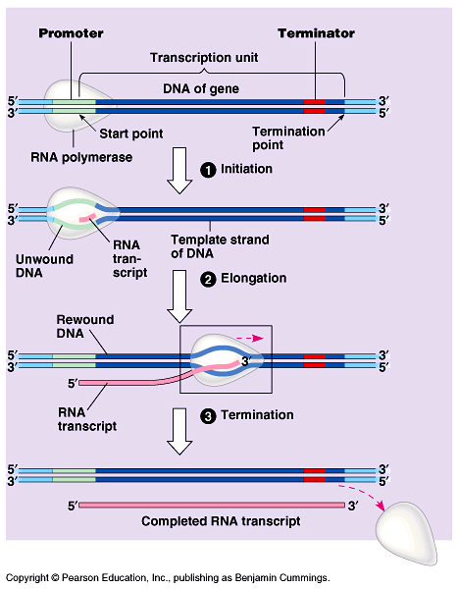

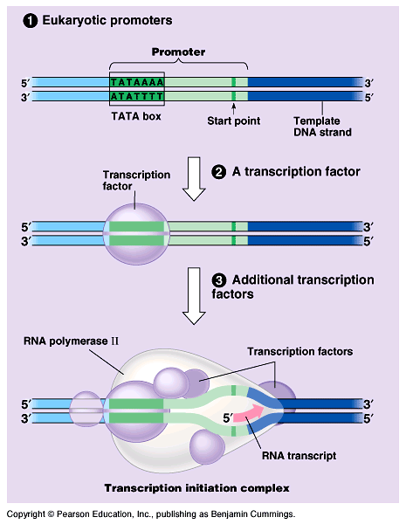

Once the RNA Polymerase attaches to the promoter, it starts to read the gene and make pre-mRNA.

Once the RNA Polymerase hits the Terminator, it lets go and the DNA rewinds.

DNA = ATTGCACGA (“sense” strand)
RNA = UAACGUGCU

http://www.youtube.com/watch?v=5MfSYnItYvg (basic)

http://www.youtube.com/watch?v=SMtWvDbfHLo&NR=1 (adv)

Pre-mRNA must be processed before leaving the nucleus.
- Add a 5’ cap (added to the top of the chain – to add stability)
- Add a poly – A tail is added to the 3’ end. AAAAAAAAAAAAAAAAAAAAAAAA.
- Remove some non-coding sequences, introns (interrupting sequences), leave the exons (expressed sequences). A splicesome removes the introns. Splicesomes are made of snRNP’s (small nucleotide Ribonucleoproteins – another type of RNA).

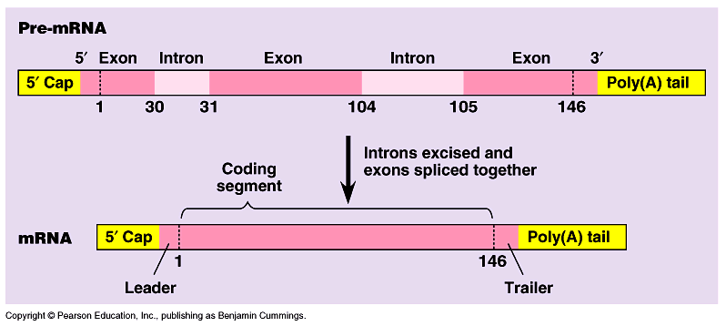

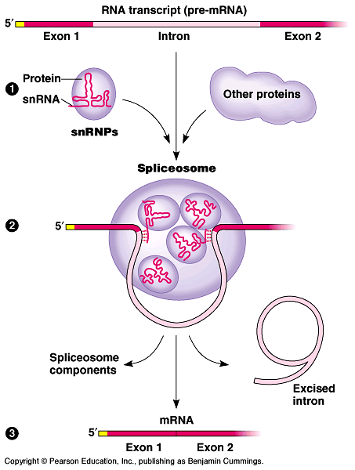

http://www.youtube.com/watch?v=FVuAwBGw_pQ

(splicing)

NOW we have mRNA!!!!! Ready to leave the nucleus… out the nuclear pores to the cytoplasm and the ribosomes… actually the ribosomes find the mRNA.

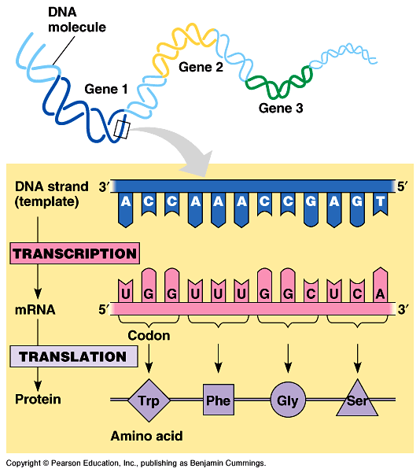

There are 20 amino acids. All have different chemical structures.

DNA → AAG ATG AAT AGG
mRNA→ UUC UAC UUA UCC
AA → Phe Tyr Leu Ser

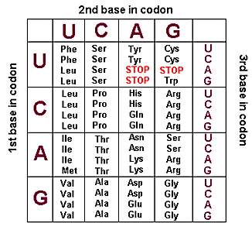

In real life… cells must attach amino acids to the proper tRNA (transfer RNA)

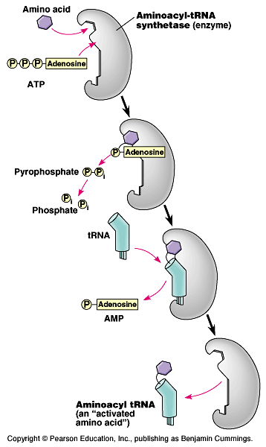
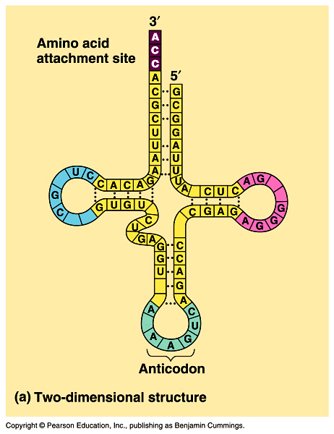
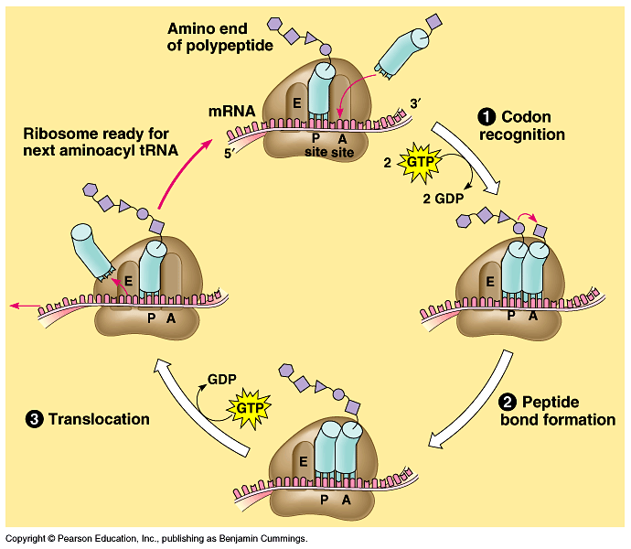
Translation: (translates mRNA code into polypeptide code)

- Ribosome subunits latch onto a piece of mRNA.
- The tRNA’s bring over the appropriate amino acids.
- The growing chain is transferred from the tRNA in the “P’ site over to the tRNA in the “A” site.
- The mRNA moves down one codon, so now the original tRNA is in the E site and falls off, and the growing chain is in the P site. Keeps repeating steps 2-4.

http://www.abdn.ac.uk/~clt011/flash/samples/protein.swf (figure 4)

http://www.youtube.com/watch?v=TfYf_rPWUdY

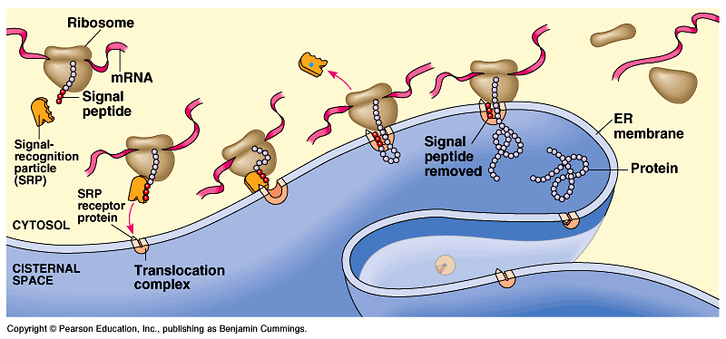
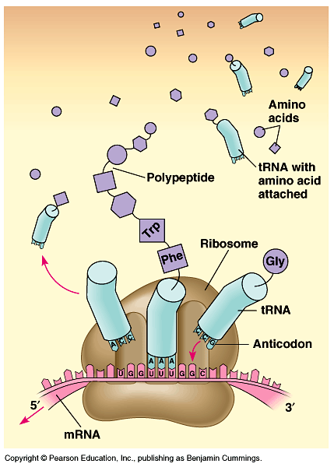

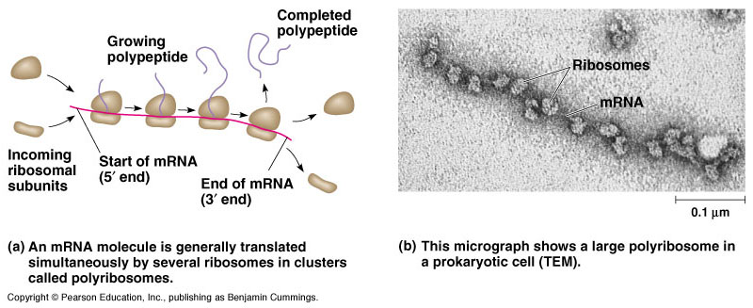
Mutations: Sometimes occur when DNA is being transcribed, mistakes are made, which sometimes results in… dysfunctional peptides (protein).

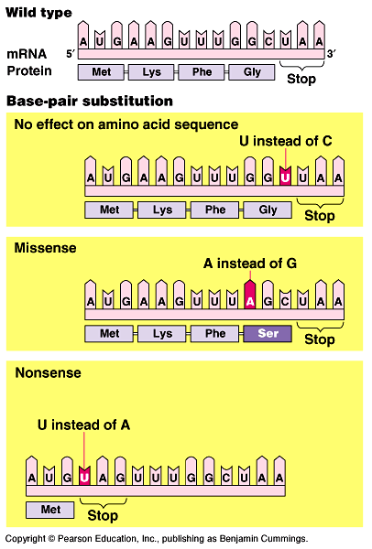
Point Mutation: Changing one letter…
- Substitution – wrong letter
  - Sometimes there’s no effect, if it’s the same amino acid (silent mutation).
  - Sometimes it codes for the wrong amino acid, could have a huge effect depending on the amino acid. Could change the whole shape of peptide. (missense mutation).
  - Sometimes it codes for a stop codon, and stops translation too early (non-sense mutation)

- Deletion or Insertion – taking out or putting an extra base.
  - Results in a frame shift (moves the reading frame).

Cat – hat – sat –mat – fat
cth – ats – atm – atf – at…

- Deletion or inserting of 3 bases, is less detrimental. Can still keep the reading frame.

