Ch 26: Origin of Early Earth – origin of life
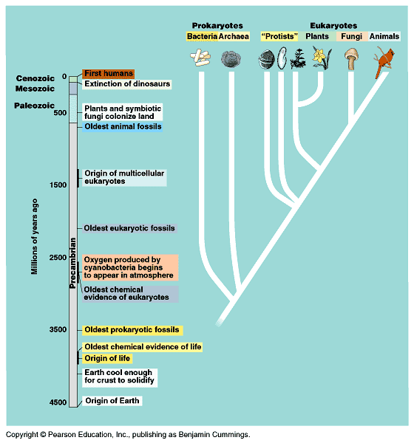
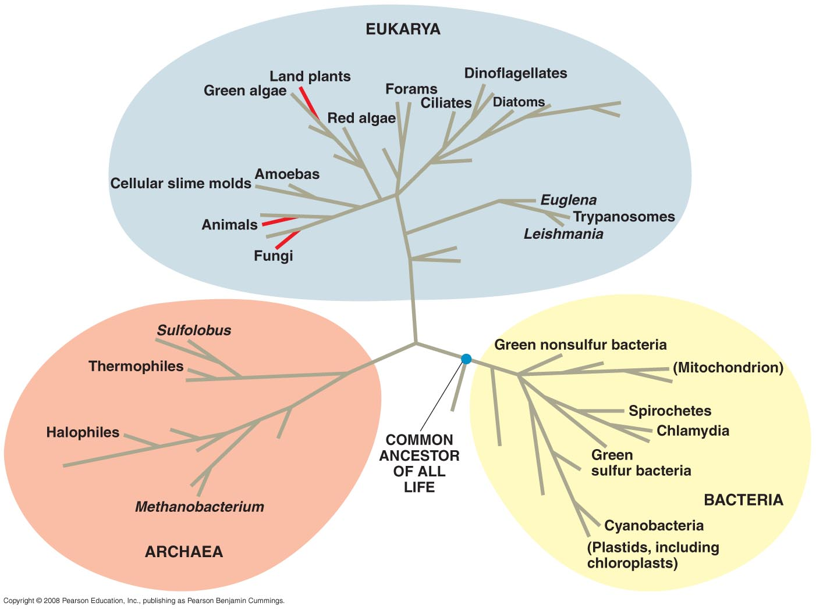

1920’s A.I. Oparin (Russian), J.B.S. Haldane (British). Theories of the origin of life (organic molecules).

Maybe if given enough time, and you took the substances found at the origin of life (CO₂, NH₃, H₂, CH₄, H₂O, Lightning, Heat (volcanoes), you could create an organic molecule.

1953 Miller and Urey, made a model to see if this is possible. Got some amino acids.
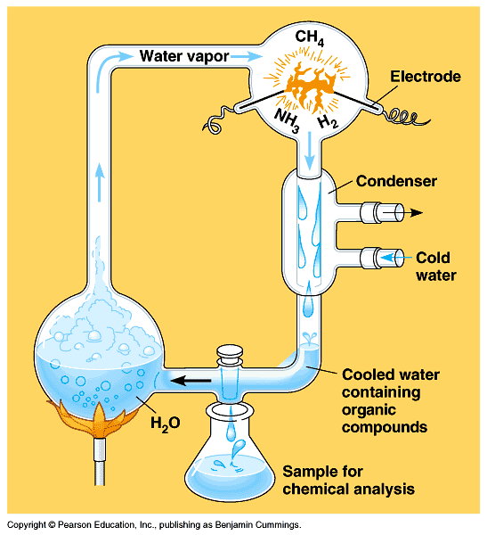

2000’s Some organic molecules are possibly found in space. Adenine, cyanide (from almonds). Some “starter” molecules found in space?

Other Theories: Assuming we got organic molecules somehow…

RNA world theory. RNA may have been the first substances that could reproduce itself. Could have been a catalyst for life.

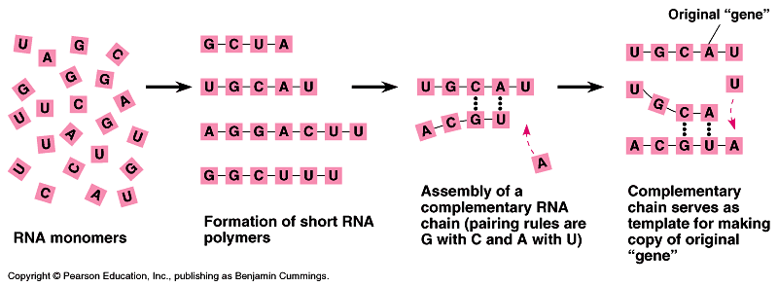

Protobionts: ancestors to first cells. Membrane that could enclosed a “mini-laboratory.” Primitive metabolism, semi-permeable environment, RNA inside.

Bottom-line is… the debate continues… we don’t really know where life started.

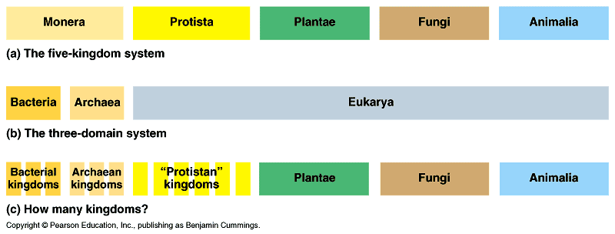

Biological Hierarchy:
Domain – Kingdom (6) – Phylum – Class – Order – Family – Genus – Species.

