Ch 27: Bacteria and Archaea (prokaryotes)

Can live in almost any environment. Biomass = all eukaryotes times 10.
5,000 species known… possibly millions uknown.
Affects:
- Decomposers: breaks down materials into molecules. (CO₂, H₂O… )
- Diseases: Strep Throat, TB…
- Symbiosis (living together)
  - Mutualism (ex: legume – bean’s have bacteria in their roots that make Nitrogen fertilizers)
  - Commensalism (ex: humans, we have lots of bacteria that neither harms nor helps us)
  - Parasite (ex: streptococcus) When one organism lives off the other potentially harming it.
- Biotechnology: using bacteria for a technological purpose.
  - Yogurt/cheese
  - Producing medicines
  - Bioremediation: using bacteria to clean up fuel spills.
  - Biofuels: using bacteria to break down cellulose to make fuels.

Bacteria have a cell wall made out of peptidoglycan (absent in Archaea)

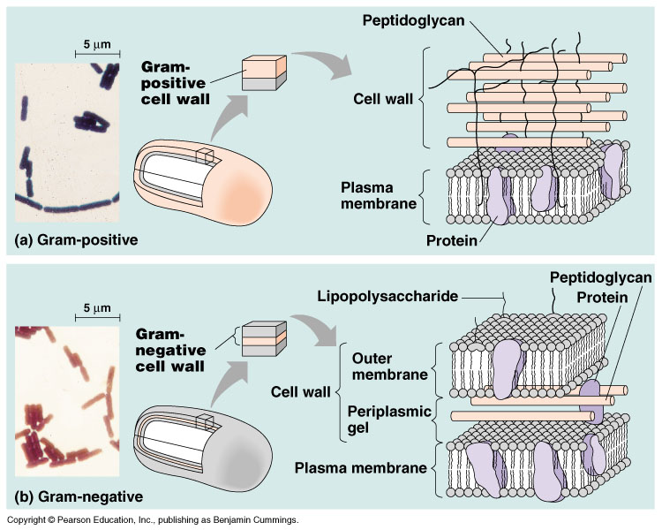7

Three main shapes of bacteria:
Spherical: Cocci 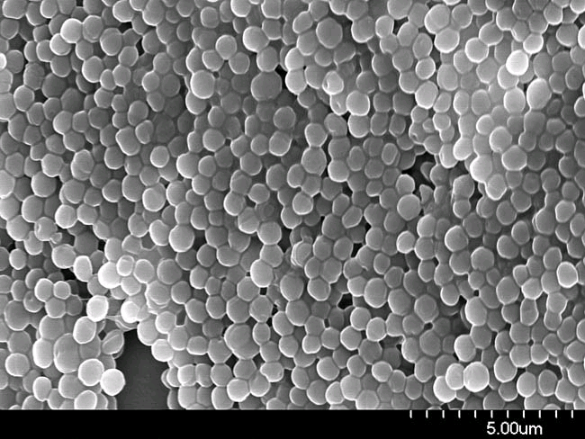
Rod Shaped: Bacilli 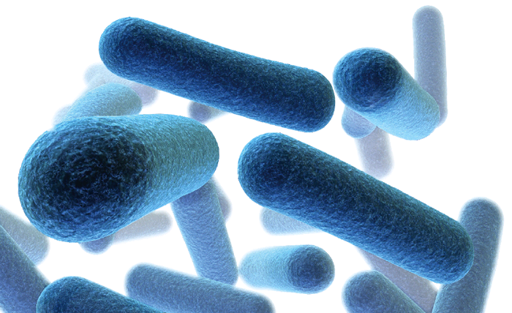

Spiral: Helical 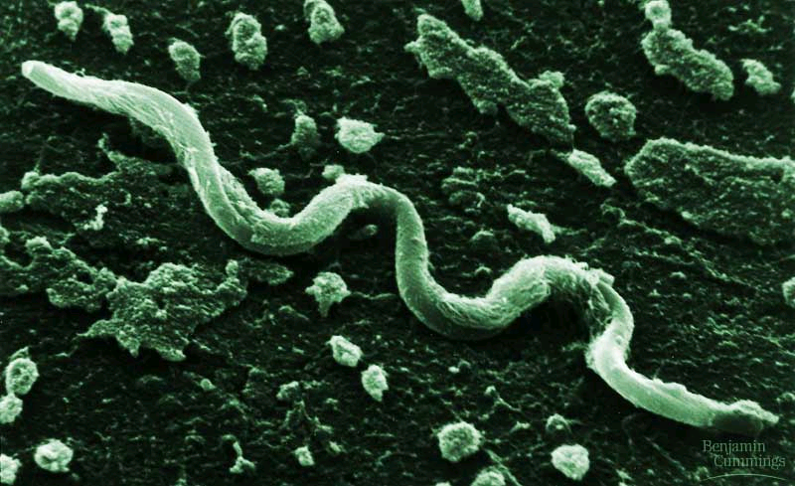

Motility: Use a flagellum

Reproduction:

No Nucleus… but Nucleoid (clump of DNA)
Plasmids are rings of DNA with a few genes on them. They exchange these.

Binary Fission: Bacteria make a copy of their DNA and other vital parts (ribosomes, enzymes)… then they split. Can be fast… 20 minutes

Metabolism: (the reactions in an organism)
Photo – energy from sun (light),
Auto - carbon from atmosphere (inorganic source)
Chemo – energy from chemicals
heterotroph – carbon from other organisms

Some Bacteria:
- Saprobes: decomposers (they absorb their food).
- Parasites: absorb nutrients from a host.
- Nitrogen fixing. Take nitrogen from air and turn it into nitrogen that plants can use. (very important for the ecosystem).
- Anaerobic – don’t use oxygen, so they do fermentation. (usually stinky)
  - Obligate anaerobe (must not have oxygen). Possibly first organisms.
  - Facultative anaerobe – can live with out or with oxygen.

- Aerobic – must have oxygen. Do aerobic respiration (Kreb’s)

Pg 537 know the chart.
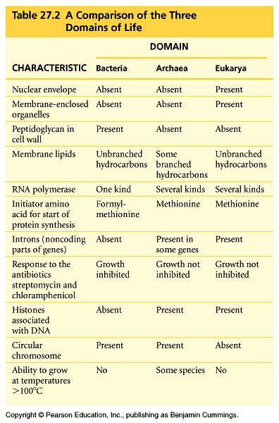

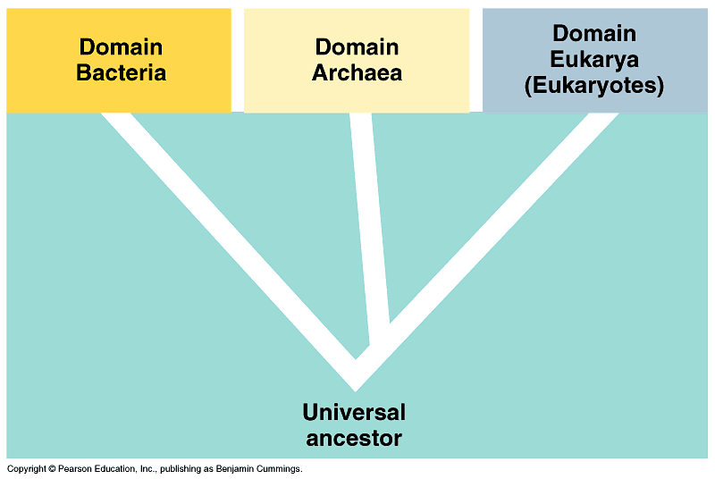

Some examples:

Bacteria:
E. coli, salmonella. Cyanobacteria (first photosynthesizer).

Archea:
Extreme Halophiles: Loves salt.
Extreme Thermophile: Love heat
Methanogens: use methane for energy

Some bacteria are parasites: lyme disease caused by a bacteria.

Streptacoccus Pneumoniae: lives in your throat.

