Ch 28 Notes: Protistan Diversity

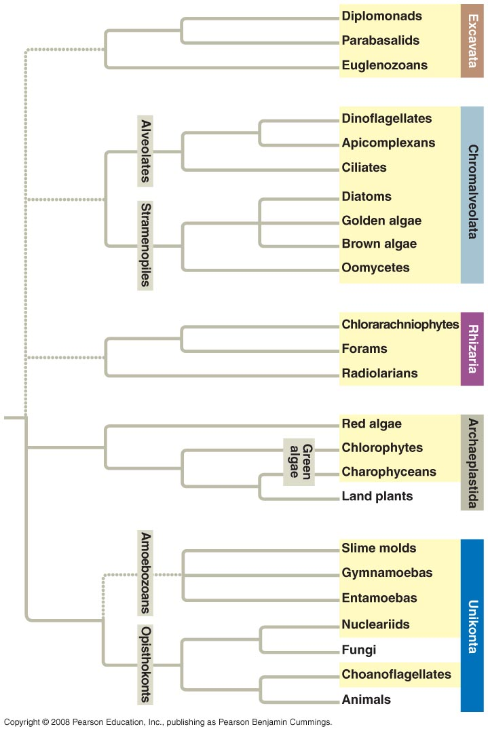

Where did the first Eukaryotes come from?

Endosymbiotic Theory: that an early prokaryote might have engulfed a heterotroph that became a mitochondria. And maybe
engulfed an autrotroph that became a plastid (i.e. chloroplast)

Evidence:
- They (chloroplasts/mitochondria) have their own DNA. They can reproduce on their own.
- They have a double membrane (so maybe when engulfed they kept the extra membrane.
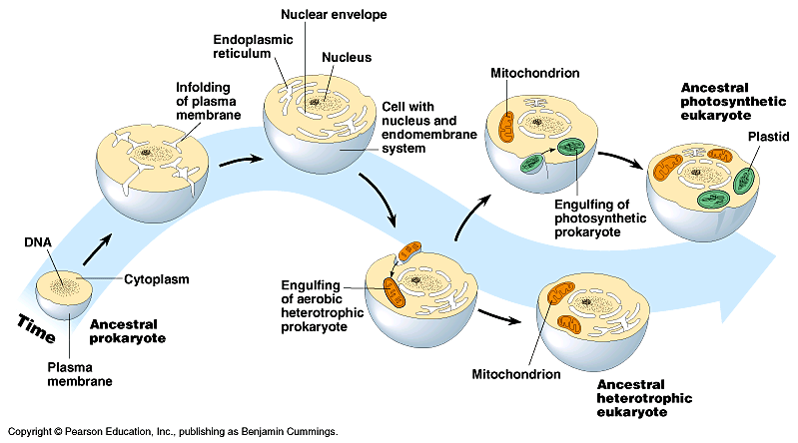

How eukaryotes (may) have evolved:

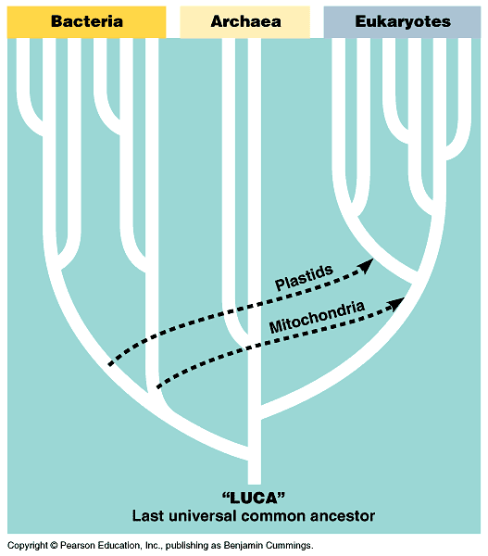

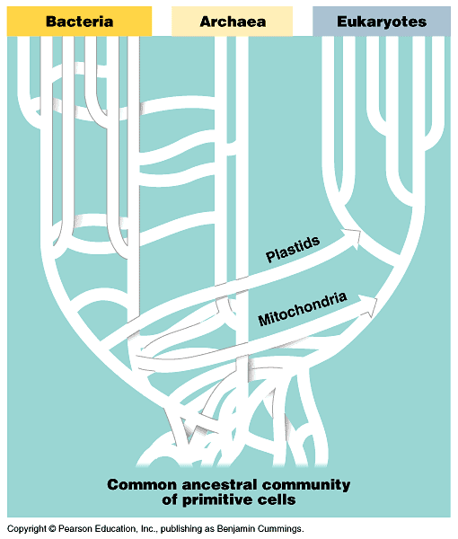

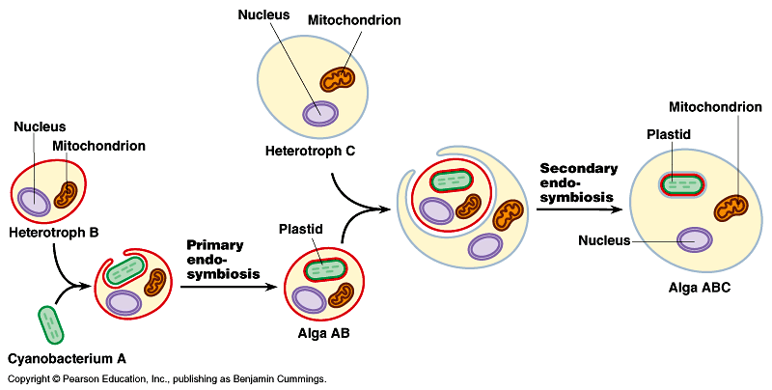

Protista is a very diverse kingdom. Possibly multiple kingdoms???

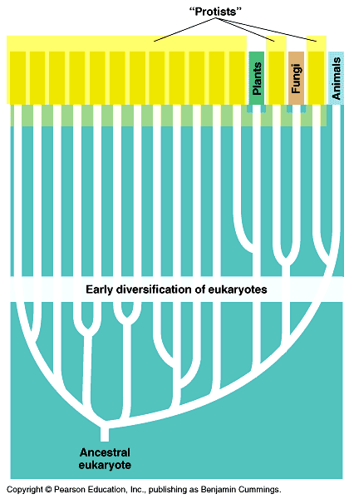

Can be categorized by mode of nutrition and movement. (Chart on pg 573 – only need to know the ones in the notes)

2) (Excavates) Euglenozoa –mixotrophic flagellates. Example: euglena.

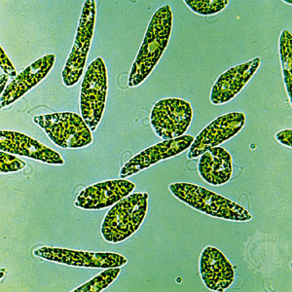

3) (Chromaveolates):
a) Alveolata (membrane bound sacs). A group called ciliates use hair like cilia. Example: Paramecium.

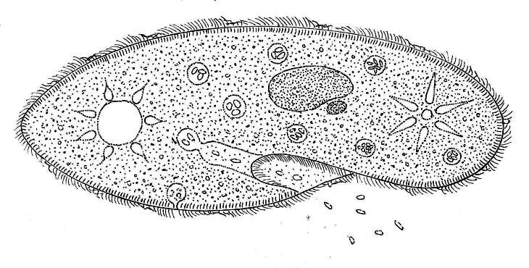
b)Stramenopila. “hairy” flagella. Examples are algaes (brown algae, diatoms – silica skeleton). Do photosynthesis.

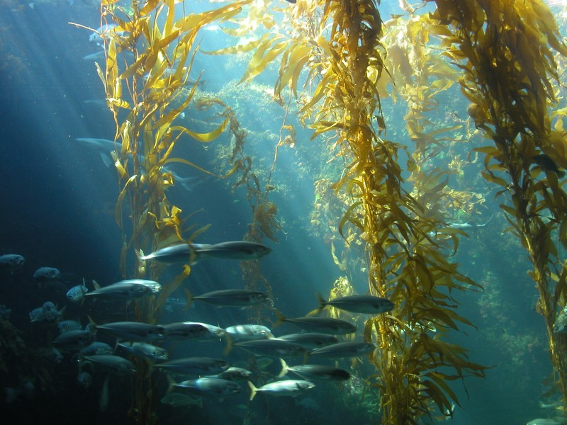

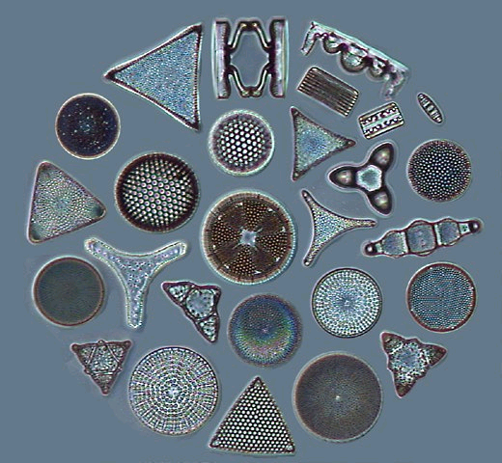

4) (Archaeplastida) Plant like chloroplasts. Chlorophyta (green algae). Ancestors to plants.

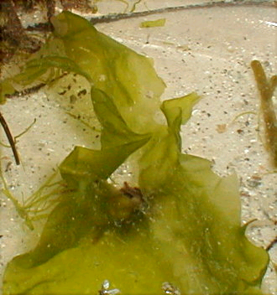

5) (Unikonta) Rhizopoda.
a) Amoebazoans: use pseudopodia to move (fake feet) Example: Amoeba. Use “blob like” extensions in cytoplasm to move and engulf food.
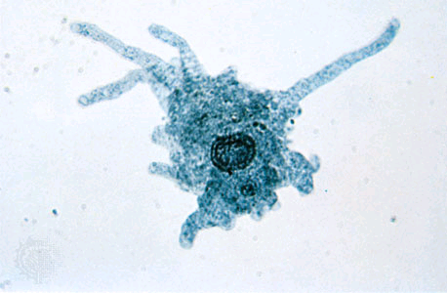

b) Mycetozoa: fungi like protists. Example= slime molds.

Significance of Protists (to us)

1) Base of all aquatic food pyramids.
2) Protists do a major part of the earth’s photosynthesis. (oceans)
3) Protists can cause diseases.

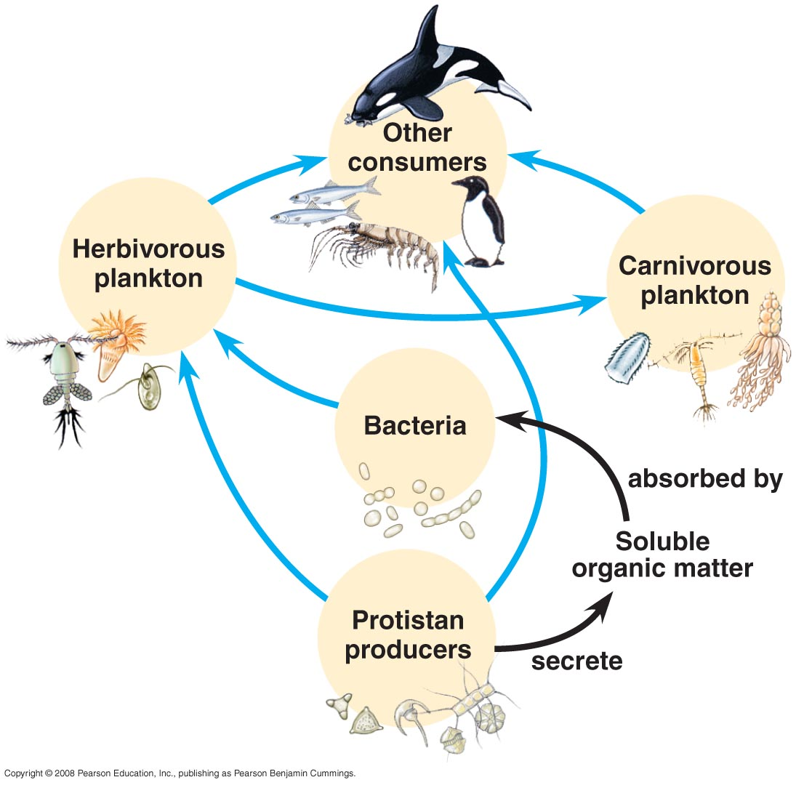

Trichomonas , vaginalis
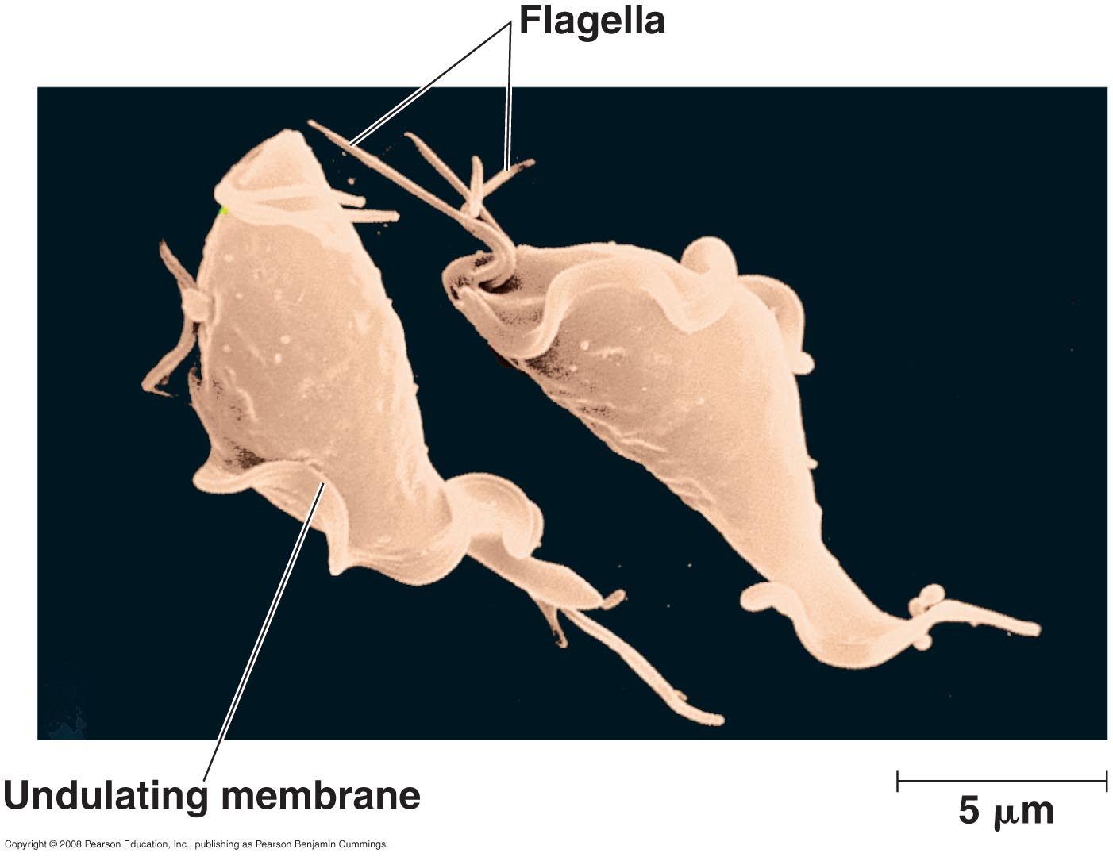

Typanosoma: Sleeping Sickness

