Ch 29 Notes: Plant Diversity I

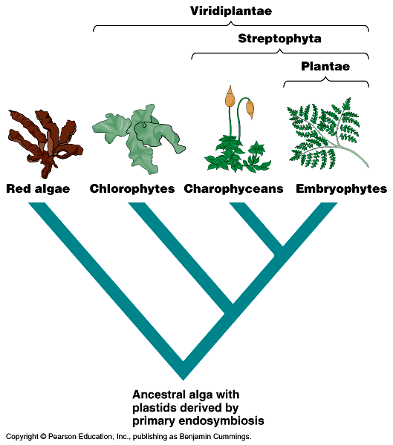

Plants most likely evolved from green algae. There are some links to a group called charophyceans.
- Both have chlorophyll (both a & b)
- Cell walls made of cellulose

Early plants had to overcome moving onto land:
- Needed to get water
- Need to protect against drying out and too much light.
- Need to protect against herbivores
- Need to get minerals and nutrients
- Need to reproduce

Bryophytes: Mosses, liverworts, hornworts…
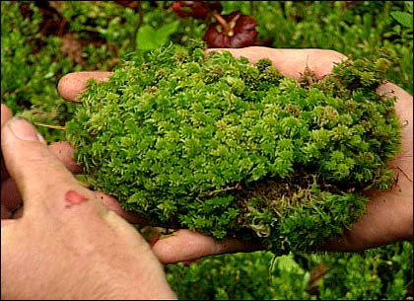

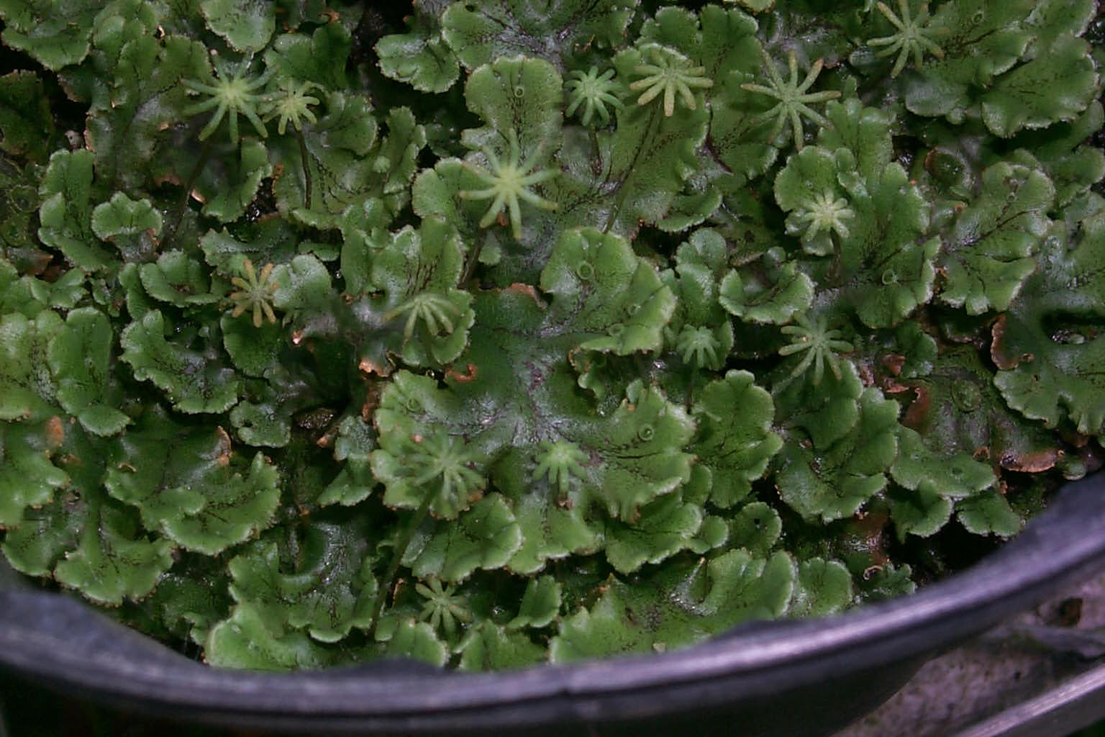

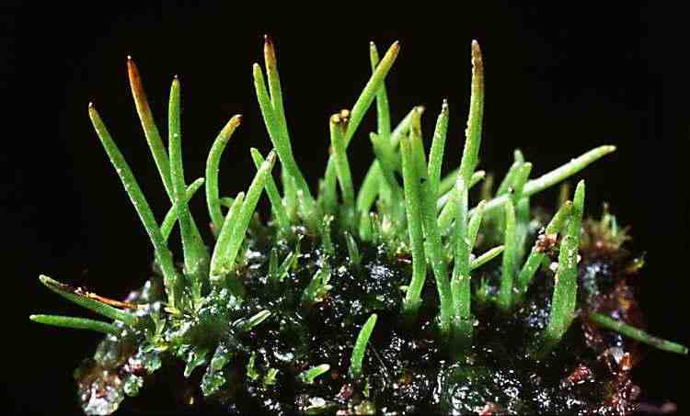

- Small, non-vascular (don’t have water conducting tubes), seedless (use spores).
- Found in shady areas, wet areas.
- Don’t need soil, can grow on rock, brick… Can make soil by breaking down rock.

Alternation of Generations: goes through distinct life generations.
- One life = sporophyte (diploid)
- One life = gametophyte (haploid)

Pg 586:

Male gametophyte makes sperm with flagella that must swim in water. Mosses must live near water.
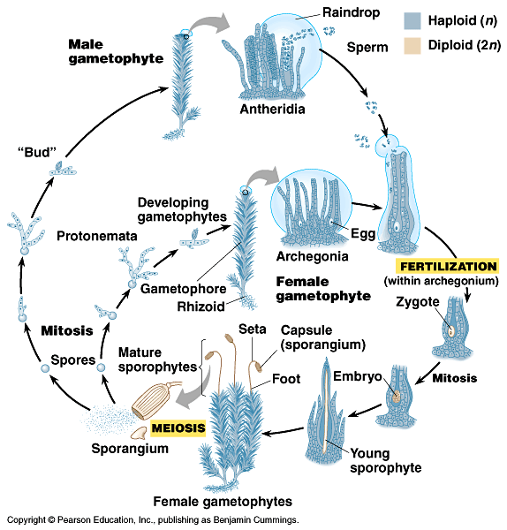

Pteridiophytes (ferns): Vascular Plants! But still seedless…(still need water for sperm to swim)

Also do alternation of generations: (pg 592)

