Ch 31: Fungi
Characteristics of Fungi:
- Eukaryotes, most multi-cellular (yeast = unicellular)
- Heterotrophs → saprobes (absorb food, decomposers), parasites (off of living things), or symbionts (live together)
- Have cell walls made of CHITIN (a carb)
- Fungi disperse and reproduce by releasing spores

- 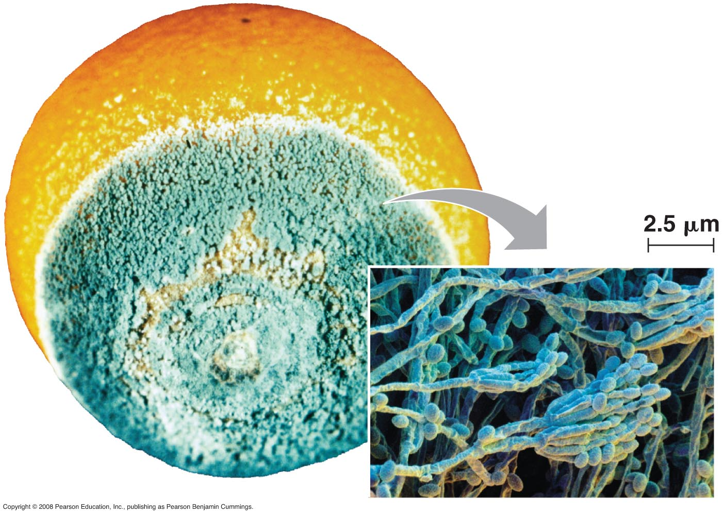
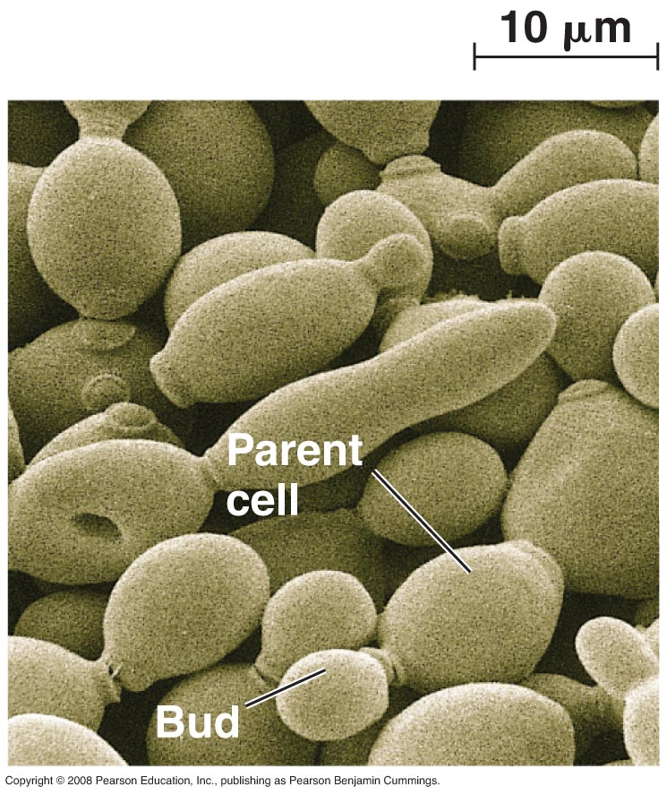
- spores can be produced sexually or asexually (carried by wind or water).
- Made of hyphae, separated by septa. Some have more than one nucleus per cell (can be heterokaryotic – nuclei from different “parents” by fusion)

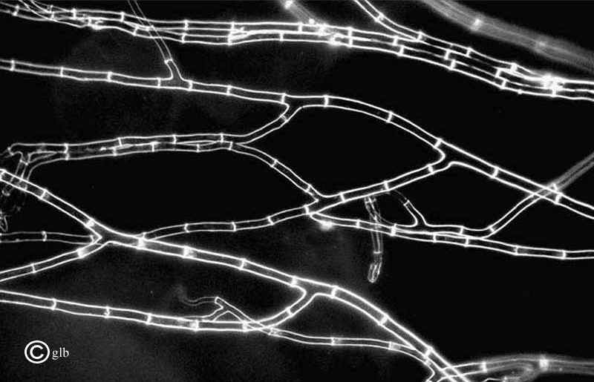
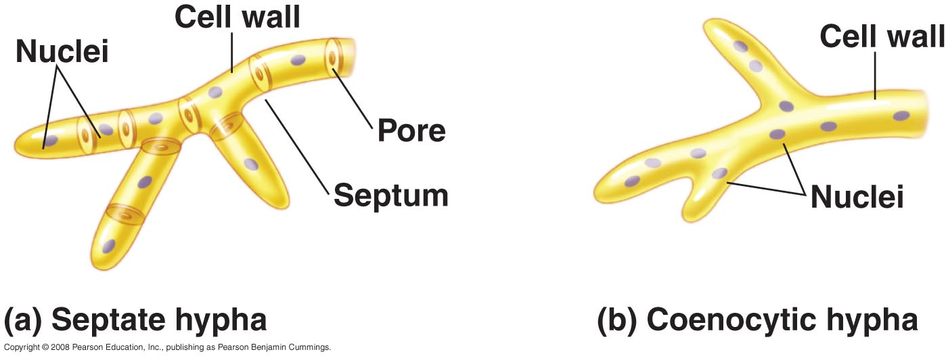

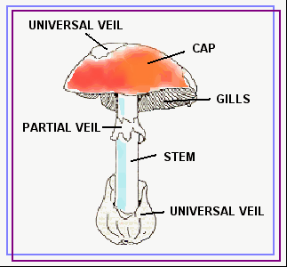

- Phylum Zygomycota: terrestrial, on soil or dead plant or animals. Ex: bread mold
- Phylum Basidiomycota (L. “little pedestal”) ex: mushrooms.
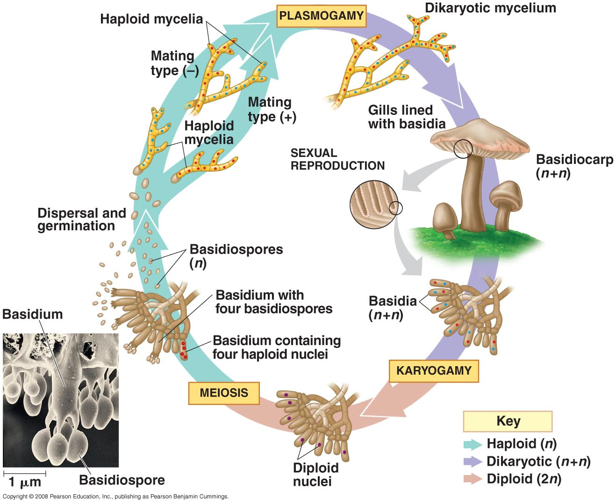

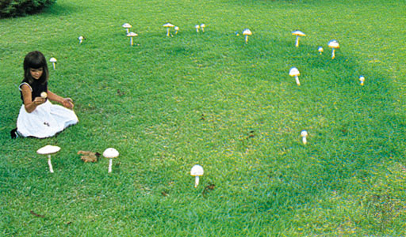

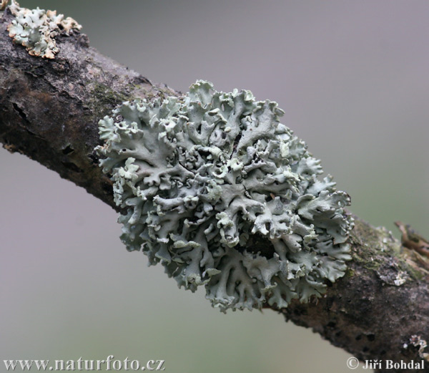
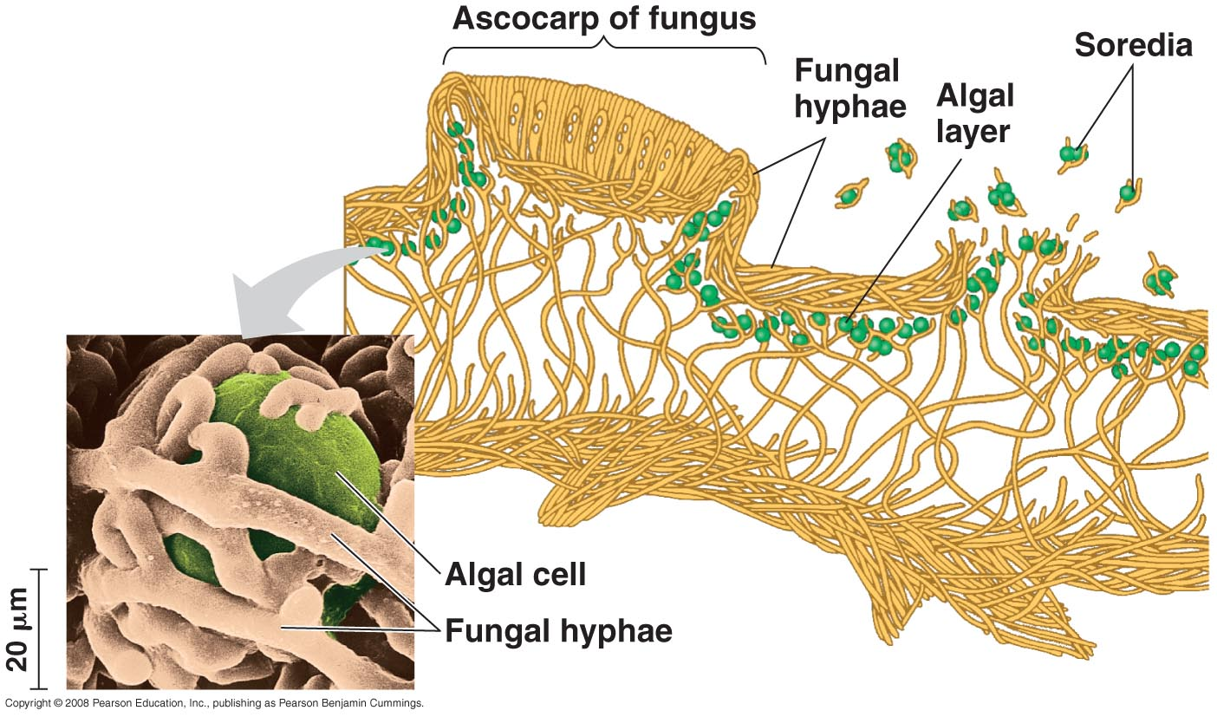

Symbiosis: Living together (mutually beneficial… or not)
Fungi can live with other organisms, such as:
- Lichen (fungus/algae) fungus gets free sugar from the algae’s photosynthesis, algae gets mobility, and live on land, nutrients.
- Fungi can live outside roots and give nutrients to plants. Mycorrhizae.

