Chapter 32: Animal Evolution

What is an animal?
A lot of variation.
- Multicellular
- Eukaryotic
- Heterotrophic
  - Usually ingestion
- Lack cell walls
- Muscles and Nerves are only found in animals.
- Most animals reproduce sexually.
- Usually development changes dramatically when the embryo is forming, due to hox gene.

Where did animals come from?
Probably a heterotrophic Protist.

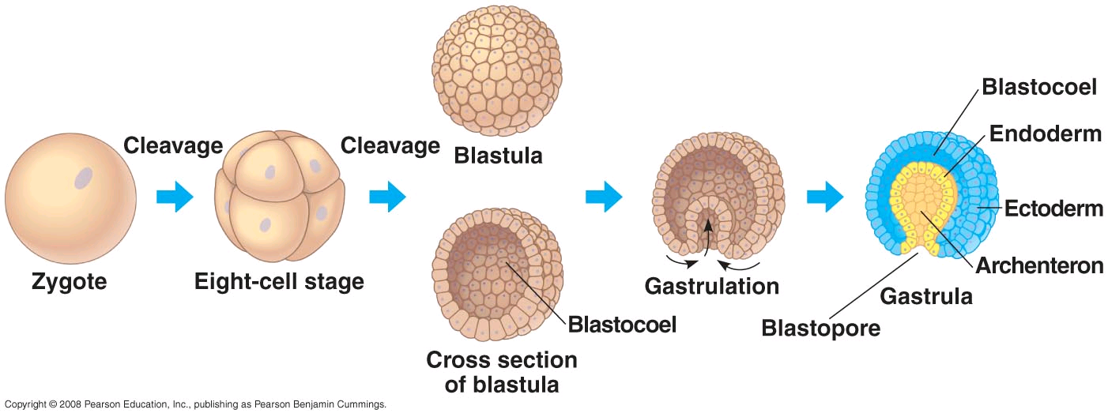

Animals are categorized by physical shape: radial symmetry or bilateral symmetry.

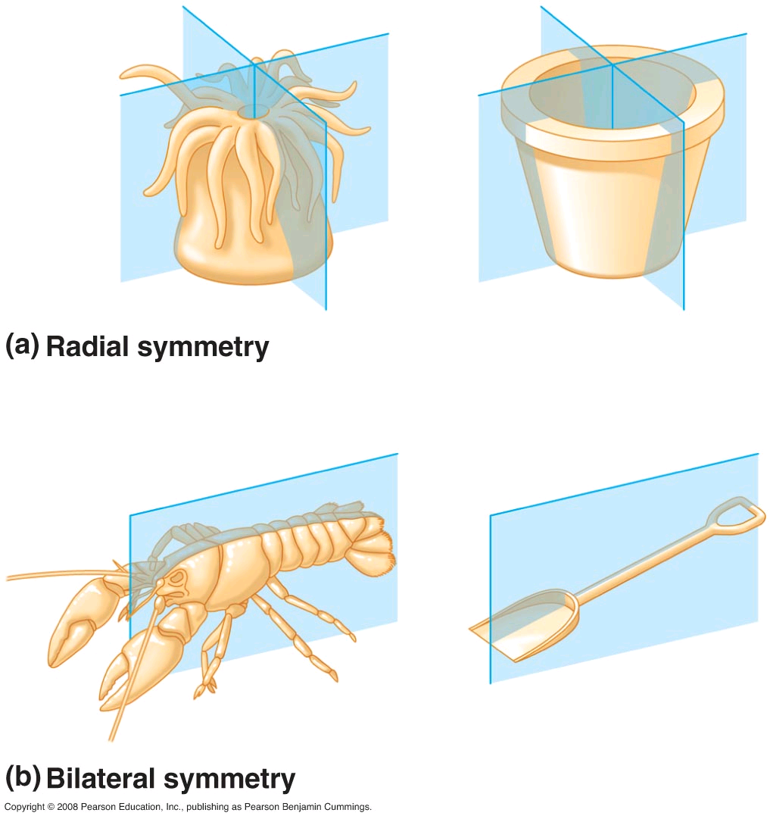

Coelom or no coelom or in between… (coelom is a body cavity wrapped in mesoderm).
Pg 638, picture 32.6.
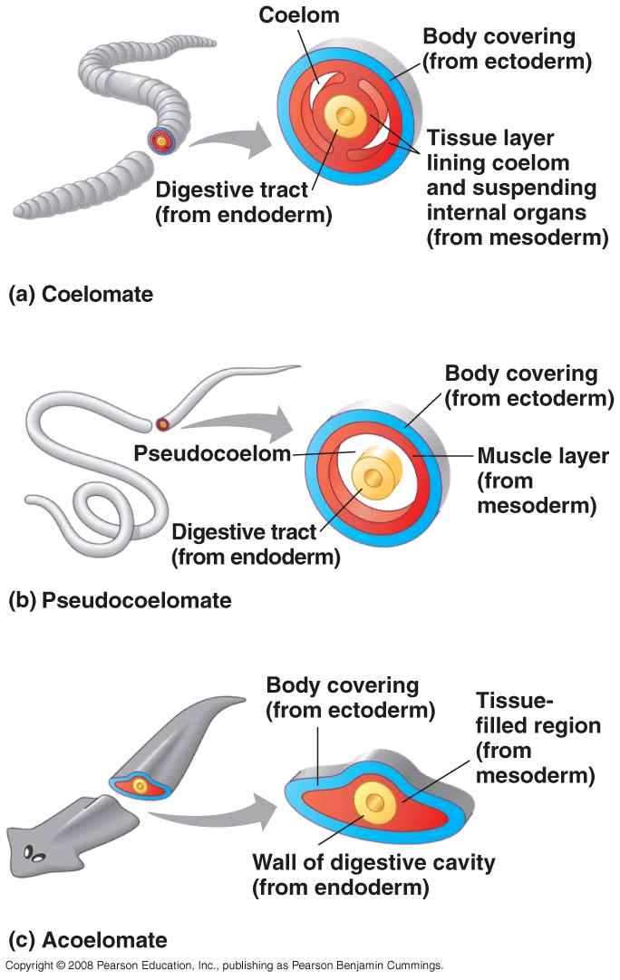

Protostome or a Deuterostome:
Pg 639, fig 32.7

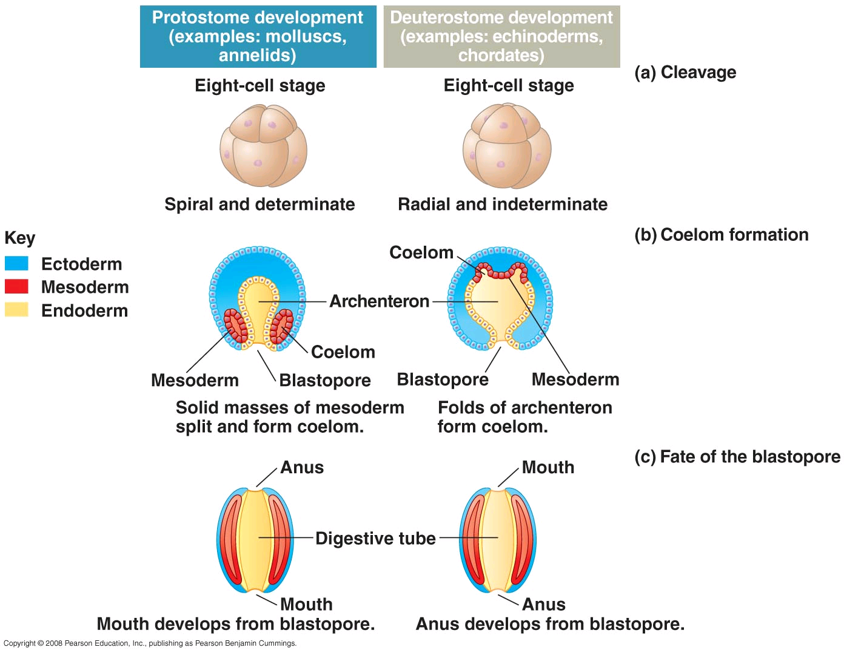
Anatomical Terms:
- Ventral: bottom (stomach side)
- Dorsal: top (the back)
- Superior: Above
- Inferior: Below
- Anterior: Towards the head
- Posterior: Towards the butt

