Notes Ch. 4 :

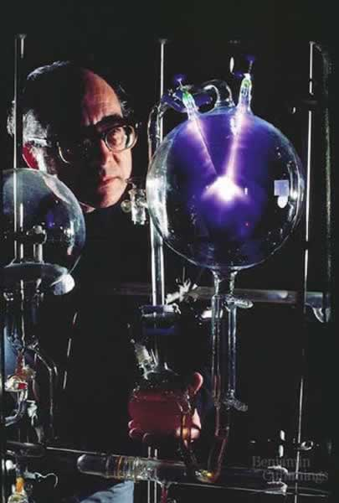

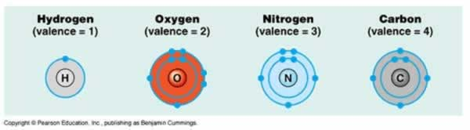

The outer shell (valence) determines how many bonds an atom will form.

Carbon is a good building block, because it wants to form 4 bonds, which makes it a good molecular skeleton for all living things.

CH₄ – Methane.

C₂H₄ – Ethylene Gas (used for ripening bananas)

C₄H₁₀ - Butane (gas for lighters)

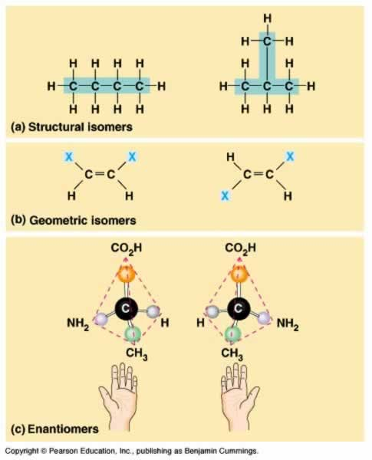

Chemical isomers are same formula, different shape. But, shape affects function.

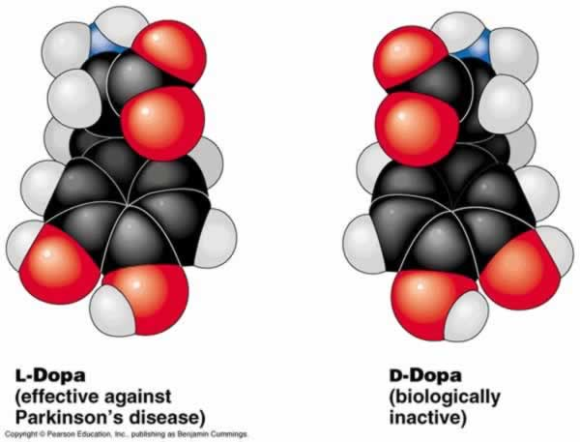

Carbon is able to make a wide variety of molecules by combining functional groups.

Functional groups are certain groups of atoms that are frequently attached to carbon skeletons, to give it a unique property.

Table 4-1. Functional Groups of Organic Compounds
Functional Group | Formula | Name of Compounds | Example
Hydroxyl |  | Alcohols | 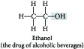
Carbonyl | 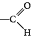 | Aldehydes | 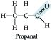
 |  | Ketones | 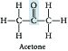
Carboxyl | 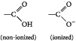 | Carboxylic acids | 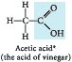
Amino | 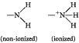 | Amines | 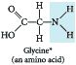
Sulfhydryl |  | Thiols | 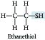
Phosphate | 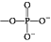 | Organic phosphates | 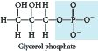

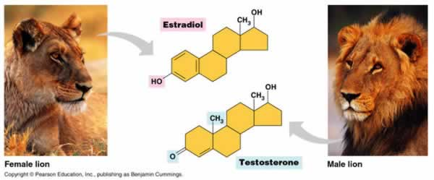

Evolution Connection
Some scientists believe that life elsewhere in the universe might be based on the element silicon, rather than on carbon, as on Earth. What properties does silicon share with carbon that would make silicon-based life more likely than, say, neon-based life or aluminum-based life? (see FIGURE 2.30, p. 32)

The Process of Science
In 1918, an epidemic of sleeping sickness caused an unusual rigid paralysis in some survivors, similiar to symptoms of advanced Parkinson’s disease. Years later, L-Dopa, a chemical used to treat Parkinson’s disease (see FIGURE 4.7), was given to some of these patients, as dramatized in the movie Awakenings, L-Dopa was remarkably effective at eliminating the paralysis, at least temporarily. However, its enantiomer, D-Dopa, was subsequently shown to have no effect at all, as is the case for Parkinson’s disease. Suggest a hypothesis to explain why, for both diseases, one enantiomer is effective and the other is not.

