Ch 5 Notes: The Structure and Function of Macromolecules.

Macromolecules: “big” molecules that contain many atoms. Usually made up of smaller molecules called: monomers. Put together they equal a polymer.

Ex: Carbohydrates, Lipids, Proteins, Nucleic Acids.

Polymers are put together using *condensation* or aka *dehydration synthesis*. To put together by removing a water molecule.

Hydrolysis (to split apart using water)

Carbohydrates: Made of Carbon and Water (H₂ + O), also have a Carbonyl group (Aldehyde or Ketone).

Basic formula for carbohydrates (CH₂O)_{x} or a Carbon + water times (x).

C₆H₁₂O₆ = glucose (the ultimate carb monomer) ( a monosaccharide)

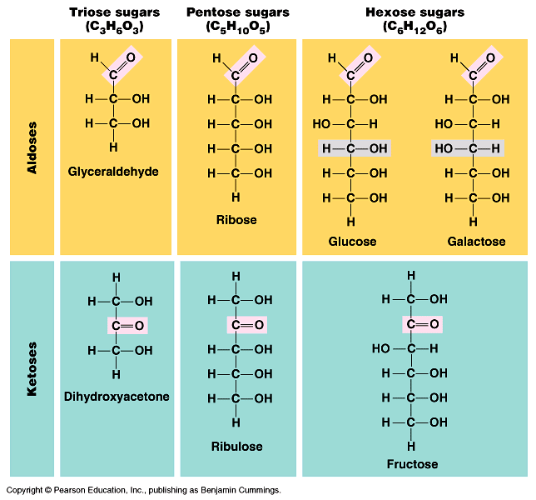

Polysaccharides: used for many different things. Food storage: ex. Wheat, corn, rice (starch)… energy for the next generation of plant. In animals we store energy as: glycogen (blood sugar and in liver)

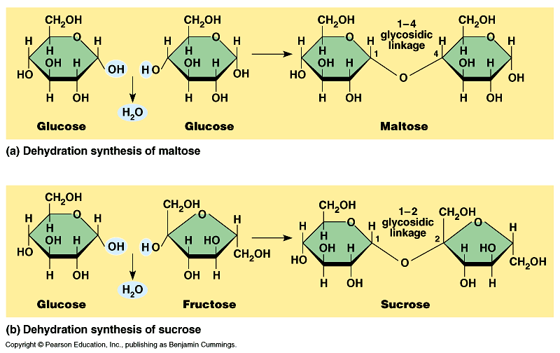

Some polysaccharides can be quite strong. Often water proof. Indigestible to animals.

Structures: cell walls, wood, stems (cellulose), chitin (exoskeletons of arthropods and mushrooms)

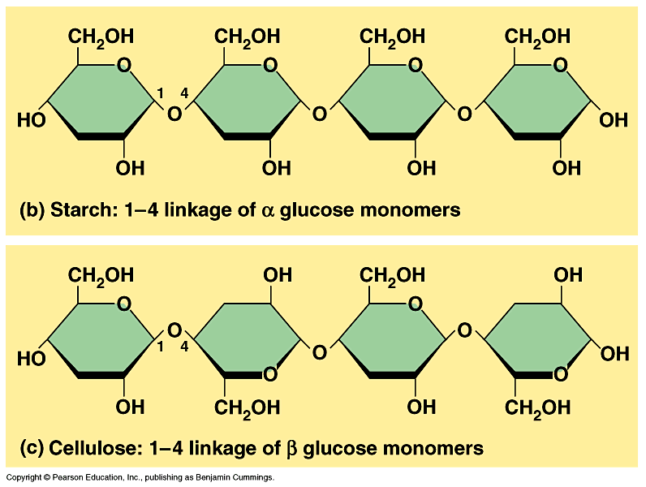

Lipids: Fats, Waxes, Oils, Sterols.

Fats: Structure. Basically long chains of fatty acids (CH – hydro carbons) with a glycerol.

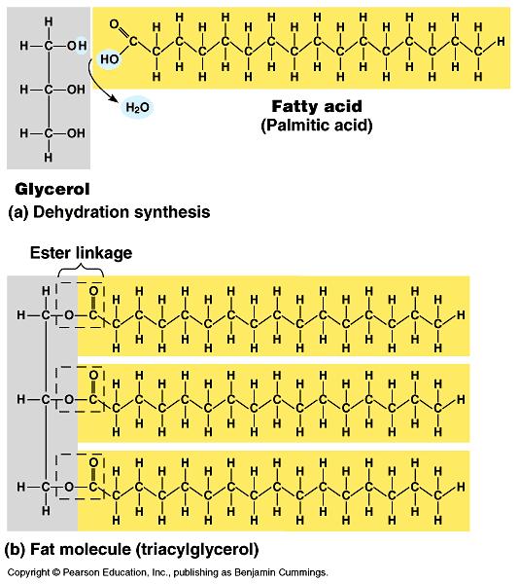

Lots of energy stored in C-C bonds.

Fat is used to store energy. Mostly animals, some plants. Because there are lots of bonds, also fats are lighter than carbs (per calorie), calories/gram is more for fats.

Fat: 1 gram = 9 calories
Protein: 1 gram = 4 calories
Carbohydrates: 1 gram = 4 calories
Fatty acids are non-polar, due to the lack of Oxygens. HYDROPHOBIC→hate water.

Phospholipids are unique, because the “heads” are polar (because of phosphate group), and tails are non- polar.
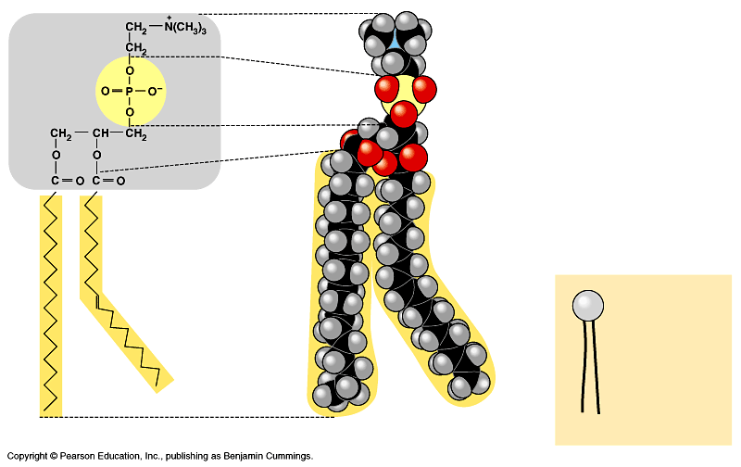
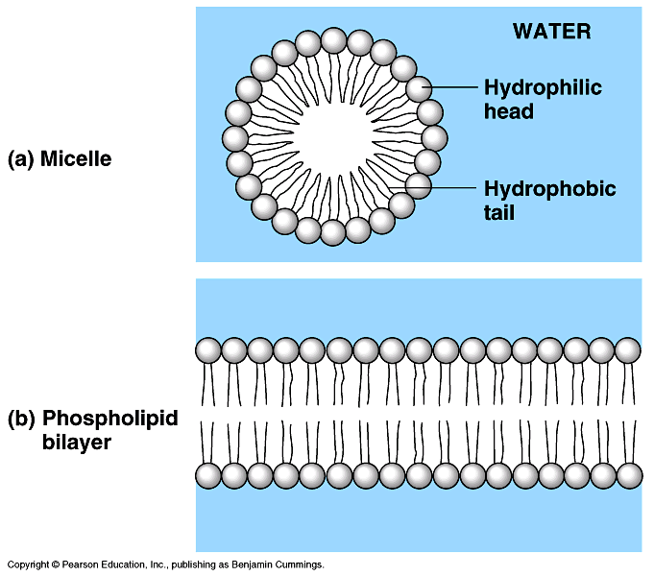

Sterols are lipids with ring structures. They have a variety of functions.
- Cholesterol – part of the cell membrane
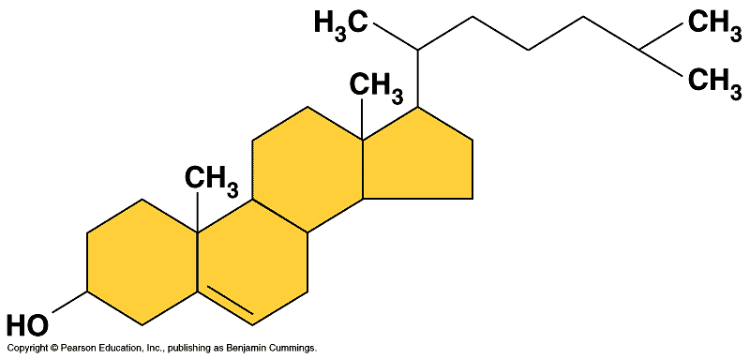
- Testosterone/Steroids – hormones that affect sex characteristics.

Proteins are involved in almost every biochemical reaction (enzymes) and almost every structure (muscles/skin/organs/blood) as well as many other functions in animals (less so in plants, but still important).

Functions of proteins and examples: ( table 5.1)
- Structural for support: hair, feathers, skin
- Storage: Albumin (eggs)
- Transport: Hemoglobin (oxygen)
- Hormones for communication: Insulin
- Receptor for receiving signals: on cell membranes or neurons.
- Contractile for movement: Muscles
- Defensive Proteins: Antibodies
- Enzymatic for chemical reactions : Amylase

In humans there are tens of thousands of types of genes that may code for over 2 million different proteins…

In all living things maybe 10’s of millions, billions? … This is due to virtually unlimited combinations of amino acids.

Example: if you wanted to make a protein that is a chain of 100 amino acids, there are 20¹⁰⁰ possible combinations that you could make using the amino acid “alphabet.”

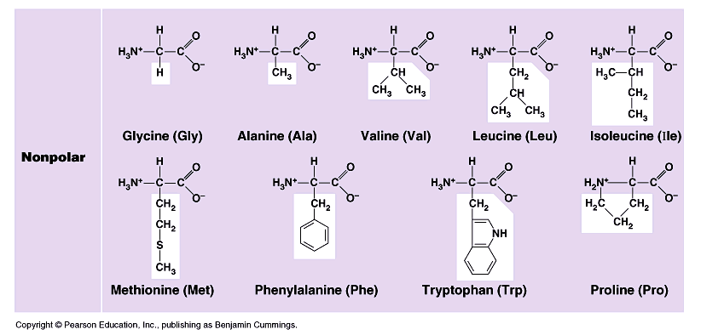

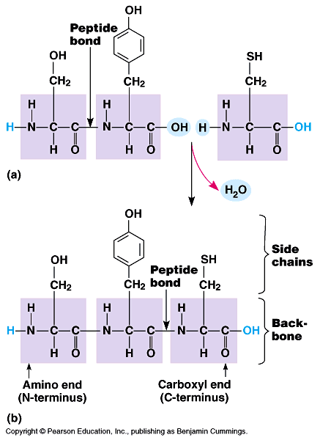

Protein structure (3-D shape) is KEY to their function.
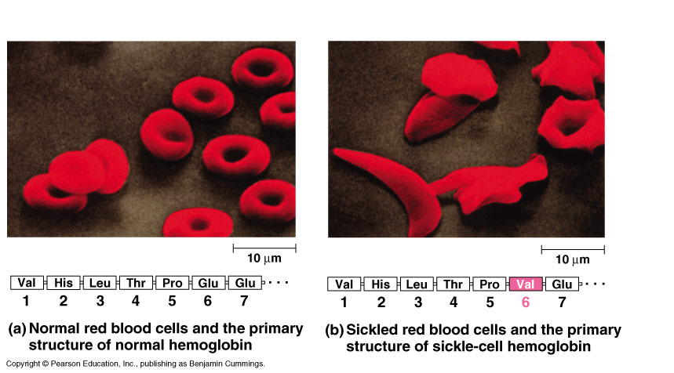

We can describe the structures in levels.

1° (Primary Structure) the amino acids linked together (polypeptide chain).
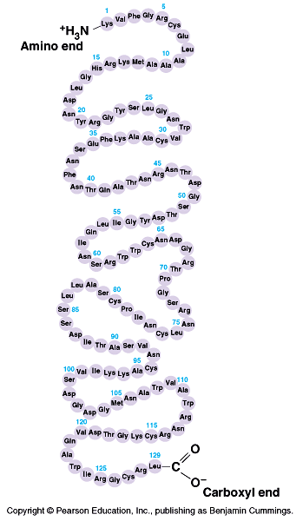
2° The chains form, alpha helix or a beta (pleated) sheet.
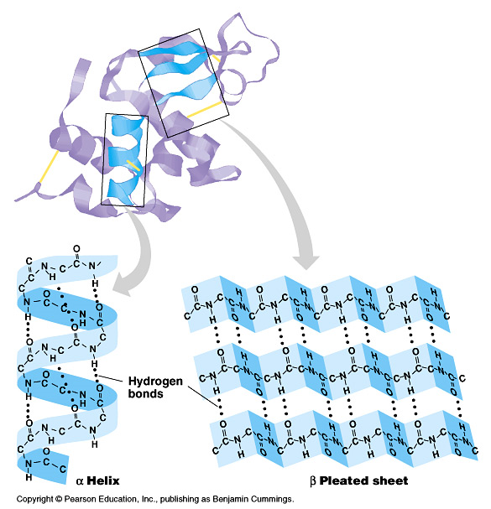
3° (Tertiary) The chain combines helices and sheets. Folds over onto itself. Different bonds give it shape.
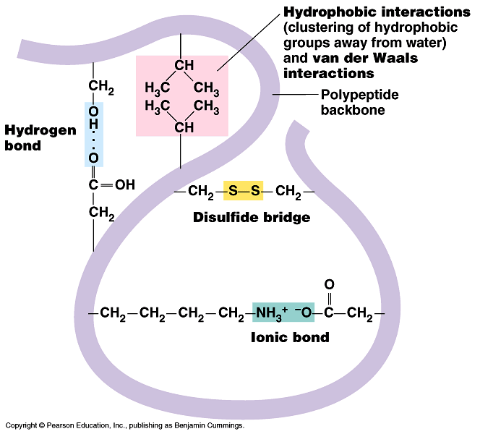
4° (Quarternary) More than one chain can combine.
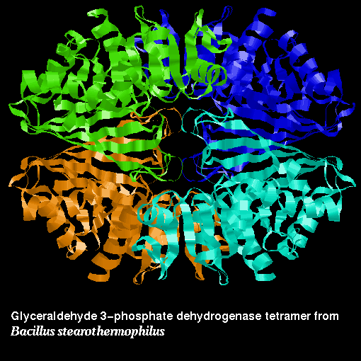

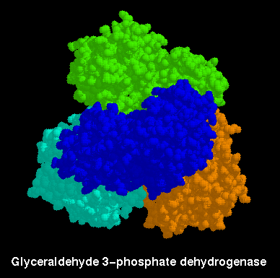

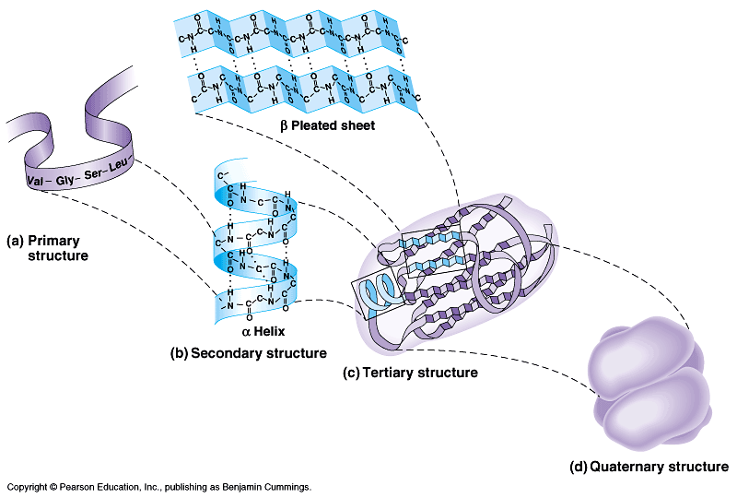

Proteins can be denatured (shape changed) by different things. Such as…
- pH
- Temperature
- Salinity
- Interactions with other molecules
- Physical Changes (beating egg white)

Usually protein loses its function when denatured. But… sometimes can be renatured if the conditions return to normal.

DNA holds the blueprint or instructions for making the polypeptides. Uses 4 “bases” (ATGC)... 3 billion in a human. The letters (bases) of the DNA work in 3’s (codon) = amino acid.

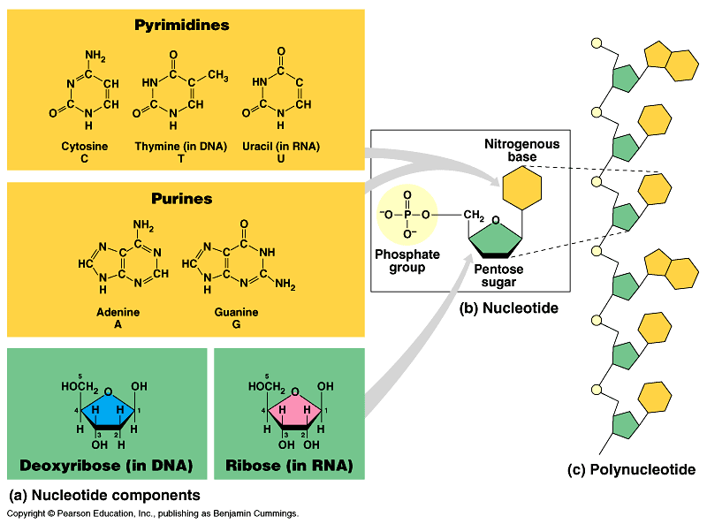

Pyrimidines: cytosine, thymine (uracil). Single ring. Less double bonds.

Purines: Guanine, Adenine. Double rings. More double bonds.

The spine of DNA (RNA) is held together using phosphate/sugar bonds (covalent = strong)

The bases (or the rungs of the ladder) are attached using hydrogen bonds (relatively weak)

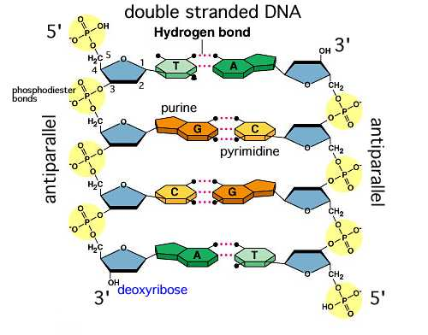

If maltose is 2 glucoses stuck together what is the chemical formula?

(C₆H₁₂O₆ = glucose) You have to minus the water because of dehydration synthesis!!!
C₁₂H₂₄O₁₂ – H₂O = C₁₂H₂₂O₁₁

What is the chemical formula for 5 glucoses stuck together!!!!!?!??!?!?

You have to minus 4 waters:
-8H’s, -4O’s

C₃₀H₆₀O₃₀ – 4(H₂O) = C₃₀H₅₂O₂₆

What is the chemical “identifier” for fats

What is the chemical “identifier” for carbohydrates?

What is the chemical “identifier” for proteins?

What is the chemical identifier for nucleic acids?

