Chapter 10 Notes:

Jan Baptiste Van Helmont planted a tree branch… he weighed the soil when he planted the tree… 2 years later…

Where did the weight come from? Water + air (CO₂) = carbohydrates.

Photosynthesis is…the process of transforming light energy into chemical energy, by “fixing” carbon dioxide from the air, and releasing Oxygen.

Types of getting energy/carbon:
Photo… gets energy from light
Chemo…gets energy from chemicals
Autotroph…gets Carbon from inorganic source (CO₂)
Heterotroph… gets Carbon from an organic source (other organisms)

Photoautotroph – energy from light/carbon from inorganic source. (Plants, Algae…)

Chemoheterotroph – energy from chemicals/carbon from organic. (animals, fungi, your momma)

Photoheterotroph -(bacteria – rare)

Chemoautotroph – (bacteria – sulfur bacteria)

Write the chemical or word formula for photosynthesis:

Light (energy) + water + Carbon Dioxide → Oxygen +glucose

6CO₂ + 6H₂O + Light → C₆H₁₂O₆ + 6O₂

Somewhere along the road of evolution… a photoautotroph evolved… some bacteria (cyanobacteria) did photosynthesis and made sugar and oxygen from light. These bacteria evolved into algae and plants.

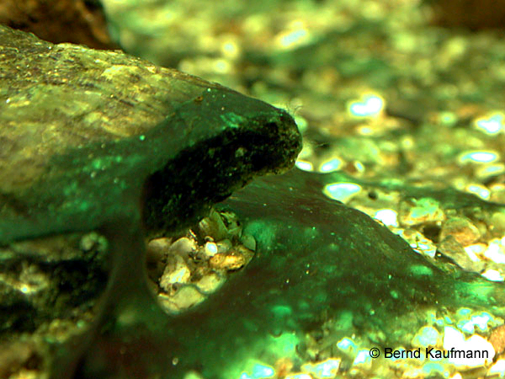

- Chloroplast (probably was a cyanobacteria), double membrane, own DNA…
- Chloroplasts have stacks of thylakoids (stacks called grana)
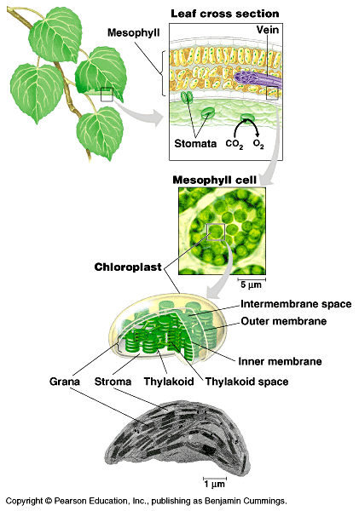

- Full of chlorophyll (and other pigments) that absorb light.

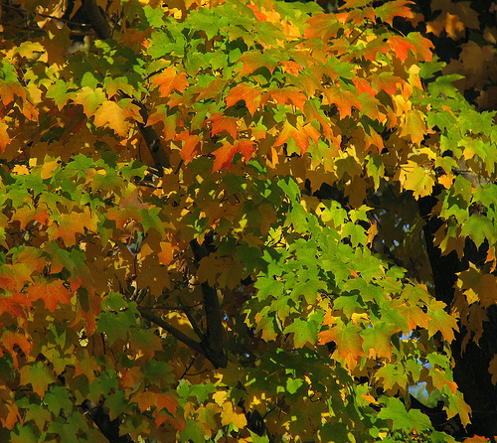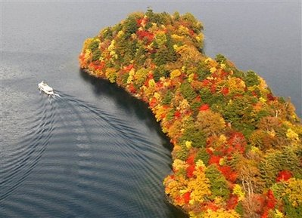
- On the leaf are also stomata, holes that plants breath in CO₂

- Side note about light… plants use visible light, wavelengths 380nm – 750nm. Smaller wavelengths is UV, longer is Infrared. Light comes to earth as photons → tiny packet of light energy… wave? Particle?

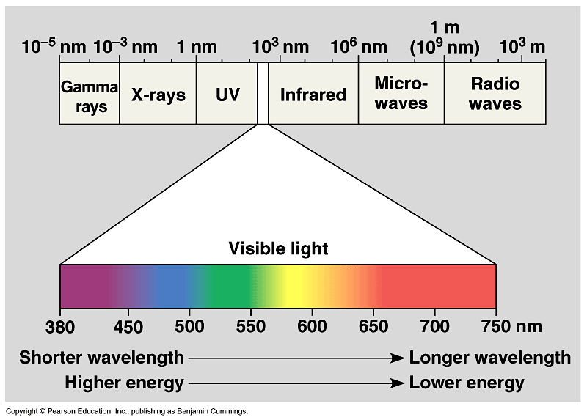

Plants with chlorophyll look green, because they reflect green.

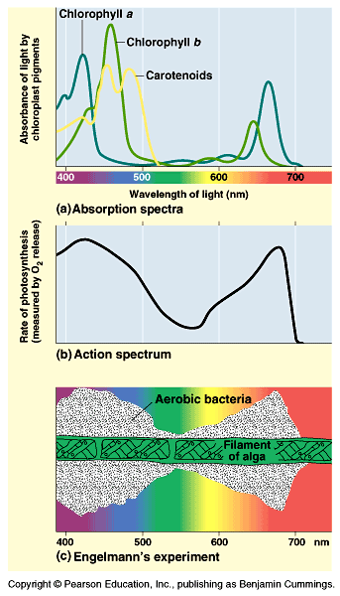

Plants want more than one pigment so they can absorb a wider range of light.

Photosynthesis: 2 main steps

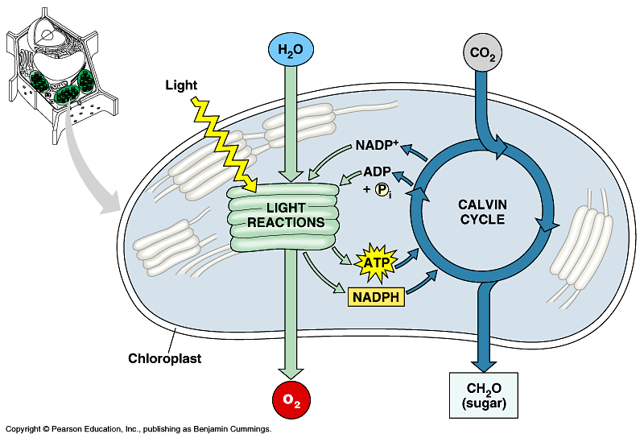
Light Rxns: splits a water molecule using light, catches an electron at a high level. (releases Oxygen)

Light independent rxns (Calvin Cycle): absorb CO₂ to make sugars.

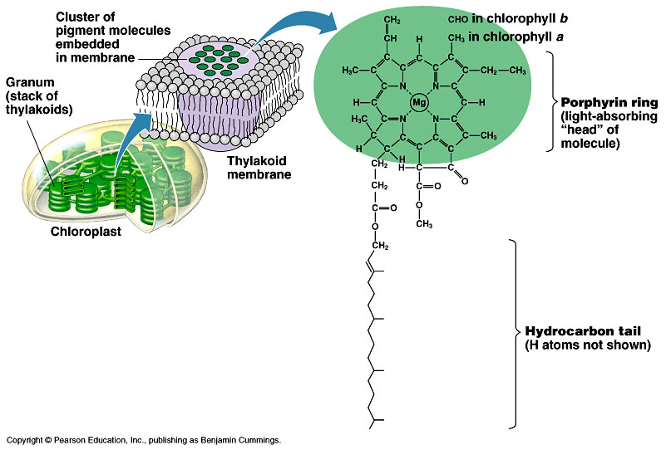

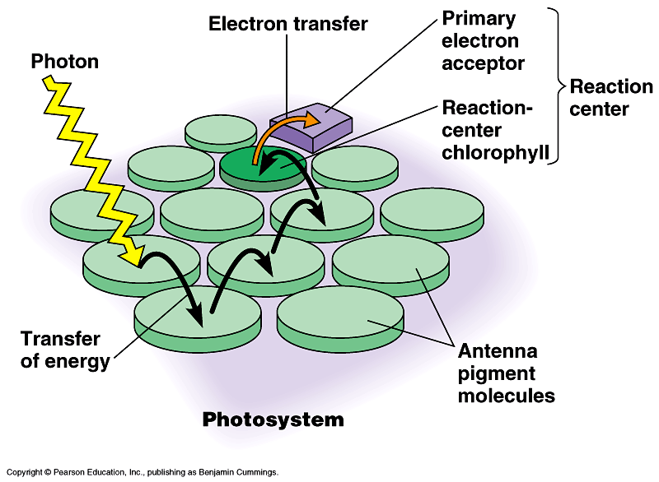

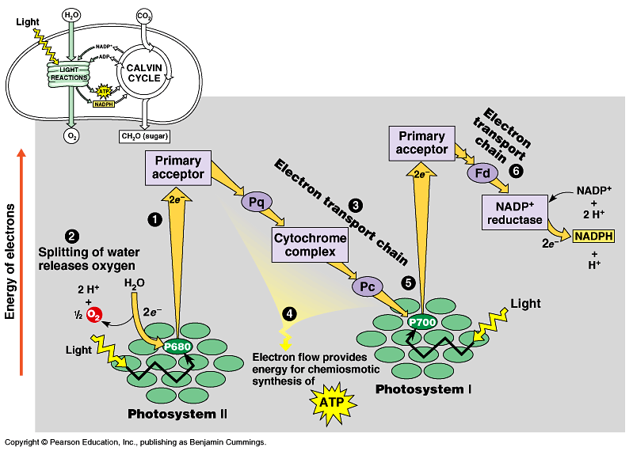

Non-Cyclic Photophosphorylation: Light reactions. Where an electron is not recycled… it’s passed on to the Calvin Cycle.

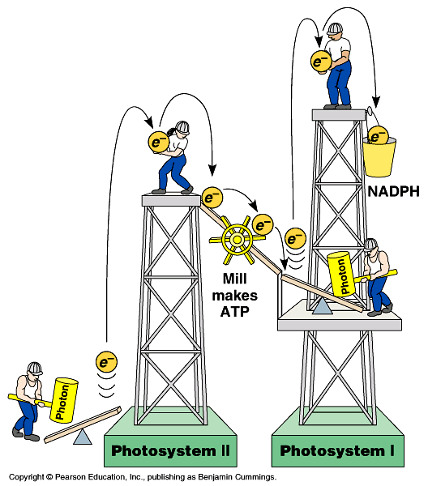

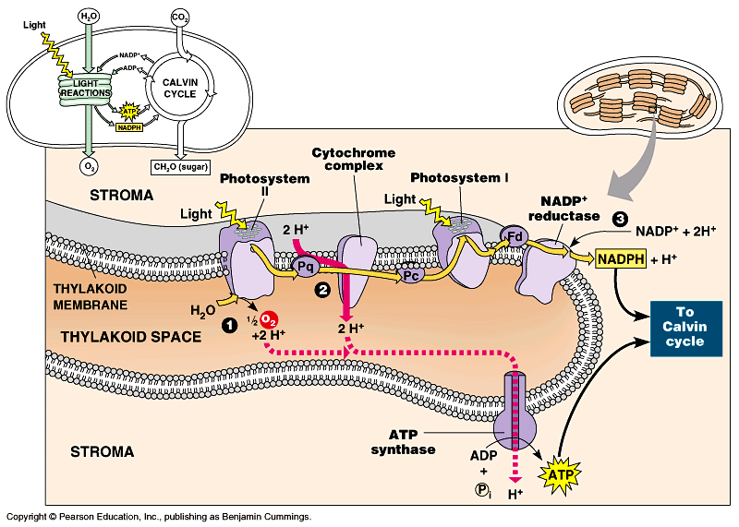

Sometimes plants need ATP right away… they can go through: Cyclic Phosphorylation.

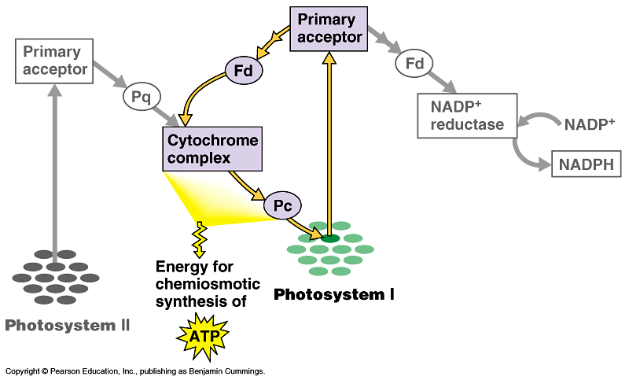

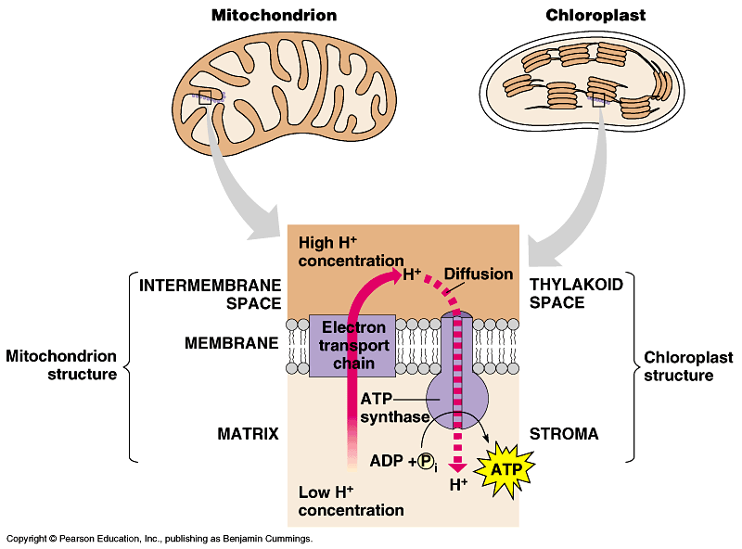

Calvin Cycle a.k.a. light independent… a.k.a. dark reactions. Uses the excited electrons (NADPH) and ATP to make a sugar from CO₂.

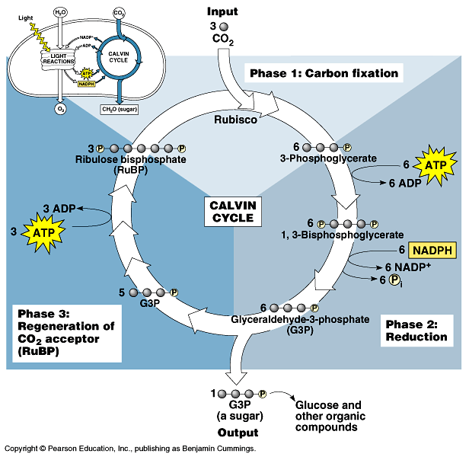
G3P = simple sugar = half a glucose.

How efficient is photosynthesis? 6.6% about… turning sunlight into sugar.

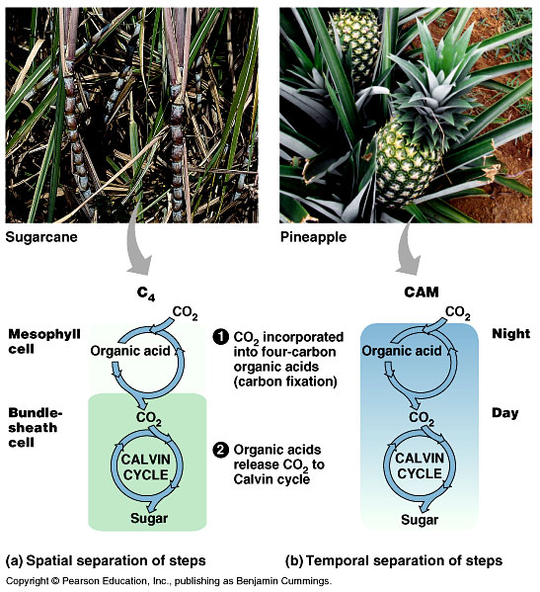
Plants have a problem with the stomata, the problem is… the stomata must be open in order to get CO₂ , but water also goes through the stomata… The problem is if it’s sunny/warm… you want the CO₂ for photosynthesis, but then you lose all your water due to transpiration. When it’s too hot, and stomata are closed, then they do photorespiration = when you burn sugar for no reason. Regular plants are C₃ (most plants)

C4 plants, Take the CO₂ in the mesophyll, and turn it into an acid, then move it to the bundle sheath cell (another compartment) where it does Calvin Cycle. So their stomata aren’t open as much so they save water.

CAM Plants:(Crassulacean Acid Metabolism) example Pineapple, or cacti. Open stomata at night, store CO₂ (as chemical) use during the day, and have stomata closed.

For the Test:
Glycolysis
Kreb’s
Electron Transport Chain
Light Reactions (non-cyclic)
Calvin Cycle
Diff between Cyclic/Non-Cyclic Photophosphorylation
Fermentation
CAM, C₄, C₃
Pigments (which likes what wavelength)
Autotroph…
Anatomy of the Mitochondria/Chloroplast?
Can trace the path of an electron through photosynthesis or cellular respiration.

