Ch 6 Notes: Metabolism: Sum of all chemical reactions in an organism.

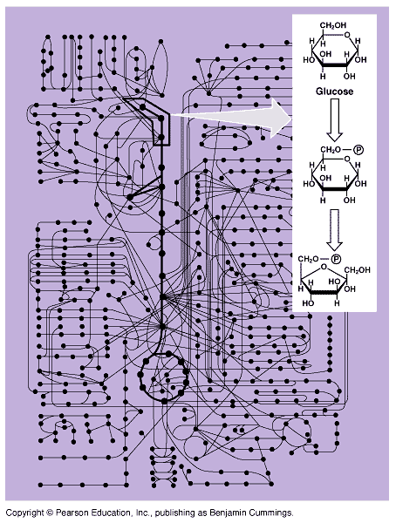

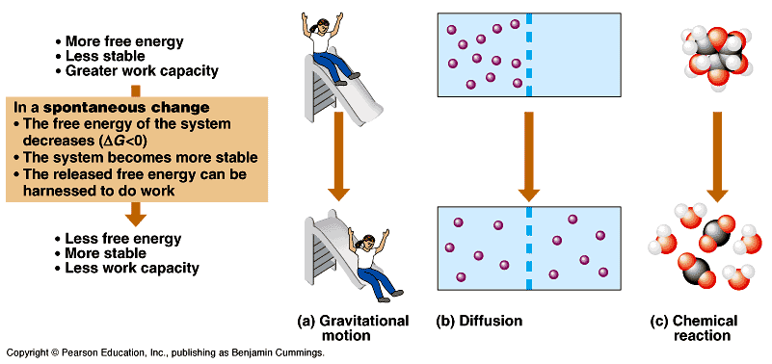

You must know these pictures 6.6
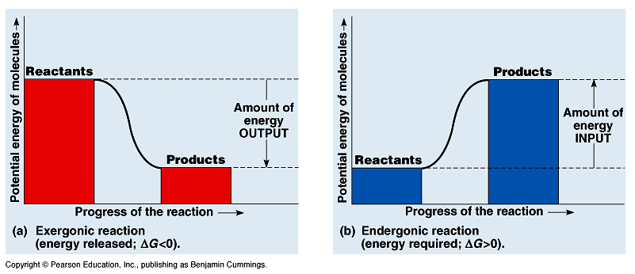

a) Exergonic reaction = ΔG is negative, energy was released. “downhill reaction” example: cellular respiration. (when you break bonds). Catabolic → when you break bonds

b) Endergonic reaction = ΔG is positive, “uphill” reaction → if you push a rock up a hill, it has more potential energy. Making bonds
Anabolic → making bonds. Ex: Photosynthesis

Potential energy is stored energy that can do work if it is transformed. Ex in humans: fat, or food. In plants = sugars and starches (some fats).

ATP is the temporary energy molecule for living things. It powers most biochemical reactions. (GTP is another one). ADP is adenosine diphosphate.
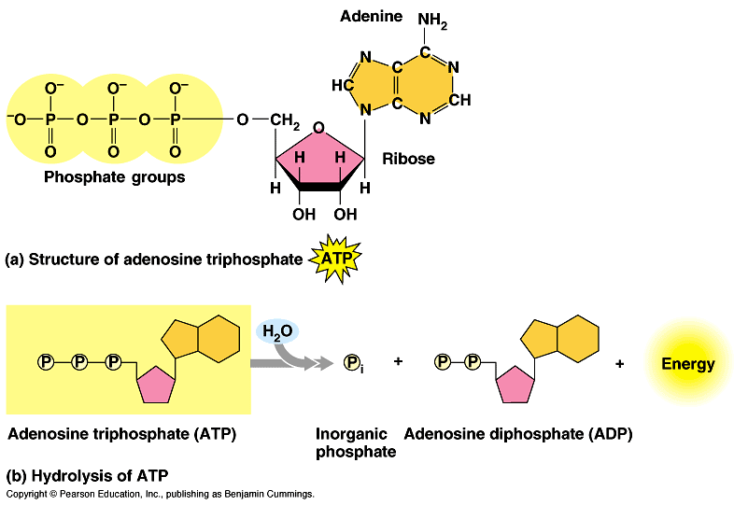

ATP is a coupled reaction. It is partnered with other reactions, one reaction (ATP) gives energy (exergonic), the other reaction takes energy (endergonic reaction) to do work.

The energy to anabolize ADP back to ATP comes from light (in plants) or from food (heterotrophs).

Work that organisms do: (all need ATP)
- Mechanical: movement (contractions), growth
- Transport: moving molecules across a membrane against a gradient (not diffusion).
- Chemical: reactions, protein synthesis

Which of these types of work, do you think uses the most energy in humans??????? Transport

Sir Isaac Newton and biology?

1st Law of Thermodynamics: energy can neither be created nor destroyed, only transformed/transferred.

Sun → autotrophs (plants, algae, some microbes) → heterotrophs → some is decomposed when we die.

Most energy in humans is used to do some sort of work and/or lost as heat. (we’re not very efficient as machines).

2nd Law of Thermodynamics: In chemical reactions, energy is lost and leads to entropy (randomness)

i.e.: sandwich → you (stored energy → heat)

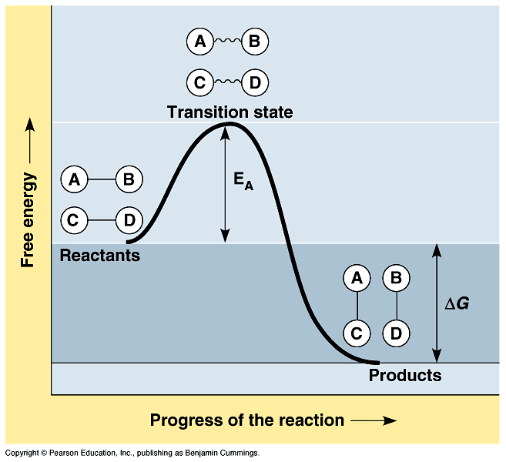

E_{A} = Activation energy. The energy required before a reaction will proceed spontaneously.

Before E_{A} is reached the energy is potential, after E_{A} the energy is kinetic and can do work.

French fry example: why don’t we burst in flames when we eat french fries?

Answer: we have enzymes to slow the process down, and they help to lower activation energy.

Catalysts called enzymes, they help the reaction go, by lowering the activation energy required.
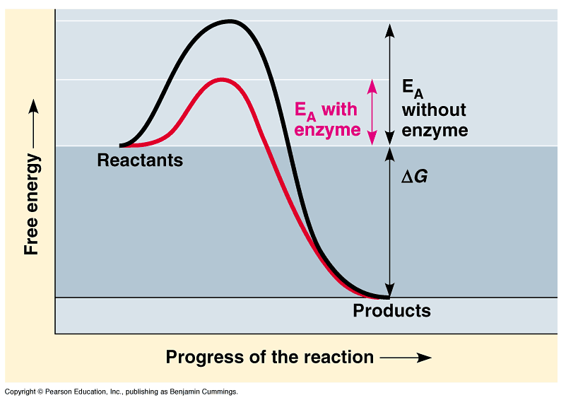

Enzymes are proteins, they usually end is –ase, e.g. amylase, or kinase, or lipase…

Enzymes are 3D, molecules, that depend on their shape. If they lose their shape they lose their function.

The substrate is the molecule that the enzyme acts upon.

Ex: Hydrolytic enzymes break things up using water.
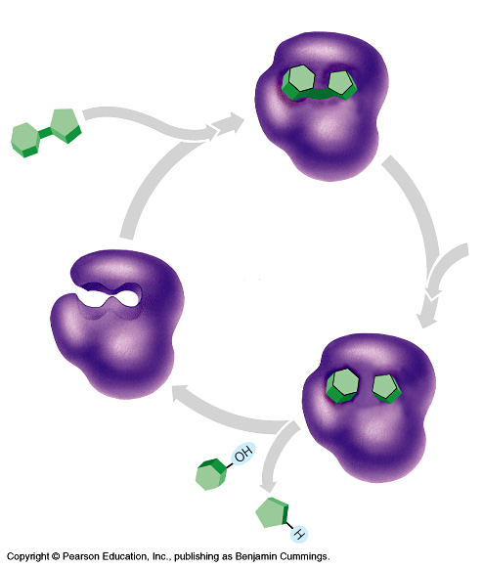

The rate that enzymes work is a factor of several things:
- Temperature
  - Hotter = faster, b/c more kinetic energy kinetic energy causes the molecules to move faster, which helps them find each other
  - If colder, enzymes move slower, because there’s less kinetic energy.

- Amount of substrate,
  - more substrate = higher rate (easier for enzyme to find something to react with)

- Competition can lower or increase rate.
  - Competitive inhibition. Another molecule will compete for the active site of an enzyme. The substrate is blocked.
  - Non-competitive inhibition. When a molecule changes the shape of the active site.

- If something denatures a protein that will obviously affect the rate (basically rate = 0 because enzyme is “dead.”)
  - Things that can denature
    - Temperature
    - pH can change the shape of an enzyme (extra H+ can change the bonding pattern)
    - chemicals that disrupt the bonds (going from aqueous to organic solvent)
    - Salt

