Ch 11 – Cell Communications
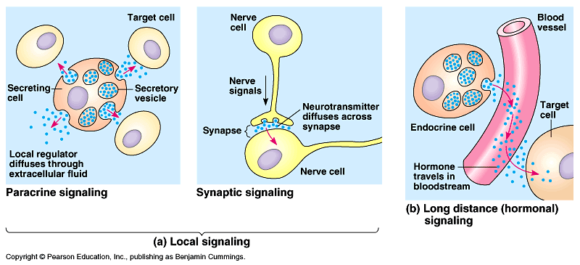

Cell Signaling: Why do cells communicate?
- To work together.
- To get another cell to do something.
  - A message from stomach to intestines
  - Puberty – secondary sexual characteristics (hormones)
- To trigger fear mechanisms… fight/flight

How do cells communicate?
Can be local or long distance
- Local
  - Paracrine signaling (secretion nearby)
  - Synaptic signaling (nerves)
- Long Distance
  - Hormones (testosterone)

Once the signal is received by the cell (it received by a membrane protein)

- Reception: the target cell detects a signal on its surface. (a chemical signal). Signal binds with surface protein
- Transduction: After the receptor protein gets the signal, the message is sent, through a cascade of molecules (proteins). Relay molecules.
- Response: The cell responds some way. For example: the nucleus initiates a protein ( a gene is read… RNA is made…)

