Chapter 12 Notes: Mitosis and the Cell Cycle

Why would cells divide?
- Growth
- To replace a dead/dying cell
- To reproduce (some plants, rarely in animals)

In prokaryotic cells (bacteria). Go through binary fission. (simpler split than mitosis). They do need to duplicate DNA, the rest is more like cytokinesis.

Mitosis: the duplication of a cell (clone)
Meiosis: the making of sex cells (gametes), unique and haploid (half “your” DNA)

Cell Cycle:
Interphase ~ 90% of cell’s life.
- Three stages of interphase
  - G1 → Growth 1 (when cells are growing) Cell is being a cell.
  - S → Synthesis (when the DNA is replicating)
  - G2 → Growth 2 (make membrane, make more organelles)
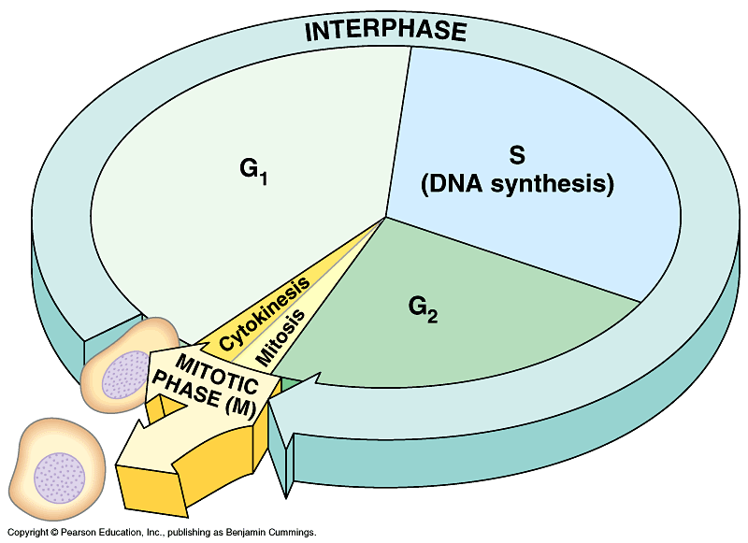

Mitosis: is when cells make a copy of themselves. Cytokinesis: is when the cells split.

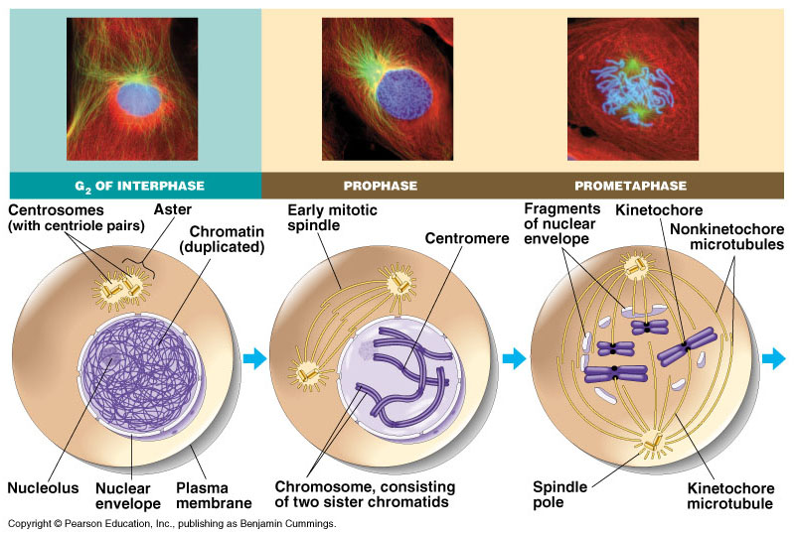

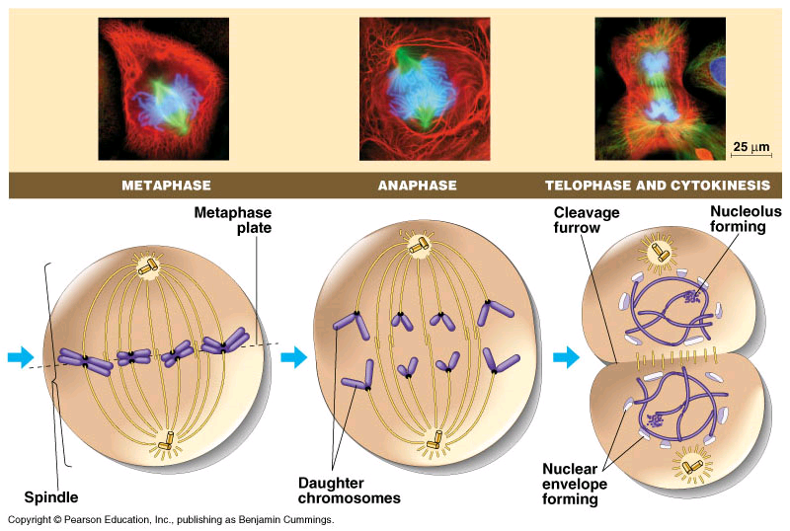
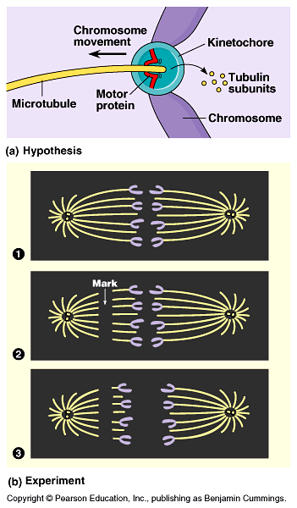

Video from Campbell

How do cells know when to divide?
- Size. If a cell gets too big, it will divide. (remember: the larger it is… the harder it is for things to diffuse in).
- Density Dependence. If cells are too crowded… cells will stop dividing.

  - Experiment:
Empty dish = divide/grow
Full dish = stop dividing
Take some out from dish = divide again
Cancer cells = fill up dish regardless

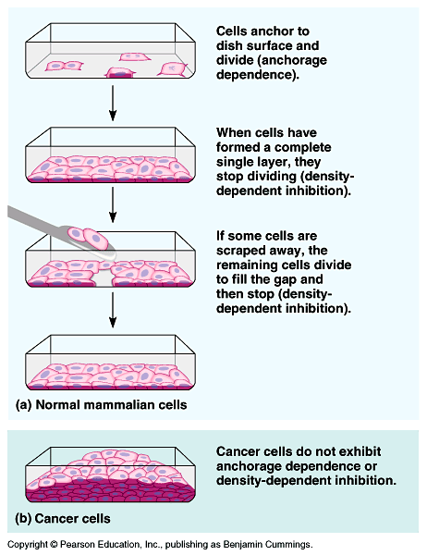
- Chemical Signals
  - MPF (Maturation Promoting Factor)
  - Works together with other proteins called cyclin and Cdk. (they combine to form MPF).
  - No cyclin – no Mitosis

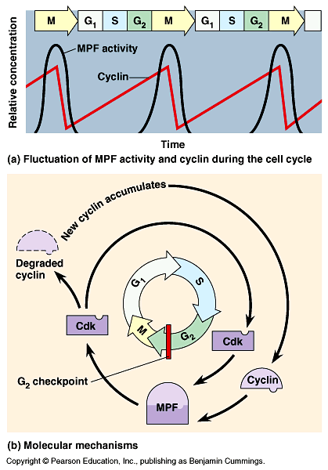

Some cells are stuck at G1 checkpoint, they will actually switch out to G₀ → specialized nerve cells (brain and spinal cord), muscle cells… liver cells are at G₀ can be reversed back to G1.

Red Blood Cells don’t divide (no nucleus – instead they die and are replaced by stem cells which become new RBC’s).

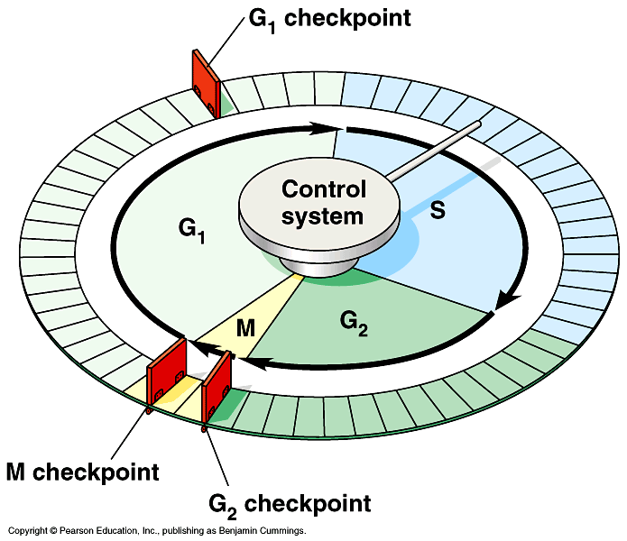

Cancer: cells that don’t have the regular cycle controls.
- Tumor: mass of cells that are growing uncontrolled.
  - Benign = not spreading.
  - Malignant = invasive (take over organ)
    - Metastasis → spreads to other locations in your body.

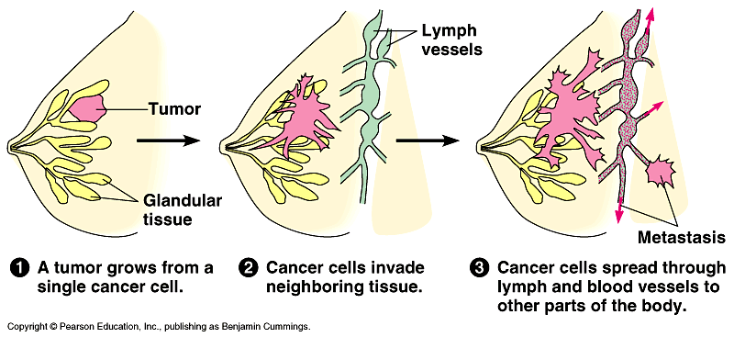

Treatments: Difficult to “cure” cancer, b/c the cells are basically “you.”
- The only thing you can do is remove (surgery) Mastectomy = remove the breast
- Only other thing is to poison the cells
  - Chemotherapy = drugs that stop cells from dividing.
  - Radiation = shoot tumor with X-rays.

