Notes Ch 13: Meiosis

True or False… and why?

“Like Begets Like… but not exactly”

DNA makes you look like your parents. Genetic Information is passed along… that’s heredity.

You don’t look exactly like your parents because, the genes are mixed which affects phenotype.

Phenotype (how the genes are expressed) is often different because, you are a mixture of all your ancestors.

All this mixing is due to a process called Meiosis. This creates diversity.

We are now entering the Genetics Unit. Meiosis is more about genetics than it is about cells.

Introduction Heredity: the passing down of traits to offspring.

Genes were the “particles” that were passed on (1870’s)… 1950’s learned about DNA. 1990’s when we started to learn how to manipulate DNA. The 2000’s… are learning how to control it and solve some of life’s great mysteries.

Sexual reproduction is how the traits are passed on to offspring… namely chromosomes. (colored bodies under a microscope = chromosome)

Chromosomes are actually large strands of DNA, that contain genes (genes = regions of DNA that code for traits).

Only present (visible) during… cell division. The rest of the time (interphase), they are in their chromatin form. Humans: 46 chromosomes, 23 pairs (one from mom and one from dad). 44 autosomes... regular chromosomes with genes. 2 sex chromosomes (XX = females Xy = males).

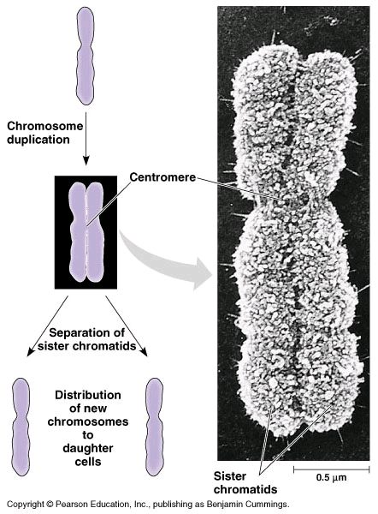

Diploid = 2n (46) double set, paired set of chromosomes

Haploid = n (23) single set, unpaired chromosomes (found in gametes)

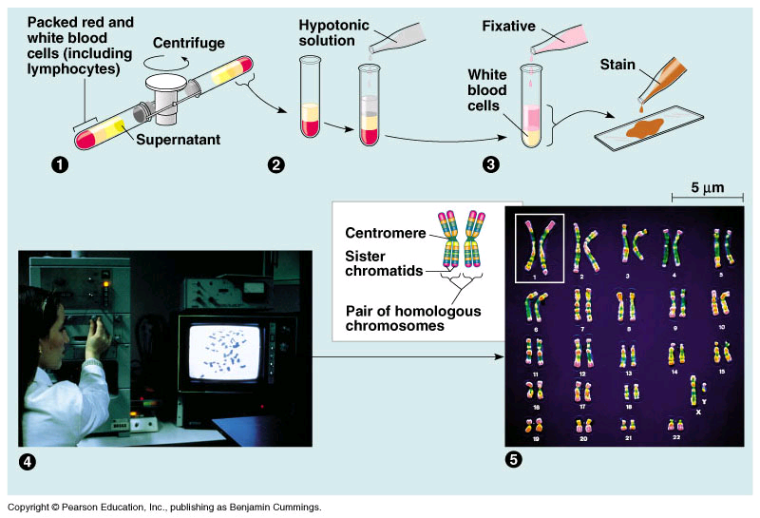
Meiosis is the cell division that produces gametes. In males, takes place in the testes. In females takes place in the ovaries. Gametes are haploid.

Meiosis. It’s like two cycles of mitosis.

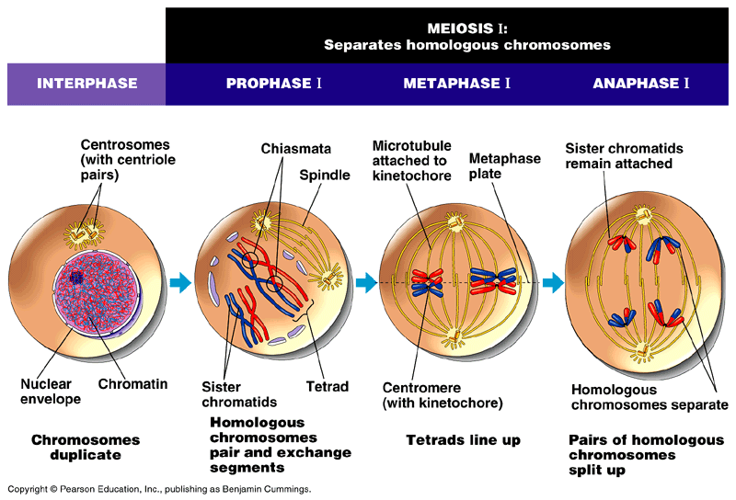
Prophase 1: Homologous chromosomes, pair up and form tetrads. Sister chromatids make up the chromosomes. 4 chromatids make up a tetrad…

When they form a chiasmata they exchange information (CROSSING OVER). Where they overlap is called the chiasmata. So the new chromosomes are a mix from the ancestors.

The rest of prophase (similar to mitosis), nuclear envelop dissolves, and spindle fibers form.

Metaphase I: Homologous chromosomes line up as pairs.

Anaphase I: The pairs split apart. (in mitosis the sister chromatids split)

Telophase I: Pretty much the same (as mitosis)… except between cytokinesis I and Meiosis II there is no Synthesis of DNA. So your amount of DNA is going to be halved.

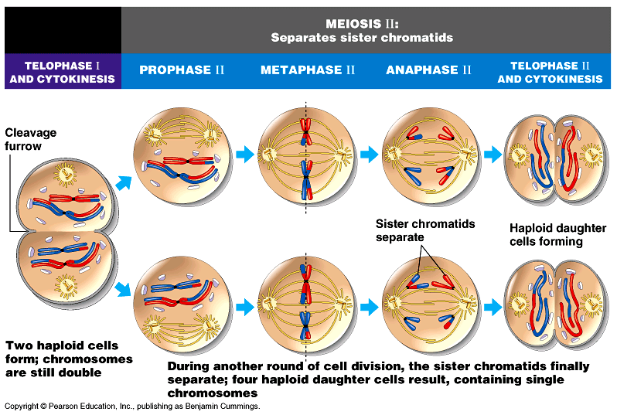

For Meiosis II, it is basically the same as MITOSIS. Except: the differences between Mitosis/Meiosis II are:
- You don’t double the DNA before you split (in Meisosis II).
- You have 2 cells going through all the phases (in Meiosis II.)
- And the chromosomes are mixed b/c of crossing over.

Final result of meiosis (the whole thing) different than mitosis.
- 4 daughter cells (mitosis: 2)
- Each cell is unique because of crossing over (mitosis: every cell same)
- Cells have half the DNA, haploid, n. (mitosis: 2n)
- Meiosis only takes place in gonads.

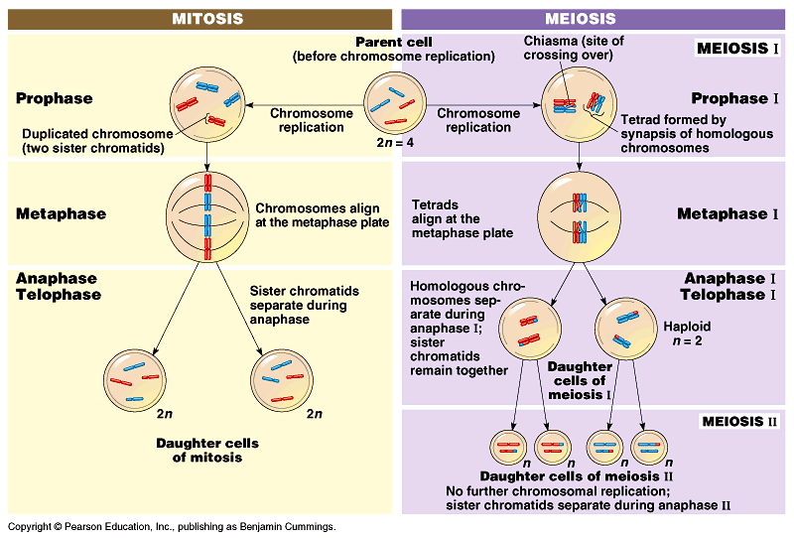
Independent Assortment: each chromosome is independent from each other. They can sort however they want. This creates even more chance for diversity.

Random fertilization: the combination of egg and sperm are random as well, so that creates even more diversity.

