Ch 14: Mendel and the Idea of the Gene

Mendel Worked with Pea Plants: Good choice for a number of reasons:
- Easily recognizable traits… pea shape, flower color, seed color, height…
- Grew and reproduced quickly
- The traits were one or the other…ex: either purple or white… not lavender…
- There were several traits to observe.
- They were easy to manipulate.

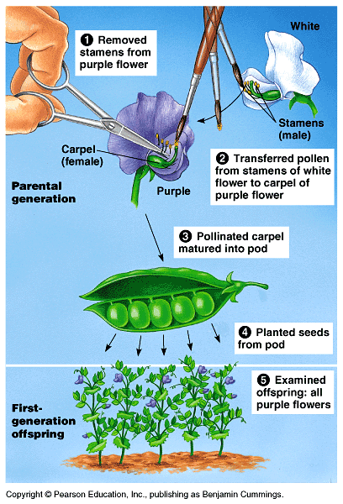

Mendel’s Famous Experiment

Mendel’s observations:
- Dominant and recessive “genes”. If there is a dominant gene, then it will show up. Recessive only shows up if there is no dominant.
- Genes travel in pairs (one from mom + dad)
- The traits segregate during reproduction… in other words they go to different egg and sperm.

On chromosomes, you have genes that are located at a particular LOCI.

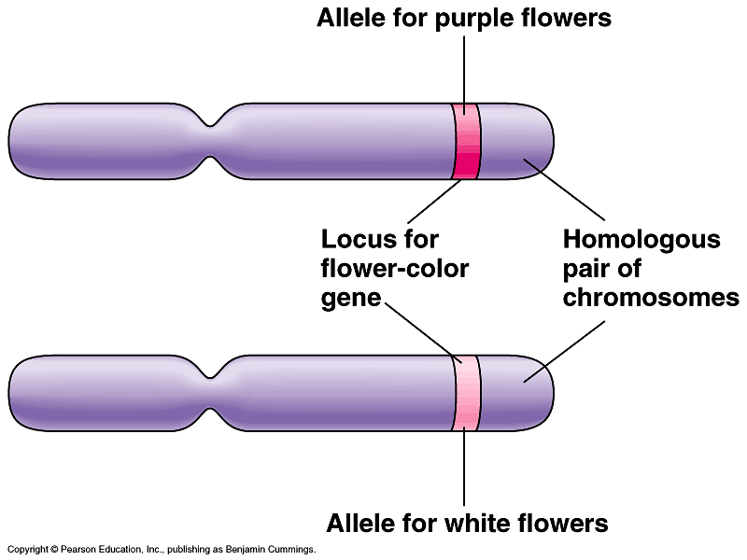

Variations of a gene are called ALLELES.

Genotype = the actual allele pairs ex: AA, Aa,
Phenotype = what it “looks” like
Homozygous = two of the same alleles
Heterozygous = one of each

The rules of probability: What are the chances of something happening.

Multiplication Rule: whatever possibility there is of something happening, if it happens more than once you multiply the chances.

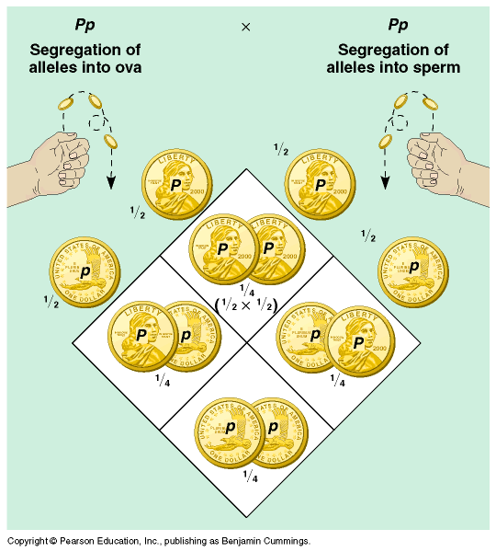
Ex: if you flip a coin… 4 times, what are the chances you will get all heads? 1/16

Addition Rule: If there is more than one way of getting a particular outcome you add chances.

Ex: flipping a coin twice, and getting one head and one tail?
¼ + ¼=½ because…

HH ½ x ½ = ¼
HT ½ x ½ = ¼
TH ½ x ½ = ¼
TT ½ x ½ = ¼

What are the chances of having 2 boys and 1 girl (in any order)

2 Dogs that can hear and are genotype →Dd, what are the chances of them having 3 puppies that are deaf (dd)?

What are the chances of one deaf dog? ¼

Chances of 3 = 1/64

What are the chances of getting 3 dogs that can hear?

What are the chances of getting one deaf dog, one heterozygous dog, 1 homozygous dominant dogs?

What are the chances of getting 3 girls and a boy in this order: ggbg?

What are the chances of getting 3 girls and a boy in any order?

Dihybrid Cross = more than one trait.

Yellow/Green Peas Y/y
Tall/Short Plants T/t

If we have YyTt x YYTt , what percentage of: Yellow/Tall =
Yellow/Short =
Green/Tall =
Green/Short =
What are the chances of getting: 3 Yellow/Talls and in row….

You’re a dog farmer:

B = Brown fur
b = spotted fur

Male Bb x Female bb What offspring? How many will be male and brown fur? Female and spotted fur?

You are a fish farmer.

Long = L
Short = l
Red = R
Blue = r

Take Llrr x LlRr

What are the possible phenotypes (and %)?

What are the chances of getting:

Male: Lr Female: LR, Lr, lR, lr

LLRr, LLrr, LlRr, Llrr

Long/Red =
Long/Blue =

¼ x ¼ x ¼ = 1/64

3/64

Some variations on Mendel’s work:

Incomplete Dominance: neither allele is totally dominant over the other, results in a mixing of traits. Red flower x White flower = pink flower.

Rr x Rr = ¼ Red, ½ pink, ¼ white plants.

Co-Dominance: both are dominant. Ex: roan colored horse. Brown hairs and white hairs next to each other. Results in a combo.

B = brown b = white if you had Bb = roan
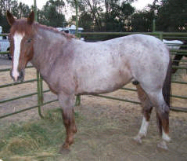

Epistasis: When other traits depend on another one. (lit. meaning = to stand upon)

Color or no color gene… then it depends on the other allele for color… second gene depends on the first.

Color gene + brown gene = brown
No color gene + brown gene = white

Plieotropy: One gene has many effects. Ex: sickle cell anemia = the one gene affects several different proteins.

Polygenetic Inheritance: Many genes affect one trait. Ex: human skin color.

D = dark, d = light…

4 loci of the gene:
DD, Dd, dd, DD = pretty dark
dd, dd, Dd, dd = pretty light
Dd, Dd, Dd, Dd = dark… but their kids…

Multiple Alleles: more than just 2 versions (alleles): blood type: A, B, 0
.
I^{A}i, I^{A}I^{A} = type A I stands for immunoglobin
I^{B}i, I^{B}I^{B} = type B
I^{A}I^{B} = type AB
ii = type 0

Mom = I^{A}i Dad = I^{B}i

I^{A}I^{B} = 25%
I^{B}i = 25%
I^{A}i = 25%
ii = 25%

Human Genetics: we can use pedigree charts to trace traits through family lines.

We worked on the practice problems at:

http://www.yhc.edu/external/jasonb/previous_semesters/Bio103_Su2004/Links_of_Interest/links_to_practice_pedigree_probs.htm
Multiple Alleles:
C = full color (dominant over all others),
c^{ch} = chinchilla (dominant over c and c^{h}),
c^{h} = Himalayan color (dominant over c),
c= Albino, no color (recessive to all)

Draw a punnett square showing a cross between:

Cc^{h} x cc^{ch}

